TABLE OF CONTENTS
Supplementary Note 1:
DRS analysis of the RNA modification landscape …………………………………………………… 2
1.1. Preparation of IVT RNA controls ……………………………………………………………. 2
1.2. Tombo analysis ………………...…………….......………………………..……………….… 3
1.2.1. noise-reduction: Tombo-MSC (Step 1)……………….……………………………….. 3
1.2.2. noise-reduction: removal of the baseline noise (Step 2) …….………….................. 4
1.2.3. signal instability at the first and the last 40 nucleotides of DRS reads…..…….….. 5
1.3. Eligos2 analysis ………………………...…………………..……………………………….... 6
1.4. Nanocompore and xPore analyses ……………………...……………...……………........ 6
1.5. Nanom6A and m6Anet analyses ……………...………………...………………………….. 7
1.6. Determining common modification sites ………………………………………….……… 8

Supplementary Note 2:
Machine-Learning: Determining m6A Modifications Per-Read Per-Position Basis……….….... 9

2.1. Read-level p-value patterns………………………………………………………….……… 9

2.2. Control RNAs. ……………………………………………………………………………….… 9

2.3. Selecting Fisher options. …………………………………………………………………… 10
2.4. Model selection. ………………………………………………………………………………. 10
2.5. 5-fold cross-validation for the accuracy of the model. ………………………………… 10
2.6. Linearity of quantification. ………………………………………………………………….. 10

Reference…………………………………………………………………………………………………...... 11

Supplementary Note 1:
DRS analysis of the RNA modification landscape
Nanopore DRS can detect various types of chemical modification based on the DRS electrical signals (raw current intensity and dwell time) and/or the detection of modification-induced base-calling errors¹. For a whole-genome-scale analysis of chemical modifications on HIV-1 RNA, we used Tombo (based on current intensity differences²; see section 1.2), Eligos2 (based on error rates³; see section 1.3), Nanocompore (based on both current intensity and dwell time differences⁴; see section 1.4) and Xpore (based on current intensity differences at the individual read level⁵; see section 1.4). We also used Nanom6A⁶ and m6Anet⁷ for a read-level detection of m6As (see section 1.5). We then cross-compared the results of Tombo, Eligos2 and Nanocompore to identify the most likely candidates of RNA modification sites (see section 1.6).

1.1. Preparation of IVT RNA controls:
We generated 3 types of HIV-1 IVT datasets: (i) full-length (with the identical nucleotide sequence to NL4.3 RNA from the nucleotide position 1 to 1973 with a poly [A] tail at the 3’ end), (ii) half-length (F1 fragment from 1 to 4587 and F2 fragment from 4588 to 9173), and (iii) short IVT (7 fragments of 1 to 2 Kb covering the whole genome)(Fig.SN1). The full-length IVT RNA reads were used for the whole-genome-scale comparison of RNA modification sites (see Fig.1). The half-length IVT datasets were used for read-level m6A determination (see Fig.5). We found the short IVT RNA sets are not suitable for the whole-genome-scale analysis due to unreliable modification signals at the ends of RNA reads (see Supplementary Note 1.3.3 below and Extended Data Fig.3).
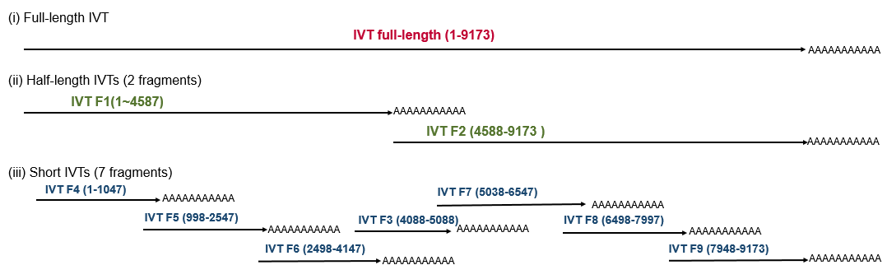

Fig. SN1. Schematic view of IVT RNA controls. DNA templates were generated with the Sp6 promotor at the 5’ end by PCR amplification using the primer sets in Table SN1. The PCR amplicons were then gel-purified (QIAquick gel extraction kit, Qiagen), and subjected for in vitro RNA transcription (RiboMAX™ Large Scale RNA Production Systems, Promega). After purification (RNA Clean XP, Beckman Coulter), 1ug of IVT RNAs were subjected to ONT DRS using ONT DRS kit (SQK-RNA002).

Table SN1. Primer sets used for IVT RNA template generation
 | Name | For (5’-3’) | Rev (5’-3’) | RNA positions
Full-length IVT | FL | ATCGATATTTAGGTGACACTATAGTTTGCCTGT ACTGGGTCTC TCT | T(30)GAAGCACTCAAGGCAAGCTTTATTG | 1-9173
Half-length IVT | F1 | ATCGATATTTAGGTGACACTATAGGTTCTACTTACACCAGGAAAGGC | T(10)GCGGCCGCAATCCCTGATGATCTTTGCTTTTCTTCTTG | 1-87
Half-length IVT | F2 | ATCGATATTTAGGTGACACTATAGGCGGCCGCATCTTGGCTCACTGCAACCTCTAC | T(10)GAAGCACTCAAGGCAAGCTTTATTG | 4588-9173
Short IVT | F3 | ATCGATATTTAGGTGACACTATAGAGCAGGAAGA TGGCCAGTAA | T(10)CTAACACTAGGCAAAGGTGG | 4088-5088
Short IVT | F4 | ATCGATATTTAGGTGACACTATAGGTTCTACTTACACCAGGAAAGGC | T(10)TGCTATGTCACTTCCCCTTGG | 1-1047
Short IVT | F5 | ATCGATATTTAGGTGACACTATAGGGCCTATTGCACCAGGCCAGA | T(10)GTGGAAGCACATTGTACTGAT | 998-2547
Short IVT | F6 | ATCGATATTTAGGTGACACTATAGTATAAACAATGAGACACCAGG | T(10)GTACTGGTGAAATTGCTGCCA | 2498-4147
Short IVT | F7 | ATCGATATTTAGGTGACACTATAGGCAGCATTAATAAAACCAAAA | T(10)ATTTAACAGCAGTTGAGTTGA | 5038-6547
Short IVT | F8 | ATCGATATTTAGGTGACACTATAGAATGTACACATGGAATCAGGC | T(10)GGATCTGTCTCTGTCTCTCT | 5498-7997
Short IVT | F9 | ATCGATATTTAGGTGACACTATAG GCCCGAAGGAATAGAAGAAGA | T(10)TTATTATTATTTTAGACAGTC | 7948-9173

1.2. Tombo analysis:
ONT’s Tombo software uses raw DRS current intensity data to identify modified bases. DRS raw signals can distinguish canonical and non-canonical bases within the read head of the pore protein, but they also reflect various contexts surrounding the read head, including local RNA structures and neighboring nucleotide sequences interacting with pore or motor proteins (https://github.com/nanoporetech/tombo)², Given the high-levels of noise in Tombo de-novo analysis, we employed a two-step noise-reduction procedure to refine modification signals (see below 1.2.1-1.2.2).

1.2.1. noise-reduction: Tombo-MSC (Step 1)
Tombo de-novo analysis – that calculates current intensity deviations at each site using the “expected canonical signal levels” – generated highly noisy modification signals (Fig.SN2-1). To reduce the noise, we employed Tombo model-sample-compare (MSC) for a more accurate modification detection using HIV-1 IVT RNA reads which adjust the “expected canonical signal levels” for HIV-1 RNA-specific analysis (using the “—sample-only-estimates” option). As expected, Tombo’s Tombo-MSC generated HIV-1-specific per-read p-values for modification sites and population-level “estimated fractions of significantly modified reads” (dampened_fraction or d-values; see Extended Data Fig.2a) which successfully dampened the majority of noise signals observed in Tombo de-novo analysis (Fig. SN2).
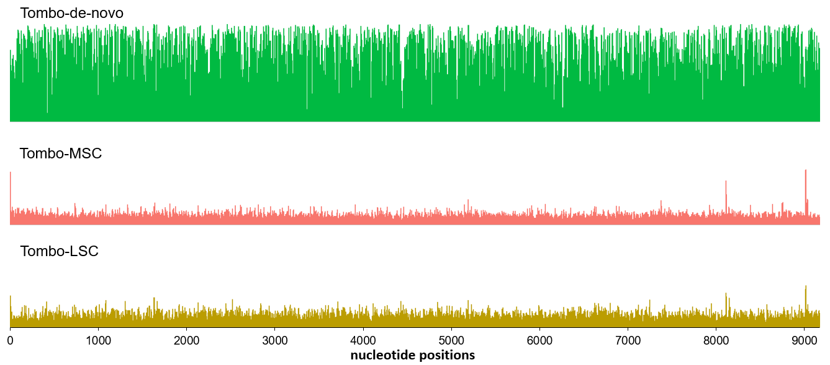
Fig. SN2. Noise-reduction using Tombo-MSC (Step 1). 3,985 reads of full-length virion RNA were analyzed with Tombo de-novo (top panel), model-sample-compare (MSC; middle panel), and level-sample-compare (LSC; bottom panel) options following the instructions (https://github.com/nanoporetech/tombo)². 5,411 reads of full-length (> 8 Kb) IVT RNA were used as a canonical control for Tombo-MSC and for Tombo-level-sample-compare (Tombo-LSC).

For a full-length comparison of modification sites, we used a total of 5,411 of full-length IVT RNA reads as a canonical control for Tombo-MSC (Fig.1 and Extended Data Fig.2a). For an analysis using the half-length IVT data, we used 26,000 reads of the first half (F1) and 28,100 reads of the second half IVTs (F2), which resulted in a similar read coverage (~ 25K) for the whole genome (see Extended Data Fig.2b).
Tombo-MSC using 25K reads of IVT RNAs generated per-red p-values that are highly reproducible, showing r² > 0.999 when compared to the p-values generated with 50K IVT reads (Extended Data Fig.2c) and r² = 0.8852 ± 0.0244 for 4 different WT HIV-1 virion RNA datasets prepared independently (Extended Data Fig.2d).

1.2.2. noise-reduction: removal of the baseline noise (Step 2)
Although significantly reduced compared to Tombo-“de novo” analysis, Tombo-MSC analysis showed a considerable level of the baseline d-value noise in our control analysis using 1,450 reads of full-length IVT reads (IVT subreads that were not used as a canonical control; see Supplementary Table 4). The d-values of IVT subreads coincided with most of d values of native HIV-1 RNA (Fig.SN3). A subtraction of the baseline noise substantially refined the modification signals of virion RNA (Fig.SN3).
(i)
Read coverage
Virion RNA : Full-length HIV-1 Virion RNA (3,985 reads)
Baseline control : Full-length HIV-1 IVT RNA (1,450 reads)

Tombo-MSC canonical control: Full-length HIV-1 IVT RNA (5,411 reads)

(ii)
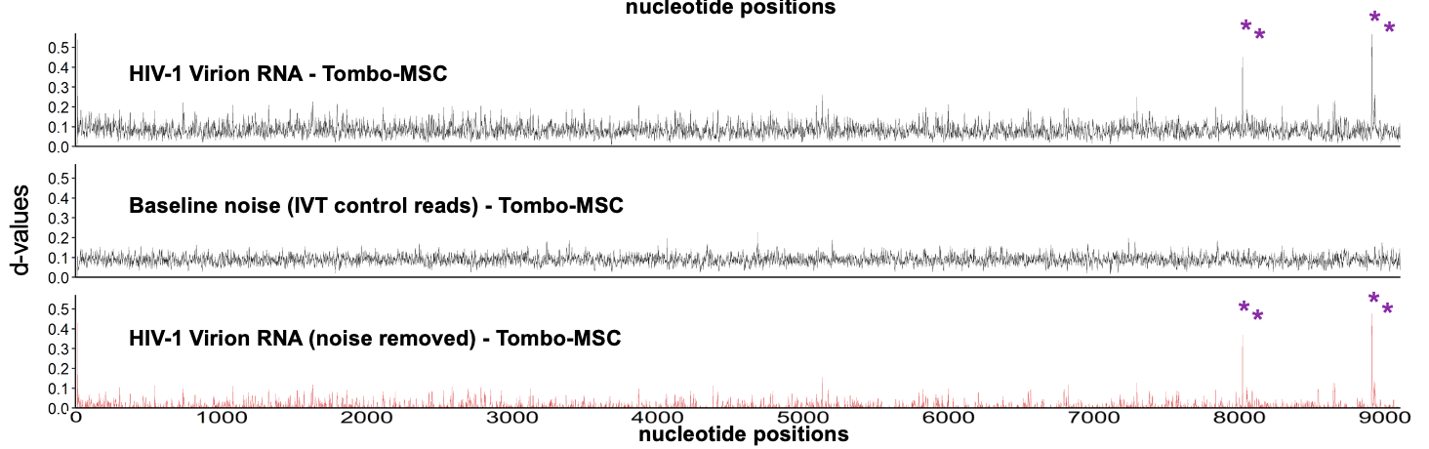
Fig. SN3. Removal of the baseline noise using IVT subreads (Step 2). (i) A total of 3,985 virion RNA reads and 1,450 IVT RNA reads were analyzed with Tombo-MSC using 5,411 reads of canonical control. The baseline control reads (1,450 IVT subreads) were not used as a canonical control. (ii) Tombo-MSC data (d-values, y-axis) for HIV-1 virion RNA (top panel) and full-length IVT subreads (middle panel, representing the baseline noise) were compared. A subtraction of the baseline noise substantially refined the d-values of HIV-1 virion RNA, identifying the four prominent modification peaks near the 3’ end (purple asterisks on the bottom panel).

A similar noise removal using IVT subreads was applied to all pre-trained detection tools used in this study, including ELIGOS2 (Supplementary Notes 1.3 and Fig.SN5), nanom6A and m6Anet (Supplementary Notes 1.5 and Fig.SN6).
1.2.3. Signal instability at the first and the last 40 nucleotides of DRS reads.
Nanopore DRS fails to read the 5’ end (the first 10-12 nucleotides) of RNAs due to the instability of the ends of RNA during the DRS runs⁸⁻¹⁰. In our data analysis, we also found that the electric signals of both ends of DRS reads (although successfully read by DRS) can still be unreliable (Extended Data Fig. 3). To clearly address this, we evaluated the stability of local DRS signals by comparing long (F1 and F2) and short IVT RNA (F3 to F9) reads with identical nucleotide sequences (Fig. SN4). A systemic evaluation of DRS signals per position from each end (5’ or 3’) of the reads showed that DRS signals of the first 10-40 nucleotides and the last 10-40 nucleotides are not reliable, showing significant difference compared to the identical sequences in the middle of long RNA reads (p < 0.01; Mann-Whitney U-tests comparing every pair of 10-base bins between long and short IVT reads; see Fig.SN4-ii- below). For an accurate detection of RNA modifications, we excluded the DRS data of the first and the last 40 nucleotides.
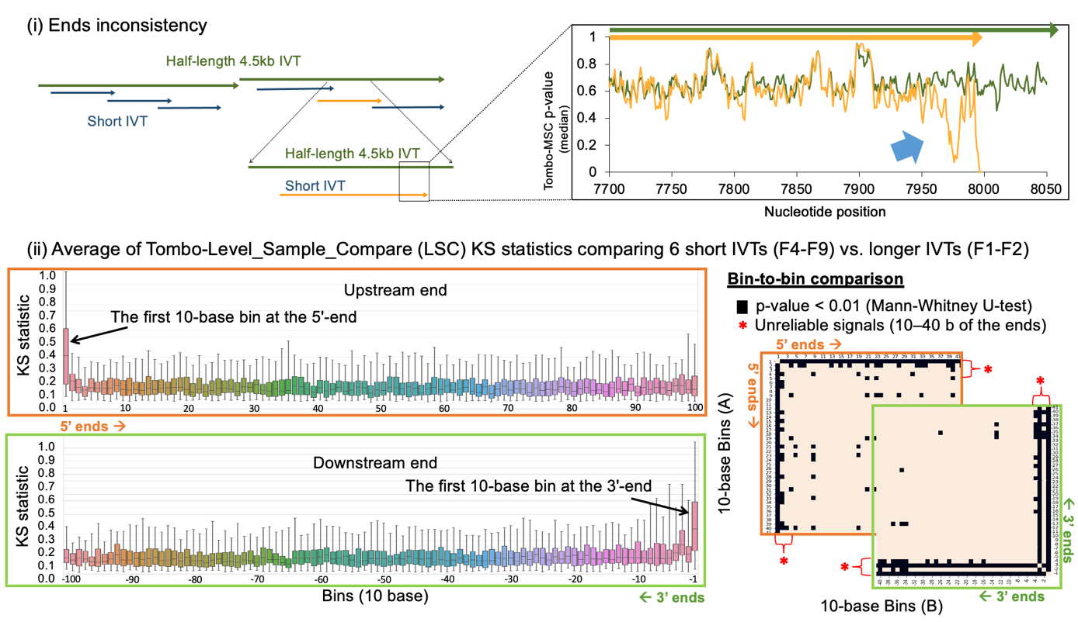
Fig. SN4. DRS signals near the end of each read are not reliable. (i) Schematic view of the analysis. To evaluate the quality of DRS signals at different positions, we compared DRS signals (e.g. per-read p-values and current levels) of identical sequences between long IVT RNAs (F1 and F2) and short IVT RNAs (F4 – F9). The right panel shows an example comparing F8 (orange) and F2 RNA (dark green). Signal deviations are evident near the 3’ end of short IVT RNAs (light blue arrow). (ii) The stability of DRS signals was systemically evaluated at both ends. The KS-statistics for each position (y-axis; calculated by Tombo-“Level Sample Compare” or Tombo-LSC) were used as a measure of signal differences between the long and short IVT datasets. The box-plots on the left show KS-statistics values (aggregated over bins of 10 base) for 6 different sets (F4 – F9 against F1-F2), plotted from the 5’ ends (upper panel; orange box) and from the 3’ ends (lower panel; green box). The right panel show Mann-Whitney U-tests comparing every pair of 10-base bins (black squares denote p < 0.01). We concluded the first 10-40 bases from either end (denoted by red asterisks) were generally unreliable, often showing significant differences (p < 0.01).

1.3. Eligos2 analysis:
Eligos2 identifies the position of modification based on the differences in “error at specific base (ESB)”³ between the native HIV-1 RNA and IVT RNA. Similar to Tombo-MSC analysis, we generated odd ratios of ESB at each position for both native RNA and IVT subread data using 5,411 reads of full-length IVTs as a canonical control (Fig. SN5). The modification signals (odd ratios) of native RNA were refined by subtracting the baseline noise (1,450 IVT subreads).
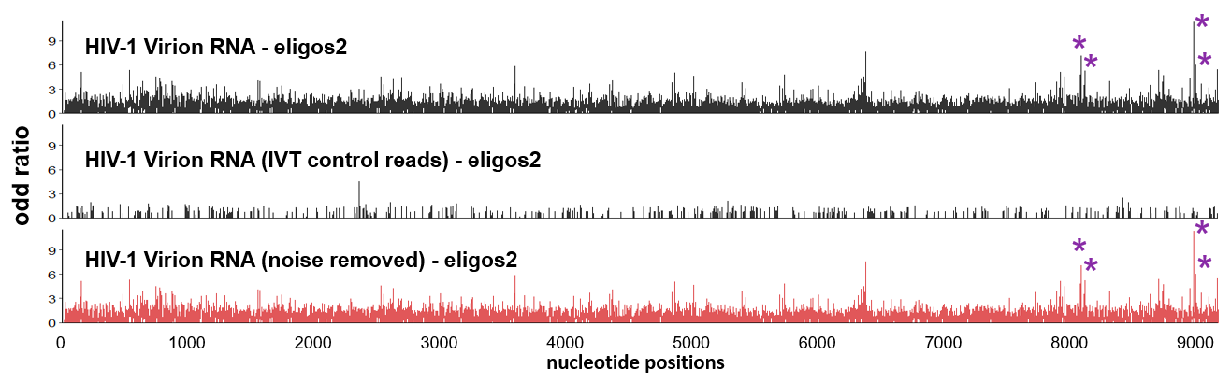
Fig. SN5. Eligos2 analysis of HIV-1 RNA modifications. Odd ratios (y-axis) from Eligos2 analysis for HIV-1 virion RNA (top panel) and full-length IVT subreads (middle panel, representing the baseline noise) were compared. A subtraction of the baseline noise substantially refined the modification signals of HIV-1 virion RNA, identifying the four prominent modification peaks near the 3’ end (purple asterisks on the bottom panel).

1.4. Nanocompore and xPore analyses
Nanocompore (evaluating current intensity and dwell-time differences)⁴ and xPore (evaluating current intensity differences within a read)⁵ compares raw DRS signals between native HIV-1 RNA and IVT RNA to detect modified nucleotides(see Fig.1 and Extended Data Fig.4). Tools that compare raw DRS signals of two comparing samples, including Nanocompore, xPore and Tombo-LSC, do not require the noise-removal using IVT subreads.

1.5. Nanom6A and m6Anet analyses:
Nanom6A⁶ and m6Anet⁷ are pre-trained tools for a read-level detection of m6As. Similar to the Tombo-MSC and Eligos2 analyses above, we generated m6A modification ratios for both native RNA and IVT subread data and performed a baseline-noise removal to refine the m6A data (Fig.SN6).
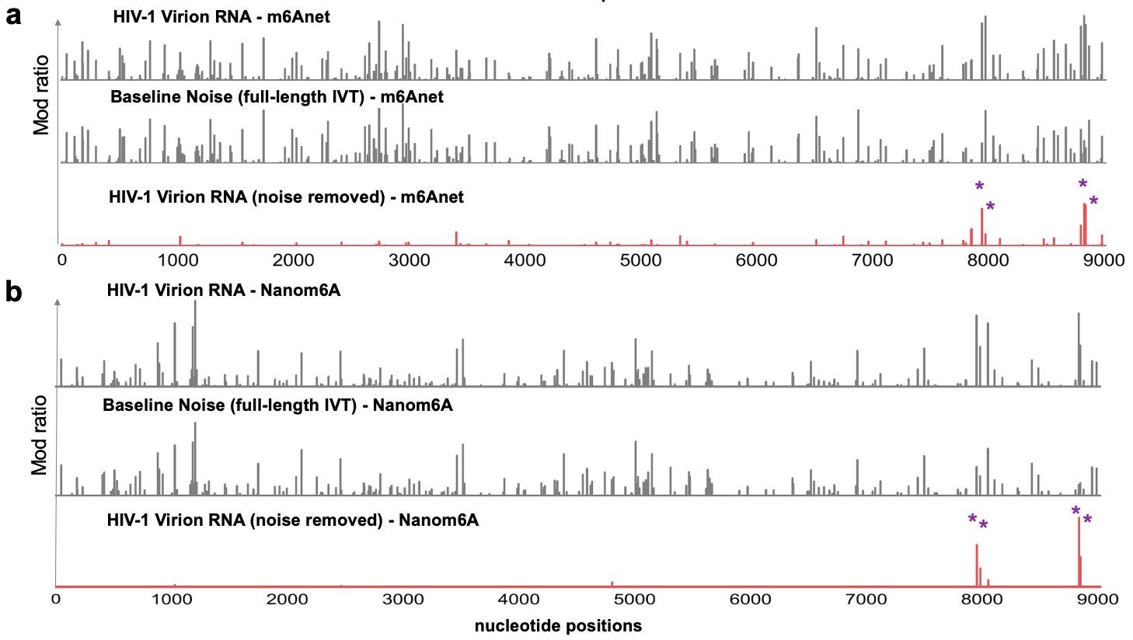
Fig. SN6. Nanom6A and m6Anet analyses of HIV-1 RNA m6As. (a-b) Modification ratios (Mod ratios, y-axis) estimated by m6Anet (a) and by nanom6A (b) are shown for HIV-1 virion RNA (top panel) and full-length IVT subreads (middle panel, representing the baseline noise). A subtraction of the baseline noise substantially refined the modification signals of HIV-1 virion RNA, identifying the four prominent m6As near the 3’ end (purple asterisks on the bottom panel).

1.6. Common modification sites among Tombo, Eligos2 and Nanocompore results.
The sensitivities of DRS signal features, including current intensities, dwell time, and base-calling error rates, can vary depending on the types and positions of the modifications¹¹. Among all the tested in our study, Tombo, Eligos2 and Nanocompore generated the most reproducible results (Extended Data Fig.4).
Given approximately 80-200 modifications of various kinds may exist per genome based on previous mass-spectrometry studies^{12, 13}, we selected and compared the 149 strongest peaks of modification signals from Tombo-MSC (d-value >0.05), 167 from Eligos2 (odd ratios > 2.4) and 156 from Nanocompore results (logit log-odd-ratio score > 0.73) (Fig.SN7a). To determine most probable modification sites among the myriad of modification signals in these analyses, we cross-compared these datasets and identified common peaks of these analyses (Fig.SN7b-c).
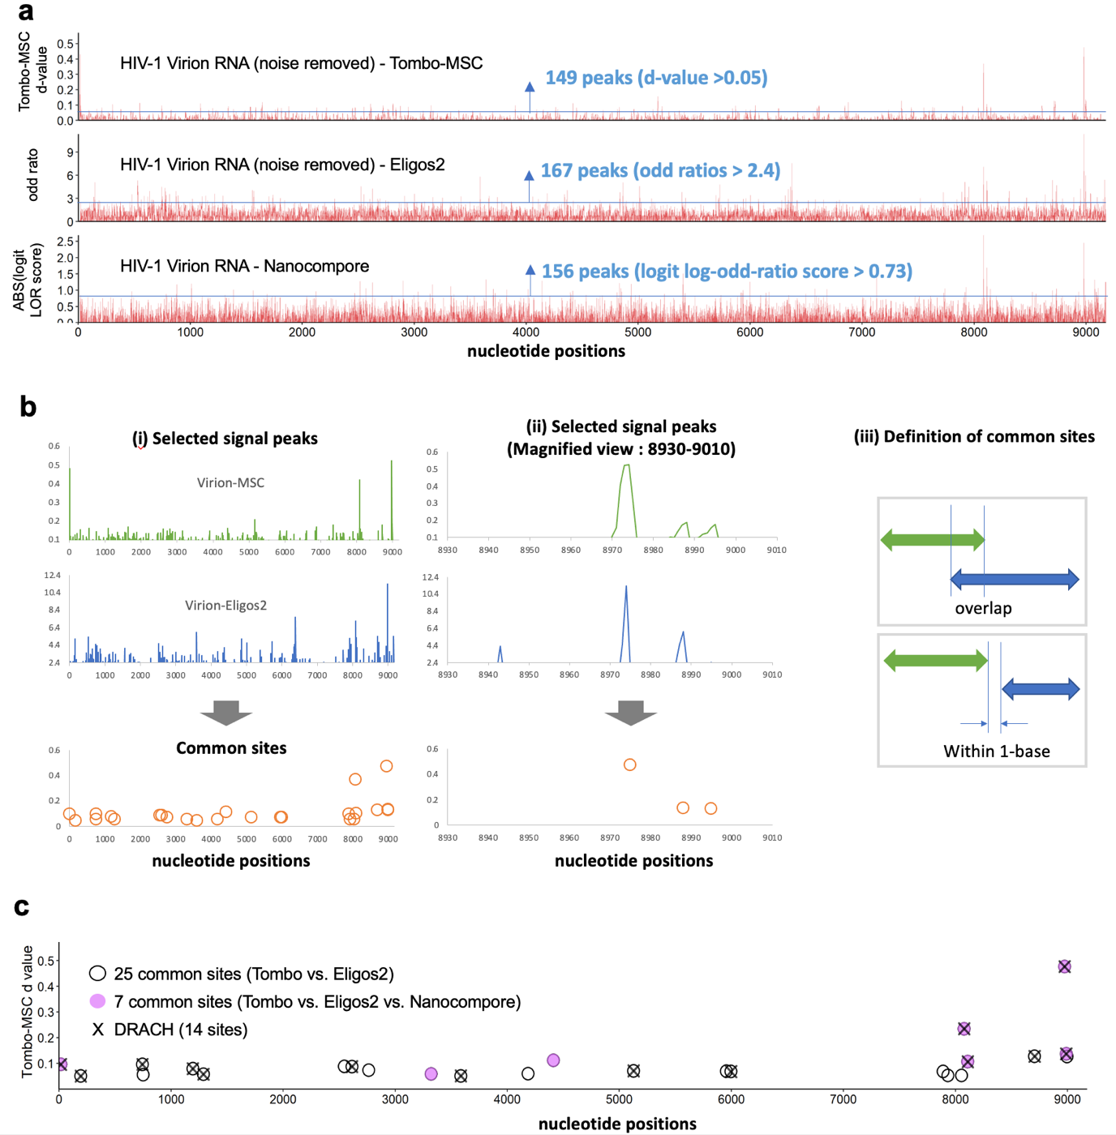
Fig. SN7. Common modification sites among Tombo, Eligos2 and Nanocompore results. (a) Top 149, 167, and 156 most probable modification sites were chosen from Tombo-MSC (top panel), Eligos2 (middle panel), and Nanocompore data (bottom panel), respectively. (b) the selected modification peaks were cross-compared to determine the most probably modification sites. The common sites were determined when two peaks were either overlap or within 1 base distance (iii). (c) 25 common peaks between Tombo-MSC and Eligos2 (circles), and 7 common peaks among all three datasets (purple circles) are shown. 14 DRACH sites overlapping with the 25 and 7 common sites are shown (crosses).

Supplementary Note 2:

Machine-Learning: Determining m6A Modifications Per-Read Per-Position Basis.
The goal is to build machine learning models that determine whether an HIV RNA molecule has m6A modifications on a per-read and per-position basis. The classification is based on the read-level p-value output from Tombo-MSC.

Read-level p-value patterns.
Tombo-MSC uses IVT data to adjust the expected current signal levels and generates per-read, per-position p-values for current signal difference of target-RNA (native HIV-1 RNA) reads. We found that Tombo-MSC’s per-read p values were highly reproducible when a sufficient number of IVT canonical control reads were used (e.g. r² > 0.999 with >20K IVT reads; Extended Data Fig.2c) and when tested in our repeated experiments using 4 sets of virion RNAs that were prepared independently of each other (Extended Data Fig.2d). We also found a consistent pattern of per-read p-value distribution near the 3 m⁶A sites (positions 8079, 8975, and 8989) on native HIV-1 RNA, showing a shift of the d values (or median p-value) to upstream of the m⁶A sites at positions N₋₄ to N₁ (N₀ = m6A site) (Fig.5a-ii- and Extended Data Fig.9e). The patterns were consistent between native HIV-1 RNAs and m⁶A-control RNAs. Here we developed new read-level binary classification methods m⁶A based on the read-level p values at positions N₋₄ to N₁ (m⁶Arp models) for the 3 predominant m⁶A sites. Additional positions (including N₂ to N₅) contributed only negligibly to the model accuracy.

Control RNAs.

We built three separate models to detect modifications at positions 8079, 8975, and 8989. We generated approximately 1 Kb long positive control RNAs using 3 synthetic RNA oligos, each harboring m⁶A at 8978, 8975, and 8989, respectively (Table SN2 and Extended Data Fig.9a-d). The 8079, 8975, and 8989 models used DRS reads of these RNAs (8978m⁶A+, 8975m⁶A+, and 8989m⁶A+ datasets) as positive-labeled training data. In parallel, in vitro transcribed RNA reads that cover the same 1 Kb region were used as negative-labeled training data. We also tested full-length IVT RNA and F2 IVT RNA reads as negative-labeled training data. These negative-labeled training data showed only negligible difference in the performance of the m⁶Arp models.

Table SN2
Primers | Sequences (5' to 3') | Note
8079 m6A synthetic RNA | TGCCTCTTCAGCTACCACCGCTTGAGAG(m6A)CTTACTCT TGATTGTAACGAGGATTGT | Synthetic m6A RNA oligo
8975 m6A synthetic RNA | GAACTGCTGACATCGAGCTTGCTACAAGGG(m6A)CTTTCCGCTGGG GACTTTCCAGGGAGGCGTGG CCTGGGCGGGACTGGGGA | Synthetic m6A RNA oligo
8989 m6A synthetic RNA | GAACTGCTGACATCGAGCTTGCTACAAGGGACTTTCCGCTGGG G(m6A)CTTTCCAGGGAGGCGTGG CCTGGGCGGGACTGGGGA | Synthetic m6A RNA oligo
8975A/8989A | CGATGTCAGCAGTTCTTGAAGTACTCCGGA | Splint DNA oligo

Synthetic RNA oligos were custom synthesized by Horizon Discovery (Extended Data Fig.9a). Positive control RNAs were generated by ligating carrier IVT RNA to synthetic RNA oligos (Extended Data Fig. 9b); the ligated RNA aligns to approximately 1 Kb of the 3’ end of HIV-1 RNA. The carrier IVT RNA were generated as described in “Supplementary Note 1.1. Preparation of IVT RNA controls” in the method section using DNA templates generated by PCR using primers shown below (Table SN3).

Table SN3
Primers | Sequences (5' to 3') | Note
Carr_8079 m6A_F | GCAATGTATGCCCCTCCCAT | PCR primers used for carrier IVT RNA for m6A standard generation
Carr_8079 m6A_R | CAGGCTCCGCAGATCGT
Carr_8975/8989 m6A_F | ATAGAAGAAGAAGGTGGAGAGAGA
Carr_8975/8989 m6A_R | TCGATGTCAGCAGTTC
Cont_8079 m6A_F | GCGTCAATGACGCTGACGGT | PCR primers used for control RNA
Cont_8079 m6A_R | GGCTCAGCTCGTCTCATTCT | PCR primers used for control RNA
Cont_8975/8989 m6A_F | TGCCTGGCTAGAAGCACAAGA | PCR primers used for control RNA
Cont_8975/8989 m6A_R | TGACTAAAAGGGTCTGAGGGATC | PCR primers used for control RNA

2.3 Selecting Fisher options.
Models trained with Tombo-MSC p-values generated with Fisher=0, 1, 2, and 3 showed varying levels of the area under the Receiver Operating Characteristics curve (AUROC) and false-positive rates (FPR) and false-negative rates (FNR) (Table SN4 and Extended Data Fig.9f). Of these, the “Fisher=0” option showed the best AUROC values for all three models (models 8079, 8975, and 8989) ranging from 0.95 to 0.97, with 8.40%–10.80% FPR and 8.90%–12.40% FNR (Supplementary Table 3).

  - Model selection.
All our machine-learning models were linear support-vector classifiers (SVCs), implemented using the scikit-learn Python package (version 0.23.2)¹⁴.Models used default scikit-learn settings, except where noted. We selected SVCs in consideration of their potentially high generalizability and resistance to over-fitting due to their small number of parameters (n+1, where n is the number of features). The magnitude of a coefficient in the model is a measure of the relevance of the corresponding feature to the classification problem. Coefficients of our trained models are reported below (Supplementary Table 3). The positive and negative classes were weighted to achieve a balanced comparison. Other than this weighting, models used default parameters as listed on the scikit-learn documentation page. As an alternative to the support-vector classifier described here, an unsupervised-learning model based on the DBSCAN algorithm was also assessed. It demonstrated a similar false-positive rate and false-negative rate to the support-vector classifier (Data not shown).

  - 5-fold cross-validation for the accuracy of the model.
The model accuracy was first assessed using 5-fold cross-validation¹⁵. In brief, to assess the accuracy of a model with dataset T, the dataset is partitioned at random into five equal-size subsets T₁, T₂, T₃, T₄, and T₅. Five new models are trained, each on its own four-fifths of the data. For example, Model M₁ is trained using the combined data of T₂, T₃, T₄, and T₅, then its false negative rate (FNR) and false positive rate (FPR) are computed using the reserved partition T₁The FNRs and FPRs from all 5 folds are averaged to estimate the model’s performance on future unseen data.

  - Linearity of quantification.
In order to evaluate the ability of each model to enumerate m6A positive and negative reads at the test site represented in their training data, we tested the linearity of quantification of the 3 models. For the three testing sites (positions 8079, 8975, and 8989), we generated 5 sets of mixed data each having positive to negative reads ratios of 0:100, 25:75, 50:50, 75:25, and 100:0 (Extended Data Fig.9g) and assessed the ability of the three new models to quantitate m6A modifications. The quantitation results were directly proportional to the fraction of m6A positive control reads in pre-mixed controls with expected FPR and FNR at both ends of mix ratios (Extended Data Fig.9g). After adjusting for each model’s FPR and FNR, the output showed nearly complete matches to the expected values.

References

1. Abebe, J.S., Verstraten, R. & Depledge, D.P. Nanopore-Based Detection of Viral RNA Modifications. mBio 13, e0370221 (2022).
2. Stoiber, M. De novo Identification of DNA Modifications Enabled by Genome-Guided Nanopore Signal Processing. . bioRxiv (2017).
3. Jenjaroenpun, P. et al. Decoding the epitranscriptional landscape from native RNA sequences. Nucleic Acids Res 49, e7 (2021).
4. Leger, A. et al. RNA modifications detection by comparative Nanopore direct RNA sequencing. Nat Commun 12, 7198 (2021).
5. Pratanwanich, P.N. et al. Identification of differential RNA modifications from nanopore direct RNA sequencing with xPore. Nat Biotechnol 39, 1394-1402 (2021).
6. Gao, Y. et al. Quantitative profiling of N(6)-methyladenosine at single-base resolution in stem-differentiating xylem of Populus trichocarpa using Nanopore direct RNA sequencing. Genome Biol 22, 22 (2021).
7. Hendra, C. et al. Detection of m6A from direct RNA sequencing using a multiple instance learning framework. Nat Methods (2022).
8. Parker, M.T. et al. Nanopore direct RNA sequencing maps the complexity of Arabidopsis mRNA processing and m(6)A modification. Elife 9 (2020).
9. Jain, M., Abu-Shumays, R., Olsen, H.E. & Akeson, M. Advances in nanopore direct RNA sequencing. Nat Methods 19, 1160-1164 (2022).
10. Workman, R.E. et al. Nanopore native RNA sequencing of a human poly(A) transcriptome. Nat Methods 16, 1297-1305 (2019).
11. Begik, O. et al. Quantitative profiling of pseudouridylation dynamics in native RNAs with nanopore sequencing. Nat Biotechnol 39, 1278-1291 (2021).
12. Courtney, D.G. et al. Epitranscriptomic Addition of m(5)C to HIV-1 Transcripts Regulates Viral Gene Expression. Cell Host Microbe 26, 217-227 e216 (2019).
13. McIntyre, W. et al. Positive-sense RNA viruses reveal the complexity and dynamics of the cellular and viral epitranscriptomes during infection. Nucleic Acids Res 46, 5776-5791 (2018).
14. Pedregosa Scikit-learn: Machine Learning in Python. JMLR (2011).
15. Hastie, T., Tibshirani, R. & Friedman, J.H. The elements of statistical learning : data mining, inference, and prediction, Edn. 2nd. (Springer, New York; 2009).

