Extended Data Figures

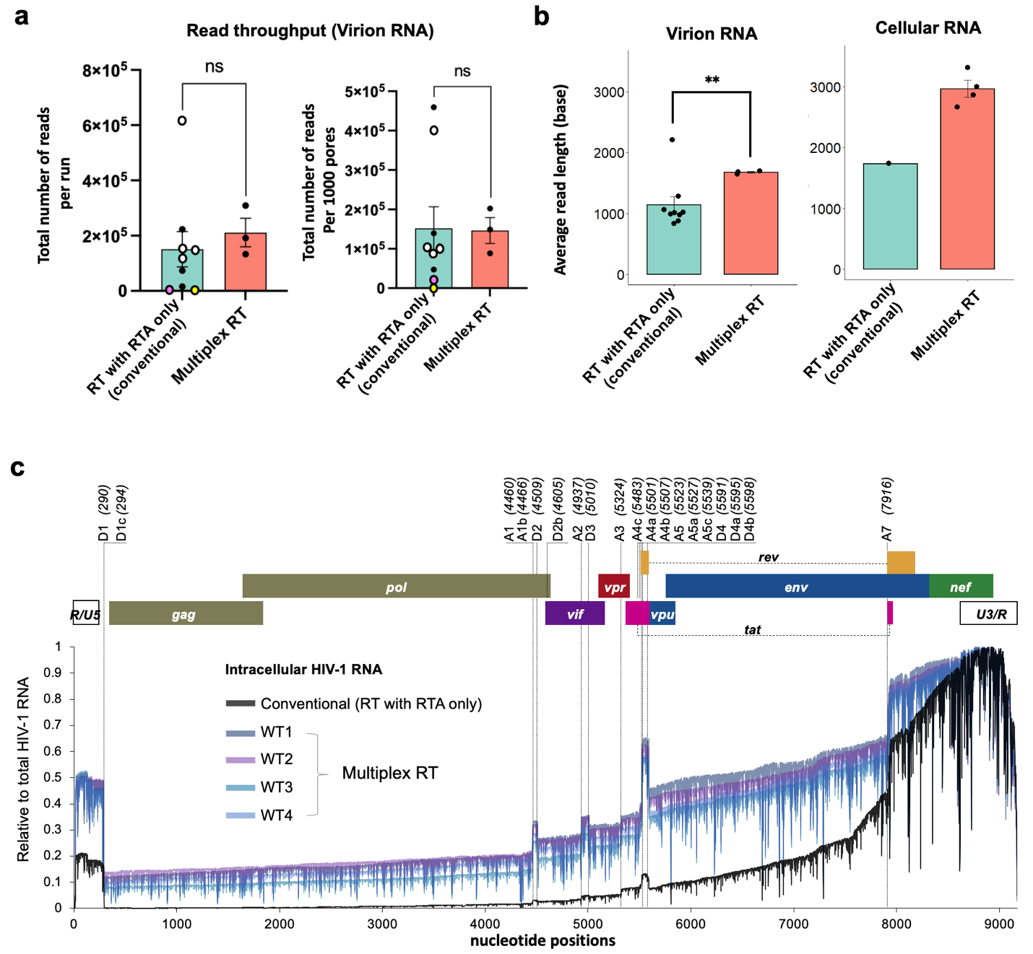
Extended Data Fig. 1: Multiplex RT improves DRS of full-length HIV-1 RNA (a-b) The DRS read throughput (a) and average read lengths (b) were compared between DRS using new Multiplex RT method (orange box) and DRS following the conventional ONT protocol (green boxes). The multiplex RT significantly improved the average read length of virion RNAs compared to the conventional ONT protocol (p=0.0052; left panel), while maintaining the read throughput. The conventional methods failed to generate more than 13 near-full-length HIV-1 virion RNA reads (> 0.01% of HIV-1 reads) in 8 out of 9 MinION runs. The multiplex RT methods showed the recovery ratios of more than 0.5% (457-898 reads per run) for virion RNAs (Supplementary Table 1). For intracellular HIV-1 RNAs, the full-length recovery rates reached to 34.9%, 31.5%, and 54.1% for unspliced (US), partially spliced (PS), and completely spliced (CS) RNAs, respectively (see Fig. 4a), which is 70- to 100-fold higher than those of virion RNA. The open circles in the green boxes are 4 repeated experiments using the DRS standard protocols; the colored circles represent DRS runs using modified RT conditions, including the conditions using TIGRT (pink circle) and marathonRT (yellow circle) that replaced SSIV RT of the conventional protocol. (c) Mapping of intracellular HIV-1 RNA. All 4 DRS runs using multiplex RT showed an improved and highly reproducible mapping onto the reference. Read depths (y-axis) of WT and mutant RNA reads are shown over the HIV-1 genome (NL4-3 strain). The positions of the splicing donor (D1-D4) and acceptor (A1-A7) sites are shown on the top.
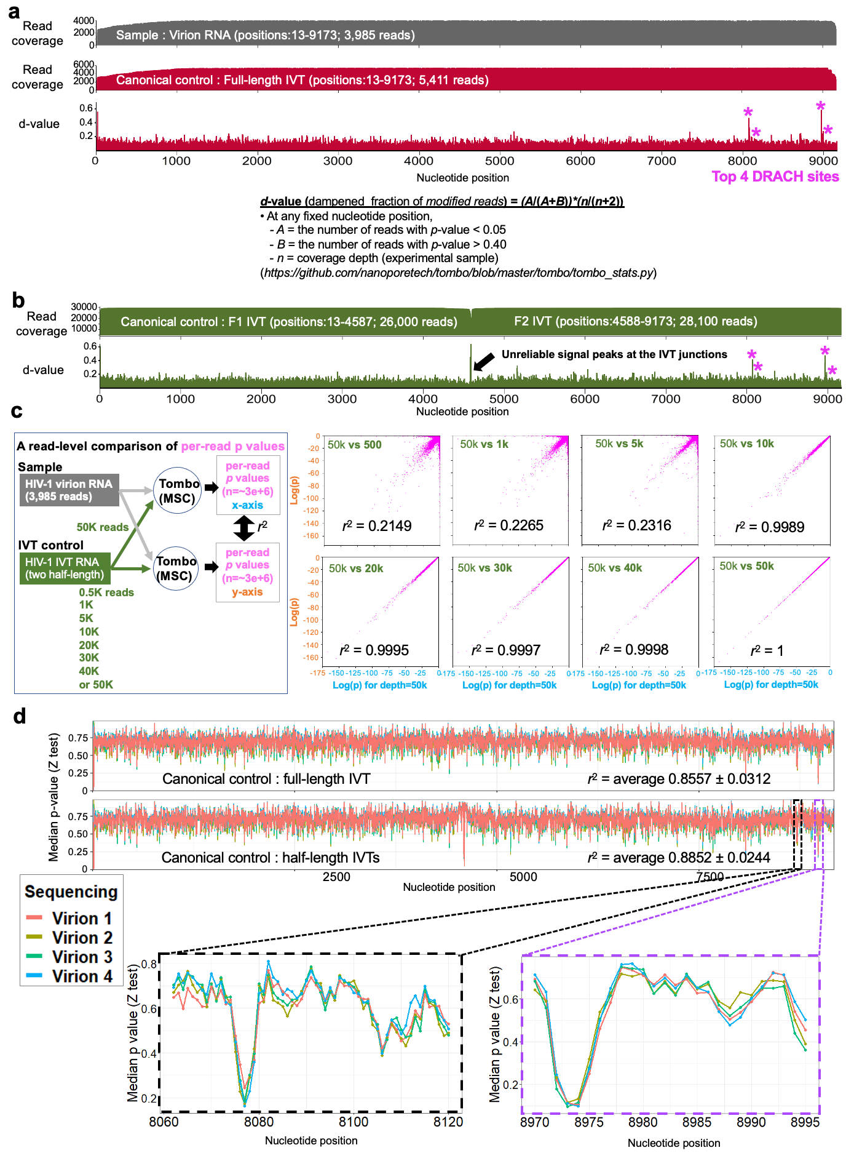
Extended Data Fig. 2: Highly reproducible Tombo analysis using HIV-1 IVT canonical controls. (a-b) Tombo-“model sample compare” (MSC) analysis for full-length virion RNA reads (grey; total 3,985 reads of >8 Kb). We used 2 different sets of HIV-1 IVT canonical controls: full-length IVT RNAs (5,411 reads) (a) and half-length IVT RNAs (26,000 reads of F1 and 28,100 reads of F2) (b). Tombo-MSC analysis using these F1 and F2 reads show a similar read depth coverage (approximately 25K reads) for both F1 and F2 regions. The resulting “d-value” plots show the 4 most prominent modification signals (purple asterisks) near the 3’ end side of the genome. (c) Consistent generation of per-read p-values. We tested the effects of the read depth of the IVT canonical control on Tombo-MSC analysis. Tombo-MSC p-values for virion RNA were generated using 0.5 K, 1K, 5K, 10K, 20K, 30K, 40K, or 50K reads of F1 and F2 IVT canonical reads (the green box in the schematic view). Per-read per-position p-values of these datasets were directly compared to p-values of the identical position of the identical reads of the control datasets generated using 50K IVT (the grey box in the schematic view). Per-read p-values generated with >20K reads were highly reproducible (r² > 0.999) when compared to those of 50K IVT dataset. (d) Tombo-MSC analysis of 4 datasets of WT virion RNA DRS (Virions 1 to 4). Median per-read p-values generated with Tombo-MSC using 5,411 reads of full-length IVT RNA (Top panel) and 25K reads of half-length IVT RNAs (lower panel) were compared. Both datasets show highly reproducible p-values for the 4 virion datasets separately run on MinIONs. For these runs, 4 different virion RNA samples were prepared by separate transfection of HEK293T cells with pNL4-3 plasmids.

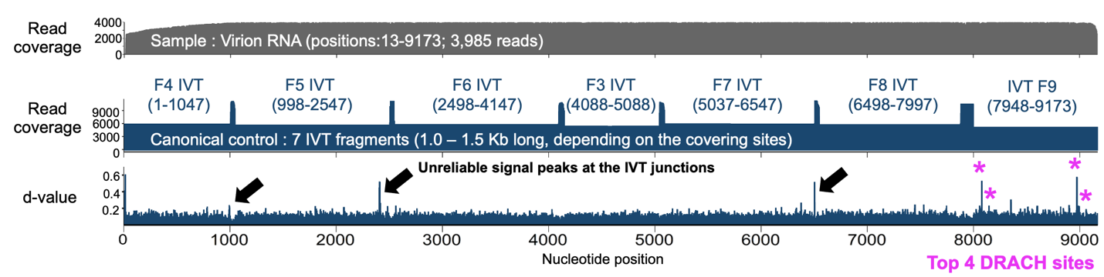
Extended Data Fig. 3: Short IVT controls generate unreliable DRS signals near the ends of RNA reads. Tombo-MSC analysis was performed for full-length virion RNA reads (grey; total 3,985 reads of >8 Kb) using IVT canonical control reads consisting of 7 fragments of 1-1.5 Kb IVT RNAs (F3-F9; approximately 6,000 reads each). Strong d-value signals were found near the junctions of neighboring IVT canonical controls (black arrows), which were not seen in similar analysis with long IVT reads (Extended Data Fig. 2a). These peaks may be the results of the DRS signal instability at the 5’ and 3’ ends of each read (see Supplementary Note 1.2.3)
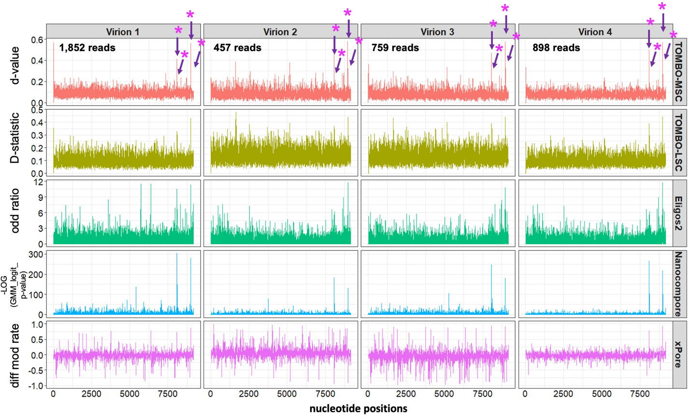
Extended Data Fig. 4: Reproducible detection of the 4 most prominent peaks. 4 sets of HIV-1 virion RNA DRS runs were tested with Tombo-MSC (top panels), Tombo-level-sample-compare (Tombo-LSC; second from the top), Eligos2 (third from the top), Nanocompore (fourth from the top), and xPore (bottom panels). All tools identified the four m⁶A sites (purple asterisks) among the most prominent modification signals. Tombo-MSC, Eligos2 and Nanocompore results showed relatively more reproducible than Tombo-LSC and xPore.

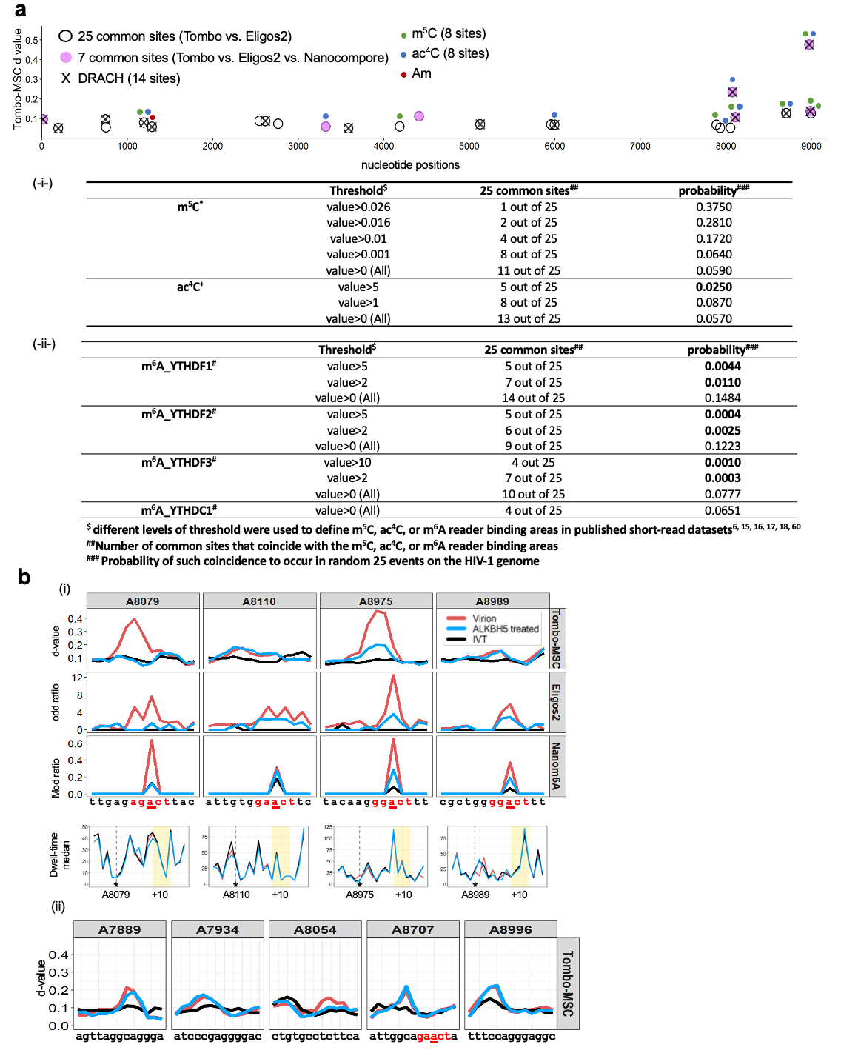
Extended Data Fig. 5: Evaluation of DRS-detected modification sites. (a) The top panel shows the 25 common sites between Tombo and Eligos2 data (circles) and 7 sites common in all three datasets (purple circles) (see Supplemental Note 1 for detailed methods). The 25 common sites show a significant correlation with DRACH sites (denoted by X) and previously m⁶A-mapped areas^{6, 9} and m⁶A-reader binding sites (-ii-)¹⁷. Other published modification sites, including 5-methylcytosine⁴ (m⁵C; green dots above the circles) N⁴-acetylcytidine⁵ (ac⁴C; blue dots above the circles) showed no significant correlation (-i-). There was only one event where the 25 common sites overlap with previously published 2’-O-methylation sites⁷ (Am; red dot above the circles; it overlaps with one of the 14 common DRACH sites). The top table (-i-) shows the number of common sites that coincide with m⁵C or ac⁴C (3rd column from left) with different data thresholds to define m⁵C- or ac⁴C-mapped areas (2nd column from left)^{4, 5} and the probability of such coincidence occurring in random 25 events in the HIV-1 genome (4th column from left). The bottom table (-ii-) shows the coincidence of the 25 commen sites to the m⁶A-reader binding sites^{6, 17} in a similar fashion. (b) The modification signals of ALKBH5-treated RNA (blue lines) and PBS-treated virion RNA (red lines) are shown. The black line denotes the IVT-subset control. (i) The DRS signals of 13 nucleotides surrounding the four DRACH sites (A8079, A8110, A8975, and A8989) are compared. Signals from Tombo-MSC (d-values; top), Eligos2 (second from the top), nanom6A (third from the top), and dwell time (fourth from the top) are shown. Dwell time differences were measured at both the putative m⁶A site and its 10 base downstream⁴⁸. (ii) The signal reduction for non-DRACH sites, including A7889, A7934, A8054, A8707 and A8996 was relatively mild or undetectable.

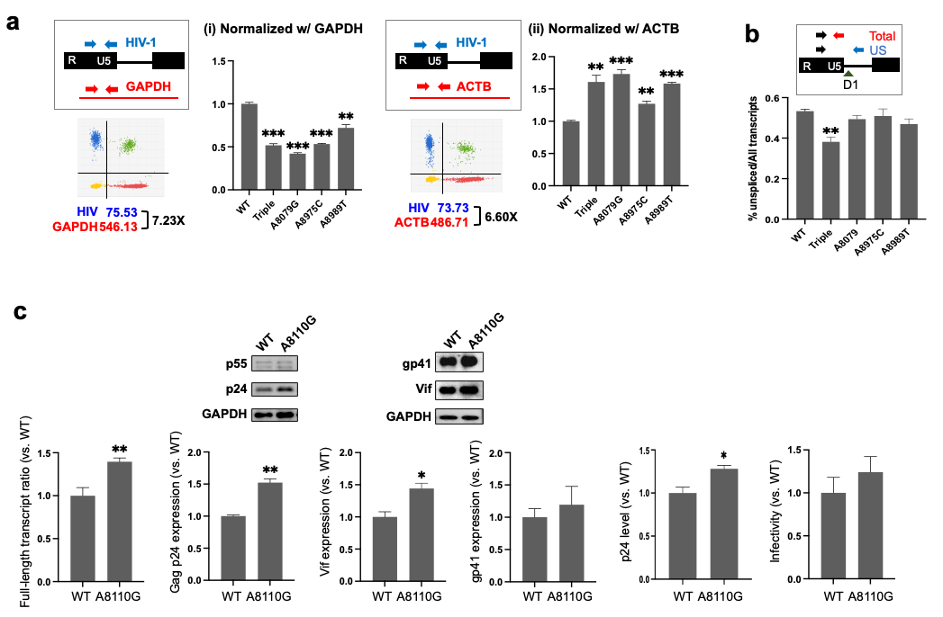
Extended Data Fig. 6: Knocking out all three dominant m⁶As, but not the single m⁶A, affects HIV-1 fitness. (a) Digital PCR was used to measure total HIV-1 RNA production normalized by glyceraldehyde-3-phosphate dehydrogenase (GAPDH) (i) or actin beta (ACTB) RNAs (ii). The relative ratios of total HIV-1 RNA and GAPDH RNA (i) or ACTB RNA (ii) were simultaneously measured by digital PCR, with total HIV RNA measured targeting the 5’ U5 region. (b) Approximately half of intracellular HIV-1 RNA is unspliced (US) RNA. The US and total HIV-1 RNA were measured by digital PCR (as shown in Fig. 5b). (c) Similar to other single mutants, the A8110G mutation did not show any notable reduction in all viral replication steps tested in this study.

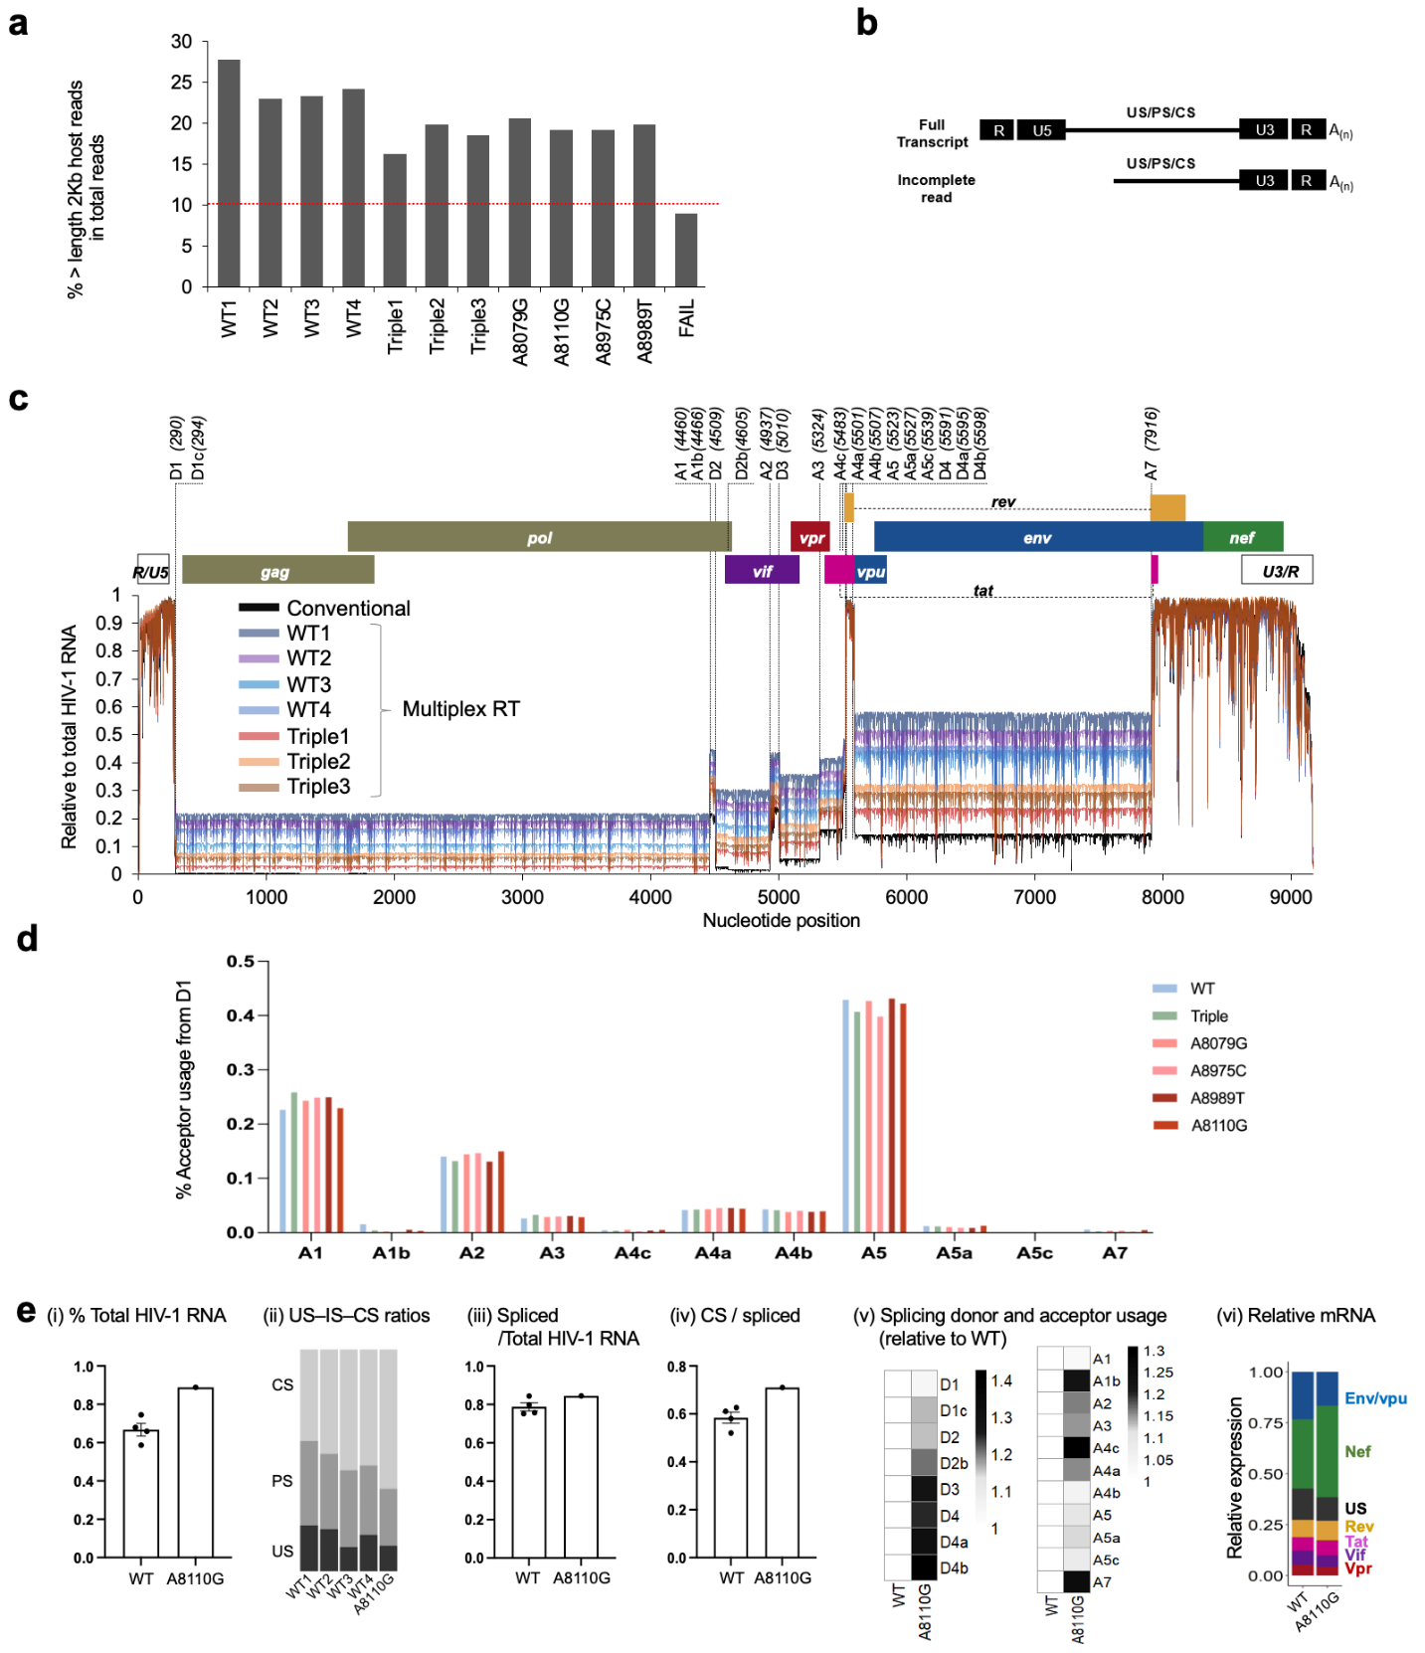Extended Data Fig. 7: Analysis of HIV-1 RNA alternative splicing. (a) DRS cellular RNA runs occasionally showed poor read length distributions (see FAIL in a & b). When the fraction of > 2 Kb RNAs is less than 10% of the total reads, these samples were considered unsuitable and excluded from HIV-1 splicing analysis. The length distributions of cellular RNA are shown for 4 WT, 3 triple mutants, 4 single mutants (A8079G, A8110G, A8975C and A8989T), and FAIL. (b) Selection of full-length HIV-1 intracellular RNAs. Any HIV-1 RNA reads that lack the U5 sequence are removed from the analyses; only full-length CS, PS, and US reads were used for the analysis. (c) The relative fraction of intracellular HIV-1 RNAs (full-length CS, PS, and US) mapped onto the reference genome (pNL4-3). A total of 186 exon combinations, including the major 53 viral RNA isoforms, utilizing various combinations of splicing donors (D1-D4) and acceptors (A1-A7) were identified. WT1-4 and Triple 1-3 Data were produced via multiplex RT method. Conventional DRS results following ONT’s standard DRS protocol (using SSIV and RTA for RT) are shown for comparison. (d) Relative usage rates of splicing acceptors (%, y-axis) are shown for WT (n=4), triple mutants (n= 3) and single mutants (A8079G, A8975G, A8989T, and A8110G). (e) Alternative splicing patterns for A8110G are shown.

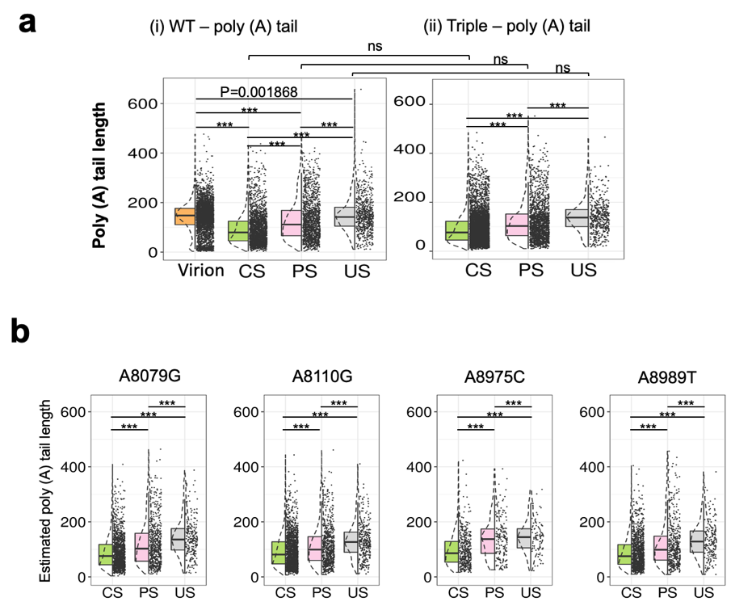
Extended Data Fig. 8: Analysis of HIV-1 RNA 3’ poly (A) tails. (a) The lengths of 3’ polyadenylation, poly (A) tail, varied significantly among CS, PS, US and virion RNAs, but there was no significant difference between WT (i) and triple mutants (ii). (b) Poly (A) length distribution of single mutants. They also showed significant differences among CS, PS and US RNA (*** p < 0.0001)

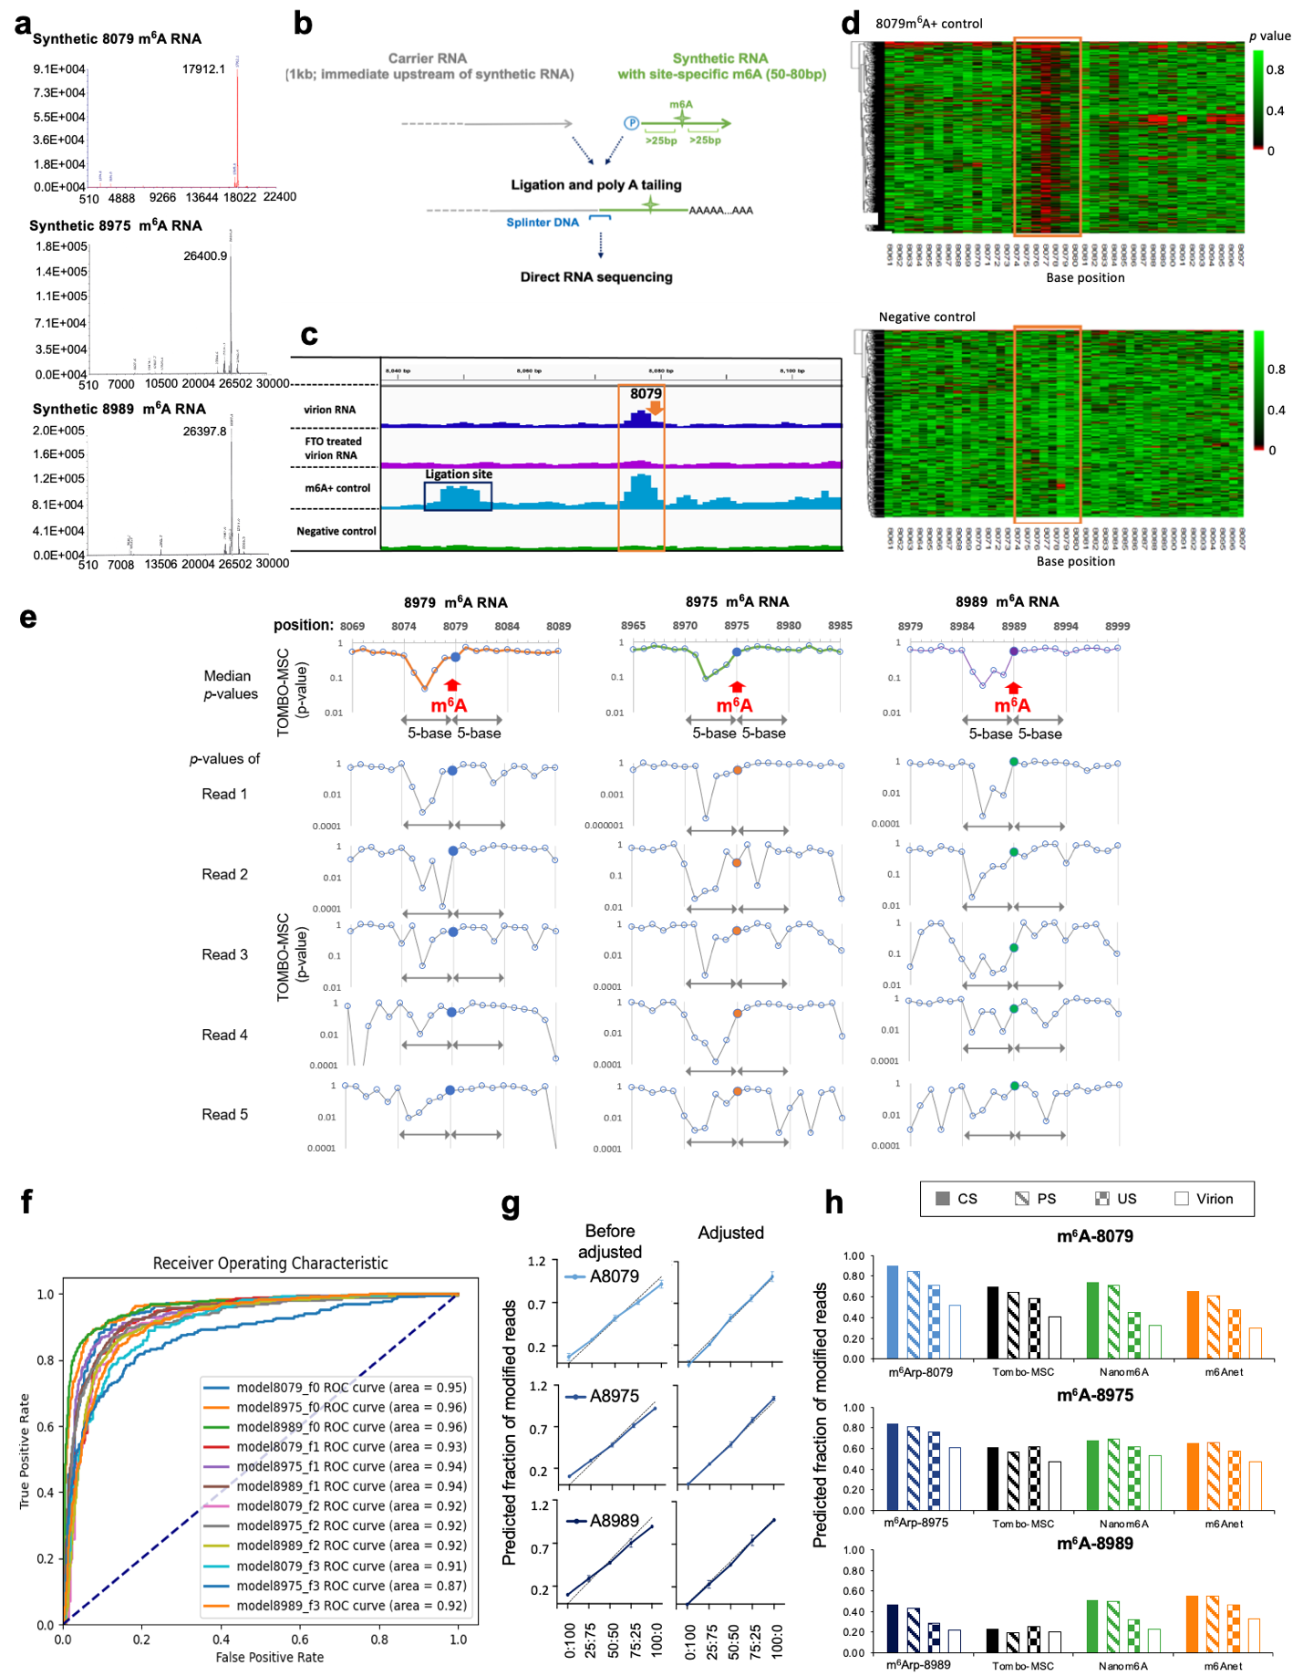
Extended Data Fig. 9: Development of binary classification models (m⁶Arp) for accurate detection of three dominant m⁶As at the read level. (a-b) Three synthetic RNAs with an m⁶A modifications at positions 8079, 8975, or 8989 were ligated to carrier RNA to generate positive control data. Nearly complete m⁶A modification in synthetic RNA control was confirmed by mass spectrometry quality control results (Horizon Discovery Ltd.) (a). A schematic view of generating positive control RNAs is shown in (b). The 3’ end of carrier IVT RNA and the 5’ end of phosphorylated synthetic RNA were joined by ligating these two RNAs. The ligated RNA was then subjected to poly (A) tailing using E. coli Poly (A) Polymerase (NEB). For further details, please see Supplementary Note 2. (c) Tombo-“model sample compare” (MSC) d-values near the position 8079 are shown as an example of DRS data for control RNAs,. Dark blue boxes represent WT virion RNA, purple boxes represent FTO-treated virion RNA, light blue boxes represent 8079m⁶A+ positive control RNA, and green boxes represent negative control IVT RNA. The ligation site of positive control RNA shows notable d-value peaks expected from the nucleotide variation at the ligation junction, which may have resulted from natural RNA degradation before or during the ligation. (d) The heatmap views show per-read p-value distributions for 8079m⁶A+ control (upper panel) and negative control (lower panel). Each row represents a different RNA molecule. (e) A shift of p-values to upstream of the modification site, common in all three m⁶A sites. The top panels show median p-values near the 8079 (left), 8975 (middle) and 8989 (right) sites with notable p-value peaks spanning -4 to +1 positions (N_{-4.}N_{-3.}N_{-2.}N_{-1.}A_{0.}N_{1.}; where A₀=m⁶A) of the m⁶A site. The patterns were consistent with those reported for cellular transcripts⁷¹, suggesting a commonality of these p-value patterns for different m⁶A DRACH sites. Per-read p-value patterns for five chosen reads (Read 1 to 5) are shown from the second from the top panels (Read 1) to the bottom panels (Read 5). Each read showed substantial variations and irregularities, but nevertheless, all reads demonstrated robust differences in the p-value patterns compared to those of the negative controls (see Supplementary Table 4 for all available data in the data repository). (f) Tombo-MSC per-read p-values were prepared with fisher=0, 1, 2 or 3 options. Per-read p-values generated without the data fusion processes (Fisher=0 option: model8079_f0, model8975_f0, and model8989_f0) showed the best area under the receiver operating characteristics curve (AUROC) (see Supplementary Table 3). (g) Our models also showed a strong linearity of quantification (R² >0.9982). Positive control RNA reads were mixed with negative control RNA reads at 100:0, 75:25, 50:50, 25:75, and 0:100 ratios (n=3) and the positive reads were quantitated with our models (see Supplementary Note 2). All three models showed strong linearity after adjustments for FNR and FPR (r²= 0.9982 to 0.9987). (h) All quantification tools, including m⁶Arp-models (light blue), Tombo d-value (dark blue), Nanom6A (green) and m6ANet (orange), showed relatively low m⁶A stoichiometry in unspliced RNA (virion and US RNA) compared to those in spliced (CS and PS) RNA for all the 3 sites, including A8079 (top panels), A8975 (middle panels), and A8989 (bottom panels).

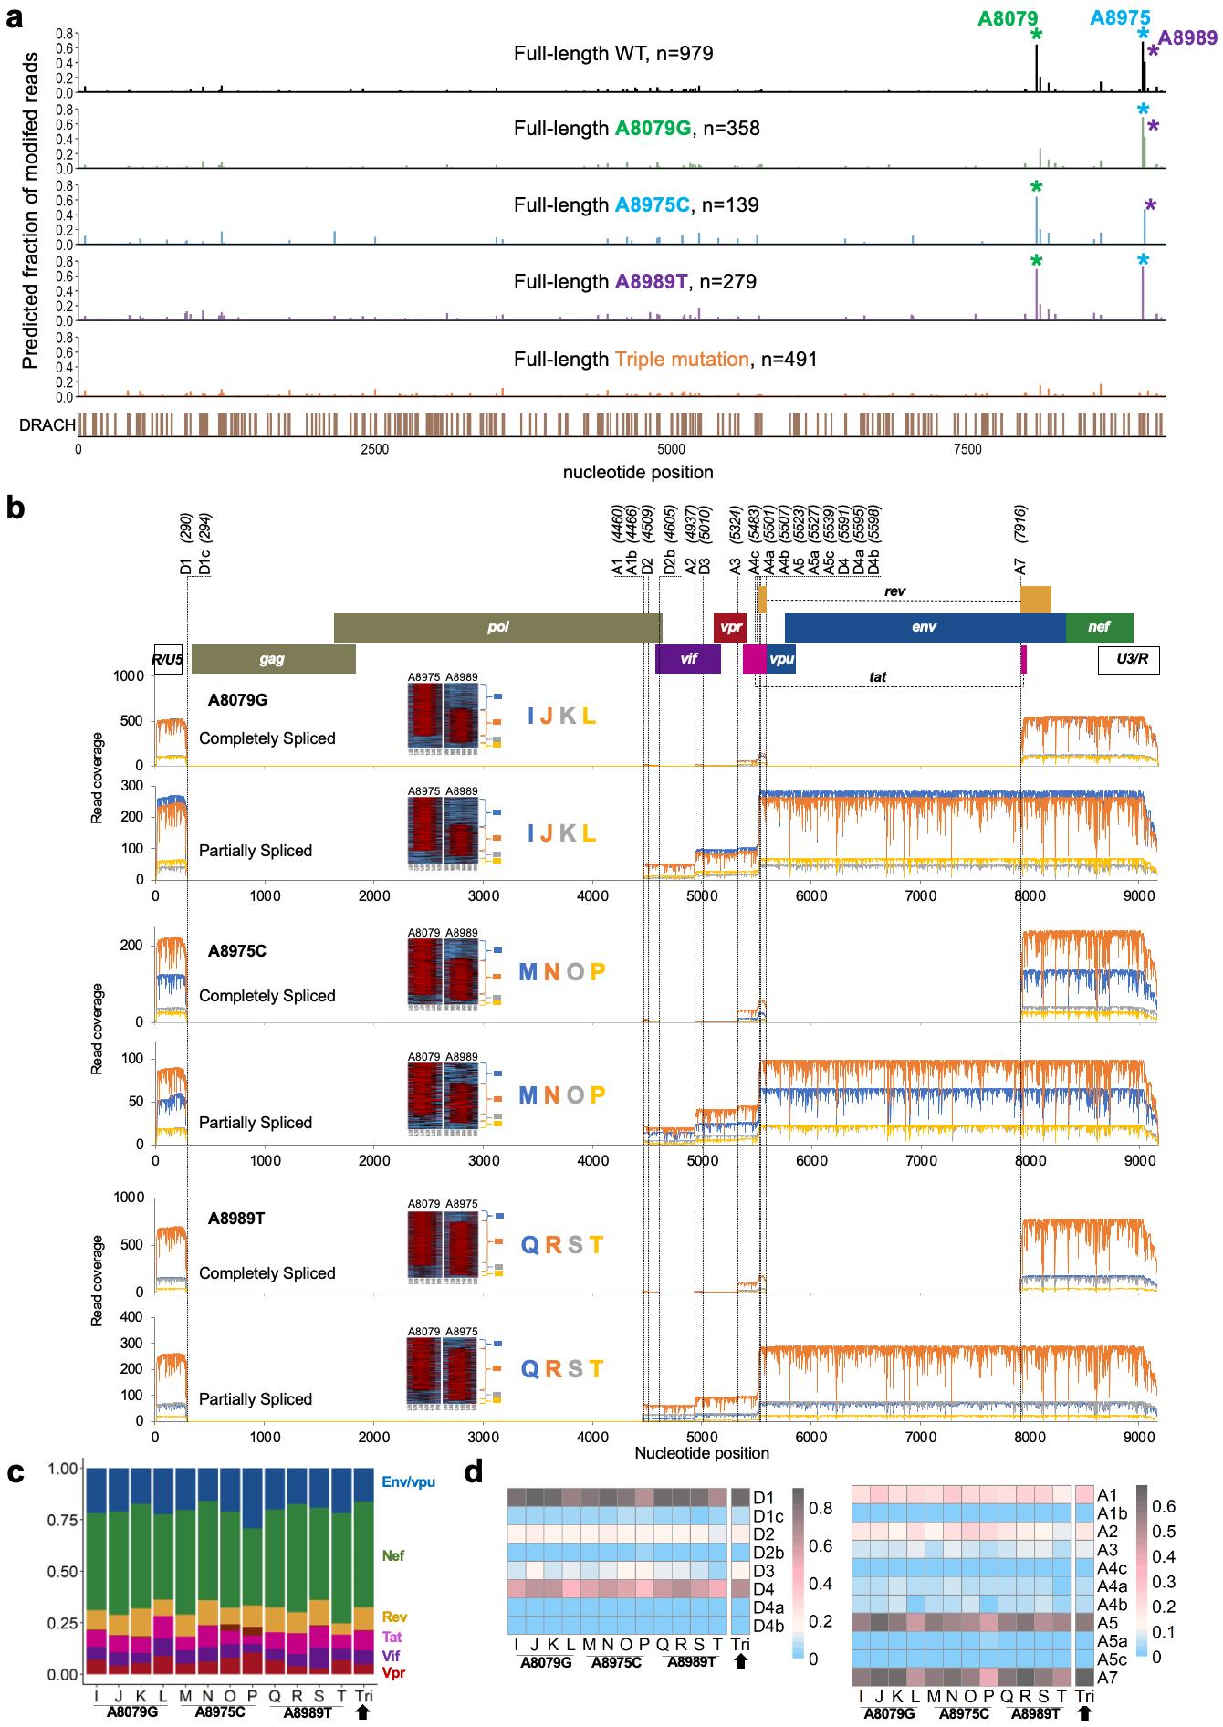
Extended Data Fig. 10: Single-RNA-level analysis reveals the functional redundancy of the m⁶As. (a) m6Anet analysis of full-length DRS reads from WT, single mutant, and triple mutant HIV-1 RNAs showed no notable signal changes in the DRACH sites in the full genome compared to the WT landscape. The dominant m⁶As at A8079, A8975, and A8989 are indicated by green, blue, and purple asterisks, respectively. Mutations effectively removed m⁶A signals at the target site. The DRACH sites are shown in the bottom panel. (b) Splicing patterns of RNA subspecies with distinct m⁶A ensembles for A8079G (top two panels), A8975C (middle two panels), and A8989T (bottom two panels). Four RNA subspecies (blue, orange, grey, and yellow, with distinct m⁶A ensembles) of completely spliced (CS) and those of partially spliced (PS) RNA were mapped onto the HIV-1 reference sequence (NL4-3 strain) to show their splicing patterns. All RNA subspecies showed indistinguishable or moderate differences in the usage of splicing donors and acceptors. (c-d) All subspecies from the three mutants (including subspecies I, J, K, and L, from A8079G; subspecies M, N, O, and P from A8975C; and subspecies Q, R, S, and T from A8989T) showed moderate differences in the production of protein-specific mRNAs (c) and donor and acceptor usage rates (d). Triple mutant data are shown for comparison (arrowheads).

