Supplementary Information for:

Polymerizing actin regulates myosin-independent mechanosensing by modulating actin elasticity and flow fluctuation

Nikhil Mittal^{1,3*}, Etienne Michels^{1*}, Kathleen Pakenas¹, Shaina P. Royer¹, Sangyoon J. Han^{1,2,3}

¹Department of Biomedical Engineering,
²Department of Mechanical Engineering and Engineering Mechanics,
³Health Research Institute, Michigan Technological University, Houghton, MI 49931

Correspondence to Sangyoon J. Han: sjhan@mtu.edu
* These authors contributed equally to the project as the co-first authors.

This file includes:
‒Figure Legends for Supplementary Figures 1‒6
‒Supplementary Tables 1 and 2
‒Supplementary Notes 1‒3
‒Captions for Supplementary Movies 1‒25
‒Supplementary Reference List

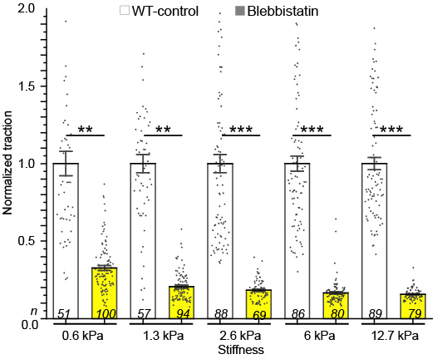

Extended Data Fig. 1. Comparison of normalized traction between WT NIH 3T3 fibroblasts (white) and BBS-treated cells (yellow) treated fibroblasts per different gel stiffness. Bar with error bar: mean ± SD. *: p<0.05, **: p<1×10⁻³⁰, ***: p<1×10⁻⁵⁰ by Mann-Whitney U test. Sample sizes, n, are denoted on bottom of each bar. Markers with error bars: mean ± s.e.m.
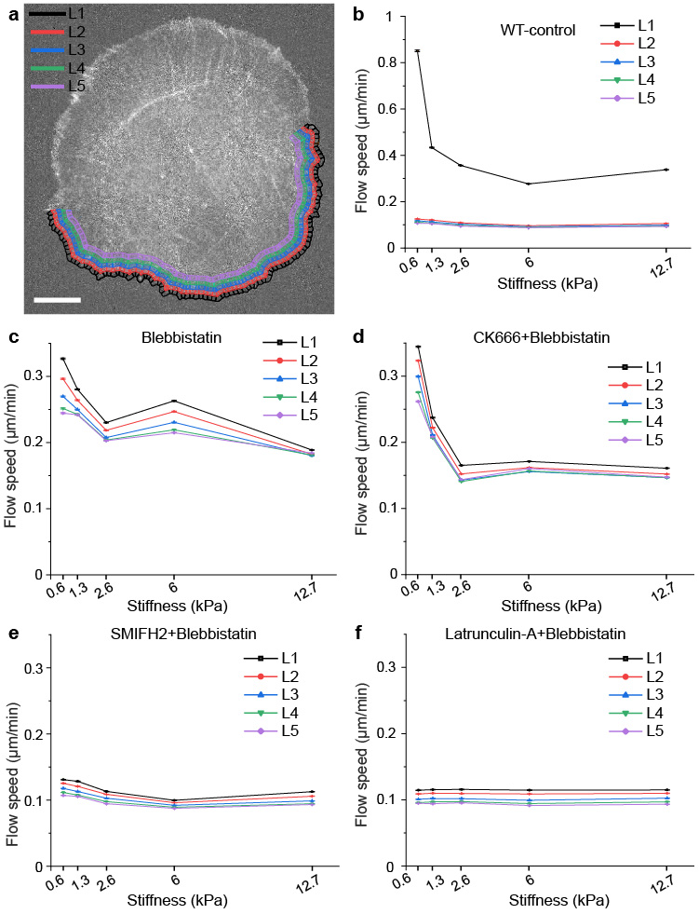
Supplementary Fig. 1. Five 2 μm-thick layers from the cell edge containing many windows to sample actin flow speed and associated speeds per layer per drug condition. a, A representative image of SNAP-actin-SiR647 of a WT fibroblast overlaid with windows of the five color-coded layers. Scale bar: 10 μm. b-f, Average F-actin flow speeds as a function of the gel stiffness in the five layers of WT-control cells (b, n = 7, 7, 7, 13, 13 cells for increasing stiffness, collected from m = 44879, 51583, 43368, 80533, 53718 windows), cells treated with 20 µM BBS (c, n = 7, 9, 9, 9, 9 cells for increasing stiffness, m = 50798, 66822, 65920, 62777, 57369 windows), cells treated with 100 µM CK666 in addition to 20 µM BBS (n = 9, 10, 10, 9, 9 cells for increasing stiffness, collected from m = 67937, 75571, 69670, 85238, 65224 windows), cells treated with 20 µM SMIFH2 in addition to 20 µM BBS (n = 8, 11, 12, 14, 9 cells for increasing stiffness, collected from m = 57937, 42861, 79091, 99196, 80533, 54022 windows), and cells treated with 1 µM Lat-A in addition to 20 µM BBS (n = 9, 10, 8, 8, 12 cells for increasing stiffness, collected from m = 52341, 52948, 36332, 45756, 65410 windows). Markers with error bars: mean ± s.e.m.

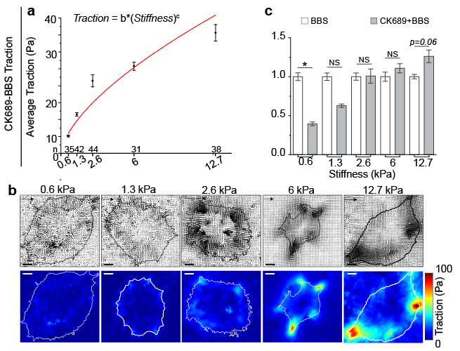
Supplementary Fig. 2. Stiffness-dependent differential force transmission is not affected by the inactive inhibitor CK689. a, Average traction integrated over 2-μm-thick cell perimeter of CK689-BBS treated fibroblasts as a function of different gel stiffness (red). Sample sizes, n, are denoted on top of each stiffness value. Markers with error bars: mean ± s.e.m. b, Representative traction vector fields (top) and traction magnitude maps (bottom) of WT-control cells. Arrow scale: 50 Pa, 75 Pa, 90 Pa, 100 Pa and 150 Pa of traction for gel stiffness of 0.6 kPa, 1.3 kPa, 2.6 kPa, 6 kPa and 12.7 kPa, respectively. Scale bar: 10 μm. Power-law curve fits (Traction = b*(Stiffness)^{c}) was added in (a) (See Supplementary Table 1 for fit parameters). c, Normalized average traction of CK666-BBS-treated cells (white) and CK689-BBS (grey). Bar with error bars: mean ± s.e.m., *: p<0.05 by Mann-Whitney U test.

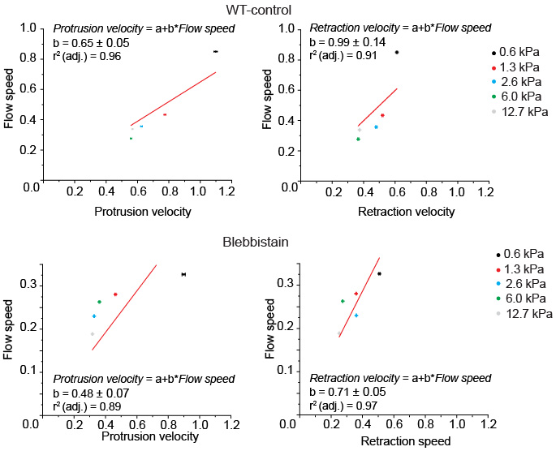
Supplementary Fig. 3. Retrograde flow speed is proportional with cell protrusion speed in response to gel stiffness demonstrating balanced contribution of actin polymerization. a, Average F-actin flow speed as a function of the average protrusion velocity of WT control cells on different gel stiffness (speckles collected from m = 44879, 51583, 43368, 80533, 53718 windows and protrusion speed from o = 3507, 3507, 3507, 6513, 6513 windows). b, Average F-actin flow speed as a function of the average retraction velocity of WT control cells on different gel stiffness (retraction speed from o = 4907, 4907, 4907, 9113, 9113 windows). Protrusion, retraction, and F-actin flow speed collected from WT cells n = 7, 7, 7, 13, 13 cells for 0.6 kPa (black), 1.3 kPa (red), 2.6 kPa (blue), 6 kPa (green), and 12.7 kPa (grey). c, Average F-actin flow speed as a function of the average protrusion velocity of BBS-treated cells on different gel stiffness (speckles collected from m = 50798, 66822, 65920, 62777, 57369 windows and protrusion speed from o = 6513, 6513, 6513, 6513, 6513 windows). b, Average F-actin flow speed as a function of the average retraction velocity of BBS-treated cells on different gel stiffness (retraction speed from o = 9113, 9113, 9113, 9113, 9113). Protrusion, retraction, and F-actin flow speed collected from BBS-treated cells n = 7, 9, 9, 9, 9 cells for 0.6 kPa (black), 1.3 kPa (red), 2.6 kPa (blue), 6 kPa (green), and 12.7 kPa (grey). Markers with error bars: mean ± s.e.m. Linear fit flow speed = a + b*protrusion speed was used to fit flow speed vs protrusion speed data, where a= 0 and b= 0.65 ± 0.05 with R² = 0.9717 for WT control; a= 0 and b= 0.48 ± 0.07with R² = 0.9159 for BBS. Linear fit flow speed = a + b*retraction speed was used to fit flow speed vs protrusion speed data, where a= 0 and b= 0.99 ± 0.14 with R² = 0.9276 for WT control; a= and b= 0.72 ± 0.05 with R² = 0.9789 for BBS.

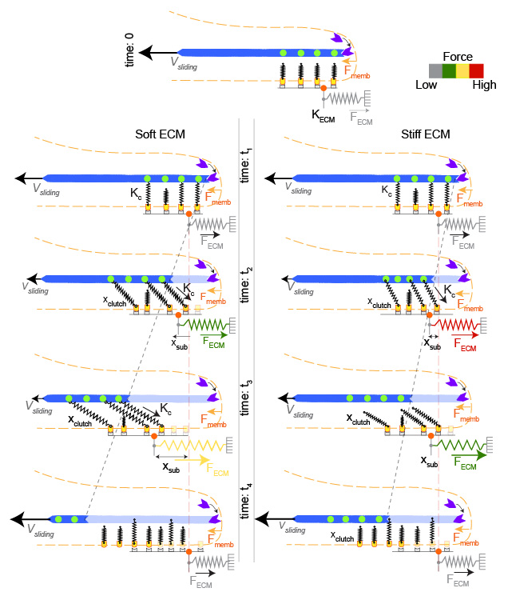
Supplementary Fig. 4. Schematic of rigid-actin-based molecular clutch model on soft and stiff substrate. Actin cables are connected to the ECM through several parallel clutches formed by adapter proteins, integrins and fibronectin. Myosin-based force was ignored. Instead, the model considers retrograde flow velocity generated by the actin-polymerization $v_{actin}=v_{max,actin}\left(1-F/F_{stall,actin}\right)$. At t=0, all the clutches are disengaged, and the actin filaments (blue) flows with a rearward speed V_{max}. At t=t₁, the clutches begin to engage in both soft and stiff substrate. At t= t₂, the engaged clutches begin getting stretched by the retrograde movement of the actin filament (shown by green points joining clutch and actin flow). At t= t₃, on Left: soft substrate, tension develops slower due to the substate being softer which results in faster actin flow velocity. Right: stiff substrate, tension develops faster as substrate is stiffer resulting in smaller actin flow velocity. At t= t₄, new cycle of clutching-unclutching begins.
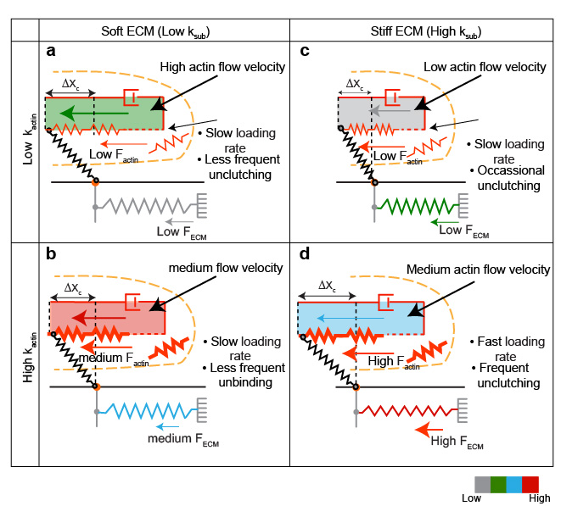
Supplementary Fig. 5 Schematic of actin elasticity-based molecular clutch model for actin-based rigidity sensing. a, on a soft substrate (low k_{sub}), in case of softer actin (low k_{actin}) e.g., by inhibition of Arp2/3 activity, actin units can be added easily due to substrate being softer and easily deformable. Tension develops slower resulting in high actin flow velocity but smaller traction. b, Similar to low k_{actin}, in case of stiffer actin (high k_{actin}) on soft substrate, e.g., in presence of Arp2/3 activity, additional actin units added due to substrate compliance leading to very high actin flow velocity as tension develops slower resulting in intermediate traction. c, on a stiff substrate (high k_{sub}), actin units can be compressed in case of softer actin (low k_{actin}), leading to small displacement, slower tension development and low actin flow velocity. d, on a stiff substrate (high k_{sub}) in high k_{actin}, tension develops faster resulting in higher traction but due to stiffer actin (high k_{actin}), addition of more actin units is limited, leading to medium actin flow velocity.

Supplementary Table 1. Nonlinear regression coefficients of the average force of 3T3s with respect to substrate shown in control, presence of myosin-inhibitor Fig. 1 a & c and in presence of Arp2/3-myosin, formin-myosin, and polymerization-myosin inhibitor in Fig. 2 a, c, e respectively. Fit function for model: Traction = b*(Stiffness)^{c}
Parameters Conditions | b | c | Adjusted R²
WT-control | 52.82 ± 6.41 | 0.51±0.07 | 0.93
Blebbistatin | 12.67 ± 0.46 | 0.34±0.02 | 0.99
CK666-Blebbistatin | 2.30 ± 0.16 | 0.47±0.05 | 0.96
Smifh2-Blebbistatin | 1.24 ± 0.02 | 0.52±0.02 | 0.99
Latrunculin A-Blebbistatin | 1.16 ± 0.11 | 0.55±0.05 | 0.96
CK689-Blebbistatin | 8.14 ±0.91 | 0.63 ±0.08 | 0.90

Supplementary Table 2. Nonlinear regression coefficients of the flow speed of 3T3s with respect to substrate shown in control, presence of myosin-inhibitor Fig. 1 e & f , and in presence of Arp2/3-myosin, formin-myosin, and polymerization-myosin inhibitor in Fig. 3 a, c, e respectively. Fit function for model: V = a*exp(R₀E) + V₀ where V₀ is initial velocity, V is final velocity, and E is Young’s modulus of the gel.
Parameters Conditions | V₀ | a | R₀ | Adjusted R²
WT-control | 304.48±24.05 | 1568.92±1038.26 | -1.81±0.79 | 0.76
Blebbistatin | 214.49±19.92 | 270±0 | -1.16±0.49 | 0.46
CK666-Blebbistatin | 163.49±5.69 | 454.09±115.53 | -1.49±0.34 | 0.96
Smifh2-Blebbistatin | 104.89±6.18 | 41.82±22.89 | -0.65±0.65 | 0.56
Latrunculin A-Blebbistatin | 114.80±0.74 | -0.51±1.29 | -0.40±2.75 | -1.81

Supplementary Table 3. Main parameters for actin-elasticity based molecular clutch model
The parameters adjusted in the different experimental conditions are listed as “adjusted”. The new parameters introduced in the model are listed as “assumed” for different conditions.

Parameters | Description | Values | References
n_{m} | Number of myosin motors | 1200: WT-control  5: (BBS) CK666-BBS, SMIFH2-BBS, Lat-A-BBS) | Elosegui-Artola et al. ^{1,2}, Chan et al. ³, Oria et al. ⁴
f_{m1} | Stall force of 1 motor (N) | -2x10¹² | Elosegui-Artola et al. ^{1,2}, Chan et al. ³, Oria et al. ⁴
v_{u} | Unloaded myosin motor velocity (m/s) | -110e-9: WT-control  0: (BBS, CK666-BBS, SMIFH2-BBS, Lat-A-BBS) | Molly et al. ⁵Elosegui-Artola et al. ^{1,2}, Chan et al. ³, Oria et al. ⁴
n_{c} | Number of molecular clutches (fibronectin molecules) | 1200 | Elosegui-Artola et al. ^{1,2}, Oria et al. ⁴
d_{int} | Density of integrin molecules | 300/µm² | Elosegui-Artola et al. ^{1,2}, Oria et al. ⁴
k_{ont} | True on-rate (µm²/s) | 2.11x10⁴ | ⁶Elosegui-Artola et al. ^{1,2}, Oria et al. ⁴
k_{off} | Unbinding rate of integrin (s⁻¹) | Adjusted | Elosegui-Artola et al. ^{1,2}, Oria et al. ⁴, Kong et al. ⁷
k_{onv} | Binding rate between vinculin and unfolded talin | 10⁸ | Elosegui-Artola et al ²,
k_{c} | Clutch spring constant (N/m) | 1 N/m | Elosegui-Artola et al.², Oria et al. ⁴, Chan et al. ³
int_{add} | Number of integrins added per sq. micron every time reinforcement happens | 2.4 | Elosegui-Artola et al. ^{1,2}
k_{sub} | Substrate spring constant (N/m) | 0.1x10⁻³- 2x10⁻³ | Chan et al. ³
ion | corresponding k_{off} data | adjusted | Kong et al. ⁷
V_{actin} | Unloaded actin-polymerization-driven actin flow speed | assumed | Introduced
d_{actin} | Density of F-actin molecules | assumed | Introduced
F_{s,actin} | force required to stall actin flow | assumed | Introduced
k_{actin} | Spring constant of individual actin unit | assumed | Introduced
L | Length of the individual actin unit | assumed | Introduced
N_{n} | number of new actin units | assumed | Introduced
N₀ | number of units in the original filament at the start of the first-time step | assumed | Introduced

Supplementary Note 1: Justification for inhibitor concentrations
Blebbistatin concentration
We found the 20 µM blebbistatin concentration to be optimal for the stiffness-dependent differential traction studies by following reasons. First, this concentration has been sufficient to inhibit nearly whole myosin contractility. In response to increasing BBS concentrations, the traction force, measured by micropillars, has been found to decrease until 20 µM, after which the average force has become virtually constant with the further increase in the BBS concentration to 40 µM⁸. Second, while in-vitro ATPase activity measurement using spectrophotometer has shown about 80-90% down-regulation of the activity of platelet or non-muscle myosin IIA and IIB activity⁹ in the presence of 20 µM blebbistatin, the concentration higher than 20 µM has shown to be cytotoxic as well as phototoxic on exposure to blue light¹⁰. Finally, our data indicates that the traction of the BBS-treated cells was further reduced, by 4- or 5-fold, in response to additional inhibition with CK666 or (SMIFH2 or LatA), respectively (Fig. 2). which suggests that the stiffness-dependent differential traction (Fig. 1c) is minimally from remaining active myosin activity but mainly from actin polymerization-based actin retrograde flow. Therefore, to inhibit almost all the myosin ATPase activity to in addition to avoiding cytotoxicity to cells, 20 µM concentration of BBS was used.
CK666, SMIFH2 and Latrunculin-A concentrations
CK666, an Arp2/3 inhibitor used in our study, stabilizes the inactive Arp2/3 complex and block the movement of Arp2 and Arp3 subunits into the active conformation¹¹. In our study, we have used CK666 at 100 µM in addition to 20 µM blebbistatin. 100 µM of CK666 has been widely used to effectively downregulate Arp2/3 activity, which has helped to show reduction in actin density at the leading edge, retraction of lamellipodial actin filament organization, reduction in dense elongated filaments¹², reduction in actin expression¹³ and in actin polymerization¹¹.
SMIFH2 is a small molecule inhibitor that inhibits the nucleation activity of formin homology domain 2. At 20 µM concentration, which we used for the study, SMIFH2 has shown to reduce F-actin bundles in NIH 3T3 fibroblasts¹⁴. High concentrations of SMIFH2 have exhibited cytotoxicity in different cell lines¹⁵ including NIH 3T3 fibroblasts¹⁴. According to Isogai et al.¹⁵, administering SMIFH2 at moderate concentrations (< 10µM) and for short treatments (< 1 hour) minimizes cytotoxicity. At concentration higher than that, e.g., ~50 µM, SMIFH2 has demonstrated a side-effect to inhibit human non-muscle myosin ATPase activity as well¹⁶. However, this side-effect does not harm our findings and associated implication because we used less SMIFH2 concentration (than 50 µM) and we anyway applied BBS inhibit myosin activity along with formin activity.
Latrunculin-A (Lat-A), an actin polymerization inhibitor, binds to actin monomers and prevents them from polymerizing into filaments^{17,18}. Lat-A exposure to Swiss 3T3 mouse fibroblasts cells at ~0.9 µM concentration for 1 hour disrupts actin organization¹⁸. We used 1 µM concentration of Lat-A to sequester actin monomer and drop down the actin polymerization rate. Treatment of fibroblasts with lat-A concentration as low as 0.1 µM has shown disintegration of actin assembly and overall decrease in cell elasticity¹⁹. Lat-A has also demonstrated to be more potent at lower concentration (~0.5 µM) and longer times compared to other actin-polymerization inhibitors, Latrunculin-B and cytochalasin D²⁰.
Supplementary Note 2: A traditional molecular clutch model assuming rigid actin treadmilling with addition of actin polymerization as another source of traction.
Model parameters and implementation
To analyze the force transmission and actin velocity in response to different ECM stiffness, the original molecular clutch model was first developed by Chan et al.³, which was modified further by including an adhesion reinforcement¹. Our model is based on this model, which we further modified with additional component of actin’s own force-velocity relationship. We refer this modified model¹ as the traditional model for description purpose.
Common parameters shared in the traditional model
The traditional model considers a given number of myosin motors (n_{m}) pulling on the actin filament generating the characteristic retrograde flow of actin towards the cell center by exerting a force F_{m}. The actin filament can bind to a given number of fibronectin (FN) molecules (n_{f}) on the substrate through talin-integrin clutches, which can be modelled as linear elastic hooks in parallel with a spring constant k_{c} (Fig. 4a). Fibronectin’s own elasticity was ignored, i.e., regarded rigidly connected to the elastic substrate with spring constant k_{sub}. In the model, FN molecules are allowed to reversibly associate to the integrins with an effective binding rate k_{on} and disassociate according to an effective unbinding rate k_{off}. As the number of FN molecules are considered fixed in the model, the effective binding rate is given by k_{on} = k_{ont}·d_{int} where k_{ont} is the true binding rate characterizing integrin-fibronectin interaction, and d_{int} is the density of integrins on the cell membrane.
The simulation begins with unbound clutch-FN linkages, i.e., the absence of adhesion to the substrate, with unloaded myosin motors. In this model, due to myosin’s force-velocity relationship,
$V_{u}= V_{a}(1-\frac{F_{sub}}{n_{m}F_{m}})$ , (1)
where F_{m} is the force required to stall a myosin motor and thus n_{m}*F_{m} is the maximum isometric tension by myosin motors and F_{sub} is the traction on the substrate, which is equivalent to the tension on the myosin due to force balance, actin filaments flow with the maximum rearward speed V_{a}. Then, in the subsequent time step, the number of bound clutches grows because k_{off} rate is not sufficient to exceed k_{on} rate due to insufficient tension in the myosin. The bound clutches are pulled by the rearward movement of actin filaments, V_{u}, thus exerting force to the substrate. After every time step, the total traction force applied to the substrate F_{sub} is calculated by applying force balance:
$F_{sub}= \frac{k_{sub}k_{c}\sum_{i=1}^{n_{bound}}{x_{i}}}{k_{sub}+n_{bound}k_{c}}$ , (2)
where x_{i} is the position of each bound molecule, and n_{bound} is the total number of bound molecules. The retrograde speed V_{u} is recalculated by the updated Fsub and the linear force-velocity relationship (1), i.e., the actin speed slows down due to the increased force.
To compare model predictions with experiments, the force applied to the substrate F_{sub} and spring constant k_{sub} were converted to cell traction stress P_{sub} and Young’s modulus E, respectively, by assuming a given adhesion radius r_{a}. The equations used are:
$E=\frac{9k_{sub}}{4πr_{a}}$ , (4)
$P_{sub}= \frac{F_{sub}}{πa^{2}}$ , (5)
which are the same as used in Elosegui-Artola et al¹. The area of the adhesion (πr_{a}²) represents thus the total surface occupied by the number of fibronectin molecules n_{f} considered in the simulation.
For myosin-independent force transmission simulation, we added the actin polymerization’s contribution to the retrograde flow by adding new parameters, v_{actin} and d_{actin},
$V_{f}=V_{u}*\left(1-\frac{k_{sub}*x_{sub}}{F_{s,myosin}}\right)+V_{actin }*(1-\frac{k_{sub}*x_{sub}}{F_{s,actin}})$ , (6)
where V_{actin} is the unloaded actin-polymerization-driven actin flow speed and F_{s,actin} is the force required to stall actin flow, which is calculated using C_{actin} which is an assumed constant for the force-velocity relation in actin calculated based on of density of actin (d_{actin})
$F_{s,actin}= \frac{-C_{actin}}{4*R}$ (7)
where R is the radius of curvature of edge of the cell. For myosin-free simulation, V_{u} was kept zero as there is no myosin contraction.
In our model with actin polymerization, the clutch unbinding rate, k_{off}, was adjusted to recapitulate high flow speed in CK666-BBS condition by increasing the unclutching rate magnitude overall to 6 compared to 0.5 in BBS (Fig. 4e,f.). k_{off} was modeled with an exponential corresponding to the experimental data from Kong et al.²¹.
$k_{off}= a\exp\left(bF_{c}\right)$ , (8)
where the constants a and b were adjusted depending on the range of F_{c}, i.e., a=0.1905 and b=2.333×10¹¹ if F_{c} < 13.2×10⁻¹² N, and a=0.04527 and b=7.251×10¹⁰ if F_{c} < 30×10⁻¹² N.

Supplementary Note 3: Actin-elasticity-based molecular clutch model
In this modified model, actin was modeled as a viscoelastic material with a length L with an individual spring constant of k_{actin} and viscosity of η. Rather than being rigidly connected to the velocity, the flow in this model is driven by the force equilibrium between the actin filament, the clutches, and the substrate.
The force generated in the purely elastic spring portion of the actin is generated by the force balance with the elastic clutch, and is found to be:
$F_{actin-k}= \frac{N_{n}L- X_{c}}{N_{o}+ N_{n}}. k_{actin}$ (9)
where N_{n} is the number of new actin units added in that time step, and N₀ the number of units in the original filament at the start of the first time-step. N_{n} is modeled to be inversely related to the maximum force in any of the individual clutches denoted as F_{c}:
$N_{n}=N_{n,max}\left(1-\frac{F_{c}}{F_{s,actin}}\right)$ (10)
F_{s,actin} is the stall force of actin addition, and N_{n,max} is the maximum number of actin units that can be added in a single time step.
The force in the substrate and clutch are described by following equations:
$F_{sub}= k_{s}*x_{sub}$ (11)
$F_{adh}= N_{c}K_{c}(x_{c}-x_{sub})$ (12)
where F_{adh} is the force in the clutch, and N_{c} is the number of bound clutches.
As the clutches are attached to the substrate, the force balance between the clutches and the substrate can be used to create the expression for the displacement of the substrate:
$X_{sub}= \frac{N_{c}k_{c}X_{c}}{k_{s}{+ k}_{c}N_{c}}$ (13)
The rate of change of the position of the clutch, equation (16), is derived using following equations:
$η{\dot{x}}_{c}=F_{actin-k}-F_{adh}$ , (14)
${\dot{x}}_{c}=\frac{1}{η}\left(\frac{N_{n}L- X_{c}}{N_{o}+ N_{n}}. k_{actin}-N_{c}k_{c}{(X}_{c}-X_{sub})\right)$ . (15)
The time derivative of the clutch position is explicitly integrated in the model using the Euler method to find the displacement following each time step of the simulation. The maximum rate of displacement of any of the clutches is considered to be the actin rearward speed.
The displacement is used to calculate the force exerted on the substrate using equations (14) and (11), which is used to find the traction exerted on the substrate using equation (4).

Captions for Supplementary Movies
Supplementary Movie 1. Time-lapse images of SNAP-SiR647-tagged actin in a representative WT NIH 3T3 fibroblast on 0.6 kPa gel, overlaid with color-coded flow vector field. The time interval per frame: 6 second. Playing speed: 10 frames/sec. Duration of the movie: 3 minutes. Scale bar: 10 μm.
Supplementary Movie 2. Time-lapse images of SNAP-SiR647-tagged actin in a representative WT NIH 3T3 fibroblast on 1.3 kPa gel, overlaid with color-coded flow vector field. The time interval per frame: 6 second. Playing speed: 10 frames/sec. Duration of the movie: 3 minutes. Scale bar: 10 μm.
Supplementary Movie 3. Time-lapse images of SNAP-SiR647-tagged actin in a representative WT NIH 3T3 fibroblast on 2.6 kPa gel, overlaid with color-coded flow vector field. The time interval per frame: 6 second. Playing speed: 10 frames/sec. Duration of the movie: 3 minutes. Scale bar: 10 μm.
Supplementary Movie 4. Time-lapse images of SNAP-SiR647-tagged actin in a representative WT NIH 3T3 fibroblast on 6.0 kPa gel, overlaid with color-coded flow vector field. The time interval per frame: 6 second. Playing speed: 10 frames/sec. Duration of the movie: 3 minutes. Scale bar: 10 μm.
Supplementary Movie 5. Time-lapse images of SNAP-SiR647-tagged actin in a representative WT NIH 3T3 fibroblast on 12.7 kPa gel, overlaid with color-coded flow vector field. The time interval per frame: 6 second. Playing speed: 10 frames/sec. Duration of the movie: 3 minutes. Scale bar: 10 μm.
Supplementary Movie 6. Time-lapse images of SNAP-SiR647-tagged actin in a representative BBS-treated NIH 3T3 fibroblast on 0.6 kPa gel, overlaid with color-coded flow vector field. The time interval per frame: 6 second. Playing speed: 10frames/sec. Duration of the movie: 3 minutes. Scale bar: 10 μm.
Supplementary Movie 7. Time-lapse images of SNAP-SiR647-tagged actin in a representative BBS-treated NIH 3T3 fibroblast on 1.3 kPa gel, overlaid with color-coded flow vector field. The time interval per frame: 6 second. Playing speed: 10 frames/sec. Duration of the movie: 3 minutes. Scale bar: 10 μm.
Supplementary Movie 8. Time-lapse images of SNAP-SiR647-tagged actin in a representative BBS-treated NIH 3T3 fibroblast on 2.6 kPa gel, overlaid with color-coded flow vector field. The time interval per frame: 6 second. Playing speed: 10 frames/sec. Duration of the movie: 3 minutes. Scale bar: 10 μm.
Supplementary Movie 9. Time-lapse images of SNAP-SiR647-tagged actin in a representative BBS-treated NIH 3T3 fibroblast on 6.0 kPa gel, overlaid with color-coded flow vector field. The time interval per frame: 6 second. Playing speed: 10 frames/sec. Duration of the movie: 3 minutes. Scale bar: 10 μm.
Supplementary Movie 10. Time-lapse images of SNAP-SiR647-tagged actin in a representative BBS-treated NIH 3T3 fibroblast on 12.7 kPa gel, overlaid with color-coded flow vector field. The time interval per frame: 6 second. Playing speed: 10 frames/sec. Duration of the movie: 3 minutes. Scale bar: 10 μm.
Supplementary Movie 11. Time-lapse images of SNAP-SiR647-tagged actin in a representative CK666-BBS-treated NIH 3T3 fibroblast on 0.6 kPa gel, overlaid with color-coded flow vector field. The time interval per frame: 6 second. Playing speed: 10 frames/sec. Duration of the movie: 3 minutes. Scale bar: 10 μm.
Supplementary Movie 12. Time-lapse images of SNAP-SiR647-tagged actin in a representative CK666-BBS-treated NIH 3T3 fibroblast on 1.3 kPa gel, overlaid with color-coded flow vector field. The time interval per frame: 6 second. Playing speed: 10 frames/sec. Duration of the movie: 3 minutes. Scale bar: 10 μm.
Supplementary Movie 13. Time-lapse images of SNAP-SiR647-tagged actin in a representative CK666-BBS-treated NIH 3T3 fibroblast on 2.6 kPa gel, overlaid with color-coded flow vector field. The time interval per frame: 6 second. Playing speed: 10 frames/sec. Duration of the movie: 3 minutes. Scale bar: 10 μm.
Supplementary Movie 14. Time-lapse images of SNAP-SiR647-tagged actin in a representative CK666-BBS-treated NIH 3T3 fibroblast on 6.0 kPa gel, overlaid with color-coded flow vector field. The time interval per frame: 6 second. Playing speed: 10 frames/sec. Duration of the movie: 3 minutes. Scale bar: 10 μm.
Supplementary Movie 15. Time-lapse images of SNAP-SiR647-tagged actin in a representative CK666-BBS-treated NIH 3T3 fibroblast on 12.7 kPa gel, overlaid with color-coded flow vector field. The time interval per frame: 6 second. Playing speed: 10 frames/sec. Duration of the movie: 3 minutes. Scale bar: 10 μm.
Supplementary Movie 16. Time-lapse images of SNAP-SiR647-tagged actin in a representative SMIFH2-BBS-treated NIH 3T3 fibroblast on 0.6 kPa gel, overlaid with color-coded flow vector field. The time interval per frame: 6 second. Playing speed: 10 frames/sec. Duration of the movie: 3 minutes. Scale bar: 10 μm.
Supplementary Movie 17. Time-lapse images of SNAP-SiR647-tagged actin in a representative SMIFH2-BBS-treated NIH 3T3 fibroblast on 1.3 kPa gel, overlaid with color-coded flow vector field. The time interval per frame: 6 second. Playing speed: 10 frames/sec. Duration of the movie: 3 minutes. Scale bar: 10 μm.
Supplementary Movie 18. Time-lapse images of SNAP-SiR647-tagged actin in a representative SMIFH2-BBS-treated NIH 3T3 fibroblast on 2.6 kPa gel, overlaid with color-coded flow vector field. The time interval per frame: 6 second. Playing speed: 10 frames/sec. Duration of the movie: 3 minutes. Scale bar: 10 μm.
Supplementary Movie 19. Time-lapse images of SNAP-SiR647-tagged actin in a representative SMIFH2-BBS-treated NIH 3T3 fibroblast on 6.0 kPa gel, overlaid with color-coded flow vector field. The time interval per frame: 6 second. Playing speed: 10frames/sec. Duration of the movie: 3 minutes. Scale bar: 10 μm.
Supplementary Movie 20. Time-lapse images of SNAP-SiR647-tagged actin in a representative SMIFH2-BBS-treated NIH 3T3 fibroblast on 12.7 kPa gel, overlaid with color-coded flow vector field. The time interval per frame: 6 second. Playing speed: 10 frames/sec. Duration of the movie: 3 minutes. Scale bar: 10 μm.
Supplementary Movie 21. Time-lapse images of SNAP-SiR647-tagged actin in a representative LatA-BBS-treated NIH 3T3 fibroblast on 0.6 kPa gel, overlaid with color-coded flow vector field. The time interval per frame: 6 second. Playing speed: 10 frames/sec. Duration of the movie: 3 minutes. Scale bar: 10 μm
Supplementary Movie 22. Time-lapse images of SNAP-SiR647-tagged actin in a representative LatA-BBS-treated NIH 3T3 fibroblast on 1.3 kPa gel, overlaid with color-coded flow vector field. The time interval per frame: 6 second. Playing speed: 10 frames/sec. Duration of the movie: 3 minutes. Scale bar: 10 μm
Supplementary Movie 23. Time-lapse images of SNAP-SiR647-tagged actin in a representative LatA-BBS-treated NIH 3T3 fibroblast on 2.6 kPa gel, overlaid with color-coded flow vector field. The time interval per frame: 6 second. Playing speed: 10 frames/sec. Duration of the movie: 3 minutes. Scale bar: 10 μm
Supplementary Movie 24. Time-lapse images of SNAP-SiR647-tagged actin in a representative LatA-BBS-treated NIH 3T3 fibroblast on 6.0 kPa gel, overlaid with color-coded flow vector field. The time interval per frame: 6 second. Playing speed: 10 frames/sec. Duration of the movie: 3 minutes. Scale bar: 10 μm
Supplementary Movie 25. Time-lapse images of SNAP-SiR647-tagged actin in a representative LatA-BBS-treated NIH 3T3 fibroblast on 12.7 kPa gel, overlaid with color-coded flow vector field. The time interval per frame: 6 second. Playing speed: 10 frames/sec. Duration of the movie: 3 minutes. Scale bar: 10 μm

References
1 Elosegui-Artola, A. et al. Rigidity sensing and adaptation through regulation of integrin types. Nature materials 13, 631-637 (2014).
2 Elosegui-Artola, A. et al. Mechanical regulation of a molecular clutch defines force transmission and transduction in response to matrix rigidity. Nature cell biology 18, 540-548 (2016).
3 Chan, C. E. & Odde, D. J. Traction dynamics of filopodia on compliant substrates. Science 322, 1687-1691 (2008).
4 Oria, R. et al. Force loading explains spatial sensing of ligands by cells. Nature 552, 219-224 (2017).
5 Molloy, J., Burns, J., Kendrick-Jones, J., Tregear, R. & White, D. Movement and force produced by a single myosin head. Nature 378, 209-212 (1995).
6 Litvinov, R. I. et al. Resolving two-dimensional kinetics of the integrin αIIbβ3-fibrinogen interactions using binding-unbinding correlation spectroscopy. Journal of Biological Chemistry 287, 35275-35285 (2012).
7 Kong, F., García, A. J., Mould, A. P., Humphries, M. J. & Zhu, C. Demonstration of catch bonds between an integrin and its ligand. Journal of Cell Biology 185, 1275-1284 (2009).
8 Doss, B. L. et al. Cell response to substrate rigidity is regulated by active and passive cytoskeletal stress. Proceedings of the National Academy of Sciences 117, 12817-12810(2020).
9 Straight, A. F. et al. Dissecting temporal and spatial control of cytokinesis with a myosin II Inhibitor. Science 299, 1743-1747 (2003).
10 Mikulich, A., Kavaliauskiene, S. & Juzenas, P. Blebbistatin, a myosin inhibitor, is phototoxic to human cancer cells under exposure to blue light. Biochimica et Biophysica Acta (BBA)-General Subjects 1820, 870-877 (2012).
11 Nolen, B. et al. Characterization of two classes of small molecule inhibitors of Arp2/3 complex. Nature 460, 1031-1034 (2009).
12 Yang, Q., Zhang, X.-F., Pollard, T. D. & Forscher, P. Arp2/3 complex–dependent actin networks constrain myosin II function in driving retrograde actin flow. Journal of Cell Biology 197, 939-956 (2012).
13 Wang, F. et al. Arp2/3 complex inhibition prevents meiotic maturation in porcine oocytes. PLoS One 9, e87700 (2014).
14 Rizvi, S. A. et al. Identification and characterization of a small molecule inhibitor of formin-mediated actin assembly. Chemistry & biology 16, 1158-1168 (2009).
15 Isogai, T., Van Der Kammen, R. & Innocenti, M. SMIFH2 has effects on Formins and p53 that perturb the cell cytoskeleton. Scientific reports 5, 1-15 (2015).
16 Nishimura, Y. et al. The formin inhibitor SMIFH2 inhibits members of the myosin superfamily. Journal of cell science 134 (2021).
17 Coué, M., Brenner, S. L., Spector, I. & Korn, E. D. Inhibition of actin polymerization by latrunculin A. FEBS letters 213, 316-318 (1987).
18 Spector, I., Shochet, N. R., Kashman, Y. & Groweiss, A. Latrunculins: novel marine toxins that disrupt microfilament organization in cultured cells. Science 219, 493-495 (1983).
19 Rotsch, C. & Radmacher, M. Drug-induced changes of cytoskeletal structure and mechanics in fibroblasts: an atomic force microscopy study. Biophysical journal 78, 520-535 (2000).
20 Spector, I., Shochet, N. R., Blasberger, D. & Kashman, Y. Latrunculins—novel marine macrolides that disrupt microfilament organization and affect cell growth: I. Comparison with cytochalasin D. Cell motility and the cytoskeleton 13, 127-144 (1989).
21 Kong, F. et al. Cyclic mechanical reinforcement of integrin–ligand interactions. Molecular cell 49, 1060-1068 (2013).

