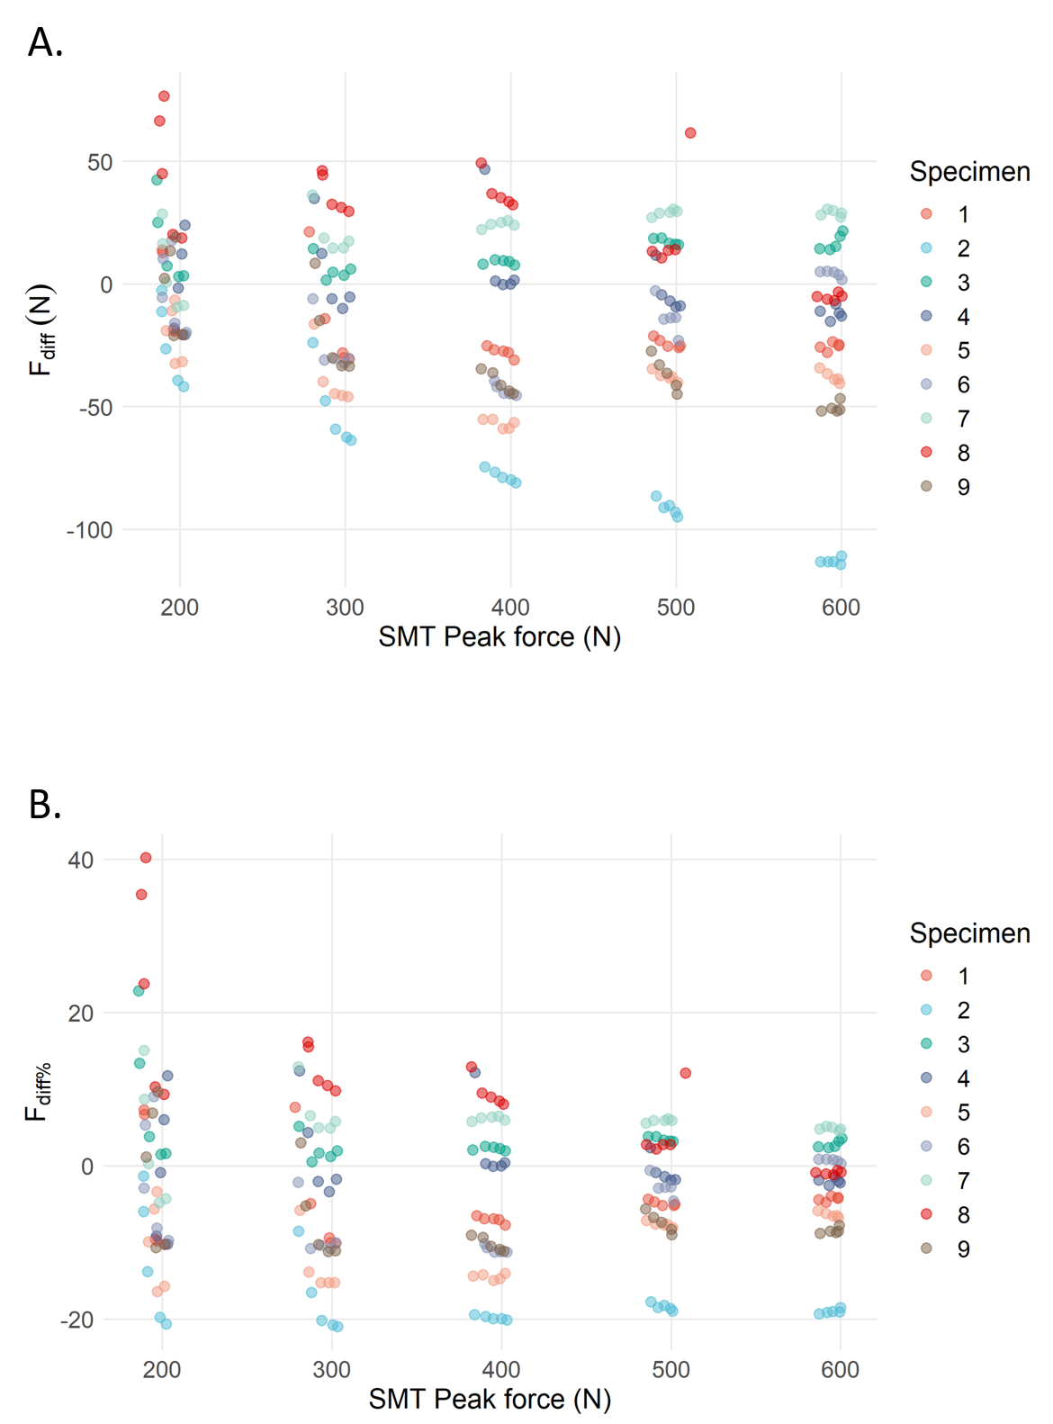
Supplementary figure 1. Visualization of the variation in F_{diff} (figure 1A) and F_{diff%} (figure 1B) in function of the 5 distinct SMT peak force. The results of the 5 rate of force applications for each SMT peak force are depicted per specimen.

