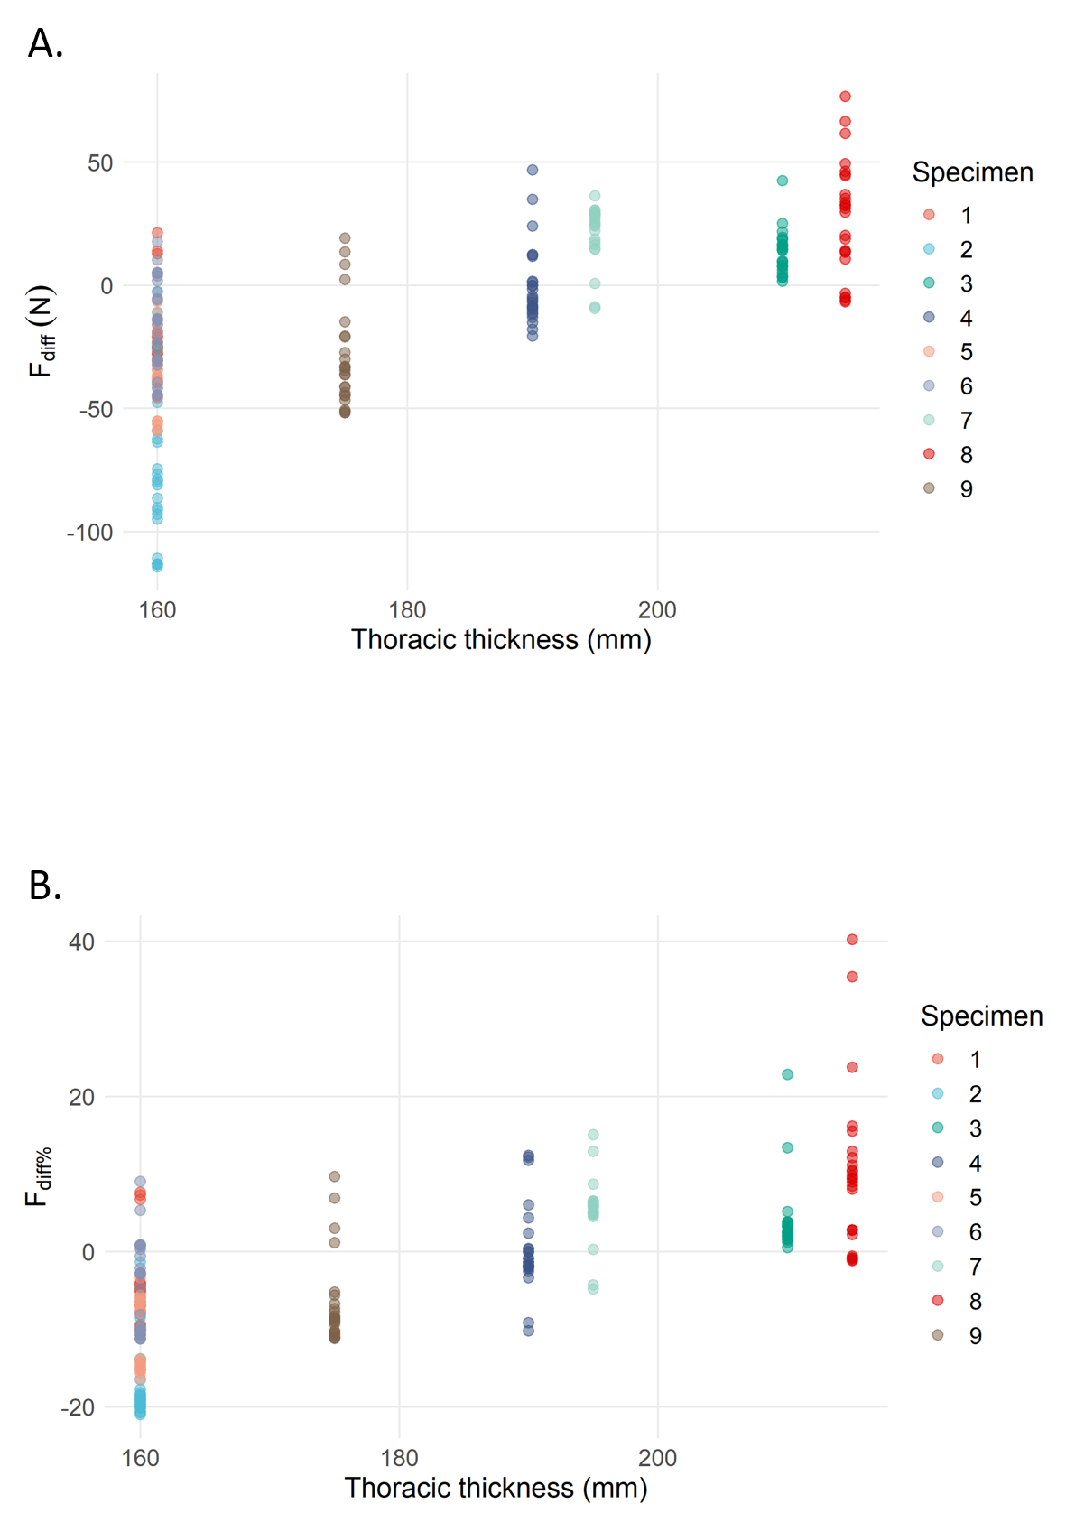
Supplementary figure 2. Visualization of the variation in F_{diff} (figure 2A) and F_{diff%} (figure 2B) in function of the thoracic thickness measurement. Results obtained for the 25 SMTs are depicted for each specimen.

