In vitro cytotoxic effect of 3β-Stigmasterol derivatives against breast cancer cells
Nondumiso Premilla Dube ª, Vuyelwa Jacqueline Tembu ª, Getrude R Nyemba ^{b}, Candace Davison ^{b}, Goitsemodimo Herckious Rakodi ª, Douglas Kemboi ^{a,d}, Jo-Anne de la Mare ^{b}, Xavier Siwe-Noundou ^{c}, Amanda Ezra-Lee Manicum ^{a*}
ª Department of Chemistry, Tshwane University of Technology, Private Bag X680, Pretoria 0001, South Africa
^{b} Department of Biochemistry and Microbiology, Female Cancers Research at Rhodes University (FemCR₂U), Makhanda/Grahamstown, 6140, South Africa
^{c} Department of Pharmaceutical Science, Sefako Makgatho Health Science University, Pretoria 0204, South Africa.
^{d}Department of Physical Sciences, University of Kabianga, Kericho, 2030, Kenya.
*Correspondence: dubendumi@gmail.com, ManicumAE@tut.ac.za;
Abstract
Background: 3β-Stigmasterol is an unsaturated phytosterol that belong to the class of tetracyclic steroids abundant in Rhoicissus tridentata. Stigmasterol is an important constituent since it has shown impressive pharmacological effects such as anti-osteoarthritis, anticancer, anti-diabetic, anti-inflammatory, antiparasitic, immunomodulatory, antifungal, antioxidant, antibacterial, and neuroprotective activities. Furthermore, due to the presence of π system and hydroxyl group, stigmasterol is readily derivatized through substitution and addition reactions, allowing for the synthesis of a wide variety of stigmasterol derivatives.
Methods: 3β-Stigmasterol (1) isolated from Rhoicissus tridentata was used as starting material to yield eight bio-active derivatives (2-9) through acetylation, epoxidation, epoxide ring opening, oxidation, and dihydroxylation reactions. The structures of all the compounds were established using spectroscopic techniques, NMR, IR, MS, and melting points. The synthesized stigmasterol derivatives were screened for cytotoxicity against the hormone receptor-positive breast cancer (MCF-7), triple-negative breast cancer (HCC70), and non-tumorigenic mammary epithelial (MCF-12A) cell lines using the resazurin assay.
Results: Eight stigmasterol derivatives were successfully synthesized namely; Stigmasterol acetate (2), Stigmasta-5,22-dien-3,7-dione (3), 5,6-Epoxystigmast-22-en-3β-ol (4), 5,6-Epoxystigmasta-3β,22,23-triol (5), Stigmastane-3β,5,6,22,23-pentol (6), Stigmasta-5-en-3,7-dion-22,23-diol (7), Stigmasta-3,7-dion-5,6,22,23-ol (8) and Stigmast-5-ene-3β,22,23-triol (9).The synthesized stigmasterol analogues showed improved cytotoxic activity overall compared to the 3β-stigmasterol (1), which was not toxic to the three cell lines tested (EC₅₀ ˃ 250 µM). In particular, 5,6-Epoxystigmast-22-en-3β-ol (4) and stigmast-5-ene-3β,22,23-triol (9) displayed improved cytotoxicity and selectivity against MCF-7 breast cancer cells (EC₅₀ values of 21.92 and 22.94 µM, respectively), while stigmastane-3β,5,6,22,23-pentol (6) showed improved cytotoxic activity against the HCC70 cell line (EC₅₀: 16.82 µM).
Conclusion: Natural products from Rhoicissus tridentata and their derivatives exhibit a wide range of pharmacological activities, including anticancer activity. The results obtained from this study indicate that molecular modification of 3β-stigmasterol functional groups can generate structural analogues with improved anticancer activity. Stigmasterol derivatives have potential as candidates for novel anticancer drugs.
Keywords: 3β-stigmasterol; Cytotoxicity; MCF-7; HCC70; MCF-12A.

Appendix 1: IR spectrum of 3β-Stigmasterol (1)

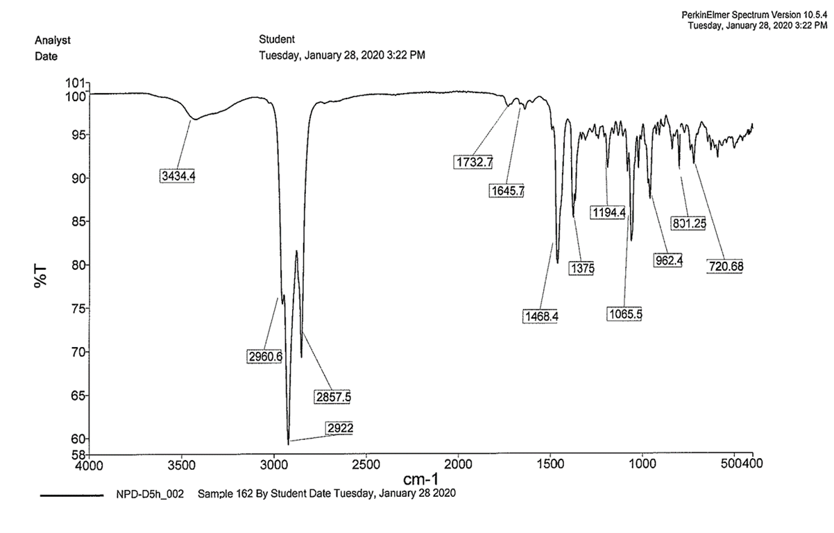

Appendix 2: MS spectrum of 3β-Stigmasterol (1)

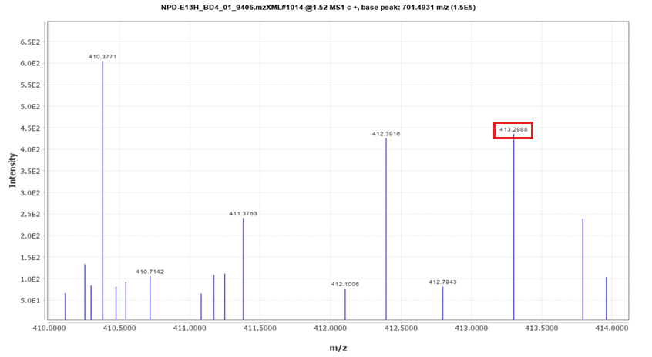

Appendix 3: ¹H NMR spectrum of 3β-Stigmasterol (1) in CDCl₃

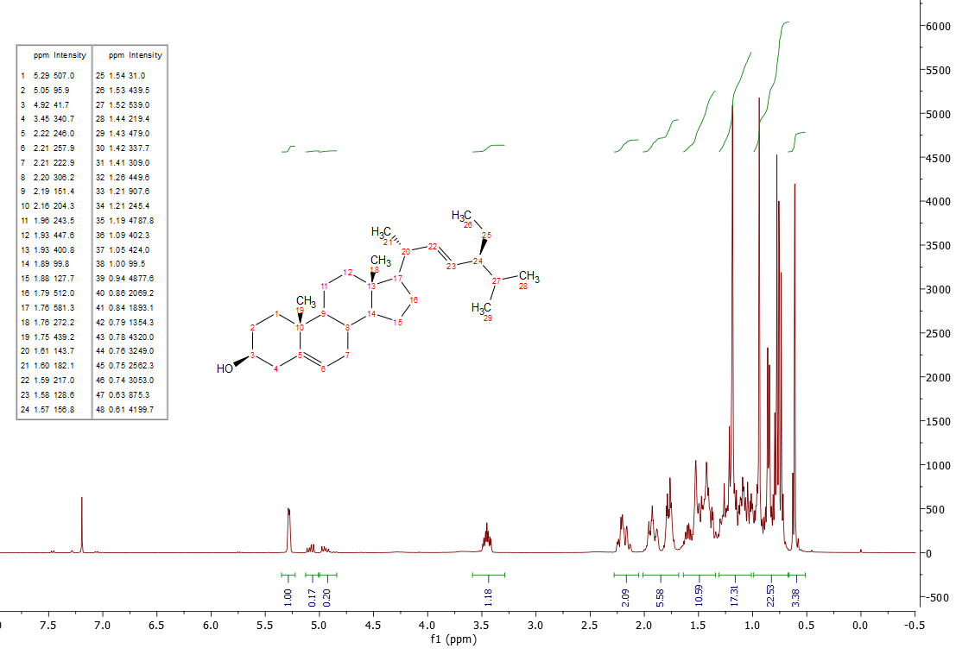

Appendix 4: ¹³C NMR spectrum of 3β-Stigmasterol (1) in CDCl₃

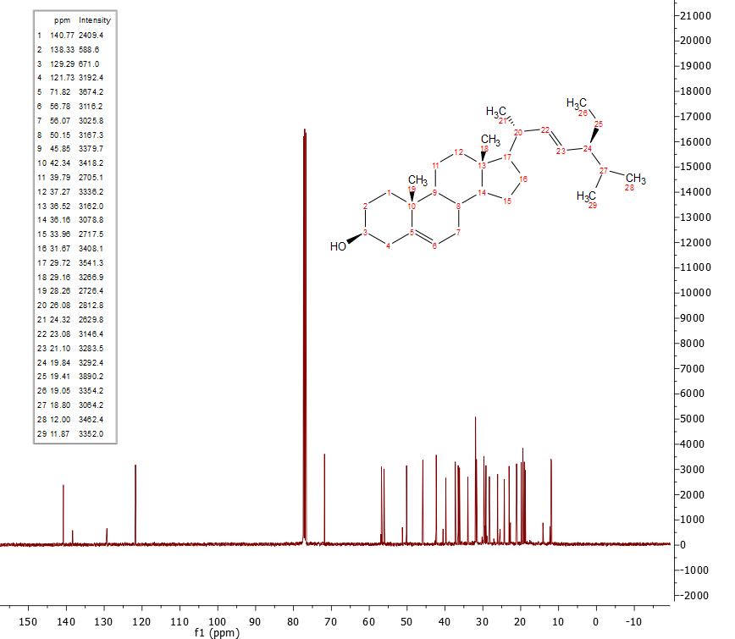

Appendix 5: DEPT spectrum of 3β-Stigmasterol (1)

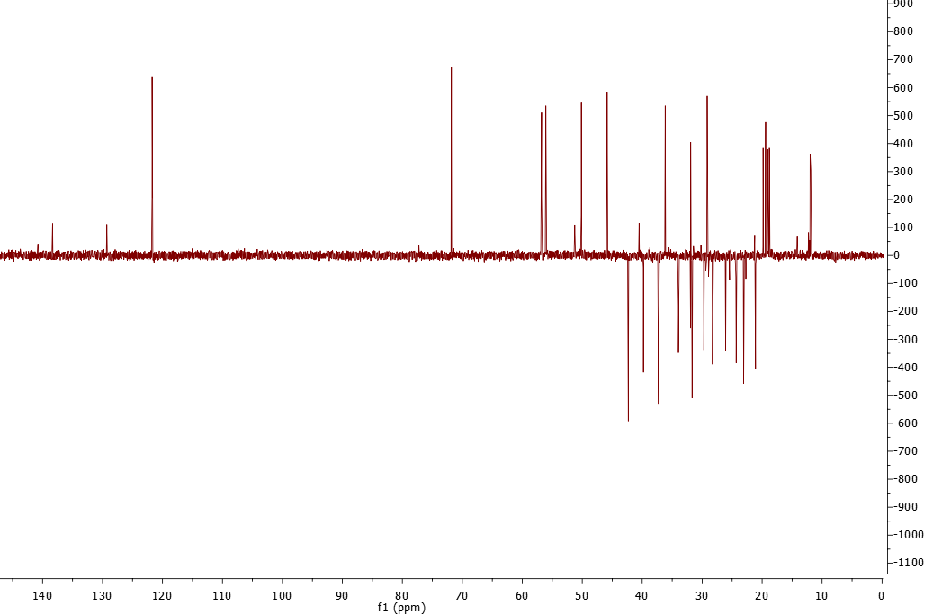

Appendix 6: HSQC spectrum of 3β-Stigmasterol (1)

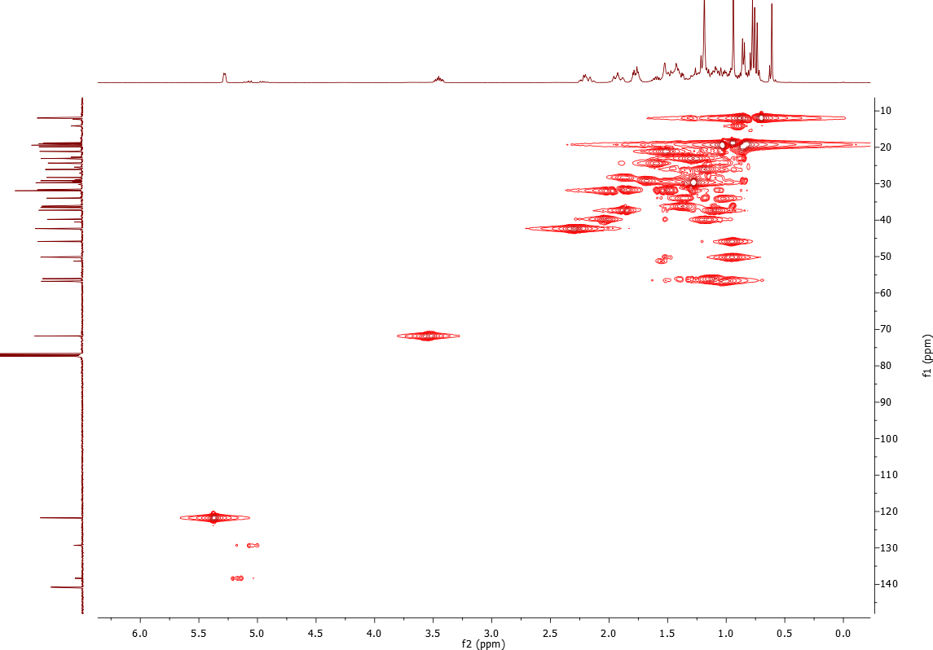

Appendix 7: HMBC spectrum of 3β-Stigmasterol (1)

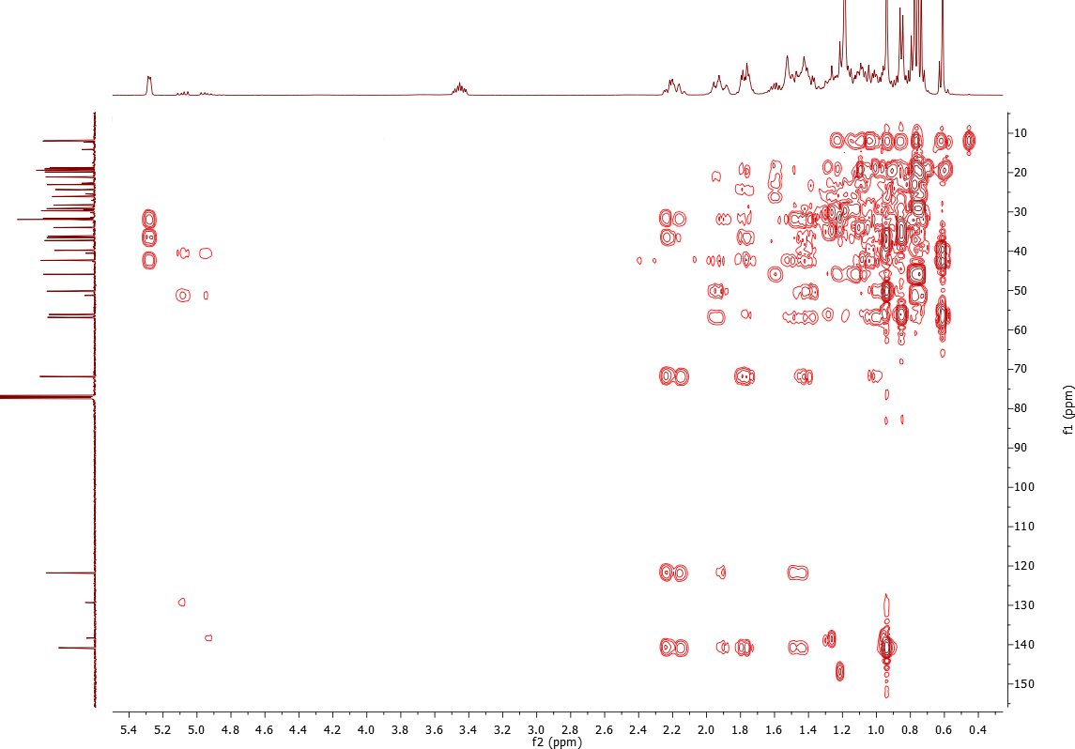

Appendix 8: COSY spectrum of 3β-Stigmasterol (1)

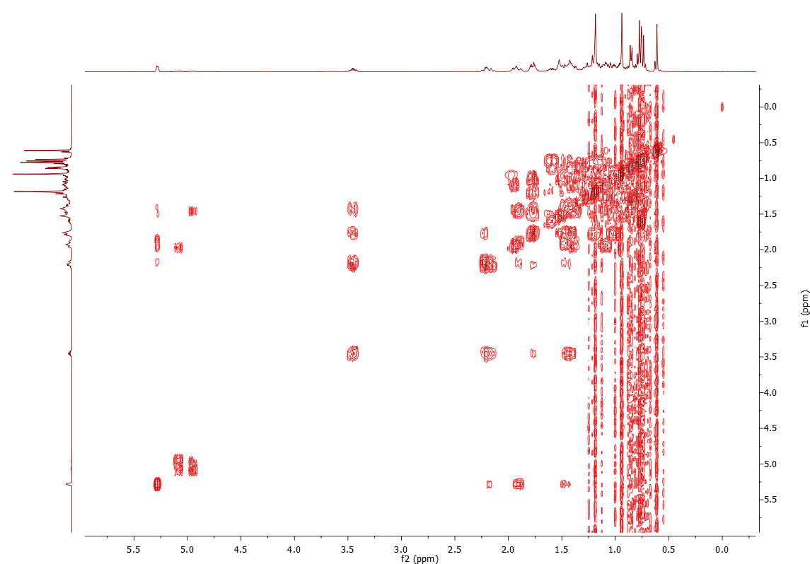

Appendix 9: NOESY spectrum of 3β-Stigmasterol (1)

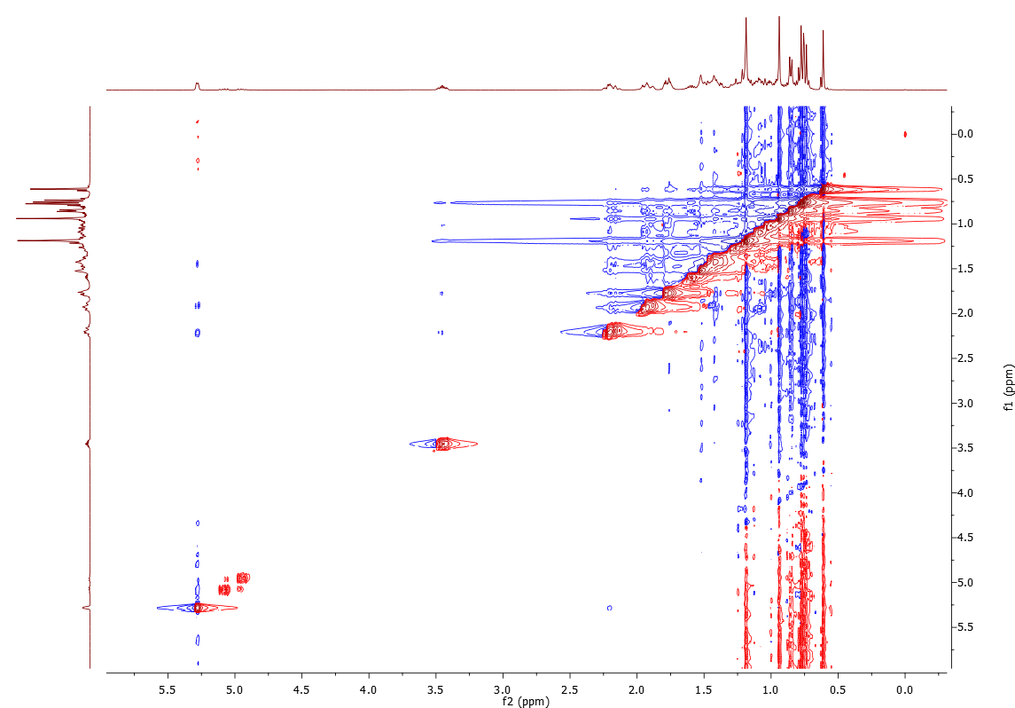

Appendix 10: IR spectrum of Stigmasterol acetate (2)

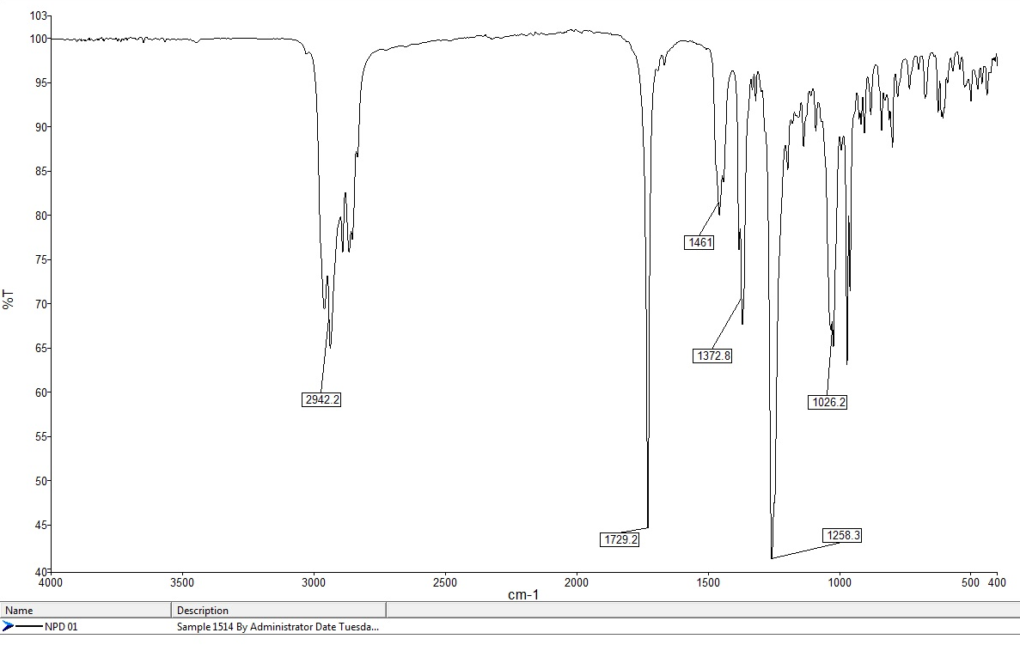

Appendix 11: MS spectrum of Stigmasterol acetate (2)

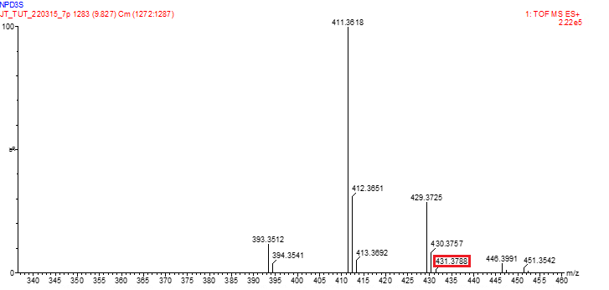

Appendix 12: ¹H NMR spectrum of Stigmasterol acetate (2) in CDCl₃

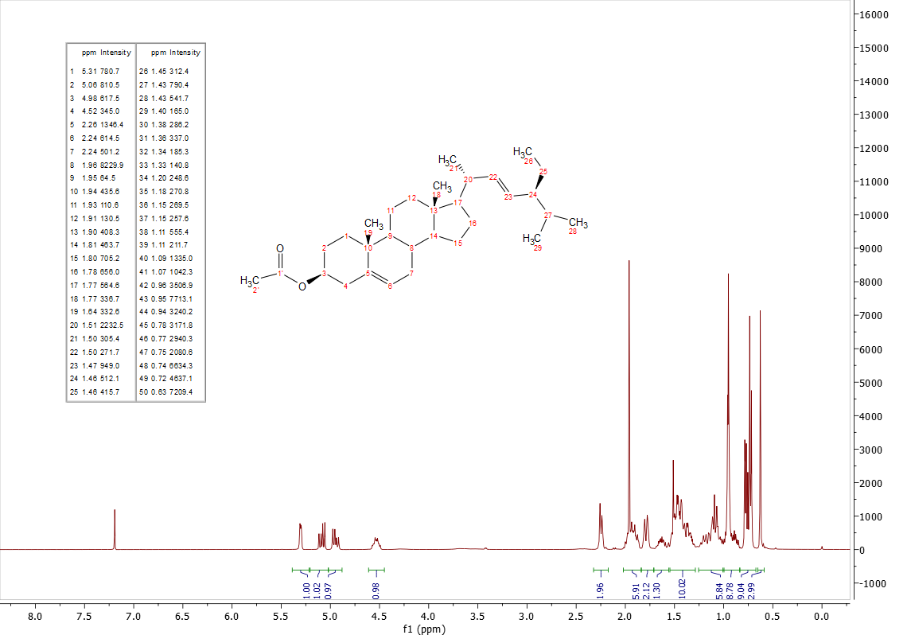

Appendix 13: ¹³C NMR spectrum of Stigmasterol acetate (2) in CDCl₃

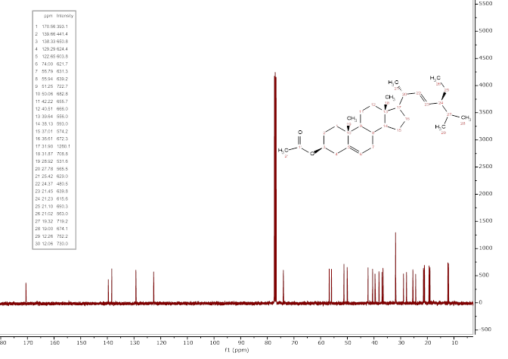

Appendix 14: IR spectrum of Stigmasta-5,22-dien-3,7-dione (3)

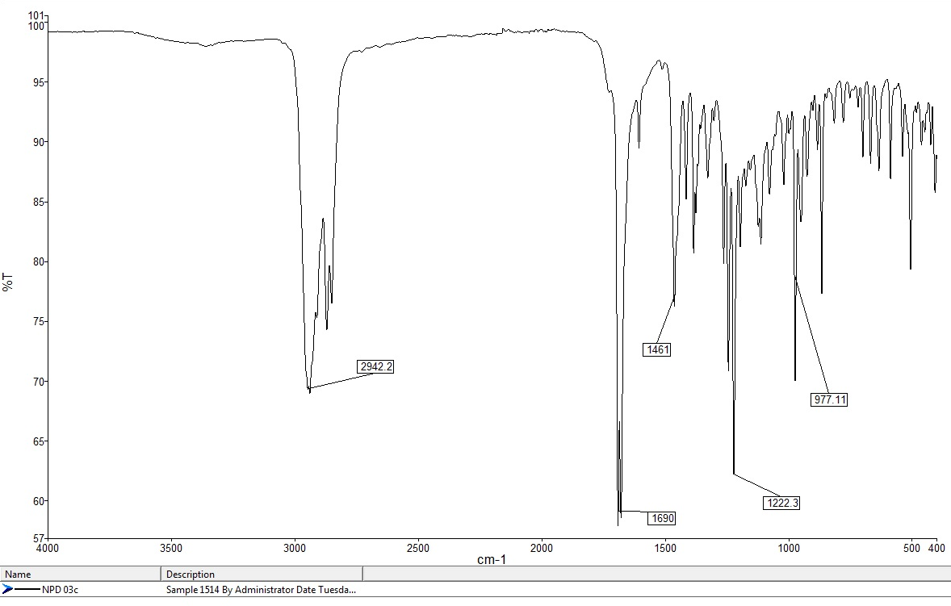

Appendix 15: MS spectrum of Stigmasta-5,22-dien-3,7-dione (3)

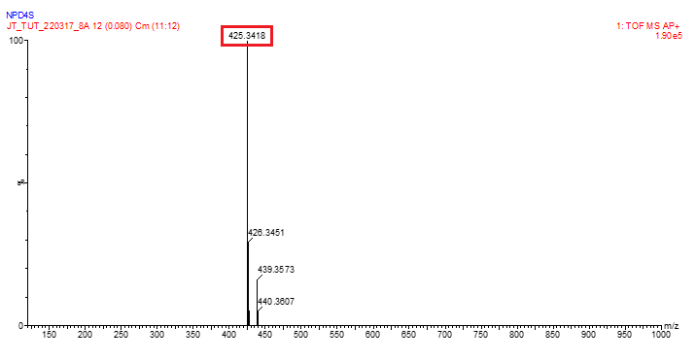

Appendix 16: ¹H NMR spectrum of Stigmasta-5,22-dien-3,7-dione (3) in CDCl₃
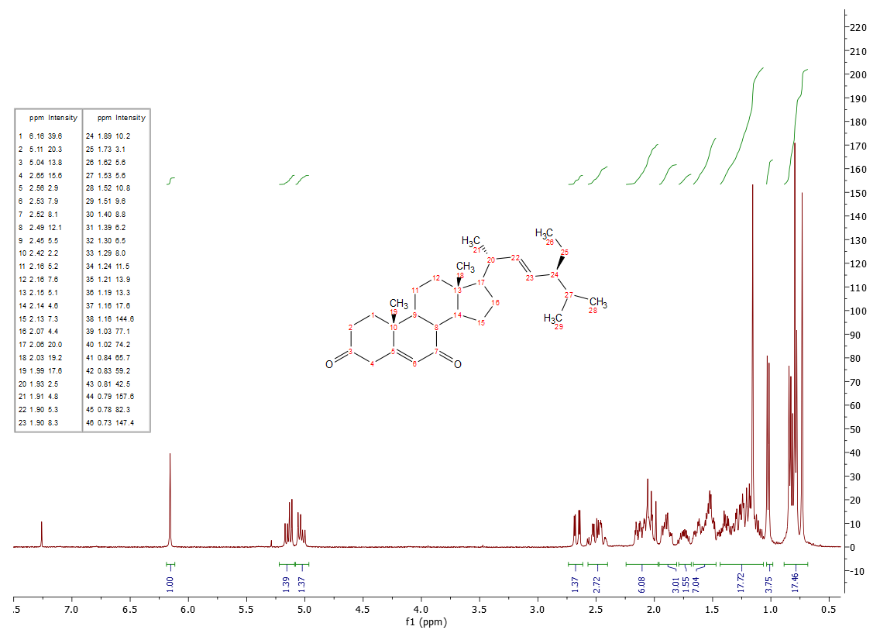

Appendix 17: ¹³C NMR spectrum of Stigmasta-5,22-dien-3,7-dione (3) in CDCl₃

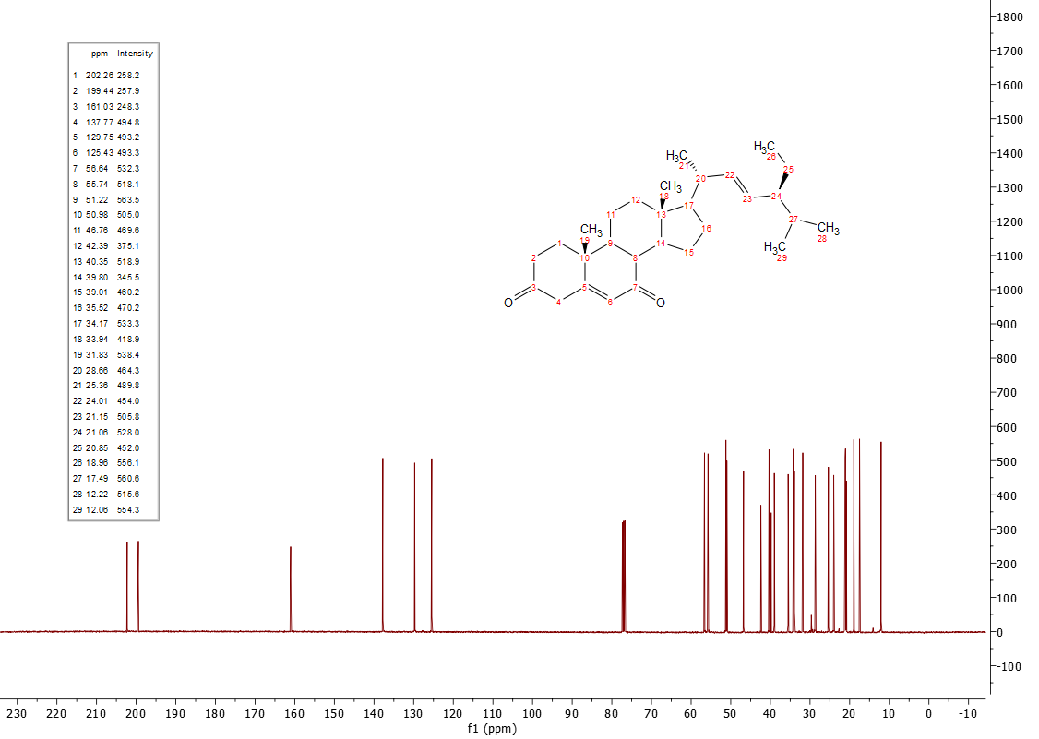

Appendix 18: DEPT spectrum of Stigmasta-5,22-dien-3,7-dione (3)

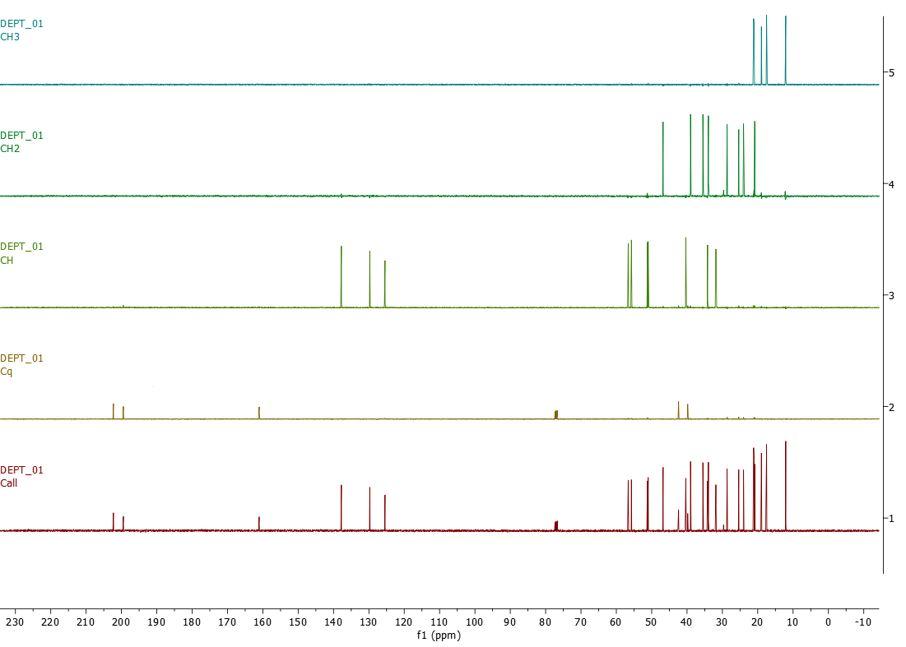

Appendix 19: HSQC spectrum of Stigmasta-5,22-dien-3,7-dione (3)

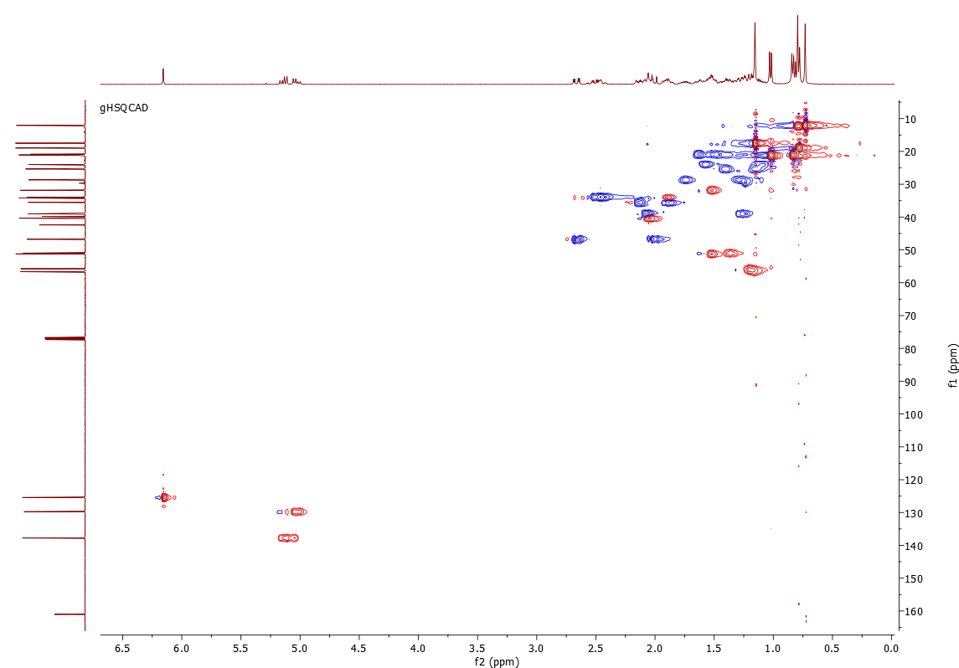

Appendix 20: HMBC spectrum of Stigmasta-5,22-dien-3,7-dione (3)

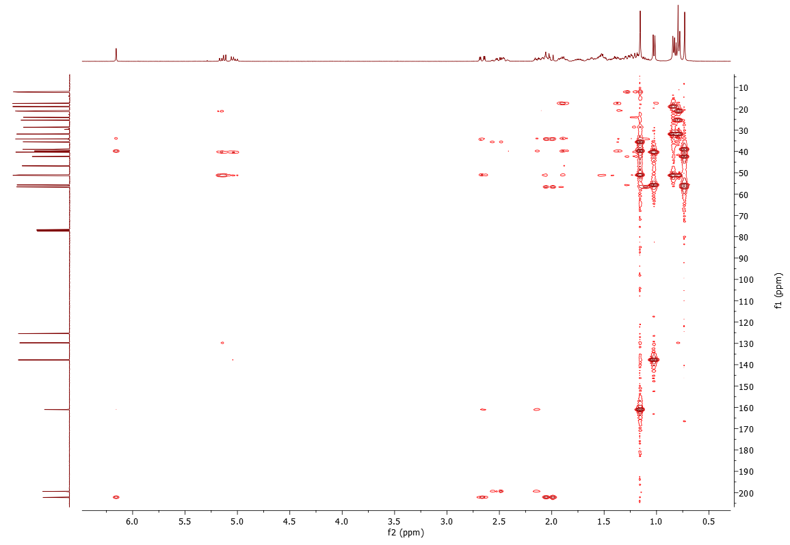

Appendix 21: COSY spectrum of Stigmasta-5,22-dien-3,7-dione (3)

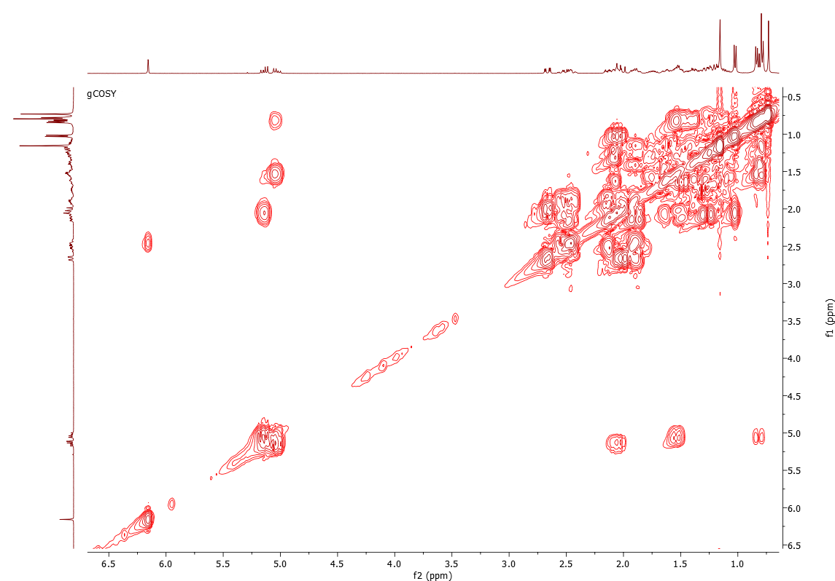

Appendix 22: IR spectrum of 5,6-Epoxystigmast-22-en-3β-ol (4)

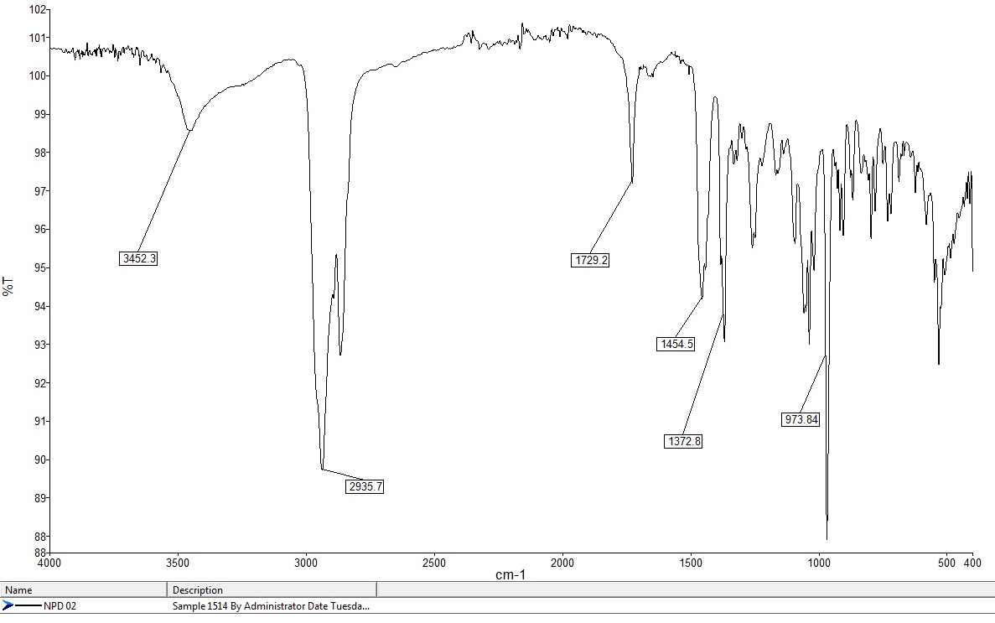

Appendix 23: MS spectrum of 5,6-Epoxystigmast-22-en-3β-ol (4)

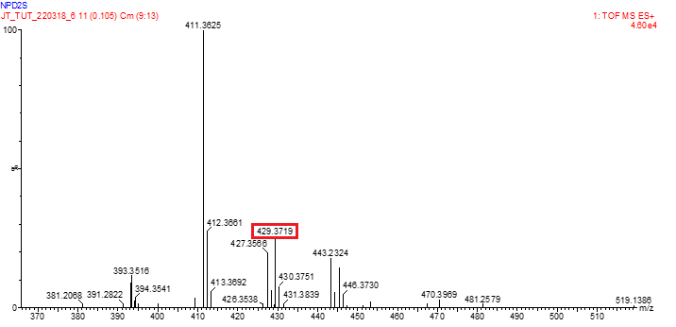

Appendix 24: ¹H NMR spectrum of 5,6-Epoxystigmast-22-en-3β-ol (4) in CDCl₃

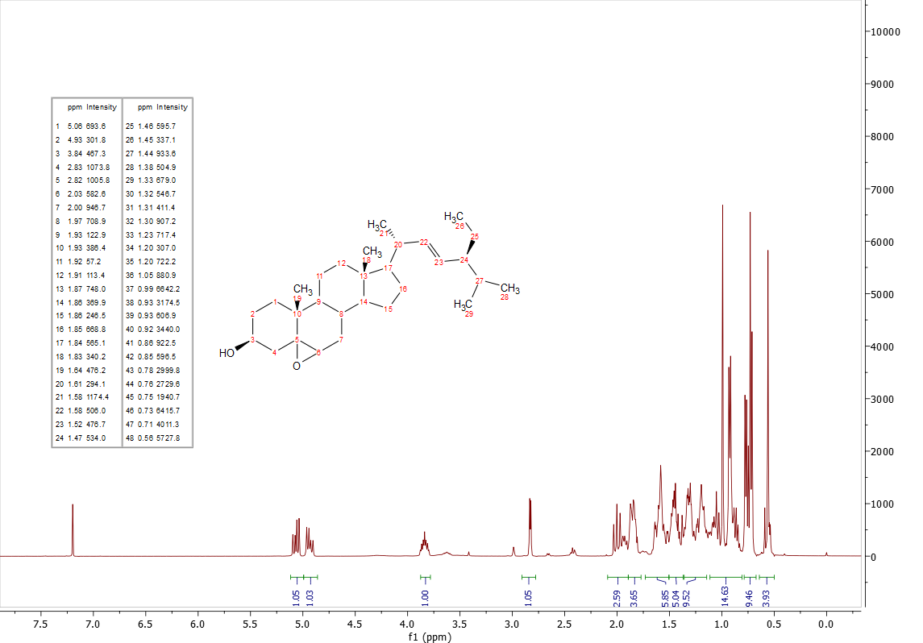

Appendix 25: ¹³C NMR spectrum of 5,6-Epoxystigmast-22-en-3β-ol (4) in CDCl₃

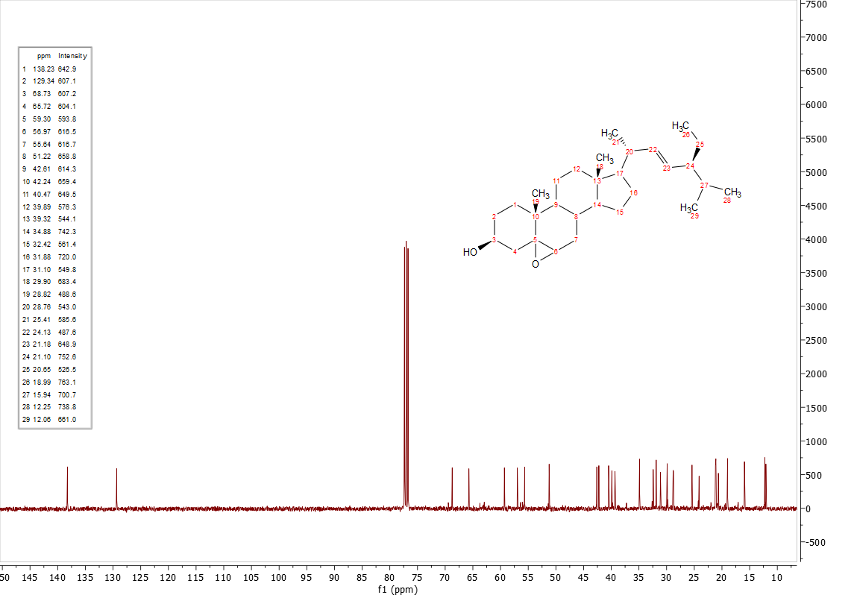

Appendix 26: IR spectrum of 5,6-Epoxystigmasta-3β,22,23-triol (5)

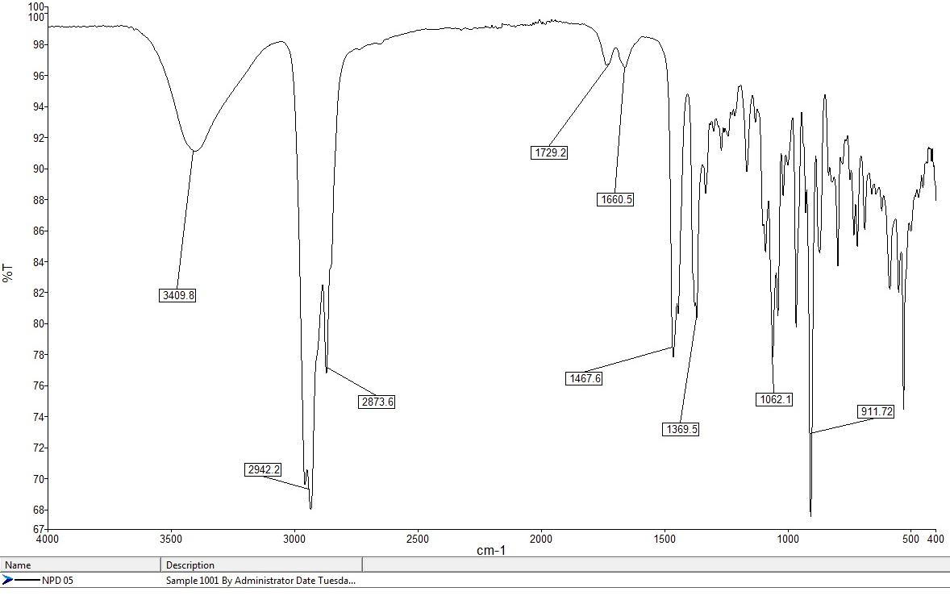

Appendix 27: MS spectrum of 5,6-Epoxystigmasta-3β,22,23-triol (5)

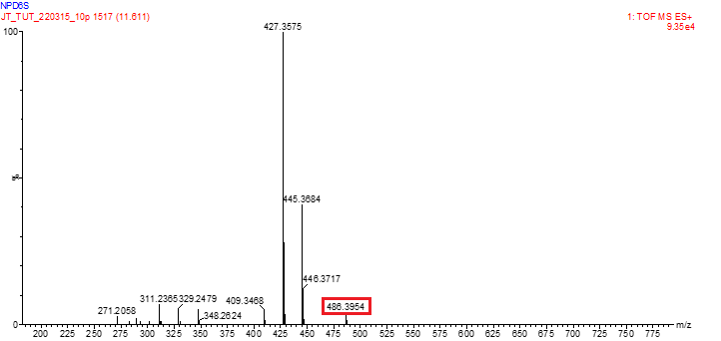

Appendix 28: ¹H NMR spectrum of 5,6-Epoxystigmasta-3β,22,23-triol (5) in CDCl₃

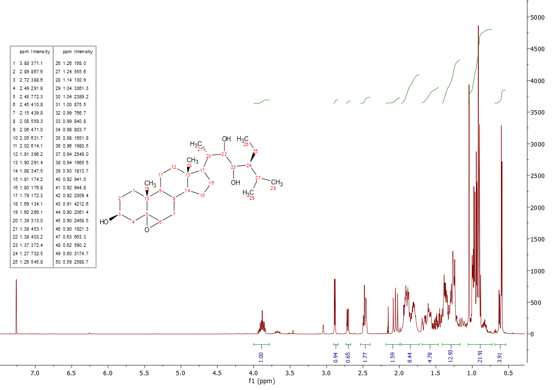

Appendix 29: ¹³C NMR spectrum of 5,6-Epoxystigmasta-3β,22,23-triol (5) in CDCl₃

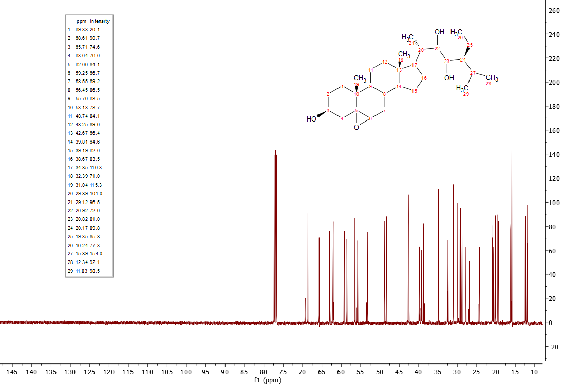

Appendix 30: HSQC spectrum of 5,6-Epoxystigmasta-3β,22,23-triol (5)

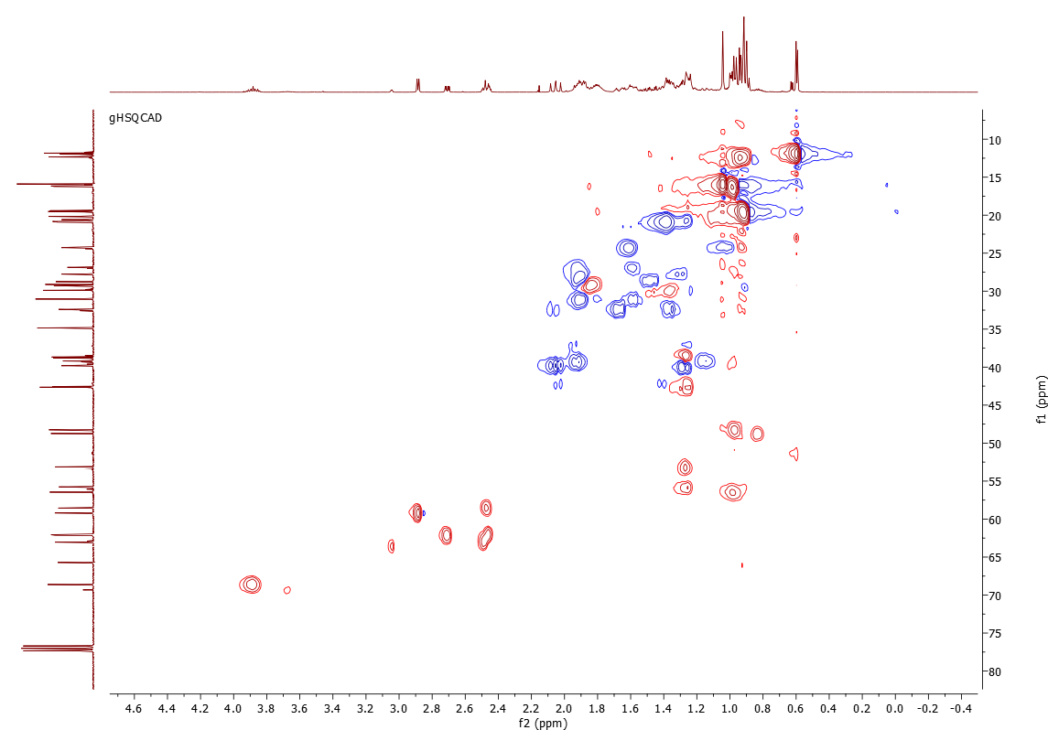

Appendix 31: HMBC spectrum of 5,6-Epoxystigmasta-3β,22,23-triol (5)

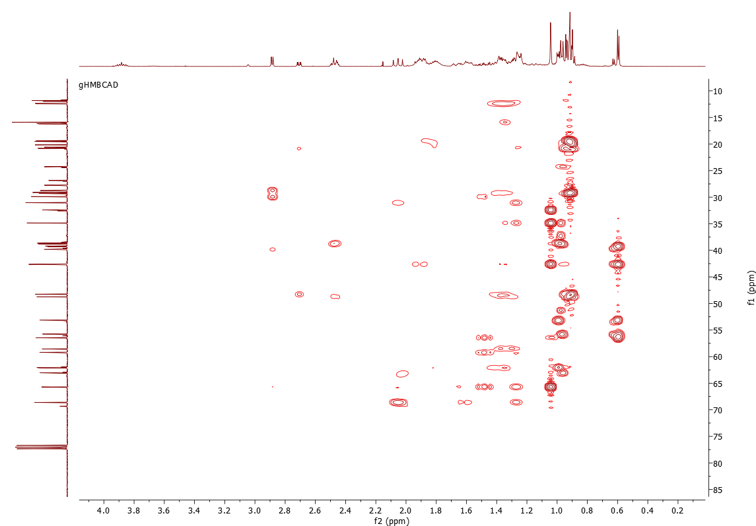

Appendix 32: IR spectrum of Stigmastane pentaol (6)

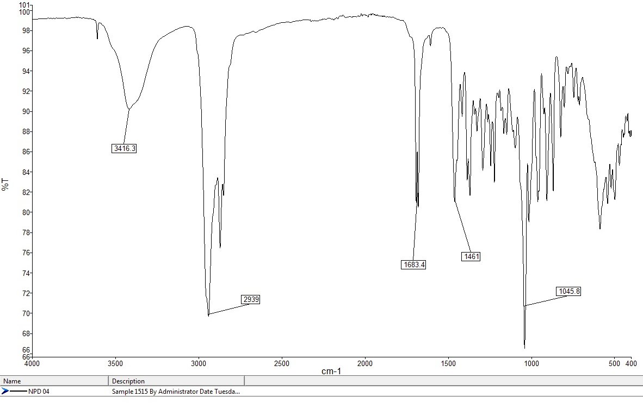

Appendix 33: MS spectrum of Stigmastane pentaol (6)

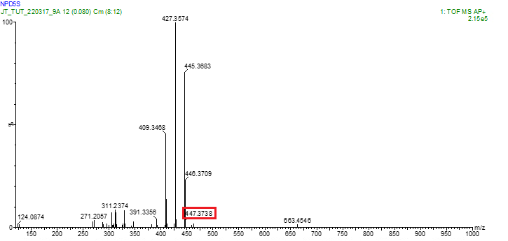

Appendix 34: ¹H NMR spectrum of Stigmastane pentaol (6) in CDCl₃
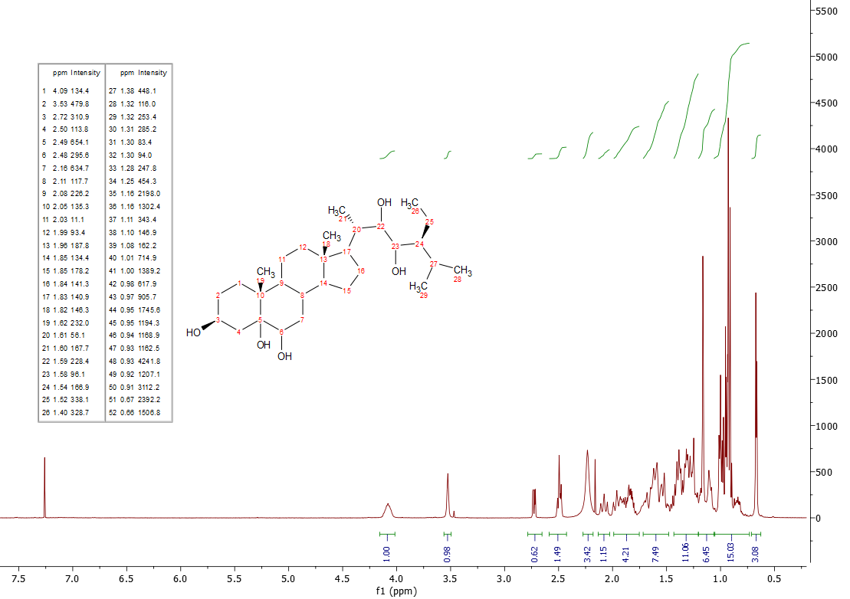

Appendix 35: ¹³C NMR spectrum of Stigmastane pentaol (6) in CDCl₃

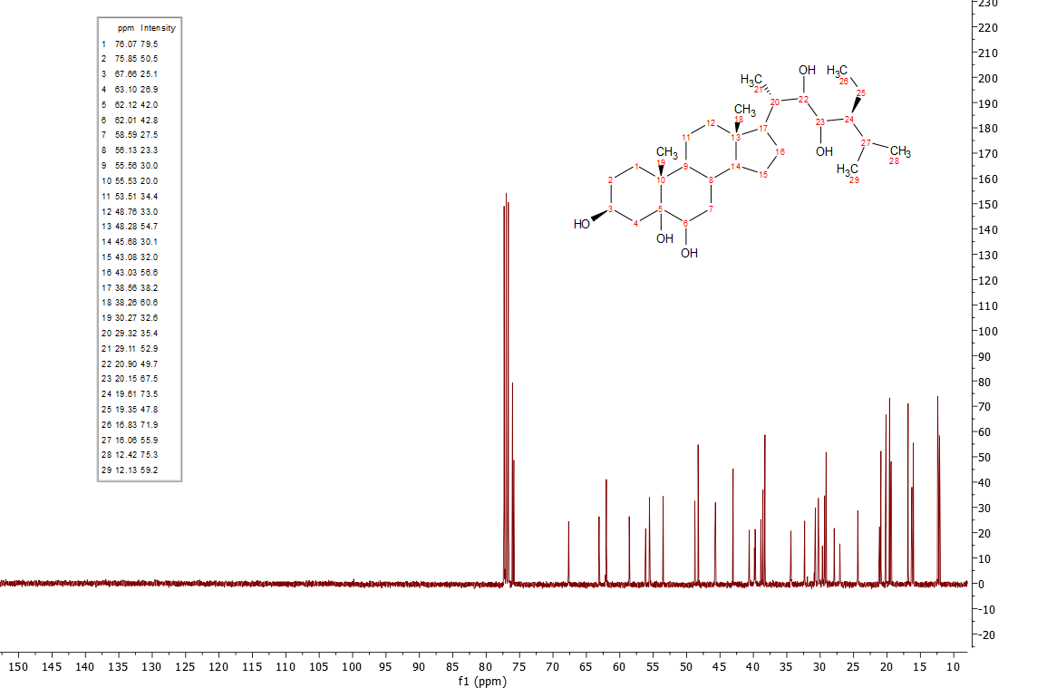

Appendix 36: HSQC spectrum of Stigmastane pentaol (6)

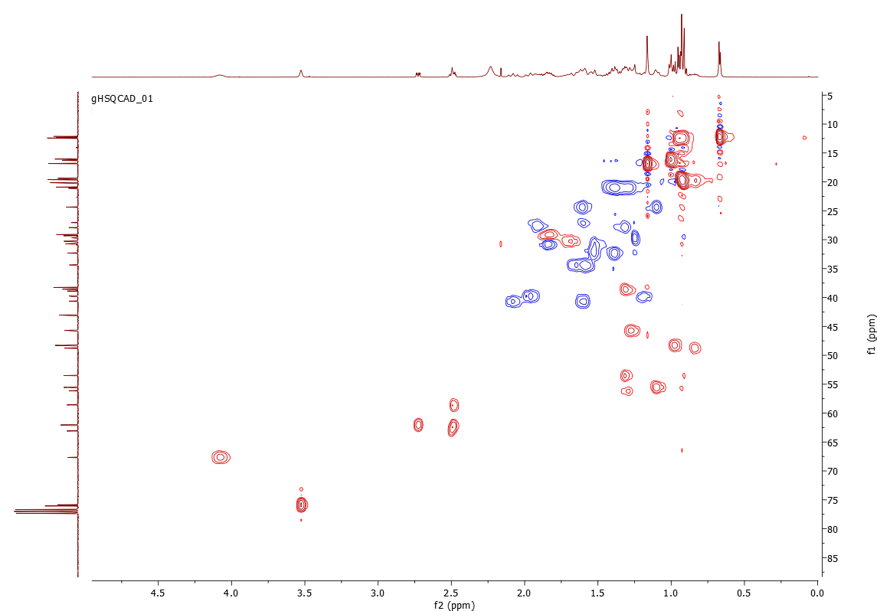

Appendix 37: HMBC spectrum of Stigmastane pentaol (6)

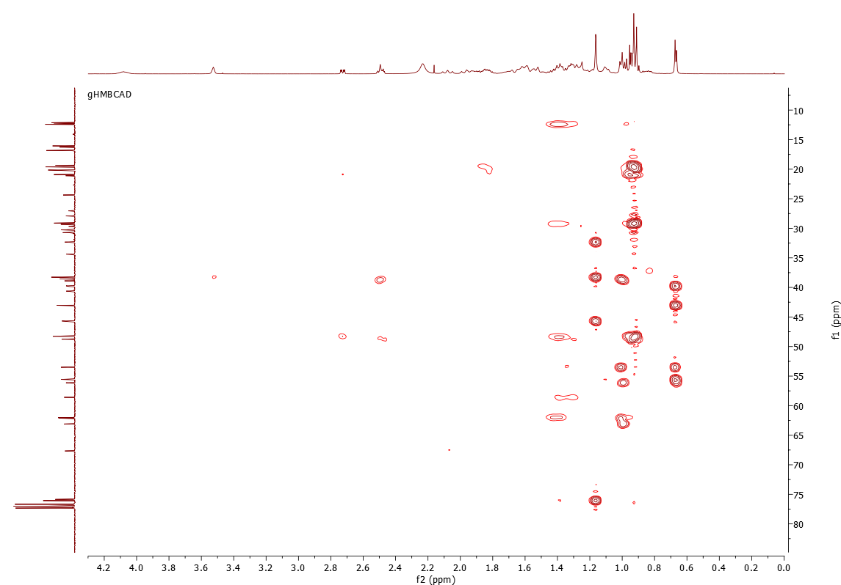

Appendix 38: IR spectrum of Stigmasta-5-en-3,7-dion-22,23-diol (7)

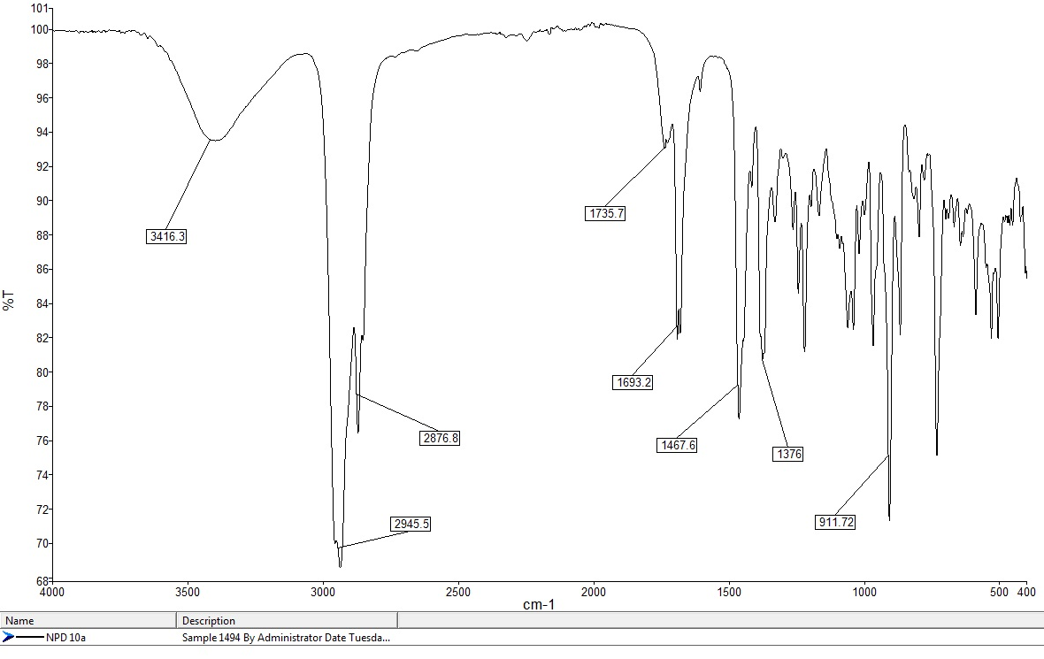

Appendix 39: MS spectrum of Stigmasta-5-en-3,7-dion-22,23-diol (7)

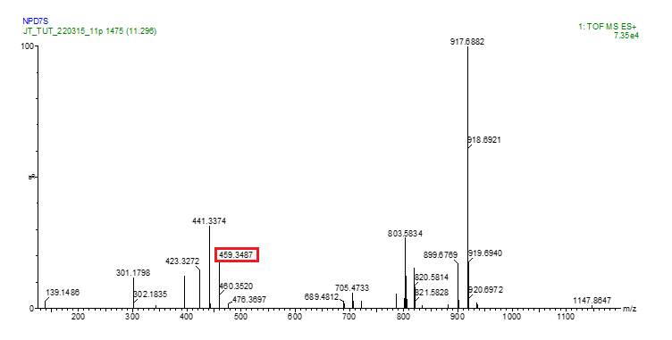

Appendix 40: ¹H NMR spectrum of Stigmasta-5-en-3,7-dion-22,23-diol (7) in CDCl₃

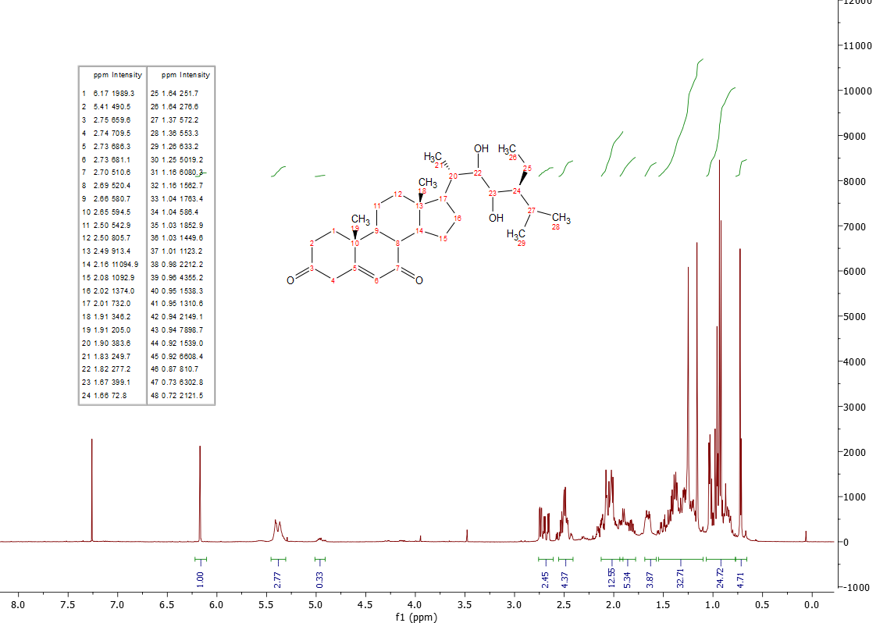

Appendix 41: ¹³C NMR spectrum of Stigmasta-5-en-3,7-dion-22,23-diol (7) in CDCl₃

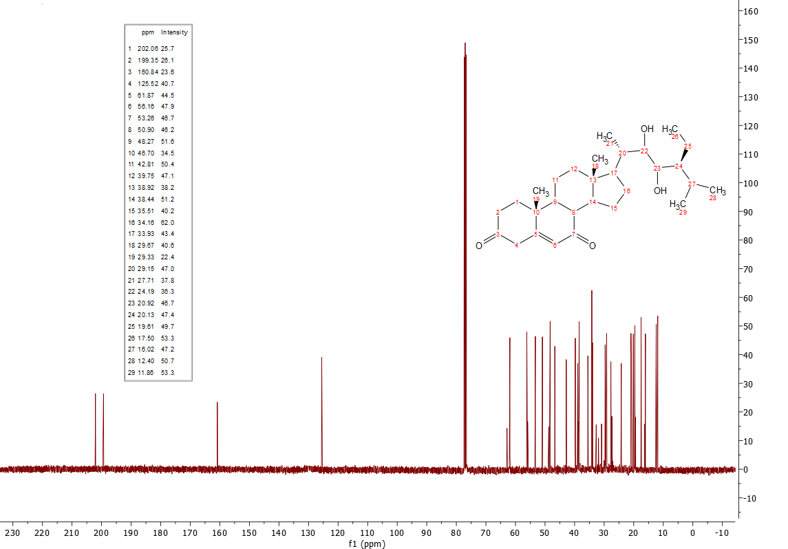

Appendix 42: DEPT spectrum of Stigmasta-5-en-3,7-dion-22,23-diol (7)

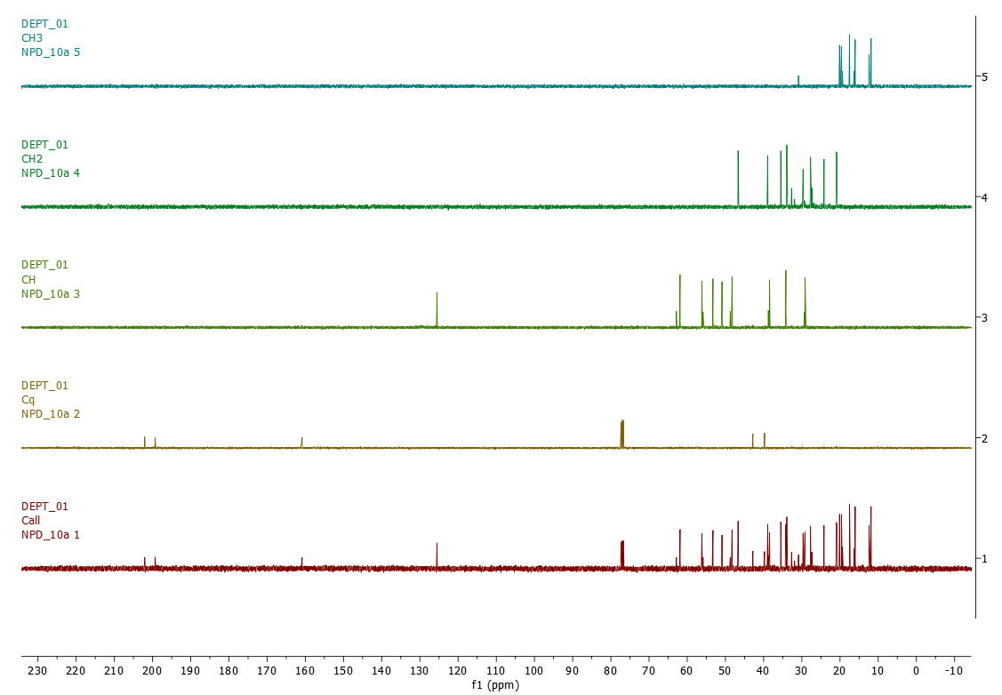

Appendix 43: HSQC spectrum of Stigmasta-5-en-3,7-dion-22,23-diol (7)

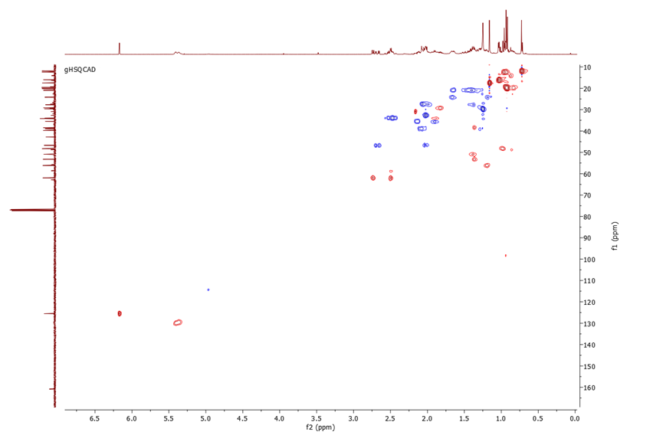

Appendix 44: HMBC spectrum of Stigmasta-5-en-3,7-dion-22,23-diol (7)

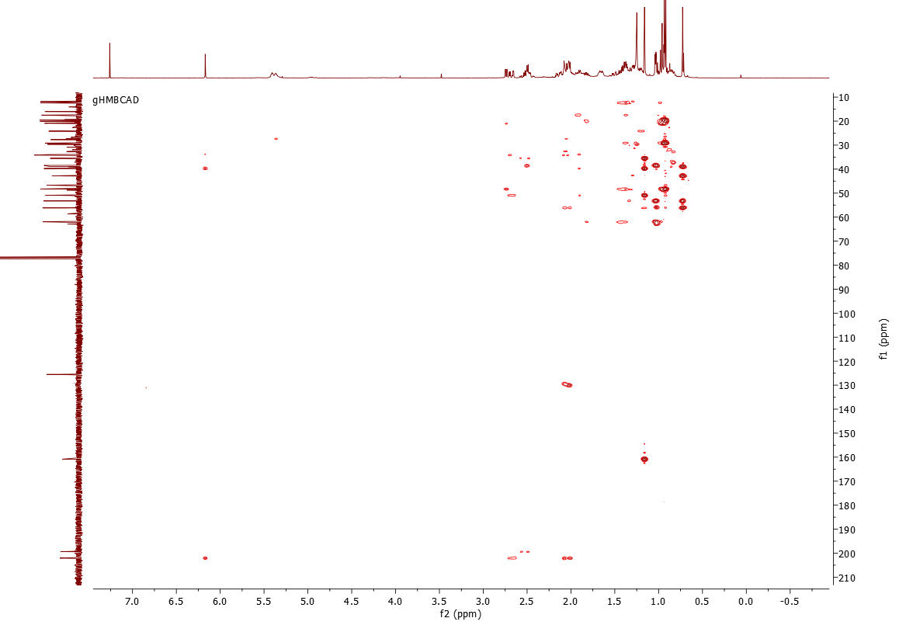

Appendix 45: IR spectrum of Stigmasta-3,7-dion-5,6,22,23-ol (8)

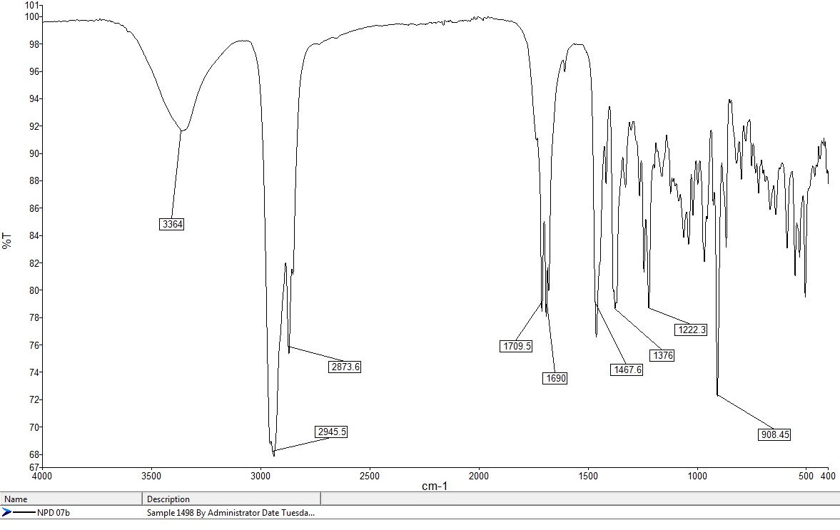

Appendix 46: MS spectrum of Stigmasta-3,7-dion-5,6,22,23-ol (8)
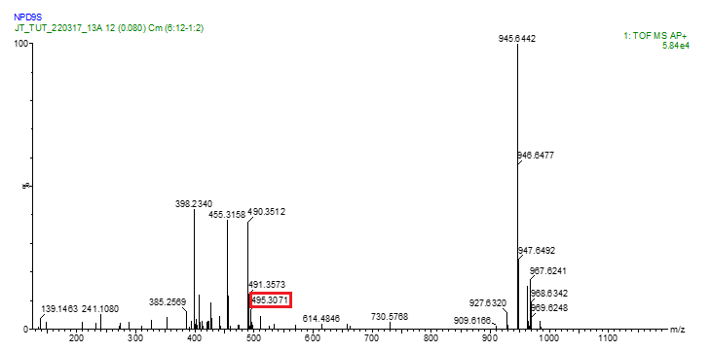

Appendix 47: ¹H NMR spectrum of Stigmasta-3,7-dion-5,6,22,23-ol (8) in CDCl₃

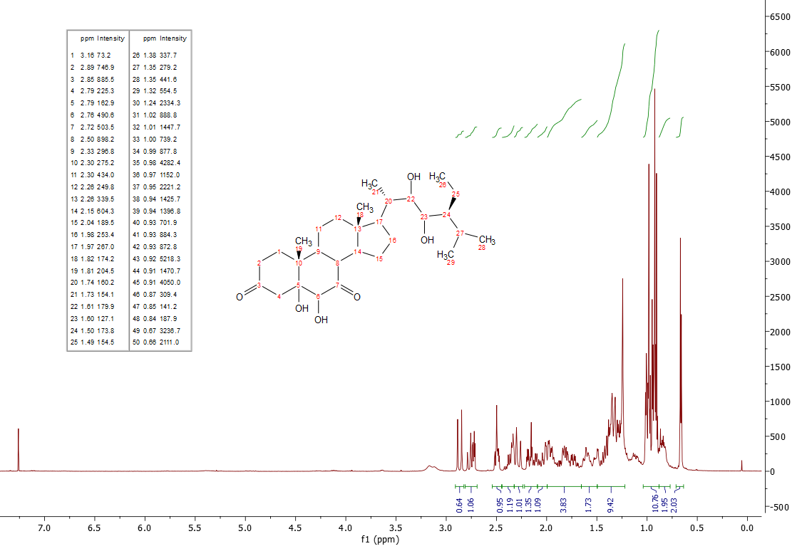

Appendix 48: ¹³C NMR spectrum of Stigmasta-3,7-dion-5,6,22,23-ol (8) in CDCl₃

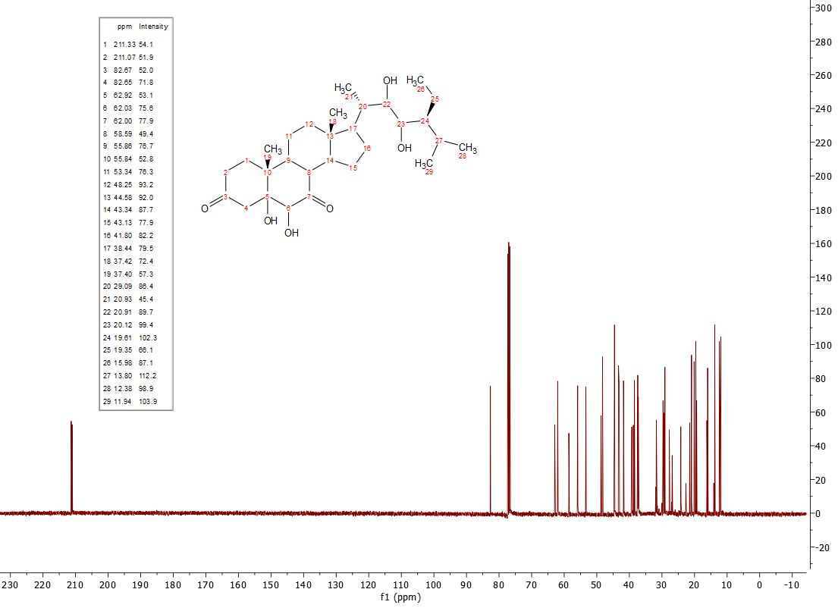

Appendix 49: HSQC spectrum of Stigmasta-3,7-dion-5,6,22,23-ol (8)

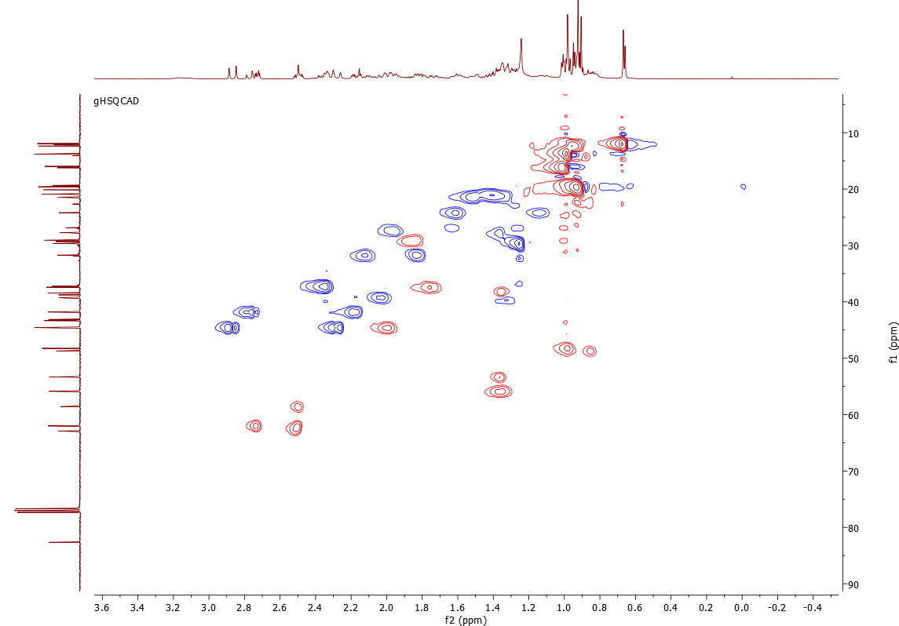

Appendix 50: HMBC spectrum of Stigmasta-3,7-dion-5,6,22,23-ol (8)

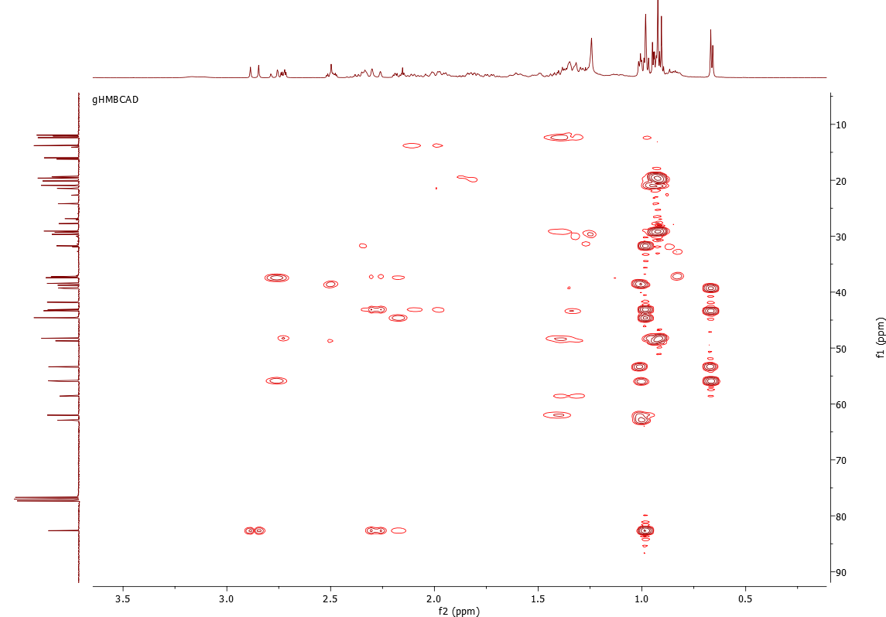

Appendix 51: IR spectrum of Stigmast-5-ene-3β,22,23-triol (9)

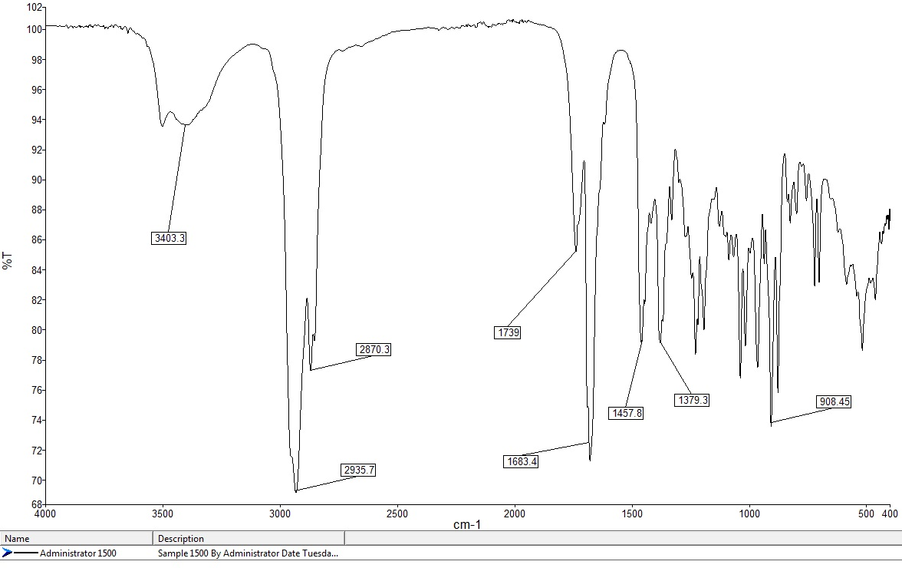

Appendix 52: MS spectrum of Stigmast-5-ene-3β,22,23-triol (9)

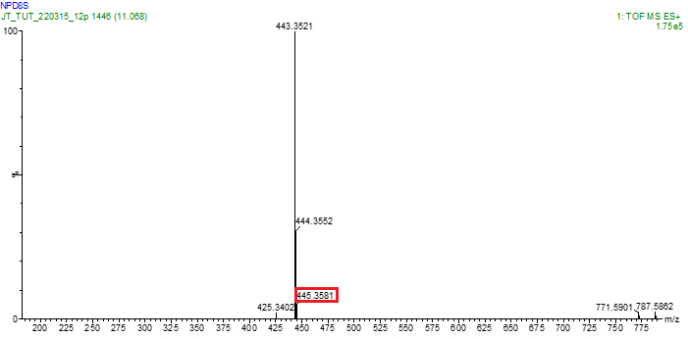

Appendix 53: ¹H NMR spectrum of Stigmast-5-ene-3β,22,23-triol (9) in CDCl₃

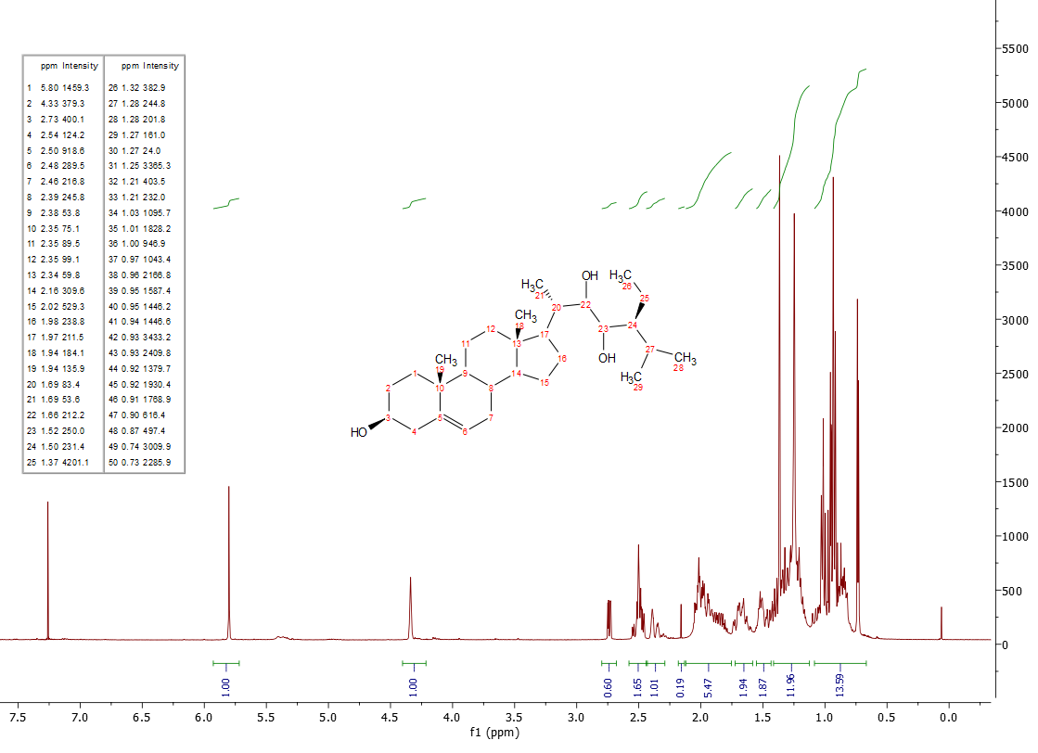

Appendix 54: ¹³C NMR spectrum of Stigmast-5-ene-3β,22,23-triol (9) in CDCl₃

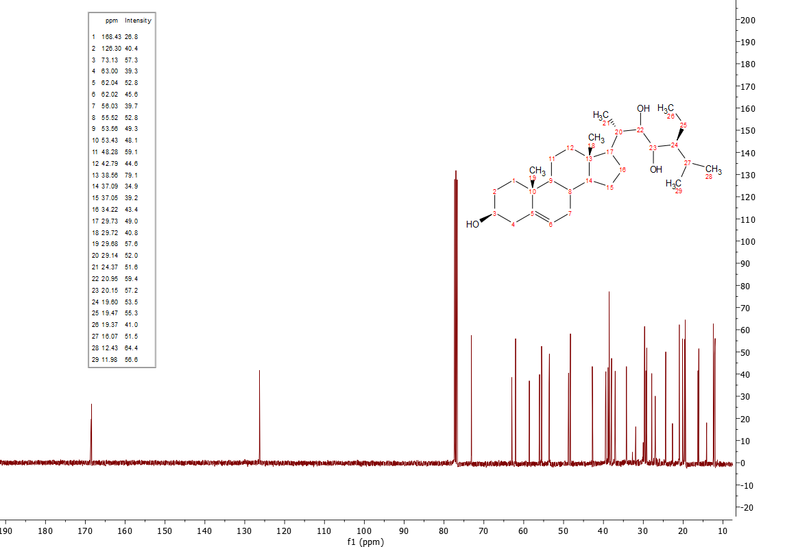

Appendix 55: DEPT spectrum of Stigmast-5-ene-3β,22,23-triol (9)

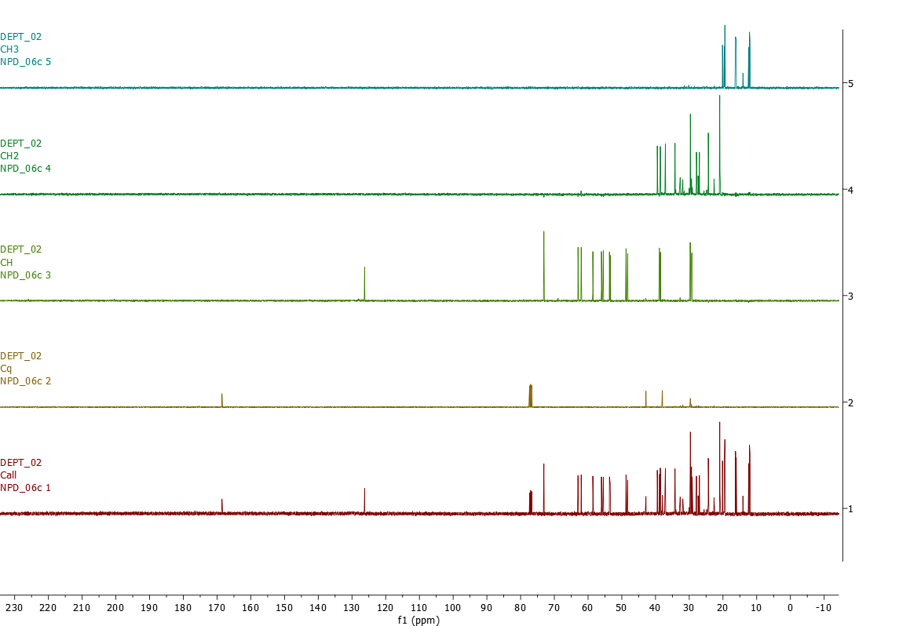

Appendix 56: HSQC spectrum of Stigmast-5-ene-3β,22,23-triol (9)

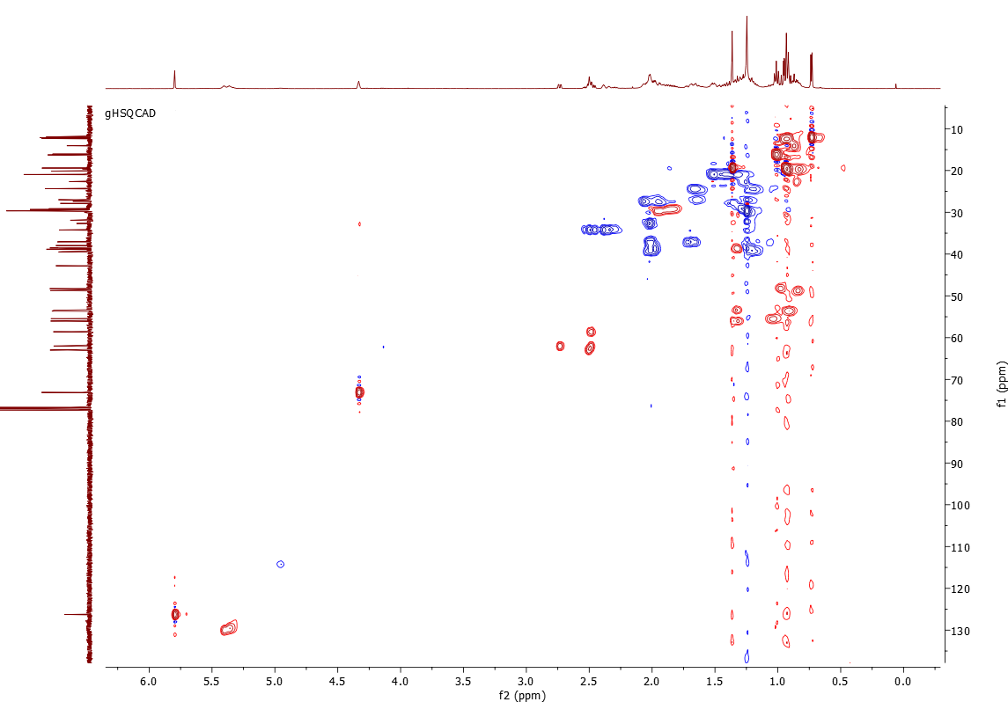

Appendix 57: HMBC spectrum of Stigmast-5-ene-3β,22,23-triol (9)

