Characterization of the belowground microbial community in a poplar-assisted bioremediation strategy applied for restoring a multi-contaminated soil
Anna Barra Caracciolo¹, Paola Grenni¹, Gian Luigi Garbini¹, Ludovica Rolando^{1,4}, Claudia Campanale², Giorgia Aimola², Manuel Fernandez-Lopez³, Antonio José Fernandez-Gonzalez³, Pablo José Villadas³, Valeria Ancona²
¹ National Research Council, Water Research Institute, Montelibretti (Rome), Italy
² National Research Council, Water Research Institute, Bari, Italy
³ Consejo Superior de Investigaciones Científicas (CSIC) Zaidin Experimental Station, Granada, Spain
⁴ Department of Ecological and Biological science (DEB-Tuscia University), Viterbo, Italy

Table S1. PCB congeners (average values expressed as ng/g ± standard deviation) detected in unplanted (Control) and planted plots (Bulk soil and Rhizosphere) before the poplar plantation (t=0) and at 55 months (t=55 months).
 |  | PCB markers (ng/g) |  |  |  |  |  | PCB dioxin like (ng/g) |  | TOTAL  (ng/g)
 |  | 28 | 52 | 101 | 153 | 138 | 180 | 105 | 118 | TOTAL  (ng/g)
UN-PLANTED PLOT | Control Soil t=0 | 7.65±2.26 | 33.21±9.05 | 92.41±31.32 | 405.76±182.45 | 273.59±103.60 | 458.20±203.22 | 45.51±4.79 | 85.53±14.11 | 1401.85±550.81
UN-PLANTED PLOT | Control Soil t=55 months | 19.87±28.16 | 29.56±24.34 | 101.06±71.12 | 378.40±249.50 | 305.05±193.70 | 406.51±255.55 | 45.62±35.90 | 108.24±75.83 | 1394.31±934.09
PLANTED PLOT | Bulk soil t=0 | 7.25±0.07 | 11.90±0.42 | 10.35±0.77 | 59.75±1.76 | 73.25±3.18 | 42.15±0.77 | 15.55±1.34 | 25.75±0.35 | 245.95±8.69
PLANTED PLOT | Rhizosphere t=55 months | 0.76±0.37 | 1.60±0.62 | 0.56±0.44 | 5.47±1.42 | 9.86±3.35 | 10.26±3.07 | 0.59±0.46 | 1.26±0.32 | 30.37±10.03
PLANTED PLOT | Bulk Soil t=55 months | 0.48±0.04 | 1.47±0.57 | 1.31±0.33 | 5.15±0.47 | 8.80±0.75 | 8.52±0.70 | 1.18±0.21 | 1.81±0.52 | 28.72±3.59
Table S2. Heavy metals (average values expressed as mg/kg ± standard deviation) detected in unplanted (Control) and planted plots (Bulk soil and Rhizosphere) before the poplar plantation (t=0) and at 55 months (t=55 months). The Italian legal limits in mg/kg (Decree 152/06) are in brackets; the values higher than the legal limits are in red.
 |  | Heavy metals (part A) expressed in mg/kg
 |  | Be  (2) | Se  (3) | Cd  (2) | Tl  (1) | Sn  (1) | Sb  (10) | Co  (20) | As  (20)
UN-PLANTED PLOT | Control Soil t=0 | 3.80±0.00 | 15.30±3.50 | 1.50±0.00 | 0.80±0.00 | 24.80±2.80 | 8.90±0.00 | 17.8±1.40 | 45.10±5.00
UN-PLANTED PLOT | Control Soil t=55 months | 0.97±0.09 | 1.40±0.11 | 0.91±0.32 | 0.37±0.05 | 12.83±3.53 | 8.13±5.98 | 9.92±0.64 | 32.07±14.47
PLANTED PLOT | Topsoil t=0 | 1.90±0.20 | 10.40±2.10 | 0.50±0.00 | 0.70±0.20 | 5.90±2.10 | 4.70±0.10 | 19.40±2.10 | 17.60±3.20
PLANTED PLOT | Rhizosphere t=55 months | 0.92±0.04 | 1.37±0.15 | 0.18±0.01 | 0.26±0.01 | 1.77±0.26 | 0.47±0.14 | 11.98±0.77 | 5.05±0.77
PLANTED PLOT | Bulk Soil t=55 months | 0.89±0.03 | 1.33±0.12 | 0.17±0.02 | 0.24±0.01 | 2.61±1.15 | 0.54±0.10 | 34.26±8.97 | 5.03±0.44

 |  | Heavy metals (part B) expressed in mg/kg
 |  | V  (90) | Ni  (120) | Cu  (120) | Cr  (150) | Zn  (150) | Pb  (100)
UN-PLANTED PLOT | Control Soil t=0 | 123.8±9.90 | 89.10±4.30 | 156.40±11.40 | 132.70±15.60 | 767.30±35.90 | 276.30±26.90
UN-PLANTED PLOT | Control Soil t=55 months | 67.16±9.45 | 68.33±3.44 | 158.93±79.06 | 73.74±7.25 | 549.73±193.70 | 159.30±67.51
PLANTED PLOT | Topsoil t=0 | 127.40±17.90 | 156.20±19.30 | 47.70±4.20 | 179.5±20.70 | 181.30±17.50 | 74.5±7.7
PLANTED PLOT | Rhizosphere t=55 months | 66.20±2.92 | 115.62±10.56 | 18.51±0.87 | 120.28±12.48 | 77.01±3.44 | 19.39±4.60
PLANTED PLOT | Bulk Soil t=55 months | 65.07±1.48 | 112.38±7.97 | 18.51±0.71 | 117.19±7.01 | 74.74±7.18 | 21.77±5.86

Table S3. Kruskal-Wallis test paired for alpha indices (Chao1 index, Shannon Index, Evenness)
Chao1 Index
Group 1 | Group 2 | H | p-value | q-value
Control | Rhizosphere DNA | 3.682 | 0.055 | 0.128
Control | Bulk Soil DNA | 6.545 | 0.010 | 0.074
Bulk Soil DNA | Rhizosphere DNA | 0.102 | 0.749 | 0.873
Bulk Soil RNA | Rhizosphere RNA | 3.102 | 0.078 | 0.164
Shannon Index
Group 1 | Group 2 | H | p-value | q-value
Control | Rhizosphere DNA | 6.545 | 0.010 | 0.037
Control | Bulk Soil DNA | 6.545 | 0.010 | 0.037
Bulk Soil DNA | Rhizosphere DNA | 3.102 | 0.078 | 0.037
Bulk Soil RNA | Rhizosphere RNA | 6.564 | 0.010 | 0.037
Evenness
Group 1 | Group 2 | H | p-value | q-value
Control | Rhizosphere DNA | 6.545 | 0.010 | 0.037
Control | Bulk Soil DNA | 6.545 | 0.010 | 0.037
Bulk Soil DNA | Rhizosphere DNA | 4.333 | 0.037 | 0.063
Bulk Soil RNA | Rhizosphere RNA | 7.41 | 0.006 | 0.037

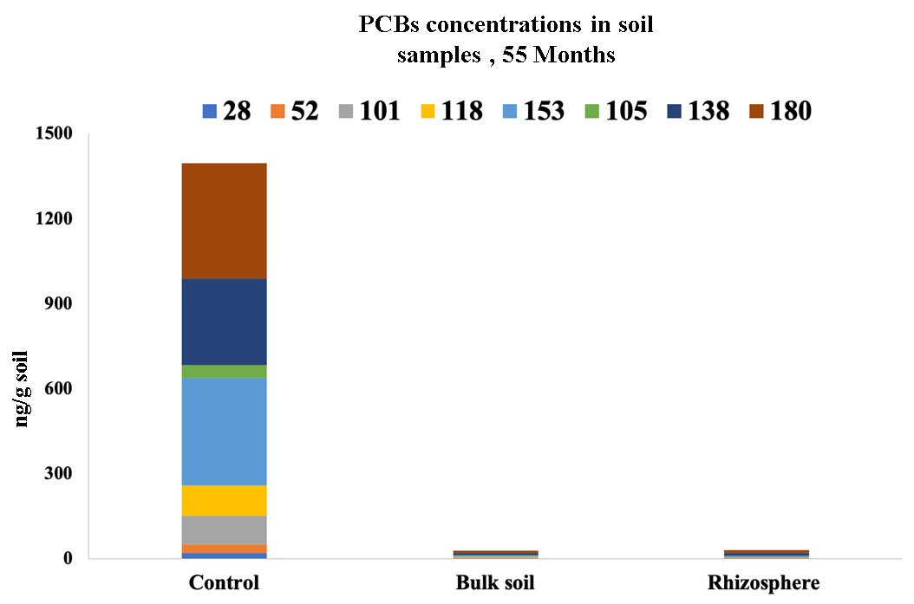
Fig. S1 Sum of PCB congeners found in soil samples collected at 55 months after poplar plantation.

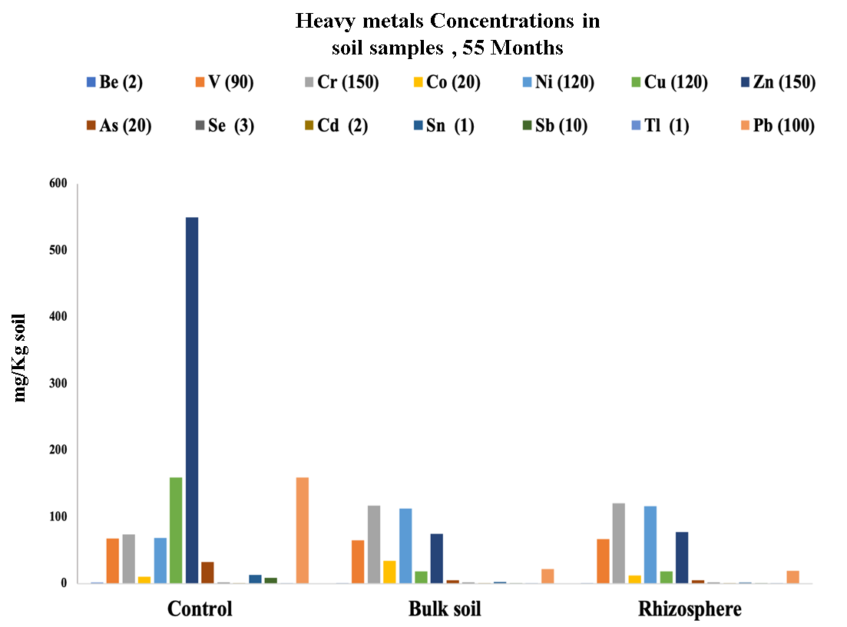
Fig. S2 Heavy metal concentrations (mg/kg) found in soil samples collected at 55 months after poplar plantation. The Italian law limits are reported for each metal in brackets.

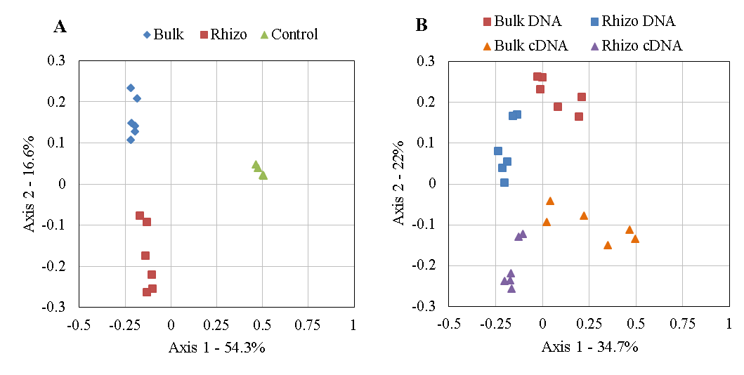
Fig. S3 Bray-Curtis principal coordinate analisys at OTUs level considering DNA (A, Permanova p < 0.001) and cDNA (B, Permanova p < 0.001) samples.

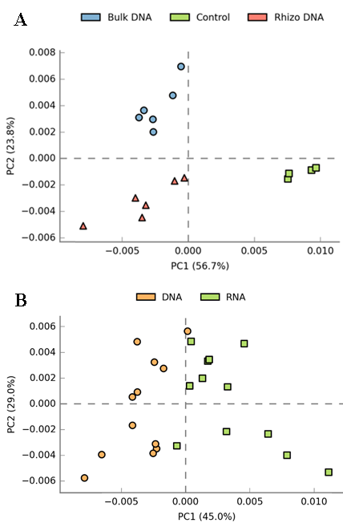
Fig. S4 (A) PCA of functional genes profiling of DNA samples (B) Comparison of DNA and cDNA

