SUPPLEMENTARY MATERIAL

Vinegars from fruits of Myrciaria cauliflora (Mart.) O.Berg and Myrciaria jaboticaba (Vell.) Berg:
Phytochemical, volatile and, sensory profiles, antioxidant activity and chemical characteristics

Cesar Luiz PAGLIARINI, Mateus Alcides PAGLIARINI, Viviane Aparecida Figueredo Oliveira SANTOS; Cristiano André STEFFENS, Rodrigo Barcellos HOFF, Jocinei DOGNINI, Ilene CRESTANI, Marina Volpato DACOREGGIO, Lucíola BAGATINI, Aniela Pinto KEMPKA*

*Address for Correspondence: Dr. Aniela Pinto Kempka, Santa Catarina State University, Department of Food Engineering and Chemical Engineering, Fernando de Noronha Street, BR 282, Km 573.5 Pinhalzinho, SC, Brazil, Zip Code 89870-000. Phone: +55 49 20499594. aniela.kempka@udesc.br; http://orcid.org/0000-0002-7864-7416.

Table S1 – Profile of volatile compounds comprising the aroma of fruits of Myrciaria cauliflora (Mart.) O.Berg and Myrciaria jaboticaba (Vell.) Berg.
Aromatic compounds | Relative percentage (%) |  |  |  | Aroma note
Aromatic compounds | Fruits of Myrciaria cauliflora (Mart.) O.Berg |  | Fruits of Myrciaria jaboticaba (Vell.) Berg. |  | Aroma note
Aromatic compounds | With peel | Without peel | With peel | Without peel | Aroma note
Alcohol
Ethanol | 18.31 ± 7.57 | 4.79 ± 1.17 | 5.53 ± 1.41 | 3.14 ±1.22 | Sweet
Isopropanol | 3.40 ± 1.87 | Nd | Nd | Nd | Alcohol, pungent
Hex-3-en-1-ol | 1.30 ± 1.18 | Nd | Nd | Nd | Grass
4-Amino-1-butanol | Nd | 0.64 ± 0.13 | Nd | Nd
4-Pentyn-2-ol | Nd | Nd | 1.04 ± 0.01 | Nd
Aldehyde
Hexanal | 2.39 ± 3.59 | Nd | Nd | Nd | Grass, tallow, fat
Amide
Lactamide | Nd | Nd | 1.68 ± 0.16 | Nd
Propanamide | 4.68 ± 1.64 | Nd | Nd | Nd
Amino acid
Arginine | 0.28 ± 0.01 | Nd | Nd | Nd
Ester
cis-3-Hexenyl acetate | 0.48 ± 0.47 | Nd | Nd | Nd | Green, banana
4-Hexen-1-ol acetate | Nd | Nd | 0.39 ± 0.16 | Nd
D-Allothreonine | 0.20 ± 0.30 | Nd | Nd | Nd
Diisobutyl phthalate | 0.29 ± 0.32 | Nd | Nd | Nd
Ethyl acetate | 24.23 ± 3.33 | 10.77 ± 3.63 | 29.20 ± 12.03 | 13.63 ± 7.46 | Pineapple
Ethyl benzoate | 1.91 ± 0.76 | 0.93 ± 0.49 | 0.97 ± 0.20 | Nd | Camomile, flower, celery, fruit
Ethyl butanoate | 0.80 ± 0.26 | 0.58 ± 0.01 | 1.16 ± 0.02 | Nd
Ethyl crotonate | 10.36 ± 5.36 | 6.19 ± 0.84 | Nd | Nd
Ethyl isohexanoate | Nd | Nd | 0.23 ± 0.01 | Nd | Fruit
Ethyl (Z)-2-butenoate | Nd | Nd | 18.85 ± 15.49 | 8.17 ± 5.93
Linalool | 2.44 ± 3.04 | Nd | Nd | Nd | Flower, lavender
Methyl benzoate | 2.51 ± 3.78 | Nd | Nd | Nd | Prune, lettuce, herb, sweet
Propyl acetate | Nd | Nd | 0.95 ± 0.24 | Nd
Ketone
Isophorone | 4.25 ± 3.65 | Nd | 6.55 ± 0.04 | 1.49 ± 0.01
Monoterpene
2-Pinene | Nd | 7.07 ± 0.65 | 5.41 ± 9.47 | 5.88 ± 1.81 | Pine, resin, turpentine
1R-α-Pinene | 1.43 ± 1.75 | Nd | Nd | 3.72 ± 1.25 | Pine, turpentine
3-Carene | Nd | 4.47 ± 0.14 | 3.35 ± 5.41 | Nd | Lemon, resin
D-Limonene | 0.15 ± 0.23 | 7.43 ± 0.94 | 0.71 ± 0.01 | 1.05 ± 0.26 | Lemon, orange
Eucalyptol | 0.23 ± 0.43 | 4.55 ± 0.37 | 0.52 ± 0.72 | 3.92 ± 1.05
Linalyl acetate | Nd | 0.62 ± 0.08 | 0.15 ± 0.24 | Nd | Sweet, fruit
Linalool | Nd | Nd | Nd | 0.46 ± 0.06 | Flower, lavender
trans-β-Ocimene | Nd | Nd | 3.10 ± 4.88 | 4.81 ± 1.17
α-Phellandrene | Nd | 1.39 ± 0.21 | 0.34 ± 0.01 | Nd | Turpentine, mint, spice
Terpineol | 3.51 ± 0.13 | Nd | Nd | Nd | Oil, anise, mint
β-cis-Ocimene | Nd | Nd | 3.13 ± 0.01 | Nd
β-Myrcene | Nd | 0.55 ± 0.08 | 0.88 ± 0.01 | 0.64 ± 0.16 | Balsamic, must, spice
β-Ocimene | Nd | 2.89 ± 0.36 | Nd | 2.53 ± 1.05 | Sweet, herb
4-Carvomenthenol | 0.16 ± 0.29 | Nd | Nd | Nd
γ-Terpinene | Nd | Nd | 0.40 ± 0.01 | 0.58 ± 0.11 | Gasoline, turpentine
o-Cymene | Nd | 0.83 ± 0.32 | Nd | Nd
Nitrile
Acetonitrile | Nd | 0.85 ± 0.34 | Nd | Nd
Sesquiterpene
(+)-9-epi-β-Caryophyllene | Nd | Nd | 0.42 ± 0.01 | Nd
Aromandendrene | 0.07 ± 0.12 | 0.44 ± 0.15 | 0.41 ± 0.22 | 0.44 ± 0.05 | Wood
Bicyclogermacrene | Nd | Nd | 1.90 ± 2.48 | 5.86 ± 0.66 | Green, wood
Cadalene | 1.45 ± 0.53 | 0.46 ± 0.08 | 0.53 ± 0.08 | Nd | Tar
Caryophyllene | Nd | 4.49 ± 1.19 | 4.71 ± 6.02 | 15.82 ± 1.06 | Wood, spice
Caryophyllene oxide | Nd | 0.15 ± 0.04 | Nd | Nd | Herb, sweet, spice
Calamenene | 3.51 ± 3.26 | 2.58 ± 1.68 | Nd | Nd
Copaene | Nd | 2.05 ± 0.41 | Nd | Nd | Wood, spice
Cubenene | Nd | 0.26 ± 0.01 | Nd | Nd
Guaia-1(10),11-diene | Nd | Nd | Nd | 0.27 ± 0.15
Guaia-6,9-diene | Nd | 0.22 ± 0.04 | Nd | 0.18 ± 0.01
Germacrene B | Nd | 0.29 ± 0.04 | Nd | Nd | Wood, earth, spice
Humulene | Nd | 1.62 ± 0.05 | 1.97 ± 2.11 | 5.46 ± 0.19 | Wood
Isocaryophyllene | 1.34 ± 0.69 | Nd | 0.13 ± 0.13 | 14.79 ± 0.01 | Wood
Isoledene | 0.61 ± 0.63 | 0.47 ± 0.07 | Nd | Nd
α-Cadinene | 0.59 ± 0.22 | 0.53 ± 0.20 | Nd | Nd
α-Copaene | Nd | 0.26 ± 0.15 | Nd | 0.89 ± 0.01 | Wood, spice
α-Calacorene | 1.84 ± 2.23 | 0.59 ± 0.09 | Nd | Nd | Wood
α-Cubebene | Nd | 0.67 ± 0.13 | Nd | Nd | Herb, wax
α-Guaiene | 1.16 ± 0.72 | Nd | Nd | 0.79 ± 0.09 | Wood, balsamic
α-Muurolene | Nd | 0.24 ± 0.13 | Nd | Nd | Wood
β-Cadinene | Nd | Nd | Nd | 0.37 ± 0.12
β-Copaene | Nd | 15.58 ± 2.73 | Nd | Nd
β-Elemene | Nd | Nd | 1.22 ± 1.31 | 1.97 ± 0.22 | Herb, wax, fresh
β-Eudesmene | Nd | 1.67 ± 0.49 | Nd | 0.82 ± 0.24
β-Guaiene | Nd | Nd | 0.92 ± 0.20 | Nd | Wood, spice
β-Gurjunene | Nd | 1.38 ± 0.34 | Nd | Nd
β-Longipinene | 0.08 ± 0.14 | Nd | Nd | Nd
γ-Cadinene | 0.53 ± 0.54 | Nd | 0.88 ± 0.01 | Nd | Wood
γ-Gurjunene | 0.38 ± 0.70 | 3.21 ± 0.08 | 0.20 ± 0.03 | 0.31 ± 0.05
γ-Himachalene | 0.75 ± 0.21 | 0.28 ± 0.04 | Nd | Nd
γ-Muurolene | 0.26 ± 0.39 | 1.29 ± 0.32 | 0.18 ± 0.01 | Nd | Herb, wood, spice
δ-Cadinene | 0.52 ± 0.78 | 1.63 ± 0.23 | 0.09 ± 0.09 | Nd | Thyme, medicine, wood
δ-Elemene | 0.22 ± 0.34 | 1.56 ± 0.34 | Nd | Nd | Herb, wax, fresh
Selina-3,7(11)-diene | Nd | Nd | 0.17 ± 0.16 | 0.46 ± 0.12 | Tar
(+)-Ledene | Nd | Nd | 0.80 ± 0.34 | Nd
Gamma-selinene | Nd | Nd | Nd | 0.25 ± 0.12 | Tar
2-Isopropenyl-4a,8-dimethyl-1,2,3,4,4a,5,6,7-octahydronaphthalene | Nd | Nd | 0.19 ± 0.21 | Nd
Others
Humulen-(V1) | Nd | Nd | Nd | 0.30 ± 0.05
Clovene | Nd | Nd | 0.44 ± 0.04 | Nd
Isogermacrene D | Nd | Nd | Nd | 0.97 ± 0.09
Note: Nd is not detected.

Table S2 – Profile of volatile compounds comprising the aroma of vinegars from the fruits of Myrciaria cauliflora (Mart.) O.Berg and Myrciaria jaboticaba (Vell.) Berg.
Aromatic compounds | Relative percentage (%) |  |  |  | Aroma note
Aromatic compounds | McP | Mc | MjP | Mj | Aroma note
Alcohol
Ethanol | 21.81 ± 6.84 | 27.30 ± 6.24 | 32.03 ± 3.77 | 27.10 ± 1.43 | Sweet
Isobutanol | Nd | Nd | Nd | 1.90 ± 0.12 | Wine, solvent, bitter
2-Methyl-1-butanol | 5.34 ± 0.58 | 6.13 ± 1.61 | 5.26 ± 0.42 | 5.47 ± 0.20 | -
Isoamyl alcohol | 24.48 ± 6.08 | 15.53 ± 11.20 | 25.41 ± 2.55 | 26.88 ± 3.02 | -
Isobutanol | 0.71 ± 0.20 | 2.03 ± 0.60 | 2.22 ± 0.23 | Nd | -
2-Phenylethanol | 8.16 ± 1.68 | 9.23 ± 0.75 | 9.79 ± 1.92 | 6.99 ± 0.38 | -
Ester
Isoamyl acetate | Nd | 11.38 ± 1.16 | Nd | Nd | -
Butanoic acid | Nd | Nd | 0.16 ± 0.03 | Nd | -
Diethyl succinate | 1.64 ± 0.37 | 1.52 ± 0.29 | 6.68 ± 1.37 | 3.42 ± 0.73 | Wine, fruit
Ethyl acetate | 3.48 ± 0.55 | 5.91 ± 1.09 | 2.97 ± 0.46 | 5.64 ± 0.15 | Pineapple
(Z)-Ethyl cinnamate | 2.20 ± 0.40 | Nd | Nd | Nd | -
Ethyl 9-decenoate | 0.31 ± 0.42 | Nd | 0.04 ± 0.01 | Nd | -
Linalool | 0.11 ± 0.05 | Nd | Nd | Nd | Citrus, coriander
Ethyl benzoate | 0.85 ± 0.12 | 0.76 ± 0.04 | 0.60 ± 0.04 | 0.85 ± 0.17 | Camomile, flower, celery, fruit
Ethyl butyrate | 0.13 ± 0.10 | Nd | 0.16 ± 0.01 | 0.20 ± 0.02 | -
Ethyl cinnamate | Nd | 0.66 ± 0.19 | 0.65 ± 0.26 | Nd | Honey, cinnamon
Ethyl decanoate | 3.15 ± 0.40 | 3.63 ± 0.82 | 2.31 ± 0.72 | 3.36 ± 0.41 | Grape
Ethyl dihydrocinnamate | 0.24 ± 0.03 | 0.22 ± 0.02 | Nd | Nd | Flower
Ethyl dodecanoate | 0.13 ± 0.01 | 0.14 ± 0.04 | 0.14 ± 0.02 | 0.21 ± 0.04 | -
Ethyl hexanoate | 2.54 ± 0.32 | 2.79 ± 0.43 | 1.95 ± 1.09 | 3.36 ± 0.57 | Apple peel, fruit
Ethyl isobutyrate | Nd | Nd | 0.21 ± 0.05 | 0.16 ± 0.01 | Sweet, rubber
Ethyl isovalerate | Nd | Nd | Nd | 0.15 ± 0.01 | -
Ethyl octanoate | 7.71 ± 0.28 | 8.33 ± 1.07 | 5.04 ± 2.78 | 9.92 ± 0.89 | Fruit, fat
Ethyl 2-methylbutyrate | Nd | Nd | 0.05 ± 0.01 | Nd | -
Isoamyl acetate | 11.42 ± 0.87 | Nd | 3.23 ± 1.67 | 2.39 ± 0.36 | Banana
Methyl benzoate | 0.50 ± 0.06 | Nd | Nd | Nd | Prune, lettuce, herb, sweet
Phenethyl acetate | 3.44 ± 0.42 | 3.97 ± 0.49 | 0.95 ± 0.18 | 0.50 ± 0.11 | Rose, honey, tobacco
Ketone
Isophorone | Nd | Nd | Nd | 0.41 ± 0.06 | -
Monoterpene
3-Carene | Nd | 0.19 ± 0.12 | Nd | Nd | Lemon, resin
Eucalyptol | 0.03 ± 0.00 | 0.08 ± 0.01 | Nd | 0.31 ± 0.07 | -
α-Terpineol | 0.12 ± 0.03 | 0.20 ± 0.04 | Nd | Nd | Oil, anise, mint
Sesquiterpene
Isocaryophillene | Nd | Nd | 0.13 ± 0.07 | Nd | Wood
β-Longipinene | Nd | Nd | Nd | 0.04 ± 0.01 | -
Vinylarene
Styrene | 1.49 ± 0.07 | Nd | Nd | Nd | Balsamic, gasoline
Note: McP and Mc are the vinegars of the M. cauliflora variety, whose first step of alcoholic fermentation took place with fruits with and without peel, respectively; MjP and Mj are the vinegars of the M. jaboticaba variety, whose first step of alcoholic fermentation took place with fruits with and without peel, respectively. Nd is not detected.

Table S3 - Elemental composition of vinegars from the fruits of Myrciaria cauliflora (Mart.) O.Berg and Myrciaria jaboticaba (Vell.) Berg.
Compound | % of total mineral content*
Compound | McP | Mc | MjP | Mj
K | 84.627 | 81.130 | 79.422 | 77.892
Ca | 10.323 | 12.255 | 12.970 | 13.125
S | 2.084 | 2.446 | 3.157 | 3.223
P | 2.072 | 12.255 | 2.686 | 3.766
Fe | 0.280 | 0.352 | 0.631 | 0.419
Cu | 0.192 | 0.258 | 0.236 | 0.349
Zn | 0.155 | 0.170 | 0.305 | 0.388
*Percentage in relation to the total of minerals. Note: McP and Mc are the vinegars of the M. cauliflora variety, whose first step of alcoholic fermentation took place with fruits with and without peel. respectively; MjP and Mj are the vinegars of the M. jaboticaba variety, whose first step of alcoholic fermentation took place with fruits with and without peel, respectively.

Figure S1 - Visual aspect of the preparation of musts using Jabuticaba with and without peel.
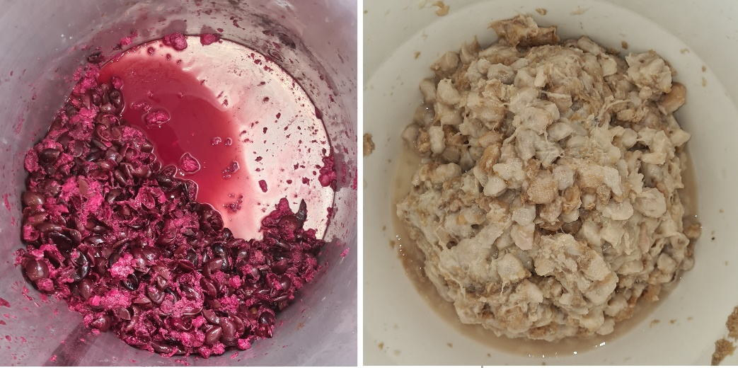

Figure S2 - Visual aspect of the vinegars made with Jabuticaba with and without peel, from the species Myrciaria cauliflora (Mart.) O.Berg and Myrciaria jaboticaba (Vell.) Berg.
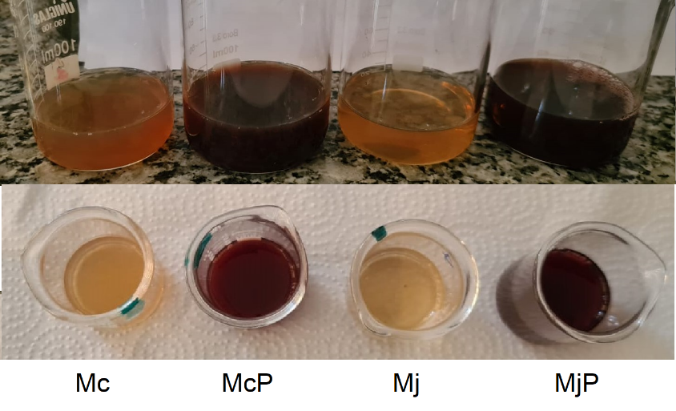
Note: McP and Mc are the vinegars of the M. cauliflora variety, whose first step of alcoholic fermentation took place with fruits with and without peel, respectively; MjP and Mj are the vinegars of the M. jaboticaba variety, whose first step of alcoholic fermentation took place with fruits with and without peel, respectively.

