Supplementary figures and notes to: The rising global economic costs of Aedes and Aedes-borne diseases

Supplementary Figure 1: PRISMA conceptual framework for the construction of the cost records dataset. Note that records corresponding to the opportunistic search (n = 166) were also subjected to a full text screening, and only those that met the criteria were retained.

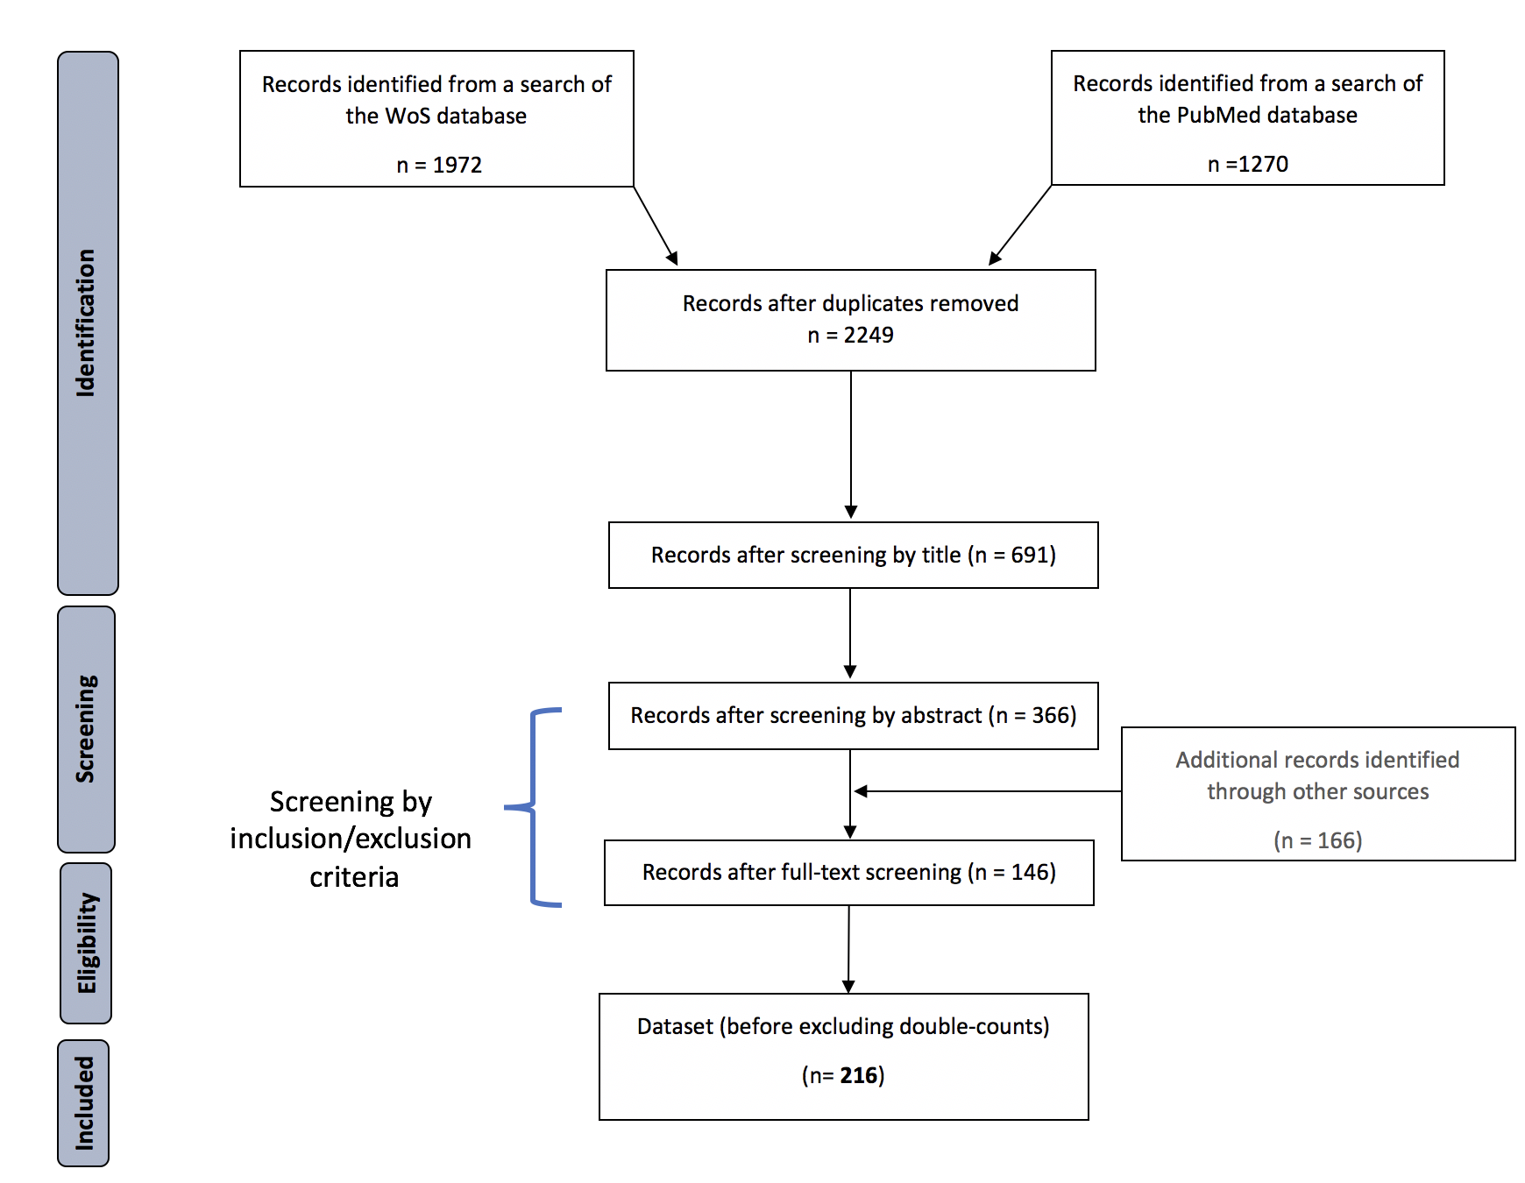

Supplementary Figure 2. Decision tree for the selection of cost records when there is more than one report available for the same disease, mosquito species and cost type, and there is a spatial or a temporal overlap. *Note that global and intercontinental costs are not included.
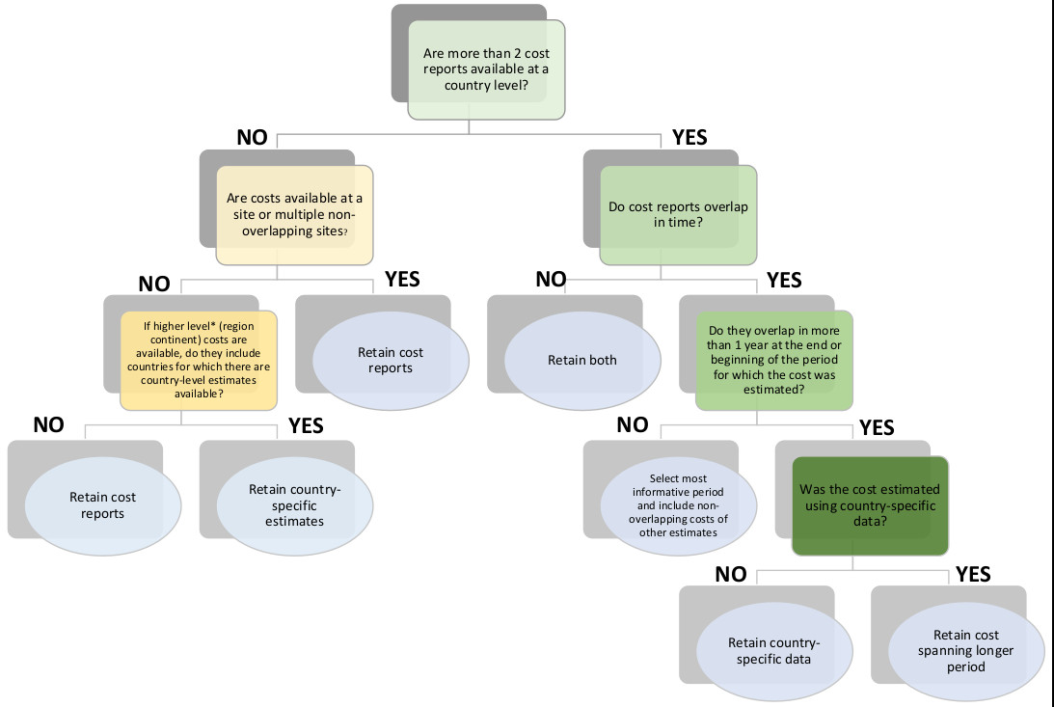

Supplementary Figure 3. Total costs for each subcategory of damage (in 2022 US$ millions) by disease and Aedes species. Cost subcategories are defined extensively in the main text (Typology of Costs section). The joint cost subcategory comprises combined estimates for two or more damage subcategories that could not be separated (e.g. losses + direct medical costs). DM = Direct medical costs, DNM = Direct non-medical costs. These estimations do not include the costs of sequelae.
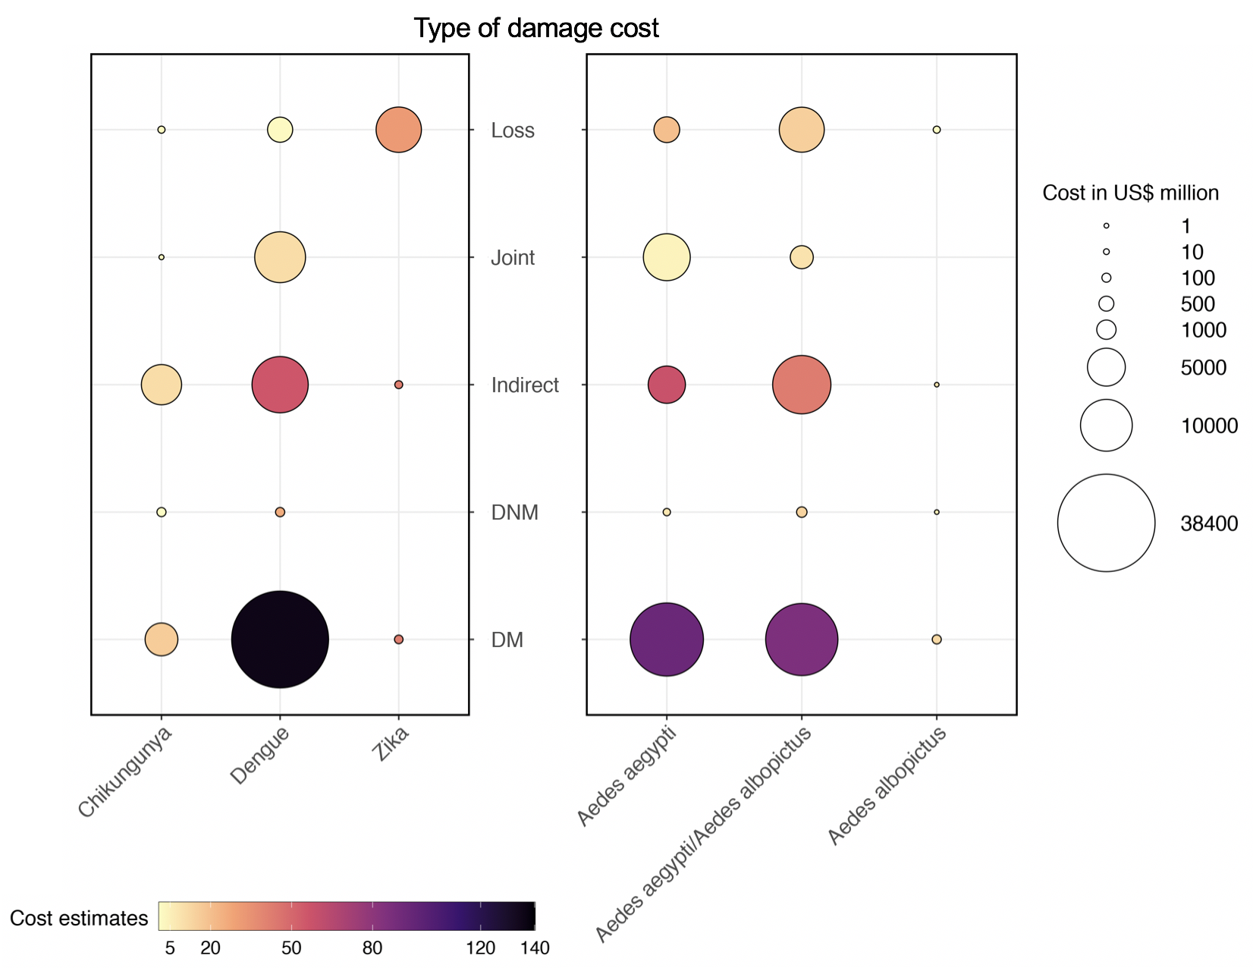

Supplementary Figure 4. Estimated delay between economic impact and publication date of Aedes-related economic costs, calculated using the conservative subset of the data. Quartiles of publication lag are used as an indicator of how complete the dataset is for a given year or set of years (i.e., delay to reach completeness). In the case of our dataset, the median delay between the economic impact and the publication date of the estimated costs was 3 years, with the first quartile having a value of 2, and the third quartile a value of 7 years (i.e., 2 years to reach 25% completeness, and 7 years to reach 75% completeness). Thus, while the total accumulated costs took into account the whole dataset, data compiled for the most recent years are likely to highly underestimating the total actual costs.

Supplementary Figure 5. Modelling techniques assessing the global temporal trends in damage and management costs of Aedes and Aedes-transmitted diseases. A) Robust linear regression, B) Robust quadratic regression, C) GAM. Note that scales may differ among subplots. Shaded areas represent 95% confidence intervals,

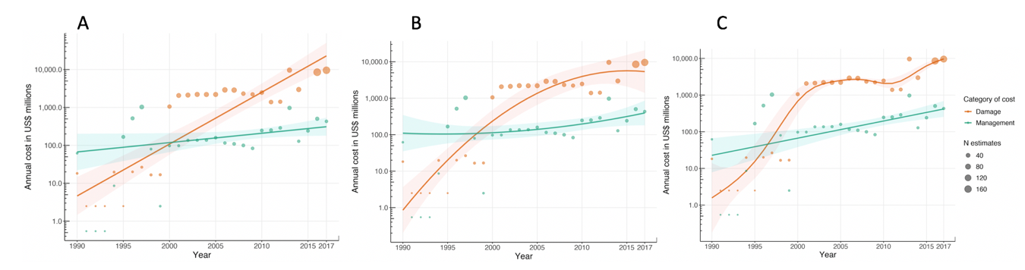

Appendix 1. Updated database on the economic costs of Aedes.

Appendix 2. Historical database of Aedes aegypti and Aedes albopictus invasions in the countries studied.

Supplementary Note 1. Model methods and model results
The selection of the models implemented within the modelCosts function was driven by the characteristics of econometric data, which tend to present heteroskedasticity, temporal autocorrelation and outliers, thus requiring modelling methods robust to these issues. The list of implemented models include: ordinary least squares regression (linear and quadratic), robust regressions (linear and quadratic, from R package ‘robustbase’¹, multivariate additive regression splines (MARS, from R package ‘earth’)² and generalized additive models (GAM, from R package ‘mgvc’)². Using this set of models, we examined the trends of damage and management costs using the conservative data subset and data from 1990 to 2017.
Data for damage costs prior to 1990 are discontinuous, with no information available between 1985 and 1989, and sparse information between 1975 and 1984. This likely reflects the lack of systematic cost recording apart from a few, well-studied dengue outbreaks (see for example Guzmán et al. 1992)³, and the difficulties of retrospectively estimating costs given limited data availability. We also excluded data from 2018-2020 based on the impact of the estimated publication lag on the completeness of cost data; for the last three years, only 50% of the data can be expected to be available. These corrections to the analysis period were aimed at reducing the underestimation of costs and to avoid spurious patterns of data behavior driven by model sensitivity to incomplete cost data due to publication lags or data sparsity.
We assessed model performance based on the root mean square error (RMSE; lower values indicate a better fit. Note this metric is meaningless for the quantile regression as it does not fit the average trend) and the statistical significance of model coefficients. The residual sum of squares, penalized by the effective number of model parameters (GRSq) was also used to assess the adequacy of the MARS model, with higher values indicating a better fit.
All models assessed converged in their predictions, suggesting an increase in damage and management costs over the study period and larger comparative increases in the former (supplementary Fig. 5). Temporal trends in damage costs were best described by the MARS model (RMSE = 0.388) with a GRSq value of 0.868. The OLS regression was removed from further analysis as either one or both their linear or quadratic variations were not significant. Coefficients for the robust regression and GAM were significant, but both had higher RMSE than the MARS model (see Supplementary Table 1). The MARS model also provided the best fit for the temporal trends in management costs (RMSE = 0.669) with a GRSq value of 0.366. Model coefficients were not significant for the OLS or robust regressions. Thus, based on the RMSE, the non-linear patterns in the costs and the simplicity of interpretation, we determined that the MARS model provided the best approach to describe the behavior of damage and management costs over time.

Supplementary Note 2. Comparisons with other estimates of economic costs
While large-scale global estimates of the costs of Aedes-transmitted diseases are scarce, we compared our results with the available information on the global economic burden of dengue and Zika. For example, Shepard et al. (2016)⁵ estimated the cost of dengue at US$ 8.9 billion in 2013, within the same order of magnitude of our estimate of US$ 9.9 billion for that same year. Other estimates for dengue amounted US$ 3.3 billion valued on a Power Purchase Parity (PPP) basis for 2015⁶, or US$ 3 billion per year for Latin America⁷. Assuming a high coverage of medical treatment for dengue cases within the formal health sector, a large number of fatal cases and generalized productivity losses, Selck and colleagues (2014)⁸ arrived at an estimate of US$ 39 billion in 2011, which includes extrapolated potential costs. A study conducted by the World Bank estimated that Zika costed the world US$ 3.5 billion in 2017⁹, whereas our estimate for the same year was similar at US$ 2.8 billion. We must insist that our results are based on reported costs, and excluded potential hypothetical costs such as those that may be associated with future loss of productivity due to premature mortality, a likely source of the differences in estimates from other studies. Additionally, the double-counting exclusion criteria allowed us to refine previous estimations¹⁰. Thus, our methodology represents an alternative approach to estimating the global economic burden of Aedes-borne disease based on a comprehensive and systematic analysis of the available information of reported economic costs of these diseases.

Supplementary Note 3. Estimating the cost of the sequelae of chikungunya and Zika in relation to Table 4.
Few studies have estimated the economic costs of the neurological and inflammatory sequelae associated with Zika and chikungunya. Basing their estimates on Alfaro-Murillo et al. (2016)¹¹ and using the number of reported dengue cases as a proxy for Zika cases, Colón-González and his team arrived at an economic burden of the direct medical costs of Zika sequelae for Latin America and the Caribbean of US$ 2.3 billion per annum¹². Other estimates of Zika sequelae costs are available at a country level of resolution, e.g. Brazil^{13,14}. Our estimate for this country (Table 4) is based on the UNDP report on Zika projections for Latin America and the Caribbean¹⁵, which uses a baseline scenario of Zika infections based on projections by the Pan American Health Organization (PAHO), and is a more conservative scenario than the one proposed by Colón González et al., including the direct as well as indirect medical costs of sequelae. Note, however, that both estimates are within the same order of magnitude.
Estimates of the costs associated with the inflammatory sequelae of chikungunya are even rarer, and we found only one such study on a large-scale¹⁶, which reported both the direct medical costs and the indirect costs associated with reduced productivity due to disability, long term medication, and perinatal sequelae in the Americas. It is interesting that, according to the available estimates, the costs associated with the sequelae of chikungunya are more than 50 times greater than those of Zika, which could be due to differences in their respective estimated levels of prevalence. A review of the global burden of these diseases¹⁷ found that the average estimated prevalence of complications due to chikungunya was 42.5% (range 7.0% - 89.7%), higher than the estimated prevalence of complications associated with Zika sequelae (Guillian-Barré syndrome: 0.02%, range 0.016% - 0.024%; congenital Zika syndrome: 7.0%, range 3.4% - 14.4%). It should also be noted that none of the estimates takes into account additional expenses, such as specialized child-care support for children with congenital Zika syndrome or the long-term psychological toll on patients with these diseases or their families. Further research is therefore needed to estimate the most complete as possible cost of the long-term sequelae associated with Zika and chikungunya.

Supplementary Table 1. RMSE values of the assessed models.
Model | Damage | Management
OLS linear | 0.713 | 0.590
OLS quadratic | 0.686 | 0.504
Robust linear | 0.844 | 0.592
Robust quadratic | 0.885 | 0.508
MARS | 0.669 | 0.388
GAM | 0.743 | 0.435

Supplementary Table 2. Main recommendations to improve the collection of economic cost records for Aedes and Aedes-borne diseases with the aim of reducing uncertainty and underreporting, with bibliographic examples.
Recommendations | First author | Year | Country/Region
Collect data on all the different types of costs | Tran et al.¹⁸ | 2018 | Vietnam
Collect data on all the different types of costs | Kajimoto and Kitajima ¹⁹ | 2020 | Japan
Capture the losses, such as in tourism | Arnaud et al. ²⁰ | 2006 | France
Capture the losses, such as in tourism | Nishikawa et al.²¹ | 2016 | Brazil
Capture the out-of-pocket expenses paid by individuals and households | Vijayakumar et al.²² | 2013 | India
 | Loroño-Pino et al.²³ | 2014 | Mexico
 | Nhi et al.²⁴ | 2016 | Vietnam
Considerer private healthcare and third-party payers | Vieria Machado et al.²⁵ | 2014 | Brazil
Include the cost of diagnosing the different arboviruses | Liumbruno et al.²⁶ | 2008 | Italy
Include the cost of diagnosing the different arboviruses | Veater et al.²⁷ | 2018 | UK
Include the cost of diagnosing the different arboviruses | Saa et al.²⁸ | 2018 | US
Carry out studies in epidemic and non-epidemic periods | Hubert et al.²⁹ | 2001 | France
Carry out studies in epidemic and non-epidemic periods | Hariharan et al.³⁰ | 2017 | India
Differentiate between dengue fever, dengue hemorrhagic fever, and dengue shock syndrome | Añez et al.³¹ | 2006 | Venezuela
 | Hung et al.³² | 2019 | review
Resolve the lack of consistency using expansion factors and asymptomatic or mild symptoms | Zubieta-Zavala et al.³³ | 2018 | Mexico
 | Nadjib et al.³⁴ | 2019 | Indonesia
Obtain high-quality records of historical and current reported economic costs of other Aedes-borne diseases (e.g., Mayaro) | Utz et al.³⁵ | 2003 | US
 | Marchi et al.³⁶ | 2018 | review
Improve quantification of indirect costs | Hung et al.³⁷ | 2020 | Asia
Improve the quantification of the management costs of different vector control strategies | Thompson et al.³⁸ | 2020 | global

References
- Maechler, M. et al. robustbase: Basic Robust Statistics R package version 0.95-0. Retrieved from http://CRAN.R-project.org/package=robustbase (2002).
- Milborrow, S. Derived from mda:mars by Hastie T and Tibshirani R, and Uses Alan Miller's Fortran utilities with Thomas Lumley's leaps wrapper. Earth: Multivariate adaptive regression splines. Retrieved from https://cran.r-project.org/package=earth (2019).
- Wood, S., Pya, N. & Säfken, B. Smoothing parameter and model selection for general smooth models. J. Am. Stat. Assoc. 111, 1548– 1575 (2016).
- Guzmán, M. G., Triana, C., Bravo, J. & Kourí, G. The estimation of the economic damages caused as a consequence of the epidemic of hemorrhagic dengue in Cuba in 1981. Rev. Cubana Med. Trop. 44, 13–17 (1992).
- Shepard, D.S., Undurraga, E.A., Halasa, Y.A. & Stanaway, J.D. The global economic burden of dengue: a systematic analysis. Lancet Inf. Dis. 16(8), 935-941 (2016).
- Oliveira, L.N.D.S., Itria, A. & Lima, E.C. Cost of illness and program of dengue: A systematic review. PLoS one 14(2), e0211401 (2019).
- Laserna, A., Barahona-Correa, J., Baquero, L., Castañeda-Cardona, C. & Rosselli, D. Economic impact of dengue fever in Latin America and the Caribbean: a systematic review. Revista Panamericana de Salud Pública 42, e111 (2018).
- Selck, F.W., Adalja, A.A. & Boddie, C.R., An estimate of the global health care and lost productivity costs of dengue. Vector-Borne and Zoonotic Dis. 14(11), 824-826 (2014).
- World Bank. Economic impact of Zika virus. Zika virus disease, from origin to outbreak. Ch. 11 (Cambridge, Massachussetts, US, 2008)
- Diagne, C. et al. High and rising economic costs of biological invasions worldwide. Nature 592(7855), 571-576 (2021).
- Alfaro-Murillo, J.A. et al. A cost-effectiveness tool for informing policies on Zika virus control. PLoS Negl. Trop. Dis. 10(5), e0004743 (2016).
- Colón-González, F.J., Peres, C.A., Steiner São Bernardo, C., Hunter, P.R. & Lake, I.R. After the epidemic: Zika virus projections for Latin America and the Caribbean. PLoS Negl. Trop. Dis. 11(11), e0006007 (2017).
- Peixoto, H. M., Romero, G. A. S., de Araújo, W. N. & de Oliveira, M. R. F. Guillain–Barré syndrome associated with Zika virus infection in Brazil: a cost-of-illness study. Trans. R. Soc. of Trop. Med. Hyg. 113, 252–258 (2019).
- Pinto, M., Lopes Moreira, M.E., de Paula Barros, L.B., Carioca da Costa, A.C., Fernandes, S. & Kuper, H. Gasto catastrófico na síndrome congênita do vírus Zika: resultados de um estudo transversal com cuidadores de crianças no Rio de Janeiro, Brasil. Cad. Saúde Pública 37, e00007021 (2021).
- UNDP. A Socio-economic impact assessment of the Zika virus in Latin America and the Caribbean. https://www.undp.org/publications/socio-economic-impact-assessment-zika-virus-latin-america-and-caribbean (2017).
- Bloch, Danielle. "The cost and burden of chikungunya in the Americas." https://elischolar.library.yale.edu/cgi/viewcontent.cgi?article=1021&context=ysphtdl (2016).
- Puntasecca, C. J., King, C. H. and LaBeaud, A. D. Measuring the global burden of chikungunya and Zika viruses: A systematic review. PLoS Negl. Trop. Dis. 15(3), e0009055 (2021).
- Tran, B. X. et al. Cost-of-Illness and the Health-Related Quality of Life of Patients in the Dengue Fever Outbreak in Hanoi in 2017. International Journal of Environmental Research and Public Health 15, 1174 (2018).
- Kajimoto, Y. & Kitajima, T. Patient and National Economic Burden of Dengue in Japan: Results from Japanese National Claims Database. Am. J. Trop. Med. 102, 1237–1243 (2020).
- Arnaud, J. N. Tourisme: La crise du chikungunya a coûté 500 emplois salariés. Économie de La Réunion 133, 1-5 (2006).
- Nishikawa, A. M., Clark, O. A., Genovez, V., Pinho, A. & Durand, L. Economic impact of dengue in tourism in Brazil. Value in Health 19, A216 (2016).
- Vijayakumar, K. et al. Economic impact of chikungunya epidemic: out-of-pocket health expenditures during the 2007 outbreak in Kerala, India. Southeast Asian J. Trop. Med. Public Health 44, 8 (2013).
- Loroño-Pino, M. A. et al. Household use of insecticide consumer products in a dengue-endemic area in México. Trop. Med. Int. Health 19, 1267–1275 (2014).
- Nhi Yen, T. N. & Trung, V. Q. The economic value of informal care for dengue patients in Vietnam. Int. J. Res. Ayurveda Pharm. 7, 101–106 (2017).
- Vieira Machado, A. A. et al. Direct Costs of Dengue Hospitalization in Brazil: Public and Private Health Care Systems and Use of WHO Guidelines. PLoS Negl Trop Dis 8, e3104 (2014).
- Liumbruno, G. M. et al. The Chikungunya epidemic in Italy and its repercussion on the blood system. Blood Transfus. 6, 199–210 (2008).
- Veater, J. et al. Cost effectiveness of screening for dengue infection in a UK teaching hospital. J. Infect. 76, 214–217 (2018).
- Saá, P. et al. Investigational Testing for Zika Virus among U.S. Blood Donors. N. Engl. J. Med. 378, 1778–1788 (2018).
- Hubert, B. Epidémie de dengue 1 en Polynésie Française - 200. (2001).
- Hariharan, D., Das, M. K., Shepard, D. S. & Arora, N. K. Economic burden of dengue illness in India from 2013 to 2016: A systematic analysis. Int. J. of Infect. Dis. 84, S68–S73 (2019).
- Añez, G., Balza, R., Valero, N. & Larreal, Y. Impacto económico del dengue y del dengue hemorrágico en el Estado de Zulia, Venezuela, 1997-2003. Rev Panam Salud Publica 19, (2006).
- Hung, T., Wills, B., Clapham, H., Yacoub, S. & Turner, H. The Uncertainty Surrounding the Burden of Post-acute Consequences of Dengue Infection. Trends. Parasitol. 35, 673–676 (2019).
- Zubieta-Zavala, A. et al. Economic impact of dengue in Mexico considering reported cases for 2012 to 2016. PLoS Negl. Trop. Dis. 12, e0006938 (2018).
- Nadjib, M. et al. Economic burden of dengue in Indonesia. PLoS Negl. Trop. Dis. 13, e0007038 (2019).
- Utz, J. T. et al (2003). Economic and social impacts of La Crosse encephalitis in western North Carolina. The American journal of tropical medicine and hygiene, 69(5), 509-518 (2003).
- Marchi, S., Trombetta, C. M., Montomoli, E. Emerging and re-emerging arboviral diseases as a global health problem. Public Health: Emerging and Re-emerging Issues. United Kindgom: IntechOpen, 25-46 (2018).
- Hung, T. M. et al. Productivity costs from a dengue episode in Asia: a systematic literature review. BMC Infect. Dis. 20, 393 (2020).
- Thompson, R., Del Campo, J. & Constenla, D. A review of the economic evidence of Aedes-borne arboviruses and Aedes-borne arboviral disease prevention and control strategies. Expert review of vaccines 19, 143–162 (2020).

