Additional files
Additional file 1: Figure S1. Initial extraction plan.
Additional file 2: Table S1. Summary of sequencing quality control data for each sample.
Additional file 3: Table S2. Species assigned to negative control samples by each classifier.
Additional file 4: Figure S2. Functional analysis of bovine and human milk samples.

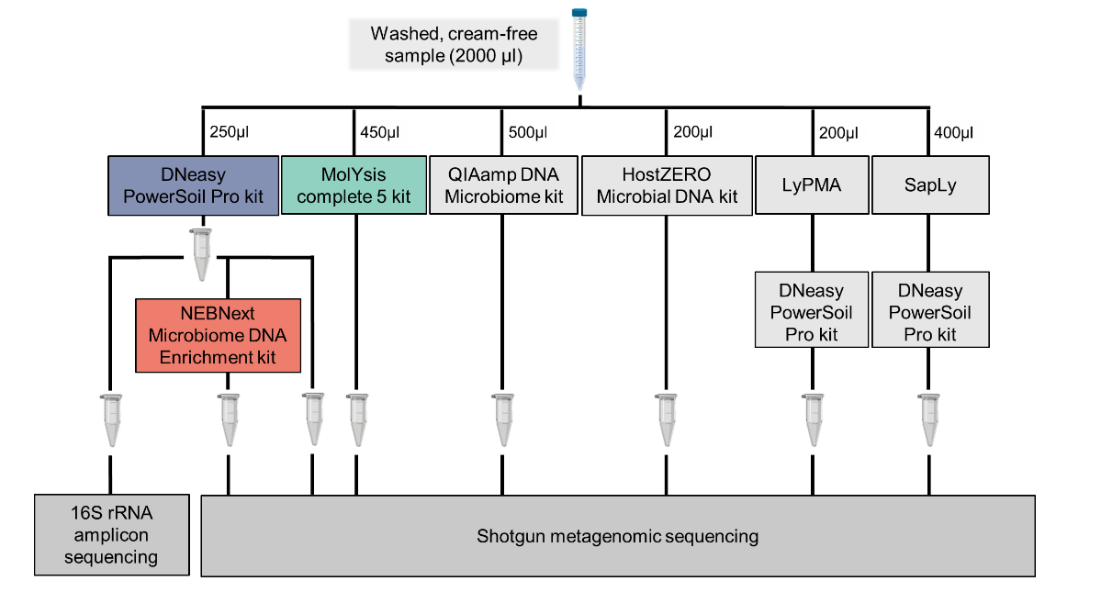
Additional file 1: Figure S1. Initial extraction plan. Two millilitres of the cream-free milk sample were to be divided into varying volumes depending on sample volume input recommended by the different kits and methods. The QIAamp DNA Microbiome kit and HostZERO Microbial DNA kit were both available commercially (Qiagen and Zymo Research). Both kits selectively lyse host cells prior to extraction of DNA from bacterial cells. Host depletion and subsequent DNA extractions were done according to the manufacturer’s instructions for both kits. The LyPMA method, according to Charalampous et al. (2019), involves osmotic lysis of host cells followed by PMA treatment to remove non-microbial cells in the sample. The SapLy method, according to Marotz et al. (2018), uses a detergent to lyse host cells followed by enzymatic removal before further extraction of DNA from microbial cells. Further evaluation of the methods in grey were discontinued due to the limited starting sample volumes.

Additional file 2: Supplementary Table 1. Summary of sequencing quality control data for each sample.
Sample | DNA yield (ng/µl) | Total number of raw reads | Total number of quality-filtered reads | Total number of microbial reads
BM7_ML | 1.22 | 4,803,678 | 4,799,422 | 414,123
BM8_ML | 2.02 | 4,218,166 | 4,213,627 | 521,433
BM9_ML | 0.418 | 5,831,258 | 5,826,847 | 5,108,499
BM10_ML | 0.764 | 5,503,695 | 5,489,219 | 1,559,305
BM11_ML | 1.87 | 3,752,539 | 3,749,575 | 2,597,792
BMS12_ML | 12 | 3,961,530 | 3,956,586 | 2,714,533
HM7_ML | 0.134 | 4,577,558 | 4,572,083 | 801,292
HM8_ML | 0.304 | 367,496 | 366,997 | 13,288
HM9_ML | < 0.001 | 899,823 | 898,330 | 22,347
HM10_ML | 0.155 | 14,301,289 | 14,289,863 | 9,427,921
HM11_ML | < 0.001 | 2,558,808 | 2,555,194 | 51,285
HMS12_ML | 4.01 | 3,135,085 | 3,128,637 | 2,913,481
PBS_ML | < 0.001 | 8,145 | 8,136 | 8,136
BM7_NEB | 3.74 | 4,634,478 | 4,630,852 | 47,889
BM8_NEB | 0.389 | 4,623,058 | 4,619,434 | 61,189
BM9_NEB | 2.92 | 5,145,897 | 5,142,366 | 2,141,081
BM10_NEB | 2.43 | 4,384,900 | 4,378,312 | 114,853
BM11_NEB | 0.468 | 5,620,335 | 5,616,578 | 2,050,519
BMS12_NEB | 2.4 | 2,990,318 | 2,987,713 | 588,814
HM7_NEB | 2.17 | 3,714,043 | 3,711,382 | 118,695
HM8_NEB | 2.86 | 3,505,245 | 3,502,584 | 76,561
HM9_NEB | < 0.001 | 7,449,515 | 7,444,889 | 137,544
HM10_NEB | 1.54 | 4,046,734 | 4,043,758 | 166,690
HM11_NEB | < 0.001 | 4,773,599 | 4,770,318 | 124,328
HMS12_NEB | 1.73 | 3,251,920 | 3,248,935 | 1,059,091
PBS_NEB | < 0.001 | 4,804 | 4,791 | 4,791
BM7_PS | 16.6 | 4,306,883 | 4,298,577 | 53,485
BM8_PS | 1.4 | 4,466,519 | 4,462,271 | 54,412
BM9_PS | 12.2 | 949,504 | 948,705 | 174,822
BM10_PS | 5.32 | 5,057,336 | 5,045,050 | 140,571
BM11_PS | 1.93 | 4,039,654 | 4,036,626 | 511,785
BMS12_PS | 5.83 | 3,734,020 | 3,730,408 | 712,548
HM7_PS | 4.49 | 4,779,699 | 4,775,683 | 166,226
HM8_PS | 5.45 | 3,434,585 | 3,431,627 | 97,069
HM9_PS | 0.409 | 4,432,677 | 4,429,588 | 132,241
HM10_PS | 4.08 | 4,606,083 | 4,598,639 | 201,712
HM11_PS | 0.207 | 3,626,184 | 3,623,049 | 111,156
HMS12_PS | 4.03 | 3,604,484 | 3,600,859 | 1,090,248
PBS_PS | < 0.001 | 659 | 654 | 654

Additional file 3: Supplementary Table 2. List of species (> 1% relative abundance) assigned to negative control samples by each classifier
Classifier | PBS_ML | PBS_NEB | PBS_PS
MetaPhlAn2 | Lactobacillus crispatus  Aerococcus viridans | No species assigned | No species assigned
Kraken2 | Aerococcus viridans  Cutibacterium acnes  Lactobacillus amylovorus  Actinoalloteichus sp. AHMU CJ021  Klebsiella pneumoniae  Lactobacillus johnsonii  Aerococcus urinaeequi  Negativicoccus massiliensis  Escherichia coli  Enterococcus faecalis  Rhodobacter sphaeroides  Acinetobacter johnsonii  Moraxella osloensis | Cutibacterium acnes  Propionibacterium sp. oral taxon 193  Pseudomonas pseudoalcaligenes  Micrococcus luteus | Pseudomonas alcaliphila  Negativicoccus massiliensis
Kaiju | Staphylococcus aureus  Aerococcus viridans  Lactobacillus crispatus  Escherichia coli | Staphylococcus aureus | Ralstonia solanacearum  Pseudomonas sp. 286  Acinetobacter nosocomialis  Enterobacter cloacae  Clostridioides difficile  Acinetobacter johnsonii

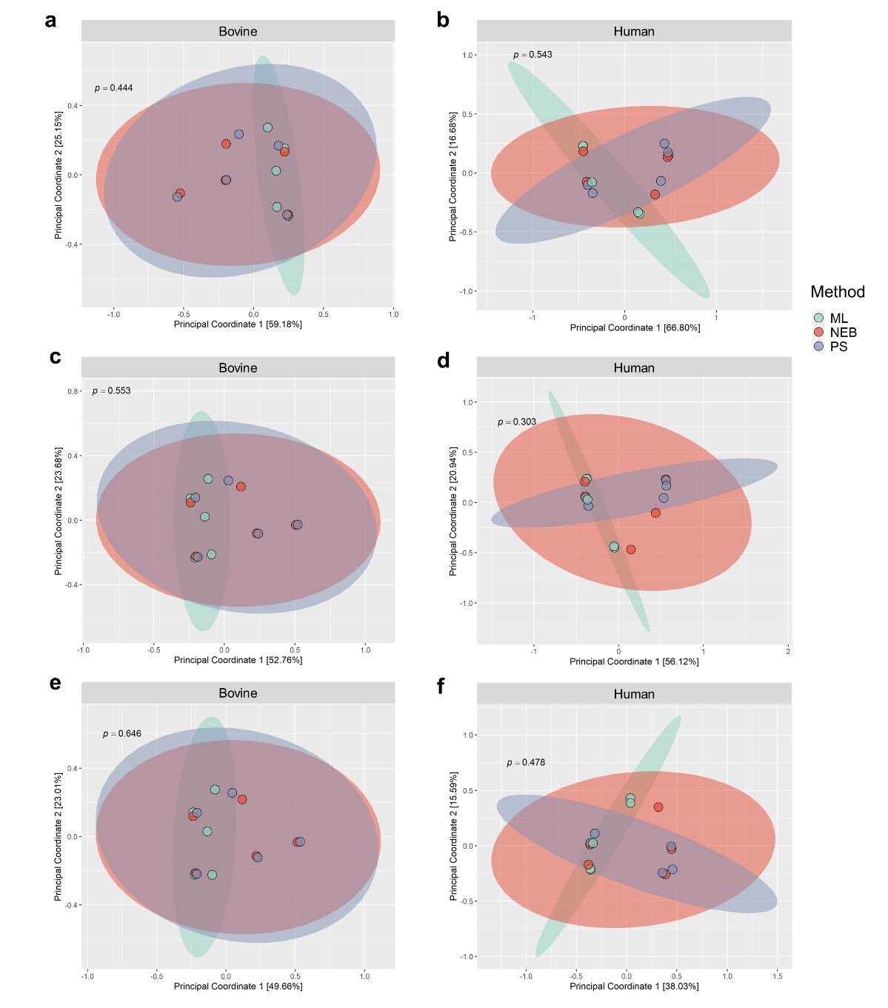
Additional file 4: Figure S2. Functional analysis of bovine and human milk samples as based on gene ontology domains. (a) Gene families related to cellular components for bovine and (b) human milk samples. (c) Gene families related to biological processes for bovine and (d) human milk samples. (e) Gene families related to molecular function for bovine and (f) human milk samples.

