Molecular Insight into the Genetic structure and Banding pattern Analysis of Bambara groundnut (Vigna subterranea L.) with Random Amplified Microsatellites (RAMs)

Md Mahmudul Hasan Khan^{1, 3*}, Mohd Y. Rafii^{1, 2*}, Shairul Izan Ramlee², Mashitah Jusoh², Md Al Mamun¹, and Bimal Chandra Kundu³

¹ Laboratory of Climate-Smart Food Crop Production, Institute of Tropical Agriculture and Food Security (ITAFoS), Universiti Putra Malaysia (UPM), 43400, UPM Serdang, Selangor, Malaysia.
²Department of Crop Science, Faculty of Agriculture, Universiti Putra Malaysia (UPM), 43400, UPM Serdang, Selangor, Malaysia.
³ Bangladesh Agricultural Research Institute (BARI), Gazipur-1701, Bangladesh.

*Correspondence: M.M.H. Khan, (mhasan.bari12@gmail.com) Tel.: +8801712693101.

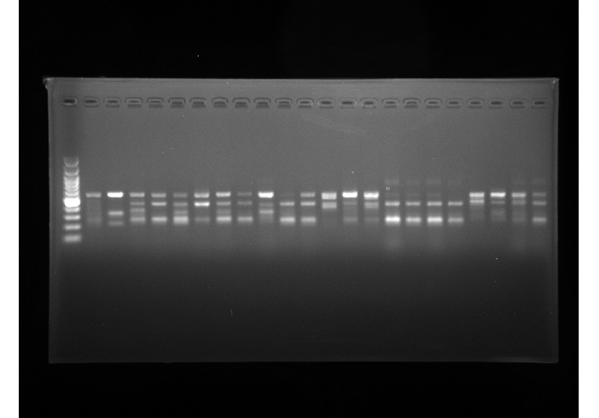
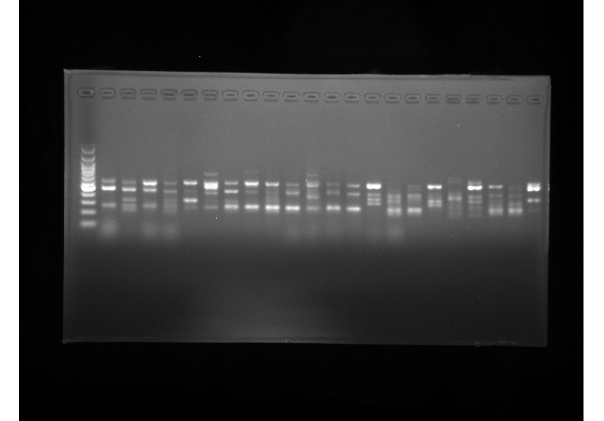
Supplementary Figure S1: Full length Gel/Blot Picture used for study

M G1 G2 G3 G4 G5 G6 G7 G8 G9 G10 G11 G12 G13 G14 G15 G16 G17 G18 G19 G20 G21 G22

400 -
1100 -
100 -
bp

a) UBC 808

M G23 G24 G25 G26 G27 G28 G29 G30 G31 G132 G33 G34 G35 G36 G37 G38 G39 G40 G41 G42 G43 G44
1100 -
400 -
100 -

bp

- UBC 808

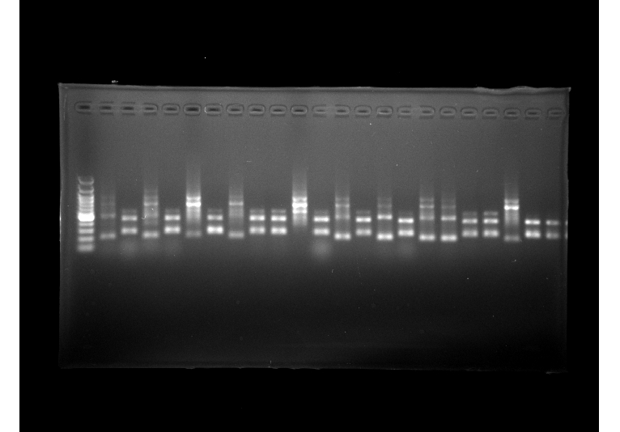

M G1 G2 G3 G4 G5 G6 G7 G8 G9 G10 G11 G12 G13 G14 G15 G16 G17 G18 G19 G20 G21 G22
1200 -
400 -
bp
100 -

b) UBC 809

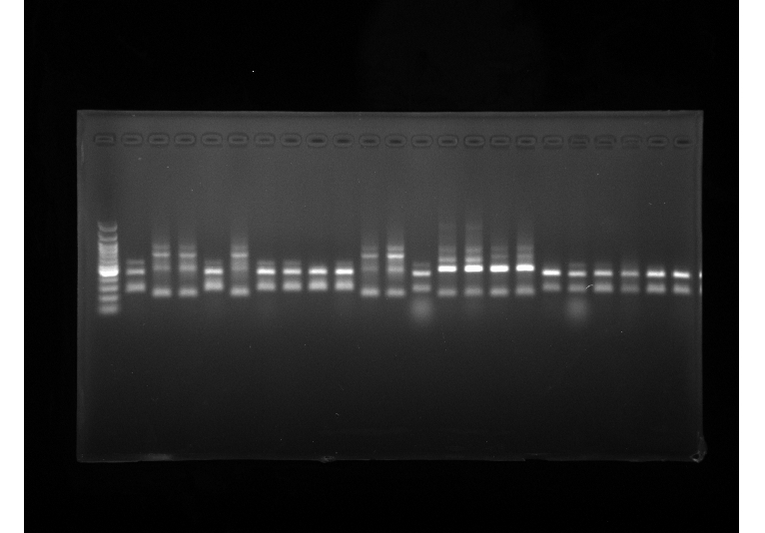

M G23 G24 G25 G26 G27 G28 G29 G30 G31 G132 G33 G34 G35 G36 G37 G38 G39 G40 G41 G42 G43 G44

1200 -
100 -
400 -
bp

b) UBC 809

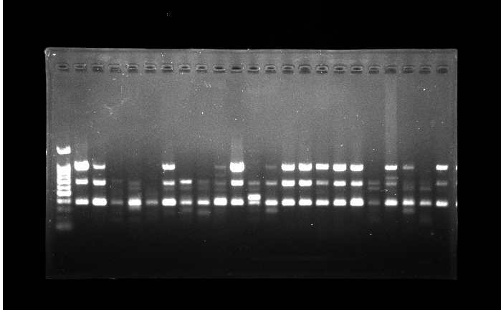

M G1 G2 G3 G4 G5 G6 G7 G8 G9 G10 G11 G12 G13 G14 G15 G16 G17 G18 G19 G20 G21 G22

1000 -

400 -
bp
100 -

c) UBC 841

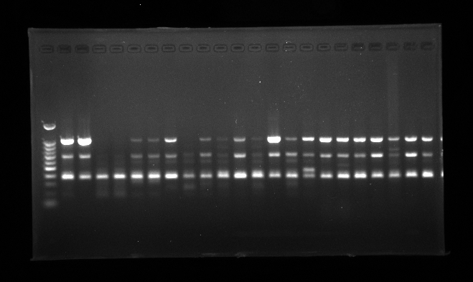
c) UBC 841
M G23 G24 G25 G26 G27 G28 G29 G30 G31 G132 G33 G34 G35 G36 G37 G38 G39 G40 G41 G42 G43 G44

1000 -

400 -
bp
100 -

Figure S1: Inter Simple Sequence (ISSR) banding profiles of 44 V. subterranea accessions. The PCR product of a) UBC 808, b) UBC 809 and c) UBC 841 primer amplified with Agarose gel electrophoresis. In each gel we run 22 accessions at a time and lane M refers to 100 bp DNA ladder and lane with numeric number refers to the accession number listed in Table 1.

Supplementary Table S1: The details of the Zheng’s Protocol used for DNA isolation from the plant leaves sample
Zheng’s Protocol for genomic DNA isolation | For DNA extraction 2.5g of fresh foliar tissue from the seedling of 14 days of age, healthy and without mechanical damage were used performing the modified protocol of Zheng, [31]. Using the mortar and pestle, the presence of liquid nitrogen young healthy leaves tissues was milled into fine powder. The ground leaves tissues were transferred in a 2-mL Eppendorf tube and mixed well with 800 𝜇l of CTAB extraction buffer [100mMTris-HCl (pH 8.0), 20 mM EDTA (pH 8.0), 1.4 M NaCl, and 2% CTAB] and 2 𝜇l 𝛽-mercapto-ethanol using vortex for 5 mins. The suspension was incubated at 65°C for 60 min with 500rpm using an electric thermal shaker with continuous gentle shaking. Afterward, an equal volume of chloroform/isoamyl alcohol, CIA (24:1 v/v), was added and the mixture was centrifuged at 4°C temperature with 14,000 rpm for 10 mins to sediment the leaf residues. Collect the supernatant, then transferred it into a new 1.5 ml tube and add an equal volume of ice-cold Isopropanol and incubated at 4°C temperature for 30 mins afterwards centrifuge the tubes again at 14,000 rpm for 5 mins to obtain the DNA pellet. To remove the RNA, the RNase enzyme (50 µg/ml) was added and incubated at 37°C temperature for 60 mins. For the purification purpose, ethanol precipitation was done by the addition of potassium acetate (5.0M) with 2 Vol. of isopropanol at -20°C temperature followed by shaking for 1-2 mins and centrifuged at 13,000 rpm at 4°C temperature for 10 mins. After discarding the top aqueous phase, the DNA pellet was principiated and washed twice by mixing 800 𝜇l 75% ethanol at -20°C then centrifuged at 13,000 rpm for 10mins, discarded the ethanol, dried at room temperature. The obtained DNA pellet is dissolved in 50 𝜇l of TE buffer (10 mM Tris, 1 mM EDTA pH 8.0). The solution with genomic DNA was measured to check the concentration and quality by the Thermo Scientific™ NanoDrop Lite Spectrophotometer (Thermo Fisher Scientific, Waltham, MA, USA). The quality of DNA extracted was also checked by running the electrophoresis (Bio-Rad, USA) on a 1% agarose gel of DNA samples. To ensure the DNA purity, ratio absorbance 260/280nm and 260/230nm of more than 1.8 were considered as a standard to proceed for the next steps. A portion of the DNA template was diluted to a final concentration of 40 ng/𝜇l as a working sample for use. Both the stock and diluted DNAs (working sample) were stored at -80°C until further use.

