The United States Government retains and the publisher, by accepting the article for publication, acknowledges that the United States Government retains a nonexclusive, paid-up, irrevocable, worldwide license to publish or reproduce the published form of this manuscript, or allow others to do so, for the United States Government purposes. The Department of Energy will provide public access to these results of federally sponsored research in accordance with the DOE Public Access Plan (http://energy.gov/downloads/doe-public-access-plan).

Supplementary Information of: High speed mapping of surface charge dynamics via Spiral Scanning Kelvin Probe Force Microscopy
Marti Checa^{1*}, Kyle P. Kelley¹, Changhyo Sun², Rama Vasudevan¹, Maxim Ziadtinov^{1,3}, Ilia Ivanov¹, Seok Joon Yun¹, Kai Xiao¹, Alp Sehirlioglu⁴, Yunseok Kim², Pankaj Sharma^{5,6}, Neus Domingo¹, Stephen Jesse¹, Liam Collins^{1*}
¹Center for Nanophase Materials Sciences, Oak Ridge National Laboratory, Oak Ridge, Tennessee 37831, United States.
²School of Advanced Materials Science and Engineering, Sungkyunkwan University, Suwon 16419, Republic of Korea.
³Computational Sciences and Engineering Division, Oak Ridge National Laboratory, Oak Ridge, TN 37923, USA.
⁴Department of Materials Science and Engineering, Case Western Reserve University, Cleveland, Ohio 44106, United States.
⁵College of Science and Engineering, Flinders University, Bedford Park, SA 5042, Australia.
⁶ARC Centre of Excellence in Future Low-Energy Electronics Technologies (FLEET), UNSW Sydney, NSW 2052, Australia.
S1: Comparison of AM-KPFM with H-KPFM
Amplitude modulated KPFM (AM-KPFM) in lift (2-pass) mode is the most common implementation of KPFM, mainly due to its easy implementation. However, as it is based in force detection instead of force gradient detection, its CPD accuracy suffers from non-local stray capacitance between cone, cantilever, and sample, resulting in a reduction of spatial resolution and quantitativeness. To solve that issue, Sugawara et al.¹ developed heterodyne KPFM (H-KPFM), which boosts short range force sensitivity reducing CPD crosstalk.
There are a few different implementations of force-gradient sensitive KPFM (see details of each implementation in ²), but 2 of them are the most commonly used:
- FM Sideband KPFM, where the frequency of electrical excitation is lower than the first eigenmode of the cantilever (ω_{E} < ω₀), while the detection is performed using the sidebands at ω_{m} ± ω_{E} with the mechanical oscillation frequency ω_{m} at the first eigenmode. In this implementation, ω_{m} should be sufficiently high to decouple the detection sidebands from the mechanical carrier, which turns into a decrease of the SNR as detection is performed further away from the resonance. Therefore, this mode typically uses higher AC voltages and low detection bandwidths, limiting the speed of the measurement.
- FM Heterodyne KPFM, where the electrical excitation is performed at ω_{E=} ω₁₋ ω₀, which shifts the sideband frequency to the second eigenmode of the cantilever ω_{1.} The main advantage of it being the use of resonance amplification, boosting SNR, enabling faster imaging speeds. This is the implementation we have used in this work, and it is also the implementation of the benchmark high-speed KPFM by Garret et al^{3,4}.
In Figure S1 we show the implementation of AM-KPFM and H-KPFM onto the same sample (interdigitated electrodes deposited onto glass). CPD maps are acquired during DC bias application between the planar electrodes. Images (S1a and S1b) show the superior locality of H-KPFM and profiles in S1c show how AM-KPFM fails to recover the ±1.5V externally applied due to the previously mentioned artifacts. Finally, in Figure S1d both techniques are also applied to image 2D WS₂ flakes deposited onto a silicon substrate (same sample as Figure 1 in the main manuscript), where we can see the increased spatial resolution of H-KPFM through the sharper edges of the flake as compared to the AM-KPFM image (S1d Inset).
Figure S1: a) AM-KPFM and b) H-KPFM of the interdigitated electrodes, applying an external voltage of ±1.5V. c) Profiles of the AM-KPFM and H-KPFM images. d) H-KPFM of a WS2 flake grown on a Si substrate. Inset is the AM-KPFM of the same region.
S2: Detailed schematics of the experimental setup
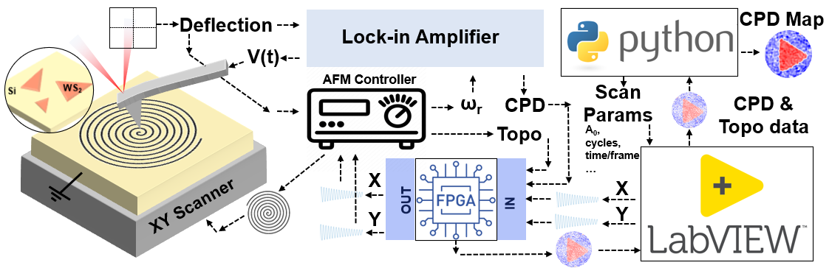
Figure S2: Detailed schematic of the experimental setup for SS-KPFM: A python script sets up the scan parameters and sends it to LabVIEW, which generate the X and Y piezo volage signals and inputs it to the FPGA, which sends it to the XY scanner through the AFM controller. H-KPFM is running in parallel using an external Lock-in amplifier while the spiral scan path is being performed. CPD and topography are read by the FPGA and sent to LabVIEW. Finally, Python performs the GP processing on sparse scan data to obtain the final CPD Map.
S3: SNR analysis
Figure S3: a) Raw data of raster scan H-KPFM image. b) Masked raster scan H-KPFM image. c) GP reconstructed image in b. e) Raw data of SS-KPFM. F) GP reconstructed image in e. d) Profiles along the black dashed line.

S4: Correlation Length parameter for GP inpainting
In Figure S1 we can see the effect of the correlation length for the GP algorithm. There is a compromise between spatial resolution and signal to noise ratio. Images inpainted using longer correlation length seem to have less spatial resolution and less noise appearing as more “blurred” but “smooth”, whereas images using shorter correlation length seem to have more spatial resolution, but also more noise.
Figure S4: a) Raw data for the 24 cycles spiral on the WS2 triangular flake (same as in Figure 2 of the main manuscript). b) GP inpainting with L=2. c) GP inpainting with L=3. d) GP inpainting with L=4. e) GP inpainting with L=5. f) GP inpainting with L=7. g) GP inpainting with L=10. h) Profiles.

S5: Animation of SS-KPFM for negative bias on LAO/STO. (Attached)
S6: Animation of SS-KPFM for positive bias on LAO/STO. (Attached)

S7: Bulk Impedance measurements
Figure S5: a) Nyquist plot of the LAO/STO planar device for a 100mV AC bias. b) Characteristic times of the device derived from a. c) Nyquist plot of the LAO/STO planar device for a 500mV AC bias. d) Characteristic times of the device derived from c.

S8: CPD evolution with lateral DC bias
CPD signal shows that the long characteristic time (10s range) is not activated for biases below 500mV, where there is only a fast response (on the ms range). Which points towards the slower response being related to the activation of a faradaic process.
Figure S6: a) H-KPFM CPD maps over the grounded electrode as a function of lateral DC bias from 0V to +6V. b) CPD line profiles over each different DC bias step. c) CPD temporal profile along a black dashed line in a.
S9: Animation of SS-KPFM for +10V. (Attached)
S10: Animation of SS-KPFM for +8V. (Attached)
S11: Animation of SS-KPFM for +5V. (Attached)
S12: Animation of SS-KPFM for -5V. (Attached)
S13: Animation of SS-KPFM for -8V. (Attached)
S14: Animation of SS-KPFM for -10V. (Attached)
S15: Gradient images for TiO₂ data set.
Figure S7: a) Topography image. b) Gradient of the topography, which highlights the grain boundaries. c) and d) are CPD images after 10V and 8V bias pulses, respectively. e) and f) are the corresponding CPD gradient images, where the borders of the charge injected regions are highlighted. Gradient images are calculated as the square root of the sum of the squares of the gradient along x and y directions.

References:
1 Sugawara, Y. et al. High potential sensitivity in heterodyne amplitude-modulation Kelvin probe force microscopy. Applied Physics Letters 100, 223104 (2012).
2 Axt, A., Hermes, I. M., Bergmann, V. W., Tausendpfund, N. & Weber, S. A. Know your full potential: Quantitative Kelvin probe force microscopy on nanoscale electrical devices. Beilstein journal of nanotechnology 9, 1809-1819 (2018).
3 Garrett, J. L. & Munday, J. N. Fast, high-resolution surface potential measurements in air with heterodyne Kelvin probe force microscopy. Nanotechnology 27, 245705 (2016).
4 Garrett, J. L. et al. Real-time nanoscale open-circuit voltage dynamics of perovskite solar cells. Nano letters 17, 2554-2560 (2017).

