Extended data
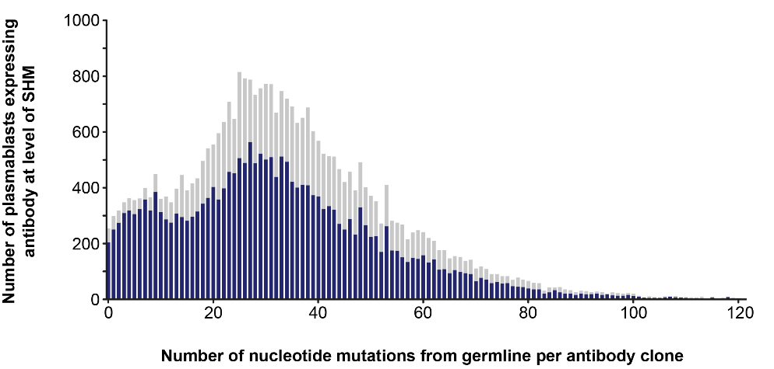
Extended Data Fig. 1 | Levels of SHM among antibody sequences. Histogram of the number of nucleotide mutations from germline of combined IgG heavy and light chains from blood PBs collected 7 days after administration of the third dose (blue, n = 22,319) or fourth dose (grey, n = 10,629) of RTS,S.

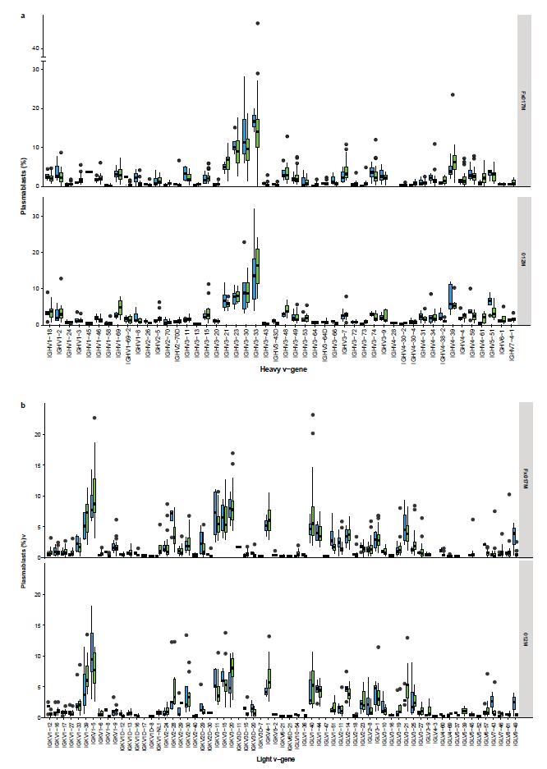
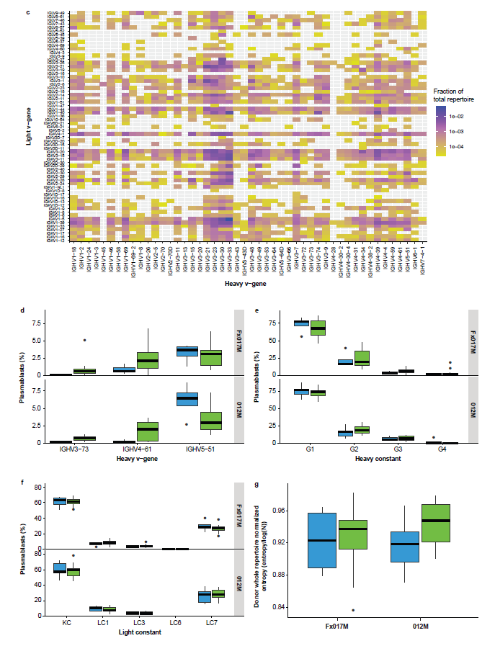

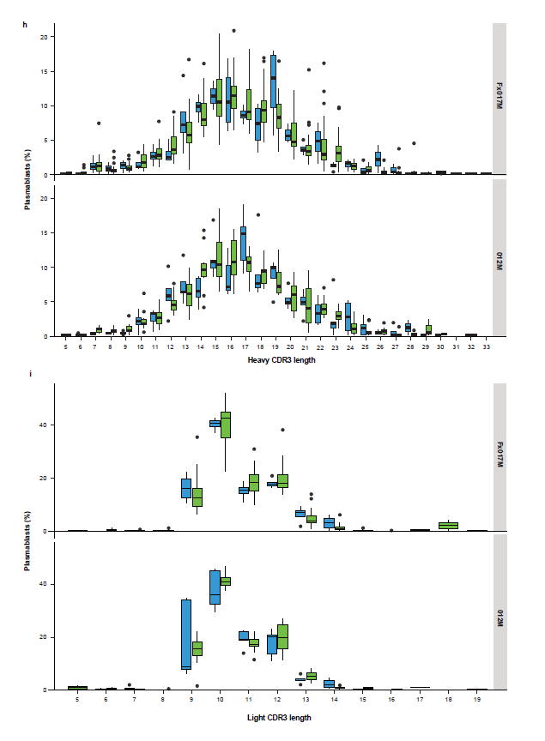
Extended Data Fig. 2 | IgG sequence and repertoire features of the PB response after the third dose of RTS,S. a–c Germline V-gene usage compared between protected (green, n = 36) and not protected (blue, n = 9) subjects and across dose groups for a, heavy and, b, light chains, with IGHV3-30, IGHV3-33, KV1-5, KV3-20, and LV1-40 showing high prevalence. c, Specific pairings of heavy and light chain genes. d, Three heavy chain germline genes, IGHV3-73, IGHV4-61, and IGHV5-51, were initially associated with vaccinees’ protection status (P < 0.05, Wilcoxon Rank Sum test) but were not associated after correcting for multiple hypothesis testing. All were P > 0.05, Benjamini–Hochberg or Bonferroni tests. No significant associations were detected between vaccinees’ protection status and dose groups for, e–f, IgG heavy and light chain constant region subclass (P > 0.05 for all analyses, Wilcoxon Rank Sum test), g, repertoire clonality for analyses that included the lineages that contain only one PB (Normalised Shannon entropy, P > 0.05 for all analyses, Wilcoxon rank sum test or Kolmogorov–Smirnov test), and length of the, h, heavy or, i, light chain complementarity determining region 3 (CDR3, P > 0.05 for both, Wilcoxon Rank Sum test). Boxes indicate interquartile ranges, lines within boxes are medians, whiskers represent farthest data points within 1.5 x the interquartile range, and points outside whiskers are plotted individually as outliers.

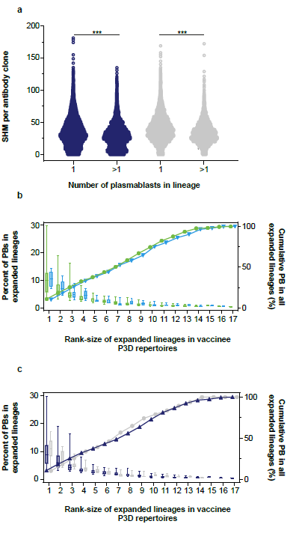
Extended Data Fig. 3 | SHM and size distribution of expanded PB IgG lineages. a, Range of nucleotide mutations from germline in heavy plus light chain for antibodies in expanded lineages (>1 PB) compared to antibodies in lineages that lack evidence of recent expansion (1 PB) from PBs collected 7 days after administration of the third dose (blue, n = 11,478 and n = 10,841, respectively) or fourth dose (grey, n = 5,538 and n = 5,091, respectively) of RTS,S, ***P < 0.0001 unpaired two-tailed Mann–Whitney test. b–c, By vaccinee, the size of each expanded lineage was calculated by dividing the number of PBs in that lineage by the number of PBs in all expanded lineages within each repertoire and then assigning a rank-size. Box and whisker plots represent the distribution of lineage sizes across vaccinees for each rank-size from, b, protected (green, n = 36) versus not protected (blue, n = 9) vaccinees, and, c, from vaccinees administered a third standard dose (grey, n = 15) versus vaccinees administered a delayed fractional dose (blue, n = 30) of RTS,S. Boxes indicate interquartile ranges, lines within boxes are medians, and whiskers represent minimum and maximum across vaccinees.

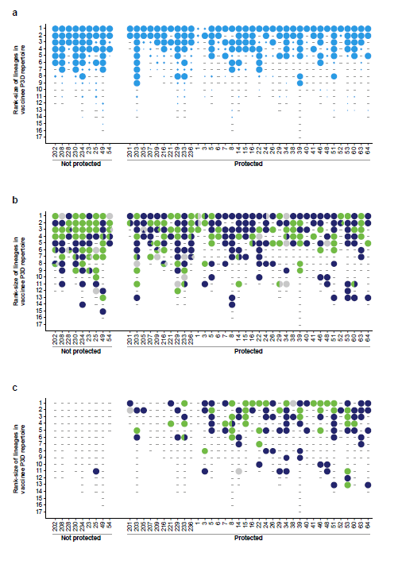
Extended Data Fig. 4 | Antibody lineages tested in binding assays and reactivity to CSP or HBsAg. a–c, Rank-size of expanded lineages in each protected and not protected vaccinee repertoire from PBs collected 7 days after the third dose of RTS,S. a, Expanded PB antibody lineages (circles representing ≥1 lineages) for each rank-size and vaccinee from which a mAb was selected, recombinantly expressed and screened (n = 349 mAbs, 282 circles) in the CSP ELISA. Circle sizes are proportional to the fraction of lineages tested among all lineages observed at each rank-size and vaccinee. Lineages from a vaccinee that have the same number of PBs have the same rank-size. The largest circles indicate all lineages from the vaccinee at that rank-size were tested. The smallest circle indicates only one 1 of the 58 lineages observed from the vaccinee at that rank-size was tested. In some cases, none of the lineages from a vaccinee at an indicated rank-size were tested (grey bars). b–c, Expanded PB antibody lineages (circles representing 1–5 lineages) for each rank-size and vaccinee from which a mAb was tested in, b, a CSP ELISA, reactive (green, n = 135 mAbs, 94 circles), indeterminant (grey, n = 29 mAbs, 14 circles), not reactive (blue, n = 185 mAbs, 144 circles), or a combination of these outcomes for different mAbs from lineages of same rank-size and vaccinee (pie charts of mixed colours, 30 circles), and tested in, c, an HBsAg ELISA, reactive (green, n = 38 mAbs, 36 circles), indeterminant (grey, n = 3 mAbs, three circles), not reactive (blue, n = 77 mAbs, 72 circles), or a combination of these outcomes for different mAbs from lineages of same rank-size and vaccinee (pie charts of mixed colours, two circles).

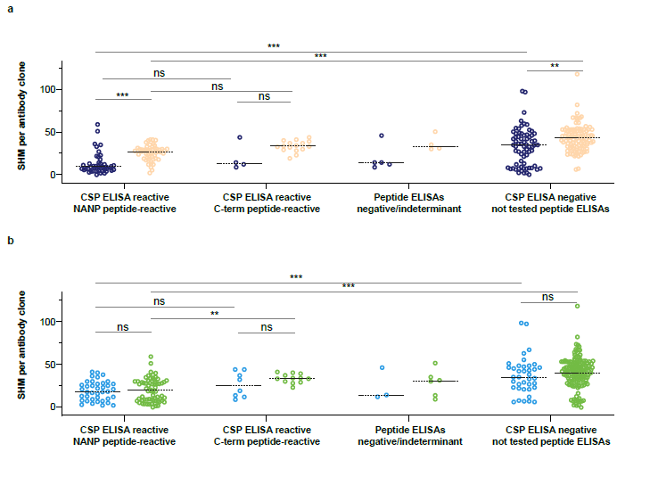
Extended Data Fig. 5 | SHM and CSP-peptide binding of mAbs versus RTS,S dose group and vaccinee protection status. a–b, Distribution of SHM levels for mAbs from expanded lineages of vaccinees, a, administered a third standard dose (dark blue, n = 15) or a delayed fractional dose (orange, n = 30) of RTS,S with mAbs shown reactive to CSP repeat region (NANP6, n = 45 and n = 53, respectively), to the CSP C-terminal region (C-terminal, n = 4 and n = 16, respectively), or neither peptide (negative, n = 5 and n = 4, respectively) in comparison to mAbs not reactive in the CSP ELISA (n = 72 and n = 113, respectively), and, b, from vaccinees that were protected (green, n = 36) or not protected (light blue, n = 9) with mAbs shown reactive to CSP repeat region (n = 59 and n = 39, respectively)], to the CSP C-terminal region (n = 12 and n = 8, respectively), or neither peptide (negative, n = 6 and n = 3, respectively) in comparison to mAbs not reactive in CSP ELISA (n = 147 and n = 38, respectively), lines are medians, ***P < 0.0001, **P < 0.001, *P < 0.02, or P > 0.1 (“ns”), unpaired two-tailed Mann–Whitney test.

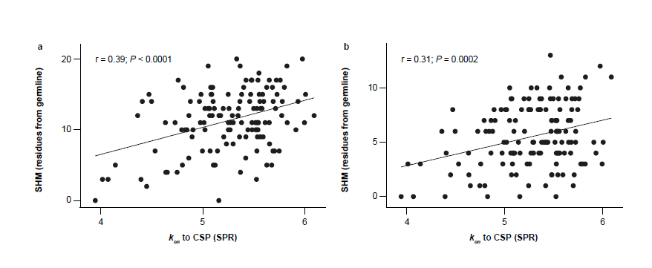
Extended Data Fig. 6 | CSP-binding on-rates and mAb residue divergence from germline. a–b, SPR binding on-rates (k_{on}) to CSP of mAbs (n = 141) from 35 of the most efficacious lineages tested compared to the number of, a, heavy, and, b, light chain residue differences from germline, linear regression of log-transformed data shown. For correlations of non-transformed data, P < 0.008 for all comparisons (Spearman test), and P < 0.007 for all comparisons (Pearson test), see Extended Data Table 1.

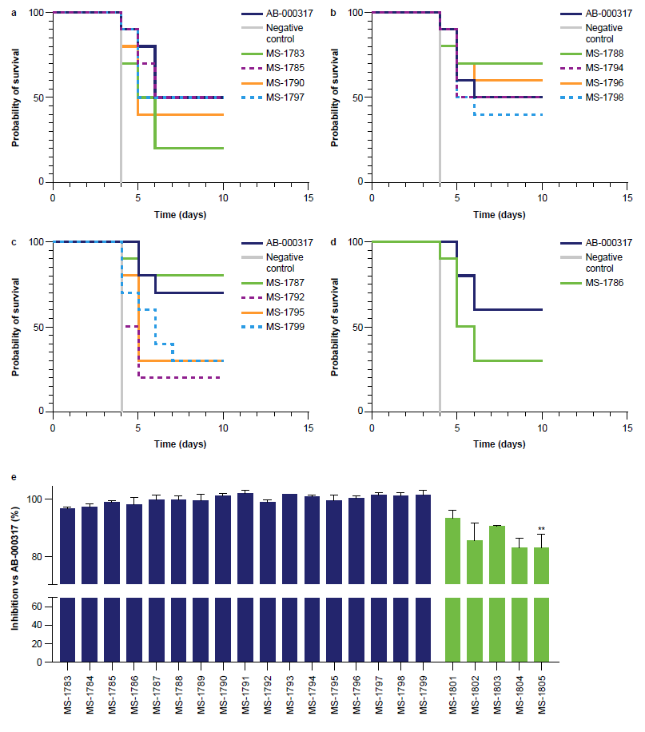
Extended Data Fig. 7 | In vivo activity of engineered mAb variants. a–d, Mosquito-bite parasitaemia survival curves for 13 variants (n = 10 mice), including the eight that had the best aggregate score from the developability assays. e, Sporozoite liver burden percent inhibition compared to untreated, infected mice (geometric mean, n = 5) and normalised to the activity of AB-000317, mean+SEM, 2–5 independent experiments per mAb, **P = 0.005 or P > 0.05 for all other variants, Dunn’s multiple comparisons test verses AB-000317 (see Extended Data Table 3 for details).

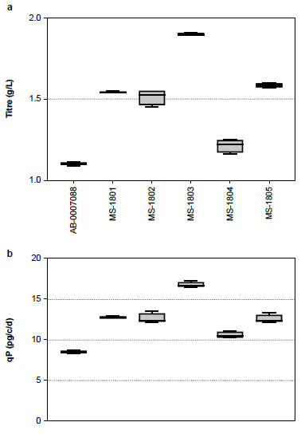
Extended Data Fig. 8 | Characterisation of stable cell production pools generated from engineered mAb variants of AB-007088. a Production titres, Titre (g/L), and b, cell-specific productivity (qP, pg per cell per day) compared to parental AB-007088. Boxes indicate interquartile ranges, lines within boxes are medians, and whiskers represent minimum and maximum across replicate pools (4 per engineered variant).

Extended Data Table 1 | Correlations of SHM, binding data, and in vivo inhibition
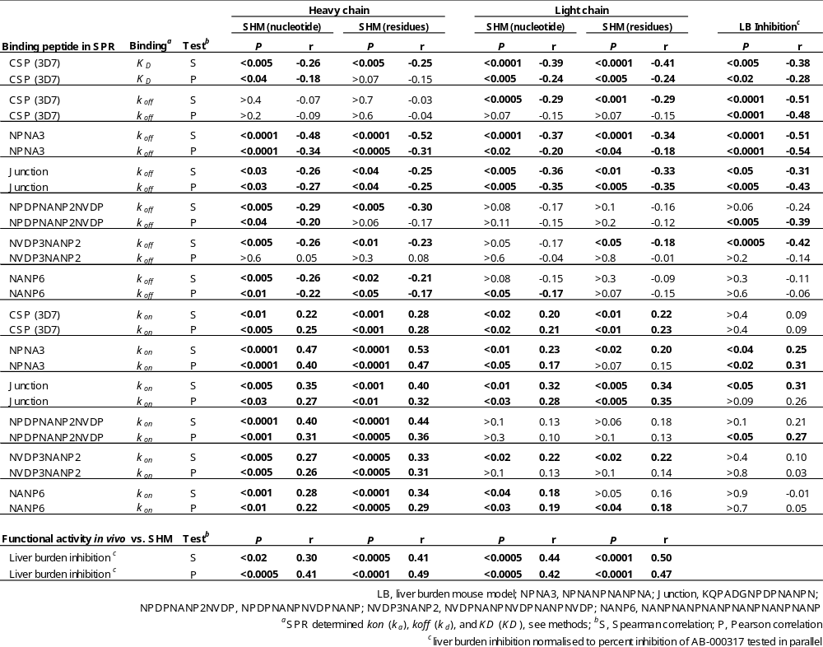
Extended Data Table 2 | Binding data to CSP-derived peptides of engineered mAbs
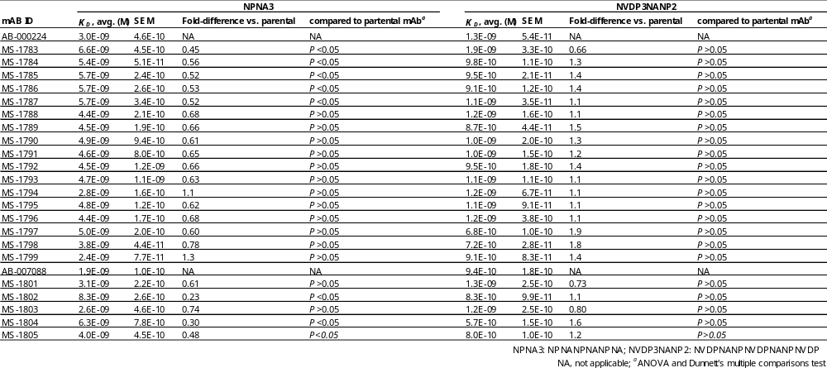

Extended Data Table 3 | Developability rank and in vivo data of engineered mAbs
