NiZnFe₂O₄: An eco-compatible and magnetically separable catalyst for multicomponent synthesis of 2-amino-4H-chromenes
Sandip P. Patil*, Sachinkumar K. Shinde, Vikram M. Desai, Arvind A. Pawar, Suresh S. Patil
¹Synthetic Research Laboratory, PG Department of Chemistry, PDVP College, (Affiliated to Shivaji University, Kolhapur) Tasgaon, Sangli (MS), India-416312
*Corresponding author, Email: sagar.chem30@gmail.com

Electronic Supplemental Information (ESI)

Sr. No. | Table of Contents | Pages
1 | FTIR, ¹H and ¹³C NMR spectroscopic data of all products | 1-6
2 | FTIR, ¹H and ¹³C NMR spectrum of selected products of 4-H-chromene derivatives | 7-18

SPECTRAL DATA
- Spectroscopic data of synthesized compounds 4a-s and 5a-j:

2-amino-4-(nitromethyl)-4H-chromene-3-carbonitrile (4a)
FTIR (KBr, ν cm⁻¹): 3447 and 3336 (NH₂), 2187, 1649, 1534, 1376, 1223, 755 cm⁻¹; ¹H NMR (400 MHz, DMSO-d₆): δ 7.31 (bs, 2H, NH₂), 7.00-7.18 (m, 4H, Ar-H), 4.77 (m, 1H, CH), 4.65 (m, 1H, CH), 4.30 (t, 1H, CH), ppm; ¹³C NMR (100 MHz, DMSO-d₆): δ 162.12, 149.38, 129.07, 128.29, 124.74, 119.73, 119.39, 116.12, 80.72, 49.95, 34.64, ppm; Mass: 231.06 [M+].
2-amino-6-bromo-4-(nitromethyl)-4H-chromene-3-carbonitrile (4b)
FTIR (KBr, ν cm⁻¹): 3438, 3391, 3323, 2197, 1647, 1607, 1523, 1477, 1413, 1271, 1213, 807 cm⁻¹; ¹H NMR (400 MHz, DMSO-d₆): δ (300 MHz, DMSO-d6): δ = 7.62 (s, 1H, NH₂ ), 7.47 (m, J = 8.7 Hz, 1H, NH₂), 7.20 (s, 2H, Ar-H), 6.98 (d, J = 8.7 Hz, 1H, Ar-H), 4.86 (m, J = 12.8, 4.8 Hz, 1H, CH), 4.68 (m, J = 12.8, 4.8 Hz, 1H, CH), 4.32 (t, J = 4.8 Hz, 1H, CH) ppm; ¹³C NMR (100 MHz, DMSO-d₆): δ 161.81, 148.78, 131.79, 130.86, 121.96, 119.46, 118.34, 116.16, 80.34, 49.71, 39.49, 34.25 ppm; Mass: 308.97 [M+];
2-amino-6-chloro-4-(nitromethyl)-4H-chromene-3-carbonitrile (4c)
FTIR (KBr, ν cm⁻¹): 3340 and 3158(NH₂), 2200, 1716, 1589, 1543, 1463, 1402, 1204, 1113, 1069, 779 cm⁻¹ ; ¹H NMR (400 MHz, DMSO-d₆): δ 6.67 (s, 2H, NH₂), 6.43-6.46 (t, 3H, Ar-H), 4.67(t, 1H, CH),4.51-4.60 (m, 2H, CH), ppm; ¹³C NMR (100 MHz, DMSO-d₆): δ 160.40, 159.80, 156.57, 152.22, 147.57, 128.75, 116.53, 107.80, 105.96, 98.22, 85.99, 79.49, 70.53, 43.61, 32.03 ppm.
Mass: 265.03 [M+].
2-amino-6-nitro-4-(nitromethyl)-4H-chromene-3-carbonitrile (4d)
FTIR (KBr, ν cm⁻¹): 3448, 3366, 2189, 1648, 1587, 1418, 1349, 1309, 1267; ¹H NMR (300 MHz, DMSO-d6): δ = 8.40 (d, J = 2.71 Hz, 1H, Ar-H), 8.20 (dd, J = 9.0, 2.7 Hz, 1H, Ar-H), 7.38 (s, 2H, NH₂), 7.26(d, J = 9.0 Hz, 1H, Ar-H), 4.94 (dd, J = 12.7, 4.5 Hz, 1H, CH), 4.72 (dd, J = 12.7, 4.5 Hz, 1H, CH), 4.49 (t, J = 4.5 Hz, 1H, CH) ppm; ¹³C NMR (100 MHz, DMSO-d₆): δ 161.7, 153.2, 144.8, 125.1, 125.4, 121.4, 119.3, 118.2, 80.3, 50.5, 34.4 ppm.
Mass: 276.05 [M+].
2-amino-7-(diethylamino)-4-(nitromethyl)-4H-chromene-3-carbonitrile (4e)
FTIR (KBr, ν cm⁻¹): 3480, 3388, 2201, 1630, 1583, 1525, 1399, 1262, 1210, 633 cm⁻¹; ¹H NMR (400 MHz, DMSO-d₆): δ 6.98–7.00 (d, 1H, Ar-H), 6.67 (br s, 2H, -NH₂), 6.43-6.46 (m, J = 8.0, 4.4 Hz, 3H, Ar-H), 6.23 (d, J = 11.2, 4.4 Hz, 1H, CH), 4.67 (t, J = 11.2, 8.0 Hz, 1H, CH), 4.51–4.59 (m, 2H, CH₂), 1.06 (t, J = 7.1 Hz, 6H, 2 CH₃) ppm; ¹³C NMR (100 MHz, DMSO-d₆): δ 160.39, 159.80, 156.57, 152.22, 147.97, 128.75, 116.52, 107.80, 105.96, 98.22, 85.99, 79.49, 70.52, 43.61, 32.02, 12.34 ppm;
Mass: 302.14 [M+].
2-amino-5-methoxy-4-(nitromethyl)-4H-chromene-3-carbonitrile (4f)
FTIR (KBr, ν cm⁻¹): 3443, 3332, 2190, 1647, 1639, 1622, 1599, 1488, 1470, 1421, 1252, 1091 cm⁻¹; ¹H NMR (400 MHz, DMSO-d₆): δ 7.28 (t, J = 8.2 Hz, 1H, Ar-H), 7.16 (s, 2H, NH₂), 6.84 (d, J = 8.2 Hz, 1H, Ar-H), 6.65 (d, J = 8.2 Hz, 1H, Ar-H), 4.66–4.56 (m, 2H, CH), 4.27 (t, J = 4.8 Hz, 1H, CH), 3.83 (s, 3H, CH₃) ppm; ¹³C NMR (100 MHz, DMSO-d₆): δ 162.3, 156.8, 150.4, 129.2, 120.7, 108.6, 108.4, 107.6, 79.5, 56.4, 50.8, 31.6 ppm.
Mass: 261.07 [M+].
2-amino-8-ethoxy-4-(nitromethyl)-4H-chromene-3-carbonitrile (4g)
FTIR (KBr, ν cm⁻¹): 3519 and 3469(NH₂), 3298, 1675, 1618, 1538, 1478, 1381, 641 cm⁻¹; ¹H NMR (400 MHz, DMSO-d₆): δ 7.10 (t, J = 8.0 Hz, 1H, ArH), 7.03 (dd, J1 = 8.5 Hz, J2 = 1.2 Hz, 1H, ArH), 6.88 (dd, J1 = 7.5 Hz, J2 = 1.2 Hz, 1H, ArH), 6.48 (s, 2H, NH₂), 4.80 (dd, J1 = 12.3 Hz, J2 = 5.2 Hz, 1H, CH₂), 4.69 (dd, J1 = 12.3 Hz, J2 = 5.6 Hz, 1H, CH₂), 4.34 (t, J = 5.4 Hz, 1H, CH), 4.13 (q, J = 7.0 Hz, 2H, OCH₂), 1.37 (t, J = 7.0 Hz, 1H, CH₃); ¹³C NMR (100 MHz, DMSO-d₆): δ 164.4, 148.2, 140.9, 125.3, 122.8, 120.1, 119.7, 115.1, 83.1, 65.2, 54.2, 37.4, 16.4.
Mass: 275.09 [M+]
2-amino-6,8-dibromo-4-(nitromethyl)-4H-chromene-3-carbonitrile (4h)
FTIR (KBr, ν cm⁻¹): 3429, 3315, 2214, 1663, 1619, 1574, 1540, 1467, 1422, 1379, 1254, 1201 cm^{–1}; ¹H NMR (400 MHz, DMSO-d₆): δ 7.70 (d, J = 2.5 Hz, 1H, Ar-H), 7.54 (d, J = 2.5 Hz, 1H, Ar-H), 7.39 (s, 2H, NH₂), 4.85 (dd, J = 12.6, 4.8 Hz, 1H, CH), 4.68 (dd, J = 12.6, 4.8 Hz, 1H, CH), 4.39 (t, J = 4.8 Hz, 1H, CH) ppm; ¹³C NMR (100 MHz, DMSO-d₆): δ 161.5, 144.2, 128.6, 128.5, 127.4, 123.4, 121.5, 119.2, 80.4, 49.7, 34.3 ppm.
Mass: 386.89 [M+].
2-amino-6,8-dichloro-4-(nitromethyl)-4H-chromene-3-carbonitrile (4i)
FTIR (KBr, ν cm⁻¹): 3426, 3319, 2214, 1665, 1619, 1573, 1540, 1467, 1425, 1380, 1249, 1200 cm^{–1}; ¹H NMR (400 MHz, DMSO-d₆): δ 7.69 (d, J = 2.5 Hz, 1H, Ar-H), 7.55 (d, J = 2.5 Hz, 1H, Ar-H), 7.39 (s, 2H, NH₂), 4.90 (dd, J = 12.7, 4.8 Hz, 1H, CH), 4.70 (dd, J = 12.7, 4.8 Hz, 1H, CH), 4.39 (t, J = 4.9 Hz, 1H, CH) ppm; ¹³C NMR (100 MHz, DMSO-d₆): δ 161.2, 144.4, 128.7, 128.5, 127.1, 123.3, 121.4, 119.1, 80.2, 49.8, 34.4 ppm.
Mass: 298.99 [M+].
2-amino-4-(1-nitroethyl)-4H-chromene-3-carbonitrile (4j)
FTIR (KBr, ν cm⁻¹): 3426, 3310, 3204, 2190, 1630, 1608, 1534, 1409, 1387, 611cm⁻¹; ¹H NMR (400 MHz, DMSO-d₆): δ 7.25–7.36 (m, 4H, Ar-H), 7.02-7.20 (m, 2H, NH₂), 7.10–7.01 (m, 1H), 4.79 (m, 1H, CH), 4.22 (m, 1H, CH), 1.31 (m, 3H, CH₃) ppm; ¹³C NMR (100 MHz, DMSO-d₆): δ 163.21, 163.04, 149.92, 149.84, 129.17, 128.51, 128.31, 124.81, 120.33, 119.89, 119.81, 119.38, 116.17, 115.99, 87.35, 86.96, 49.17, 48.36, 14.16, 13.55 ppm;
Mass: 245.08 [M+].
2-amino-7-(diethylamino)-4-(1-nitroethyl)-4H-chromene-3-carbonitrile (4k)
FTIR (KBr, ν cm⁻¹): 3452, 3331, 2203, 1709, 1631, 1590, 1540, 1463, 1405, 1353, 1207, 637 cm⁻¹; ¹H NMR (400 MHz, DMSO-d₆): δ 6.69–6.71 (br s, 2H, NH₂), 6.32-6.83 (m, 3H, Ar-H), 6.29-6.43 (m, J = 11.2, 4.4 Hz, 1H, CH), 4.85-4.86 (d, J = 11.2, 8.0 Hz, 1H, CH), 4.65–4.71 (q, J = 7.1 Hz, 4H, 2CH₂), 1.01-1.08 (t, J = 7.1 Hz, 6H, 2CH₃) 1.23 (m, 3H, CH₃), ppm; ¹³C NMR (100 MHz, DMSO-d₆): δ 160.93, 159.86, 156.59, 153.05, 148.21, 128.86, 116.39, 107.63, 104.64, 98.12, 86.91, 84.49, 70.92, 43.59, 36.96, 12.57, 12.32, ppm;
Mass: 316.15 [M+].
ethyl 2-amino-4-(nitromethyl)-4H-chromene-3-carboxylate (5a)
FTIR (KBr, ν cm⁻¹): 3448, 3303, 1675, 1626, 1529, 1465, 1407, 1293, 606 cm⁻¹; ¹H NMR (400 MHz, DMSO-d₆): δ 7.02–7.32 (m, 4H, Ar-H), 7.75 (br s, 2H, NH₂), 4.66 (m, J = 8.0, 4.4 Hz, 1H), 4.54 (m, J = 11.2, 4.4 Hz, 1H, CH), 4.45 (t, J = 11.2, 8.0 Hz, 1H, CH), 4.04–4.18 (m, 2H, CH₂), 1.23 (t, J = 7.1 Hz, 3H, CH₃) ppm; ¹³C NMR (100 MHz, DMSO-d₆): δ 167.53, 162.23, 149.66, 128.75, 128.41, 124.56, 121.83, 115.74, 81.39, 70.35, 58.93, 34.05, 14.35 ppm;
Mass: 278.09 [M+].
ethyl 2-amino-6-bromo-4-(nitromethyl)-4H-chromene-3-carboxylate (5b)
FTIR (KBr, ν cm⁻¹): 3460, 3308, 1679, 1618, 1543, 1477, 1413, 1378, 1314, 1292, 1223 cm^{–1}; ¹H NMR (400 MHz, DMSO-d₆): δ 7.32 (dd, J = 8.6, 2.4 Hz, 1H, Ar-H), 7.36 (d, J = 2.5 Hz, 1H, Ar-H), 6.89 (d, J = 8.6 Hz, 1H, Ar-H), 6.80–5.88 (br s, 2H, NH₂), 4.57 (dd, J = 7.5, 4.2 Hz, 1H, CH), 4.58 (dd, J = 11.5, 4.2 Hz, 1H, CH), 4.45 (dd, J = 11.5, 7.5 Hz, 1H, CH), 4.30–4.18 (m, 2H, CH₂), 1.34 (t, J = 7.2 Hz, 3H, CH₃) ppm¹³C NMR (100 MHz, DMSO-d₆): δ 167.8, 161.4, 148.7, 131.9, 130.4, 123.5, 117.7, 117.5, 80.8, 72.9, 59.7, 33.6, 14.2 ppm.
Mass: 356 [M+].
ethyl 2-amino-6-chloro-4-(nitromethyl)-4H-chromene-3-carboxylate (5c)
FTIR (KBr, ν cm⁻¹): 3472, 3302, 2980, 1668, 1623, 1549, 1512, 1478, 1419, 1376, 1319, 1290, 1220 cm^{–1}; ¹H NMR (400 MHz, DMSO-d₆): δ 7.19 (dd, J = 8.5, 2.4 Hz, 1H, Ar-H), 7.17 (d, J = 2.3 Hz, 1H, Ar-H), 6.92 (d, J = 8.5 Hz, 1H, Ar-H), 6.80–5.95 (br s, 2H, NH₂), 4.57 (dd, J = 7.4, 4.2 Hz, 1H, CH), 4.57 (dd, J = 11.7, 4.2 Hz, 1H, CH), 4.47 (dd, J = 11.7, 7.5 Hz, 1H, CH), 4.30–4.18 (m, 2H, CH₂), 1.33 (t, J = 7.2 Hz, 3H, CH₃) ppm; ¹³C NMR (100 MHz, DMSO-d₆): δ 167.4, 161.2, 148.6, 129.4, 128.6, 127.9, 123.5, 117.3, 80.2, 72.0, 59.7, 33.7, 14.4 ppm.
Mass: 312.05 [M+].
ethyl 2-amino-6-nitro-4-(nitromethyl)-4H-chromene-3-carboxylate (5d)
FTIR (KBr, ν cm⁻¹): 3458 and 3336(NH₂), 1640, 1662, 1548, 1443, 1345, 1248, 1070, 748 cm⁻¹; ¹H NMR (400 MHz, DMSO-d₆): δ 6.97-7.31 (m, 3H, Ar-H), 6.24-6.76 (bs, 2H, NH₂), 4.64-4.76 (dd, 1H, CH), 4.60 (dd,1H, CH), 4.37 (dd,1H, CH), 4.22 (q, 2H, CH₂), 1.39 (t, 3H, CH₃), ppm; ¹³C NMR (100 MHz, DMSO-d₆): δ (75 MHz,CDCl₃): δ 170.2, 167.1, 159.8, 149.2, 129.7, 128.6, 128.4, 120.7, 81.2, 71.5, 60.4, 34.3, 15.3, ppm;
Mass: 323.08 [M+].
ethyl 2-amino-5-methoxy-4-(nitromethyl)-4H-chromene-3-carboxylate (5e)
FTIR (KBr, ν cm⁻¹): 3440, 3312, 2980, 1684, 1641, 1544, 1523, 1470, 1438, 1284, 1226, 1204, 1099, 1071 cm^{–1}; ¹H NMR (400 MHz, DMSO-d₆): δ 7.20 (t, J = 8.3 Hz, 1H, Ar-H), 6.64 (d, J = 8.3 Hz, 1H, Ar-H), 6.62 (d, J = 8.3 Hz, 1H, Ar-H), 4.67–4.58 (m, 3H, CH), 4.31–4.15 (m, 2H, CH₂), 3.88 (s, 3H, CH₃), 1.35 (t, J = 7.0 Hz, 3H, CH₃) ppm¹³C NMR (100 MHz, DMSO-d₆): δ 167.8, 161.3, 156.4, 151.5, 128.1, 110.7, 107.7, 105.0, 79.7, 73.4, 59.6, 55.5, 30.4, 14.7 ppm.
Mass: 308.091 [M+].
ethyl 2-amino-6,8-dibromo-4-(nitromethyl)-4H-chromene-3-carboxylate (5f)
FTIR (KBr, ν cm⁻¹): 3452, 3319, 1670, 1619, 1575, 1547, 1522, 1454, 1404, 1381, 1343, 1312, 1279, 1249 cm^{–1}; ¹H NMR (400 MHz, DMSO-d₆): δ 7.62 (d, J = 2.2 Hz, 1H, Ar-H), 7.32 (d, J = 2.2 Hz, 1H, Ar-H), 6.95–5.79 (br s, 2H, NH₂), 4.69 (dd, J = 7.7, 4.2 Hz, 1H, CH), 4.52 (dd, J = 11.7, 4.3 Hz, 1H, CH), 4.43 (dd, J = 11.7, 7.9 Hz, 1H, CH), 4.24 (q, J = 7.2 Hz, 2H, CH₂), 1.35 (t, J = 7.2 Hz, 3H, CH₃) ppm; ¹³C NMR (100 MHz, DMSO-d₆): δ 167.2, 161.5, 146.6, 135.4, 130.7, 125.8, 117.1, 111.8, 80.3, 72.9, 60.4, 34.8, 14.4 ppm.
Mass: 433.91 [M+].
ethyl 2-amino-6,8-dichloro-4-(nitromethyl)-4H-chromene-3-carboxylate (5g)
FTIR (KBr, ν cm⁻¹): 3464, 3319, 1676, 1619, 1580, 1538, 1458, 1401, 1380, 1319, 1278, 1250 cm⁻¹; ¹H NMR (400 MHz, DMSO-d₆): δ 7.34 (d, J = 2.4 Hz, 1H, Ar-H), 7.09 (d, J = 2.4 Hz, 1H, Ar-H), 6.94–5.72 (br s, 2H, NH₂), 4.60 (dd, J = 7.8, 4.2 Hz, 1H, CH), 4.50 (dd, J = 11.7, 4.2 Hz, 1H, CH), 4.40 (dd, J = 11.7, 7.9 Hz, 1H, CH), 4.30–4.20 (m, 2H, CH₂), 1.33 (t, J = 7.2 Hz, 3H, CH₃) ppm; ¹³C NMR (100 MHz, DMSO-d₆): δ 167.5, 161.8, 144.5, 129.3, 129.7, 126.2, 124.5, 122.2, 80.1, 72.8, 60.0, 34.9, 14.2 ppm;
Mass: 346.01[M+].
ethyl 2-amino-8-methoxy-4-(nitromethyl)-4H-chromene-3-carboxylate (5h)
FTIR (KBr, ν cm⁻¹): 3521 and 3468(NH2), 3296, 1672, 1615, 1540, 1479, 1378, 640 cm⁻¹; ¹H NMR (400 MHz, DMSO-d₆): δ 6.98 -7.09 (m, 3H, Ar-H), 7.82 (bs, 2H, NH₂), 4.6, 4.5 (t, 1H, CH), 4.43 (d,1H, CH₂), 4.10 (m, 2H, CH₂), 3.81 (s, 3H, OCH₃), 1.22 (t, 3H, CH₃), ppm; ¹³C NMR (100 MHz, DMSO-d₆): δ 167.57, 162.19, 146.92, 138.95, 124.42, 122.66, 119.40, 111.48, 81.36, 70.28, 58.95, 55.62, 34.17, 14.35, ppm; Mass: 308.01 [M+].
ethyl 2-amino-6-methoxy-4-(nitromethyl)-4H-chromene-3-carboxylate (5i)
FTIR (KBr, ν cm⁻¹): 3420, 3295, 2978, 1670, 1625, 1592, 1541, 1489, 1418, 1375, 1340, 1294, 1270, 1222 cm^{–1}; ¹H NMR (400 MHz, DMSO-d₆): δ 6.92 (d, J = 9.0 Hz, 1H, Ar-H), 6.78 (dd, J = 9.0, 3.0 Hz, 1H, Ar-H), 6.65 (d, J = 2.9 Hz, 1H, Ar-H), 6.60–5.99 (br s, 2H, NH₂), 4.64 (dd, J = 8.0, 4.4 Hz, 1H, CH), 4.59 (dd, J = 11.3, 4.4 Hz, 1H, CH), 4.37 (dd, J = 11.2, 8.0 Hz, 1H, CH), 4.27–4.19 (m, 2H, CH₂), 3.76 (s, 3H, CH₃), 1.33 (t, J = 7.1 Hz, 3H, CH₃) ppm; ¹³C NMR (100 MHz, DMSO-d₆): δ 167.9, 162.4, 156.5, 144.6, 123.3, 116.2, 114.1, 112.4, 80.7, 72.5, 59.9, 55.2, 34.8, 14.4 ppm.
Mass: 308.01 [M+].
ethyl 2-amino-5,7-dichloro-4-(nitromethyl)-4H-chromene-3-carboxylate (5j)
FTIR (KBr, ν cm⁻¹): 3445, 3319, 2968, 1688, 1644, 1609, 1556, 1512, 1460, 1408, 1377, 1305, 1268, 1214 cm^{–1}; ¹H NMR (400 MHz, DMSO-d₆): δ 7.23 (d, J = 2.0 Hz, 1H, Ar-H), 6.97 (d, J = 2.0 Hz, 1H, Ar-H), 6.78–5.92 (br s, 2H, NH₂), 4.72–4.64 (m, 2H), 4.21–4.41 (m, 2H), 1.30 (t, J = 7.1 Hz, 3H) ppm; ¹³C NMR (100 MHz, DMSO-d₆): δ 167.2, 160.8, 151.9, 134.4, 132.4, 125.1, 119.4, 115.2, 78.9, 72.2, 60.8, 32.4, 14.9 ppm.
Mass: 346.01 [M+]

- Spectra of selected synthesized compounds
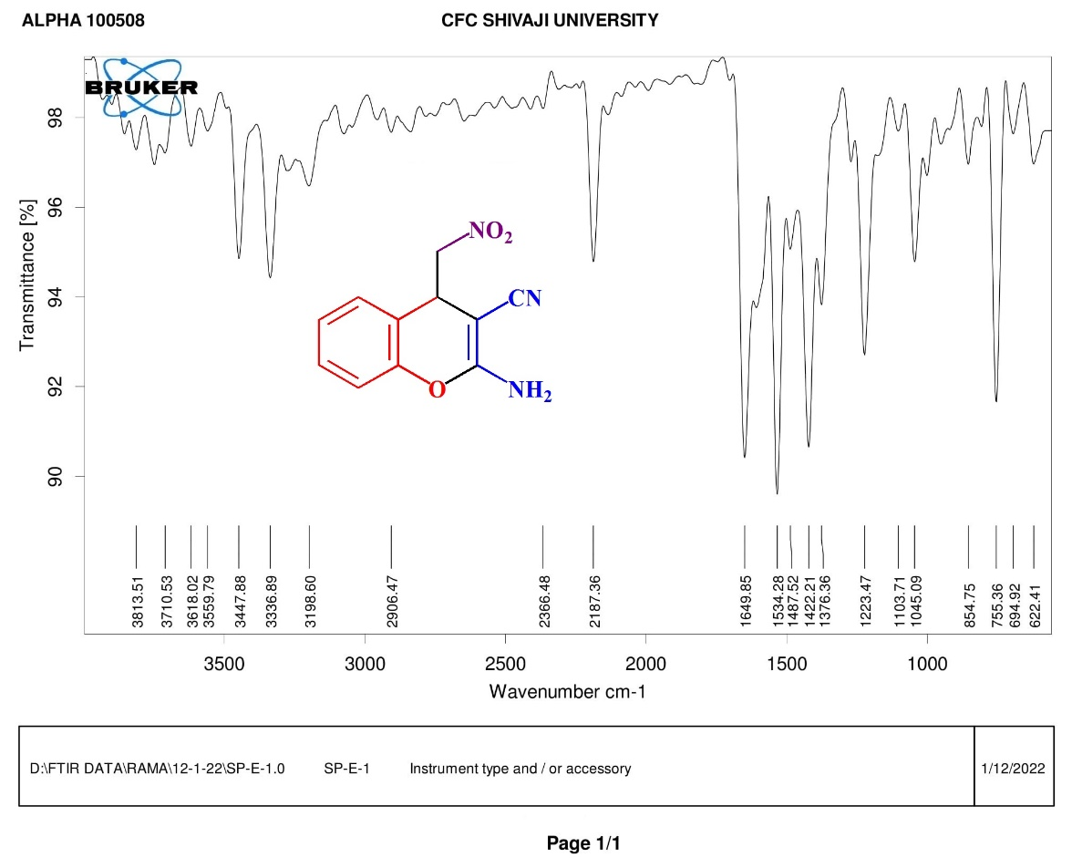
Fig.1 FT-IR spectrum of compound 4a
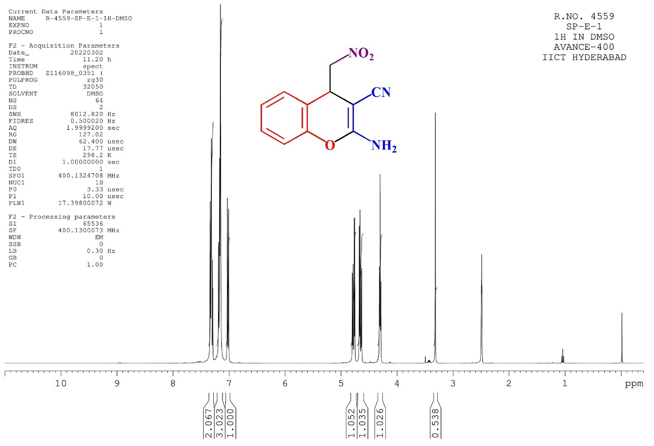
Fig.2 ¹H NMR spectrum of compound 4a

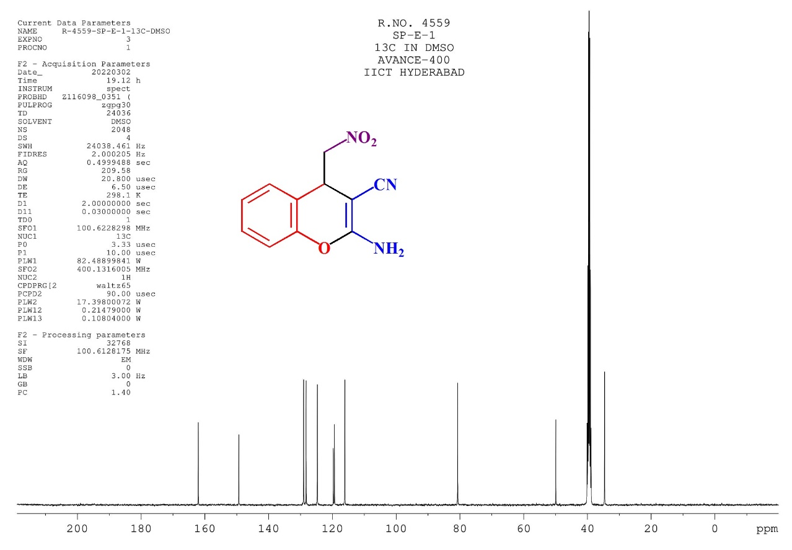
Fig.3 ¹³C NMR spectrum of compound 4a
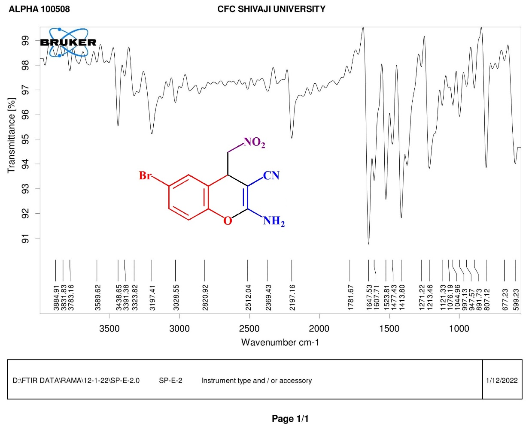
Fig.4 FT-IR spectrum of compound 4b

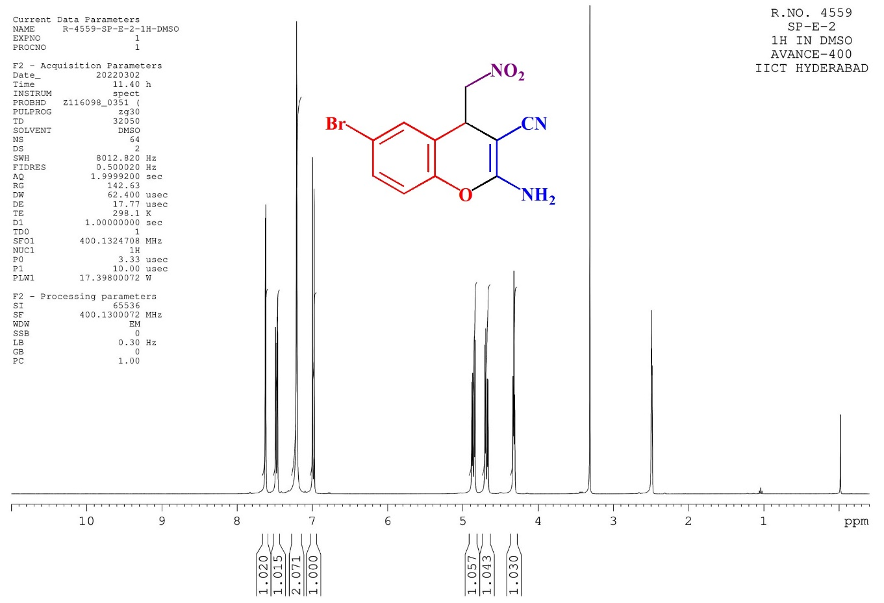
Fig.5 ¹H NMR spectrum of compound 4b

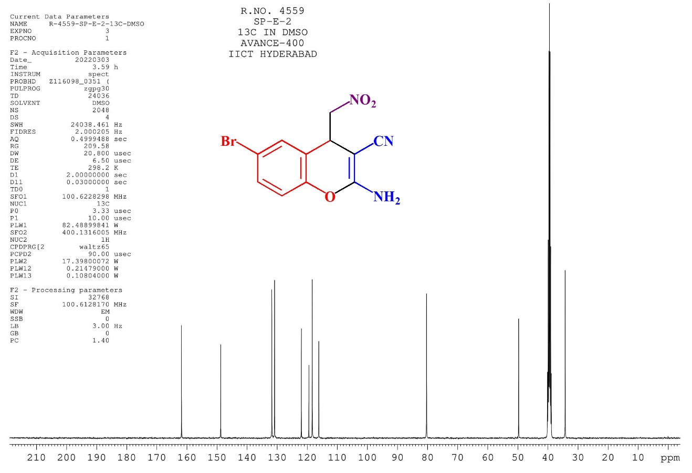
Fig.6 ¹³C NMR spectrum of compound 4b

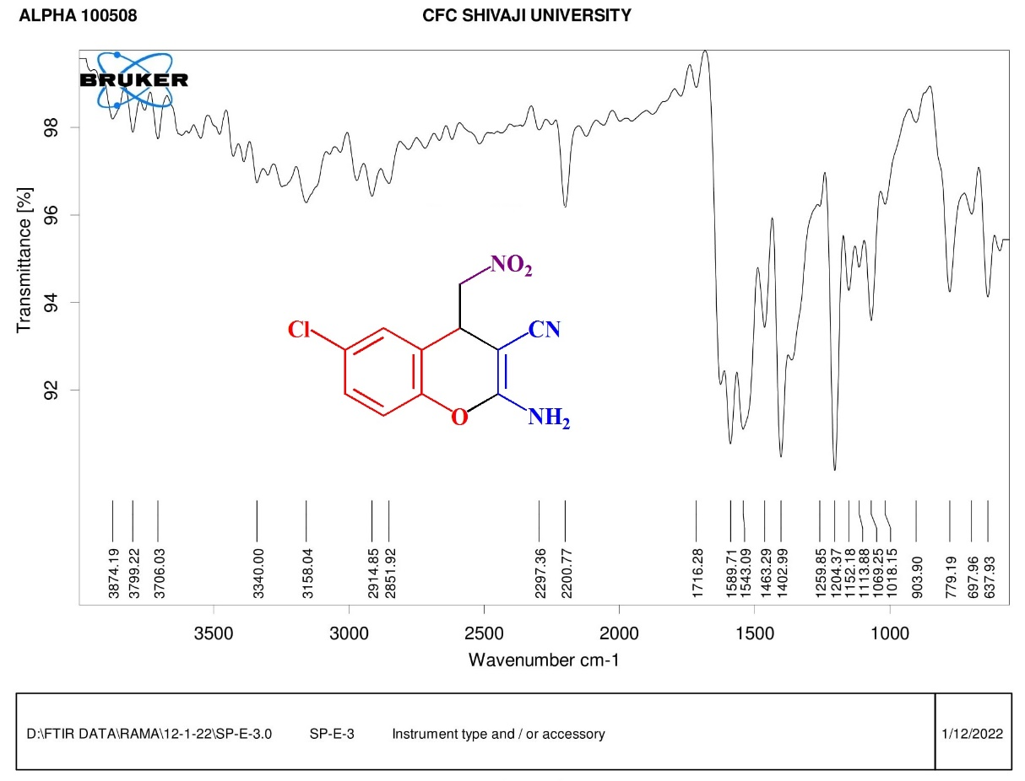
Fig.7 FT-IR spectrum of compound 4c

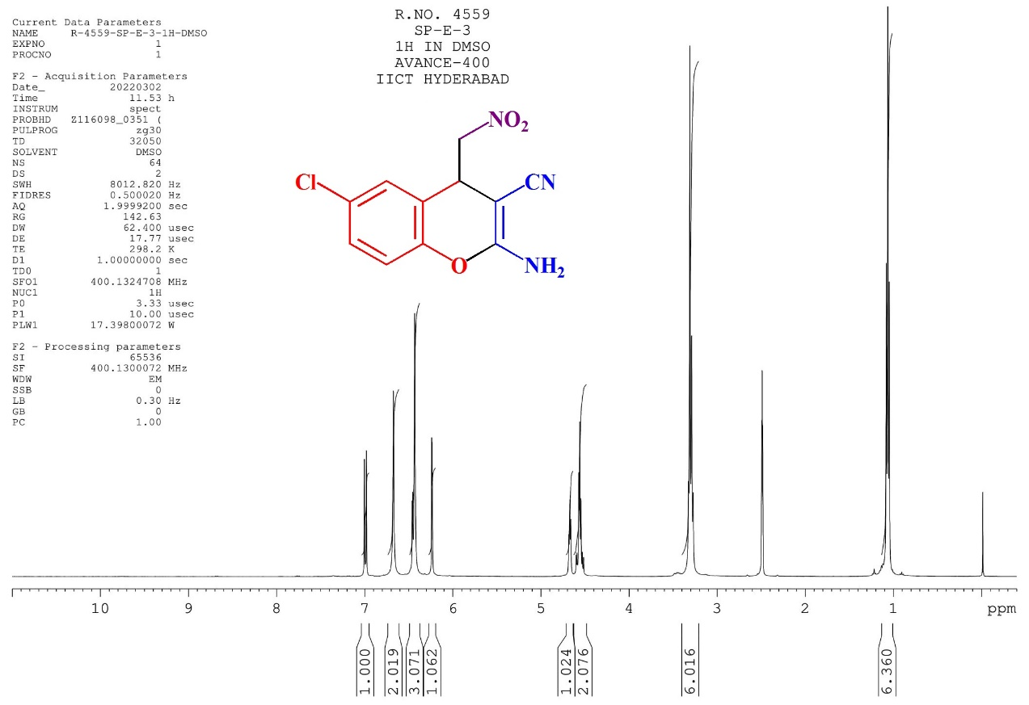
Fig.8 ¹H NMR spectrum of compound 4c
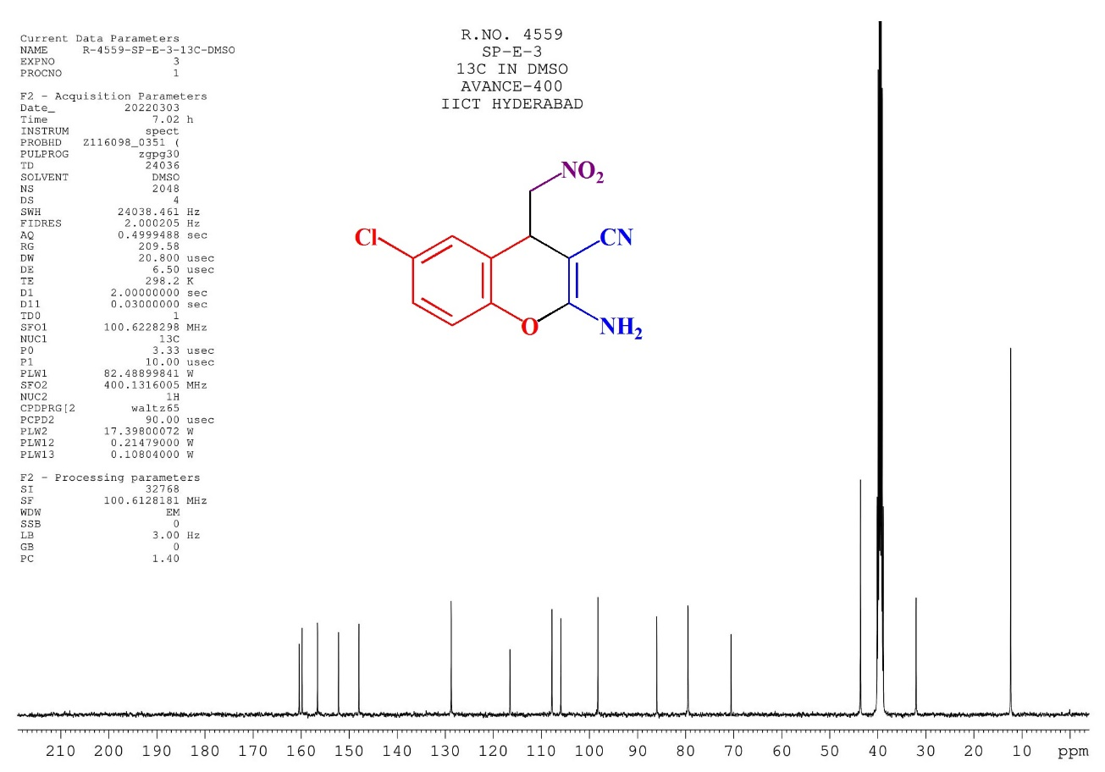
Fig.9 ¹³C NMR spectrum of compound 4c

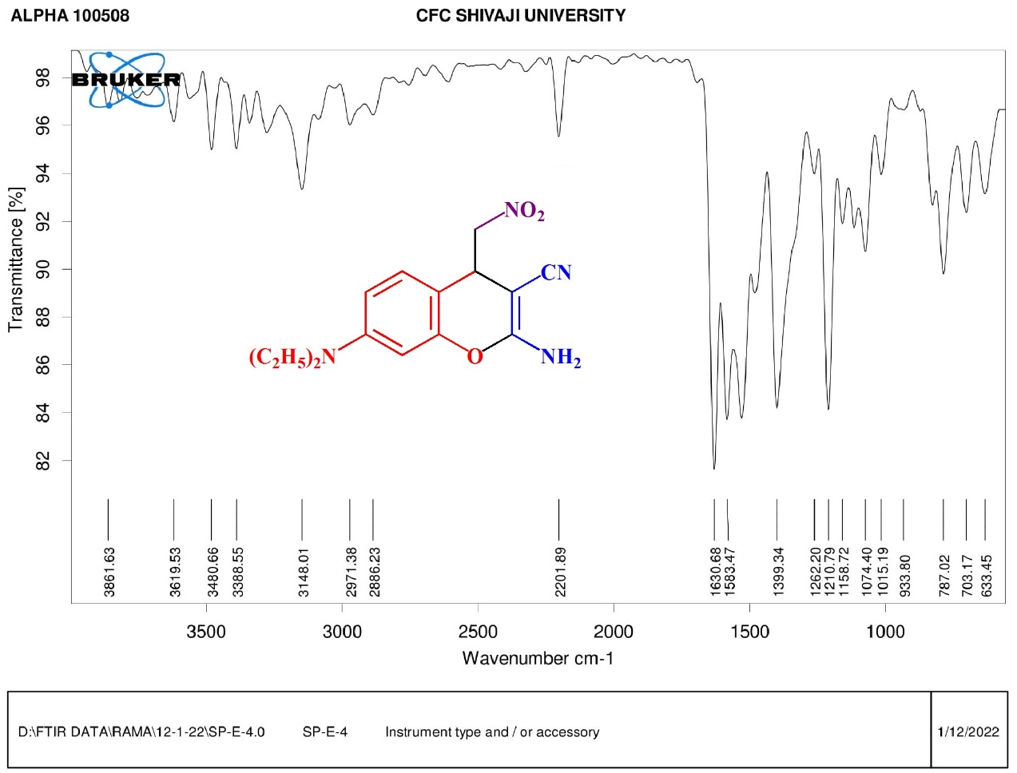
Fig.10 FT-IR spectrum of compound 4e

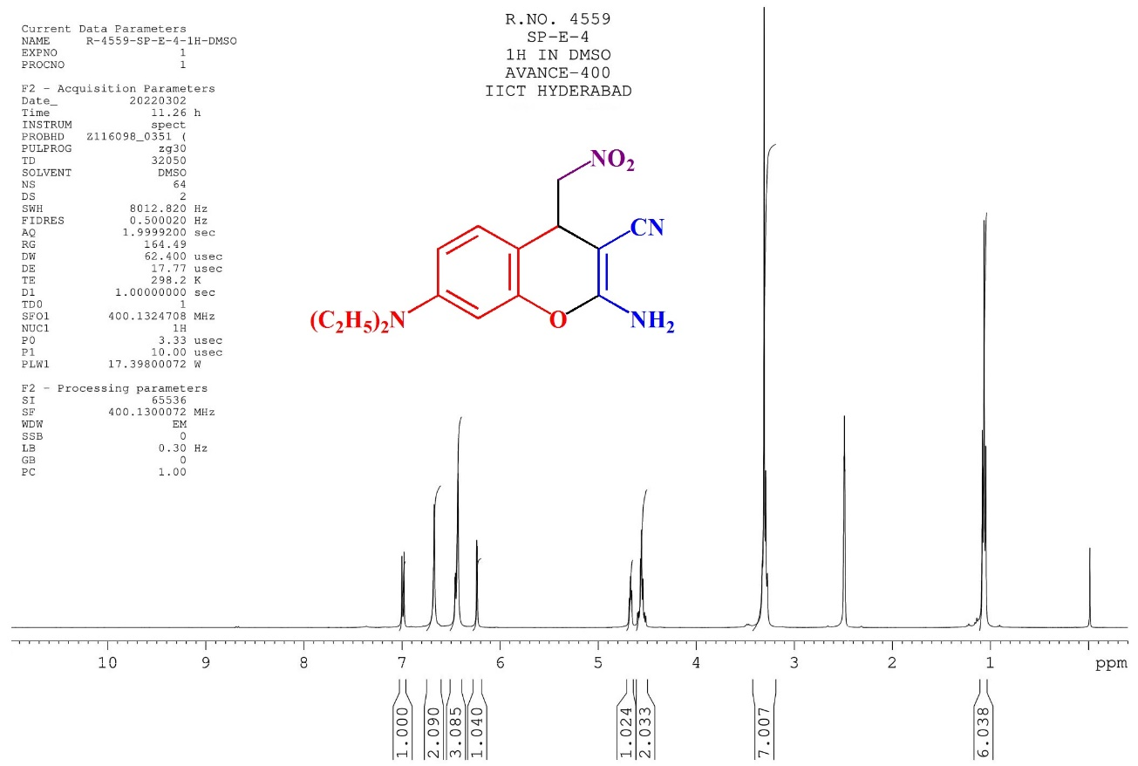
Fig.11 ¹H NMR spectrum of compound 4e
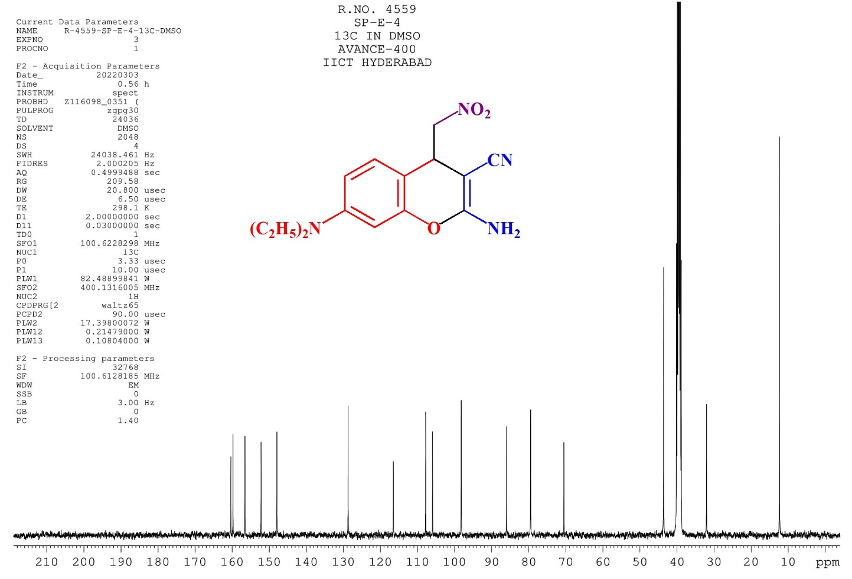
Fig.12 ¹³C NMR spectrum of compound 4e

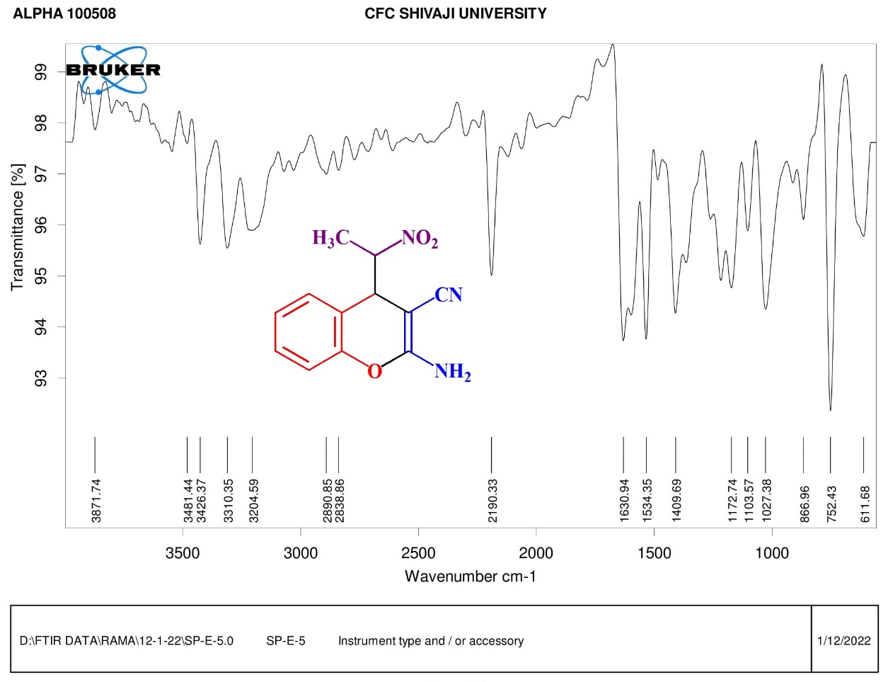
Fig.13 FT-IR spectrum of compound 4j
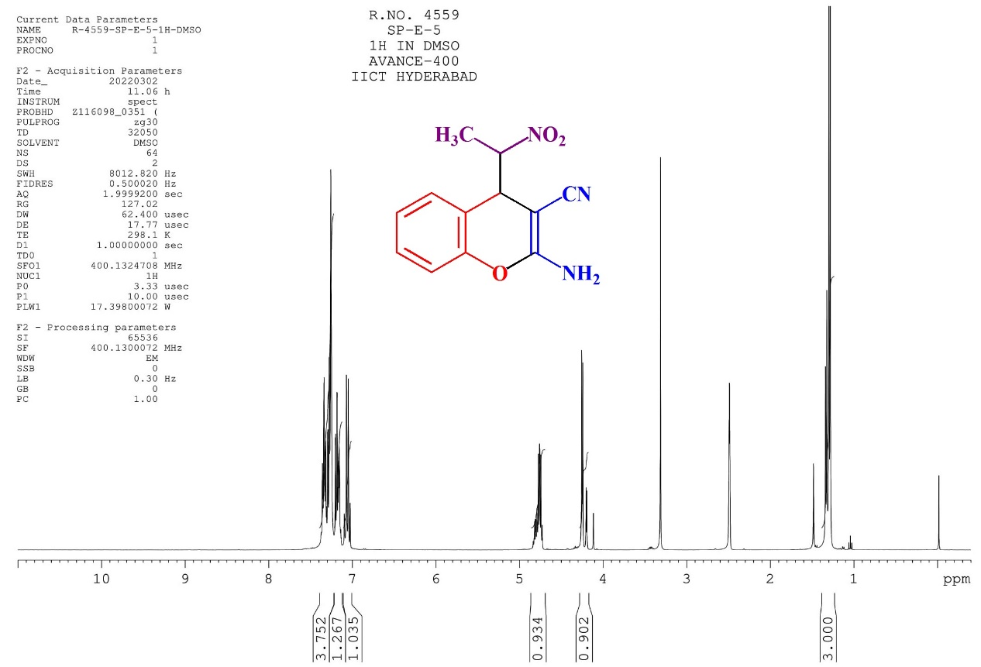
Fig.14 ¹H NMR spectrum of compound 4j
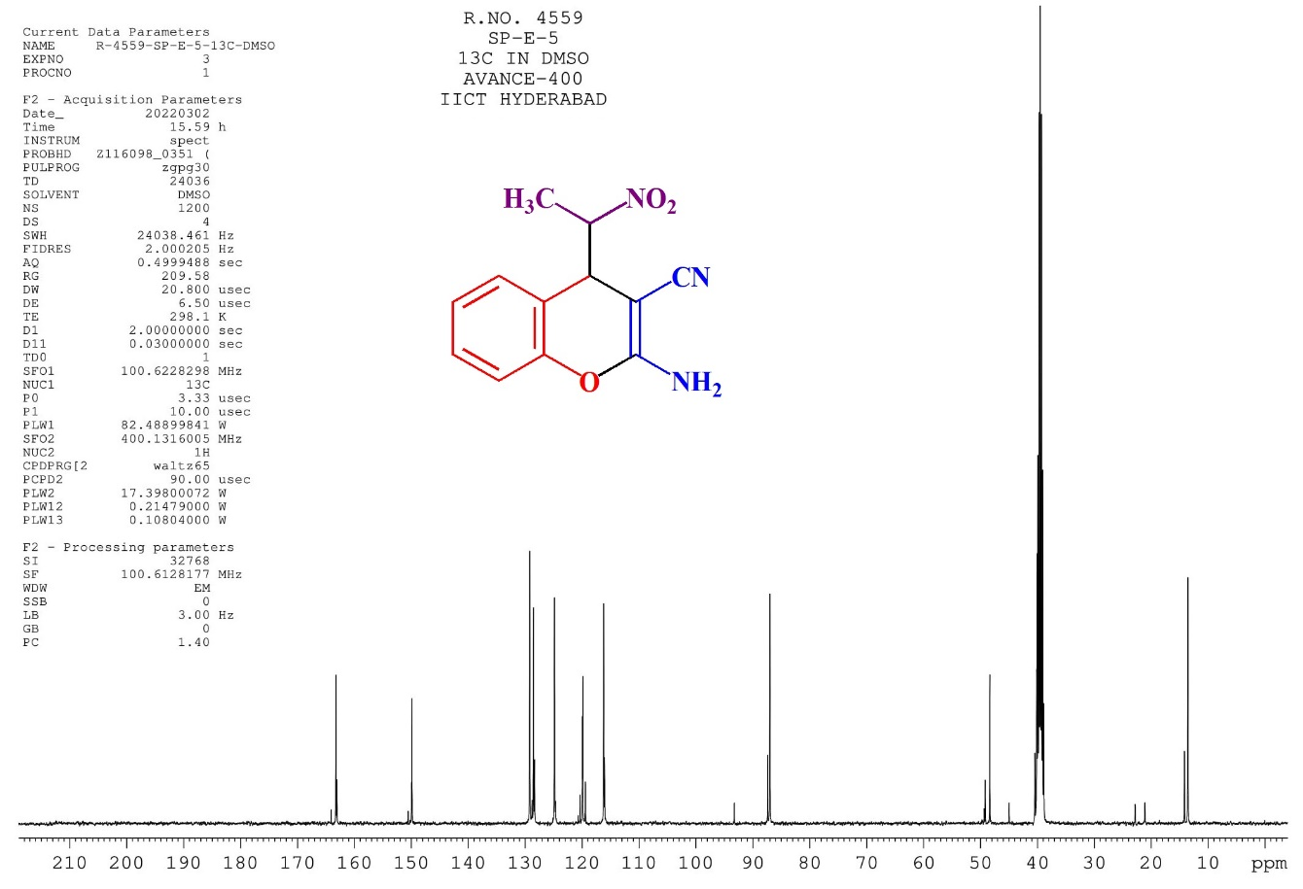
Fig.15 ¹³C NMR spectrum of compound 4j

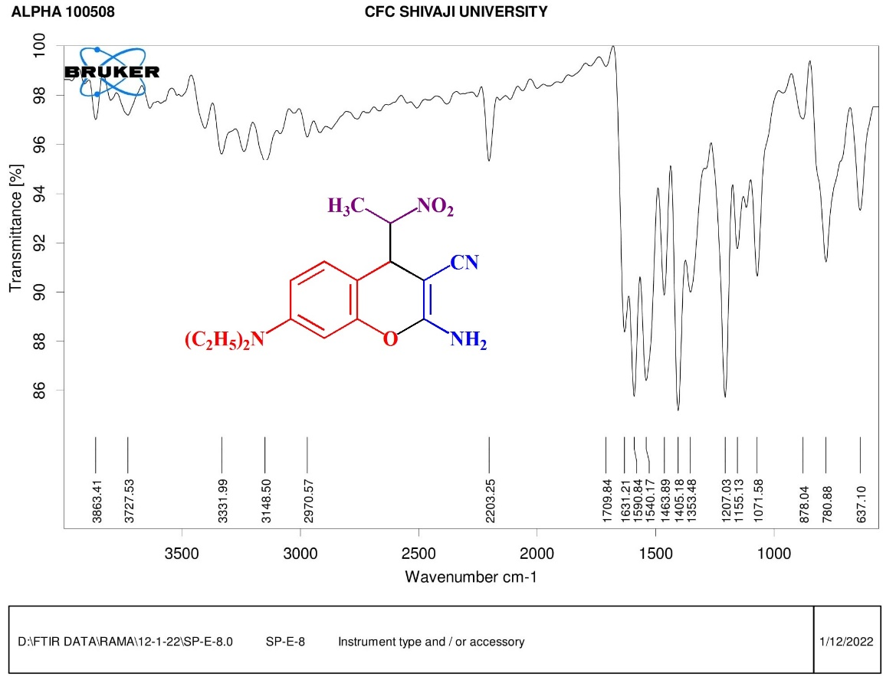
Fig.16 FT-IR spectrum of compound 4k

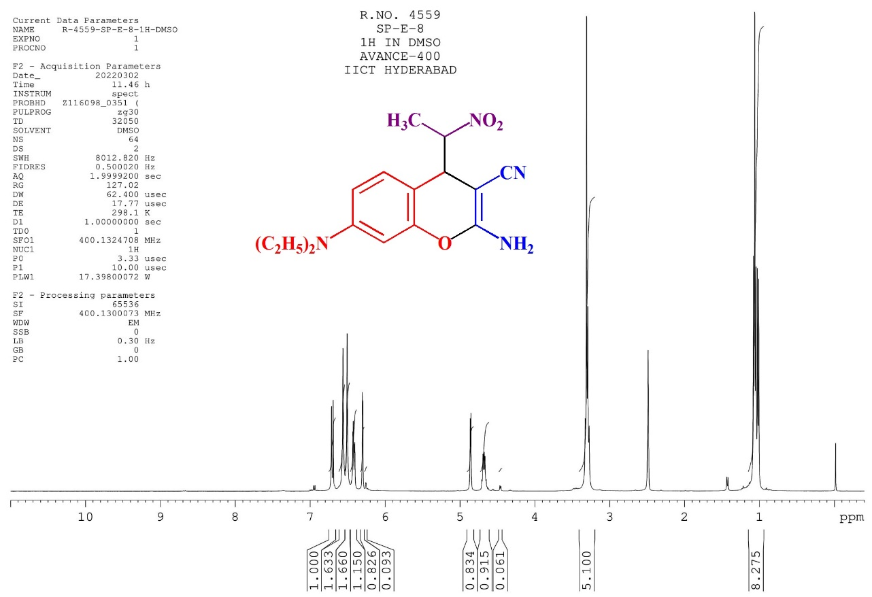
Fig.17 ¹H NMR spectrum of compound 4k
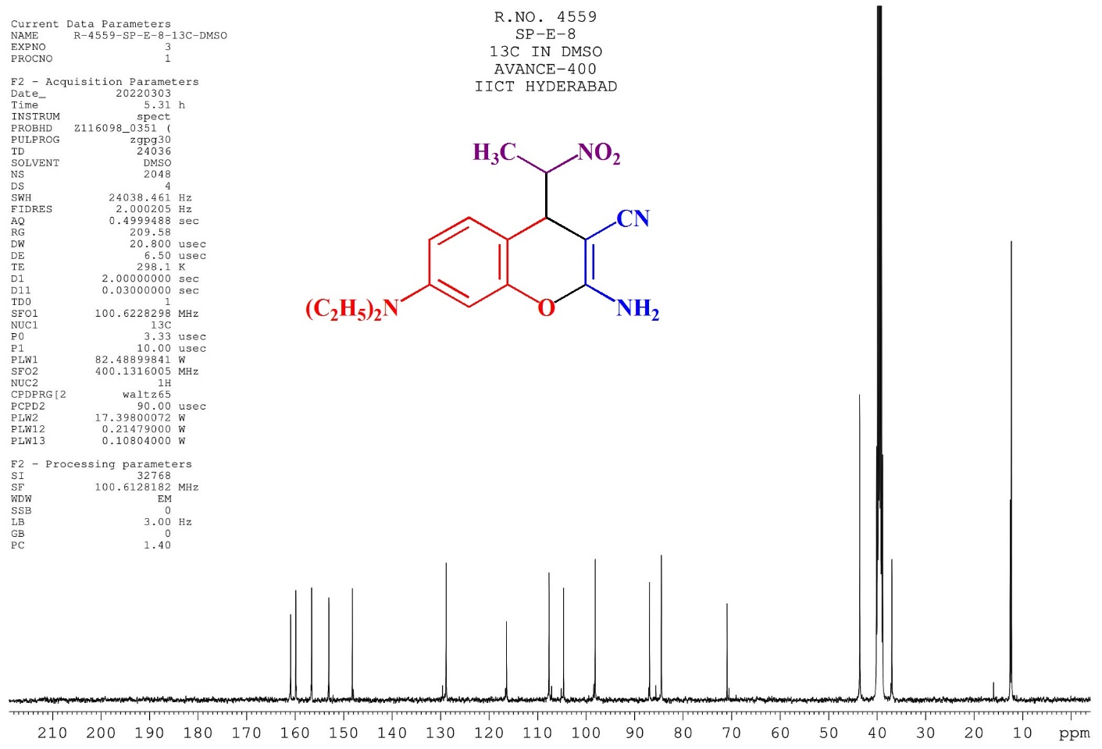
Fig.18 ¹³C NMR spectrum of compound 4k
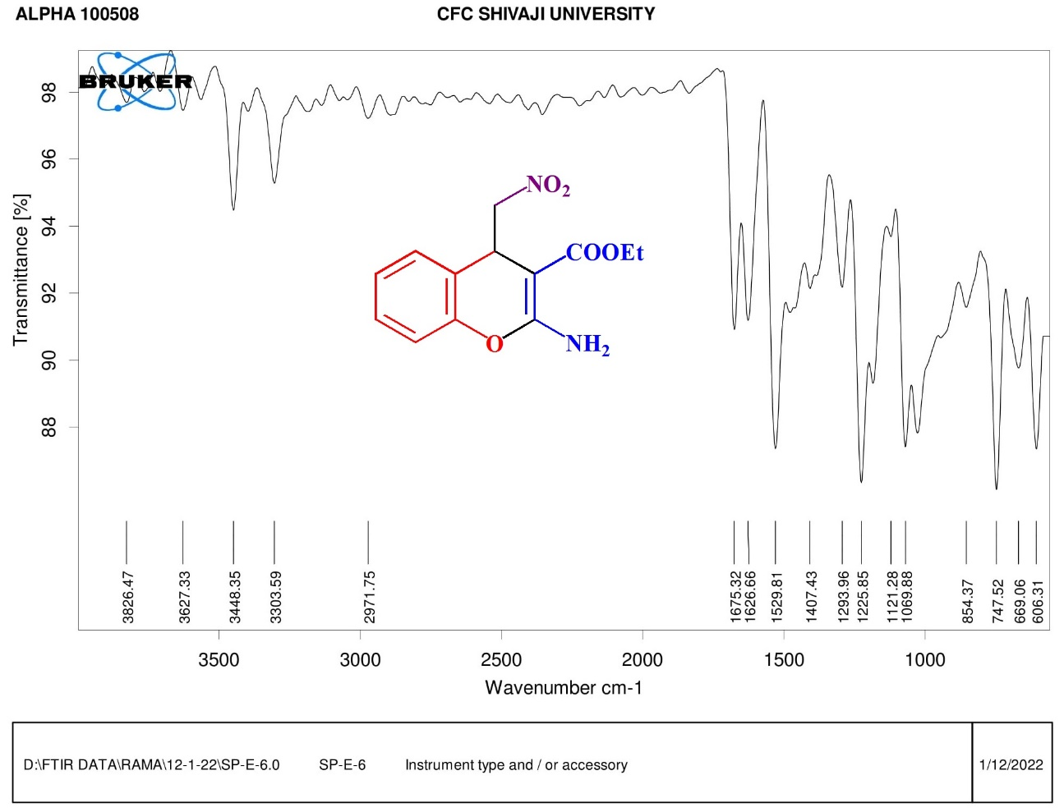
Fig.19 FT-IR spectrum of compound 5a

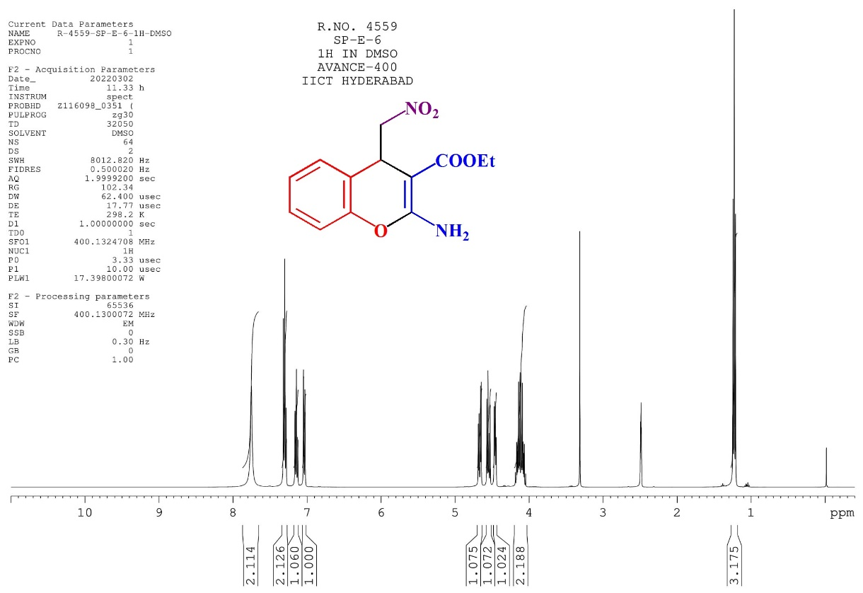
Fig.20 ¹H NMR spectrum of compound 5a
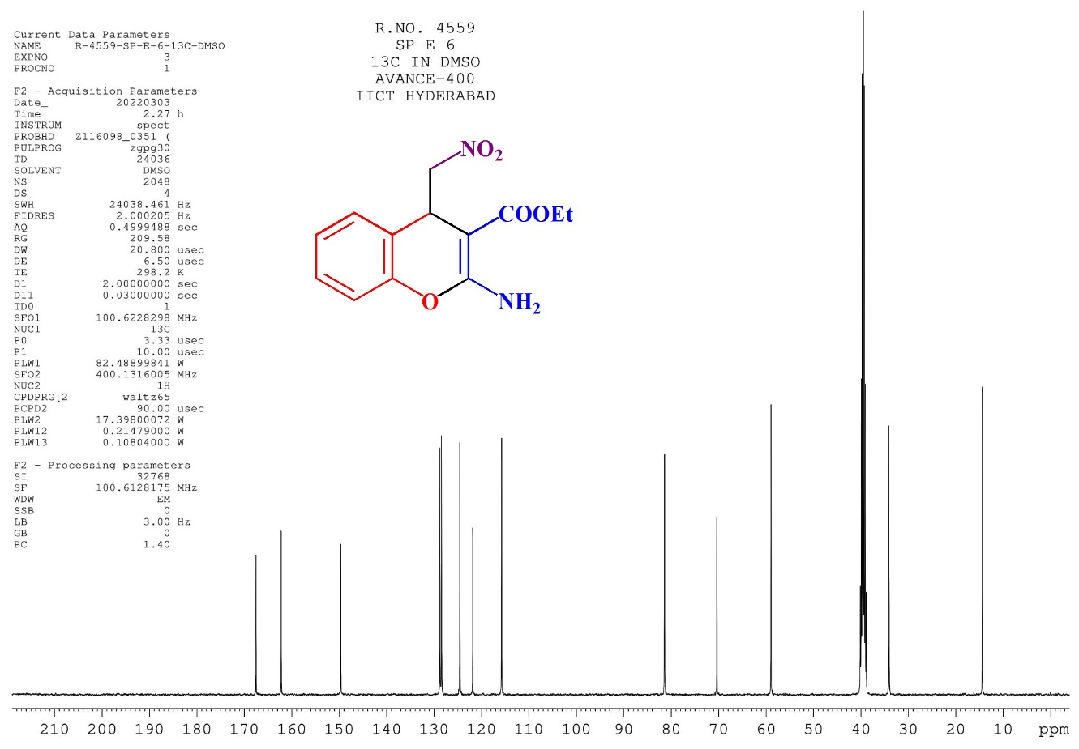
Fig.21 ¹³C NMR spectrum of compound 5a
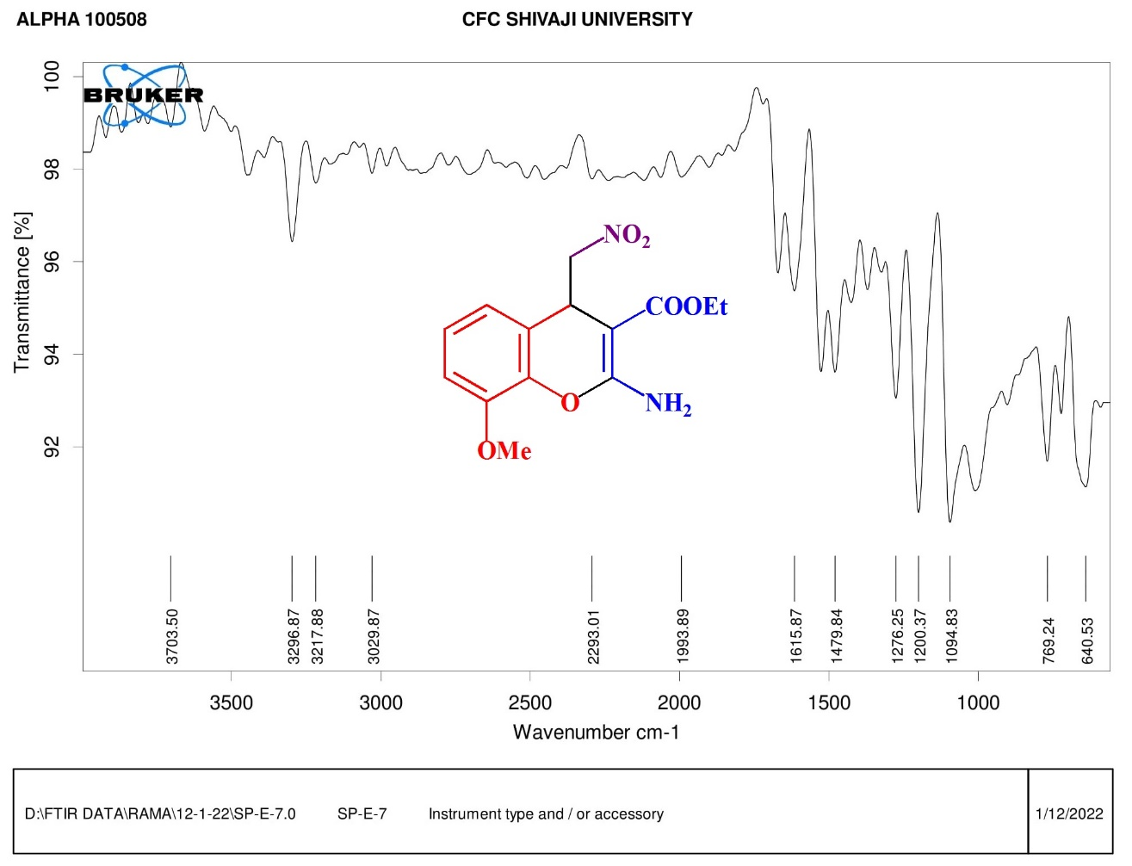
Fig.22 FT-IR spectrum of compound 5h

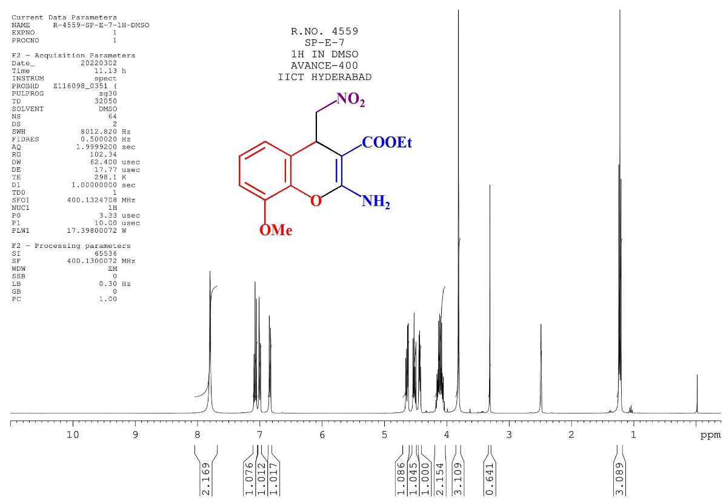
Fig.23 ¹H NMR spectrum of compound 5h

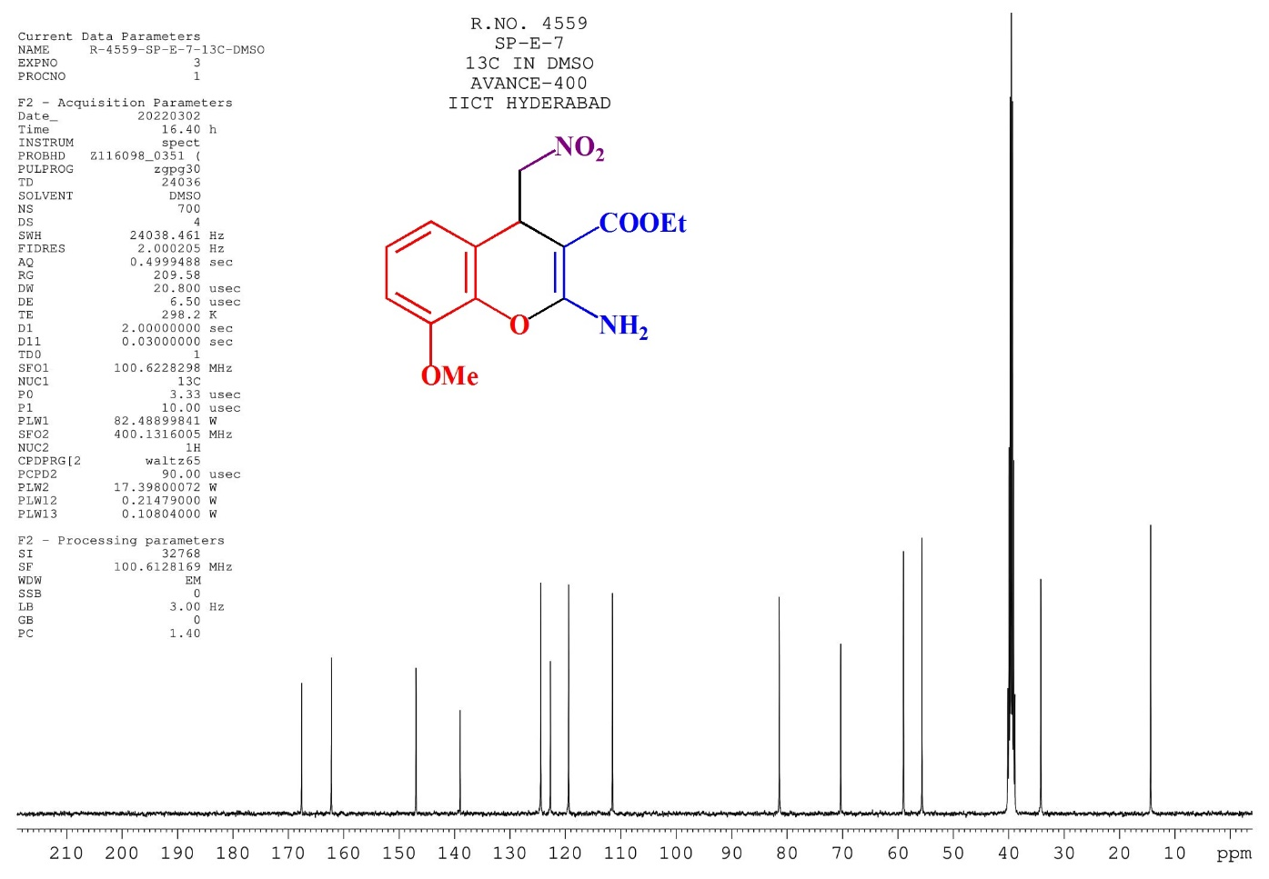
Fig.24 ¹³C NMR spectrum of compound 5h

