Supporting Information

Synergistic effects of Li&Na co-doping enabling flexible Cu₂ZnSn(S,Se)₄ solar cells with over 10% certified efficiency

Quanzhen Sun^{a, b}, Chen Shi^{a, b}, Weihao Xie^{a, b}, Yifan Li^{a, b}, Yaling Li^{a, b}, Caixia Zhang^{a, b}, Jionghua Wu^{a, b}, Qiao Zheng^{a, b, c}，Hui Deng^{a, b, *}, and Shuying Cheng^{a, b, c, *}

ªInstitute of Micro-Nano Devices and Solar Cells, College of Physics and Information Engineering, Fuzhou University, Fuzhou, 350108, P. R. China.
^{b}Fujian Science & Technology Innovation Laboratory for Optoelectronic Information of China, Fuzhou, Fujian 350108, P. R. China.
^{c}Jiangsu Collaborative Innovation Center of Photovoltaic Science and Engineering, Changzhou 213164, P. R. China.
* Email: denghui@fzu.edu.cn (H. Deng); sycheng@fzu.edu.cn (S. Cheng)

Fig. S1. The PCE statistics of flexible CZTSSe solar cells with (a) different Li/(Cu+Zn+Sn) and (b) different Na/(Cu+Zn+Sn) ratios based on the optimal Li/(Cu+Zn+Sn).

Fig. S2. (a)The SCLC of three films. The I-V cures of (b) No doped, (c) Li doped and (d) Li &Na doped CZTSSe films in the temperature range of 100-320 K.

Table S1. Summary of the average photovoltaic parameters with standard deviations for flexible CZTSSe devices.
Solar cell | V_{oc} (mV) | J_{sc} (mA/cm²) | FF (%) | PCE (%)
No doped | 410±5.2 | 31.76±0.80 | 60.47±1.35 | 7.78±0.27
Li doped | 469±8.1 | 30.13±0.94 | 63.29±1.48 | 8.94±0.34
Li&Na doped | 499±7.2 | 30.94±0.90 | 65.19±1.36 | 10.06±0.27

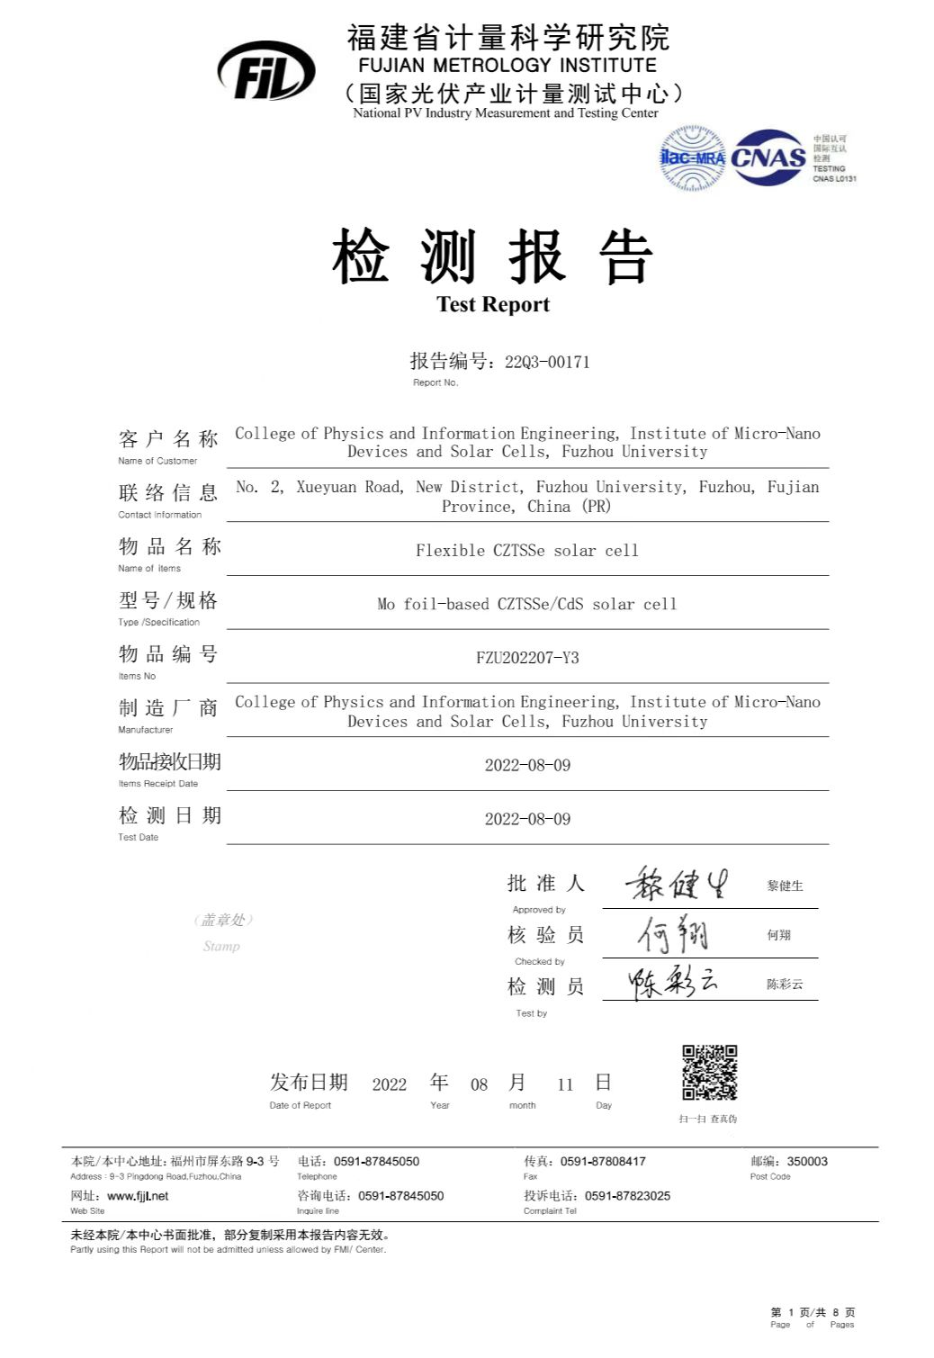

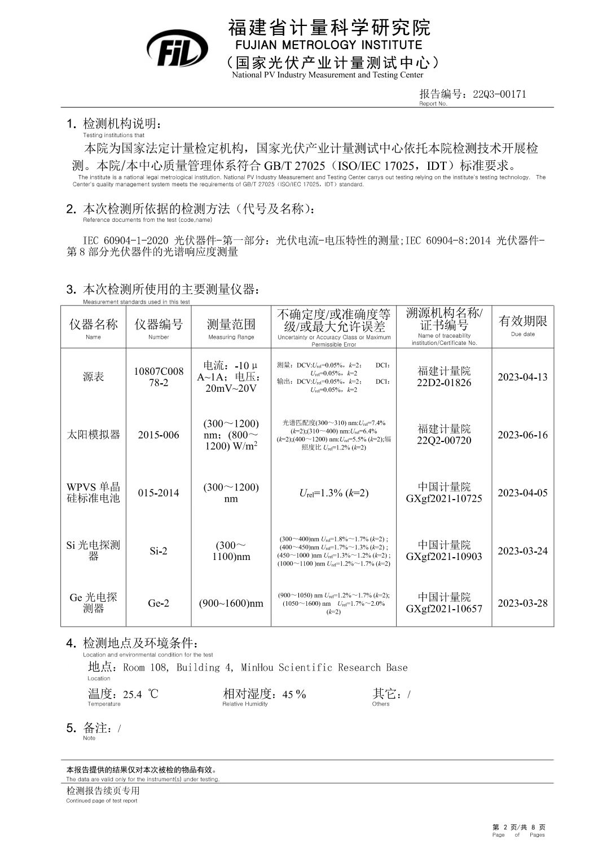

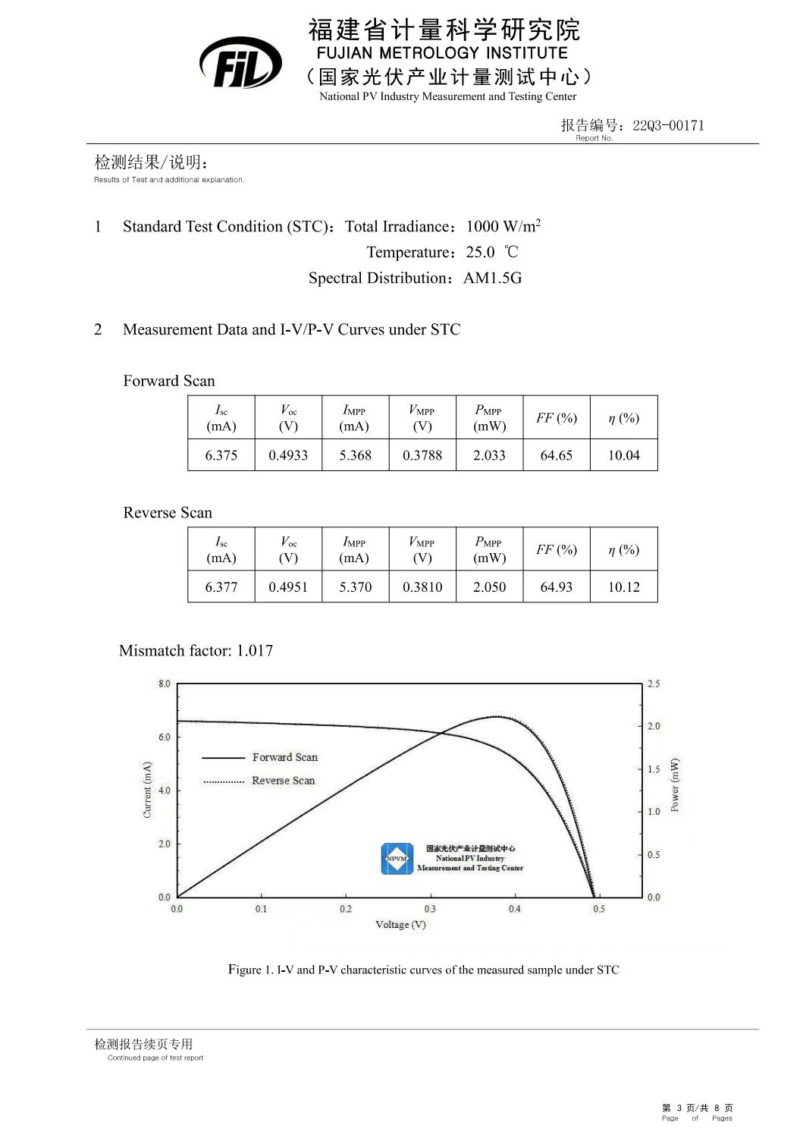

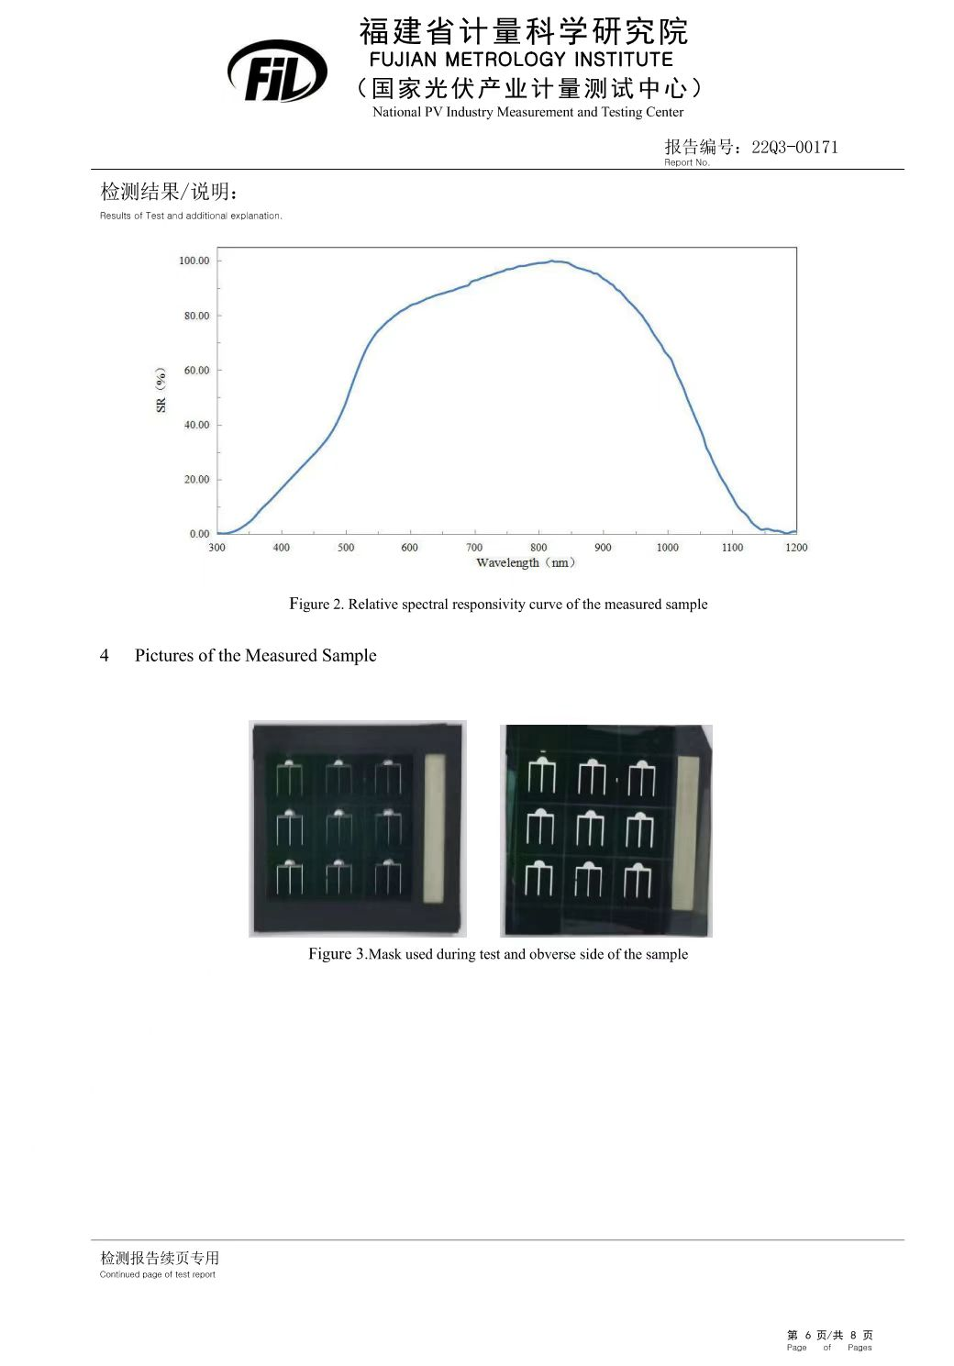

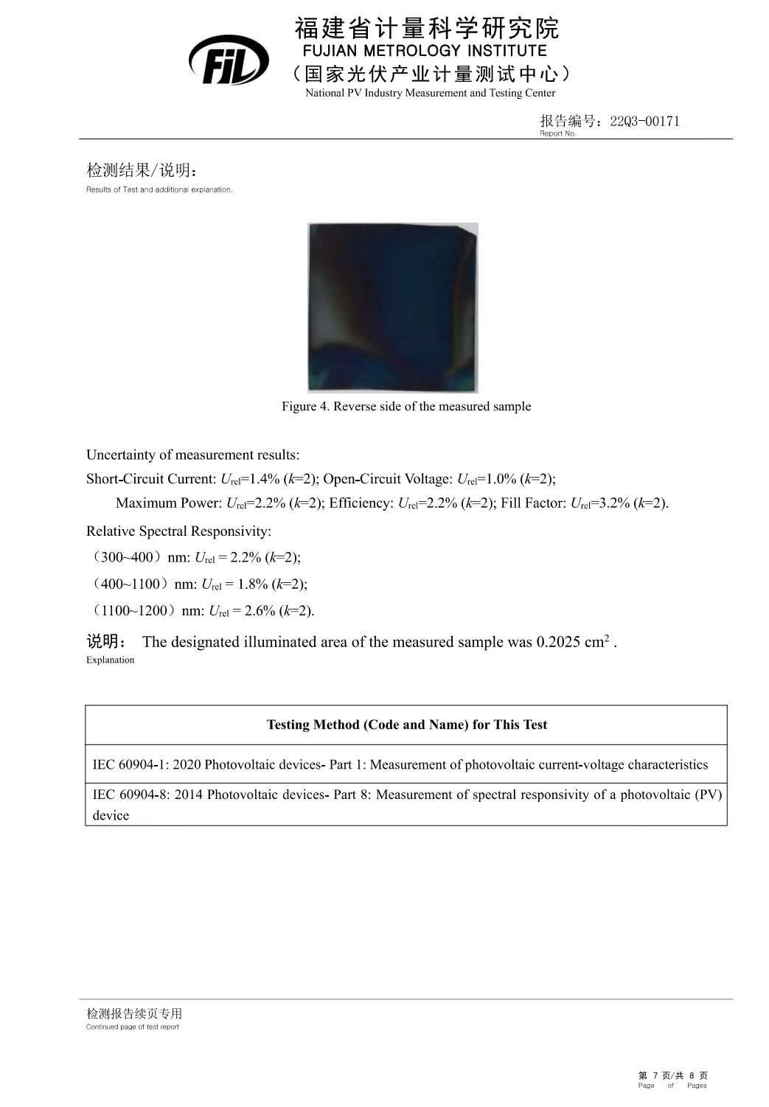
Fig. S3. The certified results of the Li&Na co-doped flexible CZTSSe solar cell measured at by Fujian Metrology Institute/National PV Industry Measurement and Testing Center (NPVM). The certified illuminated area is 0.2025 cm² , and certified PCE is 10.12% (V_{OC} = 0.4951 V, J_{SC} = 31.49 mA/cm², FF = 64.93%).

Fig. S4. The statistical performance box plots for the small (0.205 cm²) and large (2.38 cm²) area Li&Na doped flexible CZTSSe devices: (a) V_{oc} and (b) J_{sc}.

