Developing method of simultaneously determining 11 triterpene alcohols and analyzing their characteristics in camellia oil

Appendixes

Yonglin Li, Shengmin Zhou, Yaoyao Dong, Qi Li, Yuan Gao, Xiuzhu Yu*
Table captions
Table A1. Calibration curves of determined 11 triterpene alcohols
Table A1. Calibration curves of determined 11 triterpene alcohols
Triterpene alcohol | Calibration curve | R²
Lanosterol | y=1.3161x-0.0474 | 0.9982
Germanicol | y=2.7723x-0.1487 | 0.9984
Taraxerol | y=0.8073x-0.348 | 0.9981
β-Amyrin | y=2.6683x-0.1767 | 0.9983
Butyrospermol | y=0.657x-0.0289 | 0.9969
α-Amyrin | y=3.9469x-0.2705 | 0.9983
Cycloartenol | y=0.4292x-0.0046 | 0.9964
Lupeol | y=1.9256x-0.1183 | 0.9989
Parkeol | y=0.4054x-0.0254 | 0.9984
ψ-Taraxasterol | y=0.1254x+0.0124 | 0.9981
Epifriedelanol | y=0.2062x-0.0185 | 0.9975

Figure Captions
Fig. A1. Triterpene alcohols contents of olive oil, rice bran oil, linseed oil (a), and Shea fat (b)
Fig. A2. Triterpene alcohols contents in samples that underwent long-term storage

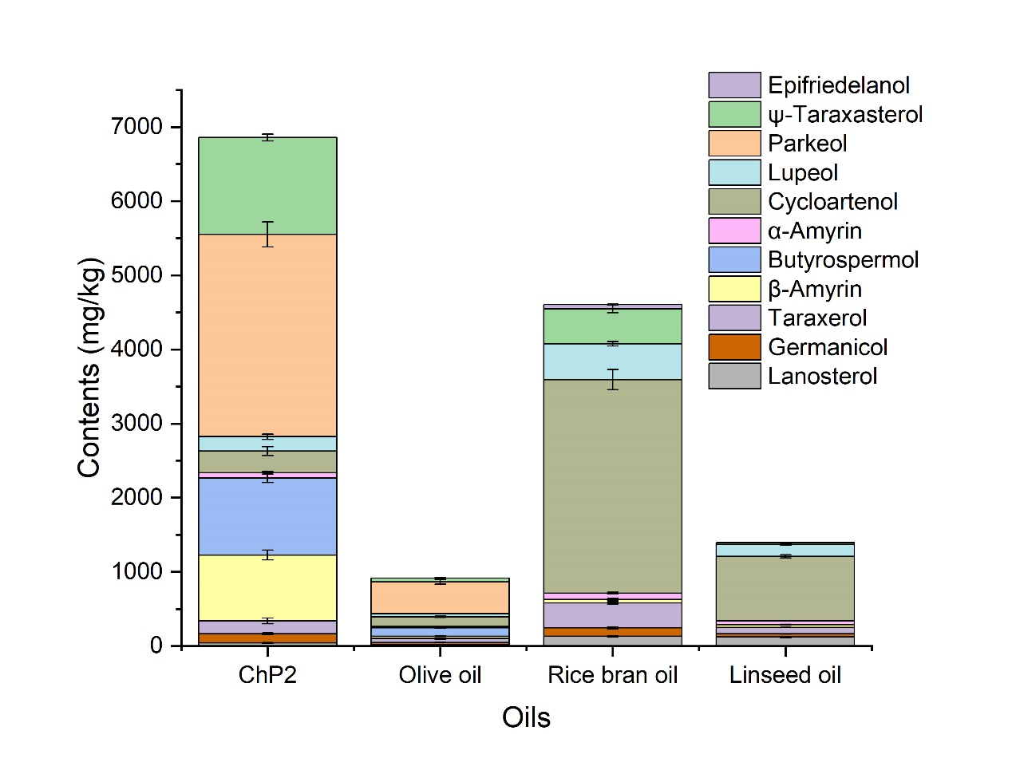
(a)
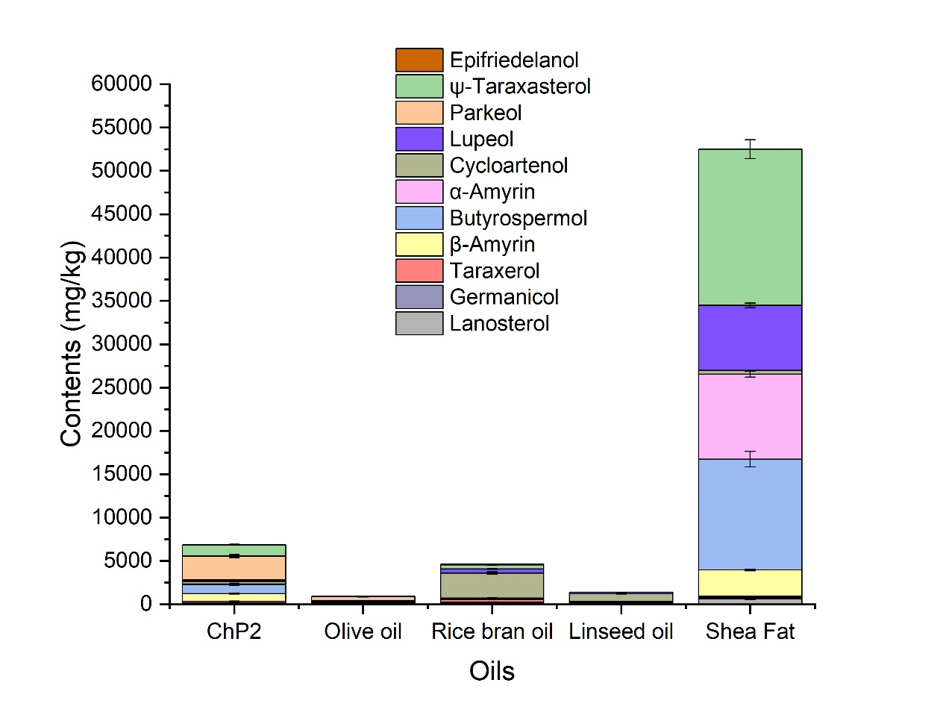
(b)
Fig. A1. Triterpene alcohols contents of olive oil, rice bran oil, linseed oil (a), and Shea fat (b)
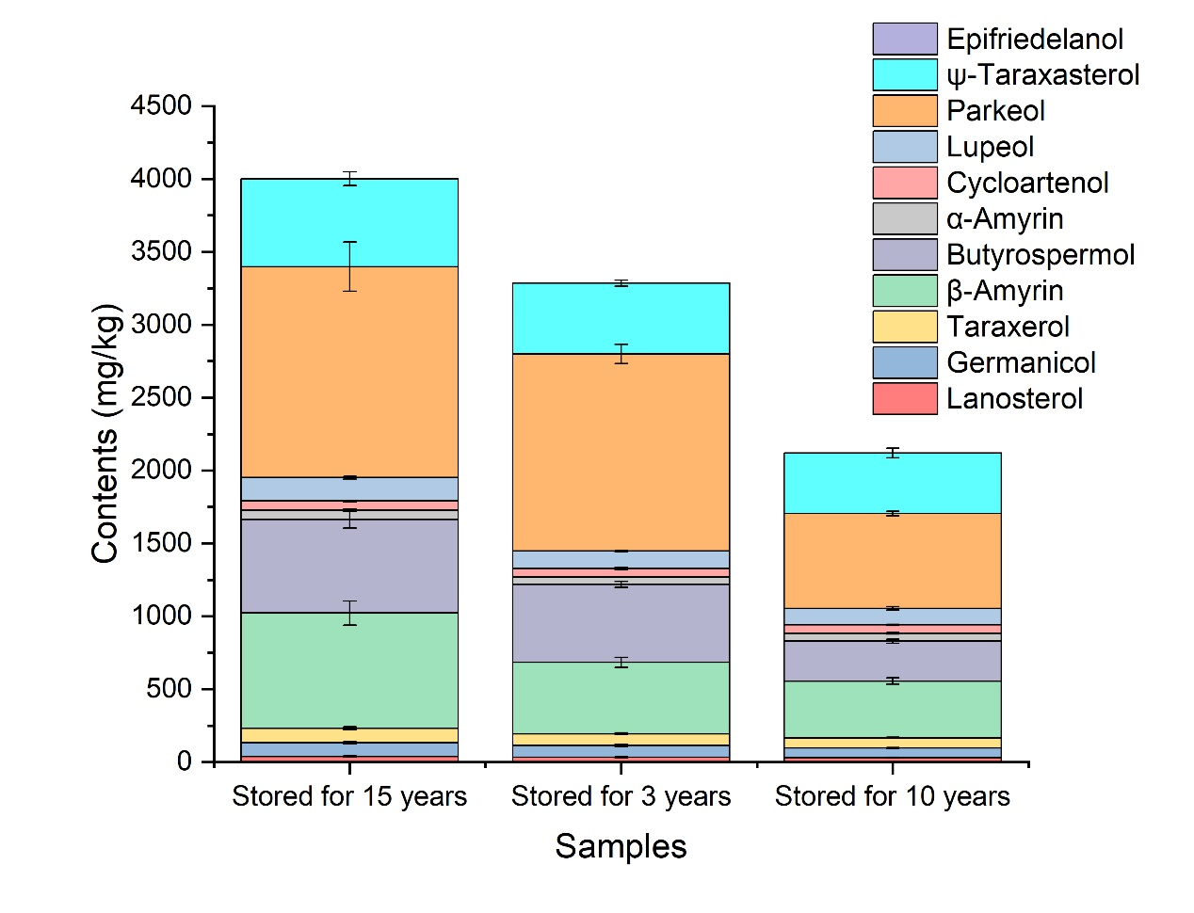
Fig. A2. Triterpene alcohols contents in samples that underwent long-term storage

