Table 2. Quantifier and qualifier ions and possible fragmentation pattern of triterpene alcohols
Triterpene alcohol | Quantifier ion (target ion) | Qualifier ion (reference ion) 1 | Qualifier ion (reference ion) 2 | Fragmentation pattern of quantifier ion
5α-Cholestan-3β-ol (internal standard) | 215.2 | 355.4 | 305.3 | -
Lanosterol | 393.4 | 483.5 | 241.2 | 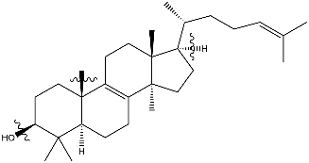
Germanicol | 204.2 | 189.2 | 121.1 | 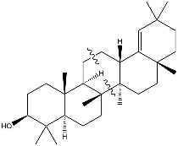
Taraxerol | 269.3 | 218.2 | 175.2 | 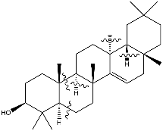
β-Amyrin | 218.2 | 203.2 | 189.2 | 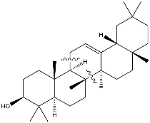
Butyrospermol | 393.4 | 411.1 | 241.2 | 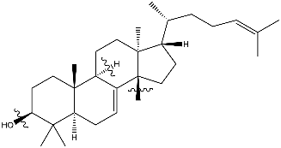
α-Amyrin | 218.2 | 189.2 | 203.2 | 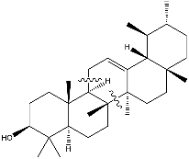
Cycloartenol | 365.4 | 339.4 | 393.4 | 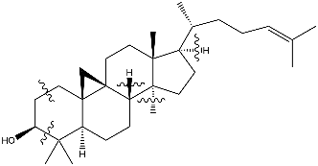
Lupeol | 203.2 | 218.3 | 147.1 | 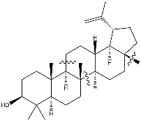
Parkeol | 393.4 | 173.2 | 257.3 | 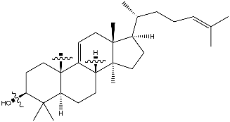
ψ-Taraxasterol | 189.2 | 369.4 | 175.2 | 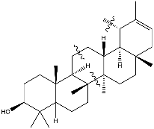
Epifriedelanol | 413.4 | 275.3 | 165.2 | 