Cover sheet for Supplementary material for Publication
Xuemei Zhong^{a,b}, Xuan Zhou^{c1}, Gongwen Luoª, Ying Huangª, Yuanfan Wu^{d}, Ruliang Cao^{e}, Chang Tian^{a,}*, Jianwei Peng^{a,}*
Manuscript title: Soil mineral nitrogen, soil urease activity, nitrogen losses, and nitrogen footprint under machine-transplanted rice with side-deep fertilization
Figure of contents
Figure S1. Daily temperature and precipitation of the entire rice gowing season from April to November in 2018.
Figure S2. Percentage of reactive N footprint in total N footprint from different fertilization treatments.
Figure S3. Relationship of total N footprint with N application rates in double cropping rice system.
Figure S4. Relationship of N leaching loss and runoff loss with N application rate in double-cropping rice system.

Table of contents
Table S1. Basic soil properties in soil tested.
Table S2. Description of the experiment: Fertilization method and amount.

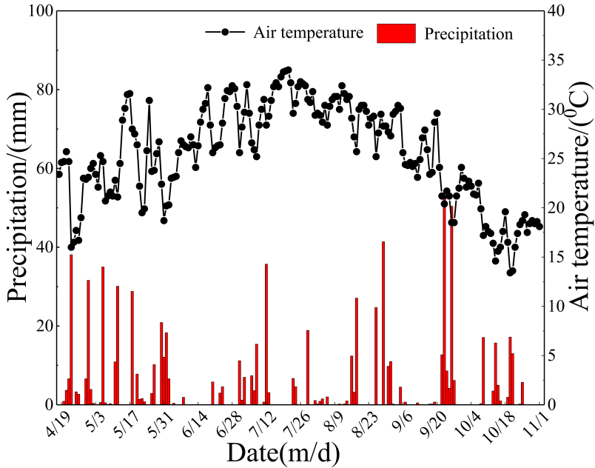
Fig. S1. Daily temperature and precipitation of the entire rice growing season from April to November in 2018.
Average day-time temperature and precipitation were 26.7°C and 4.0 mm for ESR (April–July), respectively, and 24.1°C and 3.9 mm for LSR (August–October), respectively.

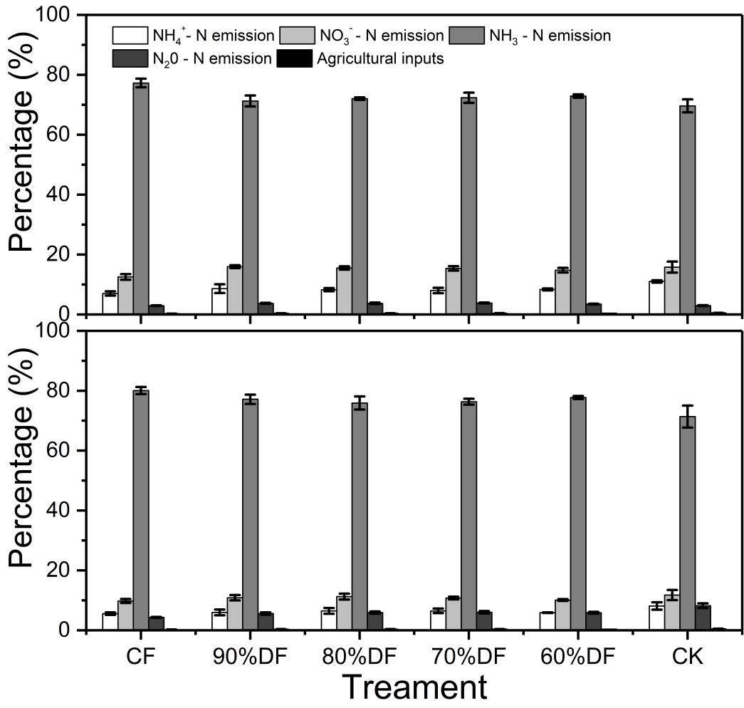
Fig. S2. Percentage of reactive N footprint in total N footprint from different fertilization treatments.
Bars represent standard error of the mean (n = 3).
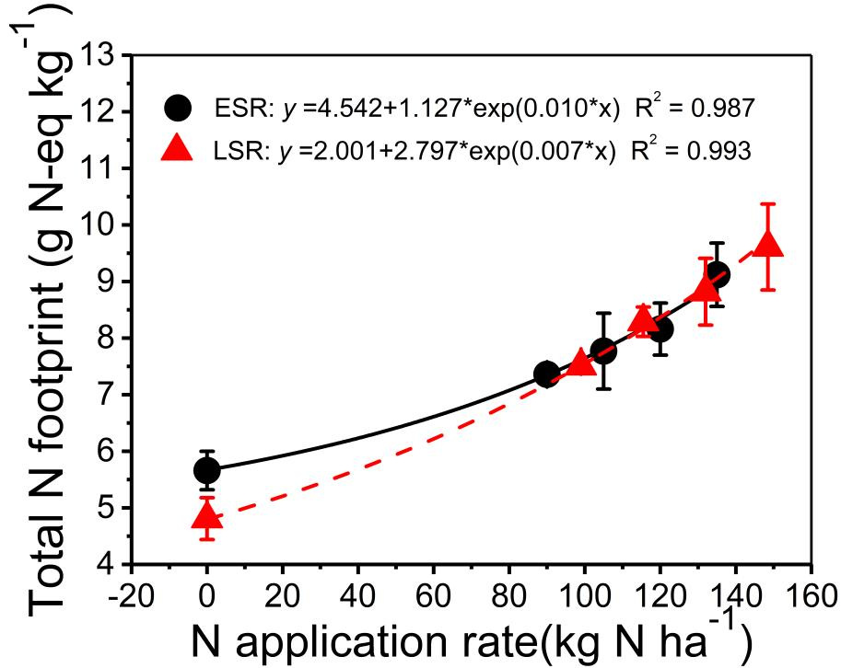
Fig. S3. Relationship of total N footprint with N application rates in double cropping rice system.
Bars represent standard error of the mean (n = 3). ESR: Early season rice; LSR: Late season rice.

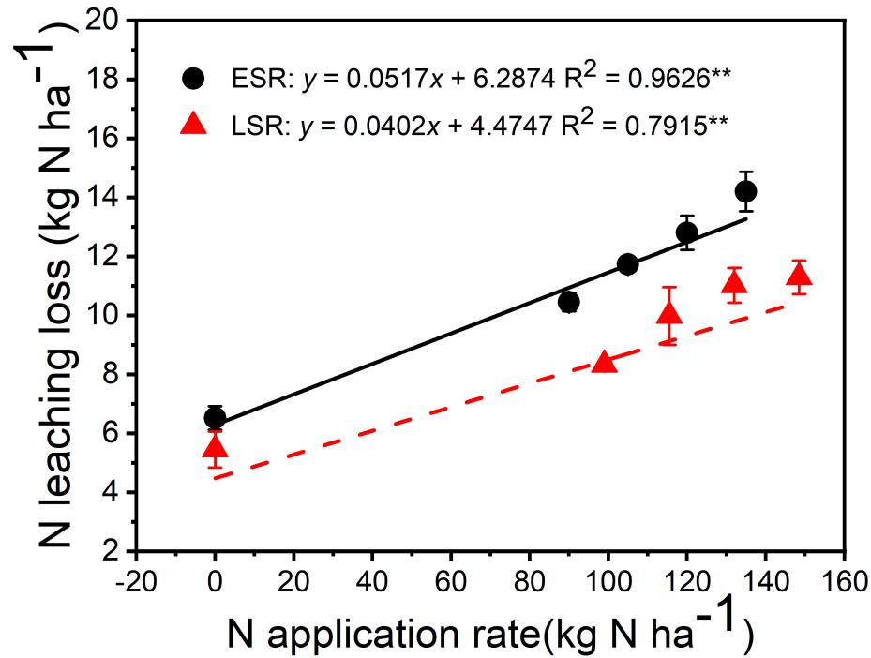
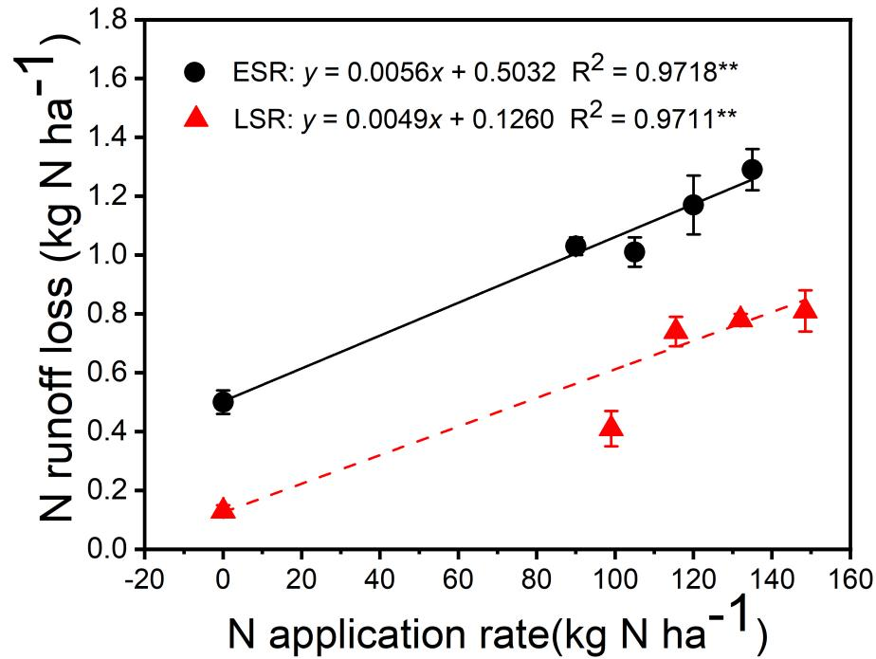
Fig. S4. Relationship of N leaching loss and runoff loss with N application rate in double-cropping rice system.
Bars represent standard error of the mean (n = 3). ESR: Early season rice; LSR: Late season rice.

Table S1. Basic soil properties in soil tested.
Item | pH (H2O) | Organic matter (g/kg) | Total N (g/kg) | Total P (g/kg) | Total K (g/kg) | Available N (mg/kg) | Available P (mg/kg) | Available K (mg/kg)
Yiyang | 6.1 | 39.21 | 1.95 | 0.54 | 11.26 | 157.15 | 7.8 | 118.6
Table S2 Description of the experiment: Fertilization method and amount.
Season | Treatment | Base fertilizer (N-P₂O₅-K₂O%)/ (kg ha⁻¹) |  | Tillering fertilizer/ (kg ha⁻¹)
ESRª | CF^{b} | Compound fertilizer (20-10-10）450 |  | Urea 130.5 | KCl 75.0
ESRª | 100%DF | Compound fertilizer (27.1-8.1-16.2）555.0
ESRª | 90%DF | Special fertilizer（26.1-8.7-17.4）517.3
ESRª | 80%DF | Special fertilizer（24.8-9.3-18.6）483.9
ESRª | 70%DF | Special fertilizer（23.1-9.9-19.8）454.6
ESRª | 60%DF | Special fertilizer（21.0-10.5-21.0）428.6
ESRª | CK | Calcium superphosphate 375.0 | KCl 75.0 |  | KCl 75.0
LSR | CF | Compound fertilizer（20.0-8.0-12.0）450 |  | Urea 163.05 | KCl 60.0
LSR | 100%DF | Special fertilizer (30.3-6.6-16.5）546.0
LSR | 90%DF | Special fertilizer（28.9-7.0-17.5）514.05
LSR | 80%DF | Special fertilizer（27.1-7.4-18.5）486.45
LSR | 70%DF | Special fertilizer（25.4-7.9-19.8）455.7
LSR | 60%DF | Special fertilizer（23.1-8.4-21.0）428.55
LSR | CK | Calcium superphosphate 300.0 | KCl 75.0 |  | KCl 75.0
ª ESR: early season rice; LSR: late season rice.
^{b} CK: no N fertilizer; CF: 100% Urea-N; 100%DF: 100%DF-N; 90%DF: 90%DF-N; 80%DF: 80%DF-N; 70%DF: 70%DF-N; 60%DF: 60%DF-N.

