Appendix
Table 1 Data sources of the variables used in the model
Variable | Source
Elevation | Geospatial Data Cloud (http://www.gscloud.cn/)
Slope | produced by Spatial Analysis module in ArcGIS 10.6
Aspect | produced by Spatial Analysis module in ArcGIS 10.6
Relief | produced by Spatial Analysis module in ArcGIS 10.6
NDVI | Xu Xinliang. Spatial distribution data set of China Annual Vegetation Index (NDVI). Data Registration and Publishing System of Resource and Environment Science and Data Center, Chinese Academy of Sciences (http://www.resdc.cn/DOI),2018.DOI:10.12078/2018060601
Vegetation | Chinese Academy of Sciences. Vegetation atlas of China[M]. Science Press, 2001.
Landuse | National Catalogue Service For Geographic Information (https://www.webmap.cn/)
Nighttime lights | Resource and Environment Science and Data Center, Chinese Academy of Sciences (https://www.resdc.cn/)
Distance to river | produced by Spatial Analysis module in ArcGIS 10.6
Distance to road | produced by Spatial Analysis module in ArcGIS 10.6
Distance to settlement | produced by Spatial Analysis module in ArcGIS 10.6
River density | produced by Density Analysis module in ArcGIS 10.6
Road density | produced by Density Analysis module in ArcGIS 10.6
Settlement density | produced by Density Analysis module in ArcGIS 10.6
Bioclimatic variable | WorldClim (https://www.worldclim.org/)

Table 2 The class and code of the Landuse variable
Code | Class | Content
10 | Cultivated Land | Lands used for agriculture, horticulture and gardens.
20 | Forest | Lands covered with trees, with vegetation cover over 30%.
30 | Grassland | Lands covered by natural grass with cover over 10%.
40 | Shrubland | Lands covered with shrubs with cover over 30%.
50 | Wetland | Lands covered with wetland plants and water bodies.
60 | Water Bodies | Water bodies in the land area.
70 | Tundra | Lands covered by lichen, moss, hardy perennial herb and shrubs in the polar regions.
80 | Artificial Surfaces | Lands modified bu human activities.
90 | Bareland | Lands with vegetation cover lower than 10%.
100 | Permanent Snow & Ice | Lands covered by permanent snow, glacier and icecap.

Table 3 The class and code of the Vegetation variable
Code | Class
1 | Others
2 | Cultivated Vegetation
3 | Grasslands
4 | Meadows
5 | Scrubs
6 | Broad-leaf Forests
7 | Needle-leaf Forests

Table 4 The class and code of the bioclimatic variables
Code | Class
Bio1 | Annual Mean Temperature
Bio2 | Mean Diurnal Range (Mean of monthly (max temp - min temp))
Bio3 | Isothermality (BIO2/BIO7) (×100)
Bio4 | Temperature Seasonality (standard deviation ×100)
Bio5 | Max Temperature of Warmest Month
Bio6 | Min Temperature of Coldest Month
Bio7 | Temperature Annual Range (BIO5-BIO6)
Bio8 | Mean Temperature of Wettest Quarter
Bio9 | Mean Temperature of Driest Quarter
Bio10 | Mean Temperature of Warmest Quarter
Bio11 | Mean Temperature of Coldest Quarter
Bio12 | Annual Precipitation
Bio13 | Precipitation of Wettest Month
Bio14 | Precipitation of Driest Month
Bio15 | Precipitation Seasonality (Coefficient of Variation)
Bio16 | Precipitation of Wettest Quarter
Bio17 | Precipitation of Driest Quarter
Bio18 | Precipitation of Warmest Quarter
Bio19 | Precipitation of Coldest Quarter

Table 5 The contribution of variables on the 1-km scale
Variable | Percent contribution | Permutation importance
elevation | 66.9 | 73.8
slope | 9.8 | 11.6
NDVI | 8.3 | 1.9
vegetation | 6 | 3.4
human modification | 3 | 3
landuse | 1.8 | 0.8
distance to road | 1.8 | 1.8
aspect | 1.1 | 1.4
road density | 0.7 | 1.4
river density | 0.3 | 0.4
settlement density | 0.1 | 0.2
nighttime lights | 0.1 | 0.1
distance to settlement | 0 | 0.1
distance to river | 0 | 0.2
patch density | 0 | 0.1

Table 6 The contribution of variables on the 5-km scale
Variable | Percent contribution | Permutation importance
elevation | 45.6 | 48.5
human modification | 8.9 | 10
slope | 7.5 | 6.3
NDVI | 6.9 | 1.6
settlement density | 6.6 | 6.5
aspect | 4.9 | 5
road density | 4 | 5.5
vegetation | 3.9 | 1.6
landuse | 3.5 | 3.1
river density | 2.4 | 3.8
distance to road | 1.7 | 2.3
distance to settlement | 1.6 | 1.7
patch density | 1.3 | 1.7
distance to river | 0.7 | 1.8
nighttime lights | 0.4 | 0.5

Table 7 The contribution of variables on the 10-km scale
Variable | Percent contribution | Permutation importance
elevation | 28 | 43.6
human modification | 14.4 | 4.1
road density | 13.8 | 8.5
vegetation | 9.3 | 5.6
aspect | 8.4 | 6.9
settlement density | 7.4 | 1.7
landuse | 5.3 | 6.9
river density | 5 | 4.9
slope | 3.6 | 5.8
patch density | 1.3 | 5.5
NDVI | 1.2 | 2.2
nighttime lights | 0.8 | 1.8
distance to settlement | 0.8 | 1.2
distance to river | 0.5 | 1.1
distance to road | 0.2 | 0

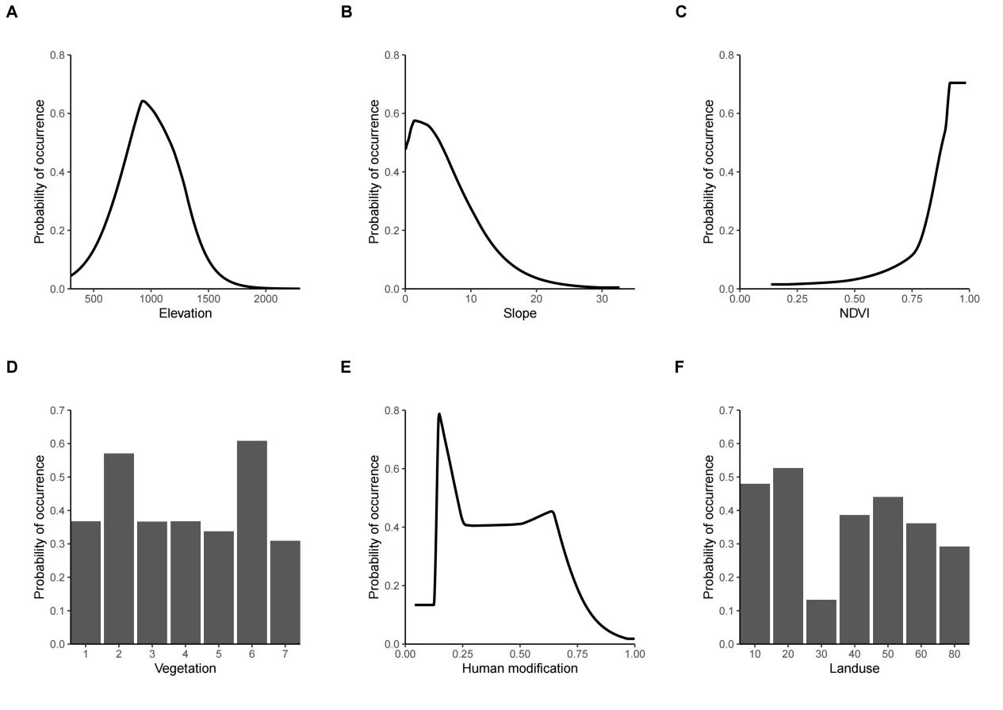
Fig. 1 The Response curves of variables on the 1-km scale
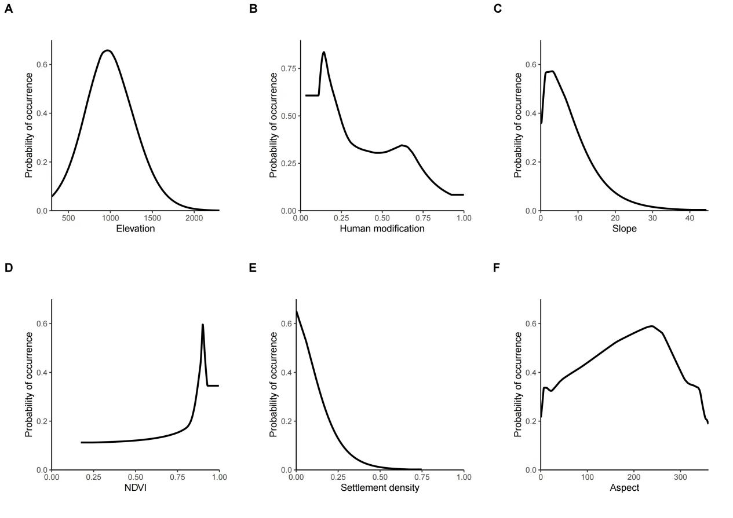
Fig. 2 The Response curves of variables on the 5-km scale
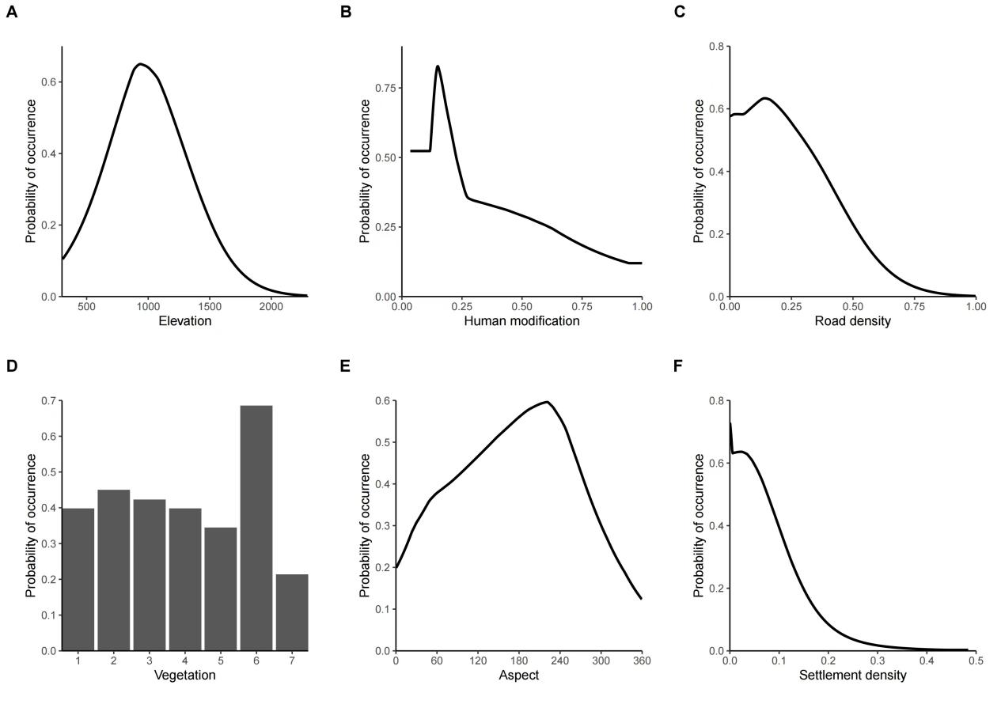
Fig. 3 The Response curves of top 6 variables on the 10-km scale

