Supporting Information for
Amplified Arctic warming causes Eurasian cooling via nonlinear feedback of reduced synoptic eddy activities in winter

Manman Yin¹, Xiu-Qun Yang^{1,2}*, Xiaozhuo Sang¹, Lingfeng Tao¹, Linyuan Sun¹,
Jiabei Fang^{1,2}, Xuguang Sun¹, Huijun Wang³
¹China Meteorological Administration Key Laboratory for Climate Prediction Studies, School of Atmospheric Sciences, Nanjing University, Nanjing 210023, China.
² Southern Marine Science and Engineering Guangdong Laboratory (Zhuhai), Zhuhai 519082, China
³ Collaborative Innovation Center on Forecast and Evaluation of Meteorological Disasters/Ministry of Education Key Laboratory of Meteorological Disaster, Nanjing University of Information Science and Technology, Nanjing 210044, China

*Corresponding author:
Dr. Xiu-Qun Yang, xqyang@nju.edu.cn
School of Atmospheric Sciences,
Nanjing University,
Nanjing 210023, China

Contents of this file:
Supplementary Figs. 1-6
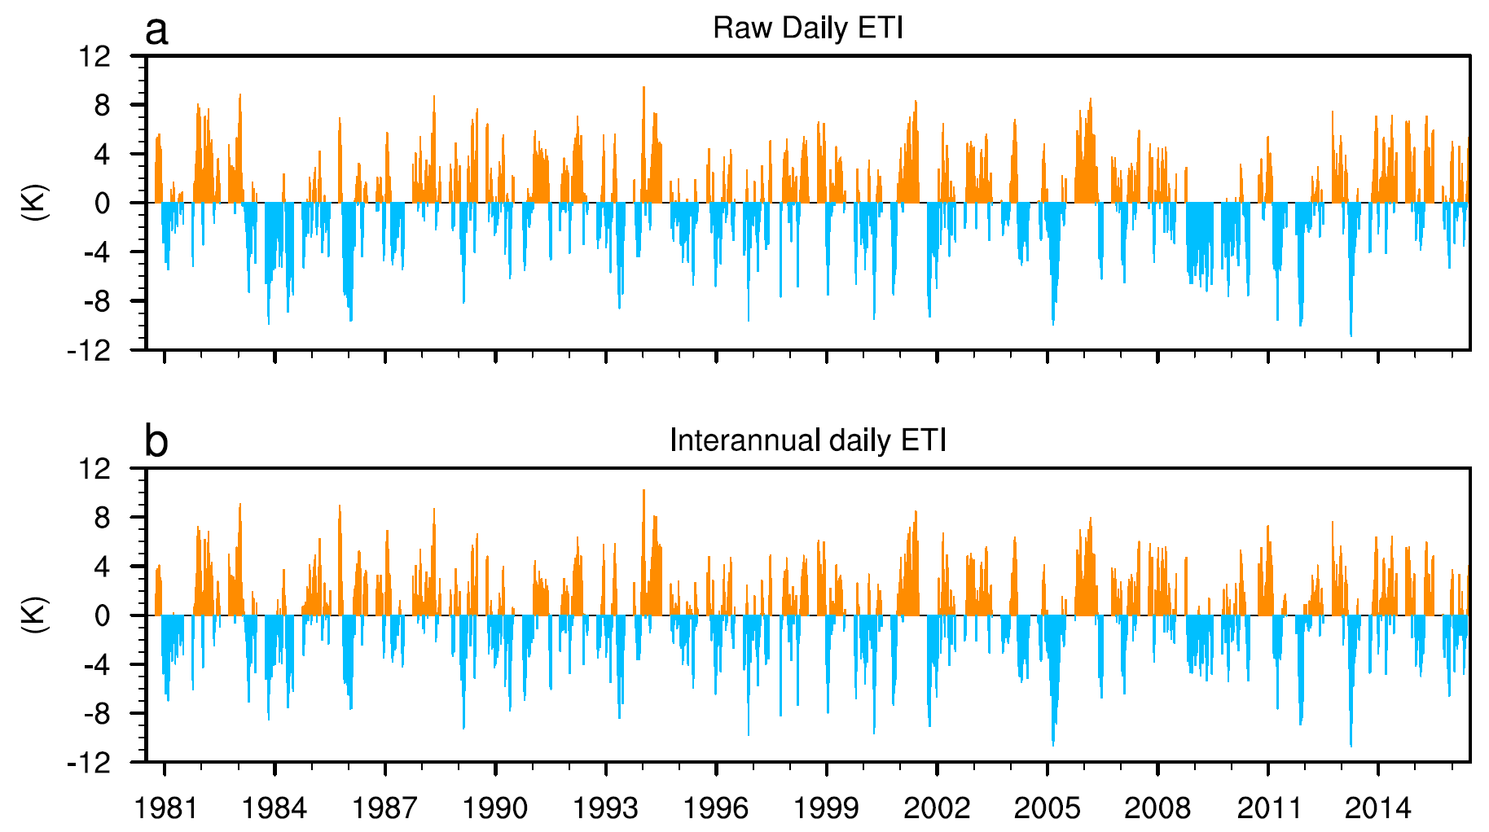

Supplementary Fig. 1 | Characterization of the Eurasian cooling with daily SAT index. Histograms of time series of wintertime daily Eurasian temperature index (ETI, unit: K) defined as (a) raw and (b) interannual daily surface air temperature (SAT) anomalies at the level of sigma 0.995 averaged over the Eurasian domain (30ºE-120ºE and 45ºN-65ºN).

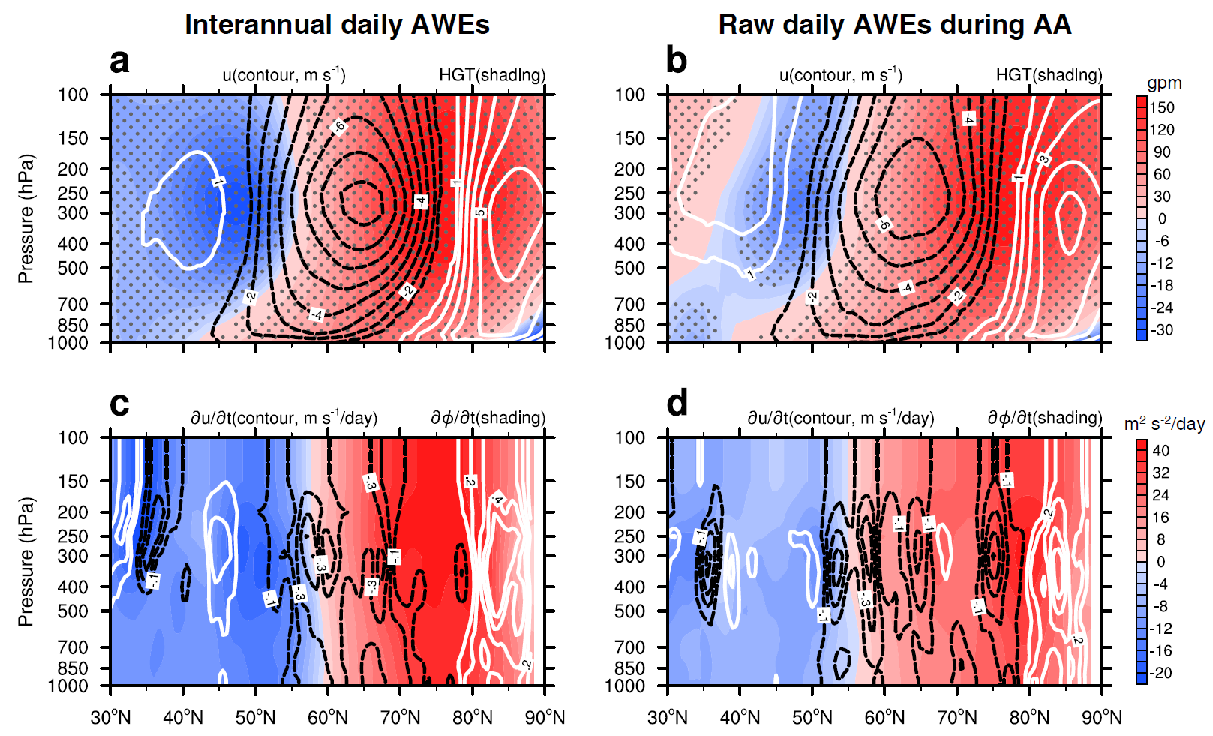
Supplementary Fig. 2 | Arctic warming-caused meridional dipoles of geopotential height anomalies and associated zonal wind anomalies via feedback of reduced synoptic eddy activities. Altitude-latitude sections averaged over 30ºE-120ºE of the composite geopotential height (shadings, unit: gpm) and zonal wind (contours, unit: m s⁻¹) anomalies lagging AWEs by 0-2 days for (a) top 300 interannual daily AWEs and (b) top 300 raw daily AWEs during the AA period. c, d Same as a, b, but for the anomalies of (c) mean geopotential tendency $∂∆\overline{Φ}/∂t$ (shading, unit: m² s^{–2} day^{–1}) and (d) mean zonal wind tendency$∂∆\overline{u}/∂t$ (contours, unit: m s^{–1} day^{–1}) induced by the lagged synoptic eddy vorticity forcing anomalies $∆{\overline{F}}_{eddy}$. Note that the solid (dashed) contours indicate positive (negative) anomalies and that the areas with anomalies exceeding 95% confidence level with the Student's t–test are stippled in (a) and (b).

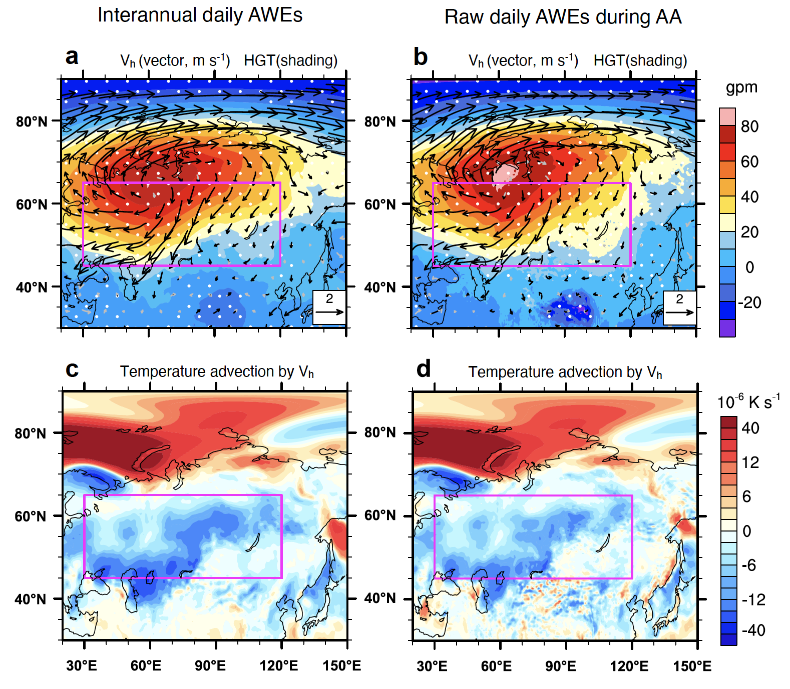
Supplementary Fig. 3 | Arctic warming-caused surface circulation and temperature advection anomalies. Horizontal distributions of the composite (a, b) geopotential height (shading, unit: gpm) and horizontal wind (vector, unit: ms⁻¹) anomalies and (c, d) advection of climatological temperature by anomalous horizontal wind (unit: 10⁻⁶ K s⁻¹) at 1000 hPa lagging AWEs by 0-2 days for (a, c) top 300 interannual daily Arctic waming events (AWEs) and (b, d) top 300 raw daily AWEs during the AA period. Note that the white stippling and black verctors in (a) and (b) denote the anomalies exceeding 95% confidence level with the Student's t–test and that the magenta rectangles ranging from 30ºE to 120ºE and from 45ºN to 65ºN represent the midlatitude Eurasia.

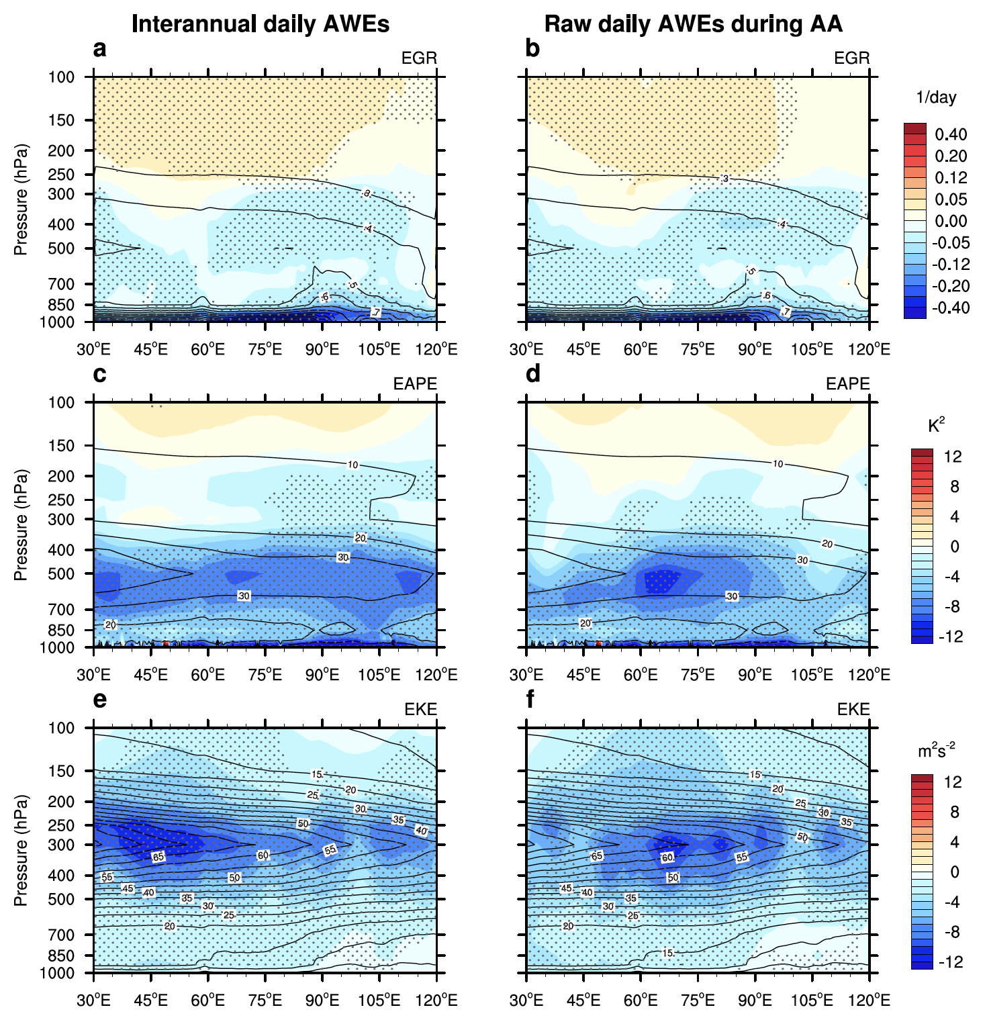
Supplementary Fig. 4 | Reduced lower-level atmospheric baroclinicity and synoptic eddy activities by the Arctic warming. Altitude-longitude sections averaged over 50ºN to 70ºN of the composite (a, b) maximum Eady growth rate (EGR, unit: day^{–1}), (c, d) available potential energy (EAPE, unit: K²), and (e, f) eddy kinetic energy (EKE, unit: m²s^{–2}) anomalies lagging AWEs by 0-2 days for (a, c, e) top 300 interannual daily AWEs and (b, d, f) top 300 raw daily AWEs during the AA period. Note that the contours indicate the climatological states for each variable and that the areas with anomalies exceeding 95% confidence level with the Student's t–test are stippled.

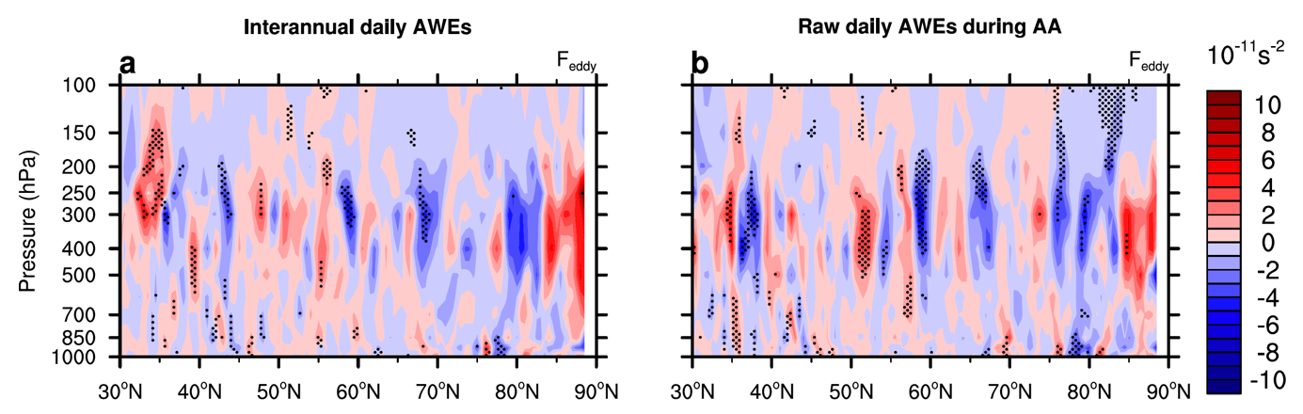
Supplementary Fig. 5 | Arctic warming-caused synoptic eddy vorticity forcing anomalies. Altitude-latitude sections averaged over 30ºE-120ºE of the composite synoptic eddy vorticity forcing anomalies ($∆{\overline{F}}_{eddy}$, unit: 10^{–11} s^{–2}) lagging AWEs by 0-2 days for (a) top 300 interannual daily AWEs and (b) top 300 raw daily AWEs during the AA period. Note that the areas with anomalies exceeding 95% confidence level with the Student's t–test are stippled.
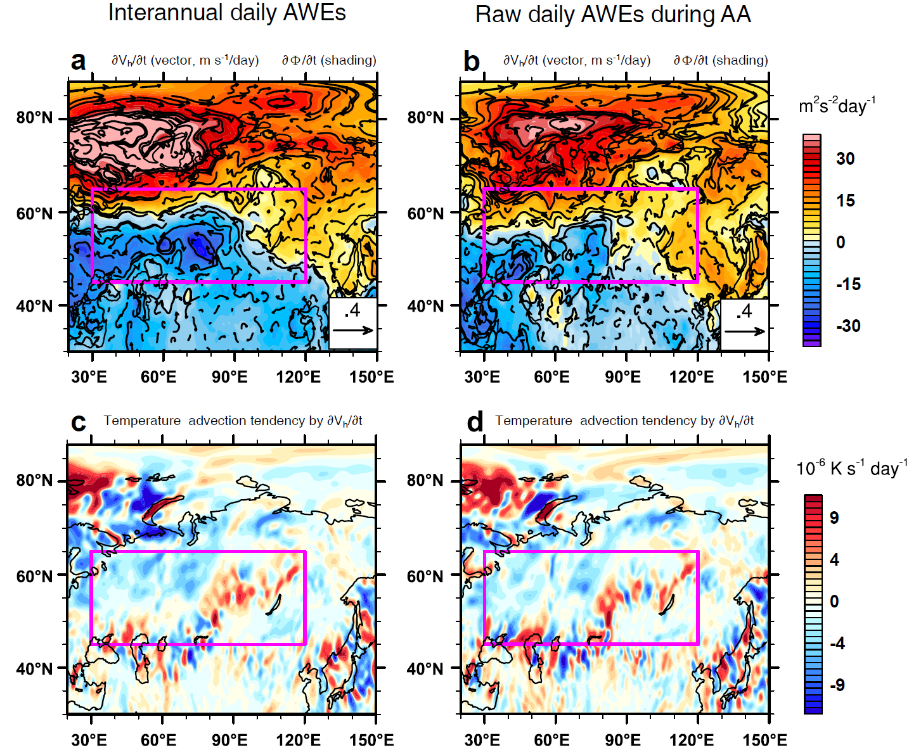
Supplementary Fig. 6 | Arctic warming-caused surface circulation and temperature tendency anomalies via feedback of reduced synoptic eddy activities. Horizontal distributions of the anomalies of (a, b) mean geopotential height tendengcy ($∂∆\overline{Φ}/∂t$, shading, unit: m²s⁻²day⁻¹) and horizontal wind tendency ($∂∆\overline{\overset{⃑}{V}}/∂t$, vector, ms⁻¹ day⁻¹) at 1000 hPa and (c, d) the advection of climatological temperature by anomalous horizontal wind tendencies (unit: 10⁻⁶ Ks⁻¹day⁻¹) at 1000 hPa, lagging AWEs by 0-2 days, for (a, c) top 300 interannual daily Arctic waming events (AWEs) and (b, d) top 300 raw daily AWEs during the AA period. Note that the magenta rectangles ranging from 30ºE to 120ºE and from 45ºN to 65ºN represent the midlatitude Eurasia.

