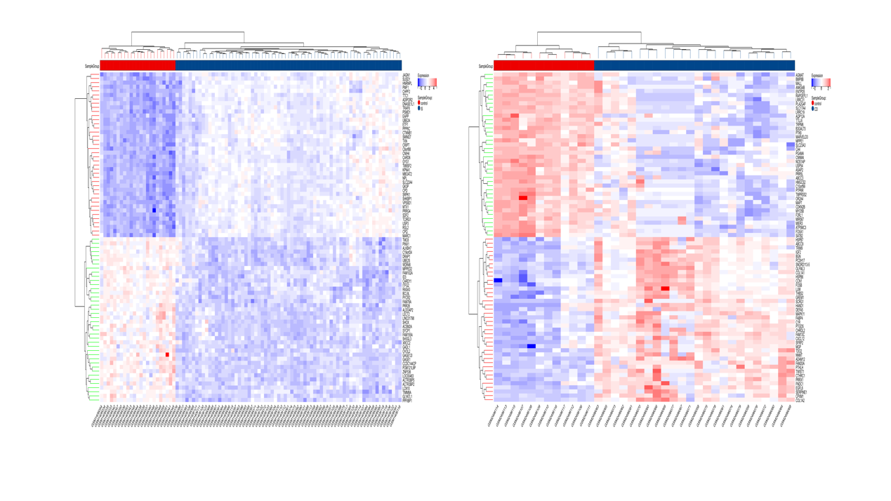
SUPPLEMENTARY FIGURE 1. Heat map. (A) Differential genes of IS and control (GSE58294). (B) Differential genes of CD and control (GSE95095).

