Supplementary figures

AVA-ADR-001 Suppresses Tumor Growth and Induces Anti-tumor Immunity by Selectively Inhibiting ADAR1 p150

Avijit Goswami^{2#}, Barnali Deb^{2#}, Ankita Mohanty², Sandeep Goyal², Kawaljit Singh², Rahul Yadav³, Princy Khurana², Narenkumar Muralidharan², Jan Rehwinkel^{4*} and Aditya Kulkarni^{1,2*}

¹Avammune Therapeutics, Pennsylvania, USA;
²Aten Porus Lifesciences, Bangalore, India,
³Department of Chemistry, Indian Institute of Science Education and Research (IISER), Bhopal
⁴Medical Research Council Human Immunology Unit, Radcliffe Department of Medicine, Medical Research Council Weatherall Institute of Molecular Medicine, University of Oxford, Oxford, UK
# These authors contributed equally
*Correspondence: aditya@avammune.com

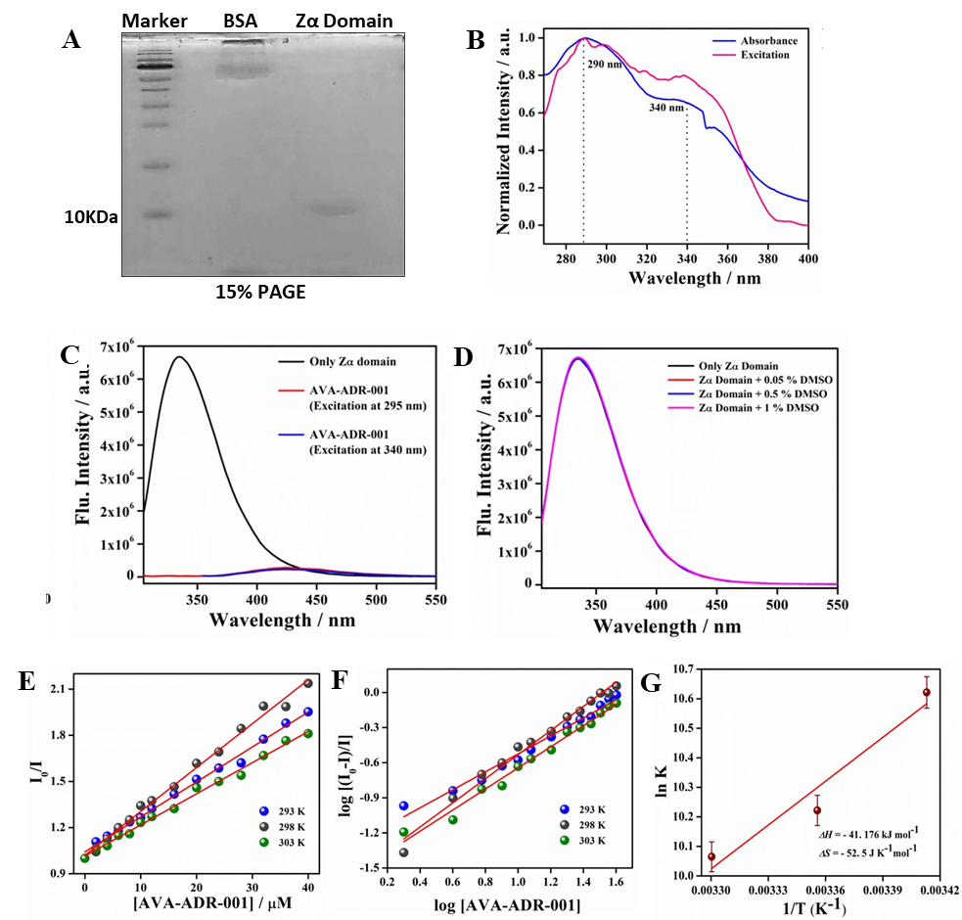
Supplementary Figure 1: (A) Purity of Zα domain using Coomassie staining. (B) Normalized absorption and excitation spectra of only AVA-ADR-001. (C) Relative fluorescence intensities of Zα domain and AVA-ADR-001. (D) Influence of DMSO on the fluorescence intensity of Zα domain. (E) Stern-Volmer plots at three different temperatures as marked in the figure. (F) Double logarithmic plots at three different temperatures as marked in the figure. (G) Van’t Hoff plot for the estimation of thermodynamic parameters.

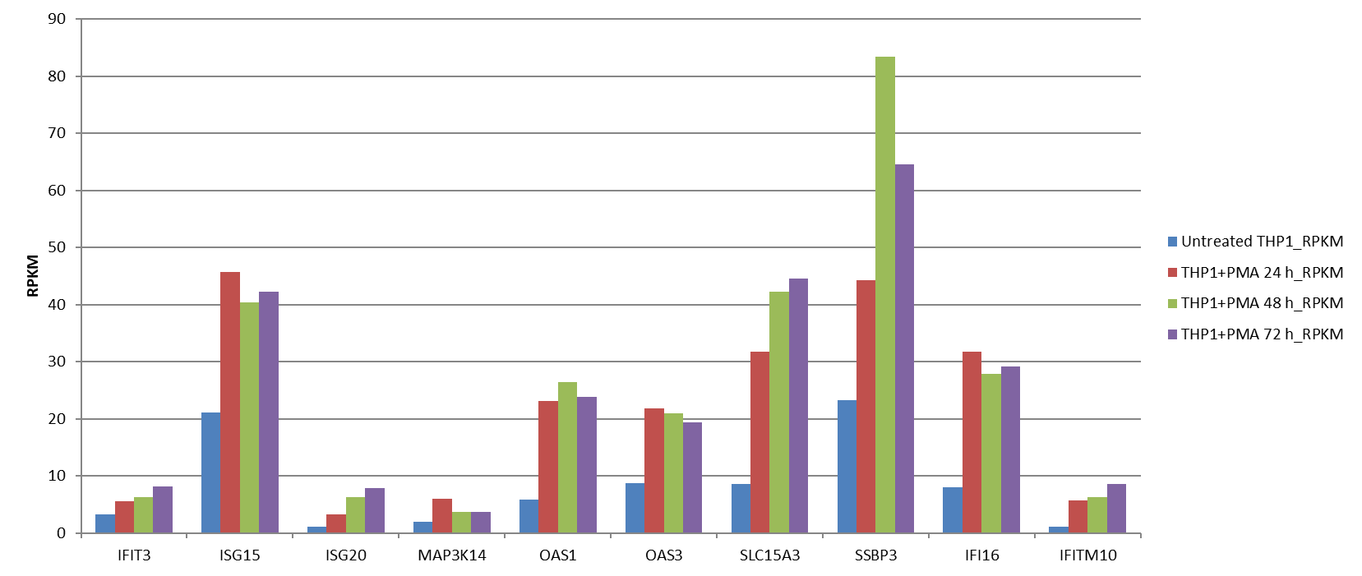
Supplementary Figure 2: RNA-seq data from Zeng et al 2015 were reanalyzed to plot specific ISGs that were upregulated. THP1 cells were treated with PMA for different time periods (24, 48 and 72 h) and subjected to RNA-seq analysis. The expression of the ISGs in the PMA treated cells were plotted in RPKM as compared to the untreated cells.

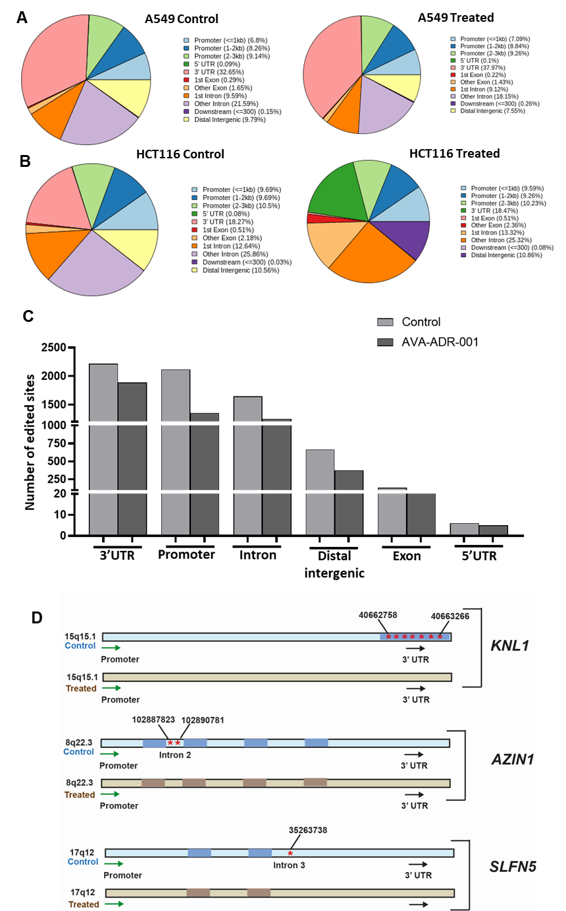
Supplementary Figure 3: Evaluation of A-I editing upon treatment with AVA-ADR-001 at different sites. (A) Percentage of editing for each genomic site in across A549 and HCT116 control and AVA-ADR-001 treated cells are depicted. (B) The number of A-to-I edited sites in A549 control and treated cells. The number of edited sites has reduced in the A549 treated cells. (C) The editing targets of ADAR1 p150 reported by Zhang et al, 2021, were evaluated to check the alterations in editing levels. (D) Schematic diagram depicting the observations of KNL1 (3’UTR), AZIN1 and SLFN5 (Exon) edited in the control cells whereas hypo-editing observed in the AVA-ADR-001 treated cells (* denotes edited sites).
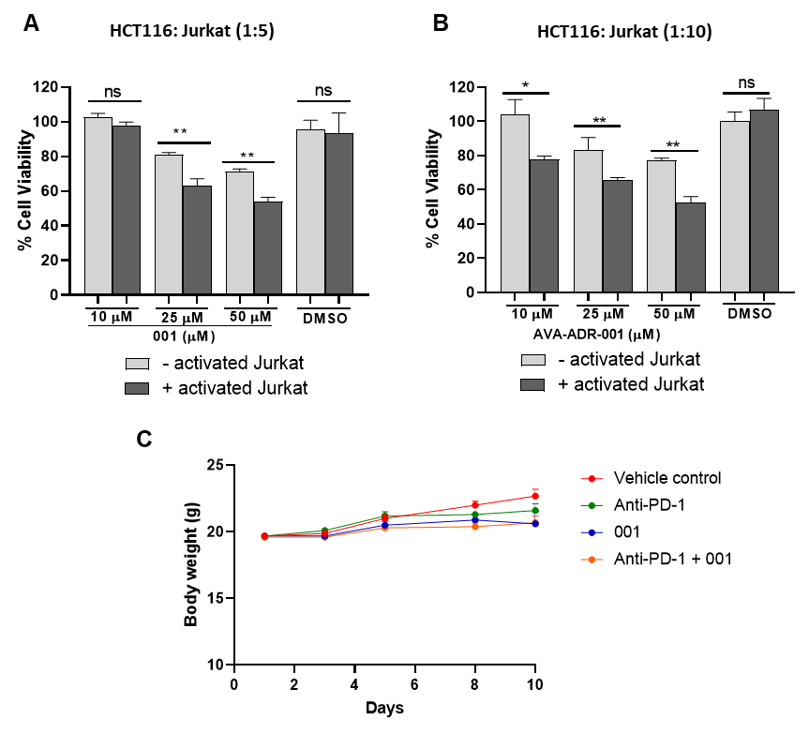

Supplementary Figure 4: (A-B) T-cell cytotoxicity was evaluated using different concentrations of AVA-ADR-001 using a co-culture experiment with HCT116 and Jurkat 6.1 cells. Cell viability of HCT116 grown in co-culture with Jurkat-6 (1:5 and 1:10 ratio) treated with AVA-ADR-001 (10, 25, 50 μM) for 72h. (C) Body weight (g) of treatment groups with administration of AVA-ADR-001 and anti-PD1 treatment were evaluated on Day 1, 3, 5, 8 and 10. Error bars represented as, Mean ± SE.

