Estimating appropriate disturbance timing for the population of an endangered butterfly inhabiting grassland patches in an agricultural landscape
Journal of Insect Conservation

Hidenori Deto^{1*} and Tadashi Miyashita¹

¹ Laboratory of Biodiversity Science, School of Agriculture and Life Sciences, The University of Tokyo, Tokyo, Japan

*Corresponding author
Correspondence to Hidenoro Deto.
Email: d.hidex55@gmail.com

Supplementary Information

Table S1. Prior distributions for parameters estimated in models of average annual larval (1st analysis).
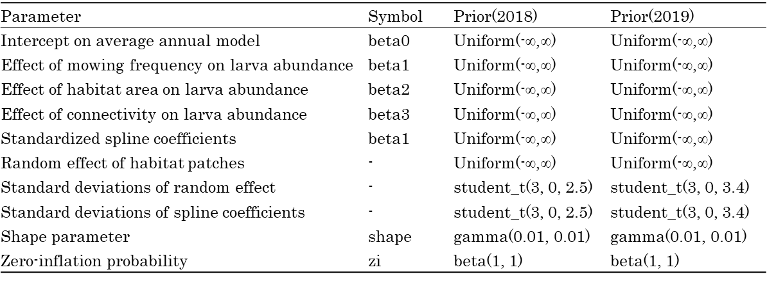

Fig. S1. Histogram showing mowing frequency of all patches (A) and mowing date for patches with different mowing frequency in 2018 and 2019 (B)

Fig. S2. Percentage of each ant species found to attend larvae of Plebejus argyrognomon in each generation. Numbers in () represents the number of samples

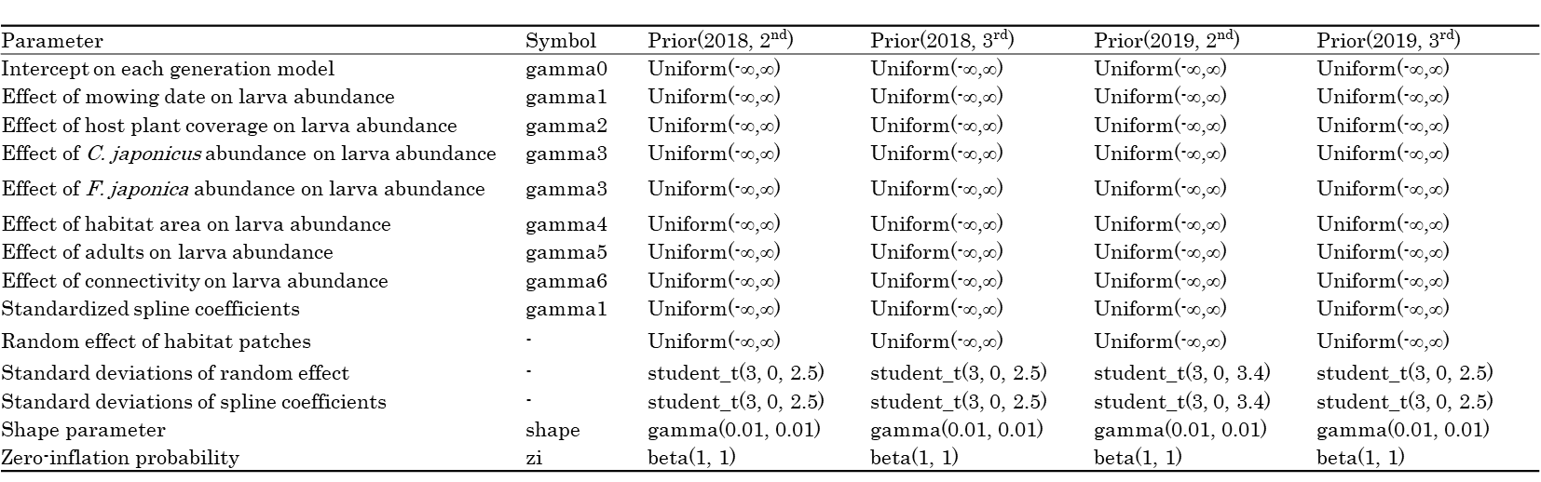
Table S2. Prior distributions for parameters estimated in models of larval abundance in each generation (2nd analysis).

Fig. S3. Mowing frequency (A), C. japonicus density (B), and F. japonica density (C) in relation to mowing frequency. Broken lines represent the 95% confidence limits

Fig. S4. The inflorescence abundance of host plants during the adult flight period of 1st and 2nd generations (June and July). Error bars indicate standard errors

