Supplemental Material
Effects of postnatal exposure to mixtures of bisphenol A and phthalates on children’s IQ at 5 years of age: Mothers and Children's Environmental Health (MOCEH) Study

Supplementary Figure 1. Correlation matrix of exposure to metabolites of chemicals age at the 24 and 36 months

Supplementary Figure 2. Sex Stratified plots of mixture of BPA and phthalates exposure-response relationships (and 95% credible intervals) by range quantile using Quantiled-based g-computation analysis

Supplementary Table 1. Distributions of metabolites of chemicals age at the 24 and 36 months

Supplementary Table 2. Stratified by sex individual associations between metabolites of chemicals and children's IQ using multiple regression

Supplementary Table 3. Sex stratified bisphenol A and phthalates mixture associations with Children’s IQ using Weighted Quantile Sum regression

Supplementary Table 4. Characteristics of maternal IQ measured and unmeasured participants

Supplementary Figure 1

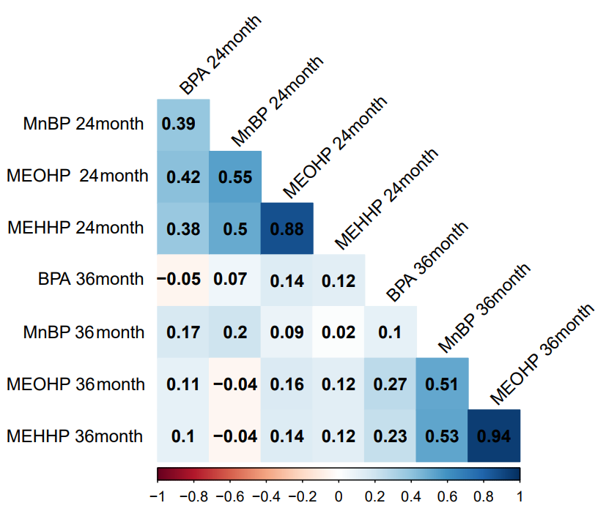
BPA: bisphenol A; MEOHP: mono-(2-ethyl-5-oxohexyl) phthalate; MEHHP: mono-(2-ethyl-5-hydroxyhxyl) phthalate; MnBP: mono-(2-ethyl-5-buyl) phthalate

Supplementary Figure 2
Model 1: adjusted for maternal age, maternal education, household income, secondhand smoking and children’s age.

Supplementary Table 1
Distributions of metabolites of chemicals age at the 24 and 36 months
Chemicals | Mean | SD | Min | P25 | P50 | P75 | Max
At 24 months
BPA(μg/g Cr) | 0.09 | 0.13 | 0.00 | 0.03 | 0.04 | 0.11 | 1.00
MEOHP(μg/g Cr) | 0.94 | 0.62 | 0.01 | 0.52 | 0.83 | 1.24 | 3.09
MEHHP(μg/g Cr) | 0.71 | 0.45 | 0.00 | 0.40 | 0.63 | 0.94 | 2.42
MnBP(μg/g Cr) | 1.68 | 1.09 | 0.12 | 1.02 | 1.50 | 2.02 | 6.68
At 36 months
BPA(μg/g Cr) | 0.06 | 0.13 | 0.00 | 0.01 | 0.03 | 0.05 | 0.92
MEOHP(μg/g Cr) | 0.76 | 0.54 | 0.02 | 0.42 | 0.63 | 0.90 | 3.66
MEHHP(μg/g Cr) | 0.61 | 0.43 | 0.02 | 0.37 | 0.50 | 0.73 | 3.15
MnBP(μg/g Cr) | 1.29 | 1.01 | 0.07 | 0.68 | 1.00 | 1.59 | 7.15
At 24 months
BPA(μg/L) | 4.40 | 6.45 | 0.14 | 0.92 | 2.12 | 4.99 | 50.57
MEOHP(μg/L) | 48.79 | 44.41 | 1.41 | 20.97 | 35.01 | 71.04 | 280.24
MEHHP(μg/L) | 37.62 | 32.37 | 0.27 | 13.64 | 29.41 | 49.21 | 196.18
MnBP(μg/L) | 93.07 | 83.02 | 2.97 | 34.81 | 79.87 | 120.22 | 489.32
At 36 months
BPA(μg/L) | 3.70 | 8.32 | 0.14 | 0.75 | 1.57 | 3.42 | 84.95
MEOHP(μg/L) | 45.01 | 32.67 | 1.29 | 22.97 | 34.67 | 54.47 | 181.46
MEHHP(μg/L) | 36.28 | 25.75 | 0.94 | 18.94 | 28.78 | 45.76 | 155.15
MnBP(μg/L) | 80.03 | 76.61 | 1.94 | 36.65 | 55.50 | 97.16 | 541.11
BPA: bisphenol A; MEOHP: mono-(2-ethyl-5-oxohexyl) phthalate; MEHHP: mono-(2-ethyl-5-hydroxyhxyl) phthalate; MnBP: mono-(2-ethyl-5-buyl) phthalate.
Supplementary Table 2
Stratified by sex individual associations between metabolites of chemicals and children's IQ using multiple regression
Chemicals | Boys(n : 87) | Girls(n : 65)
 | Estimate(95% CI) | Estimate(95% CI)
At 24 months
BPA | -1.31 (-3.12, 0.49) | -0.26 (-2.58, 2.05)
MEOHP | 0.22 (-2.64, 3.09) | -1.03 (-4.34, 2.28)
MEHHP | 0.05 (-2.41, 2.50) | -0.78 (-3.90, 2.35)
MnBP | -0.37 (-3.38, 2.65) | -3.07 (-6.86, 0.71)
At 36 months
BPA | -0.05 (-2.13, 2.03) | 0.12 (-1.84, 2.08)
MEOHP | 0.61 (-3.57, 4.79) | 0.33 (-2.94, 3.60)
MEHHP | -0.30 (-4.96, 4.37) | 4.37 (-3.04, 3.56)
MnBP | -2.84 (-6.40, 0.73) | -2.67 (-6.13, 0.80)
BPA: bisphenol A; MEOHP: mono-(2-ethyl-5-oxohexyl) phthalate; MEHHP: mono-(2-ethyl-5-hydroxyhxyl) phthalate; MnBP: mono-(2-ethyl-5-buyl) phthalate; IQ: Intelligence Quotient; CI: confidence intervals.
Model 1: adjusted for maternal age, maternal education, household income, secondhand smoking and children’s age.

Supplementary Table 3
Sex stratified bisphenol A and phthalates mixture associations with Children’s IQ using Weighted Quantile Sum regression
Boys(n : 87) |  | Girls(n : 65)
Mix namT | Mean weight | Mix name | Mean weight
BPA 36month | 0.412 | MnBP 36month | 0.454
MEHHP 24month | 0.170 | MnBP 24month | 0.286
MnBP 36month | 0.155 | BPA 36month | 0.100
MEHHP 36month | 0.137 | MEHHP 24month | 0.055
MEOHP 24month | 0.051 | BPA 24month | 0.055
MnBP 24month | 0.034 | MEOHP 36month | 0.024
BPA 24month | 0.034 | MEOHP 24month | 0.023
MEOHP 36month | 0.006 | MEHHP 36month | 0.000
Estimate | P-value | Estimate | P-value
2.48 | 0.43 | -5.58 | 0.07
BPA: bisphenol A; MEOHP: mono-(2-ethyl-5-oxohexyl) phthalate; MEHHP: mono-(2-ethyl-5-hydroxyhxyl) phthalate; MnBP: mono-(2-ethyl-5-buyl) phthalate; IQ: Intelligence Quotient.
Model 1: adjusted for maternal age, maternal education, household income, secondhand smoking and children’s age.

Supplementary Table 4
Characteristics of maternal IQ measured and unmeasured participants
Variable | Unmeasured  (n: 105) | Measured  (n: 47) | P-value ª
Maternal age, mean±SD | 30.48±3.51 | 29.7±2.42 | 0.42
Sex, N(%)
Boys | 65(61.90) | 27(57.45) | 1
Girls | 45(42.86) | 20(42.55)
Maternal education, N(%)
≤High school | 45(42.86) | 18(38.30) | 0.54
College | 51(48.57) | 27(57.45)
≥Graduate school | 9(8.57) | 2(4.26)
Household income, N(%)
< KRW2,000,000 | 27(25.71) | 12(25.53) | 0.65
KRW 2,000,000 –4,000,000 | 61(58.10) | 30(63.83)
> KRW4,000,000 | 27(25.71) | 5(10.64)
Secondhand smoking, N(%)
Yes | 58(55.24) | 25(53.19) | 0.95
No | 47(44.76) | 22(46.81)
Metabolites of endocrine-disrupting chemicals, mean±SD
At 24 months
BPA(μg/g Cr)) | 0.09±0.14 | 0.1±0.11 | 0.51
MEOHP(μg/g Cr)) | 0.92±0.6 | 0.97±0.67 | 0.68
MEHHP(μg/g Cr)) | 0.71±0.43 | 0.73±0.5 | 0.72
MnBP(μg/g Cr)) | 1.73±1.08 | 1.58±1.1 | 0.42
At 36 months
BPA(μg/g Cr)) | 0.07±0.14 | 0.05±0.08 | 0.45
MEOHP(μg/g Cr)) | 0.74±0.54 | 0.82±0.54 | 0.42
MEHHP(μg/g Cr)) | 0.61±0.46 | 0.62±0.34 | 0.20
MnBP(μg/g Cr)) | 1.23±1.02 | 1.45±0.99 | 0.22
ªP-values were obtained using the t-test, Wilcoxon rank sum test and chi-square test.
KRW: Korean Won; BPA: bisphenol A; MEOHP: mono-(2-ethyl-5-oxohexyl) phthalate; MEHHP: mono-(2-ethyl-5-hydroxyhxyl) phthalate; MnBP: mono-(2-ethyl-5-buyl) phthalate; IQ: Intelligence Quotient.

