Supplementary Table 1: Lung participant demographics ²⁰.
 | TB | XDR TB
n | 13 | 1
Age (mean ±SD) | 38±14.72 | 45
Sex
Male | 4 (30.8%) | 0
Female | 9(69.2%) | 1

Supplementary Table 2: Pearson correlation of GSDMD (pg/ml) with inflammatory soluble mediators (pg/ml)
 | Healthy |  | LTBI |  | TB
 | p | r | p | r | p | r
IL-1β | 0.863 | 0.60 | *0.036 | 0.664 | 0.219 | 0.038
IL-1RA | 0.0001 | 0.946 | *0.005 | 0.806 | 0.210 | 0.399
IL-2 | 0.593 | -0.207 | 0.580 | 0.337 | NA | NA
IL-4 | 0.438 | -0.297 | 0.197 | 0.445 | 0.795 | -0.084
IL-5 | 0.432 | -0.301 | 0.278 | 0.607 | 0.083 | 0.520
IL-6 | 0.008 | 0.815 | 0.638 | 0.362 | 0.250 | 0.360
IL-7 | 0.303 | -0.387 | 0.226 | -0.938 | 0.077 | 0.529
IL-8 | 0.047 | 0.673 | 0.846 | -0.076 | *0.005 | 0.748
IL-9 | 0.956 | -0.022 | 0.429 | 0.283 | 0.992 | 0.0003
IL-10 | 0.557 | 0.227 | 0.434 | 0.279 | 0.798 | 0.083
IL-12 | 0.760 | -0.119 | NA | NA | 0.485 | -0.224
IL-13 | NA | NA | NA | NA | 0.103 | 0.493
IL-15 | NA | NA | NA | NA | NA | NA
IL-17 | NA | NA | 0.600 | 0.400 | 0.677 | 0.134
Eotaxin | 0.616 | -0.194 | 0.299 | 0.365 | 0.431 | -0.251
FGF-basic | 0.172 | -0.498 | *0.029 | 0.686 | 0.071 | 0.539
G-CSF | 0.481 | -0.271 | 0.544 | 0.219 | 0.039 | 0.601
GM-CSF | 0.980 | -0.009 | 0.136 | 0.622 | 0.668 | 0.138
IFN-γ | 0.607 | 0.199 | 0.763 | 0.110 | 0.180 | 0.415
IP-10 | 0.009 | 0.805 | 0.637 | -0.171 | 0.013 | 0.693
MCP-1 | 0.982 | -0.009 | 0.985 | -0.007 | 0.469 | 0.232
MIP-1α | 0.535 | -0.239 | 0.622 | 0.178 | 0.007 | 0.727
PDGF-bb | 0.401 | 0.320 | 0.720 | 0.130 | 0.361 | 0.290
MIP-1β | 0.794 | 0.102 | 0.436 | 0.279 | 0.552 | 0.191
RANTES | 0.872 | -0.063 | 0.619 | 0.180 | 0.591 | 0.173
TNF-α | 0.871 | 0.063 | 0.146 | 0.495 | 0.582 | 0.177
VEGF | 0.075 | -0.620 | 0.309 | -0.383 | 0.329 | -0.309
p< 0.05 were considered significant

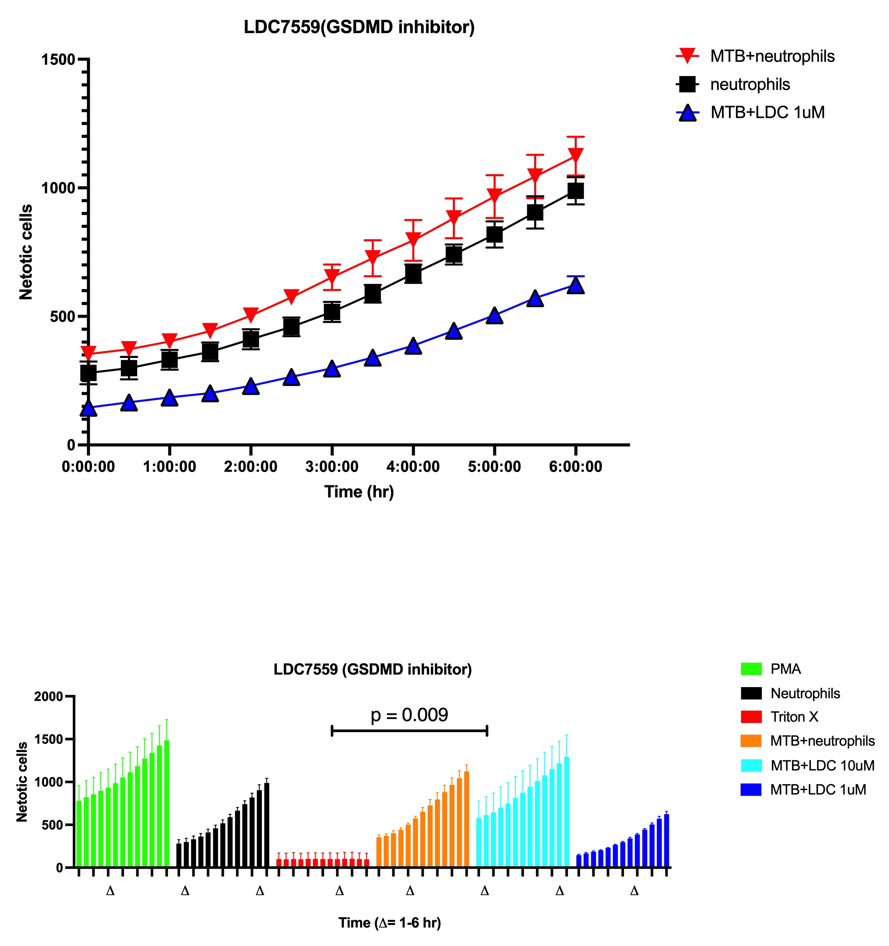

Supplementary Figure 1: Targeting NETosis with GSDMD inhibitor, LDC7559. (A) Representation of the increase in NETosis induced by Mtb H37Rv infection over time. The optimal concentration of LDC7559 used was 1μm. (B) We targeted GSDMD with 10 μm, and 1μm of LDC7559. Δ indicated kinetic imaging from 1-6 hours. Green is a positive control, neutrophils treated with PMA. Red is a negative control, with neutrophils treated with Triton X 100. Black is uninfected and untreated neutrophils. Orange is Mtb infected neutrophils, while dark blue and light blue are the neutrophils infected with Mtb and treated with 1μm and 10μm respectively. Unpaired t-test were done to determine statistical significance defined as p<0.05.

