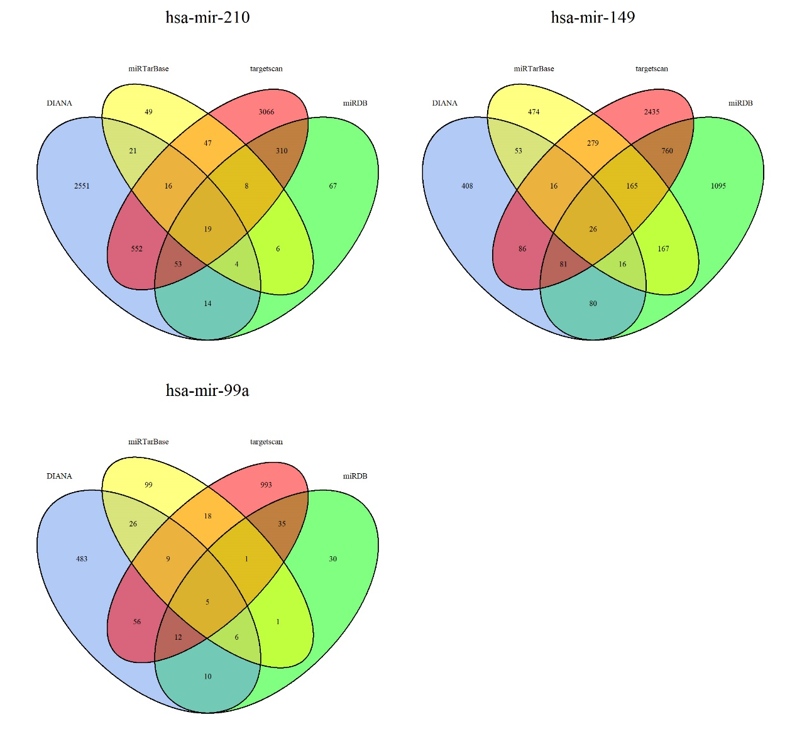
Additional file 1: Figure S1.
The Venn diagrams of the target genes. The overlapping target genes were predicted with DIANA, miRDB, miRTarBase and TargetScan databases.

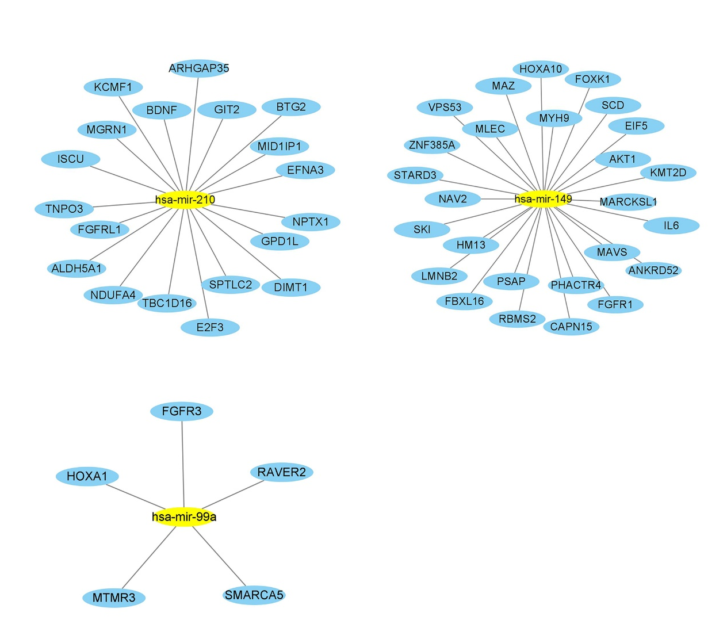
Additional file 1: Figure S2.
The network of the three miRNAs and their target genes. The yellow represented the miRNA, the blue represented the target genes, and the lines indicated the relationship between miRNAs and target genes.

