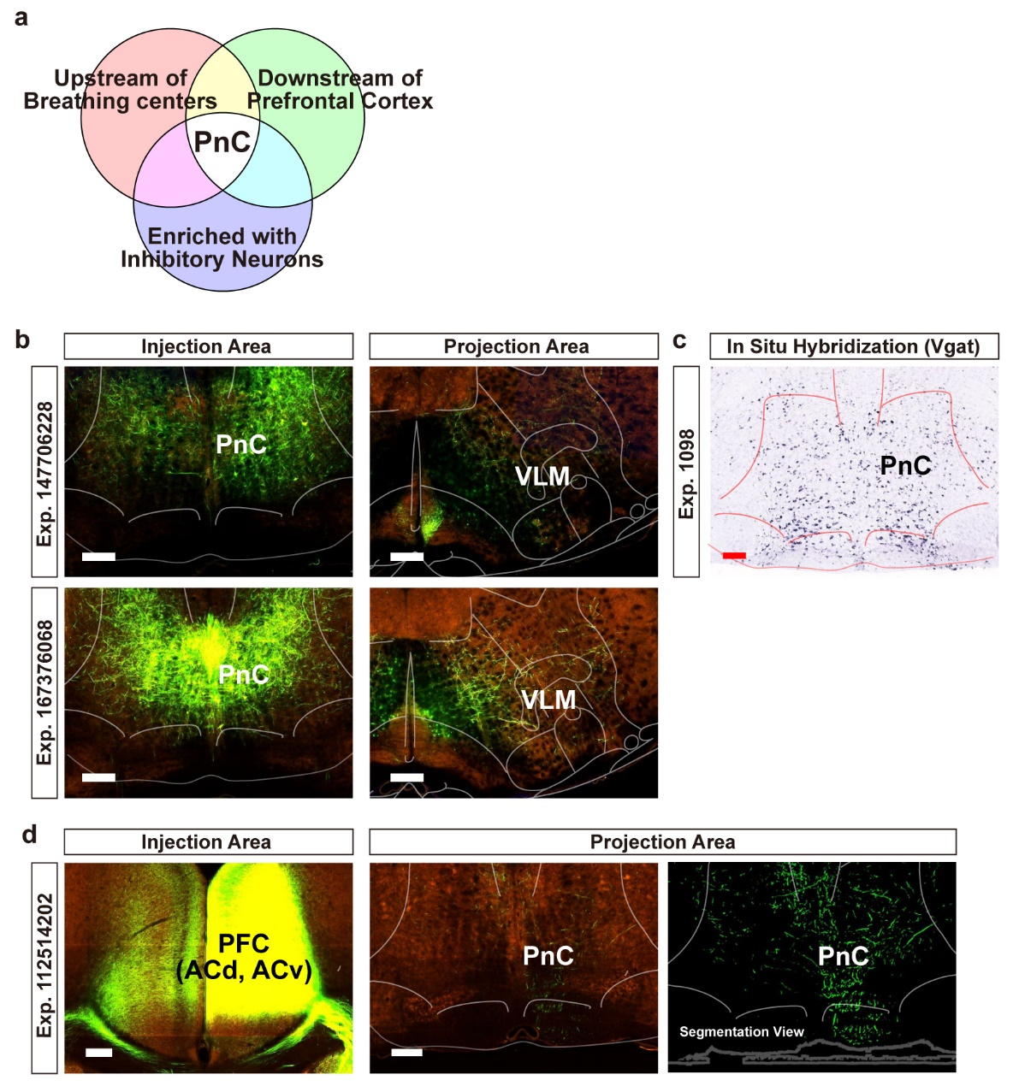
Extended Data Figure 1. Searching for candidate circuits to mediate top-down inhibitory control of breathing based on the Allen Brain Atlas. a, Summary of the criteria used to search candidate circuits. Axonal projection images were searched through the Mouse Brain Connectivity Atlas (Allen Brain Institute). In situ hybridization (ISH) images were searched through the Mouse Brain Gene Expression Atlas (Allen Brain Institute). b, Sample images showing the projections of labelled PnC neurons observed in the ventrolateral medulla (VLM). Left images show the AAV injection site (PnC) with the expression of eGFP. Right images show the eGFP-labelled terminals in the VLM. c, Sample image from a Vgat ISH experiment. The PnC is enriched with neurons that express Vgat mRNA (GABAergic cell marker). d, Sample images showing the projections of PFC neurons observed in the PnC. Left image shows the AAV injection site (PFC, prefrontal cortex; covering the dACC and vACC) with the expression of eGFP. Middle and right (in segmentation view) images show the eGFP-labelled axon terminals in the PnC. Scale bar, 200 μm.

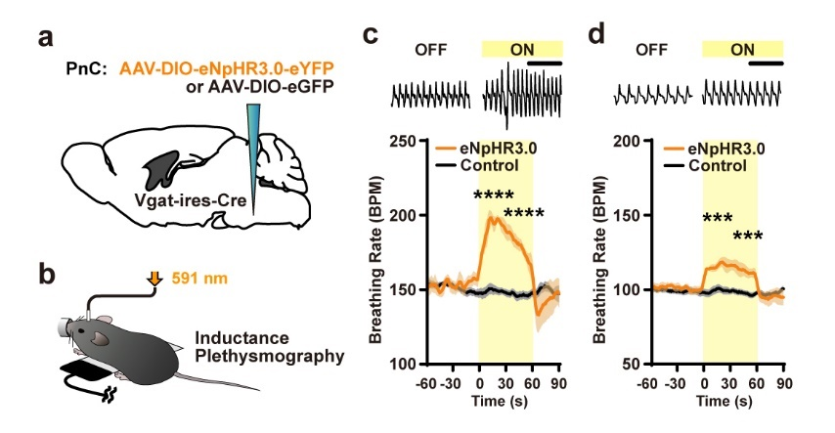
Extended Data Figure 2. Photoinhibition of PnC^{GABA} neurons increases breathing rate. a, Schematic of the virus injection surgery. b, Breathing signals were monitored by inductance plethysmography with the delivery of 591-nm light for photoinhibition. c-d, Photoinhibition of PnC^{GABA} neurons induced increased breathing rate in the eNpHR3.0 group. Top, raw breathing signals. Bottom, average (mean) breathing rate in eNpHR3.0 (n = 4) or Control (eGFP, n = 3) groups. Two different baselines at 150 BPM or 100 BPM were used in c and d. Statistical analysis was performed with repeated measures (RM) two-way ANOVA followed by Sidak’s post hoc test. Between-groups comparison ***p < 0.001, ****p < 0.0001. Data are shown as mean ± s.e.m.

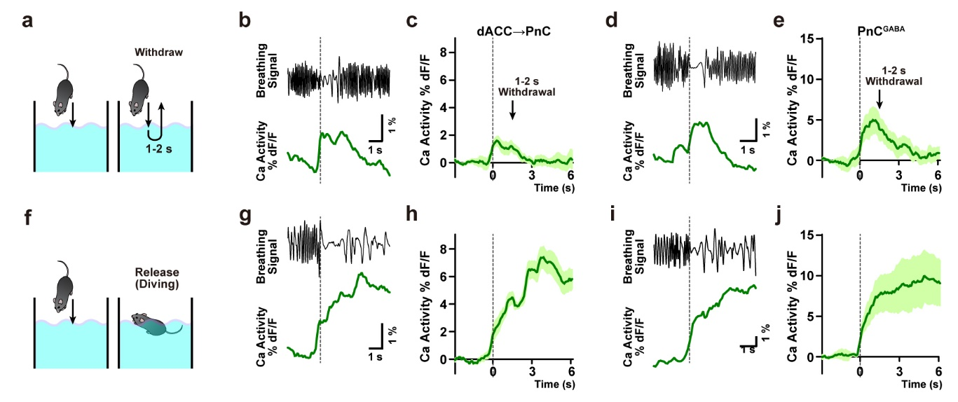
Extended Data Figure 3. dACC→PnC and PnC^{GABA} calcium activity during swimming. a, Schematic of “withdrawal” experiment in which mice were briefly (1-2 s) submerged in water and then removed. b-e, Monitoring results from mice expressing jGCaMP7s in dACC→PnC neurons (b, representative trace; c, average n = 6) or PnC^{GABA} neurons (d, representative trace; e, average n = 5). Representative breathing traces are shown in b and d. f, Schematic of “release” experiment in which mice were released after submersion. g-j, Monitoring results from mice expressing jGCaMP7s in dACC→PnC neurons (g, representative trace; h, average n = 5) or PnC^{GABA} neurons (i, representative trace; j, average n = 5) during release/swim experiment. Representative breathing traces are shown in g and i. Data are shown as mean ± s.e.m.

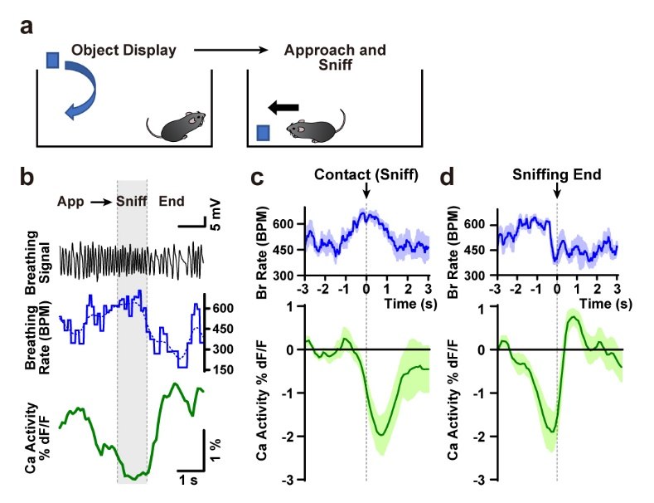
Extended Data Figure 4. dACC→PnC and PnC^{GABA} calcium activity during sniffing. a, Schematic of object sniffing experiment. b, Representative traces showing raw breathing cycles (top), breathing rate (middle), dACC→PnC calcium activity. c, At onset of contact-sniffing events, fast breathing rate (~600 BPM; top) and subsequent decrease of calcium activity were observed (bottom; n = 4). d, At the end of sniffing events, a decreased breathing rate (top) and rebound-like increase of calcium activity were observed (bottom; n = 4). Data are shown as mean ± s.e.m.

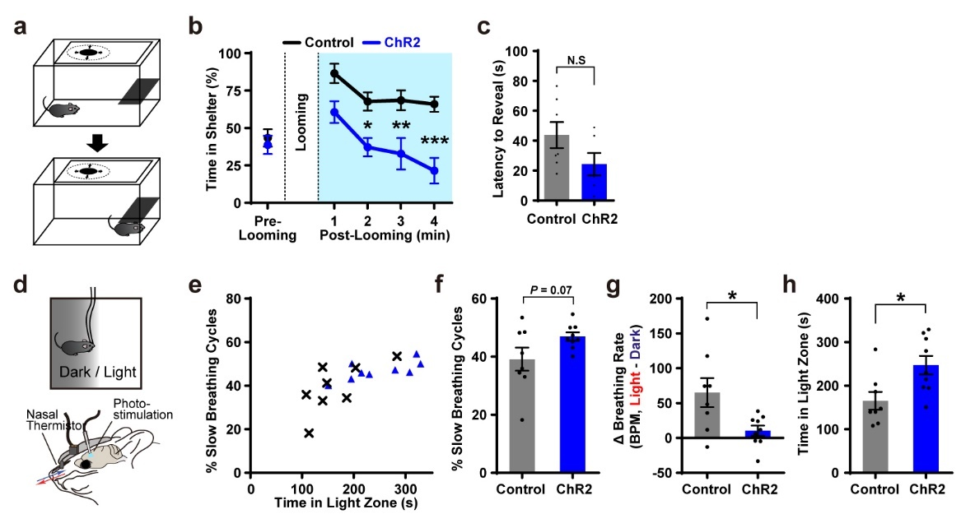
Extended Data Figure 5. Photoactivation of dACC→PnC neurons alleviates anxiety-like behaviors. a, Schematic of looming-hiding experiment. Time spent in hiding (in shelter) was observed after overhead looming stimulus. b, Photoactivation of dACC→PnC neurons reduced time spent in hiding in the ChR2 group (n = 6), compared to the control group (n = 7). c, Latency to the first reveal was not affected by photoactivation. d, Schematic of light/dark choice test with breathing monitoring and photostimulation. e-h, Breathing and behavioral correlates observed in the light/dark choice test. f, Percent of slow breathing cycles in light zone (slower than median breathing rate). g, Difference of breathing rates between light and dark zones (ΔBPM, light minus dark). h, Time spent in light zone. b, Repeated measures (RM) two-way ANOVA followed by Sidak’s post hoc test. c, f, g, Mann-Whitney U test. h, Unpaired t test. Between-groups comparison *p < 0.05, *p<0.01 ***p < 0.001. Data are shown as mean ± s.e.m.

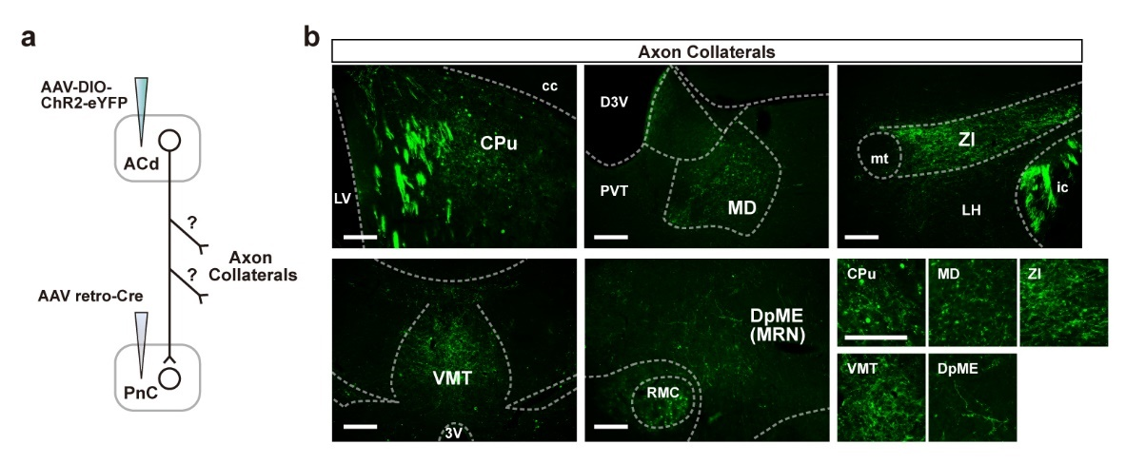
Extended Data Figure 6. Axon collaterals of dACC→PnC neurons. a, Observation of axon collaterals. AAVretro-Cre was injected into the PnC and AAV-DIO-ChR2-eYFP was injected into the dACC. Putative axon collaterals were revealed by observation of eYFP-labelled axons in brain regions other than the PnC (AAVretro-Cre injection site) area. b, Images showing axon collaterals of dACC→PnC neurons. CPu, caudate putamen. cc, corpus callosum. LV, lateral ventricle. D3V, dorsal third ventricle. PVT, paraventricular nucleus of thalamus. MD, mediodorsal nucleus of thalamus. ZI, zona incerta. mt, mammillothalamic tract. LH, lateral hypothalamus. ic, internal capsule. VMT, ventromedial nucleus of thalamus. RMC, red nucleus, magnocellular part. DpME, deep nucleus of the midbrain. Scale bar, 200 μm.

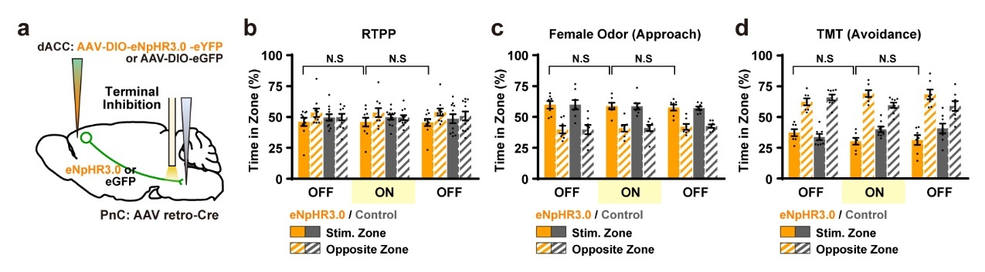
Extended Data Figure 7. Real-time place preference, female odor preference, and TMT odor avoidance tests with Photoinhibition of dACC→PnC terminals. a, Schematic showing photoinhibition of dACC→PnC terminals. b-d, Behaviors in the RTPP test (b; eNpHR3.0, n = 10; eGFP, n = 11), approach response to female odor (c; eNpHR3.0, n = 7; eGFP, n = 8), and avoidance response to TMT (d; eNpHR3.0, n = 7; eGFP, n = 8) were not affected by the photoinhibition. Repeated measures (RM) two-way ANOVA followed by Sidak’s post hoc test. Data are shown as mean ± s.e.m.

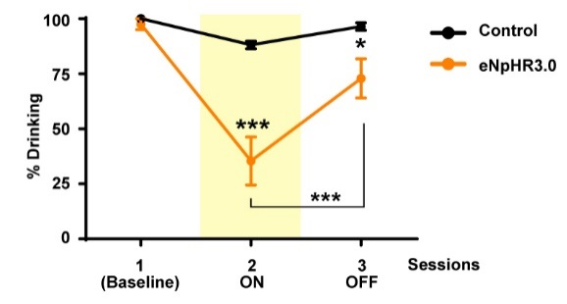
Extended Data Figure 8. Percent of successful drinking responses throughout testing sessions with or without photoinhibition of dACC→PnC terminals. Repeated measures (RM) two-way ANOVA followed by Sidak’s post hoc test. Data are shown as mean ± s.e.m.

Extended Data Table 1. Statistical analyses
Figure | Experiment | Groups | n | p | Test
Fig. 1h Left | Inductance plethysmography, baseline 200 BPM | dACC→PnC: ChR2, eGFP | 6 and 5 | F (1, 9) = 6.000 / Interaction P = 0.0368 / Light ON ChR2 vs eGFP **P = 0.0092 | RM 2-way ANOVA Sidak's post hoc test
Fig. 1h right | Inductance plethysmography, baseline 150 BPM | dACC→PnC: ChR2, eGFP | 6 and 5 | F (1, 9) = 0.3768 / Interaction P = 0.5545 / Light ON ChR2 vs eGFP P = 0.4569 | RM 2-way ANOVA Sidak's post hoc test
Fig. 1o | Inductance plethysmography, baseline 200 BPM | PnC^{GABA}: ChR2, eGFP | 5 and 4 | F (1, 7) = 8.683 / Interaction P = 0.0215 / Light ON ChR2 vs eGFP ***P = 0.0004 | RM 2-way ANOVA Sidak's post hoc test
Fig. 1p | Inductance plethysmography, baseline 150 BPM | PnC^{GABA}: ChR2, eGFP | 5 and 4 | F (1, 7) = 4.572 / Interaction P = 0.0698 / Light ON ChR2 vs eGFP *P = 0.0394 | RM 2-way ANOVA Sidak's post hoc test
Fig. 1s | Elevated platform breathing rate | dACC→PnC: ChR2, eGFP | 6 and 6 | t = 5.911, df = 10, ***P = 0.0001 | Unpaired t test
Fig. 3b | Elevated plus maze, breathing rate | dACC→PnC: GCaMP7s | 6 | t = 5.172, df = 5, **P = 0.0035 | Paired t test
Fig. 3d | Elevated plus maze, Calcium response | dACC→PnC: GCaMP7s | 6 | t = 4.119, df = 5, **P = 0.0092 | Paired t test
Fig. 3e | Elevated plus maze, breathing rate | dACC→PnC: GCaMP7s | 6 | t = 7.718, df = 5, ***P = 0.0006 | Paired t test
Fig. 3g | Elevated plus maze, breathing cycle length | dACC→PnC: GCaMP7s | 6 | F (1, 5) = 23.75 / Interaction P = 0.0046 / Exp Before vs Escape ***P = 0.0007; Escape Exp vs Ins ***P = 0.0002 | RM 2-way ANOVA Sidak's post hoc test
Fig. 3j | Elevated plus maze, Calcium response (normalized) | dACC→PnC: GCaMP7s, refrained | 42 episodes | ****P < 0.0001 | Wilcoxon signed rank test
Fig. 3k | Elevated plus maze, Calcium response (normalized) | dACC→PnC: GCaMP7s, | 10 episodes | t = 0.9181 df = 9, P = 0.3825 | Paired t test
Fig. 3l | Elevated plus maze, Calcium response (normalized) | dACC→PnC: GCaMP7s | 42 and 10 | ***P = 0.0002 | Mann Whitney U test
Fig. 5b | Real-time place preference | dACC→PnC: ChR2, eGFP | 10 and 11 | F (2, 38) = 1.415 Interaction P = 0.2555 / ON2 ChR2 vs. eGFP P = 0.9873 / ChR2 ON2 vs. OFF1 P = 0.9877, vs. OFF3 P = 0.3960 | Difference index (subtraction between zones): RM 2-way ANOVA Sidak's post hoc test
Fig. 5c | Female odor preference | dACC→PnC: ChR2, eGFP | 6 and 7 | F (2, 22) = 0.0073 / Interaction P = 0.9927 / ON2 ChR2 vs. eGFP P = 0.9764 / ChR2 ON2 vs. OFF1 P = 0.7827, vs. OFF3 P = 0.9894 | Difference index (subtraction between zones): RM 2-way ANOVA Sidak's post hoc test
Fig. 5d | TMT avoidance | dACC→PnC: ChR2, eGFP | 6 and 7 | F (2, 22) = 3.133 / Interaction P = 0.0635 / ON2 ChR2 vs. eGFP *P = 0.0444 / ChR2 ON2 vs. OFF1** P = 0.0087, vs. OFF3 **P = 0.0081 | Difference index (subtraction between zones): RM 2-way ANOVA Sidak's post hoc test
Fig. 5e | Elevated plus maze | dACC→PnC: ChR2, eGFP | 10 and 11 | F (2, 38) = 5.907 / Interaction P = 0.0058 / Light ON ChR2 vs. eGFP ***P = 0.0002 | RM 2-way ANOVA Sidak's post hoc test
Fig. 5g | Elevated plus maze | dACC→ZI projection: ChR2, eGFP | 8 and 7 | F (2, 26) = 0.6840 / Interaction P = 0.5135 / Light ON ChR2 vs. eGFP P = 0.8100 | RM 2-way ANOVA Sidak's post hoc test
Fig. 5i | Elevated plus maze | dACC→PnC projection: ChR2, eGFP | 7 and 7 | F (2, 24) = 9.010 / Interaction P = 0.0012 / Light ON ChR2 vs. eGFP **P = 0.0050 | RM 2-way ANOVA Sidak's post hoc test
Fig. 5k | Elevated plus maze | dACC→PnC projection: eNpHR3.0, eGFP | 10 and 11 | F (2, 38) = 5.328 / Interaction P = 0.0091 / Light ON eNpHR3.0 vs. eGFP **P = 0.0068 | RM 2-way ANOVA Sidak's post hoc test
Fig. 6d | Drinking test | dACC→PnC projection: eNpHR3.0, eGFP | 8 and 7 | F (16, 208) = 4.525 / Interaction P < 0.0001 / **P < 0.01 at ON-Trial 5, 7, 9 11, ***P < 0.001 at ON-Trial 8, 10, 12 | RM 2-way ANOVA Sidak's post hoc test
Fig. 6f | % Distribution of breathing cycle length | dACC→PnC projection: eNpHR3.0, eGFP | 8 and 7 | F (5, 78) = 5.339 / Interaction P = 0.0003 / Column 2 (100 ms) *P = 0.0422, Column 6 (> 300 ms) ***P = 0.0007 | RM 2-way ANOVA Sidak's post hoc test
Fig. 6g | Max. Cycle length paired with drinking episodes | dACC→PnC projection: eNpHR3.0, eGFP | 8 and 7 | **P = 0.0022 | Mann-Whitney U test
Fig. 6j | Light/dark choice test, time in light zone | dACC→PnC projection: eNpHR3.0, eGFP | 7 and 7 | t = 3.231 df = 12, **P = 0.0072 | Unpaired t test
Fig. 6k | Light/dark choice test, % of cycles slower than median rate | dACC→PnC projection: eNpHR3.0, eGFP | 7 and 7 | t = 2.627 df = 12, *P = 0.0221 | Unpaired t test
Extended Data Fig. 2c | Inductance plethysmography, baseline 150 BPM | PnC^{GABA}: eNpHR3.0, eGFP | 5 and 6 | F (2, 18) = 76.77 / Interaction P < 0.0001 / Light ON eNpHR3.0 vs eGFP P < 0.0001****, < 0.0001**** | RM 2-way ANOVA Sidak's post hoc test
Extended Data Fig. 2d | Inductance plethysmography, baseline 150 BPM | PnC^{GABA}: eNpHR3.0, eGFP | 5 and 6 | F (2, 18) = 9.544 / Interaction P = 0.0015 / Light ON eNpHR3.0 vs eGFP P = 0.0003***, = 0.0007*** | RM 2-way ANOVA Sidak's post hoc test
Extended Data Fig. 5b | Looming-hiding test, time in shelter | dACC→PnC: ChR2, eGFP | 6 and 7 | F (4, 44) = 2.386 / Interaction P = 0.0655 / Light ON ChR2 vs eGFP P = 0.0517, = 0.0138*, 0.0028**, 0.0002*** | RM 2-way ANOVA Sidak's post hoc test
Extended Data Fig. 5c | Looming-hiding test, latency to reveal | dACC→PnC: ChR2, eGFP | 6 and 7 | P = 0.1014 | Mann-Whitney U test
Extended Data Fig. 5f | Light/dark choice test, % of cycles slower than median rate | dACC→PnC: ChR2, eGFP | 9 and 8 | P = 0.1650 | Mann-Whitney U test
Extended Data Fig. 5g | Light/dark choice test, difference between breathing rates | dACC→PnC: ChR2, eGFP | 9 and 8 | *P = 0.0360 | Mann-Whitney U test
Extended Data Fig. 5h | Light/dark choice test, time in light zone | dACC→PnC: ChR2, eGFP | 9 and 8 | t = 2.749 df = 15, *P = 0.0149 | Unpaired t test
Extended Data Fig. 7b | Real-time place preference | dACC→PnC projection: eNpHR3.0, eGFP | 10 and 11 | F (2, 38) = 0.0277 Interaction P = 0.9726 / ON2 eNpHR3.0 vs. eGFP P = 0.7301 / eNpHR3.0 ON2 vs. OFF1 P > 0.9999, vs. OFF3 P = 0.9985 | Difference index (subtraction between zones): RM 2-way ANOVA Sidak's post hoc test
Extended Data Fig. 7c | Female odor preference | dACC→PnC projection: eNpHR3.0, eGFP | 7 and 8 | F (2, 26) = 0.0043 Interaction P = 0.9957 / ON2 eNpHR3.0 vs. eGFP P > 0.9999 / eNpHR3.0 ON2 vs. OFF1 P = 0.9931, vs. OFF3 P = 0.9868 | Difference index (subtraction between zones): RM 2-way ANOVA Sidak's post hoc test
Extended Data Fig. 7d | TMT avoidance | dACC→PnC projection: eNpHR3.0, eGFP | 7 and 8 | F (2, 26) = 3.927 Interaction P = 0.0323 / ON2 eNpHR3.0 vs. eGFP P = 0.1003 / eNpHR3.0 ON2 vs. OFF1 P = 0.2503, vs. OFF3 P = 0.9946 | Difference index (subtraction between zones): RM 2-way ANOVA Sidak's post hoc test
Extended Data Fig. 8 | Drinking test | dACC→PnC projection: eNpHR3.0, eGFP | 8 and 7 | F (2, 26) = 11.24 Interaction P = 0.0003 / ON2 eNpHR3.0 vs. eGFP ***P < 0.0001 / OFF3 eNpHR3.0 vs. eGFP *P = 0.0360/ eNpHR3.0 ON2 vs. OFF3 ***P < 0.0001 | RM 2-way ANOVA Sidak's post hoc test

