Supplementary
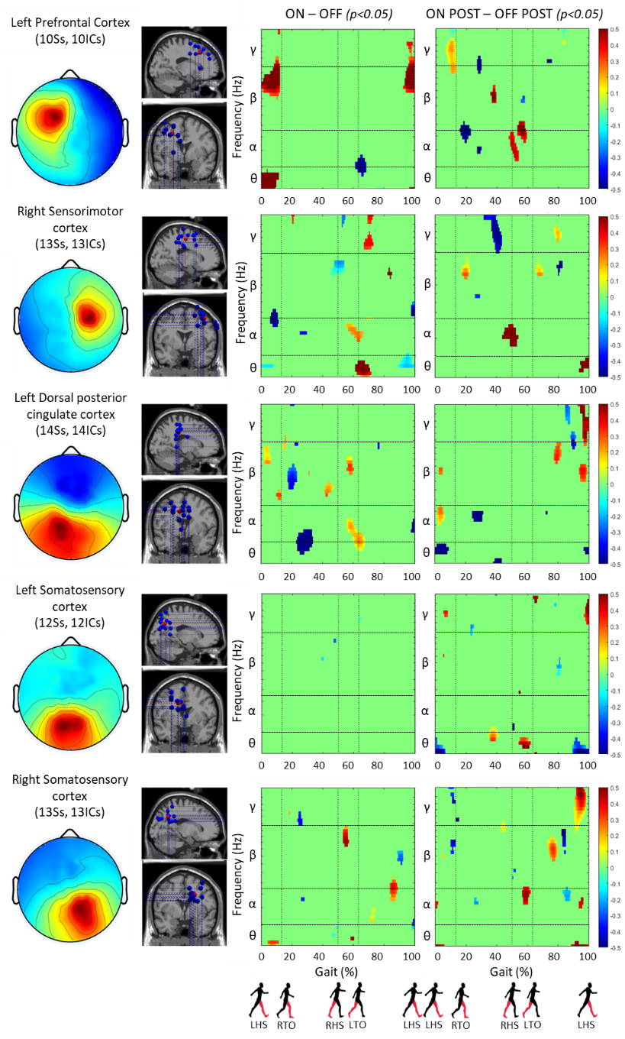
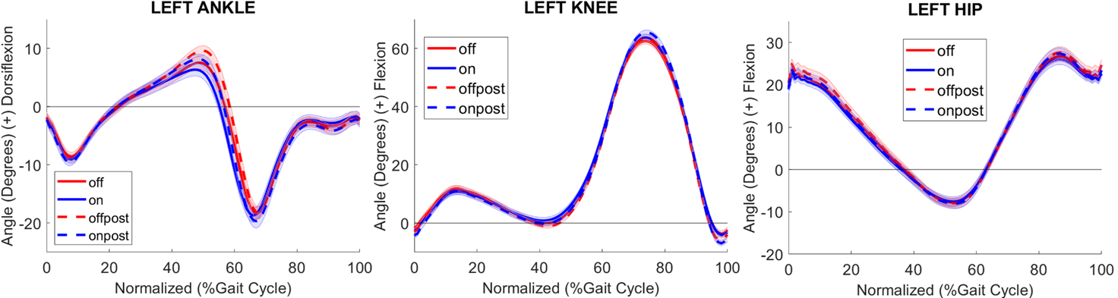
Supplementary 2. Contrast EEG ERSPs results. (Left column) Mean cluster topographic scalp map, (Middle column) Electrocortical dipole locations (blue dots: individual subject dipoles, red dots: cluster centroid), (Right columns), Component-level significantly masked ERSPs for two contrast conditions (ON-OFF and ON POST – OFF POST) across gait cycle in five regions of interest (ROIs) on the scalp. Gait cycle progression is from 0 to 100% from left HS to left HS.
Supplementary 1. Mean joint angle profiles for each of the left leg joints for all four trials. Shading around solid and dashed lines displays the standard error for each trial at each point in the gait cycle. Gait cycle progression is presented from 0 to 100% from left HS to left HS.

