Supplementary Information

Table S1. Occurrence records of Podocnemis unifilis used to generate the Ecological Niche Modeling.
(Indexed)

Table S2. All sets of environmental variables used in the preliminary Ecological Niche Model of Podocnemis unifilis.
(Indexed)

Table S3. Rapids and waterfall resistance values included in the resistance landscape scaled between 0.5 to 0.85 proportional to their extension size and based on extreme resistance values found in the original resistance model. Extension sizes are in meters.
ID | Rapids and Waterfalls | River | Longitude | Latitude | Extension | Resistance
A | Misericórdia | Madeira | -65.2918 | -10.2282 | 5,000 | 0.51
B | Caldeirão | Madeira | -64.63793 | -9.25317 | 4,070 | 0.51
C | Teotônio | Madeira | -64.06406 | -8.85804 | 2,700 | 0.50
D | Santo Antônio | Madeira | -63.93845 | -8.79293 | 2,000 | 0.50
E | Volta Grande do Xingu | Xingu | -51.71046 | -3.3959 | 130,000 | 0.85
F | Taboca | Tocantins | -49.6479 | -3.83211 | 11,000 | 0.52
G | Santa Isabel | Araguaia | -48.39872 | -6.14813 | 14,000 | 0.53
H | São João | Araguaia | -48.42459 | -6.22729 | 2,350 | 0.50
I | Remanso dos Botos | Araguaia | -48.37685 | -6.35349 | 5,000 | 0.51
J | São Miguel | Araguaia | -48.50944 | -6.35538 | 6,156 | 0.51
K | Santa Rita | Tocantins | -47.47321 | -5.7673 | 3,000 | 0.50
L | Lageado | Tocantins | -48.37305 | -9.75562 | 5,400 | 0.51
M | Arquipélago do Tropeço | Tocantins | -48.50666 | -12.0929 | 6,800 | 0.51

Table S4. Genetic diversity indices of the Podocnemis unifilis for each genetic cluster from Bayesian Analysis of Population Structure (BAPS).
Genetic cluster | N | S | h | Hd | π | D | Fs
GC1 | 152 | 56 | 3 | 0.835 +/- 0.027 | 0.006 +/- 0.003 | -2.330 | -26.787
GC2 | 126 | 36 | 7 | 0.786 +/- 0.029 | 0.005 +/- 0.003 | -2.096 | -27.172
GC3 | 27 | 12 | 3 | 0.886 +/- 0.045 | 0.006 +/- 0.004 | -0.350 | -2.975
GC4 | 65 | 14 | 3 | 0.776 +/- 0.038 | 0.005 +/- 0.003 | -0.721 | -4.231
Sum | 370 | 118 | 16
Mean | 93 | 30 | 4
Notes: Genetic clusters codes are according to Fig 2 (map of samples). N: number of individuals. S: number of polymorphic sites. h: number of haplotypes. Hd: haplotype diversity. Π: nucleotide diversity. D (Tajima 1989) and Fs (Fu 1997) neutrality tests. Bold indicates significant p values (α <=0.05).
Table S5. Pairwise φST (lower diagonal) and number of migrating Podocnemis unifilis females per generation between localities studied (upper diagonal).
 | 1 | 2 | 3 | 4 | 5 | 6 | 7 | 8 | 9 | 10 | 11 | 12 | 13 | 14 | 15 | 16 | 17 | 18 | 19 | 20 | 21 | 22
1 | - | 6.83 | 2.63 | 0.23 | 2.38 | 1.24 | 0.76 | 0.63 | 1.10 | 0.94 | 0.82 | 1.78 | 0.08 | 3.15 | 0.74 | 1.80 | 0.39 | 0.13 | 0.54 | 0.72 | 0.26 | 0.19
2 | 0.07 | - | 2.44 | 0.23 | 2.54 | 0.84 | 0.75 | 0.60 | 0.96 | 0.84 | 0.73 | 1.77 | 0.07 | 3.96 | 0.66 | 1.94 | 0.38 | 0.09 | 0.52 | 0.72 | 0.24 | 0.18
3 | 0.16 | 0.17 | - | 0.70 | Inf | 2.52 | 7.27 | 3.40 | 1.25 | 20.43 | 1.16 | 11.88 | 0.15 | 3.16 | 1.67 | 1.46 | 0.61 | 0.60 | 0.78 | 0.89 | 0.48 | 0.41
4 | 0.68* | 0.69* | 0.42* | - | 0.65 | 0.35 | 0.94 | 0.68 | 0.31 | 0.85 | 0.43 | 1.20 | 0.11 | 0.32 | 0.28 | 0.28 | 0.13 | 0.16 | 0.20 | 0.29 | 0.15 | 0.17
5 | 0.17 | 0.16 | -0.01 | 0.43* | - | 1.49 | 4.50 | 2.17 | 0.98 | 7.32 | 1.08 | 6.09 | 0.15 | 2.97 | 1.54 | 1.46 | 0.66 | 0.59 | 0.78 | 0.86 | 0.50 | 0.37
6 | 0.29* | 0.37* | 0.17 | 0.59* | 0.25* | - | 0.99 | 0.85 | 1.18 | 1.64 | 0.84 | 1.51 | 0.12 | 0.92 | 0.75 | 0.75 | 0.33 | 0.34 | 0.47 | 0.57 | 0.31 | 0.28
7 | 0.40* | 0.40* | 0.06 | 0.35* | 0.10 | 0.34* | - | 10.64 | 0.72 | 54.92 | 0.85 | 5.95 | 0.16 | 0.91 | 0.80 | 0.64 | 0.35 | 0.44 | 0.47 | 0.57 | 0.35 | 0.35
8 | 0.44 | 0.46* | 0.13 | 0.43* | 0.19 | 0.37* | 0.04 | - | 0.80 | 6.43 | 0.97 | 3.02 | 0.15 | 0.65 | 0.82 | 0.52 | 0.25 | 0.45 | 0.41 | 0.53 | 0.30 | 0.43
9 | 0.31* | 0.34* | 0.29* | 0.61* | 0.34* | 0.30* | 0.41* | 0.38* | - | 1.03 | 0.79 | 1.35 | 0.13 | 0.88 | 0.94 | 0.74 | 0.38 | 0.49 | 0.54 | 0.61 | 0.38 | 0.37
10 | 0.35 | 0.37* | 0.02 | 0.35* | 0.06 | 0.23 | 0.01 | 0.07 | 0.32* | - | 1.78 | 8.97 | 0.16 | 1.11 | 1.14 | 0.74 | 0.30 | 0.50 | 0.51 | 0.69 | 0.34 | 0.48
11 | 0.38* | 0.41* | 0.30* | 0.54* | 0.32 | 0.37* | 0.37* | 0.34* | 0.39* | 0.22 | - | 1.30 | 0.46 | 0.62 | 0.98 | 0.56 | 0.29 | 0.58 | 0.47 | 0.56 | 0.35 | 0.53
12 | 0.22* | 0.22* | 0.04 | 0.29* | 0.08 | 0.25* | 0.08 | 0.14 | 0.27* | 0.05 | 0.28 | - | 0.22 | 2.19 | 1.51 | 1.20 | 0.67 | 0.72 | 0.79 | 0.85 | 0.56 | 0.45
13 | 0.86* | 0.88* | 0.77* | 0.82* | 0.77* | 0.80* | 0.76* | 0.76* | 0.79* | 0.76* | 0.52* | 0.70* | - | 0.08 | 0.09 | 0.09 | 0.05 | 0.07 | 0.08 | 0.11 | 0.06 | 0.08
14 | 0.14 | 0.11 | 0.14 | 0.61* | 0.14 | 0.35* | 0.35* | 0.43* | 0.36* | 0.31 | 0.45* | 0.19* | 0.86* | - | 2.18 | 4.60 | 0.97 | 0.37 | 0.77 | 0.86 | 0.41 | 0.23
15 | 0.40* | 0.43* | 0.23 | 0.64* | 0.25 | 0.40 | 0.38* | 0.38* | 0.35* | 0.30 | 0.34 | 0.25 | 0.85* | 0.19 | - | Inf | 5.61 | 0.5 | 1.09 | 1.10 | 0.58 | 0.47
16 | 0.22* | 0.21* | 0.26* | 0.65* | 0.25* | 0.40* | 0.44* | 0.49* | 0.40* | 0.40* | 0.47* | 0.29* | 0.84* | 0.10 | -0.02 | - | 14.35 | 0.81 | 1.25 | 0.92 | 0.71 | 0.30
17 | 0.56* | 0.57* | 0.45* | 0.79* | 0.43* | 0.60* | 0.59* | 0.66* | 0.57* | 0.62* | 0.64* | 0.43* | 0.91* | 0.34* | 0.08 | 0.03 | - | 0.23 | 0.58 | 0.49 | 0.34 | 0.13
18 | 0.80* | 0.85* | 0.45* | 0.76* | 0.46* | 0.59* | 0.53* | 0.52* | 0.50* | 0.50 | 0.46* | 0.41* | 0.88* | 0.57* | 0.50 | 0.38* | 0.69* | - | 10.25 | 2.80 | 42.86 | 0.43
19 | 0.48* | 0.49* | 0.39* | 0.71* | 0.39* | 0.52* | 0.51* | 0.55* | 0.48* | 0.50* | 0.51* | 0.39* | 0.87* | 0.39* | 0.32* | 0.29* | 0.46* | 0.05 | - | 3.22 | 5.77 | 0.38
20 | 0.41* | 0.41* | 0.36* | 0.64* | 0.37* | 0.47* | 0.47* | 0.49* | 0.45* | 0.42* | 0.47* | 0.37* | 0.82* | 0.37* | 0.31* | 0.35* | 0.51* | 0.15 | 0.13* | - | 3.71 | 0.89
21 | 0.66* | 0.68* | 0.51* | 0.77* | 0.50* | 0.62* | 0.59* | 0.62* | 0.57* | 0.59* | 0.59* | 0.47* | 0.89* | 0.55* | 0.46* | 0.41* | 0.60* | 0.01 | 0.08 | 0.12 | - | 0.39
22 | 0.72* | 0.74* | 0.55* | 0.74* | 0.57* | 0.64* | 0.59* | 0.54* | 0.57* | 0.51* | 0.49* | 0.53* | 0.86* | 0.68* | 0.52 | 0.62* | 0.80* | 0.54 | 0.57* | 0.36* | 0.56* | -
Notes: Locality numbers according to table 1. Bold values indicate significant φST values (p < 0.05). Significant values after Bonferroni correction are with stars (p < 0.00227).
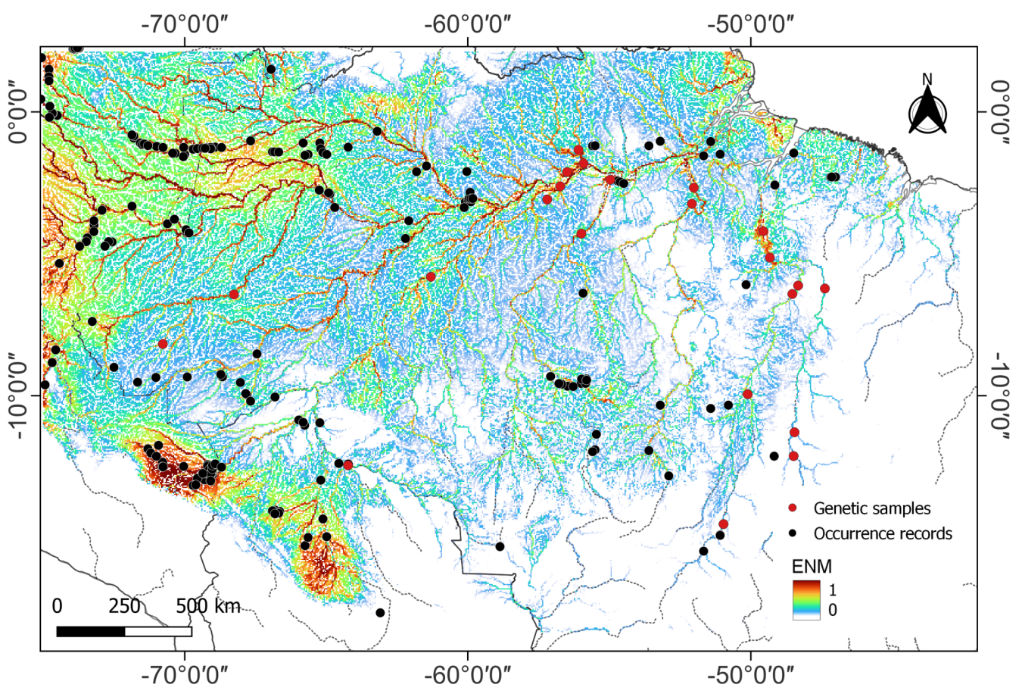
Fig. S1 Ecological niche modeling (ENM) for Podocnemis unifilis ranging from 0 in cold colors (for low environmental suitability for species occurrence) to 1 in hot colors (for high environmental suitability for species occurrence). Black dots are the occurrence records used to generate the ENM without genetic data and red dots are the occurrence records used to generate the ENM with genetic sampling
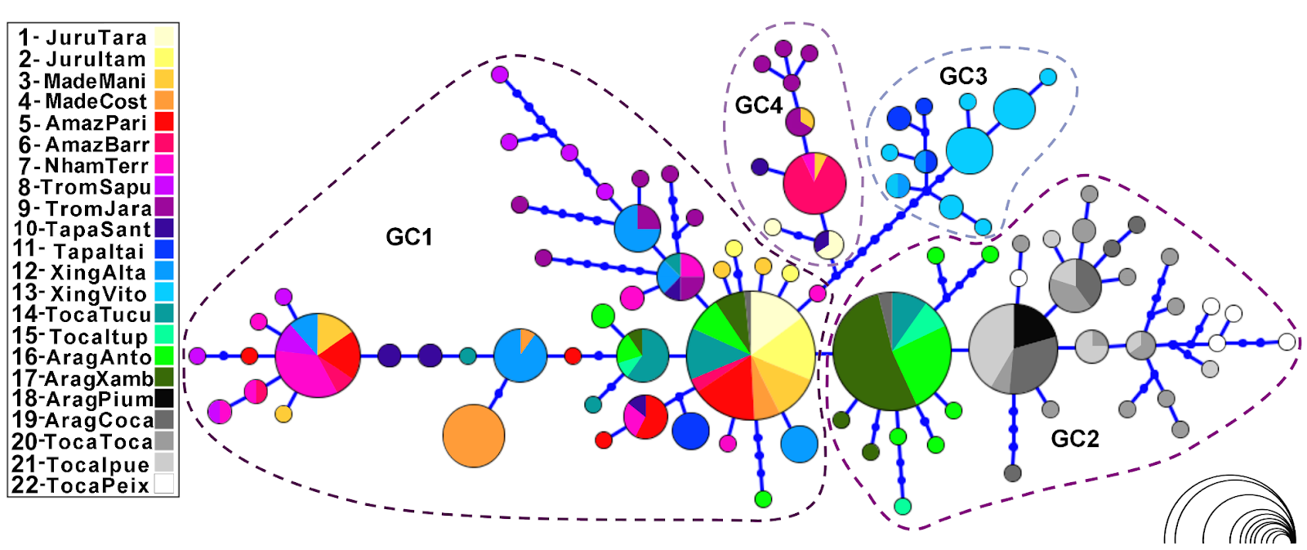​​
Fig. S2 Haplotype network of Podocnemis unifilis based on the mtDNA control region. The circle size represents the number of individuals sampled (ranging from 1 to 61 according to the scale at the bottom right). Each color represents a location. Each node represents a unique mtDNA sequence haplotype with the color denoting the location where it is found and the size of the circle accounting for its frequency. Abbreviations represent the genetic clusters (GC)
D
C
E
B
A
Fig. S3 Results from Multiple Matrix Regression with Randomization (MMRR) analyzes relating a) minimum geographic distance; b) in-water distance; c) resistance of rapids and waterfalls; d) landscape friction; and e) the final environmental resistance matrix (which combined both landscape friction and resistance caused by rapids and waterfalls) to explain the Yellow-spotted River Turtle (Podocnemis unifilis) genetic distance (ФST values) matrix

