A physician strike team to disseminate accurate and timely COVID-19 vaccination information and improve responses to patient questions

Graphic and Appendix

Graphic A: Vaccine Query Process Flow
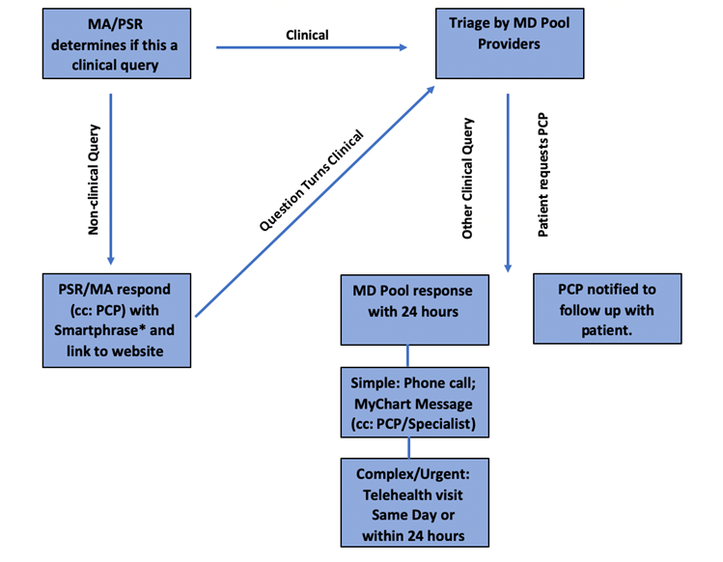

APPENDIX

Appendix B,C,D - see PDF documents for Survey Forms

Appendix E
Tally Data from the messages/call per day:
 | Calls | Messages
25-Jan | 25 | 87
26-Jan | 41 | 140
27-Jan | 30 | 200
28-Jan | 31 | 97
29-Jan | 31 | 105
1-Feb | 32 | 164
2-Feb | 27 | 109
3-Feb | 21 | 85
4-Feb | 20 | 101
5-Feb | 20 | 87
8-Feb | 3 | 80
9-Feb | 17 | 90
10-Feb | 21 | 90
11-Feb | 13 | 63
12-Feb | 10 | 83
16-Feb | 14 | 140
17-Feb | 11 | 116
18-Feb | 15 | 75
19-Feb | 12 | 61
22-Feb | 13 | 92
23-Feb | 13 | 74
24-Feb | 10 | 70
25-Feb | 13 | 74
26-Feb | 14 | 86
1-Mar | 4 | 81
2-Mar | 12 | 85
3-Mar | 13 | 121
4-Mar | 12 | 136
5-Mar | 15 | 90
8-Mar | 26 | 159
9-Mar | 15 | 117
10-Mar | 13 | 91
11-Mar | 2 | 104
12-Mar | 9 | 176
15-Mar | 6 | 98
16-Mar | 3 | 175
17-Mar | 10 | 92
18-Mar | 8 | 118
19-Mar | 16 | 125
22-Mar | 7 | 90
23-Mar | 10 | 115
24-Mar | 6 | 120
25-Mar | 6 | 55
29-Mar | 7 | 130
30-Mar | 4 | 130
31-Mar | 13 | 93
1-Apr | 8 | 88
2-Apr | 10 | 71
5-Apr | 17 | 84
6-Apr | 7 | 55
7-Apr | 7 | 47
8-Apr | 11 | 45
9-Apr | 5 | 37
12-Apr | 6 | 51
13-Apr | 15 | 74
14-Apr | 3 | 80
15-Apr | 5 | 32
16-Apr | 2 | 22
19-Apr | 1 | 15
20-Apr | 4 | 18
21-Apr | 4 | 13
22-Apr | 3 | 15
23-Apr | 3 | 15
26-Apr | 2 | 16
27-Apr | 4 | 14

Appendix F Examples of the simulated distribution of the number of messages and calls for February 2021 are given below

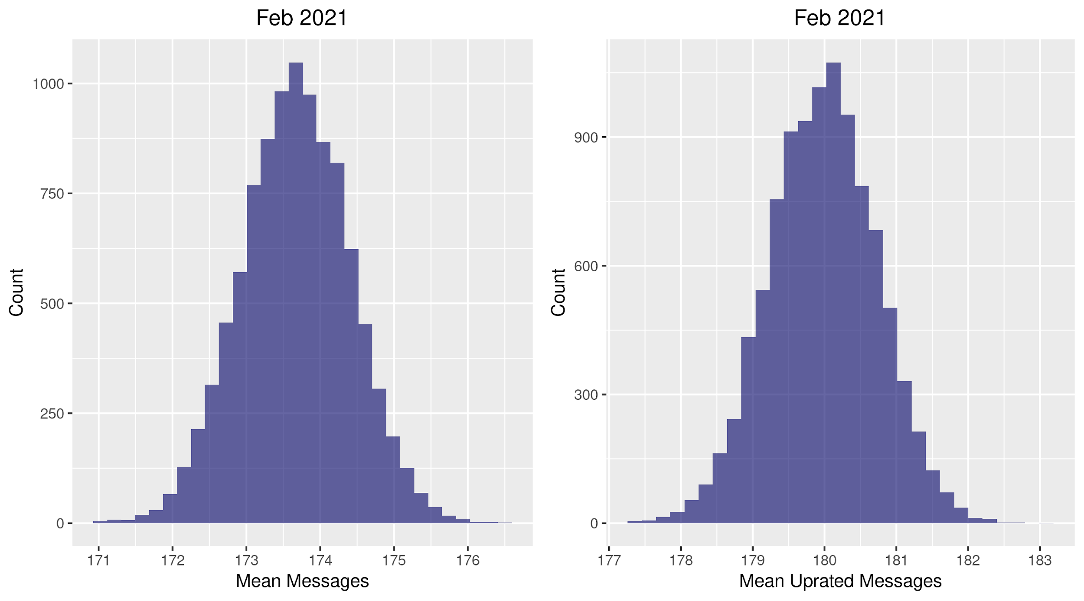
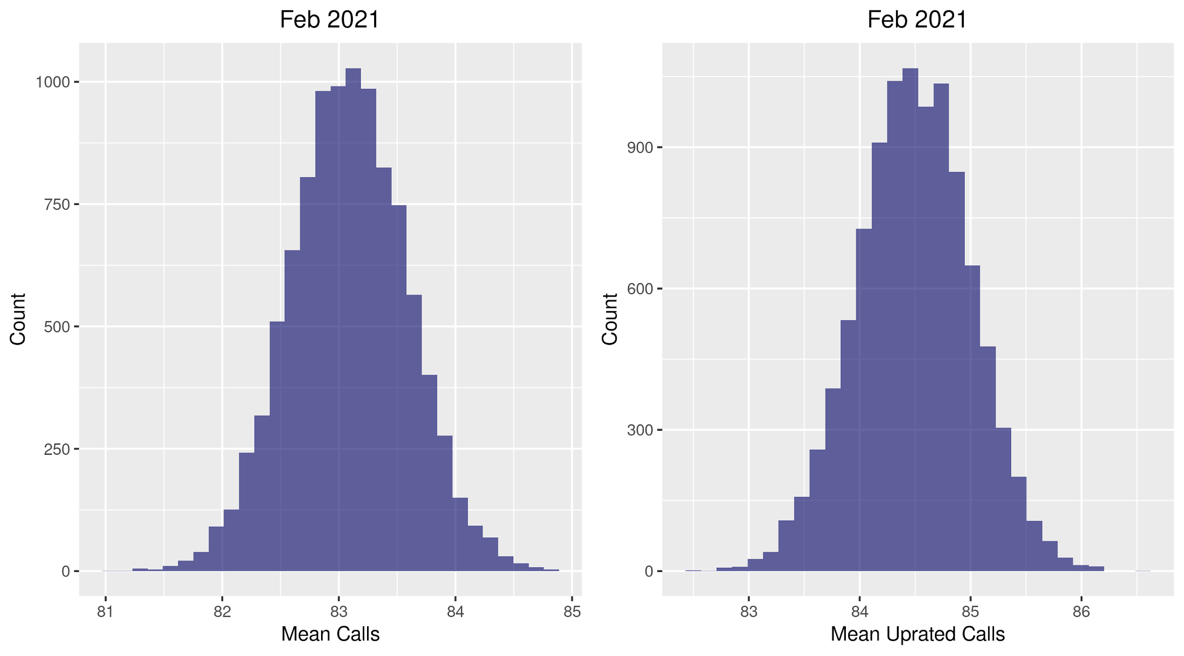

Appendix G - Time in In Basket per Provider per Day - Patient Medical Advice Request
Jan 2020 - Apr 2021

Month | Family Medicine | Internal Medicine | Grand Total
1/1/20 | 0.7 | 0.8 | 0.8
2/1/20 | 2.5 | 2.5 | 2.5
3/1/20 | 3.3 | 3.5 | 3.4
4/1/20 | 3.3 | 3.4 | 3.4
5/1/20 | 3.1 | 3.1 | 3.1
6/1/20 | 3.2 | 3.3 | 3.3
7/1/20 | 3.5 | 3.7 | 3.6
8/1/20 | 3.2 | 3.5 | 3.4
9/1/20 | 2.9 | 3.5 | 3.3
10/1/20 | 2.9 | 3.5 | 3.3
11/1/20 | 3.0 | 3.6 | 3.4
12/1/20 | 3.3 | 4.0 | 3.8
1/1/21 | 3.9 | 4.6 | 4.3
2/1/21 | 3.9 | 4.3 | 4.2
3/1/21 | 3.7 | 4.3 | 4.1
Grand Total | 3.1 | 3.5 | 3.4

