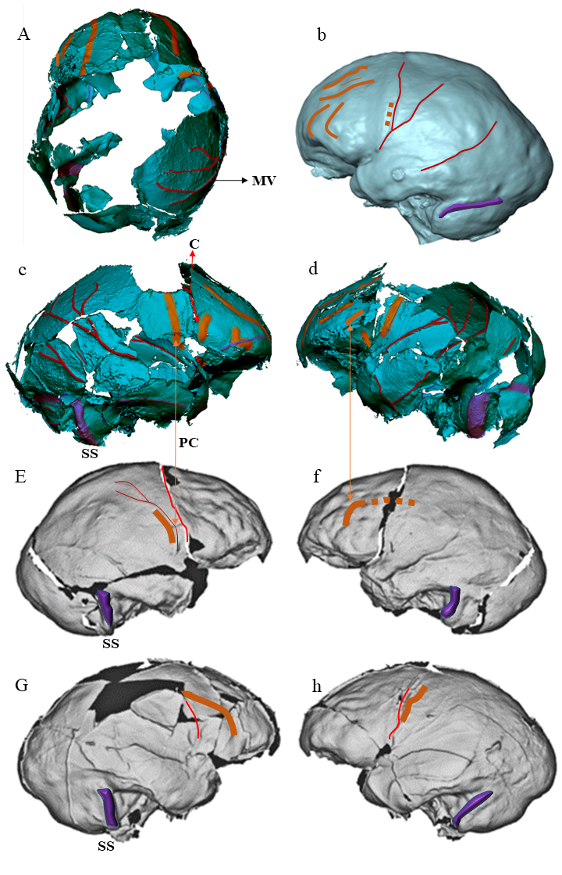

Extended Data Fig.1 Endocranial casts and cerebral organization (sulcal pattern and imprints of veins and venous sinuses) of fossil specimens representing European, Asian, and African hominid species. A-c-d, endocast Ceprano calvarium, digitally reconstructed from microCT of the original fossil specimens. A, superior view; c-d, left and right lateral view. b, Kabwe, left lateral view [Zambia, H. heidelbergensis (1,266 cm3)], new digitally reconstructed from CT scans of the original fossil specimens; E-f, left and right lateral view Zhoukoudian XII [China, East Asian H. erectus (1,048 cm3)] a reproduction of the original endocast digitally reconstructed from Ponce de León et al. ¹³; G-h, left and right lateral view Sangiran 17 [East Asian, H. erectus, 1.8- 0.2 Ma (860 cm3), digitally reconstructed from Ponce de León et al. ¹³. Overall, the interpretation of this sulcal pattern shows a derived organization of the fronto-orbital region consistent across the different taxa. Cerebral sulci in orange; Meningeal vessels in red; PC, Precentral sulcus; C, Coronal suture; MV, Meningeal Vein; SS, Sigmoid Sinus.

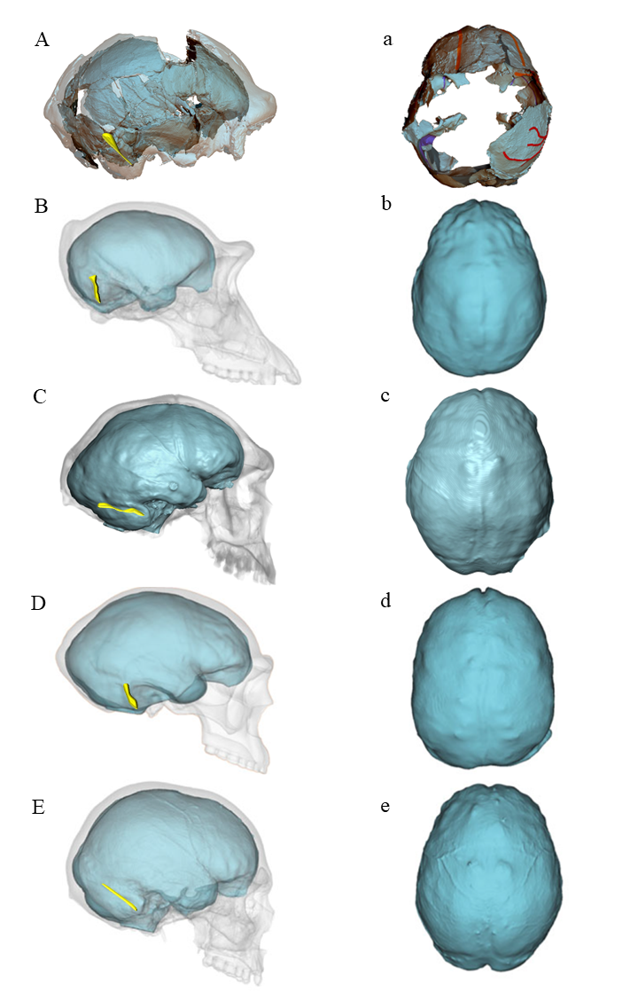

Extended Data Fig.2, Comparative analysis of endocranial and cranio-cerebral morphology. Braincase and endocast, in lateral and superior view, digitally reconstructed (microCT), of European, Asian, and African hominin species as well modern humans and great apes. A-a, Ceprano calvarium; B-b, Common Chimpanzee [P. troglodytes (368 cm³)]; C-c, Kabwe [Zambia, H. heidelbergensis (1,266 cm3)], new digitally reconstructed from CT scans of the original fossil specimens (left endocranial side); D-d, Zhoukoudian XII [China, East Asian H. erectus (1,048 cm3)] a reproduction of the original endocast digitally reconstructed from de la Cuétara¹²; E-e, Living H. modern (1,330 cm³) a reproduction of the original endocast digitally reconstructed from de la Cuétara¹². The Ceprano endocast, in superior view, exhibits a morphology modern globular shape, but the frontoorbital region has a mixed morphology primitive and derived. The left frontal lobe exhibits a pre-coronal constriction as in Chimpanzee. The pre-coronal constriction is a feature often found in Asian H. erectus ¹³. The right frontal lobe is broad indicating a derived organization of the frontal lobe. The sigmoid sinus (highlighted in yellow) follows a straight course as in Chimpanzee (see Fig. 1A in ref.¹³) and Zhoukoudian XII.

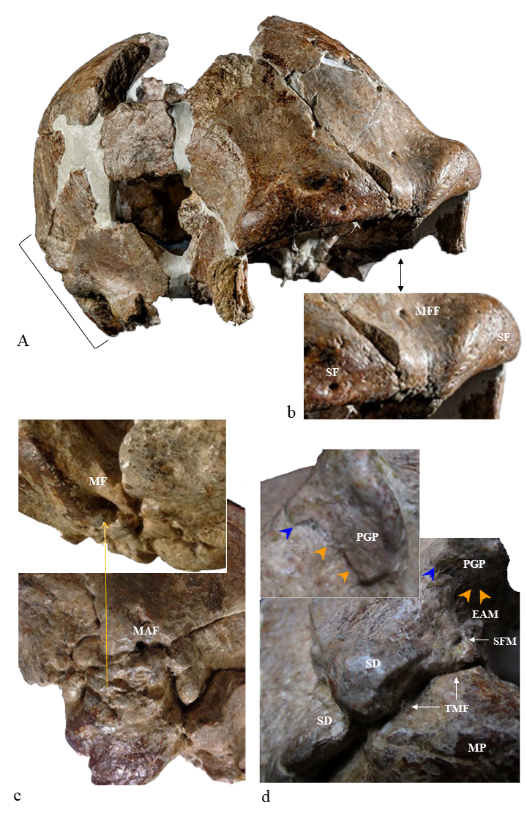

Extended Data Fig.3, Skeletal anatomy of Ceprano calvarium. A, fronto-lateral view of the original specimen (photo credit Mauro Rubini and Paolo Petrignani). b, detail of A. The open square bracket indicates the localization of the details shown in c and d. Note in c the localization of the petrosquamous (cranial part) and petrotympanic (Glaserian) fissures (orange arrowheads) and the localization of the tympanosquamous fissure (blue arrowheads). MFF, Middle Frontal Foramen; SF, Supraorbital Foramina; MF, Mastoid Foramen; MAF, Mastoid Accessory Foramen; PGP, Postglenoid Process; EAM, External Auditory Meatus; SFM, Stylomastoideum Foramen spurium [Premeatal ectocranial foramen (unknown) with function of foramen postglenoid, which we referred to as the “Stylomastoideum Spurium Foramen” (SMF) or “spurious jugular premeatal foramen”]; TMF, Tympanomastoid Fissure; SD, Sutural Denticles; MP, Mastoid Process.

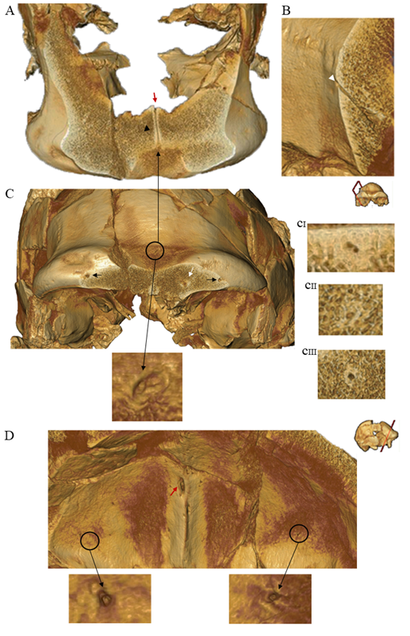

Extended Data Fig.4. Middle-frontal transosseous canal, at the pterion canal and morphology of the ecto-endocranial foramina. A, 3D axial section showing the presence of a middle-frontal transosseous canal with sclerotic margins (black arrowhead). B, incomplete transosseous canal in the pteric region (white arrowhead). C, D, ecto-endocranial foramina of the frontal transosseous canals. C, Front view of the 3D calvarium. Frontal bone of the coronal section (supraorbital torus). The ectocranial middle-frontal foramen is oval (real view extended Data Fig.3 A, b) and bifid (CI). The ectocranial orbitofrontal foramina coincide with the supraorbital foramina. In section, their morphology is tubular with a slight sclerotic margin (CII) more evident on the right (CIII). D, 3D frontal bone, intracranial view. The middle frontal endocranial foramen is located along the left side of the Frontal Crest (crista frontalis). Its morphology is oval with the major vertical axis. The endocranial orbito-frontal foramina (black circle) have a circular morphology as shown by the details.

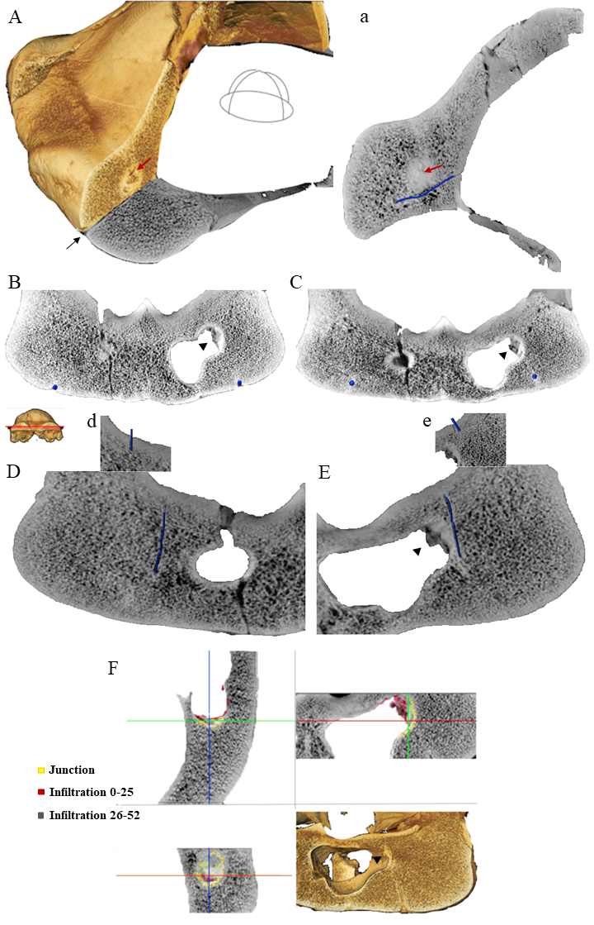

Extended Data Fig.5. Orbito-Frontal transosseous canals. A-a, 3D and 2D sagittal section. Left orbito-frontal canal (black arrow). The red arrow indicates the point of contact of the channel with the lateral recess of the respective sinus. B to E, 2D axial sections. Frontal emissary channels in which the path of the right and left orbito-frontal emissaries with the respective ecto and endocranial (d, e) outlets has been highlighted in blue. The black arrowhead indicates the calcification present in the lateral recess of the frontal sinus. In E the point of contact with the lateral recess of the left sinus is visible. F, Segmentation values. The material present in the lateral recess of the left frontal sinus has a mixed range of shades of gray.

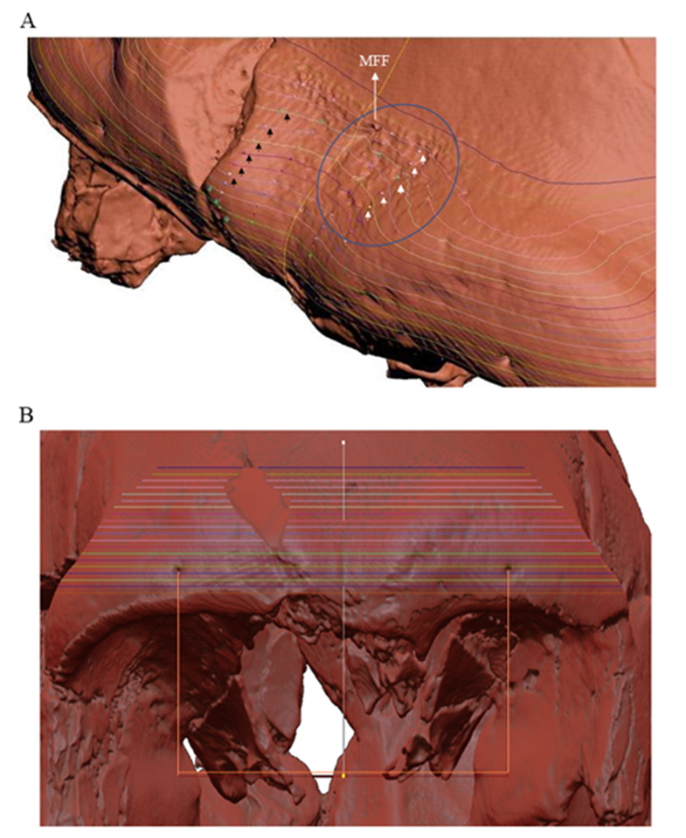

Extended Data Fig.6. The paraphysiological supratoral depression (blue circle in A). 3D frontal bone Ceprano calvarium. A, the landmarks (dots) on the right anatomical side (indicated by black arrowheads), have been mirrored on the left anatomical side (indicated by white arrowheads). Note the asymmetry, due to the depression as the dots on the left do not touch the level lines as on the right side. The green triangles are visible only on the right anatomical side. This demonstrates the presence of a volumetric deformation of the supraorbital margin caused by supratoral depression. B, the red lines mark the two foramina. The white line is perpendicular to the mid-distance point between the foramina. Since it matches the visible groove between the arches, this line is taken as the axis of symmetry. MFF, Middle Frontal Foramen.

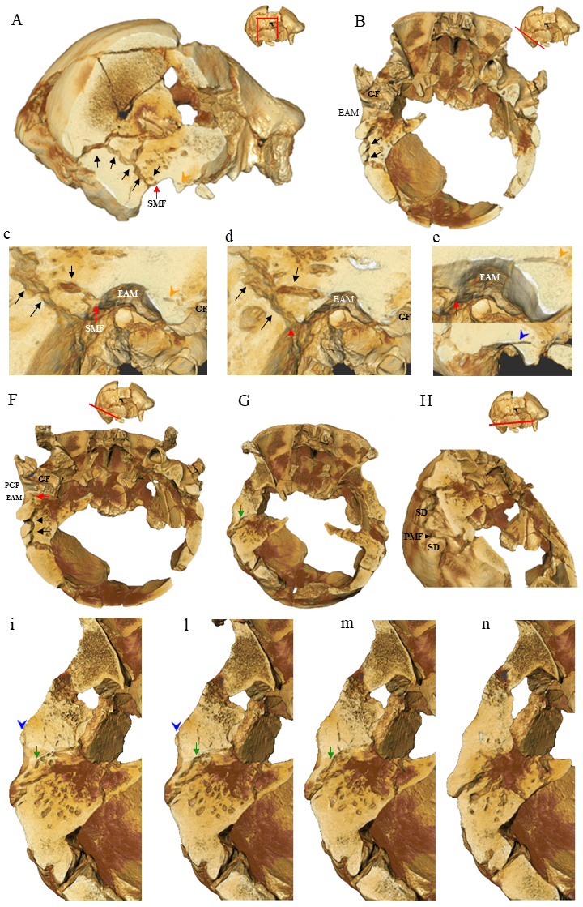

Extended Data Fig. 7. Caudal petrosquamous sinus (caudal PSS) and traces of the cranial path in regression (cranial PSS). A to e, temporal intrasutural and transosseous canal (caudal PSS). F to n, incomplete transosseous canal (cranial PSS). A, 3D calvarium right lateral view. Sagittal section of temporal bone (pars squamosa, pars mastoidea and pars tympanica). The black arrows indicate the caudal path of the petrosquamous sinus (PSS). The red arrow indicates the distal extracranial exit of the PSS in an unknown premeatal (SMF, Stilomastoideum Foramen spurium. Real view in Extended Data fig.3d). The postglenoid foramen (PGF) is absent. B, 3D calvarium, axial section temporal bone pars mastoidea right (inferior view). Black arrows, caudal PSS. Note that the pars petrosa is separated from the pars squamosa. c-d-e, details pars tympanica, sagittal sections. The orange arrowheads indicate, in A, c, e, the localization and partial persistence of the petrosquamous (cranial) and petrotympanic (Glaserian) fissures (real view in Extended Data fig.3d). The blue arrowhead indicates the localization and persistence of the tympanosquamous fissure (real view in Extended Data fig.3d).
F, 3D calvarium, axial section temporal bone pars mastoidea right (inferior view). Black arrows, caudal PSS. Red arrow SMF. G, 3D calvarium axial section of the temporal and sphenoid bones (inferior view). Green arrow, partial path of the cranial PSS. H, extracranial landmarks of F. i to n, details pars tympanica and petrous. Blue arrowhead timpanosquamous Fissure (STF). The PSS is associated with the presence of mastoid foramina (visible in Extended Data Fig.3c) consistent with a mastoid emissary vein with antero-inferior course, which extends from the upper part of the sigmoid sinus, continuing in the upper lateral region of the petrosal bone, up to the level of the plane glenoid fossa. SMF, Stylomastoideum Foramen spurium; EAM, External Auditory Meatus; GF, Glenoid Fossa; STF, tympanosquamous Fissure; PMF, Parietomastoid Fissure; SD, Sutural Denticles; PGP, Postglenoid Process.

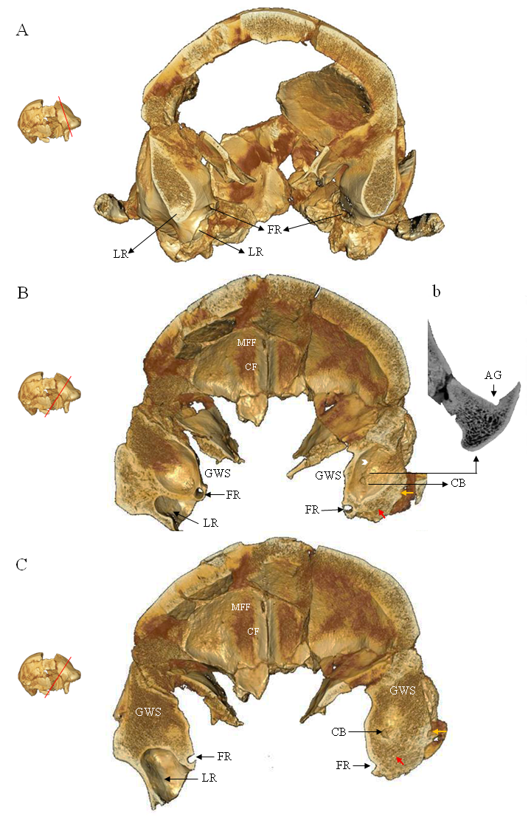

Extended Data Fig.8- Arachnoid granulations of the sphenoid bone. A-B-C, 3D coronal section of the calvarium. The section of the Greater Wings of the Sphenoid (GWSs) highlights the presence of a deep Lateral Recess of the left Sphenoid Sinus (LR) absent on the right side. The foramen rotundum (FR) is present both on the right and on the left. Note that even in the absence of the LR this region (on the right side) must have corresponded to the terminal part of the sphenoid sinus whose wall, in part, always corresponds to that of the foramen rotundum. Note, in b, on the cerebral surface of the right GWS the presence of a series of Arachnoid Granulations (AG) or arachnoid pits located laterally to the sinus and foramen rotundum. In B and C, the coronal section shows a deeper AG corresponding to an intraosseous Cortical Breach (CB) lesion site of transsphenoidal infiltration. The CB is characterized by the presence of a thick sclerotic margin. The red arrow indicates the presence of peripheral sclerotic margins. The orange arrow indicates an additional infiltration point. The white bullet arrows indicate the presence of a slight sulcus of a probable venous nature. CF, Frontal Crest (crista frontalis); MFF, Middle Frontal Foramen.

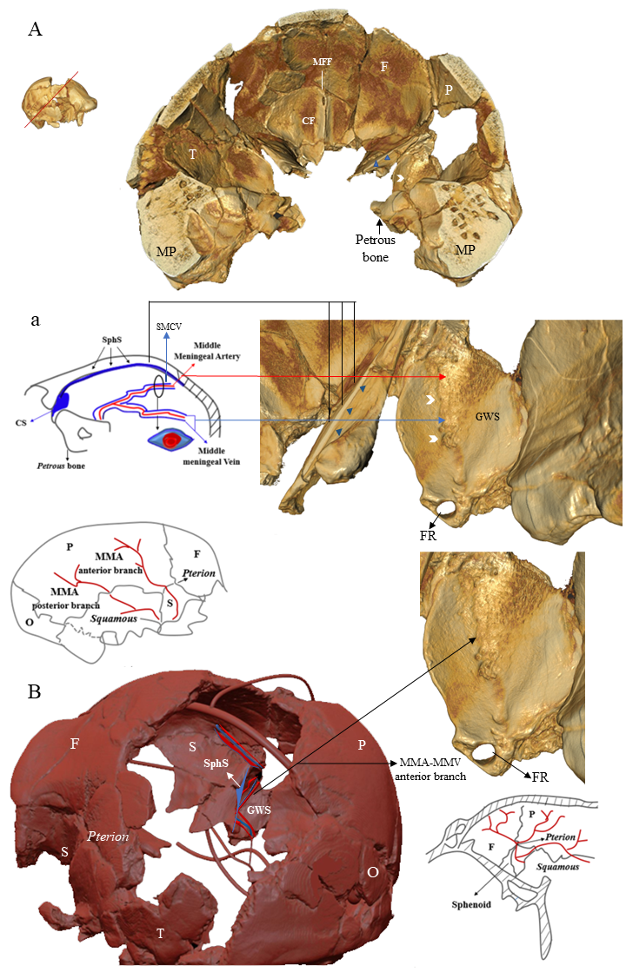

Extended Data Fig. 9- Reinterpretation venous cannels of the Middle Cranial Fossa (MCF). (A) 3D middle cranial fossa posterior view. (a) detail of (A) with arterio-venous reconstruction. The coronal microCT section shows on the cerebral surface of the right Greater Wing Sphenoid (GWS) the presence of a series of AGs associated with a superficial sulcus (white bullet arrows) very similar to the sulcus of the Middle Meningeal Vein (MMV) centered by the Middle Meningeal Artery (MMA) described in ref.²⁴ (Supplementary text, part 8). On the anterior edge of the GSW, the sphenoid portion enters a bone canal identified by Trolard as the spheno-parietal canal (SphS or Lesser Wing of Sphenoid sinus - blue arrowhead). Before entering this bone channel, the anterior branch of the MMV (B) establishes a connection with the SphS.
B, 3D calvarium arterio-venous reconstruction indicate the path of the Middle Meningeal Vein (MMV) centered by the Middle Meningeal Artery (MMA). 3D detail of the brain surface of the right Greater Wing Sphenoid (GWA). Note the venous and arterial imprint associated with the presence of arachnoid granulations indicating CSF infiltration. Top left and bottom right, reconstruction of the anterior and posterior views of the middle cranial fossa it should be noted that the anterior branch of the MMV is composed of a sphenoid portion, which constitutes the anatomical region of our interest, and a parietal. The anterior branch of the MMV crosses the floor of the middle cranial fossa to the pterion, taking the form of two parallel venous sinuses centered by the MMA.
P, Parietal; F, Frontal; O, Occipital; T, Temporal; S, Sphenoid; GSW, Greater Wing Sphenoid; SphS, Sphenoparietal Sinus; MP, Mastoid Process; SMCV, Superficial Middle Cerebral Vein; CS, Cavernous Sinus; CF, Frontal Crest (crista frontalis); MFF, Middle Frontal Foramen; FR, foramen rotundum.

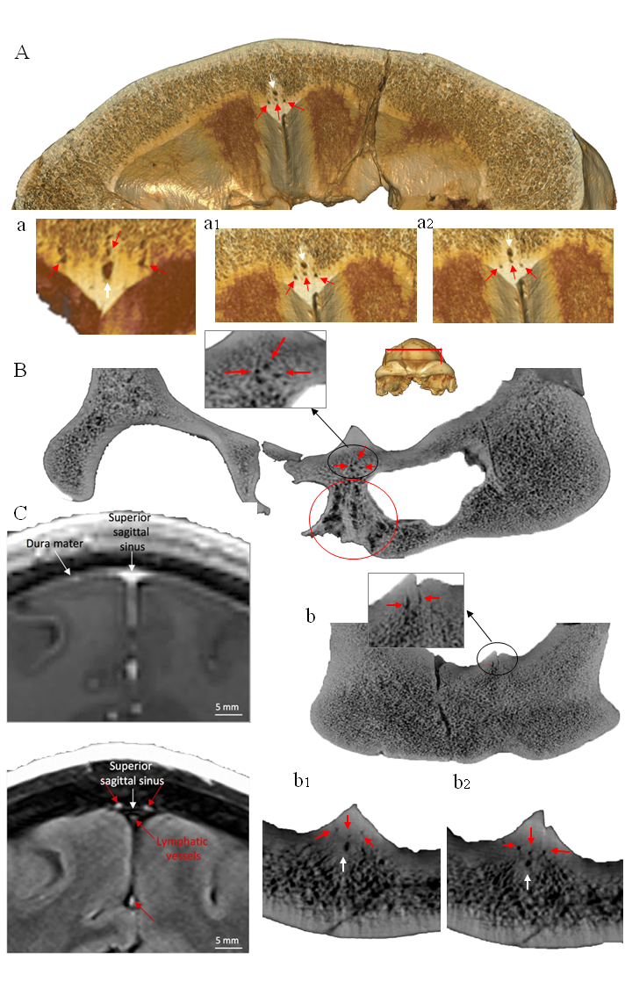

Extended Data Fig. 10. Middle-frontal transosseous canal and canaliculi compatible with the presence of an anterior vascular and lymphatic network. A to a2 and B to b2, 3D and 2D coronal sections Ceprano calvarium. In B the red circle indicates the area of diploic alteration in the ethmoid-nasal region associated with the presence of three perivascular intradiploic canaliculi (red arrows) surrounding the middle frontal transosseous canal (white arrow). Note the three perivascular canaliculi converge in the middle frontal canal which appears bifid in its distal extracranial path. In b note the intracranial opening of one of the canaliculi. C, MRI visualization of dural lymphatic vessels in modern Human ⁴³.

