Supplementary Information
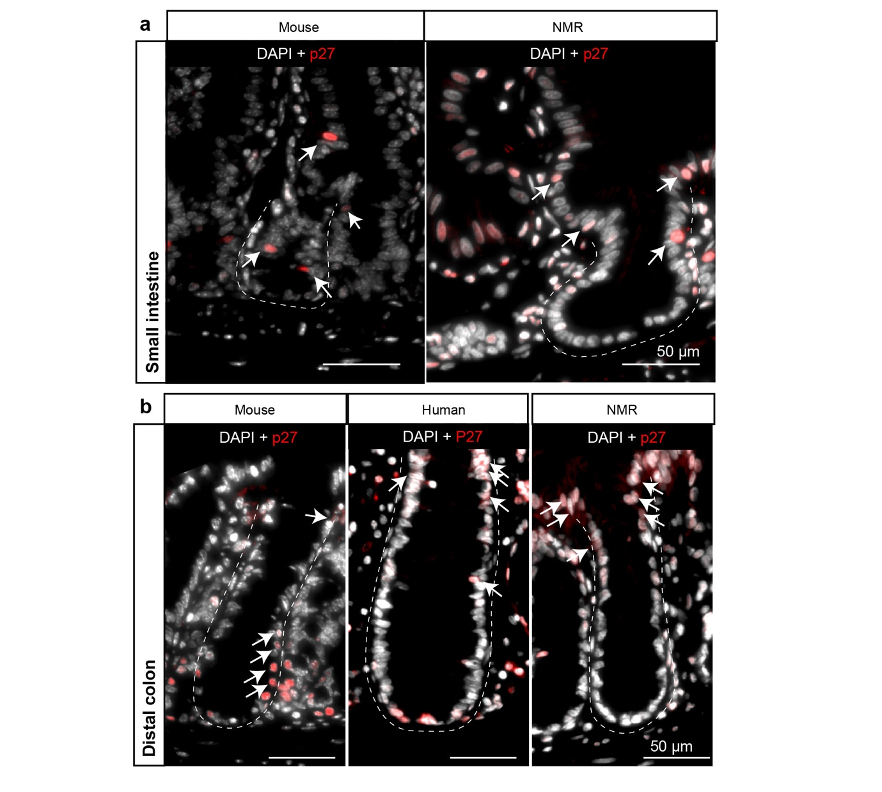
Extended Data Fig. 1 | Expression of p27/P27 in mouse, human and NMR intestine. Representative confocal images showing intestinal crypts stained with anti-P27 antibody (red) and counterstained with DAPI (grey) in a, wild-caught mouse (12 month-old) and wild-caught NMR (12 month-old) small intestine, and b, mouse (12 month-old), human (28-33 year-old) and NMR (12 month-old) colon. Dashed lines demarcate the outer periphery of crypt structures. White arrows indicate p27/P27⁺ cells outside the crypt base to the top of the crypts. Scale bar is indicated on the images (50 µm).

Supplementary Note 1: Optimising experimental parameters for administering BrdU in naked mole rats in vivo
We first determined the appropriate dose of BrdU to be administered in NMRs by injecting NMRs intraperitoneally with 100mg/kg and 200mg/kg bodyweight of BrdU, and found no difference in the percentage of cells labelled in the small intestine between the two doses although the staining with anti-BrdU antibody was stronger at the higher concentration (Extended Data Fig. 2a). As BrdU labelled cells were reliably detected at 100mg/kg, we used this concentration in subsequent experiments for reducing stress in animals as larger injection volumes (>350 μl) would be required for 200mg/kg (BrdU solubility in aqueous solution is 50mM). As each injection of BrdU labels only those proliferating cells that are in the S-phase, it was important to design an appropriate timeline for injections to ensure maximal availability of BrdU in all proliferating cells of NMR crypts. We found no difference in the percentage of BrdU⁺ cells per crypt section between animals injected every hour for 8 hours and those pulsed once and tissue assessed after 8 hours (Extended Data Fig. 2b). We next assessed the bioavailability of BrdU in NMRs over a specific period post-injection by withdrawing blood from animals after 8h and 16h after the first injection at time 0 (Extended Data Fig. 2c, top). The plasma collected at these time points was added to the growth medium of HEK293T cells and uptake by these cells was detected by anti-BrdU immunolabelling (Extended Data Fig. 2c, left). We observed 18% ± 6 of BrdU-labelled HEK293T cells (labelling index) from sera collected at 8h while no BrdU-positive cells were detected in wells supplemented with NMR sera collected after 16h of BrdU administration (Extended Data Fig. 2c, left). Using known concentrations of BrdU, we generated a standard curve with the percentage of HEK293T cells labelled with different concentrations (Extended Data Fig. 2c, middle). Using this standard curve, we found the concentration of BrdU in NMR sera after 8h injection was 15 μg/ml ± 5 (Extended Data Fig. 2c, right) which was enough to label cycling cells in the intestinal crypts (Extended Data Fig. 2a-b). A previous study using the same method in mouse, canary and quail has shown a faster clearance of BrdU (1 to 2 hours) in these species⁷⁶. Given the time between each injection had to be shorter than Ts to ensure that no proliferating cell passes completely through the S phase without being exposed to BrdU, and the period of BrdU injections had to be longer than Ts so that all proliferating cells pass through S at least once³⁶, we decided to use 8 h interval between each injection in NMR and a total of 15 injections for 5 continuous days in our experimental design (Fig. 3a, 4a). Finally, to ensure that repeated injections of BrdU did not change the cell cycle duration by stressing the intestinal cells in vivo, we used a second thymidine analogue, EdU, in NMRs that had received no BrdU injection (control) and analysed small intestinal crypts after 8 hours (Extended Data Fig 2d, top) to obtain the proportion of EdU+ cells per crypt (14%± 0.8) (Extended Data Fig 2d). In parallel, we scored EdU+ cells in NMR crypts that had previously been subjected to 15 consecutive BrdU injections and one EdU injection 8 hours prior to the termination of the experiment (Extended Data Fig 2d, top). We found the latter also to be 14.5%± 0.7 (Extended Data Fig 2d), showing that the proportion of proliferating cells in the S-phase were unaffected by repeated BrdU injections (Extended Data Fig. 2d).

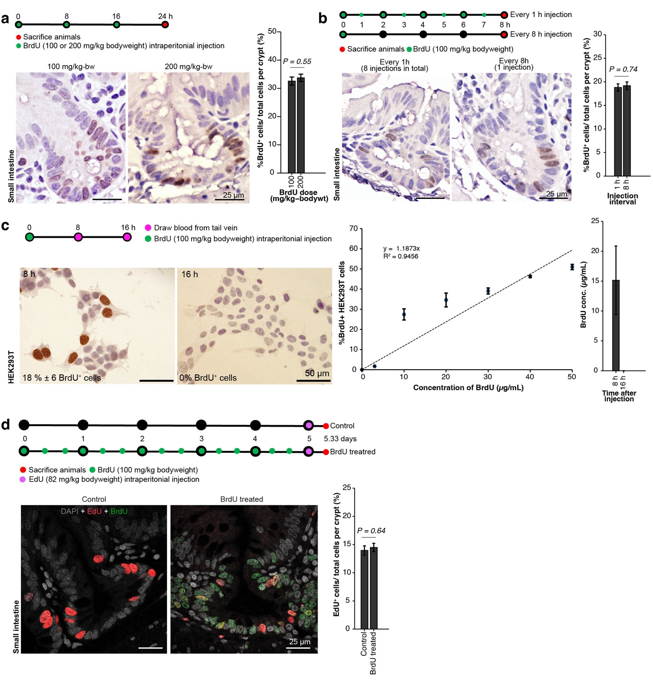
Extended Data Fig. 2 | Optimising experimental parameters for administering BrdU in naked mole rats in vivo a, Top, schema showing timeline of BrdU injections (green dots) into NMRs at two different doses (100 and 200 mg/kg-bodyweight) and time of tissue harvest (red dot). Bottom, Photomicrographs showing small intestinal crypts from both cohorts stained with anti-BrdU antibody (brown) and counterstained with haematoxylin (blue). Right, Bar graphs showing no significant difference in the proportion of BrdU⁺ cells in duodenal crypts between the two doses of BrdU used (n=42 crypts from 2 animals per dose, P=0.55). b, Top, schema illustrating two different frequencies (once only and every 1 hour for 8 hours) of BrdU injections (green dots) and time of tissue collection (red dot) after the first injection. Bottom, Brightfield images showing small intestinal crypts from both frequencies stained with anti-BrdU antibody (brown) and counterstained with Haematoxylin (blue). Bar graphs showing no significant difference in the percentage of BrdU⁺ cells in the small intestinal crypt of NMRs injected hourly for 8 h or only once (n=60 crypts from 2 animals per group, P=0.74). c, Top, schema showing time of blood collection (purple) from the tail veins of NMRs after one injection of BrdU (green). Bottom, photomicrographs of HEK293T cells supplemented with plasma collected from the BrdU-injected NMRs at 8 h and 16 h after injection and stained with anti-BrdU antibody (brown). Quantification of the BrdU⁺ HEK293T cells (counts from triplicate wells) exposed to known concentrations of BrdU used to generate a standard titration curve which gave the plasma BrdU concentration of NMRs. Bar graphs showing BrdU concentration detected in the plasma of NMRs at 8 and 16 hours after injection (n=2 animals at each time-point). d, Top, schema showing injection of 2’-deoxy-5-ethynyluridine (EdU) (purple dots) in NMRs that had not received any BrdU injections (control) or at the end of 15 consecutive BrdU injections (green dots) and tissues analysed 8h later (red dots at 5.33 days). Bottom, representative confocal images showing NMR small intestinal crypts stained with EdU-Alexa488 dye (red), anti-BrdU (green) antibody and DAPI (grey). Bar graphs showing no significant difference in EdU⁺ cells in duodenal NMR crypts with no BrdU injections or after 15 successive BrdU injections (n=40 crypts from 2 animals per group, P=0.64). In all cases, statistical significances were determined by performing Student’s t-tests using a two-tailed, unpaired, and unequal variance. Each bar represents mean ± standard error of mean. Scale bars are indicated on the images (25 µm or 50 µm).

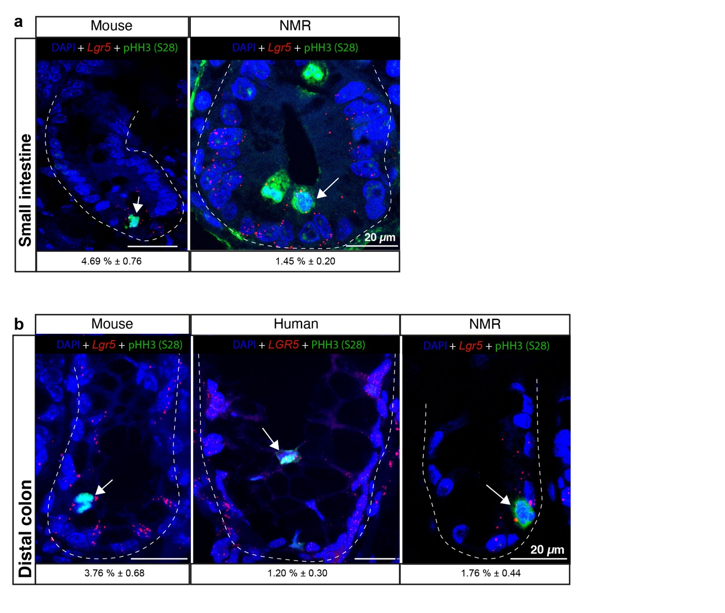
Extended Data Fig. 3 | Mitotic index (phospho-histone-H3(S28)⁺) of Lgr5/LGR5^{+CBC} cells
Confocal images showing intestinal crypts stained with Lgr5/LGR5-mRNA ISH (red), anti-phospho-histone-H3(S28) antibody (green) and counterstained with DAPI (blue) in a, wild-caught mouse (12-month old) and wild-caught NMR (12-month old) small intestines, and b, mouse, human (65-70 year-old), and NMR colons. Percentages of Lgr5/LGR5^{+CBC} cells positive for PHH3(ser28)-expression per crypt has been shown under each image (mean ± SEM of n = 150 crypts counted from 3 individuals per species). Dashed lines demarcate the outer periphery of each crypt. White arrows indicate Lgr5(LGR5)^{+CBC} phospho-histone-H3(S28)⁺ cells. Scale bar is indicated on the images (20 µm).

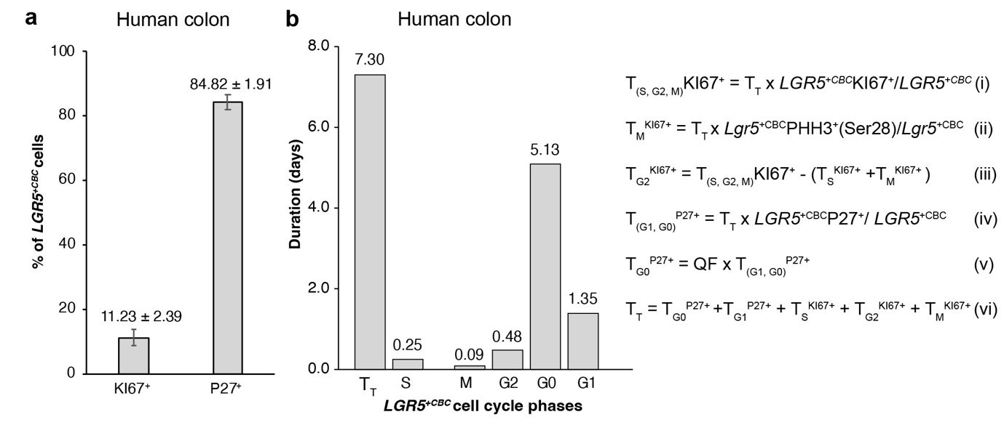
Extended Data Fig. 4 | Duration of specific cell cycle phases in human colonic LGR5^{+CBC} cells
a, Bar graph showing percentages of LGR5^{+CBC} cells positive for KI67 and P27 expression in the human colon. Each bar indicates mean ± SEM of 35 crypts counted from 5 individuals (65-70 year-old). b, Bar graph showing the duration of each phase of the cell cycle in human colonic LGR5^{+CBC} cells which have been shown to cycle every 7.3 days (T_{T}), with S phase duration of 0.25 days⁴. Using the fraction of LGR5^{+CBC} cells positive for KI67, we calculated the time of the active cell cycle (S to M) using equation (i) shown alongside the graph. Fraction of LGR5^{+CBC} cells that scored positive for PHH3(S28) (1.2% ± 0.30) was used to estimate the duration of M-phase (T_{M}) using equation (ii). The time spent in the G2 phase (T_{G2}) was calculated using equation (iii). We estimated the duration of G0 and G1 (T_{G0, G1}) in human colonic LGR5^{+CBC} cells by using the proportion of LGR5^{+CBC} P27⁺ and T_{T} in equation (iv). Then T_{G0} was estimated using the reported proportion of LGR5⁺P27⁺ cells in G0 (Quiescence Fraction, QF= 83%)⁴ in equation (v). T_{G1} was estimated using equation (vi).

Supplementary Note 2: Naked mole rat intestinal epithelium has an expanded differentiation zone
Starting by characterising the macroscopic features of the intestine, we found that NMR small intestine and colon were significantly shorter in absolute length (54% and 31%, respectively) than the mouse (Extended Data Fig. 5a, left and Supplementary Table 1). Similarly, after normalising to body mass, NMR intestinal length was significantly shorter than mouse (Extended Data Fig. 5a, right). Histological analysis of these tissues showed that the intestinal villi in NMRs were approximately 79% longer than in mice, consistent with higher cell counts (Extended Data Fig. 5b).

We quantified any differential distribution of secretory (goblet and enteroendocrine) and absorptive (enterocytes) cell types between the two species. We observed a significantly higher proportion of goblet cells, assessed by alcian blue staining, in both the crypts (48%) and villi (67%) of the NMR small intestine compared to mice (Extended Data Fig. 5c, Supplementary Table 1). In the colon due to the narrower structure of the colonic crypts in both species, it was not possible to accurately discern individual cells for counting after alcian blue staining in fixed tissues (Extended Data Fig. 5d, left). We, therefore, measured the thickness of the surface mucus layer by processing the colonic tissues in Carnoy’s solution that stabilised the mucus gel before alcian blue staining⁷⁹. Measuring the distance from the inner to the outermost layer of the mucus gel lining the surface epithelium, we found that the NMR mucin layer was 1.65 times thicker compared to mouse (Extended Data Fig. 5d right, Supplementary Table 1). Moreover, we also found higher gene expression levels of Muc2, a gene encoding the predominant gel-forming mucin in the intestine, in all regions of the NMR intestine compared to mouse (Extended Data Fig. 5e).

Chromogranin A immunohistochemistry showed a higher proportion of enteroendocrine cells in both the NMR small intestine and colon compared to mice (Extended Data Fig. 5f, Supplementary Table 1). Real time-PCR also detected elevated levels of Synaptophysin, a gene expressed by synaptic-like microvesicles secreted by enteroendocrine cells, in NMR intestinal villi and crypts compared to murine counterparts (Extended Data Fig. 5g).

Using a histochemical assay to measure alkaline phosphatase (AP) activity in the absorptive enterocytes of the small intestine, we observed a gradual decrease in AP staining in the mouse villi from the proximal to distal regions (Extended Data Fig. 5h, top panel). Conversely, we observed a sustained expression of AP throughout the small intestine in NMR villi (Extended Data Fig. 5h, bottom panel). Quantitative-PCR analysis of the small intestinal crypts and villi revealed much higher expression of AldolaseB, another marker of enterocytes^{80,81}, in NMRs compared to mice (Extended Data Fig. 5i). In summary, both the NMR small intestine and colon possessed increased numbers of every differentiated cell type we assessed compared to mouse intestine (Supplementary Table 1). We did not extend our analysis to Paneth, tuft or M cells.
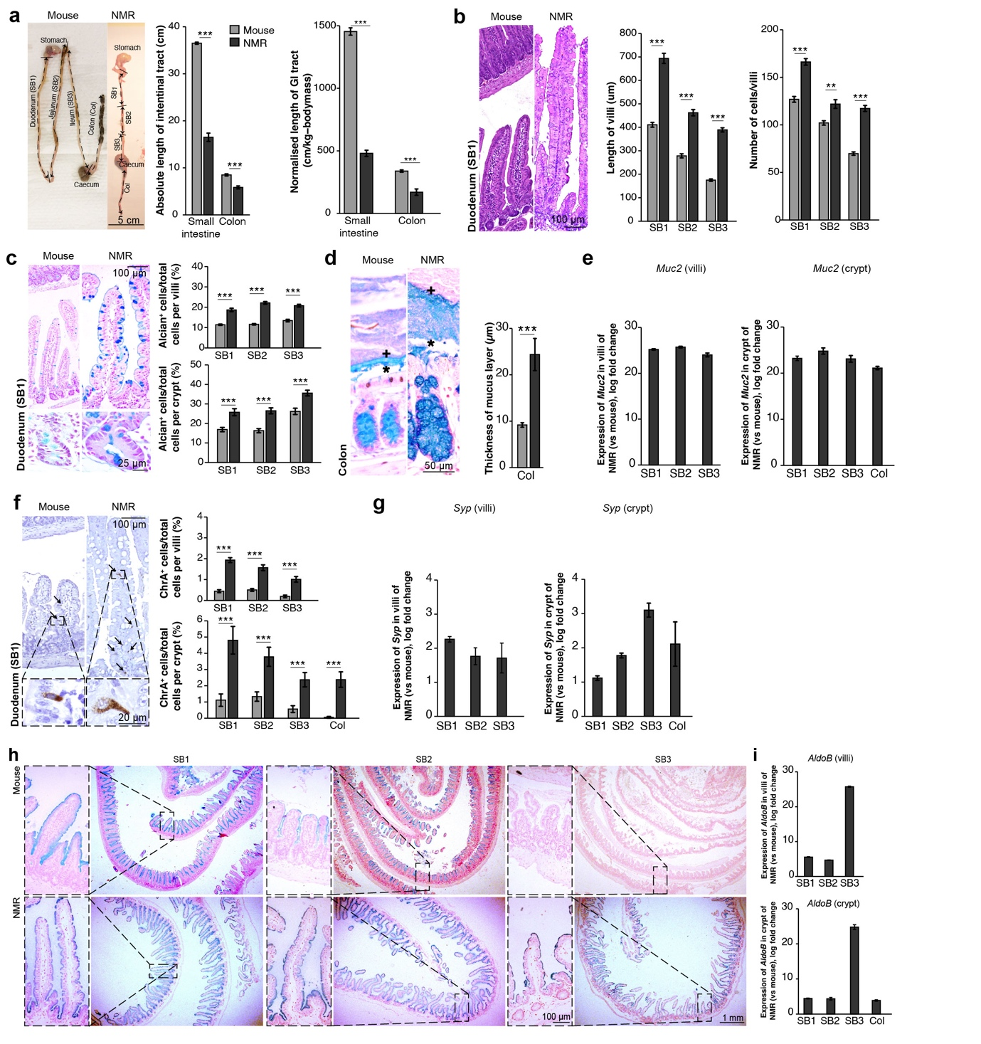
Extended Data Fig. 5 | Macroscopic and microscopic analysis of wild-caught naked mole rat (NMR) versus wild-caught mouse intestine. Significant differences were observed between NMR and mouse in a, the absolute (left) and the normalised (right) intestinal length (12 months old, n=6 animals per group; P<0.001), b,villus length (n=60 villi from 6 animals per group, P<0.001), and villus cell counts (n=60 villi from 6 animals per group, P<0.001). c, Differences were also noted in the proportion of goblet cells (Alcian blue positive) in the villi (top panel) and the crypts (bottom panel) of the duodenum (SB1), jejunum (SB2) and ileum (SB3) (n=60 crypts/villi from 6 animals per group, P<0.001). d, Measurement of the secreted mucin from the inner (denoted by *) to the outer (+) layer revealed a significantly thicker layer in the NMR colon (n=30 measurements from 3 animals per group, P<0.001). e, qRT-PCR analysis showed elevated expression of Muc2 in NMR villi and crypts compared to mice (n=3 animals per group) f, Proportion of enteroendocrine cells (Chromagranin A⁺) were also higher in both the NMR villi (top panel) as well as crypts (bottom panel) of SB1, SB2, SB3 and colon compared to mice (n=60 crypts/villi from 6 animals per group, P<0.01). g, qRT-PCR measurement of Synaptophysin gene expression showed higher levels in NMR villi and crypts (n=3 animals per group). h, Photomicrographs of alkaline phosphatase staining to mark enterocytes (blue) in the small intestine showed a gradual decline in the mouse (top panel) whereas sustained expression throughout the small bowel in the NMR (bottom panel). i, qRT-PCR analysis of Aldolase B expression showed higher levels in NMR villi (top) and crypts (bottom) compared to mice (n=3 animals per group). In all cases, statistical significances were determined by performing Student’s t-tests using a two-tailed, unpaired, and unequal variance. Significant P-values are denoted as ***<0.001. Each bar represents mean ± standard error of mean. Scale bars are indicated on the images (20 µm, 25 µm, 50 µm, 100 µm, 1 mm, 5 cm).

Supplementary Table 1. Summary of histological comparison between wild-caught NMR and wild-caught mouse intestine

 | Small intestine |  |  | Colon
 | Mouse¹ | NMR¹ | P-value² | Mouse¹ | NMR¹ | P-value²
Length of GI track (cm) | 36.5 ± 0.22 | 16.5 ± 0.88 | <0.001 | 8.5 ± 0.22 | 5.83 ± 0.31 | <0.001
Length of villi (µm) | 288.01 ± 8.60 | 515.15 ± 13.13 | <0.001 | ---
Number of EPCAM+ cells/villi | 100.23 ± 1.99 | 140.36 ± 2.72 | <0.001 | ---
Alcian+ cell/villi (%) | 12.11 ± 0.26 | 20.23 ± 0.46 | <0.001 | ---
Alcian+ cell/crypt (%) | 19.79 ± 0.88 | 29.27 ± 1.03 | <0.001 | ---
Thickness of mucus layer (µm) | --- |  |  | 9.19 ± 0.48 | 24.37 ± 3.46 | <0.001
ChrA+ cell/villi (%) | 0.38 ± 0.04 | 1.57 ± 0.08 | <0.001 | ---
ChrA+ cell/crypt (%) | 1.00 ± 0.18 | 3.59 ± 0.38 | <0.001 | 0.05 ± 0.05 | 2.38 ± 0.48 | <0.001
Crypt width (µm) | 51.71 ± 0.84 | 82.45 ± 1.50 | <0.001 | 45.99 ± 1.30 | 44.09 ± 1.80 | 0.39
Crypt length (µm) | 80.13 ± 2.64 | 78.54 ± 1.48 | 0.32 | 177.56 ± 6.26 | 161.40 ± 2.84 | <0.05
Crypt cell count (µm) | 35.93 ± 0.55 | 46.74 ± 1.05 | <0.001 | 55.29 ± 1.48 | 43.83 ± 1.57 | <0.001
Lgr5+ cell/crypt (%) | 10.58 ± 0.55 | 26.62 ± 0.70 | <0.001 | 4.25 ± 0.37 | 6.64 ± 0.38 | <0.001
¹mean ± standard error of mean
²p-value for Student's t-test using two-tailed, unpaired, and unequal variance

Supplementary Note 3. Comparison of DSS administration via oral gavage and drinking water in mice
To establish the effectiveness of administering DSS via oral gavage in inducing epithelial damage, we first test our experimental strategy in mice where DSS administration in drinking water has been shown to induce intestinal injury in 3-7 days^{53,54}. We gavaged mice (C57BL/6J) orally with 2.5% DSS for 3 days (Extended Data Fig. 6a) and observed only mild degree of epithelial damage in 30% of the distal colon (Extended Data Fig. 6c, 6e). The damage to the colonic tissue architecture was characterized by branching and shortening of crypts, variation in crypt width, expansion of crypts into muscularis mucosa, and beginning of erosion of surface epithelium. Besides, a mild level of immune infiltration was also observed in lamina propria and submucosa region in the gavaged mice (Extended Data Fig. 6c). However, sign of severe degree of epithelial damage such as crypt atrophy, tissue granulation, ulceration, and immune infiltration deep into bowel wall was not observed in any of the mice receiving DSS via oral gavage. We concluded that our oral gavaging strategy (Extended Data Fig. 6a) only caused mild level of epithelial injury similar to a previously described chronic DSS model where mice were administered 1% DSS in drinking water over 42 days in 3 cycles of weekly administration and recovery⁵⁵.

We then administered 2.5% DSS in drinking water for 7 days in mice (Extended Data Fig. 6b) and detected severe degree of epithelial damage in 80% of mid to distal colon (Extended Data Fig. 6d) similar to previously published results⁵⁹. These damages can be described as alteration of lamina propria cellularity (immune infiltration), architectural damage to tissue and epithelial abnormalities. In the treated mice, there was severe degree of neutrophil infiltration present with fibrin and necrotic debris above the ulcerated mucosa. Nearly 60% of distal colonic crypts in the affected area underwent total crypt atrophy marked by flattening of mucosa and absence of crypts. The remaining 40% of the crypts exhibited signatures of severe crypt distortion such as glandular rarefaction, shortening and extensive branching of crypts, and loss of goblet cells (Extended Data Fig. 6d). In summary, while oral gavaging for 3 days caused only mild degree of epithelial damage in mice, administration of DSS in drinking water for 7 days resulted in significantly higher degree of epithelial injury (Extended Data Fig. 6e).
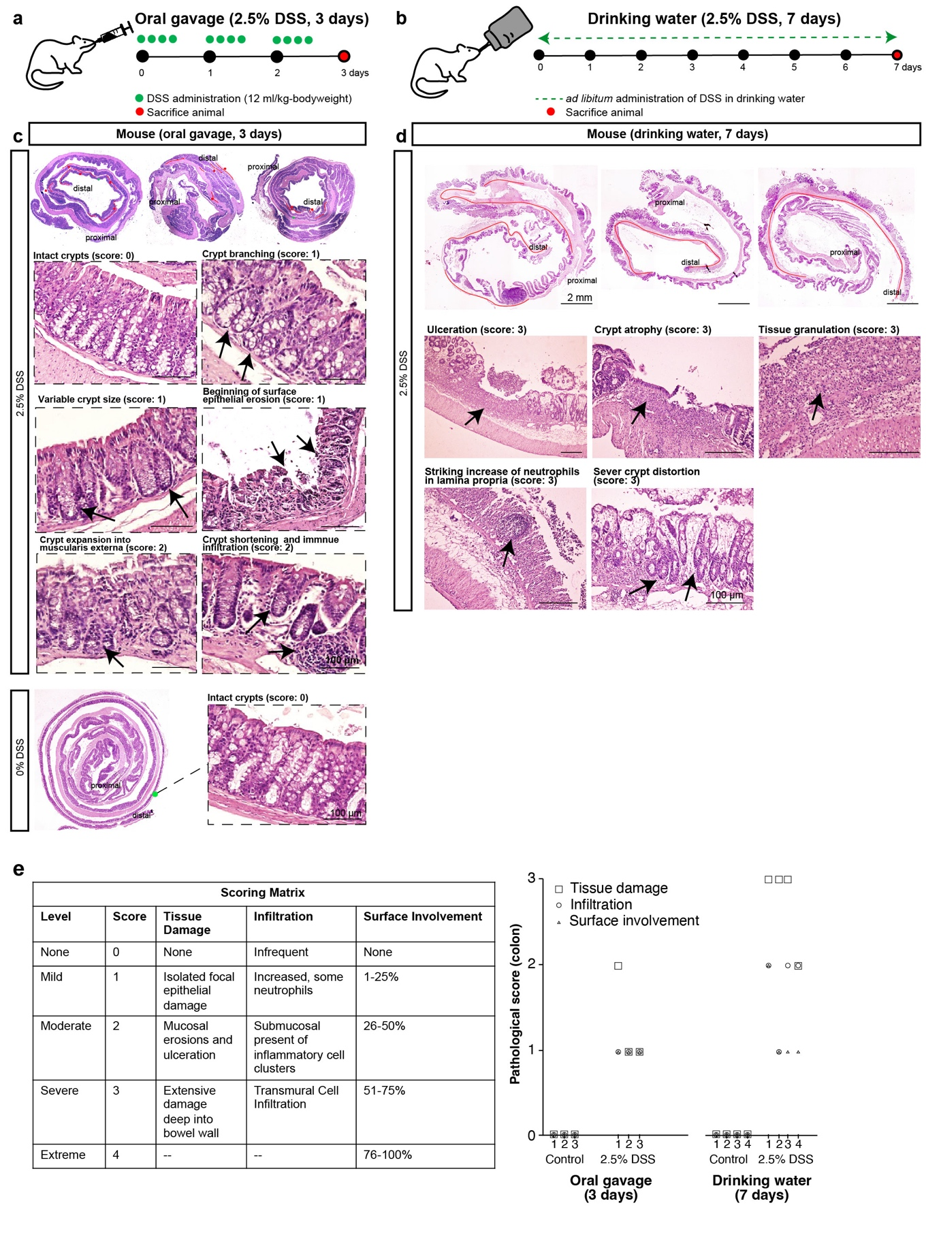
Extended Data Fig. 6 | Histopathological analysis of colon from mice treated with 2.5% dextran sodium sulphate (DSS) by oral gavage and drinking water. a, Schema illustrating the experimental design for administering 2.5% DSS via oral gavage at specific time points (green dots) for 3 days and day of tissue harvest (red dot) in C57BL/6J mice. b, Schematic representation of the experimental strategy for administering 2.5% DSS in drinking water (green dashed line) for 7 days and day of tissue harvest (red dot) in C57BL/6J mice. c, Haematoxylin and Eosin (H&E) staining of 2.5% DSS-treated mouse (oral gavage for 3 days) shows areas of tissue damage in the distal colon highlighted in red (top). Magnified images show crypt shortening, expansion and branching, and immune infiltration (top). Black arrows indicate damage. H&E staining in untreated mouse showing normal crypt structures in the distal colon (bottom). d, Haematoxylin and Eosin (H&E) staining of colon from mice (n=4) treated with 2.5% DSS in drinking water for 7 days shows areas of severe tissue damage in the mid to distal colon highlighted in red. Magnified images show ulceration, crypt atrophy, tissue granulation, striking increase of neutrophil infiltration and severe crypt distortion. e, A table (left) showing the criteria used by pathologists to score tissue damage in the colon. Pathological scoring (right) showing significant differences in colonic tissue damage (square), neutrophil infiltration (circle) and percentage of area involved in damage (triangle) between mice treated with 2.5% DSS via oral gavage (n=3) and drinking water (n=4) (p<0.05). Numbers on x-axis show numeric identifier tagged to each animal. In all cases, statistical significances were determined by using a two-tailed Wilcoxon rank sum test.

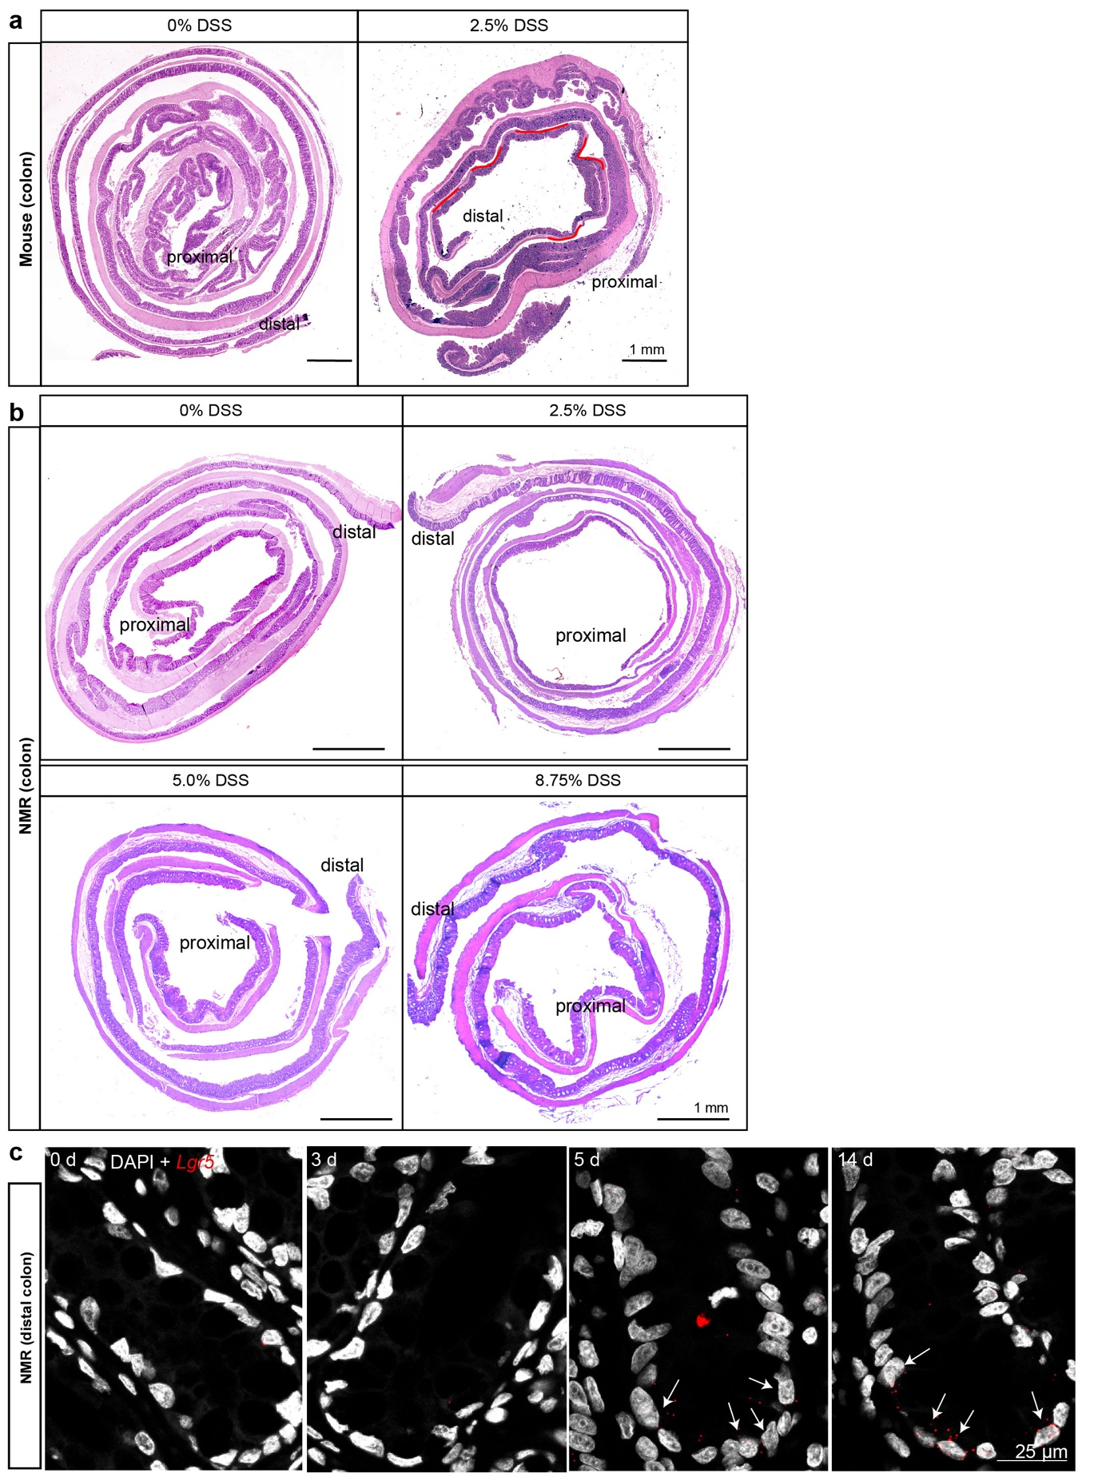

Extended Data Fig. 7 | Histological evaluation of DSS-induced damage in mouse and NMR colon. a, Haematoxylin and Eosin (H&E) staining of colonic tissue from C57BL6/J mice treated with 0% DSS (left) and 2.5% DSS (right) via oral gavage for 3 days. Areas of tissue damage in the distal colon are highlighted in red (right). b, Photomicrographs showing no damage in the colon of NMRs treated with 2.5-8.75% DSS (oral gavage for 3 days). c, Confocal images showing staining with NMR-specific RNAscope Lgr5 probe (red) and DAPI (grey) exhibiting the re-expression of Lgr5 in cells at the crypt base after day 5 of recovery in the distal colon (marked with white arrows). Scale bars are indicated on the images (25 µm and 1 mm).

Supplementary Table 2. Summary of changes observed in the intestinal crypts following 2.5% DSS treatment in NMR and mouse.
Parameter of comparison* | NMR (2.5% DSS for 3 days via oral gavage) |  | Mouse (2.5% DSS for 3 days via oral gavage) |  | Mouse (Davidson et al⁵⁹) (2.5% DSS for 5 days via drinking water)
Parameter of comparison* | Distal colon | Duodenum | Distal colon | Duodenum | Distal colon | Proximal colon
Number of Lgr5⁺cells/crypt | 100% loss | 80% loss | No change | No change | 100% loss | No change
Apoptotic index (Number of TUNEL+ cells/ 100 crypt) | 6-fold increase | 6-fold increase | No change | No change | 4-fold increase | 4-fold increase
Apoptotic index (Number of TUNEL+ cells/ 100 crypt) at crypt base | 18-fold increase | 6-fold increase | No change | No change | not available | not available
Apoptotic index (Number of TUNEL+ cells/ 100 crypt) above crypt | 5-fold increase | 8-fold increase | No change | No change | not available | not available
%Lgr5^{+CBC}Ki67⁺ cells | N/A | No change | No change | No change | N/A | not available
%Ki67+ cells/total cells per crypt | 90% decrease | 70% decrease | 20% decrease | 10% decrease | not available | not available
% of crypt with EdU+ cells | N/A | N/A | N/A | N/A | 90% decrease | 35% decrease
Recovery of Lgr5+ | 5 days | 3 days | N/A | N/A | 6 days | not available
*all results shown for comparison between animals treated with 2.5% DSS vs untreated control

79 Matsuo, K., Ota, H., Akamatsu, T., Sugiyama, A. & Katsuyama, T. Histochemistry of the surface mucous gel layer of the human colon. Gut 40, 782-789 (1997). https://doi.org:10.1136/gut.40.6.782
80 Lukonin, I. et al. Phenotypic landscape of intestinal organoid regeneration. Nature 586, 275-280 (2020). https://doi.org:10.1038/s41586-020-2776-9
81 Chang, J. et al. Proteomic changes during intestinal cell maturation in vivo. J Proteomics 71, 530-546 (2008). https://doi.org:10.1016/j.jprot.2008.08.003

