Estimating shifts in fuel stacking among solid biomass fuels and liquified petroleum gas in rural households: A pan-India analysis
Supplementary information
The document contains:
Figure S1-S7
Table S1-S7

Supplementary Figures
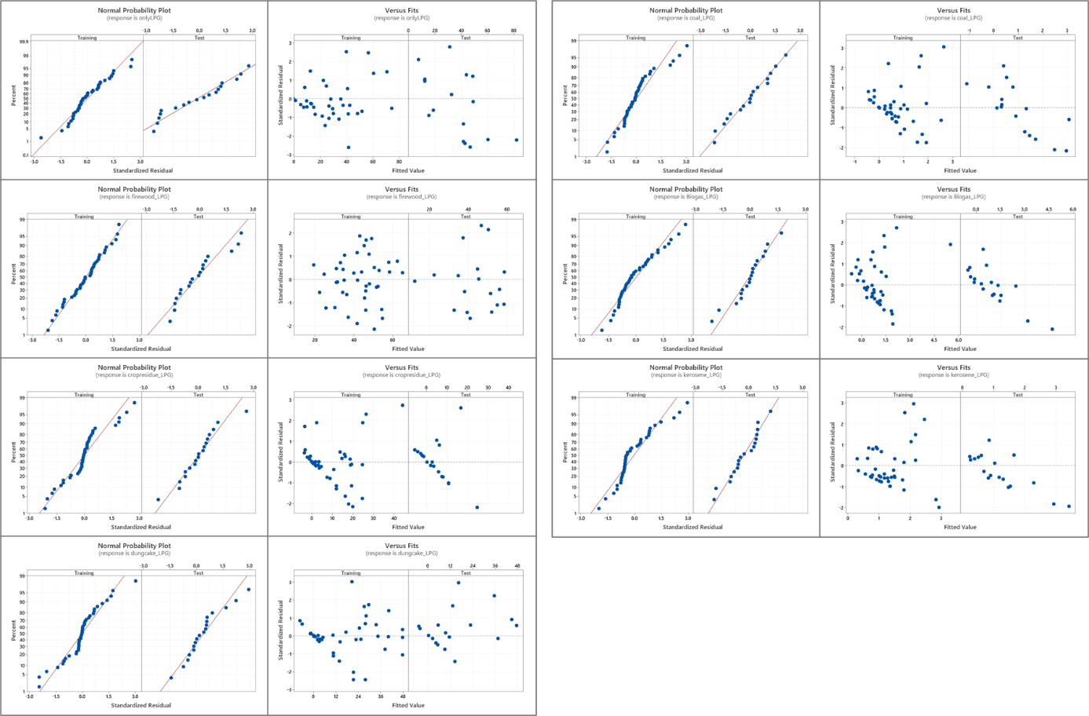
Fig. S1 | Regression model residual plots for all dependent variables
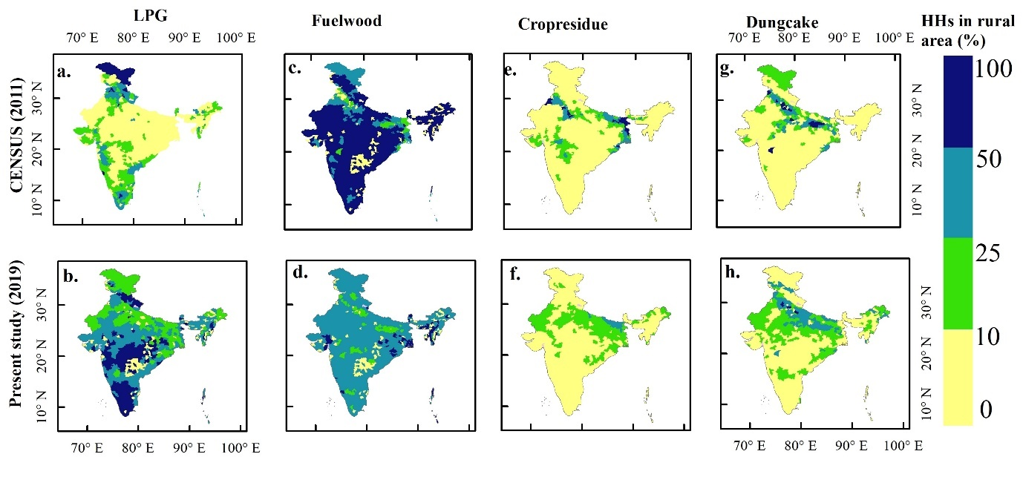
Fig. S2 | The spatial distribution map represents the decadal shift in the household % at the district level for rural areas
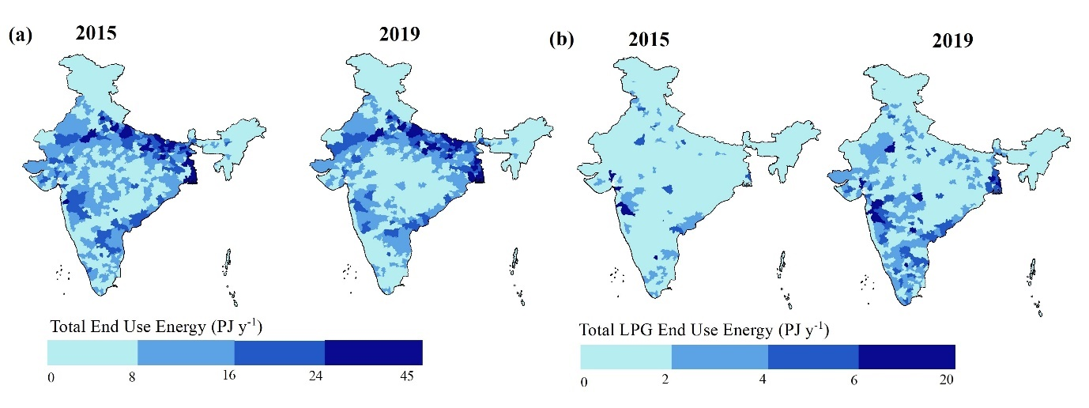
Fig. S3 | Comparison of District-level present estimate with 2015 reported by Pandey et al., (2014) (a) total End-use energy (PJ y⁻¹) (b) total LPG end-use energy (PJ y⁻¹)
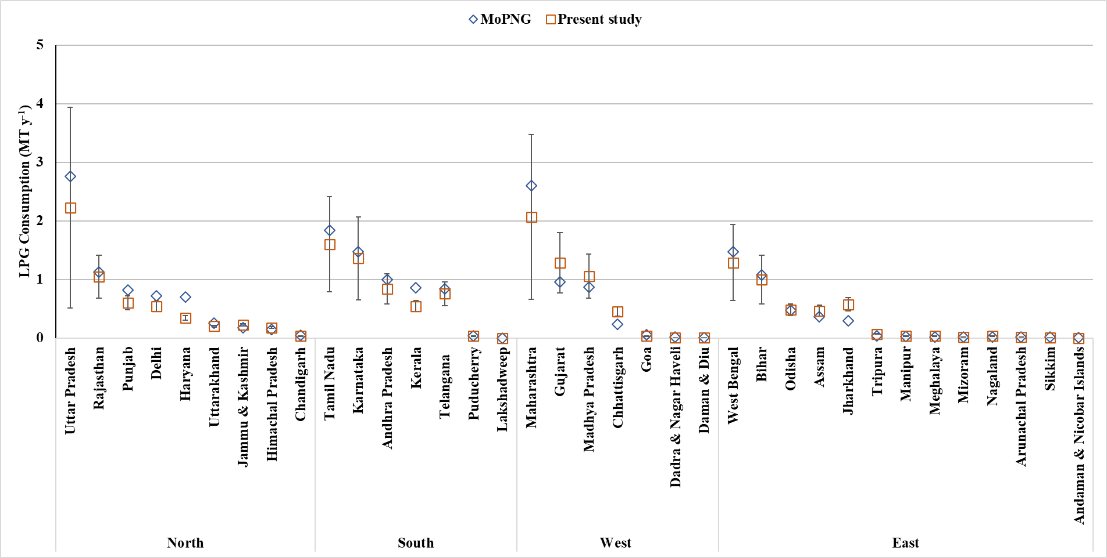
Fig. S4 | Comparison of the present study estimated LPG consumption (MT y⁻¹) with error bars at 1σ and total MoPNG reported value (including both PMUY and non-PMUY LPG connections) for domestic use
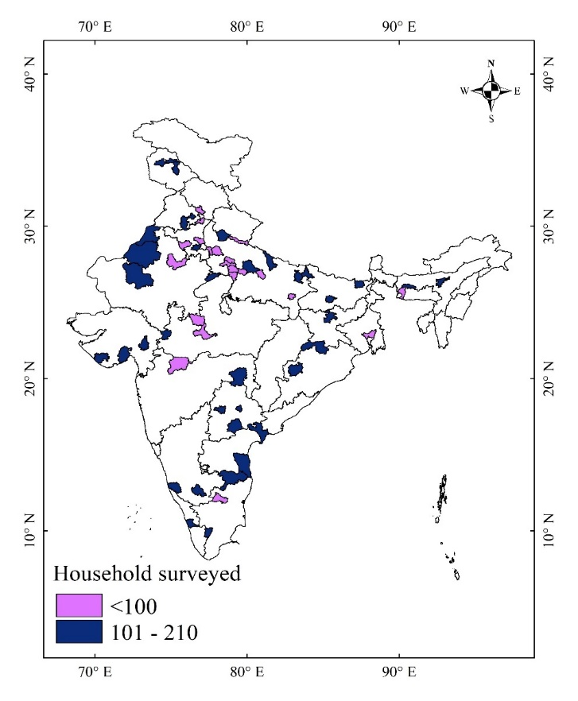
Fig. S5 | The districts surveyed in the present study
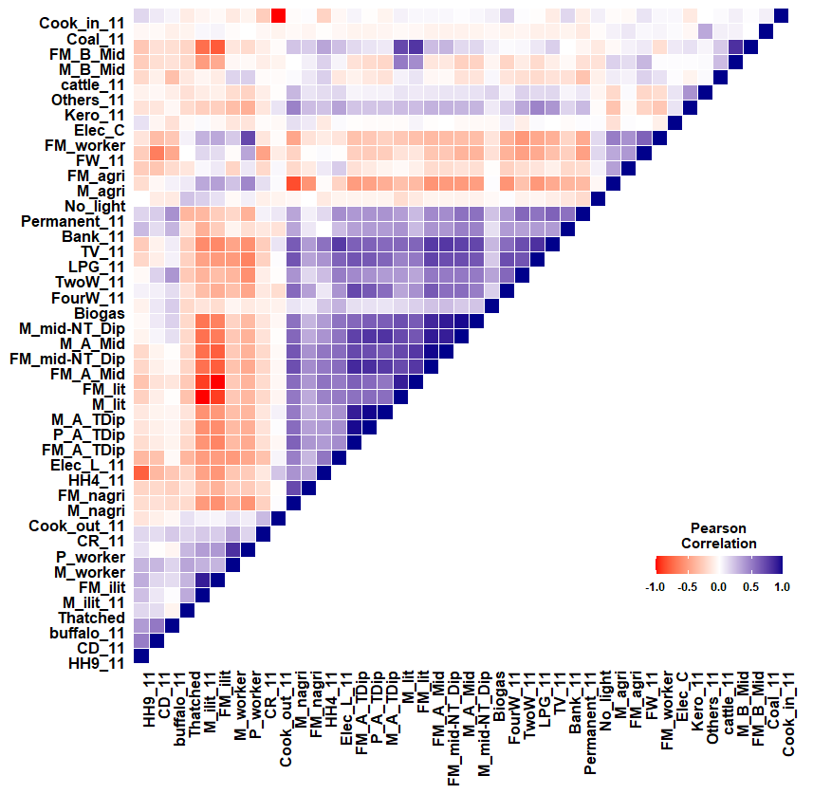
Fig. S6 | Correlation between the Census 2011 socioeconomic parameters
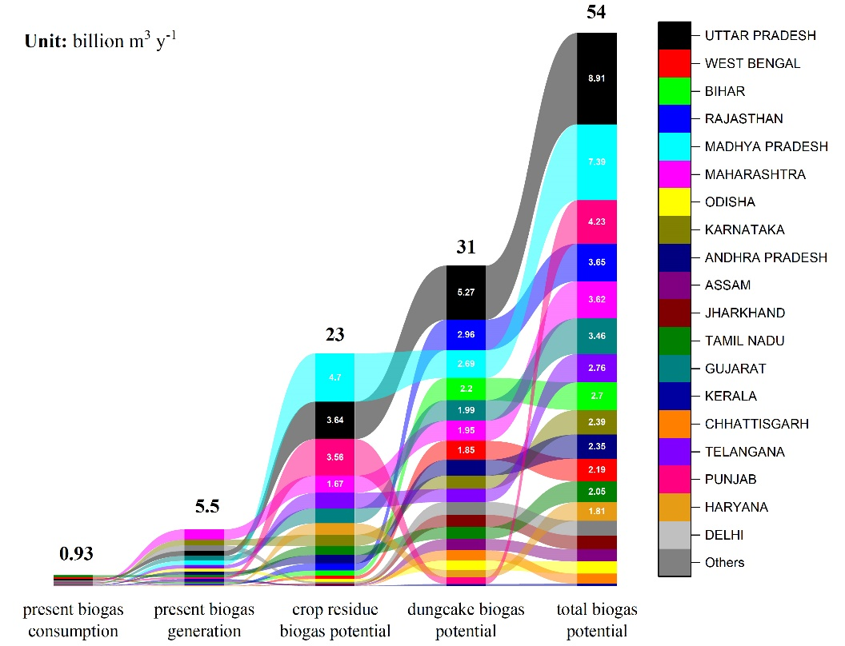
Fig. S7 | The graph represents the gap between present biogas consumption versus present biogas generation and potential; total biogas potential is the sum of biogas potential from dung cake and crop residue.
Supplementary Tables
Table S1 | Present study survey data and IRES 2020 survey data % households using LPG and solid biomass fuel for cooking and statistical hypothesis and test results
States | Fuel User Household (%)
States | Present study |  | IRES (2020)
States | LPG | Solid biomass fuel | LPG | Solid biomass fuel
ANDHRA PRADESH | 38.5 | 61.3 | 46.1 | 49.2
ASSAM | 56.0 | 44.0 | 35.8 | 40.7
BIHAR | 29.1 | 70.9 | 28.6 | 62.3
GUJARAT | 34.5 | 64.2 | 23.8 | 69.4
HARYANA | 27.5 | 71.8 | 74.1 | 21.3
HIMACHAL PRADESH | 51.5 | 48.5 | 25.9 | 55.8
JHARKHAND | 23.8 | 76.2 | 20.2 | 66.8
KARNATAKA | 41.7 | 57.9 | 63.9 | 32.5
KERALA | 23.1 | 76.9 | 15.5 | 64.6
MADHYA PRADESH | 17.7 | 54.5 | 20.3 | 66.7
MAHARASHTRA | 69.3 | 28.2 | 39.4 | 51.2
ODISHA | 10.3 | 89.7 | 15.9 | 58.2
PUNJAB | 42.7 | 57.3 | 42.2 | 52.8
RAJASTHAN | 24.9 | 74.7 | 28.3 | 65.2
TAMIL NADU | 76.7 | 16.1 | 39.0 | 51.4
TELANGANA | 72.1 | 27.4 | 43.6 | 50.4
UTTAR PRADESH | 11.2 | 88.6 | 36.4 | 58.0
UTTARAKHAND | 44.6 | 51.2 | 52.1 | 43.6
WEST BENGAL | 18.3 | 81.7 | 19.5 | 73.3
Average | 37.6 | 60.1 | 35.3 | 54.4
Variance | 405.6 | 429.1 | 258.7 | 174.9
Null Hypothesis: the state averages of the present study is equal to that of IRES.
Alternate Hypothesis: the state averages of the present study is not equal to that of IRES.
Test Statistics: T-Test for unequal variance
Tail: 2-Tailed Test
Significance level: 0.95
Two Sample unequal variance | Two-tailed test
Two Sample unequal variance | p_{value}>0.05

Table S2 | Independent variables used from Census 2011 dataset in a multivariate regression model
Socio-economic parameters | Description | Abbreviation
% Household using various fuels for cooking | Fuelwood | FW
% Household using various fuels for cooking | Crop residue | CR
% Household using various fuels for cooking | Cow dung | CD
% Household using various fuels for cooking | Coal | Coal
% Household using various fuels for cooking | Kerosene | Kero
% Household using various fuels for cooking | LPG | LPG
Type of kitchen | % Cooking inside the house | Cook_in
Type of kitchen | % Outside House | Cook_out
Household size | Members in house | HH 4
Household size | Members in house | HH 9+
% Households having the following assets | Television | TV
% Households having the following assets | Two wheeler | 2W
% Households having the following assets | Four wheeler | 4W
% Household using light for electricity |  | Elec_L
Banking facility |  | Bank
House type | Permanent/Thatched/Other | Permanent; Thatched
Education level  (FM ~ female, M ~ male,  P ~ Person) | Illiterate | M_ilit; FM_illit
Education level  (FM ~ female, M ~ male,  P ~ Person) | illiterate | M_lit; FM_lit
Education level  (FM ~ female, M ~ male,  P ~ Person) | below middle school | M_B_Mid; F_B_Mid
Education level  (FM ~ female, M ~ male,  P ~ Person) | above middle school | M_A_Mid; FM_A_Mid
Education level  (FM ~ female, M ~ male,  P ~ Person) | Between middle school and non-technical diploma | M_mid-NT_Dip; FM_mid-NT_Dip
Education level  (FM ~ female, M ~ male,  P ~ Person) | Above technical diploma | M_A_TDip; F_A_Tdip; P_A_Tdip
Employment  (FM ~ female, M~ male) | working in the agriculture field | M_agri; F_agri
Employment  (FM ~ female, M~ male) | working in the non-agriculture field | M_nagri; FM_nagri
Employment  (FM ~ female, M~ male) | labour | P_worker
Livestock | cattle/buffalo | Cattle; buffalo

Table S3 | Multivariate model description
Dependent variable | variable description | Independent variable selected | Coefficient | SE Coefficient | P-Value | VIF | R-sq(adj)
LPG | use coal for cooking | Coal | -8.15 | 2.96 | 0.009 | 1.16 | 0.8
LPG | have thatched roof | Thatched | -0.82 | 0.19 | <0.05 | 3.27 | 0.8
LPG | have buffalo roof | buffalo | -0.59 | 0.12 | <0.05 | 3.10 | 0.8
LPG | female above middle school and non-technical diploma | FM_mid-NT_Dip | 2.09 | 0.51 | <0.05 | 4.04 | 0.8
LPG | male involved in agriculture | M_agri | 1.17 | 0.19 | <0.05 | 7.58 | 0.8
firewood_LPG | use dungcake for cooking | CD | -0.43 | 0.21 | 0.05 | 1.48 | 0.79
firewood_LPG | female below middle school | FM_B_Mid | 1.27 | 0.11 | <0.05 | 1.48 | 0.79
cropresidue_LPG | use cropresidue for cooking | CR | 0.31 | 0.095 | 0.002 | 1.82 | 0.67
cropresidue_LPG | iliterate male | M_ilit | 0.32 | 0.106 | 0.005 | 5.86 | 0.67
cropresidue_LPG | person above technical diploma | P_A_TDip | 2.81 | 1.17 | 0.022 | 8.05 | 0.67
cropresidue_LPG | use electricity for light | Elec_L | -0.26 | 0.056 | <0.05 | 5.97 | 0.67
dungcake_LPG | use dung cake for cooking | CD | 0.411 | 0.114 | 0.001 | 2.1 | 0.85
dungcake_LPG | cook outside in open | Cook_out | -0.26 | 0.08 | 0.002 | 1.69 | 0.85
dungcake_LPG | have buffalo | buffalo | 0.27 | 0.063 | <0.05 | 2.94 | 0.85
dungcake_LPG | have thatched roof | Thatched | 0.43 | 0.098 | <0.05 | 2.57 | 0.85
coal_LPG | use lpg for looking | LPG | 0.102 | 0.03 | 0.001 | 7.85 | 0.5
coal_LPG | cook outside in open | Cook_out | -0.02 | 0.01 | 0.076 | 2.25 | 0.5
coal_LPG | female above technical diploma | FM_A_TDip | -0.46 | 0.205 | 0.029 | 9.41 | 0.5
coal_LPG | have thatched roof | Thatched | 0.041 | 0.009 | <0.05 | 2.21 | 0.5
biogas_LPG | use four wheeler | FourW | 0.199 | 0.109 | 0.076 | 3.5 | 0.51
biogas_LPG | use biogas for cooking | Biogas | 0.982 | 0.336 | 0.006 | 2.2 | 0.51
biogas_LPG | have cattle in house | cattle | -0.02 | 0.008 | 0.01 | 2.83 | 0.51
biogas_LPG | have thatched roof | Thatched | 0.035 | 0.011 | 0.003 | 1.94 | 0.51
kerosene_LPG | don’t have electricity | No_light | 0.85 | 0.29 | 0.006 | 1.14 | 0.51
kerosene_LPG | have thatched roof | Thatched | 0.043 | 0.009 | <0.05 | 1.14 | 0.51
Table S4 | End-use energy (PJ y⁻¹)
Fuel | Rural | Urban | National | Rural/Urban  ratio
Fuelwood | 1954 (1266-2644) | 149 (91-206) | 2103 (1340-2867) | 0.93/0.07
Crop residue | 791 (564-1017) | 6 (4-8) | 797 (568-1025) | 0.99/001
Dung cake | 1259 (909-1610) | 24 (16-31) | 1283 (926-1640) | 0.98/0.02
LPG | 536 (311-761) | 577 (410-744) | 1113 (723-1502) | 0.48/0.52
Biogas | 11 (8-14) | 8 (6-10) | 19 (14-24) | 0.58/0.42
Coal | 45.7 (28-63) | 15.7 (9-22) | 61.4 (37-85) | 0.74/0.26
Kerosene | 21.6 (15-28) | 5.8 (4-8) | 27.5 (19-36) | 0.78/0.22
TOTAL | 4619 (3101-6137) | 785 (540-1030) | 5404 (3629-7179) | 0.85/0.15
Table S5 | Present estimate average with lower and upper bound fuel consumption (MT y⁻¹) at 1σ for cooking activity
Fuel | Rural | Urban | National | Rural/Urban  ratio
Fuelwood | 121 (72-169) | 9 (5.2-13) | 130 (77-182) | 0.93/0.07
Dung cake | 107 (72-142) | 2 (1.3-2.8) | 109 (73-144) | 0.98/0.02
Crop residue | 52 (36-68) | 0.4 (0.3-0.6) | 52.4 (36-68) | 0.99/001
LPG | 9.4 (5.5-13) | 10.1 (7.2-13.1) | 19.5 (13-26) | 0.48/0.52
Biogas | 0.6 (0.5-0.8) | 0.5 (0.3-0.6) | 1.1 (0.8-1.4) | 0.58/0.42
Coal | 2.9 (1.8-4) | 1 (0.6-1.4) | 3.9 (2.4-5.4) | 0.74/0.26
Kerosene | 0.5 (0.4-0.7) | 0.14 (0.1-0.2) | 0.65 (0.5-0.9) | 0.78/0.22
National total | 293 (188-398) | 23 (15-32) | 316 (203-429) | 0.93/0.07

Table S6 | Comparison of National present estimates of biofuel and LPG Consumption for Cooking (MTyr⁻¹) with literature; ªfuelwood is the sum of fuelwood and crop residue; *central value with standard deviation are reported at 95% CI
Study | Base year | fuelwood | Crop residue | dung cake | LPG
Present study | 2019 | 130 ± 103 | 52.4 ± 32 | 109 ± 70 | 19.5 ± 13.4
Present study | 2019 | [80%] | [60%] | [64%] | [69%]
Pandey et al. (2014) | 2015 | 215 ± 179 | 62 ± 42 | 85 ± 60 | 9.8 ± 4.77
Pandey et al. (2014) | 2015 | [83%] | [68%] | [71%] | [49%]
Habib et al. (2004) | 2005 | 281 ± 129 | 36 ± 31 | 62 ± 46
Habib et al. (2004) | 2005 | [45%] | [86%] | [74%]
Stewart et al. (2021) | 2011 | 230 | 84 | 45 ± 8.7 | 13
Singh et al. (2013) | 2007 | 256 |  | 106
Streets et al. (2003)ª | 2000 | 316 |  | 105
Reddy and Venkatraman (2002) | 1996 | 302 ± 326 | 115 ± 124 | 121 ± 131 | 3
Reddy and Venkatraman (2002) | 1996 | [107%] | [107%] | [107%]
Bond et al. (2004) | 1996 | 265 ± 286 | 85 ± 92 | 128 ± 138
Bond et al. (2004) | 1996 | [107%] | [107%] | [107%]
Streets and Waldhoff (1998) | 1990 | 271 ± 298 | 126 ± 139 | 124 ± 136
Streets and Waldhoff (1998) | 1990 | [109%] | [109%] | [109%]
Smith et al. (2000) | 1990 | 169 ± 202 | 63 ± 75 | 54 ± 65 | 2
Smith et al. (2000) | 1990 | [119%] | [119%] | [119%]
yevich and Logan (2003) | 1985 | 220 ± 286 | 86 ± 112 | 93 ± 120
yevich and Logan (2003) | 1985 | [130%] | [129%] | [130%]

Table S7 | State-wise ratio of solid biomass fuel (SBF) and Biogas fuel use for the present study and Case1 (utilizing dung cake biogas potential) and Case2 (utilizing both dung cake and crop residue potential); the values are represented in MT y⁻¹.
 | Present study | Case1 | Case2
state name | SBF: Biogas | SBF: Biogas | SBF: Biogas
UTTAR PRADESH | 77.8: 0.14 | 12.2: 9.88 | 2.4: 14.33
WEST BENGAL | 22.1: 0.18 | 7.8: 2.28 | 1.8: 5.02
BIHAR | 45.0: 0.07 | 6.0: 6.16 | 0.6: 8.64
RAJASTHAN | 20.9: 0.04 | 5.3: 2.30 | 0.5: 4.49
MADHYA PRADESH | 14.3: 0.01 | 4.5: 1.33 | 0.7: 3.09
MAHARASHTRA | 10.1: 0.06 | 4.1: 0.84 | 0.3: 2.56
ODISHA | 12.4: 0.03 | 3.7: 1.28 | 0.6: 2.69
KARNATAKA | 7.6: 0.05 | 3.0: 0.63 | 0.5: 1.76
ANDHRA PRADESH | 9.1: 0.04 | 3.1: 0.83 | 0.1: 2.21
ASSAM | 8.1: 0.00 | 2.9: 0.73 | 0.2: 1.98
JHARKHAND | 12.1: 0.01 | 3.0: 1.36 | 0.3: 2.61
TAMIL NADU | 6.2: 0.20 | 2.9: 0.60 | 0.2: 1.81
GUJARAT | 9.3: 0.05 | 4.0: 0.73 | 0.6: 2.26
KERALA | 3.6: 0.02 | 2.4: 0.16 | 1.5: 0.59
CHHATTISGARH | 4.0: 0.00 | 1.6: 0.30 | 0.2: 0.95
TELANGANA | 3.8: 0.02 | 1.5: 0.32 | 0.0: 1.02
PUNJAB | 7.3: 0.06 | 1.4: 0.85 | 0.2: 1.39
HARYANA | 7.1: 0.03 | 1.4: 0.82 | 0.3: 1.32
DELHI | 0.1: 0.00 | 0.1: 0.01 | 0.1: 0.02
#Other states/UTs | 10.7: 0.05 | 3.5: 0.93 | 0.4: 2.39
National | 291.5: 1.07 | 74.6: 32.36 | 11.6: 61.13
#Other states/UTs refer to Jammu and Kashmir, Uttarakhand, Himachal Pradesh, Tripura, Puducherry, Goa, Manipur, Chandigarh, Meghalaya, Nagaland, Arunachal Pradesh, Mizoram, Daman and Diu, Dadra and Nagar Haveli, Sikkim, Andaman and Nicobar, Ladakh, and Lakshadweep.

References
- Habib, G. et al. New methodology for estimating biofuel consumption for cooking: Atmospheric emissions of black carbon and sulfur dioxide from India. Global Biogeochem Cycles 18, 1–11 (2004).
- Pandey, A., Sadavarte, P., Rao, A. B. & Venkataraman, C. Trends in multi-pollutant emissions from a technology-linked inventory for India: II. Residential, agricultural and informal industry sectors. Atmos Environ 99, 341–352 (2014).
- James Stewart, G. Sources of non-methane volatile organic compounds in Delhi, India. (2021).
- Bonjour, S. et al. Solid fuel use for household cooking: country and regional estimates for 1980–2010. Environ. Health Perspect. 121, 784–90 (2013).
- Streets, D. G. et al. An inventory of gaseous and primary aerosol emissions in Asia in the year 2000. Journal of Geophysical Research: Atmospheres 108, (2003).
- Reddy, M. S. & Venkataraman, C. Inventory of aerosol and sulphur dioxide emissions from India. Part II-biomass combustion. Atmospheric Environment vol. 36 (2002).
- Bond, T. C. et al. A technology-based global inventory of black and organic carbon emissions from combustion. Journal of Geophysical Research: Atmospheres 109, 1–43 (2004).
- Streets, D. G. & Waldhoff, S. T. Biofuel use in Asia and acidifying emissions. vol. 23 (1998).
- National Risk Management Research Laboratory. Greenhouse gases from small-scale combustion devices in developing countries: Phase IIA. (2000).
- Yevich, R. & Logan, J. A. An assessment of biofuel use and burning of agricultural waste in the developing world. Global Biogeochem Cycles 17, (2003).

