Appendix
Table A1. Each sample's bacterial sequence information.
Samples | Raw Reads | Clean Reads | Effective Reads | AvgLen (bp) | GC(%) | Effective (%)
CC1 | 80083 | 79055 | 70766 | 406 | 54.04 | 88.37
CC2 | 80298 | 80029 | 72201 | 410 | 53.21 | 89.92
CC3 | 80093 | 79726 | 70664 | 411 | 53.62 | 88.23
CC4 | 79828 | 79476 | 68644 | 408 | 53.6 | 85.99
TC1 | 80005 | 79678 | 72907 | 409 | 54.24 | 91.13
TC2 | 79819 | 79497 | 70843 | 407 | 53.62 | 88.75
TC3 | 79929 | 79565 | 71946 | 407 | 54.11 | 90.01
TC4 | 79861 | 79628 | 70070 | 407 | 53.21 | 87.74

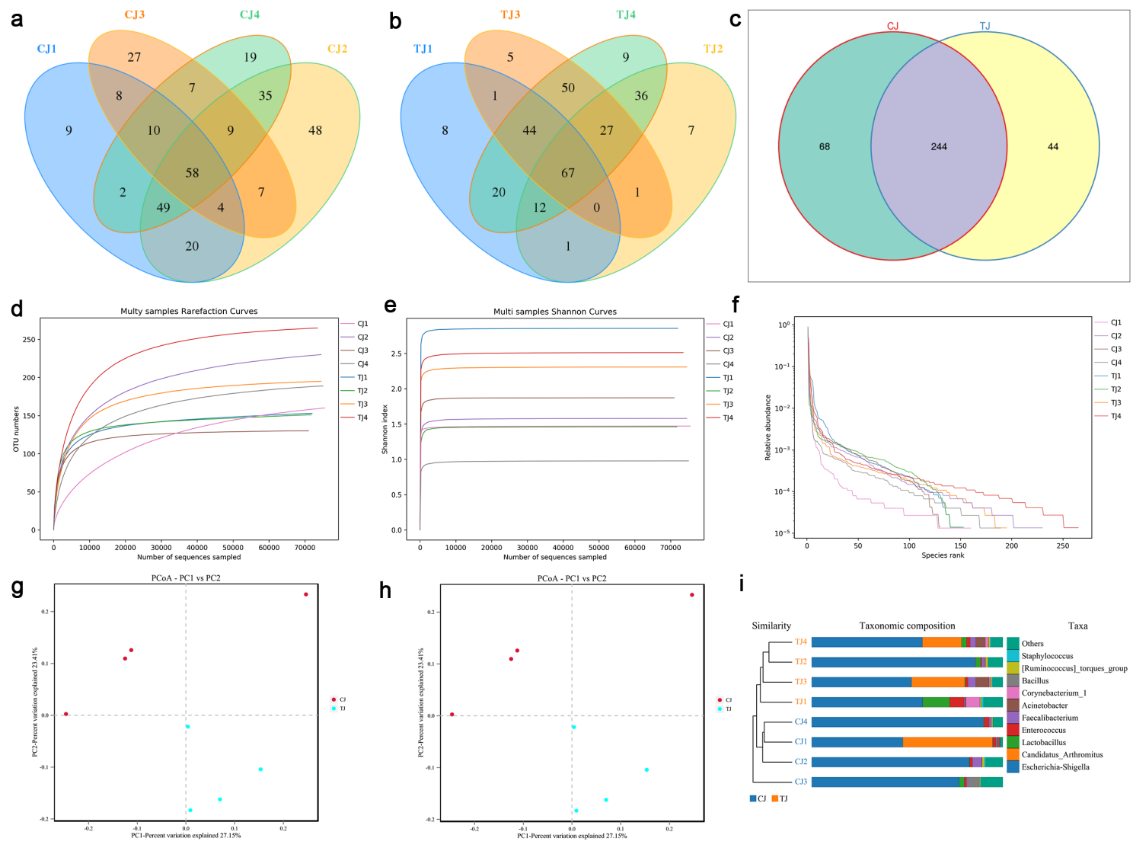
Figure A1. Gut bacterial OTUs distribution and feasibility evaluation on day 18. (a, b, c) Venn diagrams depicting the distribution of gut microbial OTUs. (d, e, f) Bacterial rarefaction and rank abundance curves were employed to measure sequencing quality, which included depth, abundance, and evenness. Each colored curve depicted in the illustrations represents a sample. (g) Principal coordinate (PCoA) analysis based on unweighted uniFrac distance of gut bacterial community. (h) NMDS analysis on unweighted uniFrac distance of intestinal microbial community. (i) Intestinal microbial clustering analysis based on unweighted pair-group method with arithmetic means (UPGMA). CJ: Jejunum of the control group; TJ: Jejunum of TD group.

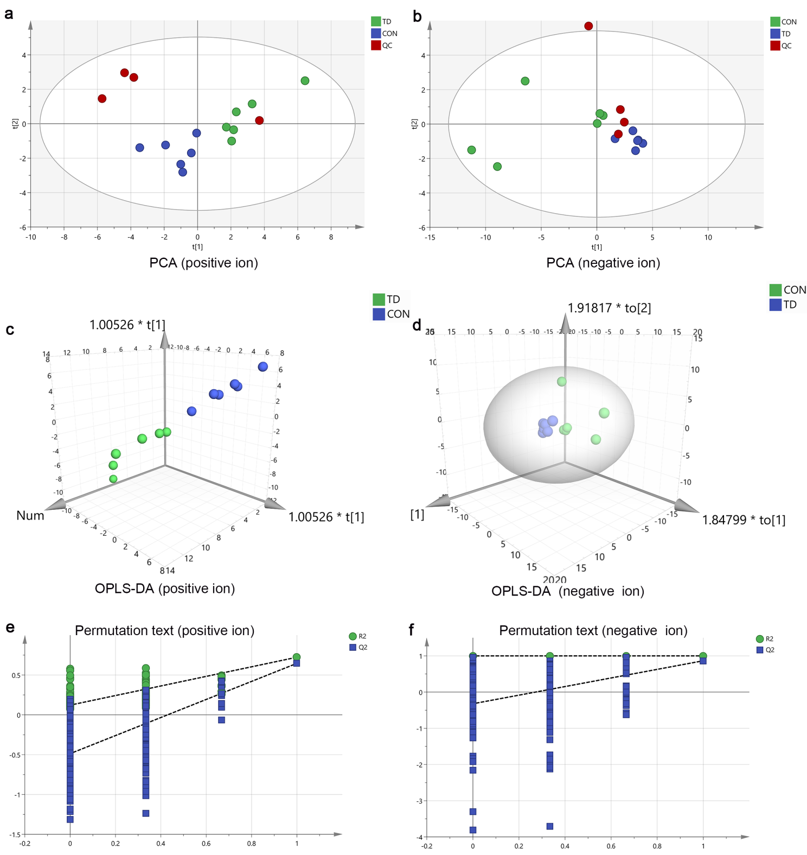
Figure A2. Establishment of serum metabolite model of broilers on the 18th day. (a, b) The PCA score plots positive and negative ions from all samples. (c, d) The OPLS-DA score of positive and negative ions was calculated to contrast the TD and control groups, (e, f) The results of the 200 permutations of positive ions and negative ions demonstrated that the two models were not overfitted.

