Supplementary Information

Ultralow Threshold Surface Emitting Ultraviolet Lasers with Semiconductor Nanowires

Mohammad Fazel Vafadar and Songrui Zhao*
Department of Electrical and Computer Engineering, McGill University, 3480 University Street, Montreal, Quebec H3A 0E9, Canada
*Email: songrui.zhao@mcgill.ca. Phone: +1-514-398-3244

Text S1: Illustration of the uniformity of the MBE-grown NPC lasing array at a large scale
The NPC lasing array had a square shape, with the side dimension of 75 μm. The large-scale SEM images are shown below in Figure S1.

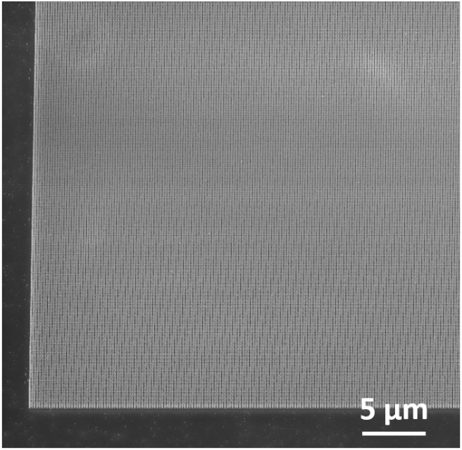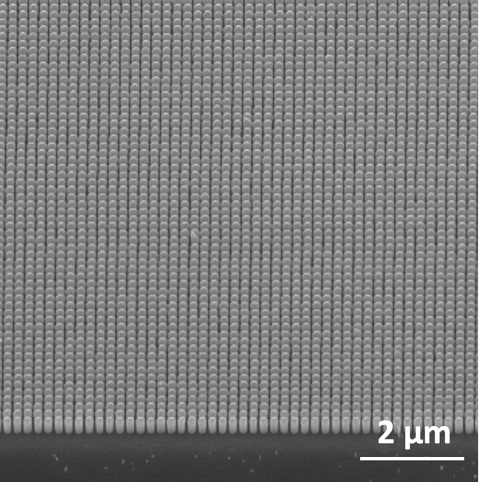

Figure S1. Large-scale SEM images of the NPC lasing array. The viewing angle is 45°.

Text S2: Non-lasing array details
Figure S2(a) shows the SEM image of the non-lasing array (a = 600 nm and d_{NW} = 325 nm). The simulated photonic band structure of the non-lasing array is shown in Figure S2(b). λ = 367 nm correlates to a reduced frequency (a/λ) of ~1.63, indicated by the dot line, which does not correlate to any band edge modes.
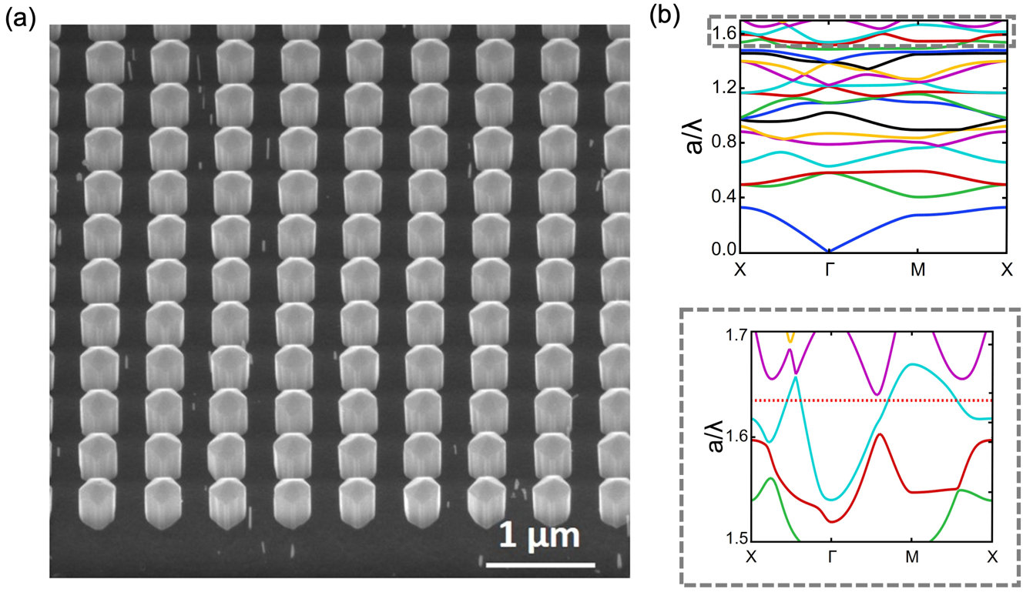

Figure S2. (a) SEM image of the non-lasing array. (b) Photonic band structure of the non-lasing array.

Text S3: RTPL spectra from the top and side of the NPC lasing array
Figure S3 shows the RTPL spectra of the lasing array measured from the top (θ = 0° with respect to the normal direction) and the side (θ = 85° with respect to the normal direction) under a peak power density of 69.7 kW/cm². It is seen that the lasing light intensity collected from the top surface is roughly 30× higher compared to that collected from the side, confirming the surface dominated light emission.
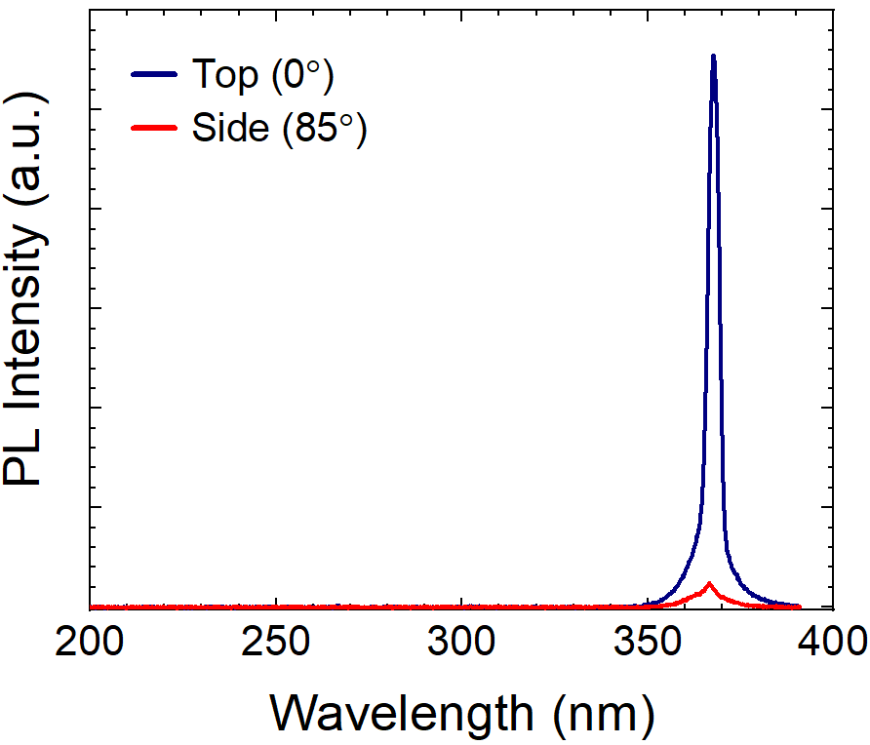

Figure S3. RTPL of the NPC lasing array collected from the top and the side.

Text S4: RTPL spectra of the GaN-on-sapphire template and the GaN-on sapphire with Ti mask
Figure S4 shows the RTPL spectra of the GaN-on-sapphire template and the GaN-on-sapphire with Ti mask under a peak power density of 63.5 kW/cm², using the same setup for the measurements of the lasing and non-lasing arrays. The extremely weak PL from the GaN-on-sapphire with Ti mask confirms that the light emission measured from the lasing and non-lasing array is from GaN nanowires grown on top.

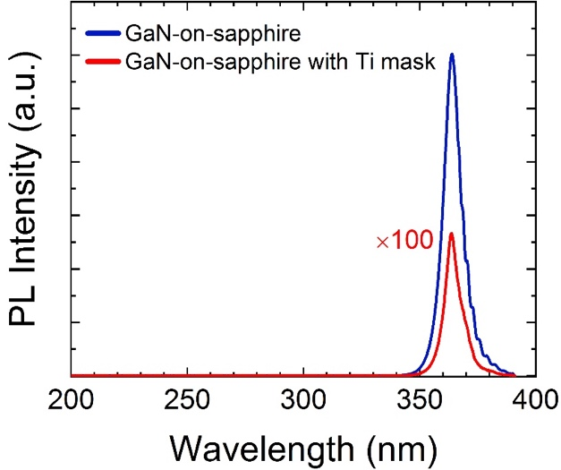
Figure S4. RTPL of the GaN-on-sapphire template and the GaN-on sapphire with Ti mask.

