Quality by design-based development and optimization of fourth-generation ternary solid dispersion of standardized Piper Longum extract for melanoma therapy
Debadatta Mohapatra¹, Dulla Naveen Kumar², Singh Shreya¹, Vivek Pandey³, Pawan K. Dubey³, Ashish Kumar Agarwal², and Alakh N Sahu¹*
¹Phytomedicine Research Laboratory, Department of Pharmaceutical Engineering & Technology, IIT (BHU), Varanasi-221005, Uttar Pradesh, India
²Nanomedicine Research Laboratory, Department of Pharmaceutical Engineering & Technology, IIT (BHU), Varanasi-221005, Uttar Pradesh, India
³Centre for Genetics Disorders, Institute of Science (BHU), Varanasi 221005, Uttar Pradesh, India

ORCID iD:
Debadatta Mohapatra: 0000-0003-3044-8706
Dulla Naveen Kumar: 0000-0003-2415-7806
Singh Shreya: 0000-0002-9242-9597
Vivek Pandey: 0000-0002-1390-133X
Pawan K. Dubey: 0000-0002-1438-3773
Ashish Kumar Agarwal: 0000-0002-7302-3647
Alakh N Sahu: 0000-0002-2378-6179

* Corresponding author:
Alakh N Sahu
E-Mail: ansahu.phe@iitbhu.ac.in
Tel.: +91 9451137862

Methodology

Molecular authentication of fruits of Piper longum
The authentication was carried out by (i) DNA isolation, (ii) DNA quality check, (iii) Polymerase Chain Reaction (PCR), (iv) agarose gel electrophoresis of PCR products, (v) removal of unwanted primers and deoxynucleoside triphosphate (dNTPs) from a PCR product, (vi) sequencing by the terminator, (vii) post-sequencing PCR clean up, and (viii) sequence analysis. DNA of dried fruits was isolated utilizing NucleoSpin® Plant II Kit (Macherey-Nagel, Germany) as per the protocol of the manufacturer. The isolated DNA quality was examined using agarose gel electrophoresis with 0.5X Tris-borate-Ethylenediaminetetraacetic acid (TBE) as electrophoresis buffer at 75 V till the front of bromophenol dye migrated to the bottom of the gel. The PCR reaction of the isolated DNA of the rbcL gene was carried out using primers, such as RBCL-AF (direction: forward, sequence (5’ to 3’): ATGTCACCACAAACAGAGACTAAAGC) and RBCL-724R (direction: reverse, sequence (5’ to 3’): TCGCATGTACCTGCAGTAGC). The PCR analysis was executed in a PCR thermal cycler (GeneAmp PCR System 9700, Applied Biosystems, USA) using 5 μL of 2X Phire Master Mix (Thermo Fisher, USA), 4 μL of distilled water (D/W), 0.25 μL of RBCL-AF, 0.25 μL of RBCL-724R, and 1μL of purified isolated DNA. The amplification profile in PCR includes (a) denaturation at 98℃ for 30 sec, (b) denaturation at 98° C for 5 sec (40 cycles), (c) annealing at 58° C for 10 sec (40 cycles), (d) extension at 72° C for 15 sec (40 cycles), (e) final extension for 60 sec at 72° C, and (f) final hold at 4° C. Then the gel electrophoresis was carried out to check the quality of PCR product in agarose gels (1.2%) prepared in 0.5 X TBE buffer comprising 0.5 µg/mL ethidium bromide using 2-log DNA ladder (New England BioLabs Inc., USA) as molecular standard. The bands were envisaged in a UV transilluminator (Genei, Bangalore, India) and the image was acquired under UV light using a gel documentation system (Bio-Rad, USA). Then the removal of unwanted primers and dNTPs from the PCR product was carried out by treating with ExoSAP-IT (GE Healthcare, Illinois, USA) as per manufacture protocol. Further, sequencing was performed in a PCR thermal cycler (GeneAmp PCR System 9700, Applied Biosystems, USA) utilizing BigDye Terminator v3.1 Cycle sequencing Kit (Applied Biosystems, USA) following the manufacture's protocol. Then the post-sequencing PCR cleanup was carried out using D/W (5 µL), 3M sodium acetate (1 µL), EDTA (0.1 µL), and 100% ethanol (44 µL). The quality of the sequence was verified using “Sequence Scanner software” v1 (Applied Biosystems, Life Technologies, USA). The sequence alignment and necessary editing of the obtained sequences were performed using Geneious Pro software (v 5.1, Auckland, New Zealand). The analyses of sequence homology were carried out using the nucleotide BLAST search (NIH, National Library of Medicine, USA).

Headspace Gas Chromatography (GC-HS) analysis for residual ethanol content in PLFEE
The residual absolute ethanol (99.99%) in the dried ethanolic extract of Piper longum fruits (PLFEE) was analyzed by GC-HS instrument (7890, Agilent, USA) equipped with a headspace injector, CombiPAL automatic headspace sampler, capillary column (HP-5, 30 m length, 0.28 mm id, and 0.25 μm film thickness), temperature- controlled oven, capillary flow technology (CFT), and a flame ionization detector (FID). The ethanol was diluted with xylene to produce a series of concentrations (10-500 ppm). One milliliter of each diluted sample was placed individually in GC headspace vials, tightly closed, and subjected to an oven at 60°C for 15 min for partitioning to the headspace until attaining equilibrium. For analysis of ethanol content in the sample (PLFEE), it was kept in the headspace vial, and subjected to an oven for partitioning the residual ethanol to the headspace in a similar way as stated above. Then 250 µL of each specimen from the head space was injected into the GC column via autosampler using Helium (He) as mobile phase with a flow rate of 1 mL/min. A run time of 20 was given and the analysis was carried out using EZChrom software (Agilent, USA). The analysis was performed in triplicate and the mean was reported.

HPLC Method for quantitative estimation of Piperine (PIP) and Piperlonguminine (PLGN)
Chromatographic separation & analysis was performed by an Agilent HPLC system (Agilent 1260 Infinity II, Agilent, USA) equipped with a quaternary pump (1260 Quat Pump VL)), diode array detector (1260 DAD WR), automatic sampler (1260 Vial Sampler), column (QuasarTM C18 LC column, Perkin Elmer, 250 × 4.6 mm with 5 μm particle size), a flow cell (13 μl, 10 mm, and 120 bar) and Open LAB CDS EZChrom Workstation VL software. The isocratic elution was carried out at a flow rate of 1.00 mL/min using a mobile phase comprised of methanol (HPLC and spectroscopy grade, Finar Limited, India) and HPLC grade water (Finar Limited, India) at a ratio of 80:20 v/v with a run time of 10 min. Quantification of two markers, i.e., PIP (the bioactive marker) and PLGN (the analytical marker) were carried out by the developed HPLC method at their respective absorption maxima (λmax of PLGN: 340 nm and PIP: 342 nm).

Preparation of primary stock solution and working standard solution
The individual primary stock solutions of PIP and PLGN each at a concentration of 1 mg/mL and their working standard solutions (2-30 μg/mL) were prepared by diluting the pure PIP (>97% Purity, Sigma Aldrich) or PLGN (≥98% purity, Cayman Chemical Company) with HPLC grade methanol. The standard solutions were vortexed, bath sonicated for 5 min, filtered through a syringe filter (0.22 µm) and stored in the amber-colored volumetric flask, and preserved at 4°C, before the HPLC analysis. Twenty microliters of working standards were injected into the HPLC system using an autosampler.

Validation of the HPLC method
The analysis was performed in triplicate, and the calibration curve was made by plotting the average area (mAU) of three independent analyses v/s the corresponding concentration (μg/mL). The developed HPLC method was validated for linearity, range, accuracy (% recovery), precision (repeatability and intermediate precision: intra-day and inter-day), limit of detection (LOD), limit of quantification (LOQ), system suitability, and robustness test as per International Conference on Harmonization Harmonised Tripartite Guideline (ICH Topic Q 2 (R1), Step 4 version, Validation Of Analytical Procedures: Text And Methodology ) [1].

Linearity and range
The linearity of the developed HPLC method was identified by observing the correlation coefficients obtained from the calibration curves of PIP and PLGN. The range of linearity was determined by fitting the data of average area (mAU) of three independent analyses with the corresponding concentration (μg/mL) to the linear equation and determining the concentrations range that follows the linearity.

Accuracy
The accuracy of the HPLC method was investigated from the percentage recovery by the standard addition method at three levels (50, 100, and 150%). Accurately 4, 8, and 12 μg/mL of working standard solution were added to pre-analyzed samples (8 μg/mL) to produce 6, 8, and 10 μg/mL, respectively. The samples were analyzed by the developed HPLC method for quantifying the PIP or PLGN. The percent recovery was calculated by Eq. (S1).
$$\% recovery=\frac{Experimental or Recovered concentration }{Theoritical concentration after addition}×100 (S1)$$

Precision
The repeatability and intermediate precision studies were performed to determine the precision of the developed HPLC method. Six replicates of the working standard solution (12 μg/mL) of PIP and PLGN were chromatographed by the HPLC method, and the repeatability of the method was assessed by determining the percent relative standard deviation (% RSD) of the obtained area. The intermediate precisions (intra-day and inter-day) were assessed by analyzing the chromatographic area of three concentrations of working standard solution (6, 12, and 18 μg/mL) and calculating the % RSD.

Limit of Detection (LOD) and Limit of Quantification (LOQ)
The LOD and LOQ of the HPLC method were estimated by the standard deviation of the response and the slope method using Eq. (S2) and Eq. (S3), respectively.
$$LOD=\frac{3.3 SD}{S} (S2)$$
$$LOQ=\frac{10 SD}{S} (S3)$$
Where the SD is the average standard deviation of responses (y-intercept) and S is the average slope of calibration curves

Robustness
The robustness of the developed HPLC method was studied by intentional changes in different chromatographic settings, such as wavelength (340, 342, and 344 nm for PIP; 338, 340, and 342 nm for PLGN), run times (8, 10, and 12 min), flow rate (0.8, 1, and 1.2 mL/min), mobile phase composition (78:22, 80:20, and 82:18 v/v of methanol: water), and analyzing the changes in the peak area and retention time (Rt) PIP and PLGN each of 12 μg/mL.

System Suitability
The consistency in the performance of the HPLC method was studied by system suitability constraints. Six replicates of working standard solution (12 μg/mL) of PIP or PLGN were injected, and parameters like % RSD of peak area, % RSD retention time (Rt), the number of theoretical plates, peak purity, capacity factor, and tailing factor were considered for system suitability analysis.

Marker-based standardization of PLFEE
Marker-based standardization was performed to quantify the amount of PIP and PLGN in the PLFEE. Accurately 20 mg of PLFEE was weighed and dissolved with 10 mL of HPLC grade methanol, vortexed (SPINIXTM Vertex shaker, Tarsons Products Pvt. Ltd., Kolkata, India) for 5 min, and sonicated in an ultrasonic bath (GT Sonic Ultrasonic Cleaner, GuangDong GT Ultrasonic Co., Ltd., China) for 10 min to achieve complete solubilization of phytoconstituents. Then it was filtered through a syringe filter (0.2 μm, PVDF), diluted suitably with HPLC grade methanol to obtain 1 mg/mL and 50 μg/mL for estimation of PLGN and PIP, respectively. Accurately, 20 μL of the sample was sampled by autosampler and injected into the HPLC system for the estimation of two markers using their respective calibration curves obtained from the validated HPLC method.

Bioanalytical HPLC method for quantitative estimation of Piperine (PIP) in plasma

Bioanalytical HPLC methodology
Chromatographic separation and analysis were performed by an Agilent HPLC system (Agilent 1260 Infinity II, Agilent, USA) equipped with a quaternary pump (1260 Quat Pump VL)), diode array detector (1260 DAD WR), automatic sampler (1260 Vial Sampler), column (QuasarTM C18 LC column, PerkinElmer, 250 × 4.6 mm with 5 μm particle size), a standard flow cell (10 mm, 13 μL, and 120 bar) and Open LAB CDS EZChrom Workstation VL software. The isocratic elution was carried out at a flow rate of 1.00 mL/min using a mobile phase comprised of methanol (HPLC & spectroscopy grade, Finar Limited, India) and HPLC grade water (Finar Limited, India) at a ratio of 80:20 v/v with a run time of 10 min. Quantification of PIP in plasma sample was carried out by the developed HPLC method at 342 nm using p-dimethylaminobenzaldehyde (p-DMAB, 99% Purity, Spectrochem Pvt. Ltd., Mumbai, India) as internal standard (IS) [2].

Blood sample collection and separation of plasma
Female SD rats were chosen for the bioavailability experiment. Animals without administration of PLFEE or formulation were chosen for the collection of blank plasma. Briefly, a blood sample (2.5 mL) was obtained from the retroorbital plexus into a heparinized tube, and plasma was collected by centrifugation of blood at 10000 rpm for 10 min in a refrigerated centrifuge (4°C). The supernatant plasma was decanted and used for the preparation of the calibration curve of PIP in plasma.

Preparation of primary stock solution and primary working standard solution
A primary stock solution of PIP (1 mg/mL) was prepared by diluting the pure PIP (>97% Purity, Sigma Aldrich) with HPLC-grade methanol. Further, the primary working standard solutions (0.5 to 256 μg/mL) were prepared from primary stock solution by diluting with HPLC-grade methanol. Similarly, the primary stock solution (1 mg/mL) of IS (p-DMAB) was prepared in HPLC grade methanol and used for the preparation of primary working standard solution (100 μg/mL) by suitable dilution.

Spiking of plasma samples, extraction, and processing
Plasma standards of both PIP with p-DMAB were made by spiking blank plasma with the primary working standard solution of PIP (0.5 to 256 μg/mL) and IS (100 μg/mL) to obtain the required concentrations. Accurately 100 μL of blank plasma samples were spiked with 100 μL of various primary working standard solutions (0.5 to 256 μg/mL) and 10 μL of IS (100 μg/mL) and incubated for 20 min. After incubation, the plasma protein precipitation and extraction of PIP and IS from plasma was carried out by adding 0.790 mL of HPLC grade methanol to produce secondary working standard solutions (0.05 to 25.6 μg/mL) containing a constant amount of IS (1 μg/mL). The samples were vortexed for 5 min at 2400 rpm (SPINIXTM Vertex shaker, Tarsons Products Pvt. Ltd., Kolkata, India) and sonicated for 10 min at 40 kH ultrasonic frequency (GT Sonic Ultrasonic Cleaner, GuangDong GT Ultrasonic Co., Ltd., China, Ultrasonic power: 150 W) for obtaining maximum recovery. Further, the samples were centrifuged (Remi CM 12 PLUS, Mumbai, India) at 10,000 rpm for 10 min at 4°C and filtered through 0.22 μm PVDF membrane filter (AXIVA Sichem Pvt. Ltd., New Delhi, India) for obtaining a clear organic layer. Then, accurately 1 mL of each organic layer was evaporated in a vacuum under a nitrogen stream, reconstituted with 1 mL of HPLC grade methanol, filtered through 0.22 μm PVDF membrane filter, kept in 1.5 mL of screw top amber colored autosampler HPLC vials (Agilent) prior to the HPLC analysis.
Three quality control (QC) samples (0.1, 1.6, and 25.6 μg/mL) were made analogously by spiking in blank plasma followed by drug extraction and reconstitution in an organic solvent. Additionally, three QC standards (0.1, 1.6, and 25.6 μg/mL) were prepared by adding 100 μL of primary working standard solutions (1, 16, and 256 μg/mL) and 10 μL of IS (100 μg/mL) and diluting up to 1 mL with HPLC grade methanol. Twenty microliters of secondary working standard solutions were injected by autosampler for quantification of PIP and IS at 342 nm by DAD detector. The analysis was performed in triplicate, and the calibration curve was made by plotting the ratio of the peak area of each analyte to IS on the y-axis versus the concentration of the analyte on the x-axis.

Validation of bioanalytical HPLC method
The developed HPLC method for quantification of PIP in plasma was validated for linearity, range, selectivity, accuracy (relative error), precision (repeatability and intermediate precision: intra-day and inter-day), sensitivity (lower limit of detection (LLOD), lower limit of quantification (LLOQ)), % recovery, robustness, system suitability, and stability test as per US Food Drug Administration (US-FDA) bioanalytical method validation guidance (Bioanalytical Method Validation Guidance for Industry, U.S. Department of Health and Human Services, FDA, Center for Drug Evaluation and Research (CDER), Center for Veterinary Medicine (CVM)) [3].

Linearity & range
The linearity of the method was examined by observing the correlation coefficients obtained from the calibration curves PIP. The range of linearity was verified by fitting the calibration data (n = 3) to the linear equation and determining the concentrations range that follows the linearity.

Selectivity
The selectivity of the method to the analyte (PIP) and IS in the plasma sample was investigated through the comparison of HPLC chromatogram of six batches of blank plasma extracted with methanol with that of blank plasma spiked with standard solutions (i.e., plasma sample spiked with IS, plasma sample spiked with PIP, and plasma sample spiked with IS with PIP).

Accuracy
The accuracy of the HPLC method was investigated from the percentage relative error (% RE) from the replicate analysis of QC samples (0.1, 1.6, and 25.6 μg/mL). The QC samples were injected into the HPLC system and the concentrations were measured from the calibration curve. The % RE was estimated by Eq. (S4).
$$\% RE=\frac{Experimental or Observed value-Expected or actual value }{Expected value}×100 (S4)$$

Precision
The precision of the developed HPLC method was ascertained by repeatability and intermediate precision study. Six replicates of the QC sample (1.6 μg/mL) were chromatographed by the HPLC method, and the repeatability of the method was assessed by determining the percent relative standard deviation (% RSD) of the obtained area ratio. The intermediate precisions (intra-day and inter-day) were assessed by analyzing the chromatographic area of three QC samples (0.1, 1.6, and 25.6 μg/mL) and calculating the % RSD.

Sensitivity: Lower Limit of Detection (LLOD) and Lower Limit of Quantification (LLOQ)
The LLOD and LLOQ of the HPLC method were estimated by the standard deviation of the response and the slope method using Eq. (S5) and Eq. S6, respectively.
$$LLOD=\frac{3.3 SD}{S} (S5)$$
$$LLOQ=\frac{10 SD}{S} (S6)$$
Where SD is the standard deviation of response (y-intercept) and S is the average slope of calibration curves

Percent extraction recovery (PER)
The PER was of PIP and IS was estimated by comparison of the peak areas of plasma extracted QC samples to that of un-extracted QC standards containing an equivalent quantity of each tested sample (i.e., to represent 100 % recovery).

Robustness
The robustness of the developed HPLC method was studied by intentional changes in different chromatographic circumstances, such as various wavelengths (340, 342, and 344 nm), various run times (8, 10, and 12 min), flow rate (0.8, 1, and 1.2 mL/min), mobile phase composition (78:22, 80:20, and 82:18 v/v of methanol: water), and analyzing the changes in the ratio of peak area and retention time (Rt) of PIP at a concentration of 1.6 μg/mL.

System Suitability
The consistency in the performance of the HPLC method was studied by system suitability constraints. Six replicates of secondary working standard solution (1.6 μg/mL) of PIP were injected, and parameters like % RSD of peak area ratio, % RSD retention time (Rt), the number of theoretical plates, peak purity, capacity factor, tailing factor were considered for system suitability analysis.

Stability test
The stability test was performed to investigate the changes in the concentration of the studied analyte, after each storage condition, and it was interrelated with the initial concentration (freshly prepared/immediately processed samples). Stability tests were conducted at three QC levels (0.1, 1.6, and 25.6 μg/mL) under different storage conditions: long-term (i.e., -20°C for 30 days) and accelerated condition (after completion of 3 freeze-thaw cycles i.e., -20°C for 12 h and 25°C for 12 h).

Acute oral toxicity study (LD50) in female C57BL/6 mice
The experiments were carried out using 10 healthy nulliparous and non-pregnant female C57BL/6 mice (8-9 weeks old, 20 ± 1.876 g body weight) as per Organization for Economic Co-operation and Development (OECD) guidelines 425 using up-and-down-procedure (UDP). Before starting the experiment, the C57BL/6 mice were housed in a cage with free access to standard food and water and were maintained on a 12 h dark/light cycle in a room at 25 ± 1°C and 55 ± 5% RH. The animals were familiarized with the laboratory environment for 1 week prior to carrying out the in-vivo study. Before administration of the dose, the animals were kept fasted (food withdrawn for 3h with easy access to water) and the body weight was recorded. Due to the lack of evidence on the toxicity profile of standardized PLFEE, as per the guideline, the main test was carried out with starting recommended dose of 175 mg/kg by gavage using a stomach tube (stainless steel, size: 18). The required amount of PLFEE was suspended in 0.5% w/v Na-CMC and administered as a single dose (not exceeding 200 µL Na-CMC solution). The neat 0.5% w/v Na-CMC was administered at a volume of 200 µL/dose to healthy mice and considered as vehicle control for comparison purposes. After administration, the mice were deprived of food for 2 h. Individually, the animals were observed after the first 30 min, with special attention at first 4 h, periodically during the first 24 h, and daily afterward for 14 days. Every animal was watched at least twice a day to observe any toxicity, survival or behavioral alteration, and change in body weight. The AOT425STATPgm software (United State Environmental Protection Agency/ US EPA) was utilized for obtaining a testing sequence and LD₅₀ (dose that causes toxicity to 50% animal population) [4]. The survival or death result of the animal after 48 h (short-term outcome) was subjected to the software and the experiment was continued as per the software’s instruction with the administration of recommended next dose in up-and-down fashion up to the attainment of “stop dosing” instruction (based upon 5 reversals in 6 tests) and through observation. The surviving mice (observed from the short-term outcome) were further observed for 14 days. After 14 days, the health of the animals was thoroughly observed, weighed, anesthetized by isoflurane, and blood was withdrawn by cardiac puncture for hematological and biochemical analysis as per the manufacturer’s instructions. The animals were humanly killed and the vital organs (heart, kidney, liver, lungs, and spleen) were carefully collected, washed with ice-cold saline, and fixed in 10% aqueous formalin for 12 h for histopathological observations. Approximately 4 μm thick paraffin organ sections were cut and stained with hematoxylin and eosin and mounted in a non-aqueous mounting medium (Dibutylphthalate Polystyrene Xylene (DPX)). The sections were optically examined under the light microscope (Magnus MLX Plus, Olympus Opto Systems India Pvt. Ltd., Uttar Pradesh, India) equipped with a 5.1 MP digital microscopic camera (Magcam DC 5) and Magvision software (version x36, 3.7.6820) at 10x magnification.

Results and discussions

DNA-based molecular characterization
The results of gel electrophoresis under UV illumination via a gel documentation system was represented in Fig. S1a. The left lane showed the 2-log DNA ladder and the right lane displayed the PCR amplification fragment of the rbcL gene. The single band in the gel documentation data represents the proper amplification of PCR product with good quality, purity, and a molecular size of 800 bp. The “.ab1” file of the FASTA sequence of the rbcL gene was obtained and then processed through Codon Code Aligner software (Version 9.0.2, CodonCode Corporation, USA) for obtaining the DNA sequencing chromatograms of PCR product. The resultant DNA sequencing chromatogram was shown in Fig. S1b. The chromatogram is a visual representation of nucleotide sequences. Each of the colors in the chromatogram represents a nucleotide. The unclean peaks or multiple broad peaks at the same region are typically found at the beginning and the end of the sequence. In the complete chromatogram, the initial portions up to the 71st nucleotide showed an unclean signal of nucleotide with superimposed broad peaks, after which the sharp distinguished peaks were found representing the clean region with very low backgrounds (noise) up to the 301st number nucleotide. The BLAST analysis was carried out using the nucleotide sequences from the clean region. The BLAST analysis results of the rbcL sequence showed a percentage identity of 100% to Piper longum (Accession: ON720789.1) confirming the authenticity of the collected fruits. The sequence match result of the sample sequence with the reported sequence (ID: ON720789.1) was given in Table S1. All the base pairs of query subjects matched with the reference database sequence. The matching score (of 231 nucleotides) showed a value of 100% and a 0% gap with the reference data. The detailed outcome of BLAST analysis of the rbcL gene of dried Piper longum fruit is shown in Table S2.
Fig. S1 Gel electrophoresis and DNA sequencing chromatogram (a) gel electrophoresis result under UV light using a gel documentation system: Left Lane: 2-log DNA ladder and right lane: the PCR amplification fragment of rbcL, (b) DNA sequencing chromatogram of rbcL gene

Table S1 Sequence matches the result of the sample sequence with the reported sequence (ID: ON720789.1)
Score  427 bits (231) | Expect  3e-115 | Identities  231/231 (100%) | Gaps  0/231 (0%) | Standard  Plus/Plus
Query 1 | 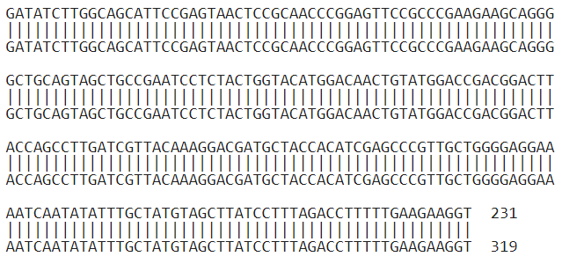 |  |  | 60
Sbjct 89 |  |  |  | 148
Query 61 |  |  |  | 120
Sbjct 149 |  |  |  | 208
Query 121 |  |  |  | 180
Sbjct 209 |  |  |  | 268
Query 181 |  |  |  | 231
Sbjct 269 |  |  |  | 319
A: adenine, G: guanine, C: cytosine, and T: thymine
Table S2 Outcomes of BLAST analysis
Parameters of BLAST analysis | Outcomes | Description
Accession | ON720789.1
Max score | 427 | It is the uppermost alignment score among the database sequence and query sequence. It signifies sequence similarity and is linearly related to the raw alignment score. The higher the score, the higher significance of the match.
E- value (Expect) | 3e-115 | E- value represents the probability that a given sequence match is purely by chance. The lower the E- value, the more significant the match.
Percentage identity | 100% | The higher the percentage, the more the match is related

Extraction of P.longum fruits
The extraction of P.longum was schematically represented in Fig. S2.
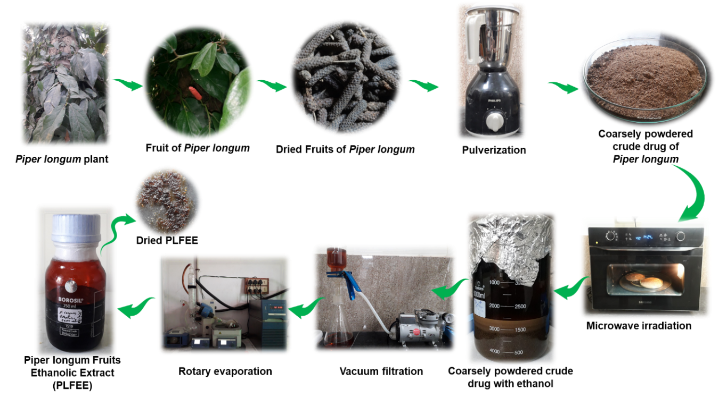
Fig. S2 Schematic representation of extraction of Piper longum fruits

Residual solvent analysis by GC-HS
The aforementioned GC conditions were selected based on the preliminary works on GC-HS analysis of ethanol with the best resolution. The GC chromatogram (Fig. S3a) showed a broad easily recognizable intense peak (starting from 1.46 min up to 2.93 min) of absolute ethanol at 2. 04 ± 0.005 min. The obtained calibration curve was found to be linear within the selected concentration range (10-500 ppm) with a linear regression equation y = 77066.494 x – 707353.883 with a correlation coefficient of 0.999 (inset Fig. S3a). The limit of detection (LOD) and limit of quantification (LOQ) was found to be 3.253 ppm and 9.859 ppm, respectively. The residual ethanol in PLFEE (Fig. S3b) showed no obvious GC-chromatogram at the retention time (R_{t}) of standard ethanol, reflecting very low (below the quantification limit) or almost absence of ethanol in the extract (PLFEE). This reflects that the PLFEE is free from ethanol and devoid of toxicity due to ethanol.
Fig. S3 GC-HS analysis for residual ethanol content (a) GC-HS-chromatogram of absolute ethanol with the retention time of 2.04 min and the inset image showing the calibration plot, (b) chromatogram of ethanol in the dried extract (PLFEE)

HPLC
Methanol and water at various volume ratios (65:35, 68: 32, 70:30, and 80: 20 v/v) were preliminarily tried as mobile phases in the HPLC method. At a higher proportion of methanol in the mobile phase (80:20 v/v), the retention time of the compounds was found to be within 10 min. Decreasing the proportion of methanol in the mobile phase (65:35 and 70:30 v/v), the Rt was found to exceed 10 min. We have tried to obtain the best-resolved peaks with minimum Rt times. Based upon the observation of the retention time of peaks and the extent of separation, methanol, and water at a volume ratio of 80:20 was selected. Very sharp and well-distinct chromatograms of PIP (Fig. S4a) and PLGN (Fig. S4b) were observed with the selected mobile phase at Rt of 7.087 ± 0.053 min and 6.413 ± 0.014 min, respectively. The absorption maxima (λmax) obtained from DAD spectra of resolved compounds were found to be 342 nm for PIP (Fig. S4c) and 340 nm for PLGN peak (Fig. S4d), confirming the identity of PIP and PLGN [5,6].
Fig. S4 HPLC chromatograms and absorption spectra of PIP and PPLGN each of 28 µg/mL in mobile phase methanol and water (80:20 v/v) (a) Chromatogram of PIP (Rt = 7.087 ± 0.053 min) at wavelength 342 nm, (b) Chromatogram of PLGN (Rt = 6.413 ± 0.014 min) at wavelength 340 nm, (c) spectrum of PIP showing the maximum absorbance at 342 nm, and (d) spectrum of PLGN showing the absorption maxima at 340 nm
The two-dimensional (2-D) and three-dimensional (3-D) chromatograms of PIP (Fig. S5a and 5b) and that of PLGN (Fig. S5c and 5d) confirmed the absence of any peaks around the elution time of PIP or PLGN. However, very min spots around Rt of 2 min and 4 min were due to the mobile phase, which intensity is very low and absent in the chromatograms (Fig. S4a and Fig. S4b) due to the higher signal-to-noise ratio of markers. The red region in the contour and 3-D plots represents the highest intensity of the marker compounds with their corresponding retention times and wavelengths.
Fig. S5 Two-dimensional (2-D) and three-dimensional (3-D) chromatograms of PIP and PLGN (a) 2-D contour chromatogram of PIP (b) 3-D chromatogram of PIP, (c) 2-D contour chromatogram of PLGN, and (d) 3-D chromatogram of PLGN

Validation

Linearity and range
The average area of three repetitive measurements for PIP and PLGN plotted against their respective concentrations were presented in Fig. S6a and Fig. S6b. A linear relationship was found between the selected concentrations of PIP (2 µg/mL to 30 µg/mL) and the chromatographic area (at 342 nm) with correlation coefficients (r² = 0.997) and regression equation y = 276947.424 x - 200378.812 (n = 3). Similarly, a linear relationship was found between the used concentrations of PLGN (2 µg/mL to 30 µg/mL) and the corresponding chromatographic area (at 340 nm) with correlation coefficients (r² = 0.996) and regression equation y = 349329.568 x - 272061.184 (n = 3). The high correlation coefficient values (r² = 0.99) in both cases of the fitted model indicate a strong relationship among the variables.
Fig. S6 HPLC-based calibration curves (a) calibration curve of PIP measured at wavelength 342 nm and (b) calibration curve of PLGN measured at wavelength 340 nm

Accuracy
The closeness of theoretical and experimental values indicates the accuracy of the analytical method. The results of the accuracy of PIP and PLGN in terms of % recovery and percentage relative standard deviation (% RSD) were represented in Table S3. The high recovery values and low percent RSD (<2%) reflect the excellent accuracy of the developed HPLC method [5].
Table S3 Accuracy studies of the developed HPLC method (n = 3)
Concentration of PIP (µg/mL) | Level (%) | PIP spiked concentration (µg/mL) | Theoretical concentration (µg/mL) | Experimental concentration (μg/mL) | % Recovery | % RSD
8 | 50 | 4 | 6 | 5.991 ± 0.045 | 99.85 | 0.757
8 | 100 | 8 | 8 | 8.082 ± 0.136 | 101.031 | 1.694
8 | 150 | 12 | 10 | 9.934 ± 0.123 | 99.345 | 1.242
Concentration of PLGN (µg/mL) | Level (%) | PLGN spiked concentration (µg/mL) | Theoretical concentration (µg/mL) | Experimental concentration (μg/mL) | % Recovery | % RSD
8 | 50 | 4 | 6 | 6.359 ± 0.027 | 105.986 | 0.425
8 | 100 | 8 | 8 | 7.998 ± 0.016 | 99.976 | 0.201
8 | 150 | 12 | 10 | 10.026 ± 0.124 | 100.268 | 1.241

Precision
Precision indicates the degree of scattering (closeness of agreement) among a series of readings obtained from multiple specimens of the same homogeneous sample under specified analytical conditions. In the present study, the repeatability and intermediate precision (intra-day and inter-day) studies were performed to examine the precision of the HPLC method for various concentrations (6, 12, and 18 µg/mL) of working standard solution. The % RSD values obtained from the repeatability study were found to be 0.16% for PIP and 0.119% for PLGN (Table S4). The results of intermediate precision studies were shown in (Table S5). From intra-day precision studies, the % RSD values of the PIP peak area ranged from 0.146 to 0.299%, and for inter-day precision, the % RSD values ranged from 0.258 to 0.369%. Similarly, the % RSD values of the PLGN peak area were found to be between 0.064 and 0.88% (intra-day precision) and between 0.721 and 1.155% (inter-day precision). In all cases, the % RSD values were lesser than 2%, which fulfilled the acceptance criteria and showed a high degree of precision of the developed HPLC method [5].
Table S4 Repeatability study of developed HPLC method (n = 6)
Concentration of PIP (µg/mL) | Mean Area (mAU) | SD | RSD (%)
12 | 3230831.167 | 5177.835 | 0.16
Concentration of PLGN (µg/mL) | Mean Area (mAU) | SD | RSD (%)
12 | 3643443.167 | 4354.112 | 0.119

Table S5 Intermediate precision (Intra-day and inter-day precision) studies of the developed HPLC method
Concentration of PIP (µg/mL) | Intra-day (at an interval of 6 h) |  | Inter-day (Day1- Day3)
Concentration of PIP (µg/mL) | Obtained Area ± SD (mAU) | RSD (%) | Obtained Area ± SD (mAU) | RSD (%)
6 | 1618408 ± 3798.53 | 0.234 | 1622421 ± 5989.94 | 0.369
12 | 3241725.333 ± 4740.057 | 0.146 | 3256179.333 ± 10828.978 | 0.332
18 | 4714037.333 ± 14102.094 | 0.299 | 4707917 ± 12164.467 | 0.258
Concentration of PLGN | Intra-day (at an interval of 6 hs) |  | Inter-day (Day1- Day3)
Concentration of PLGN | Obtained Area ± SD (mAU) | RSD (%) | Obtained Area ± SD (mAU) | RSD (%)
6 | 1880619 ± 1216.598 | 0.064 | 1850762.667 ± 13350.252 | 0.721
12 | 3687662.667 ± 32458.115 | 0.88 | 3639347.333 ± 37043.657 | 1.017
18 | 5872113.333 ± 22782.816 | 0.387 | 5845683.333 ± 9105.994 | 1.155

LOD and LOQ
The LOD and LOQ values for the determination of PIP were found to be 0.259 and 0.786 μg/mL, respectively. Similarly, the LOD and LOQ values for PLGN were found to be 0.27 and 0.819 μg/mL, respectively. The lower values of LOD and LOQ of the developed HPLC method indicated the sensitivity of the optimized method for analysis of PIP and PLGN.

Robustness and Ruggedness
It is a measure of the ability of the HPLC method to remain unaffected by slight but deliberate changes in the method variables that offer its reliability during normal usage. Robustness and ruggedness of the developed HPLC method investigated by deliberate changes in different chromatographic conditions showed the lower % RSD values (<2%) of the area and retention time (Table S6 and Table S7), which confirm the robustness of the developed HPLC method.
Table S6 Robustness and ruggedness study of developed HPLC method for PIP (12 µg/mL)
Parameters | Variations made | Area ± SD (mAU) | RSD (%) | Retention time (Rt) ± SD (min) | RSD (%)
Wavelength (nm) | 340 | 3390391.333 ± 20376.823 | 0.601 | 7.133 ± 0.021 | 0.303
Wavelength (nm) | 342 | 3377712 ± 19944.805 | 0.59 | 7.133 ± 0.021 | 0.303
Wavelength (nm) | 344 | 3340953.333 ± 19354.762 | 0.579 | 7.133 ± 0.021 | 0.303
Run Time (min) | 8 | 3382801.333 ± 11055.37 | 0.326 | 7.135 ± 0.027 | 0.387
Run Time (min) | 10 | 3227710 ± 501.352 | 0.015 | 7.092 ± 0.021 | 0.305
Run Time (min) | 12 | 3375691.667 ± 16612.698 | 0.492 | 7.173 ± 0.03 | 0.426
Flow rate (mL/min) | 0.8 | 4190108.667 ± 8244.626 | 0.196 | 8.888 ± 0.041 | 0.472
Flow rate (mL/min) | 1 | 3223921.667 ± 4744.925 | 0.147 | 7.095 ± 0.026 | 0.366
Flow rate (mL/min) | 1.2 | 2833650.333 ± 12476.467 | 0.44 | 6.028 ± 0.019 | 1.818
Mobile phase composition (Methanol: Water) v/v | 78:22 | 3450097 ± 13660.3214 | 0.395 | 8.125 ± 0.07 | 0.984
Mobile phase composition (Methanol: Water) v/v | 80:20 | 3257255 ± 42512.258 | 1.305 | 7.099 ± 0.022 | 0.317
Mobile phase composition (Methanol: Water) v/v | 82:18 | 3459427.66 ± 25292.359 | 0.731 | 6.52 ± 0.015 | 0.234

Table S7 Robustness and ruggedness study of developed HPLC method for PLGN (12 µg/mL)
Parameters | Variations made | Area ± SD (mAU) | RSD (%) | Retention time (Rt) ± SD (min) | RSD (%)
Wavelength (nm) | 338 | 3711673.667 ± 43144.199 | 1.162 | 6.411 ± 0.007 | 0.121
Wavelength (nm) | 340 | 3688361.33 ± 66729.35 | 1.809 | 6.405 ± 0.015 | 0.24
Wavelength (nm) | 342 | 3856646 ± 17489.522 | 0.453 | 6.409 ± 0.009 | 0.146
Run Time (min) | 8 | 3746709.667 ± 55753.844 | 1.488 | 6.402 ± 0.003 | 0.058
Run Time (min) | 10 | 3644321.667 ± 5695.461 | 0.156 | 6.412 ± 0.012 | 0.198
Run Time (min) | 12 | 3716112 ± 54328.062 | 1.461 | 6.401 ± 0.009 | 0.147
Flow rate (mL/min) | 0.8 | 4657913 ± 41988.913 | 0.901 | 8.072 ± 0.062 | 0.778
Flow rate (mL/min) | 1 | 3655028 ± 19590.404 | 0.535 | 6.419 ± 0.004 | 0.07
Flow rate (mL/min) | 1.2 | 3157162.333 ± 11512.149 | 0.364 | 5.308 ± 0.018 | 0.357
Mobile phase composition (Methanol: Water) v/v | 78:22 | 3775809 ± 13947.62 | 0.369 | 6.828 ± 0.034 | 0.508
Mobile phase composition (Methanol: Water) v/v | 80:20 | 3642568 ± 32103.463 | 0.881 | 6.415 ± 0.009 | 0.154
Mobile phase composition (Methanol: Water) v/v | 82:18 | 3785191.667±22562.0006 | 0.596 | 5.729±0.089 | 0.455

System Suitability
The system suitability checks the specificity and validity of the developed analytical method. The % RSD of various validation parameters, like retention time (Rt), peak area, the number of theoretical plates, peak purity, tailing factor, and capacity factor was estimated for system suitability analysis (Table S8 and Table S9). The % RSD of all examined parameters was within the permissible limits (<2%) [5]. The number of theoretical plates (N>2000) and tailing factor (<2) were within the acceptable limit [5]. The co-elution of degradants or impurities was explored by examining the peak purity. The peak purity curve for PIP at 7.087 min (Fig. S7a) and PLGN at 6.413 min ((Fig. S7b); signifies nothing was co-eluting along with PIP or PLGN and no interference at their retention times. Such purity reports were also reported elsewhere [7]. The peak purity of PIP and PLGN was found to be 1; representing a high degree of purity [7]. The purity factor was greater than the purity threshold, representing that no additional compounds were co-eluted with the markers [8]. The capacity factor (K¹) represents the degree of interaction of the analyte with the stationary phase in the column. A capacity factor of zero indicates no interaction, whereas a capacity factor >1 indicates a certain degree of interaction with the stationary phase. Ideally, a capacity factor of an analyte varies from 1-5. A higher value of capacity factor (>20), indicates a greater degree of interaction of analytes with stationary phase, which leads to prolongation of elution time. In both cases (i.e., PIP and PLGN), the K¹ values were found to be within optimal range, thus require less run time (10 min) for analysis. The system suitability results disclose the suitability of the developed HPLC system for quantitative analysis of PIP and PLGN.
Fig. S7 Purity curve of PIP and PLGN (a) purity curve of PIP and (b) purity curve of PLGN
Table S8 System suitability study of developed HPLC method for analysis of PIP (12 µg/mL), n = 6
Parameters | Average Value ± SD | RSD (%)
Area (mAU) | 3230831.167 ± 5177.835 | 0.16
Retention time (Rt) | 7.047 ± 0.023 | 0.425
Number of theoretical plates | 3592.834 ± 43.26 | 1.204
Peak purity | 0.998 ± 0.002 | 0.2
Tailing factor (Asymmetry) | 0.9235 ± 0.0017 | 0.194
Capacity factor (k¹) | 1.448 ± 0.009 | 0.646

Table S9 System suitability study of developed HPLC method for analysis of PLGN (12 µg/mL), n = 6
Parameters | Average Value ± SD | RSD (%)
Area (mAU) | 3643443.167 ± 4354.112 | 0.119
Retention time (Rt) | 6.406 ± 0.041 | 0.646
Number of theoretical plates | 3541.5 ± 31.17 | 0.88
Peak purity | 0.99 ± 0.007 | 0.775
Tailing factor | 0.868 ± 0.007 | 0.838
Capacity factor (k¹) | 1.135 ± 0.002 | 0.193

Marker-based standardization of PLFEE
The PLFEE was suitably dissolved and diluted in HPLC grade methanol and 20 µL was injected into the HPLC system for quantification of PIP and PLGN utilizing the calibration curves of the validated HPLC method. The peak of PIP and PLGN in the PLFEE was verified from their respective retention time (Rt) and corresponding absorption maxima (λmax). The Rt of PIP and PLGN in the PLFEE was obtained at 7.087 ± 0.023 min and 6.340 ± 0.046 min, respectively (Fig. S8a and Fig. S8b), which matches with the Rt of pure PIP at Rt = 7.087 ± 0.053 min and pure PLGN at 6.413 ± 0.014 min (Fig. S4a and S4b). The peak for PIP was found to be very intense compared to the peak of PLGN, reflecting the comparatively higher amount of PIP in the PLFEE than PLGN.
The corresponding λmax obtained from the DAD detector for PIP and PLGN in the PLFEE was found to be at 342 nm and 340 nm, respectively (Fig. S8c and Fig. S8d). The obtained λmax corresponding to PIP and PLGN in PLFEE is in accordance with the obtained λmax of PIP (Fig. S4c) and PLGN (Fig. S4d), confirming the existence of two selected markers in the PLFEE. However, the spectral intensity of PLGN (Fig. S8c) is very less due to its low quantity in PLFEE. Further, the contour plots (Fig. S8e and Fig. S8f) and 3-dimensional chromatograms (Fig. S8g and Fig. S8h) matched with the chromatograms of pure PIP and PLGN (Fig. S5). The area of the respective peak was considered for quantitative estimation of PIP and PLGN by analyzing the samples in triplicate. The chromatogram (Fig. S8a) for PLFEE (1 mg/mL) was selected for the quantification of PLGN at 340 nm and the chromatogram (Fig. S8b) for PLFEE (50 µg/mL) was selected for the quantification of PIP at 342 nm. The quantity of PIP was found to be 377.0687 ± 1.453 mg and PLGN was found to be 6.72 ± 0.108 mg per gram of dried PLFEE.

Fig. S8 HPLC results of PLFEE 1mg/mL and 50µg/mL in mobile phase methanol and water (80:20 v/v) (a) Chromatograms of PIP (Rt = 7.087 ± 0.023 min) and PPLGN (Rt = 6.340 ± 0.046 min) in 1 mg/mL of PLFEE at wavelength 340 nm (b) Chromatogram of PIP (Rt = 7.087 ± 0.023 min) at wavelength 342 nm and chromatogram of PLGN (Rt = 6.333 ± 0.027 min) at wavelength 342 nm, (c) spectrum of PLGN in 1 mg/mL of PLFEE showing the maximum absorbance at 340 nm, (d) spectrum of PIP in 50 µg/mL of PLFEE showing the absorption maxima at 342 nm, (e) 2-D contour chromatogram of PIP and PLGN in 1 mg/mL of PLFEE (f) 2-D contour chromatogram of PIP and PLGN in 50 µg/mL of PLFEE, (g) 3-D chromatogram of PIP and PLGN in 1 mg/mL of PLFEE, and (h) 3-D chromatogram of PIP and PLGN in 50 µg/mL of PLFEE

Phase solubility study
The Gibbs free energy (ΔGt°) transfer of PIP from water to various aqueous polymeric or surfactant solutions was shown in Table S10. The chemical structure and micellar solubilization properties of Soluplus® and Tween® 80 are represented in Fig. S9.
Table S10 Gibbs free energy (ΔG_{t}°) transfer of PIP from pure water to an aqueous polymeric or surfactant solution
Name Polymer or Surfactant | Concentration of polymer or Surfactant (% w/v) | ΔG_{t}° Values (kJ/mol) at 37°C | Slope | Intercept | R²
Kolliphor P 188 | 2% | -1.414 | 0.219 | 0.012 | 0.994
Kolliphor P 188 | 4% | -3.632
Kolliphor P 188 | 8% | -5.251
Hydroxypropyl cellulose | 2% | -2.516 | 0.053 | 0.522 | 0.933
Hydroxypropyl cellulose | 4% | -3.23
Hydroxypropyl cellulose | 8% | -3.676
Poloxamer 407 | 2% | -2.695 | 0.1907 | 0.431 | 0.865
Poloxamer 407 | 4% | -4.814
Poloxamer 407 | 8% | -5.463
Soluplus® | 2% | -3.699 | 0.284 | 0.454 | 0.985
Soluplus® | 4% | -5.236
Soluplus® | 8% | -6.402
PEG 4000 | 2% | -1.235 | 0.013 | 0.339 | 0.994
PEG 4000 | 4% | -1.453
PEG 4000 | 8% | -1.747
PEG 9000 | 2% | -0.466 | 0.009 | 0.253 | 0.983
PEG 9000 | 4% | -0.712
PEG 9000 | 8% | -0.986
PVP k30 | 2% | -0.195 | 0.006 | 0.232 | 0.941
PVP k30 | 4% | -0.437
PVP k30 | 8% | -0.620
Gelucire® 44/14 | 2% | -3.388 | 0.095 | 0.688 | 0.964
Gelucire® 44/14 | 4% | -4.172
Gelucire® 44/14 | 8% | -4.773
Kolliphor® RH 40 | 2% | -2.878 | 0.213 | 0.205 | 0.987
Kolliphor® RH 40 | 4% | -3.785
Kolliphor® RH 40 | 8% | -5.556
Tween® 20 | 2% | -4.18 | 0.203 | 0.691 | 0.993
Tween® 20 | 4% | -4.78
Tween® 20 | 8% | -6.038
Tween® 80 | 2% | -3.496 | 0.5 | 0.156 | 0.999
Tween® 80 | 4% | -5.364
Tween® 80 | 8% | -7.33

Fig. S9 Chemical structure and micellar solubilization properties of Soluplus® and Tween® 80 (a) The chemical structure and schematic illustration of the micellar solubilization of hydrophobic candidates by Soluplus® (b) The chemical structure and schematic illustration of the micellar solubilization of hydrophobic candidates by Tween®80

Response surface methodology (RSM)

Diagnostic plots and perturbation plots
Various diagnostic plots and perturbation plot for identifying the predictability of the statistical CCD model was represented in Fig. S10.

Fig. S10 Diagnostic plots and perturbation plot (a) normal plot of residuals, (b) Box-Cox plot, (c) predicted vs. actual plot, (d) residual vs. predicted plot, (e) residual vs. run, (f) residual vs. factor plot, and (g) perturbation plot for saturation solubility of PIP

In-vitro dissolution
The overall dissolution process and the hypothesized micelles of OSD during dissolution was graphically presented in Fig.S11.
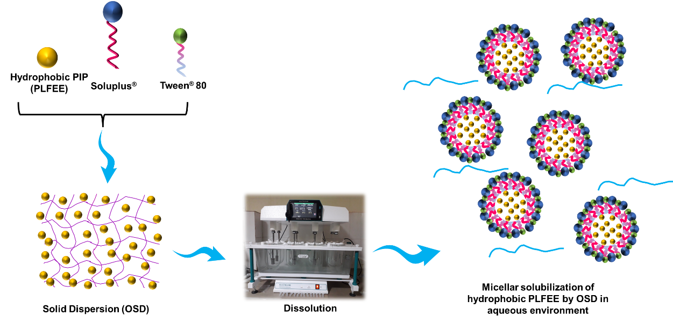
Fig. S11 The hypothesized diagram of the micelles of OSD during dissolution
Table S11 Kinetics of drug release in pH 1.2 up to 24 h
Zero order |  | First order |  | Higuchi Model |  | Korsmeyer-Peppas model |  | Hixson-Crowell model |  |  | Mechanism of drug release
K₀ | R² | K₁ | R² | K_{H} | R² | K_{kp} | R² | K_{HC} | R² | n |  | R²
11.274 | 0.65 | 0.769 | 0.904 | 35.911 | 0.835 | 59.156 | 0.916 | 0.247 | 0.548 | 0.6 |  | 0.995
K₀: zero-order release constant, K₁: first order rate constant, K_{H}: Higuchi dissolution constant, K_{kp}: Korsmeyer release rate constant, K_{HC}: Hixson-Crowell rate constant, n: drug release exponent or diffusional exponent, and R²: Correlation coefficient

Stability Study
The results of the long-term stability study and accelerated stability study were shown in Fig. S12 and Fig. S13, respectively.
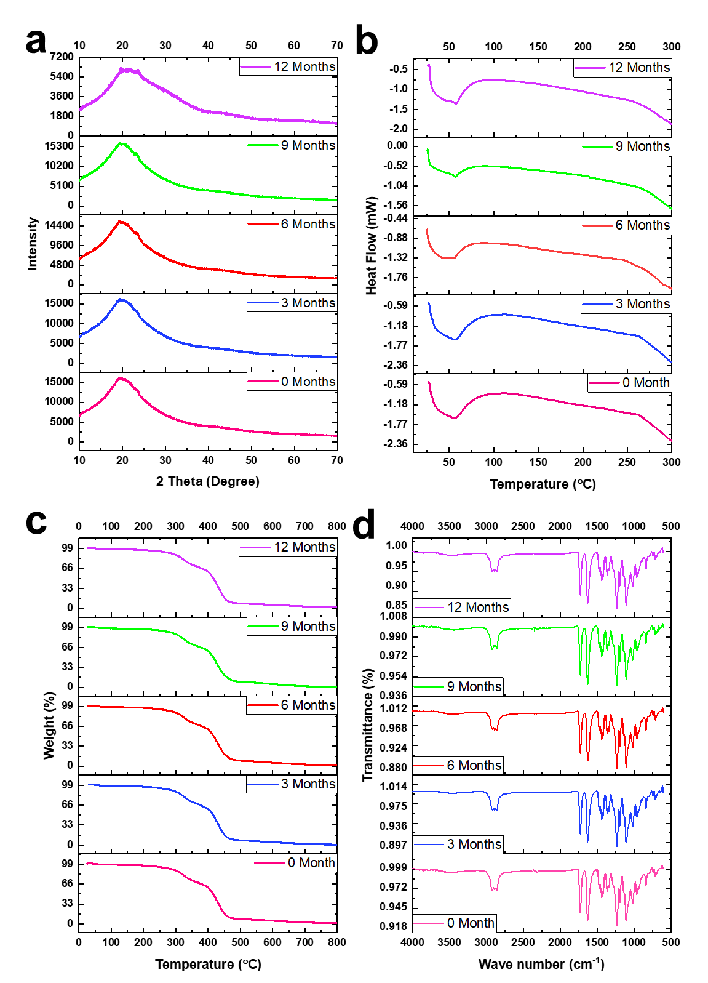
Fig. S12 Long-term stability study of SD up to 12 months at an interval of 3 months (a) XRD, (b) DSC, (c) TGA, and (d) ATR-FTIR

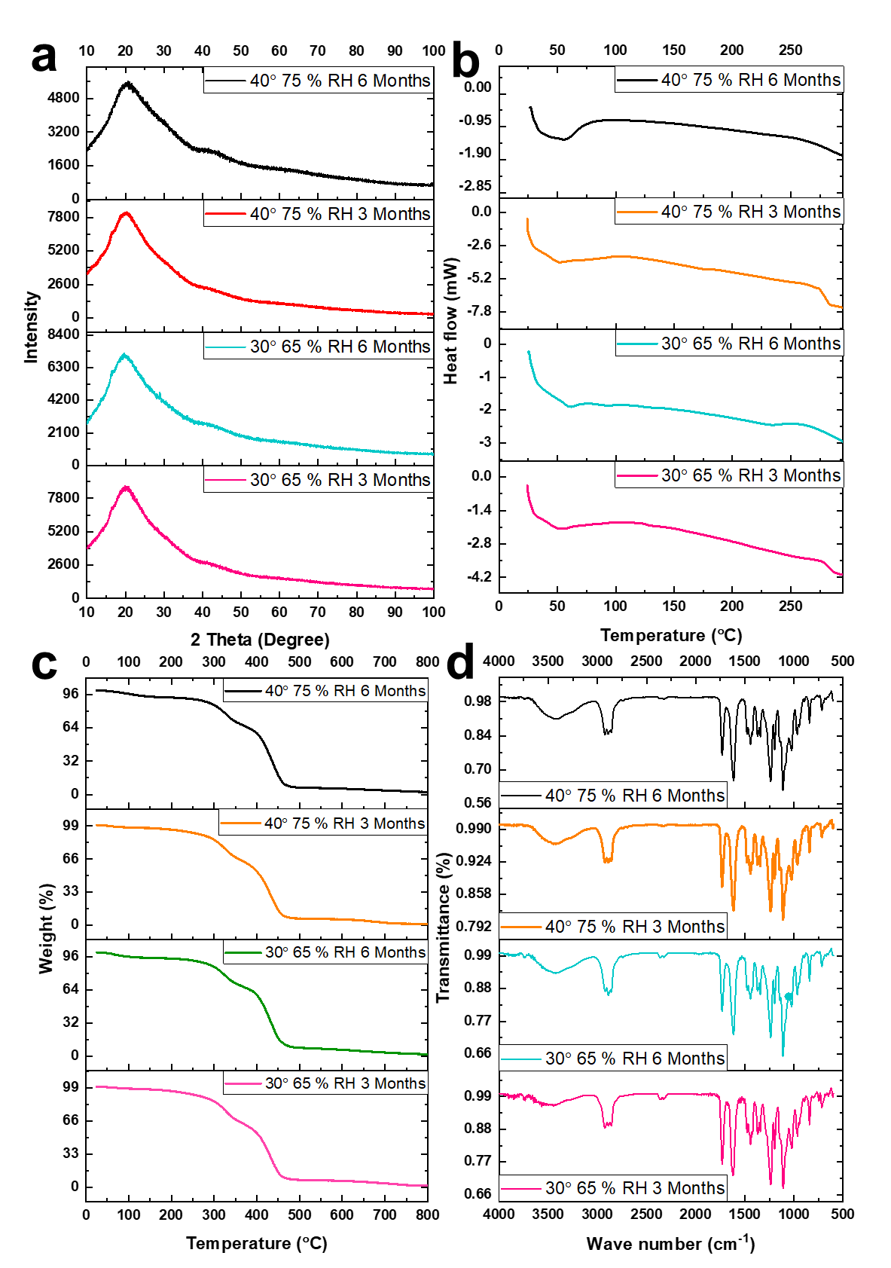
Fig. S13 Accelerated and intermediate stability study of SD up to 6 months at an interval of 3 months (a) XRD, (b) DSC, (c) TGA, and (d) ATR-FTIR

Bioanalytical HPLC Method for quantitative estimation of Piperine (PIP) in plasma
Based upon our previous observation of PIP having easily identifiable sharp peak with retention time within 10 min at 80:20 v/v methanol and water as mobile phase, the same mobile phase was tried to develop the HPLC chromatogram of p-DMAB as IS in the presence of PIP extracted from plasma samples. Very sharp and well-distinct chromatograms of PIP and IS (Fig. S14a) were observed with the selected mobile phase at Rt of 7.02 ± 0.062 and 4.113 ± 0.026 min, respectively. The absorption maxima (λmax) obtained from DAD spectra of PIP (Fig. S14b) and p-DMAB were found to be 342 and 346 nm, respectively (Fig. S14c). confirming the identity of PIP and p-DMAB [5]. The two-dimensional (2-D) and three-dimensional (3-D) chromatograms (Fig. S14d and Fig. S14e) confirmed the nonappearance of any peaks around the elution time of PIP or p-DMAB. However, every minute bands around Rt of 2-3 Min were due to the blank plasma and mobile phase, in which intensity is very low and found to be decreased upon gradual increasing the concentration of the analyte.

Validation of bioanalytical HPLC method

Fig. S14 Chromatograms of PIP (1.6 μg/mL) and p-DMAB (1 μg/mL) in mobile phase methanol and water (80:20 v/v) (a) Chromatogram of PIP (Rt = 7.02 ± 0.062 min) and p-DMAB (Rt = 4.113 ± 0.026 min) at wavelength 342 nm, (b) DAD absorption spectrum of PIP having λmax = 342 nm (c) DAD absorption spectrum of p-DMAB having λmax = 346 nm, (d) 2-D contour chromatogram of PIP and p-DMAB, and (e) 3-D chromatogram of PIP and p-DMAB

Linearity and range
The average area ratio (Area of PIP:Area of IS) of three repetitive measurements plotted against respective concentrations were presented in Fig. S15a. A linear relationship was obtained between the selected concentrations of PIP (0.05 to 25.6 µg/mL) and the chromatographic area ratio (at 342 nm) with correlation coefficients (r² = 0.999) and regression equation y = 0.67195 x – 0.04527 (n = 3).
Fig. S15 Calibration curve and selectivity results (a) calibration curve of PIP in plasma at wavelength 342 nm with p-DMAB as IS, (b) HPLC chromatograms of blank rat plasma, (c) plasma spiked with p-DMAB (0.354 μg/mL), (d) plasma spiked with PIP (25.6 μg/mL), (e) plasma spiked with p-DMAB (1 μg/mL) and PIP (25.6 μg/mL), and (f) extracted plasma sample after oral administration of optimized solid dispersion (OSD) with the p-DMAB (1 μg/mL) as IS

Selectivity
The selectivity of the HPLC method was verified for examining the endogenous interference or matrix effects of plasma components with the analyte. The selectivity of the HPLC method towards the analyte and IS was shown in Fig. S15b-f. The blank plasma showed a less intense peak around 2 to 3 min (Fig. S15b). The absence of any interfering plasma peak at the retention time of IS (Rt = 4.113 ± 0.026 min) and analyte (Rt = 7.02 ± 0.062 min) reflected the selectivity of the developed HPLC method (Fig. S15c, Fig. S15d, and Fig. S15e) [5]. The extracted plasma (Fig. S15f) after oral administration of PLFEE also showed the two distinguished peaks of p-DMAB (spiked) and PIP which is very far from the plasma matrix peak. The detection of PIP and IS by HPLC was highly selective with no interferences of the plasma matrix components.

Accuracy
The closeness of theoretical and experimental values indicates the accuracy of the analytical method. The results of the accuracy of PIP evaluated in terms of % RE were represented in Table S12. The % RE values are within the acceptance limit (<20%) prescribed as per the FDA guideline.
Table S12 Accuracy studies of the developed HPLC method for estimation of PIP in plasma (n = 3)
Level (%) | PIP spiked concentration or actual value (µg/mL) |  | Experimental concentration or observed value (µg/mL) | % RE
Low | 0.1 | 0.106 ± 0.005 |  | 6
Medium | 1.6 | 1.59 ± 0.047 |  | -0.625
High | 25.6 | 25.742 ± 0.053 |  | 0.554

Precision
Precision represents the closeness among a series of readings obtained from multiple sampling of the same homogeneous sample under specified analytical conditions. In the present study, the repeatability and intermediate precision (intra-day and inter-day) studies were performed to study the precision of the HPLC method for different concentrations (0.1, 1.6, and 25.6 µg/mL) of working standard solution. The results of the precision study are summarized in Table S13. The % RSD values obtained from the repeatability study were below 20%, which fulfilled the acceptance criteria and showed a high degree of precision of the developed HPLC method for quantitative analysis of PIP in plasma [9,3].
Table S13 Precision results of the developed HPLC method for quantification of PIP in plasma
Concentration of PIP (µg/mL) | Obtained area ratio ± SD (mAU) |  | RSD (%)
1.6 | 1.0481 ± 0.002 |  | 0.196
Concentration of PIP (µg/mL) | Intra-day (at an interval of 6 h) |  | Inter-day (Day1-Day3)
Concentration of PIP (µg/mL) | Obtained area ratio ± SD (mAU) | RSD (%) | Obtained area ratio ± SD (mAU) | RSD (%)
0.1 | 0.02888 ± 0.0004 | 1.548 | 0.02878 ± 0.0005 | 1.953
1.6 | 1.04619 ± 0.001 | 0.102 | 1.05021 ± 0.006 | 0.571
25.6 | 17.1522 ± 0.245 | 1.433 | 17.1193 ± 0.2024 | 1.182

Sensitivity (LLOD and LLOQ)
The LLOQ is the lowest concentration of the tested analyte producing a signal-to-noise ratio of 10:1 at which the accuracy and precision are less than 20% [9,10]. The LLOD and LLOQ values of the developed method for the quantification of PIP in plasma were found to be 0.031 and 0.095 μg/mL, respectively. The lower value of LOD and LOQ represents a good sensitivity of the analytical method for analysis of PIP in plasma even at very low concentrations.

Percent extraction recovery (PER)
The PER represents the extraction ability of the used organic solvent in the developed method for extraction of analyte and IS. As per the FDA guideline, the PER need not be 100%, but the extent of the recovery of an analyte and of the used IS should be reproducible and consistent [3]. The mean PER of PIP and IS from the plasma were found to be 93.023 ± 1.1529 to 94.935 ± 0.045% and 97.05 ± 1.6385%, respectively (Table S14). The consistent and high PER values demonstrated the suitability of the used method for the extraction of analytes from plasma and their quantification through the developed HPLC method.

Table S14 Percent extraction recovery (PER) of PIP and p-DMAB through the developed HPLC method (n = 3)
Level (%) | PIP spiked concentration or actual value (µg/mL) | PER ± SD (%) (n = 3)
Low | 0.1 |  | 93.023 ± 1.1529
Medium | 1.6 |  | 94.162 ± 0.25
High | 25.6 |  | 94.935 ± 0.045
 | IS spiked concentration or actual concentration (µg/mL) |  | PER ± SD (%) (n = 6)
 | 0.67 |  | 97.05 ± 1.6385

Robustness and Ruggedness
The developed HPLC method showed the lower % RSD values (<2%) of peak area ratio and retention time (Table S15) under deliberate changes in the chromatographic condition, confirming the robustness of the developed HPLC method for the estimation of PIP in plasma.
Table S15 Robustness and ruggedness study of developed HPLC method for estimation of PIP (1.6 µg/mL) in rat plasma
Parameters | Variations made | Area ratio ± SD (mAU) | RSD (%) | Retention time (Rt) ± SD (min) | RSD (%)
Wavelength (nm) | 340 | 1.058 ± 0.007 | 0.711 | 7.08 ± 0.024 | 0.352
Wavelength (nm) | 342 | 1.032 ± 0.006 | 0.603 | 7.08 ± 0.024 | 0.352
Wavelength (nm) | 344 | 1.016 ± 0.004 | 0.579 | 7.06 ± 0.013 | 0.303
Run Time (min) | 8 | 1.034 ± 0.003 | 0.342 | 7.074 ± 0.024 | 0.347
Run Time (min) | 10 | 1.0328 ± 0.006 | 0.603 | 7.08 ± 0.024 | 0.352
Run Time (min) | 12 | 1.0279 ± 0.002 | 0.273 | 7.033 ± 0.033 | 0.483
Flow rate (mL/ min) | 0.8 | 1.035 ± 0.001 | 0.099 | 8.811 ± 0.002 | 0.032
Flow rate (mL/ min) | 1 | 1.032 ± 0.007 | 0.682 | 7.08 ± 0.024 | 0.352
Flow rate (mL/ min) | 1.2 | 1.042 ± 0.008 | 0.855 | 5.877 ± 0.013 | 0.23
Mobile phase composition (Methanol: Water) (v/v) | 78:22 | 1.034 ± 0.007 | 0.686 | 7.853 ± 0.032 | 0.418
Mobile phase composition (Methanol: Water) (v/v) | 80:20 | 1.038 ± 0.004 | 0.441 | 7.08 ± 0.024 | 0.352
Mobile phase composition (Methanol: Water) (v/v) | 82:18 | 1.035 ± 0.006 | 0.633 | 6.29 ± 0.008 | 0.129

System Suitability
The system suitability checks the specificity and validity of the developed analytical method. The % RSD of different validation parameters, such as retention time (Rt), peak area, number of theoretical plates, peak purity, tailing factor, and capacity factor was estimated for system suitability analysis (Table S16). The % RSD of all examined parameters was within the permissible limits (<2%) [5]. The number of theoretical plates (N>2000) and tailing factor (<2) were within the acceptable limit [5].
The peak purity of PIP was found to be 0.992 ± 0.007, which is close to a unit; representing a high degree of purity [11]. The capacity factor (K¹) represents the degree of interaction of the analyte with the stationary phase in the column. A capacity factor of zero indicates no interaction, whereas a capacity factor >1 indicates a certain degree of interaction with the stationary phase. Ideally, a capacity factor of an analyte varies from 1-5. A higher value of capacity factor (>20), indicates a greater degree of interaction of analytes with the stationary phase, which leads to prolongation of elution time. The K¹ value for estimation of PIP was found to be within the optimal range, thus requiring less run time (10 min) for its analysis in the plasma sample. The system suitability results disclose the suitability of the developed HPLC system for quantitative analysis of PIP in rat plasma.
Table S16 System suitability study of developed HPLC method for analysis of PIP (12 µg/mL) in rat plasma (n = 6)
Parameters | Average Value ± SD | RSD (%)
Peak area ratio (mAU) | 1.048 ± 0.002 | 0.196
Retention time (Rt) | 7.041 ± 0.022 | 0.323
Number of theoretical plates | 3179.667 ± 18.292 | 0.576
Peak purity | 0.992 ± 0.007 | 0.707
Tailing factor (Asymmetry) | 0.969 ± 0.004 | 0.515
Capacity factor (k¹) | 1.413 ± 0.001 | 0.073

Stability test
The stability study results demonstrated no significant difference (p<0.05) in the concentration of the analyte (PIP) between the initial value and the value at the end of each stability study (Table S17) at high, medium, and low concentrations. The % RE of PIP in rat plasma between the initial concentrations and the concentrations after three freeze-thaw cycles or long-term stability was less than the acceptance criteria (% RE< ± 15.0%) as per FDA guidelines [3]. The stability results reflected the chemical stability of the analyte in the plasma matrix.

Table S17 Stability study reports of analyzed QC samples (n = 3)
PIP spiked concentration or actual value (µg/mL) | Concentration (μg/mL) |  |  | RE (%)
PIP spiked concentration or actual value (µg/mL) | Initial (fresh)  (Mean ± SD) | After 3 freeze-thaw cycle (Mean ± SD) | After 30 days in -20° C (Mean ± SD) | RE (%) between initial and freeze-thaw stability | RE (%) between initial and long-term stability
0.1 | 0.11 ± 0.0006 | 0.112 ± 0.003 | 0.106 ± 0.002 | 2.343 | -3.255
1.6 | 1.624 ± 0.001 | 1.603 ± 0.008 | 1.49 ± 0.122 | -1.273 | -9.011
25.6 | 25.593 ± 0.366 | 25.668 ± 0.394 | 25.121 ± 0.49 | 0.292 | -1.879

Acute oral toxicity study
The results of biochemical parameters and hematological parameters evaluated for the acute oral toxicity study were represented in Table S18 and Table S19, respectively.
Table S18 Biochemical parameters of vehicle control C57BL/6 group and PLFEE (550 mg/kg) treated C57BL/6 group
Serum biochemical parameters | Vehicle control C57BL/6 group | PLFEE (550 mg/kg) treated C57BL/6 group
Urea (mg/mL) | 43.66 ± 3.456 | 42.86 ± 4.578
Creatinine (mg/dL) | 0.23 ± 0.02 | 0.35 ± 0.01
ALP (U/L) | 45.88 ± 2.154 | 41.18 ± 3.216
SGOT (U/L) | 140.9 ± 0.231 | 138.6 ± 0.324
SGPT (U/L) | 33.95 ± 4.217 | 36.25 ± 3.218
Total Cholesterol (mg/dL) | 93.97 ± 2.746 | 91.95 ± 3.147
Triglyceride (mg/dL) | 108.4 ± 3.473 | 103.87 ± 4.126
Total protein (g/dL) | 7.147 ± 0.289 | 6.9675 ± 0.345
Glucose (mg/dL) | 215 ± 11.246 | 223 ± 7.243
ALP: alkaline phosphatase, SGOT: serum glutamic-oxaloacetic transaminase, SGPT: serum glutamic pyruvic transaminase Data are represented as Mean ± SD. Students t-test was performed at P<0.05 using GraphPad Prism 5 (GraphPad Software, Inc., San Diego, California).

Table S19 Hematological parameters of vehicle control C57BL/6 group and PLFEE (550 mg/kg) treated C57BL/6 group
Hematological parameters | Vehicle control C57BL/6 group | PLFEE (550 mg/kg) treated C57BL/6 group
Hemoglobin (gm/dL) | 12.9 ± 2.873 | 13.2 ± 3.146
TLC/ WBC (*10³/µL) | 3.7 ± 0.623 | 4.4 ± 0.437
Neutrophils (%) | 37 ± 3.423 | 34 ± 2.474
Lymphocytes (%) | 54 ± 7.543 | 58 ± 5.758
Eosinophils (%) | 2 ± 0.816 | 3 ± 0.671
Monocytes (%) | 7 ± 1.247 | 5 ± 2.546
Basophils (%) | 0 | 0
TRBCs (×10⁶/ µL) | 9.78 ± 0.316 | 9.36 ± 0.243
PCV (%) or HCT (%) | 39.8 ± 5.126 | 42.2 ± 6.498
MCV (fL) | 46.0 ± 4.983 | 45.1 ± 5.457
MCH (pg) | 11.2 ± 4.457 | 14.6 ± 3.471
MCHC (g/dL) | 33.3 ± 5.124 | 32.4 ± 7.778
RDW (%) | 16.8 ± 2.146 | 14.245 ± 3.694
Platelet (×10⁵/ µL) | 5.55 ± 0.249 | 5.16 ± 0.312
TLC: total leucocyte count, WBC: white blood cells, TRBCs: total red blood cell counts, PCV: packed cell volume or HCT: hematocrit test, MCV: mean corpuscular volume, MCH: mean corpuscular haemoglobin, MCHC: mean corpuscular haemoglobin concentration, RDW: red cell distribution width; Data are represented as Mean ± SD. Students t-test was performed at p<0.05 using GraphPad Prism 5 (GraphPad Software, Inc., San Diego, California).

Histopathology of vital organs
Fig. S16 represent the comparative histopathology of various vital organ of vehicle-treated and 550 mg/kg standardized PLFEE-treated C57BL/6 mice. The histology of vehicle-treated mice and PLFEE-treated mice showed branching myocytes (BM) of the heart, glomerulus (G) of the kidney, central vein (CV) of the liver; bronchioles (B) of the lungs, red pulp (RP) and white pulp (WP) of the spleen. The result is similar to the reported histopathological observations on mice [12]. The photomicrographs of vital organs showed no sign of abnormality or significant variances in histology between the two groups, representing the nontoxic nature of standardized PLFEE at the dose of 550 mg/kg and suggesting possible pre-clinical applications.

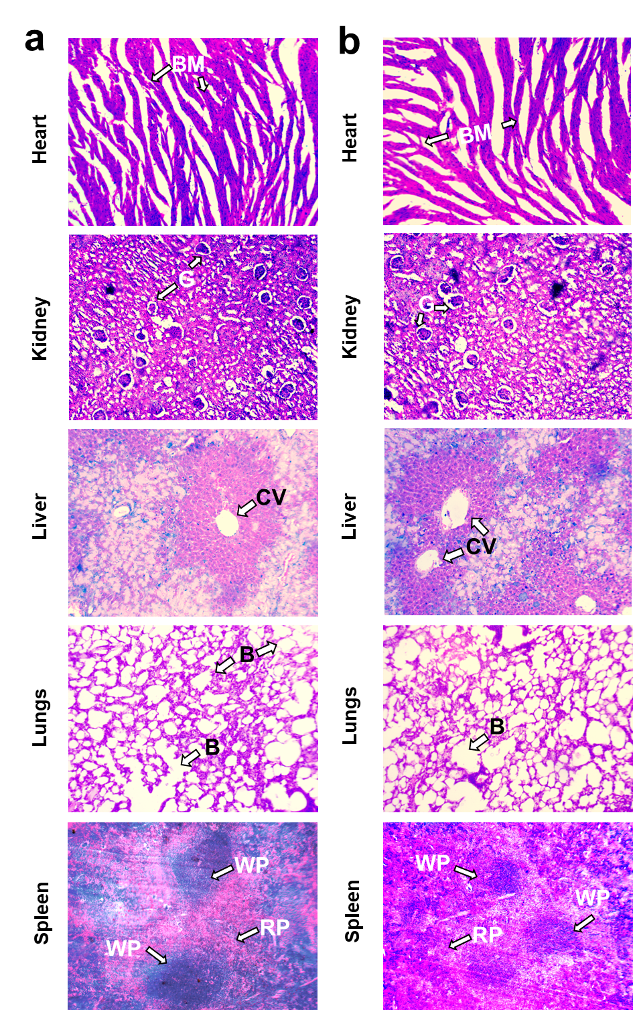
Fig. S16 Histopathology study of heart, kidney, liver, lungs, and spleen of (a) Vehicle control C57BL/6 group and (b) PLFEE (550 mg/kg) treated C57BL/6 group at 10X magnification for acute oral toxicity assessment. BM: branching myocytes; G: glomerulus; CV: central vein; B: bronchioles: RP: red pulp; and WP: white pulp

Histopathology of normal skin, skin over tumor, and tumor
The histopathological results of skin, skin over the tumor, and tumor tissues from C57BL/6 mice of various groups were represented in Fig. S17. The histology of healthy skin (Fig. S17a) showed distinct layers of epidermis, dermis, and hypodermis, representing the normal architecture. In contrast, the histology of skin over melanoma (Fig. S17b) showed ruptured architecture with the presence of live tumor cells. The tumor control group showed a higher population of live tumor cells (LTC) (Fig. S17c). In contrast, all the treatment groups significantly reduced LTC population (Fig. S17d-S17h). The group administered with standardized PLFEE showed few necrotic regions (NR) with a reduction of LTC. The SD-treated group showed a marked reduction of LTC with a relatively higher population of NR. The DTIC alone showed a pronounced decrease in the LTC population as an antineoplastic drug. Further, a marked reduction of the LTC was observed in the case of the “DTIC + PLFEE” group with a relatively higher NR. The “DTIC + SD” group showed a very low population of LTC and more NR compared to the “DTIC + PLFEE” group. The overall result reflected the higher antitumor activity of SD compared to the neat PLFEE. Further, SD as an adjuvant medication will enhance the activity of DTIC for melanoma therapy.

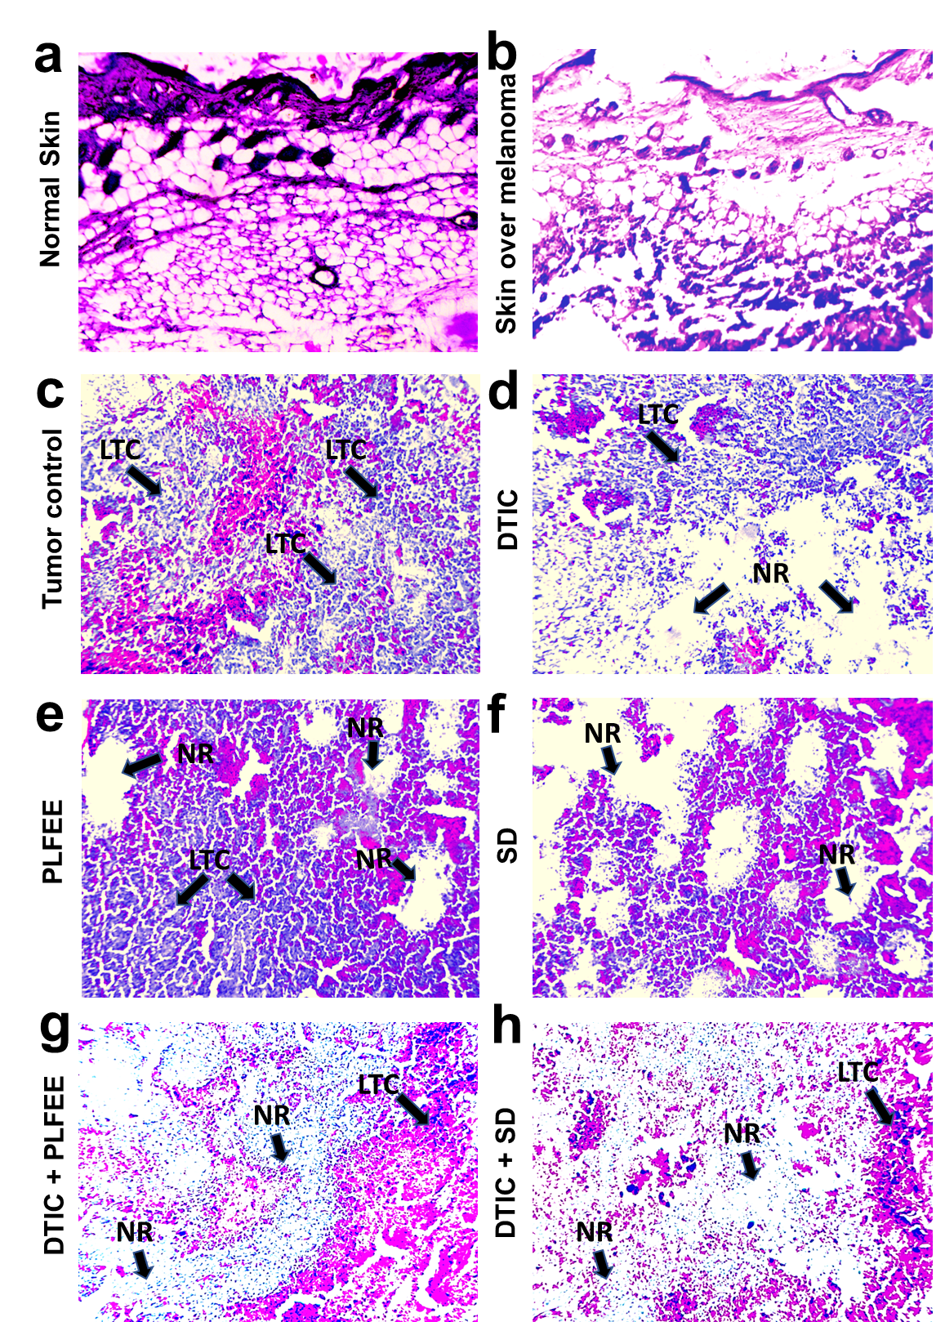
Fig. S17 Histopathology study of skin and melanoma tumor: histology of (a) normal skin, (b) skin over melanoma tumor, (c) tumor control, (d) tumor of DTIC treated, (e) tumor of PLFEE treated, (f) tumor of SD treated, (g) tumor of DTIC + PLFEE treated, and (h) tumor of DTIC + SD treated group. NR: necrotic region; LTC: live tumor cell
References
1. Guideline IHT Validation of analytical procedures: text and methodology Q2 (R1). In: International conference on harmonization of technical requirements for registration of pharmaceuticals for human use, 2005. Geneva Switzerland,
2. Zhu Y, Yu J, Zhou G, Gu Z, Adu-Frimpong M, Deng W, Yu J, Xu X (2020) Piperine fast disintegrating tablets comprising sustained-release matrix pellets with enhanced bioavailability: formulation, in vitro and in vivo evaluation. Pharm Dev Technol 25 (5):617-624
3. Bioanalytical Method Validation Guidance for Industry (2018).
4. Acute Oral Toxicity (OECD Test Guideline 425) Statistical Programme (AOT 425 StatPgm). Version: 1.0, 2001. http://www.oecd.org/oecd/pages/home/displaygeneral/0,3380,EN-document-524-nodirectorate-no-24-6775-8,FF.html.
5. Kurangi B, Jalalpure S, Jagwani S (2019) A validated stability-indicating HPLC method for simultaneous estimation of resveratrol and piperine in cubosome and human plasma. J Chromatogr B 1122:39-48
6. Sarnaizul E, Borjihan G, Baigude H (2013) LC analysis and pharmacokinetic study of synthetic piperlonguminine in rat plasma after oral administration. Biomed Chromatogr 27 (7):821-824
7. Basniwal PK, Jain D (2013) ICH guideline practice: application of novel RP-HPLC-DAD method for determination of olopatadine hydrochloride in pharmaceutical products. J Anal Sci Technol 4 (1):1-6
8. Abdelwahab NS, Abdelrahman MM (2015) Stability indicating RP-HPLC method for the determination of flubendazole in pharmaceutical dosage forms. RSC Adv 5 (15):10927-10935
9. Liu J, Bi Y, Luo R, Wu X (2011) Simultaneous UFLC–ESI–MS/MS determination of piperine and piperlonguminine in rat plasma after oral administration of alkaloids from Piper longum L.: Application to pharmacokinetic studies in rats. J Chromatogr B 879 (27):2885-2890
10. Li C, Wang Q, Ren T, Zhang Y, Lam CWK, Chow MS, Zuo Z (2016) Non-linear pharmacokinetics of piperine and its herb-drug interactions with docetaxel in Sprague-Dawley rats. J Pharm Biomed Anal 128:286-293
11. Jain D, Basniwal PKJjoas, technology (2013) ICH guideline practice: application of validated RP-HPLC-DAD method for determination of tapentadol hydrochloride in dosage form. 4 (1):1-7
12. Das B, Pal A, Pal R, Bodo V, Newme D, Chakraborty S, Sengupta M (2022) Arsenic Nanoparticles are Effective in Reducing 3-Methylcholanthrene Induced Carcinogenesis in Murine Fibrosarcoma by Promoting Anti-tumorigenic Inflammation. BioNanoScience 12 (2):555-570

