Supporting Information for:
Design, Molecular Modelling and Synthesis of Novel Benzothiazole Derivatives as BCL-2 inhibitors
Hoda S. Ismail, Amira Khalil, Rabah A. Taha, Deena S. Lasheen
Dalal A. Abou El Ella

- Synthetic Procedure of key intermediates……………………………………………………………………………………………………………..…2
- Docking poses and energies of key products…………………………………………………………………………………………………………..14
- Spectral Data of final compounds……………………………………………………………………………………………………………………..……18
- References ……………………………………………………………………………………………………………………………………………………..…….56

Synthetic Procedure of key intermediates
Ethyl 4-fluoro-3-nitrobenzoate (1):[1]

Conc. HNO₃ (8 mL) was added dropwise to a mixture of ethyl 4-fluorobenzoate (8.94 g; 53.7 mmol) in conc. H₂SO₄ (8 mL) at 0 °C. After stirring for 2 hours at 0 °C, the mixture was poured onto ice and extracted with EtOAc (3 X 50 mL). The organic layers were combined, washed with saturated NaHCO₃ solution (100 ml), dried over anhydrous Na₂SO₄ and concentrated under reduced pressure to give ethyl 4-fluoro-3-nitrobenzoate (1) as a pale yellow solid with a yield of (10.77g, 95%); m.p. 42-44 °C as reported [1].

Ethyl 3-nitro-4-(phenethylamino)benzoate (2):
Phenethylamine (2.3 mL; 17.8 mmol) was added to a stirred solution of ethyl 4-fluoro-3-nitrobenzoate (1) (3.60 g, 16.9 mmol) and K₂CO₃ (4.67 g, 33.8 mmol) in 50 mL DMF. After stirring for 4 hours at the mixture was poured onto ice water, stirred for 10 minutes, filtered and dried to give ethyl 3-nitro-4-(phenethylamino)benzoate (2) as yellow solid (4.99 g ,94%); m.p. 92-94°C; (M.wt.: 314.34, C₁₇H₁₈N₂O₄); ¹H-NMR (400 MHz, DMSO-d₆) δ 10.3 (s, 1H, NH D₂O exchangeable), 8.71 (1H, s, Ar-H), 8.25 (1H, d, J = 8.4 Hz, Ar-H), 7.28 (2H, d, J =7.8 Hz, Ar-H), 7.2 (1H, t, J= 7.7 Hz, Ar-H), 7.09 (2H, d, J= 7.8, Ar-H), 6.82 (1H, d, J = 8.4 Hz, Ar-H), 4 .45 (2H, q, J = 7.1 Hz, CH₃CH₂O-), 3.88 (2H, t, J = 5.7 Hz, -N-CH₂-CH₂-), 3.28 (2H, t, J = 5.7 Hz, -CH₂-Ar), 1.44 (3H, t, J = 7.2 Hz, CH₃CH₂O-).

3-Nitro-4-(phenethylamino)benzoic acid (3):
Ethyl 3-nitro-4-(phenethylamino)benzoate (2) (2.16 g, 6.9 mmol) was added to a solution of LiOH.H₂O (0.579 g, 13.8 mmol) in ethanol (50%, 70mL).The mixture was heated under reflux for 2 hours. The resulting solution was allowed to cool to room temperature then added to 10% HCl/ice (100 mL) with continued stirring. The resulting solid was filtered, washed with water and recrystallized from THF/water to afford 3-nitro-4-(phenethylamino)benzoic acid (3) as yellow solid (1.86 g ,94%); m.p. 198-200°C; (M.wt.: 286.28, C₁₅H₁₄N₂O₄); ¹H NMR (400 MHz, DMSO-d₆) δ 12.20 (s, 1H, COOH, D₂O exchangeable), 10.3 (s, 1H, NH D₂O exchangeable), 8.69 (1H, s, Ar-H), 7.43 (1H, d, J = 8.4 Hz, Ar-H), 7.28 (2H, d, J =7.8 Hz, Ar-H), 7.2 (1H, t, J= 7.7 Hz, Ar-H), 7.09 (2H, d, J= 7.8, Ar-H), 6.92 (1H, d, J = 8.4 Hz, Ar-H) 3.88 (2H, t, J = 5.7 Hz, -N-CH₂-CH₂-), 3.18 (2H, t, J = 5.7 Hz, -CH₂-Ar).

5.1.2.1.2. Scheme 1b
1-(Substituted-benzyloxy)-4-nitrobenzene (4a-f) [2, 3]:

General Procedure:
A mixture of 4-nitrophenol (0.4 g, 2.88 mmol), the respective substituted benzyl bromide (viz; 3-fluorobenzyl bromide, 3-chlorobenzyl bromide, 4-chlorobenzyl bromide, 4-bromobenzyl bromide, 4-methylbenzyl bromide and 4-trifluoromethyl benzyl bromide) (2.88 mmol) and anhydrous K₂CO₃ (0.66 g, 4.78 mmol) in dry DMF (10 mL) was heated at 80 ºC for 24 hours. After cooling, the reaction mixture was poured into ice/water (100 mL). The precipitated solid was filtered, washed with water, and then recrystallized from ethanol/water to afford the titled compounds (4a-f) [2, 3].
1-((3-Fluorobenzyl)oxy)-4-nitrobenzene (4a):
The titled compound was obtained as yellow solid (0.69g, 97%); m.p. 104-105°C (as reported).
1-((3-Chlorobenzyl)oxy)-4-nitrobenzene (4b):[2]
The titled compound was obtained as off-white solid (0.74g, 98%); m.p. 98-100°C (as reported).[2]
1-((4-Chlorobenzyl)oxy)-4-nitrobenzene (4c):[4]
The titled compound was obtained as white solid (0.73g, 97%); m.p. 114-115°C (as reported).[4]
1-((4-Bromobenzyl)oxy)-4-nitrobenzene (4d):[5]
The titled compound was obtained as off-white solid (0.84g, 95%); m.p. 116-118°C (as reported).[5]

1-((4-Methylbenzyl)oxy)-4-nitrobenzene (4e) [3]
The titled compound was obtained as off-white solid (0.69g, 99%); m.p. 108-109°C (as reported).[3]

1-((4-Trifluoromethylbenzyl)oxy)-4-nitrobenzene (4f):
The titled compound was obtained as off-white solid (0.86g, 100%); m.p. 74-76°C; (M.wt.= 297.23, C₁₄H₁₀F₃NO₃); ¹H NMR (400 MHz, DMSO-d₆) δ 7.43(d, J = 8.3 Hz, 2H, Ar-H), 7.28 (d, J = 8.3 Hz, 2H, Ar-H), 6.77 (d, J = 6.6 Hz, 2H, Ar–H), 6.62 (d, 𝐽 = 6.6 Hz, 2H, Ar–H), 5.22 (s, 2H, O-CH₂).

4-((Substituted-benzyl)oxy)aniline (5a-f):[6]
General Procedure:
A mixture of the relevant nitro derivative (4a-f) (3 mmol), reduced iron powder (0.5 g, 9 mmol) and NH₄Cl (1.44 g, 27 mmol) in 70% EtOH/H₂O (20 mL) was heated at reflux temperature (70 ºC) for 2 hours. The reaction mixture was filtered over a Celite pad to remove the insoluble iron oxides. The filtrate was evaporated under vacuum, EtOAc (50 mL) was added to the residue, and then the resulting suspension was filtered to remove the inorganic salts. The filtrate was dried over anhydrous Na₂SO₄ and evaporated under vacuum to afford the crystals of the titled compounds (5a-f) which were recrystallized from ethyl acetate/petroleum ether.

4-((3-Fluorobenzyl)oxy)aniline (5a):
The titled compound was obtained as brown crystals (0.65g, 85%); m.p. 84-86°C (as reported).
4-((3-Chlorobenzyl)oxy)aniline (5b)
The titled compound was obtained as brown crystals (0.68g, 97%); m.p. 60-62°C (as reported).

4-((4-Chlorobenzyl)oxy)aniline (5c):
The titled compound was obtained as brown crystals (0.60g, 84%); m.p. 108-109°C (as reported).
4-((4-Bromobenzyl)oxy)aniline (5d):
The titled compound was obtained as brown crystals (0.71g, 85%); m.p. 110-112°C (as reported).

4-((4-Methylbenzyl)oxy)aniline (5e):
The titled compound was obtained as brown crystals (0.41g, 64%); m.p. 105-106°C (as reported).

4-((4-Triflouromethylbenzyl)oxy)aniline (5f):
The titled compound was obtained as brown crystals (0.52g, 65%); m.p. 108-110°C,( M.wt. = 267.25, C₁₄H₁₂F₃NO); ¹H NMR (400 MHz, DMSO-d₆) δ 7.43(d, J = 8.3 Hz, 2H, Ar-H), 7.28 (d, J = 8.3 Hz, 2H, Ar-H), 6.77 (d, J = 6.6 Hz, 2H, Ar–H), 6.62 (d, 𝐽 = 6.6 Hz, 2H, Ar–H), 5.22 (s, 2H, O-CH₂). 4.62 (s, 2H, NH D₂O exchangeable).

5.1.2.1.1. Scheme 1c
4-Nitro-1-(substituted-phenoxy)benzene (6a,b):[7]

General Procedure:
A mixture of 1-fluoro-4-nitrobenzene (0.4 g, 2.85 mmol), the respective substituted phenol (viz; 4-bromophenol, 4-chloro-3-fluoro phenol) (2.76 mmol) and anhydrous K₂CO₃ (1.9 g, 13.8 mmol) in dry DMF (10 mL) was heated at 50 ºC for 24 hours. After cooling, the reaction mixture was poured onto ice/water (100 mL). The precipitated solid was filtered, washed with water, and dried to afford the titled compounds (6a,b).
4-Nitro-1-(4-bromophenoxy)benzene (6a):[8]
The titled compound was obtained as off-white powder (0.84 g, 100%); m.p. 96-98 ºC (as reported).[8]
4-Nitro-1-(3-fluoro-4-chlorophenoxy)benzene (6b):
The titled compound was obtained as off-white powder (0.72 g, 94%); m.p.74-76 ºC (as reported).

4-(Substituted-phenoxy)aniline (7a,b):
General Procedure:
A mixture of the relevant nitro derivative (6a,b) (1.5 mmol) and stannous chloride dihydrate (1.69 g, 7.5 mmol) in EtOAc (20 mL) was heated at reflux temperature (80 ºC) for 24 hours. After cooling, ice-cold water (100 mL) was added to the reaction mixture and then was separated, where the organic layer was washed multiple times with aqueous 10% NaOH (20 mL) then washed with brine (50 mL). The organic layer was separated, dried over anhydrous Na₂SO₄ and evaporated under vacuum to afford crystals of the titled compounds (7a,b).

4-(4-Bromophenoxy)aniline (7a):
The titled compound was obtained as brown crystals (0.36 g, 92%); m.p. 76-78ºC (as reported).

4-(3-Fluoro-4-chlorophenoxy)aniline (7b):
The titled compound was obtained as brown crystals (0.32 g, 90%); m.p. 71-72ºC (as reported).

5.1.2.2. Scheme 2:
Ethyl 2-aminobenzo[d]thiazole-6-carboxylate (8): [9]
A stirred solution of ethyl 4-aminobenzoate (benzocaine) (1.73 g, 10.5 mmol) and potassium thiocyanate (3.06 g, 31.5 mmol) in glacial acetic acid (20 mL) was cooled to 0 ºC. To this solution bromine (99%) (0.54 mL, 10.5 mmol) was added dropwise at such a rate to keep the temperature below 10 °C throughout the addition. Stirring was continued for an additional 3 hours at room temperature and the separated salt was filtered, washed with acetic acid and dried, then the residue was dissolved in hot water and neutralized with aqueous ammonia solution (25%, 50 mL), the precipitated solid was filtered, washed with water and dried, recrystallized from ethanol/water to afford the titled compound (8) as white crystals (2.10 g, 90%); m.p. 241-242ºC (as reported).[9]

Docking poses and energies of key products

Table S1. 2D interactions, C-Docker docking scores, and binding interactions of active compounds with > 50 % of BCL-2 inhibition
ID | 2D Interaction Diagram | C-Docker Interaction Energy & binding interactions
8d | 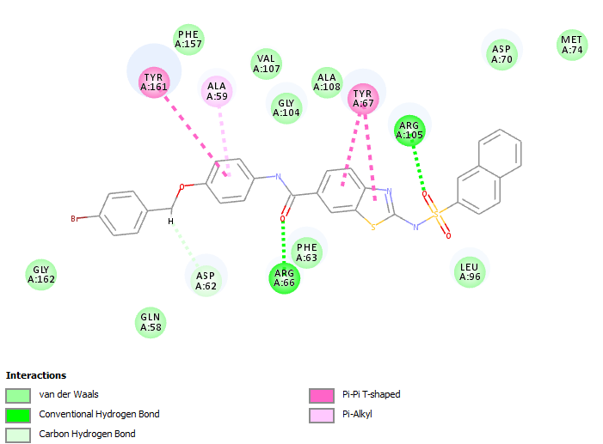 | -53.08  HBA Arg 66  HBA Arg 105  Pi-Pi Tyr 67  Pi-Pi Tyr 161
13b | 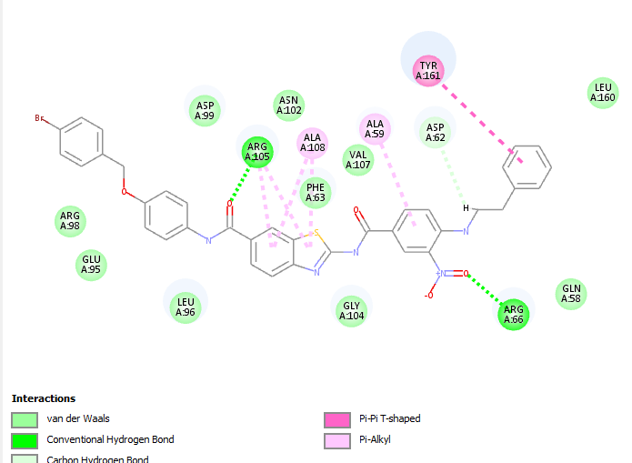 | -55.83  HBA Arg 66  HBA Arg 105  Pi-Pi Tyr 161
13c | 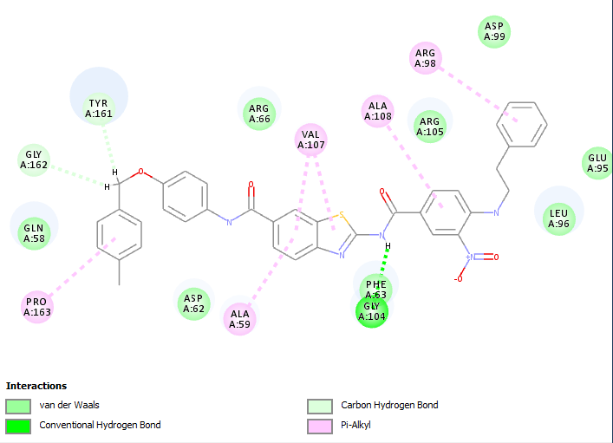 | -58.05  HBA Gly 104  Pi-Alkyl Ala 59  Pi-Alkyl Arg 98  Pi-Alkyl Val 107  Pi-Alkyl Ala 108  Pi-Alkyl Pro 163
13d | 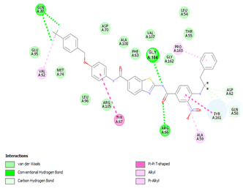 | -59.15  HBA Gly 104  Pi-Pi Tyr 67  Pi-Pi Tyr 161  Pi- Pi-Alkyl Ala 59  Pi-Alkyl Val 92  Pi-Alkyl Pro 163
17f | 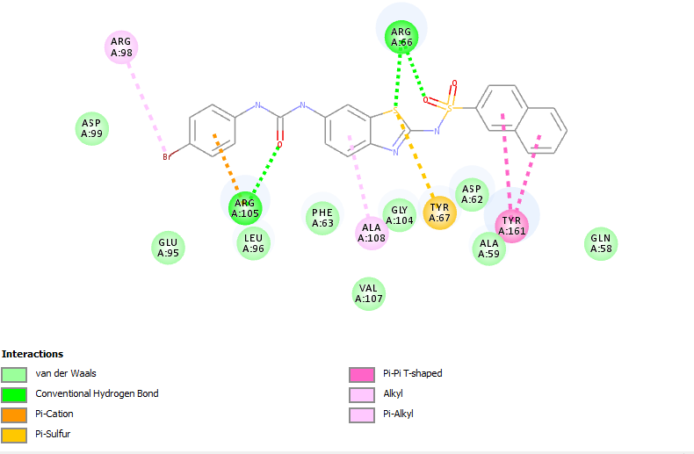 | -41.69  HBA Arg 66  HBA Arg 105  Pi-Pi Tyr 161  Pi- Sulfur Tyr 67  Pi- Alkyl Arg 98  Pi- Alkyl Ala 108

Spectral Data of final compounds

N-(6-(4-Phenylpiperazine-1-carbonyl)benzo[d]thiazol-2-yl)naphthalene-2-sulfonamide (7a):

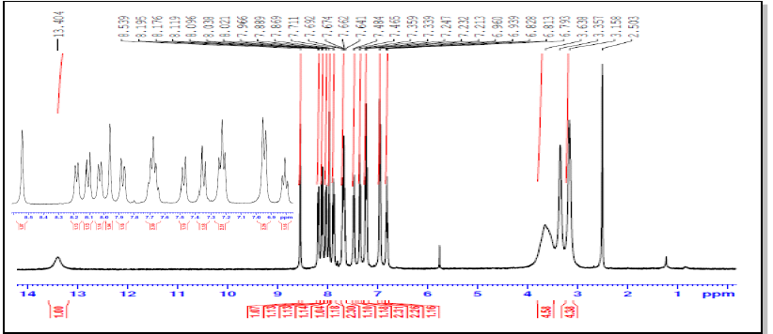
Figure S1: ¹H-NMR spectrum for compound 7a
N-(6-(4-(2-Fluorophenyl)piperazine-1-carbonyl)benzo[d]thiazol-2-yl)naphthalene-2-sulfonamide (7b):
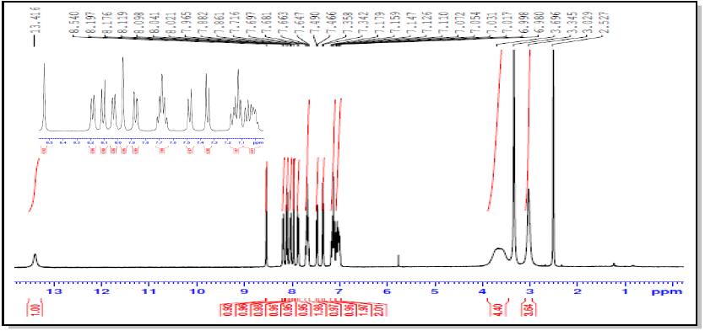
Figure S2: ¹H-NMR spectrum for compound 7b
N-(6-(4-(2-Methoxyphenyl)piperazine-1-carbonyl)benzo[d]thiazol-2-yl)naphthalene-2-sulfonamide (7c):
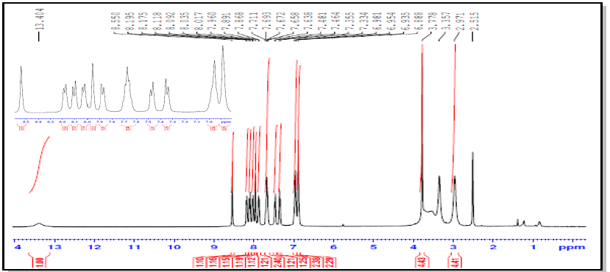
Figure S3: ¹H-NMR spectrum for compound 7c
N-(6-(4-(4-Chlorophenyl)piperazine-1-carbonyl)benzo[d]thiazol-2-yl)naphthalene-2-sulfonamide (7d):
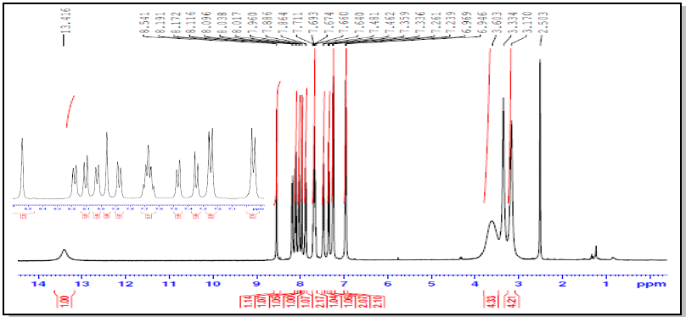
Figure S4: ¹H-NMR spectrum for compound 7d

N-(6-(4-(3,4-Dichlorophenyl)piperazine-1-carbonyl)benzo[d]thiazol-2-yl)naphthalene-2-sulfonamide (7e):

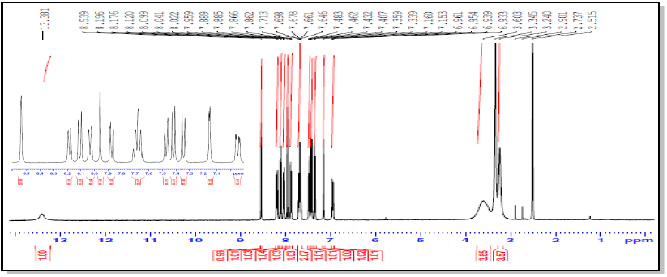
Figure S5: ¹H-NMR spectrum for compound 7e

N-(6-(4-Benzhydrylpiperazine-1-carbonyl)benzo[d]thiazol-2-yl)naphthalene-2-sulfonamide (7f):
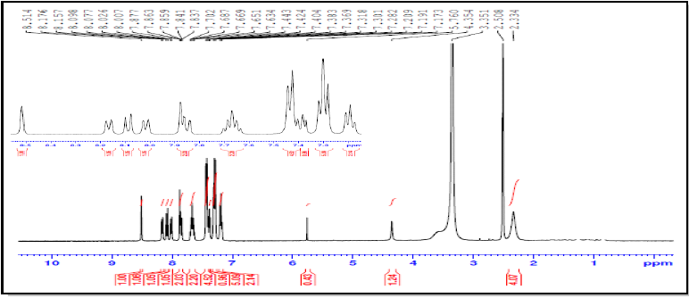
Figure S6: ¹H-NMR spectrum for compound 7f

(E)-N-(6-(4-Cinnamylpiperazine-1-carbonyl)benzo[d]thiazol-2-yl)naphthalene-2-sulfonamide( 7g):

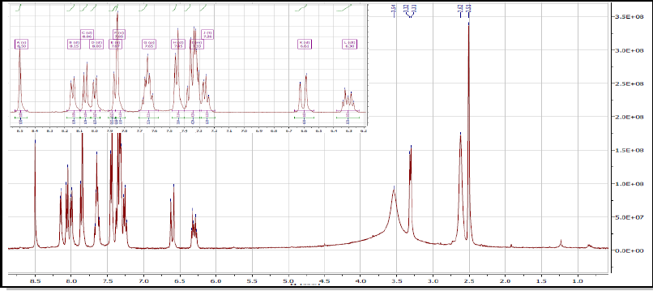
Figure S7: ¹H-NMR spectrum for compound 7g
N-(6-(4-(Benzo[d]dioxol-5-ylmethyl)piperazine-1-carbonyl)benzo[d]thiazol-2-yl)naphthalene-2-sulfonamide (7h):

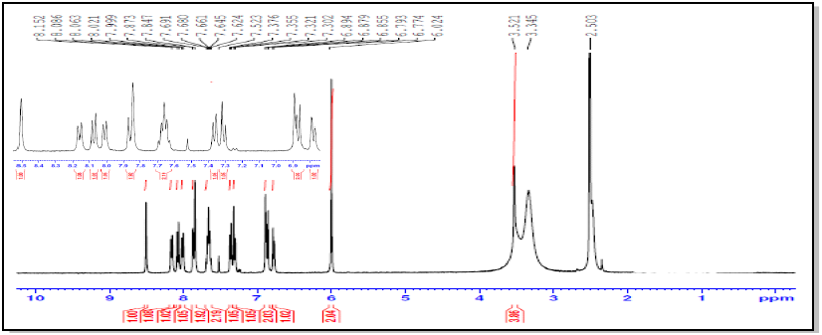
Figure S8: ¹H-NMR spectrum for compound 7h
N-(6-(4-(Tetrahydrofuran-2-carbonyl)piperazine-1-carbonyl)benzo[d]thiazol-2-yl)naphthalene-2-sulfonamide (7i) :
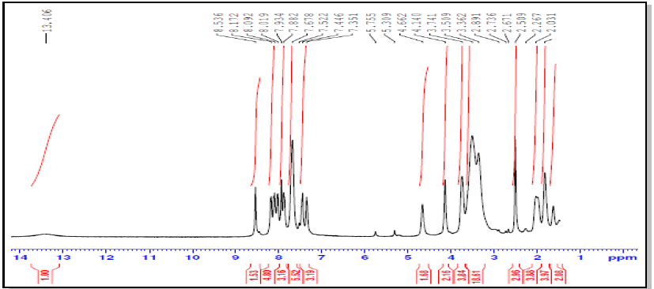
Figure S9: ¹H-NMR spectrum for compound 7i
N-(4-((3-Fluorobenzyl)oxy)phenyl)-2-(naphthalene-2-sulfonamido)benzo[d]thiazole-6-carboxamide (8a):
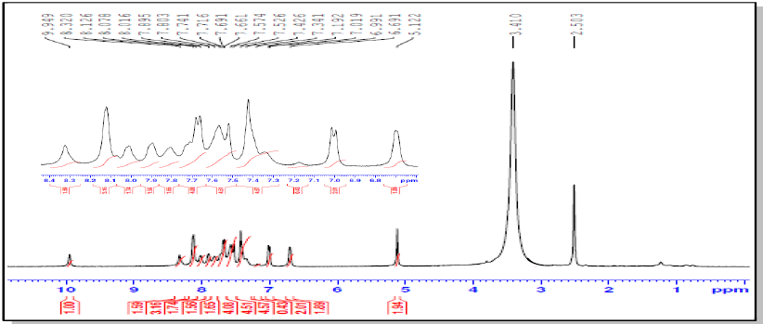
Figure S10: ¹H-NMR spectrum for compound 8a
N-(4-((3-Chlorobenzyl)oxy)phenyl)-2-(naphthalene-2-sulfonamido)benzo[d] thiazole-6-carboxamide (8b):
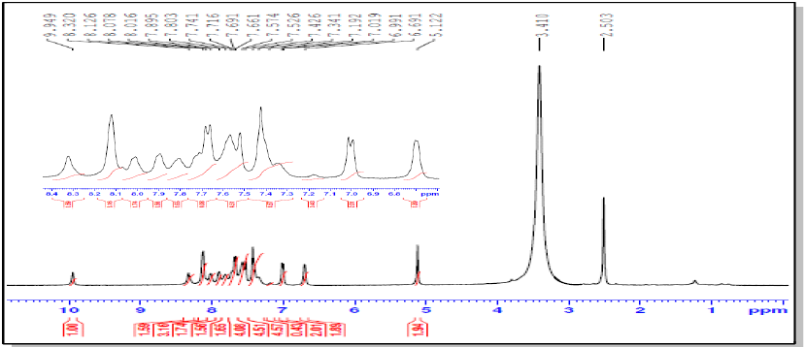
Figure S11: ¹H-NMR spectrum for compound 8b
N-(4-((4-Chlorobenzyl)oxy)phenyl)-2-(naphthalene-2-sulfonamido)benzo[d] thiazole-6-carboxamide (8c):
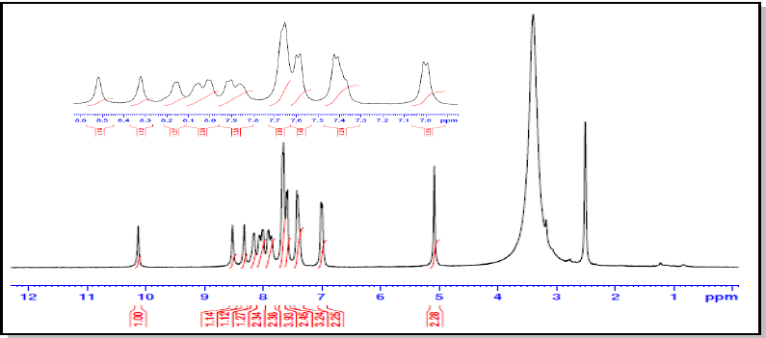
Figure S12: ¹H-NMR spectrum for compound 8c
N-(4-((4-Bromobenzyl)oxy)phenyl)-2-(naphthalene-2-sulfonamido)benzo[d] thiazole-6-carboxamide (8d):
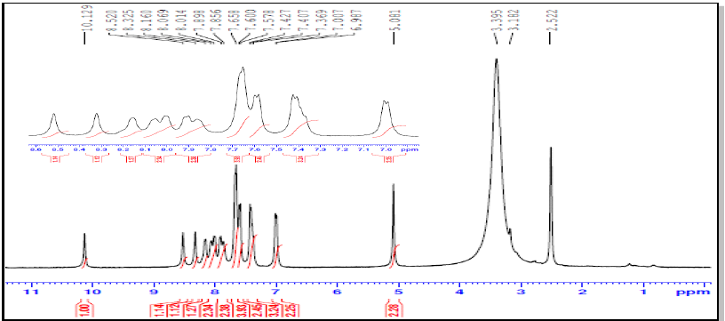
Figure S13: ¹H-NMR spectrum for compound 8d
N-(4-((4-Methylbenzyl)oxy)phenyl)-2-(naphthalene-2-sulfonamido)benzo[d] thiazole-6-carboxamide (8e):
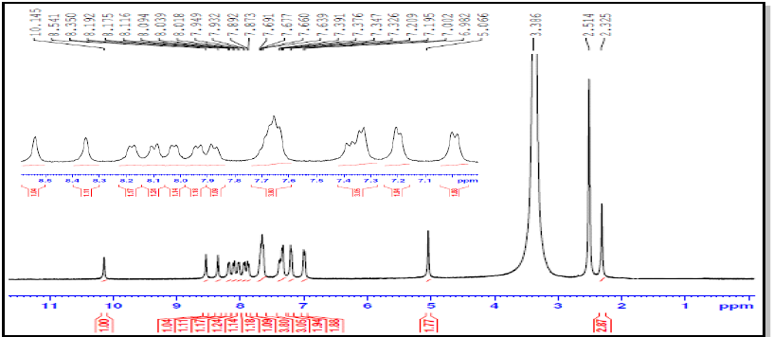
Figure S14: ¹H-NMR spectrum for compound 8e
N-(4-((4-Trifluormethylbenzyl)oxy)phenyl)-2-(naphthalene-2-sulfonamido)benzo [d]thiazole-6-carboxamide )8f):
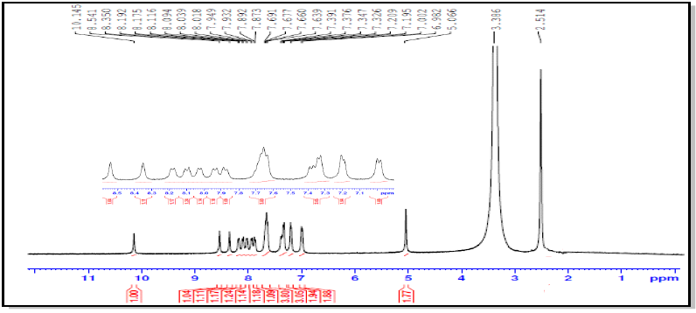
Figure S15: ¹H-NMR spectrum for compound 8f
N-(4-(4-Chloro-3-fluorophenoxy)phenyl)-2-(naphthalene-2-sulfonamido)benzo[d] thiazole-6-carboxamide (9a):
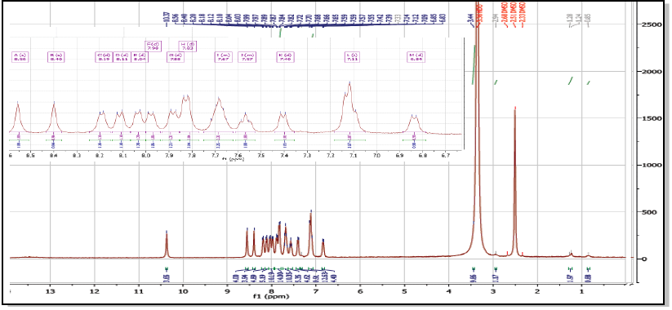
Figure S16: ¹H-NMR spectrum for compound 9a
N-(4-(4-Bromophenoxy)phenyl)-2-(naphthalene-2-sulfonamido)benzo[d]thiazole-6-carboxamide (9b):
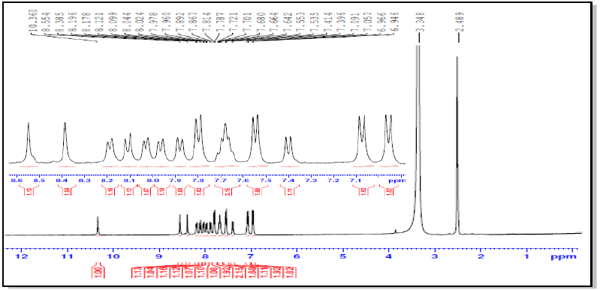
Figure S17: ¹H-NMR spectrum for compound 9b
N-(6-(4-(2-Methoxyphenyl) piperazine-1-carbonyl) benzo[d]thiazol-2-yl)-3-nitro-4-(phenethylamino)benzamide (12a):
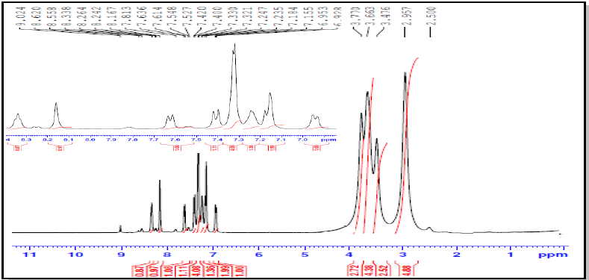

Figure S18: ¹H-NMR spectrum for compound 12a
N-(6-(4-(3,4-Dichlorophenyl)piperazine-1-carbonyl)benzo[d]thiazol-2-yl)-3-nitro-4-(phenethylamino)benzamide (12b):
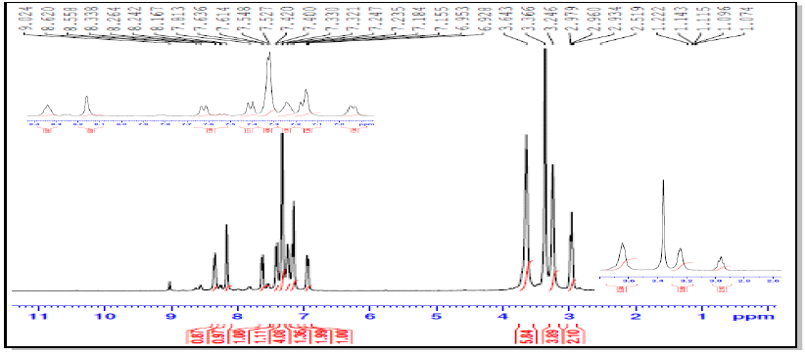
Figure S19: ¹H-NMR spectrum for compound 12b
N-(6-(4-Benzhydrylpiperazine-1-carbonyl)benzo[d]thiazol-2-yl)-3-nitro-(phenethylamino)benzamide (12c):

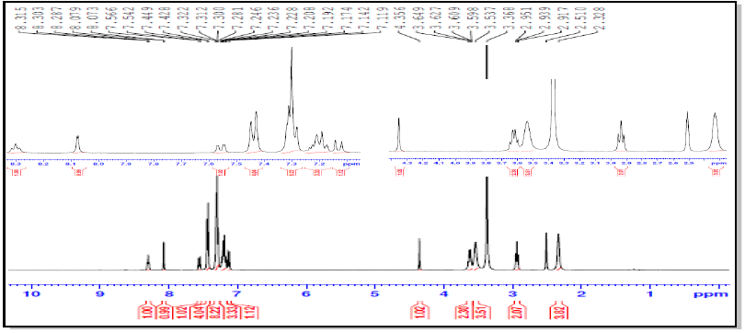
Figure S20: ¹H-NMR spectrum for compound 12c
(E)-N-(6-(4-Cinnamylpiperazine-1-carbonyl)benzo[d]thiazol-2-yl)-3-nitro-4-(phenethylamino)benzamide (12d):
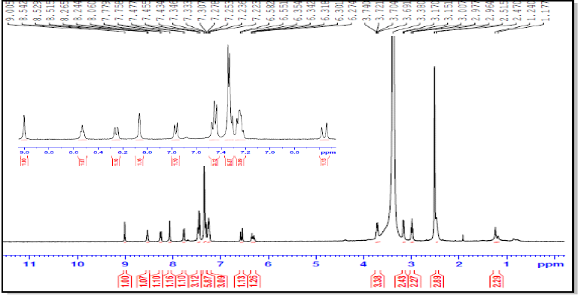

Figure S21: ¹H-NMR spectrum for compound 12d
N-(4-((3-Chlorobenzyl)oxy)phenyl)-2-(3-nitro-4-(phenethylamino)benzamido) benzo[d]thiazole-6-carboxamide (13a):
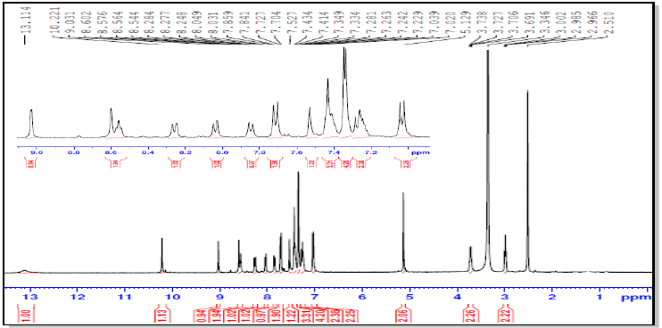

Figure S22: ¹H-NMR spectrum for compound 13a
N-(4-((4-Bromobenzyl)oxy)phenyl)-2-(3-nitro-4-(phenethylamino)benzamido) benzo[d]thiazole-6-carboxamide (13b):
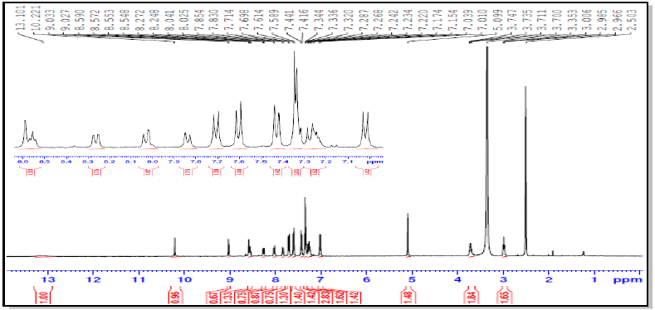
Figure S23: ¹H-NMR spectrum for compound 13b
N-(4-((4-Methylbenzyl)oxy)phenyl)-2-(3-nitro-4-(phenethylamino)benzamido)benzo[d]thiazole-6-carboxamide (13c):
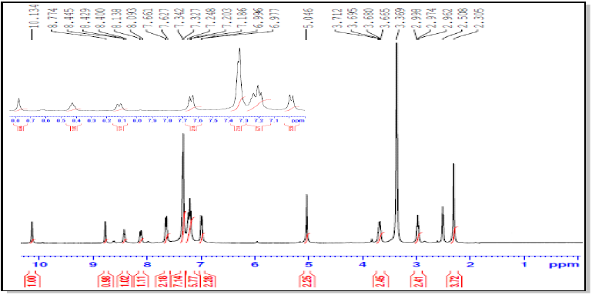
Figure S24: ¹H-NMR spectrum for compound 13c
N-(4-((4-Trifluoromethylbenzyl)oxy)phenyl)-2-(3-nitro-4-(phenethylamino)benzamido)benzo[d]thiazole-6-carboxamide (13d):
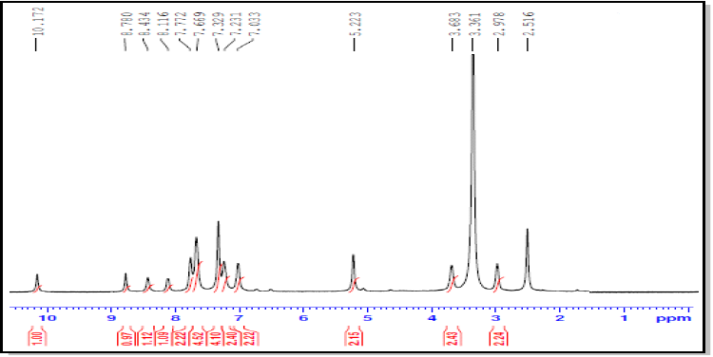
Figure S25: ¹H-NMR spectrum for compound 13d
N-(4-(4-Chloro-3-fluorophenoxy)phenyl)-2-(3-nitro-4-(phenethylamino) benzamido)benzo[d]thiazole-6-carboxamide (14a):
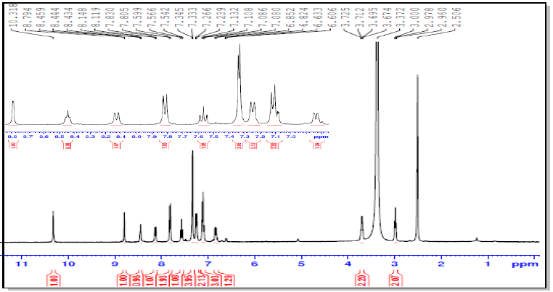
Figure S26: ¹H-NMR spectrum for compound 14a
N-(4-(4-Bromophenoxy)phenyl)-2-(3-nitro-4-(phenethylamino)benzamido benzo[d]thiazole-6-carboxamide (14b):
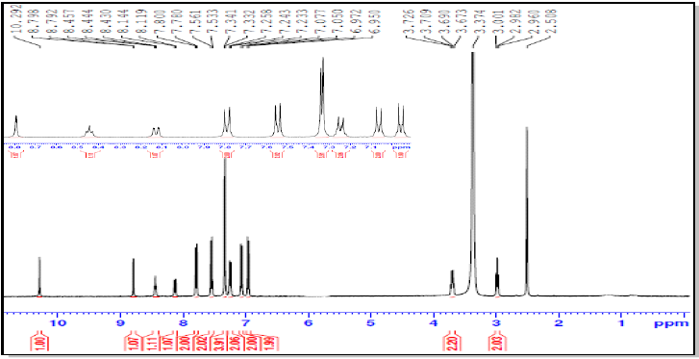

Figure S27: ¹H-NMR spectrum for compound 14b
N-(6-(3-Phenylureido)benzo[d]thiazol-2-yl)naphthalene-2-sulfonamide(17a):
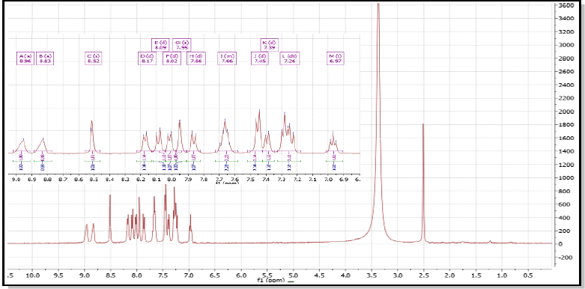

Figure S28: ¹H-NMR spectrum for compound 17a
N-(6-(3-(3-Chlorophenyl)ureido)benzo[d]thiazol-2-yl)naphthalene-2-sulfonamide (17b):
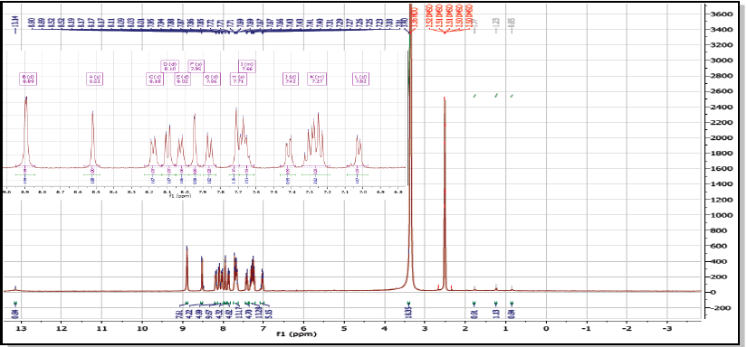

Figure S29: ¹H-NMR spectrum for compound 17b
N-(6-(3-(3-Bromophenyl)ureido)benzo[d]thiazol-2-yl)naphthalene-2-sulfonamide (17c):
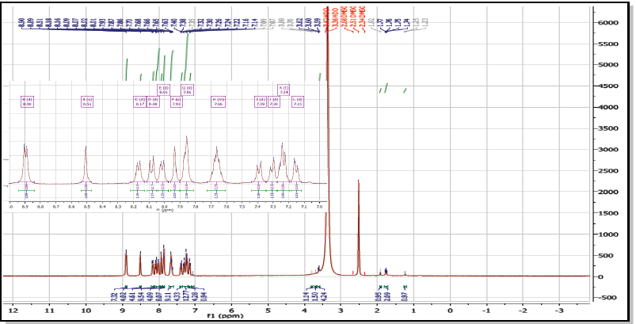
Figure S30: ¹H-NMR spectrum for compound 17c
N-(6-(3-(3-Methoxyphenyl)ureido)benzo[d]thiazol-2-yl)naphthalene-2-sulfonamide (17d):
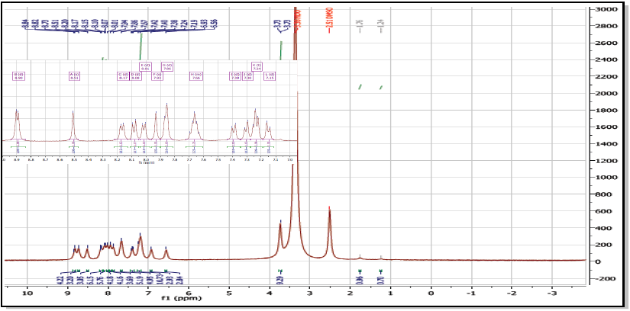
Figure S31: ¹H-NMR spectrum for compound 17d
N-(6-(3-(m-Tolyl)ureido)benzo[d]thiazol-2-yl)naphthalene-2-sulfonamide (17e):
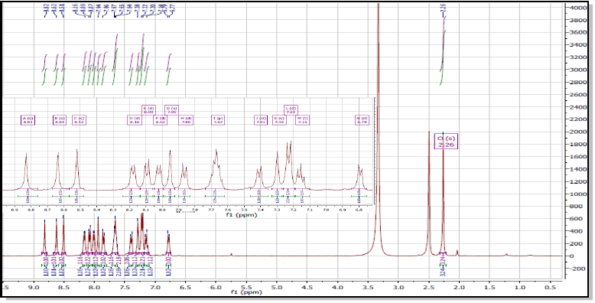

Figure S32: ¹H-NMR spectrum for compound 17e
N-(6-(3-(4-Bromophenyl)ureido)benzo[d]thiazol-2-yl)naphthalene-2-sulfonamide (17f) :
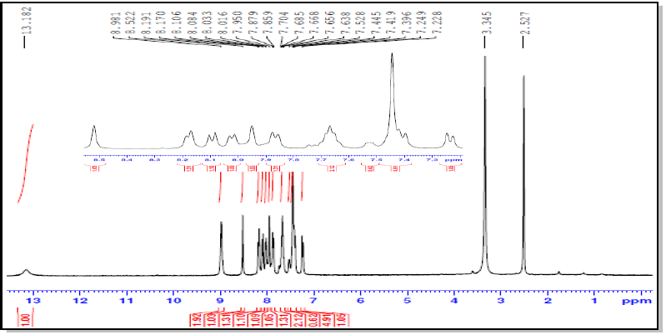
Figure S33: ¹H-NMR spectrum for compound 17f
N-(6-(3-(4-Chloro-3-(trifluoromethyl)phenyl)ureido)benzo[d]thiazol-2-yl)naphthalene-2-sulfonamide (17g):
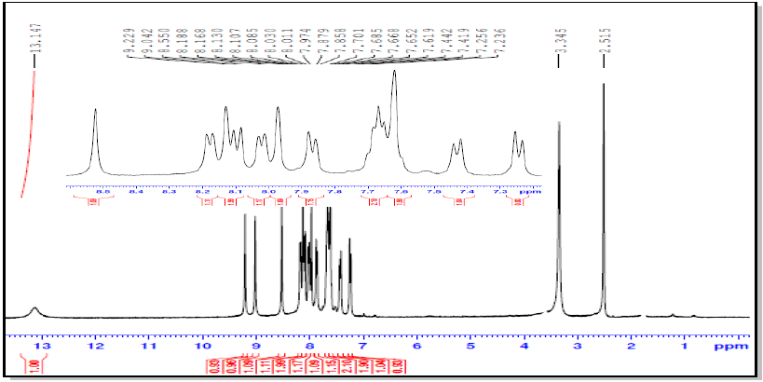
Figure S34: ¹H-NMR spectrum for compound 17g
N-(6-(3-(3,4-Dichlorophenyl)ureido)benzo[d]thiazol-2-yl)naphthalene-2-sulfonamide (17h):
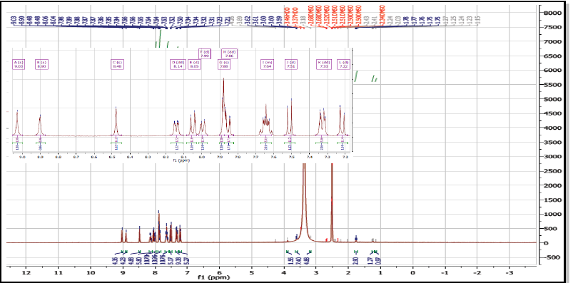

Figure S35: ¹H-NMR spectrum for compound 17h
N-(6-(3-(4-Chloro-2-methylphenyl)ureido)benzo[d]thiazol-2-yl)naphthalene-2-sulfonamide (17i):

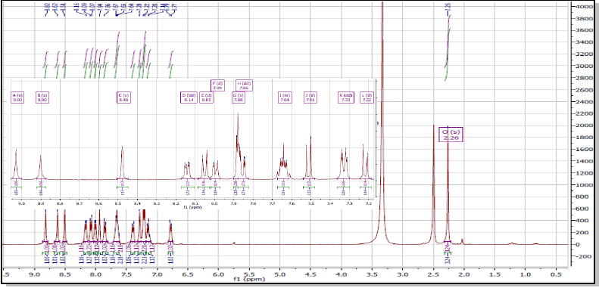
Figure S36: ¹H-NMR spectrum for compound 17i
N-(6-(3-(3-Chloro-4-methylphenyl)ureido)benzo[d]thiazol-2-yl)naphthalene-2-sulfonamide (17j):

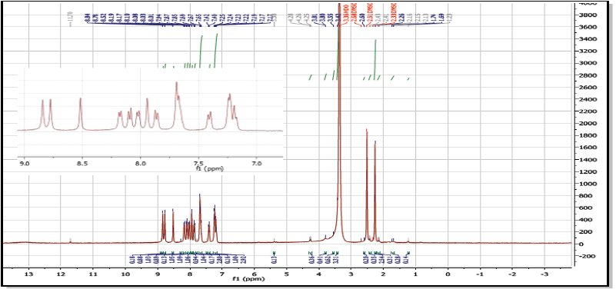

Figure S37: ¹H-NMR spectrum for compound 17j

References
1. Sydnes, M.O. and M. Isobe, Synthesis of the second generation photoaffinity probes of tautomycin. Tetrahedron, 2007. 63(12): p. 2593-2603.
2. Gates, K.S. and R.B. Silverman, 5-(Aminomethyl)-3-aryl-2-oxazolidinones. A novel class of mechanism-based inactivators of monoamine oxidase B. Journal of the American Chemical Society, 1990. 112(25): p. 9364-9372.
3. Defrenza, I., et al., 1,3‐Benzothiazoles as Antimicrobial Agents. Journal of Heterocyclic Chemistry, 2015. 52(6): p. 1705-1712.
4. Catalano, A., et al., 2-Aminobenzothiazole derivatives: search for new antifungal agents. Eur J Med Chem, 2013. 64: p. 357-64.
5. Tran, D.N., et al., Flow chemistry as a discovery tool to access sp(2)-sp(3) cross-coupling reactions via diazo compounds. Chem Sci, 2015. 6(2): p. 1120-1125.
6. Hossam, M., et al., Discovery of anilino-furo[2,3-d]pyrimidine derivatives as dual inhibitors of EGFR/HER2 tyrosine kinase and their anticancer activity. Eur J Med Chem, 2018. 144: p. 330-348.
7. Kawakita, Y., et al., Design and synthesis of pyrrolo[3,2-d]pyrimidine human epidermal growth factor receptor 2 (HER2)/epidermal growth factor receptor (EGFR) dual inhibitors: exploration of novel back-pocket binders. J Med Chem, 2012. 55(8): p. 3975-91.
8. Cortese, N.A. and R.F. Heck, Palladium catalyzed reductions of halo- and nitroaromatic compounds with triethylammonium formate. The Journal of Organic Chemistry, 1977. 42(22): p. 3491-3494.
9. Cai, J., et al., Design and synthesis of novel 4-benzothiazole amino quinazolines Dasatinib derivatives as potential anti-tumor agents. European Journal of Medicinal Chemistry, 2013. 63: p. 702-712.

