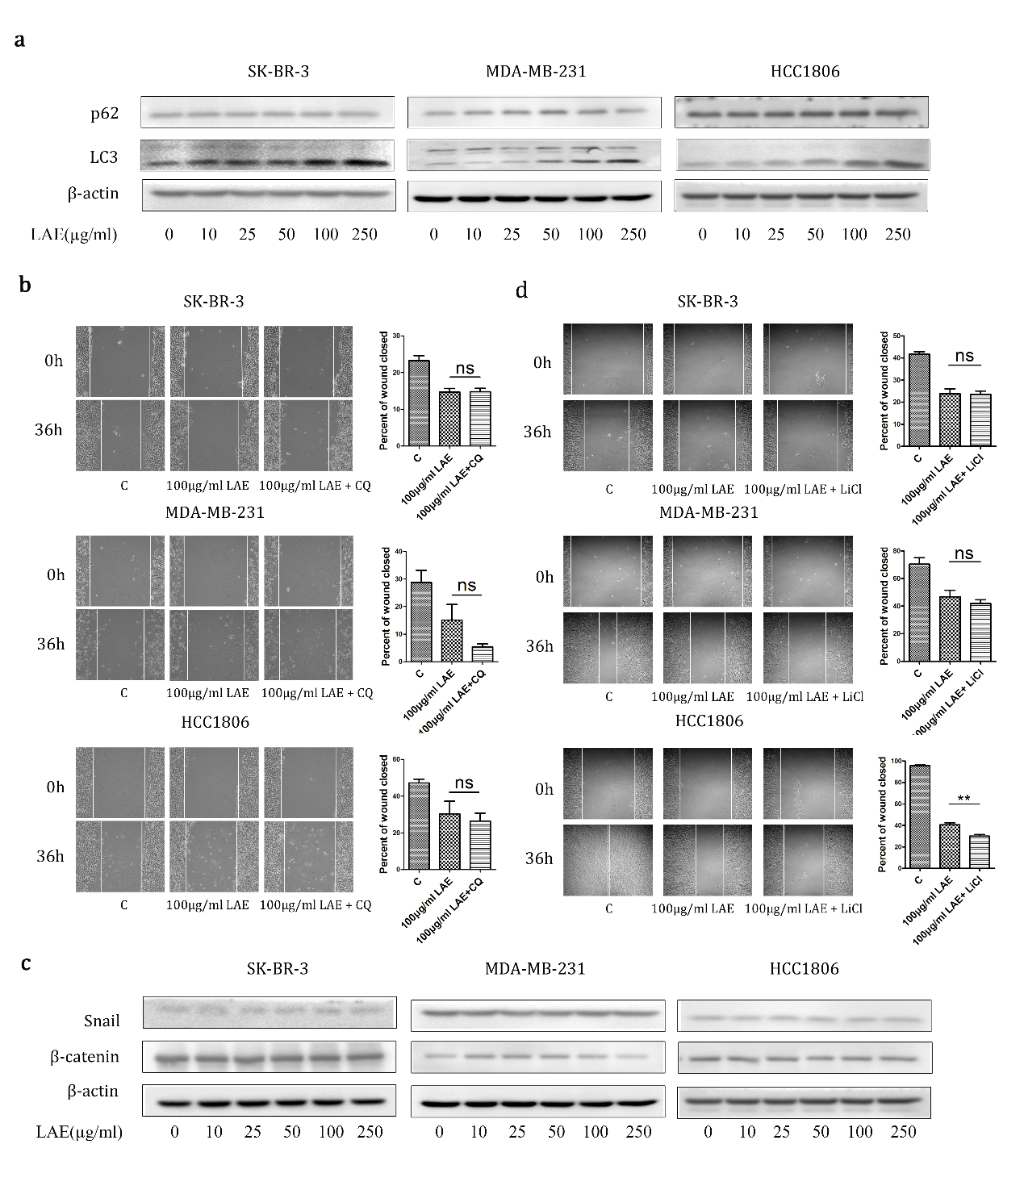
Supplementary Fig. 1 Wnt and autophagy signaling pathways. a p62 and LC3 proteins levels were determined by immunoblotting with indicated concentrations of LAE (0,10,25,50,100,250µg/ml). b Wound healing assays with LAE alone and combined with CQ (10mg/ml); c β-catenin and Snail proteins levels were determined by immunoblotting with indicated concentrations of LAE (0,10,25,50,100,250µg/ml). d Wound healing assays with LAE alone and combined with LiCl (20mM) for 36h.

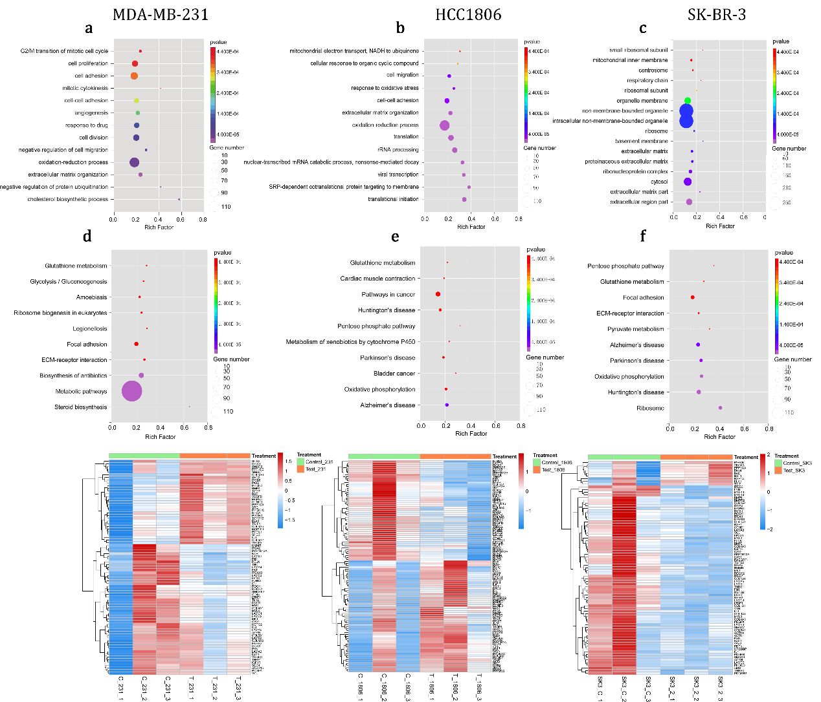
Supplementary Fig. 2 Gene expression profiles of cells with LAE supplement by RNA-sequence. a-c Significantly enriched GO terms for biological process in MDA-MB-231 and SK-BR-3 and cellular component in HCC1806 after treating with LAE. d-f KEGG analysis and gene expression pattern analysis about ECM-receptor interaction and focal adhesion in MDA-MB-231, HCC1806, SK-BR-3 cell lines.

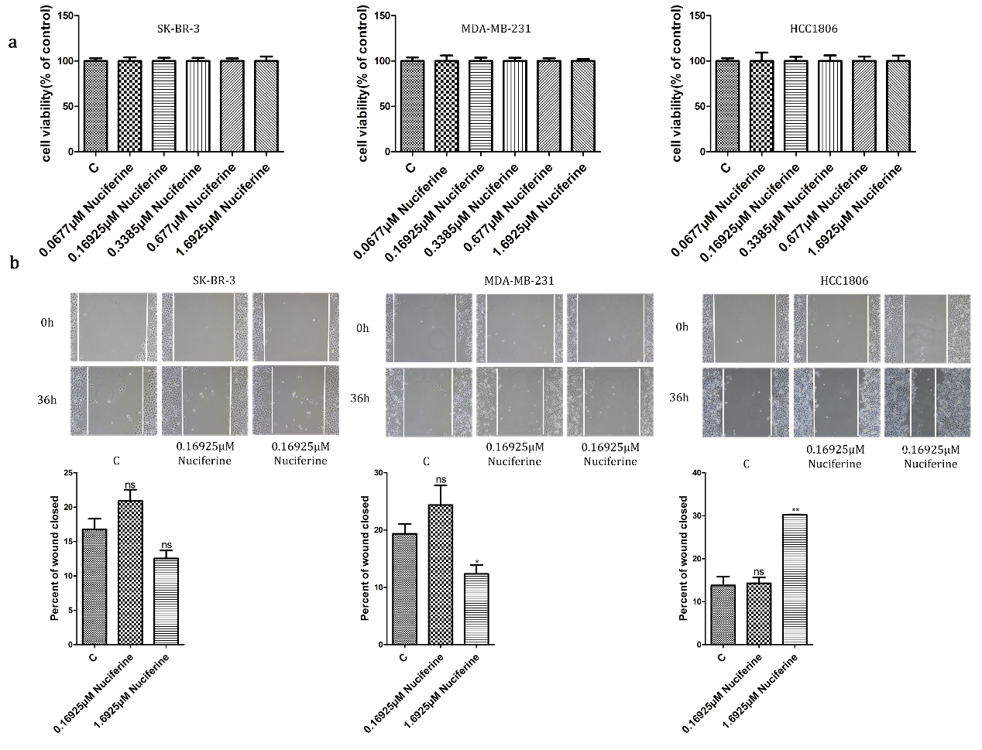
Supplementary Fig. 3 Nuciferine effect on the inhibition of cell migration by LAE. a The viability of nuciferine-treated cells was determined by CCK8 assays. b Wound healing assays after treating with nuciferine for 36h (x100 magnification). Values represent the mean ± SD (n = 3).

