SUPPLEMENTARY MATERIAL #1

COVID-19 hospitalizations by age (simple and age group). Rio de Janeiro, 2020-2022.
Supp. Figure 1 – normal age distribution among SARS by COVID-19 notifications in Rio de Janeiro.
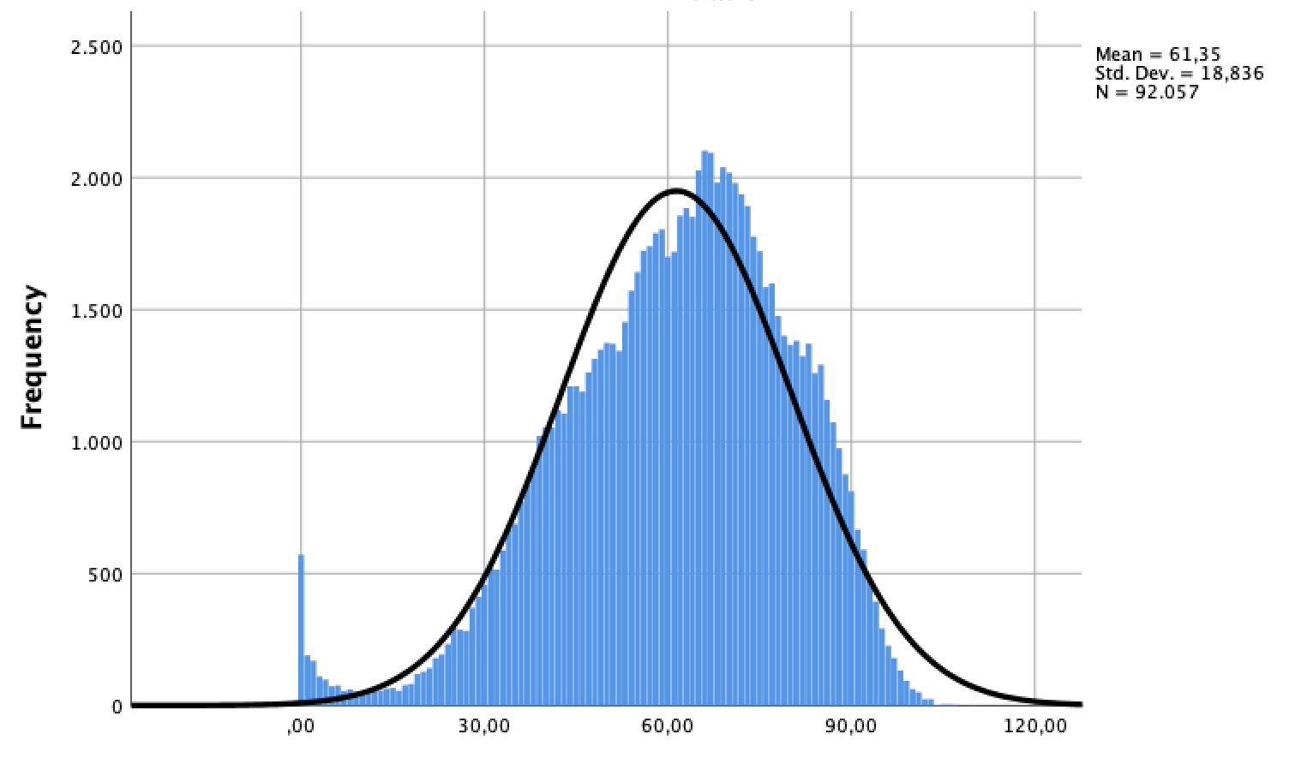
Source: SIVEP-Gripe, 2023
Supp. Figure 2 – age group pyramids of SARS by COVID-19 notifications (red) in Rio de Janeiro and general population (blue)
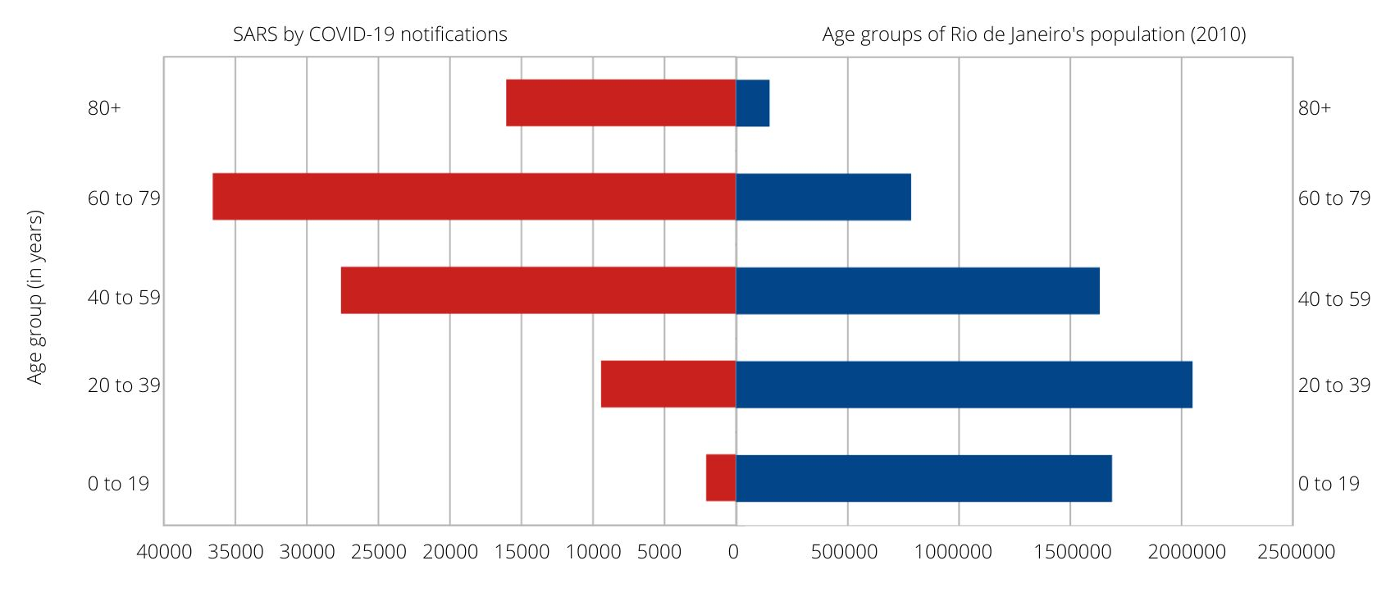
Source: SIVEP-Gripe, 2023; Censo 2010 (IBGE, 2011)

Supp. Figure 3 – SARS by COVID-19 hospitalizations age pyramid by sex. Rio de Janeiro, 2020-2022.
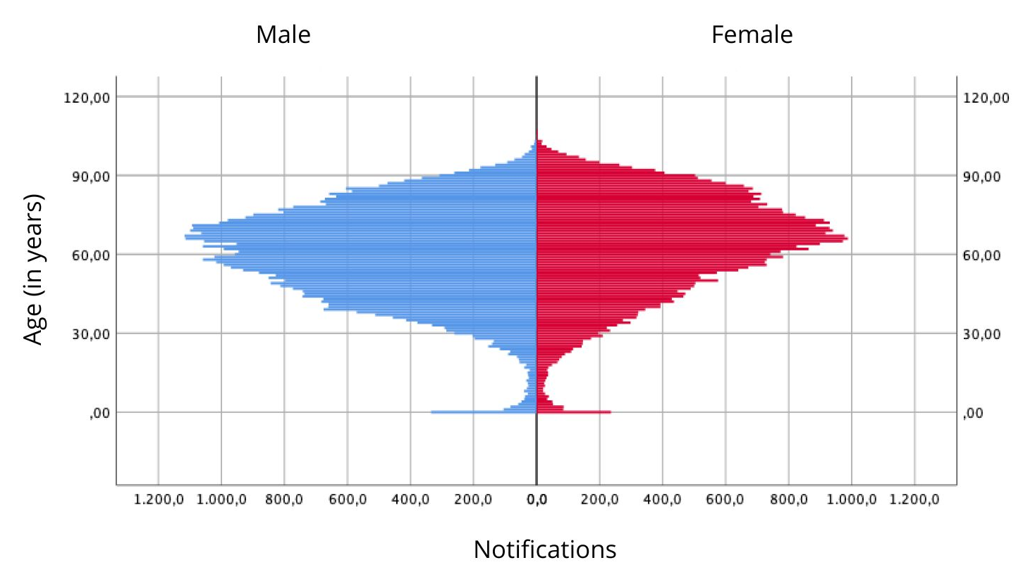
Source: SIVEP-Gripe, 2023

