SUPPLEMENTARY FIGURES S1-S3

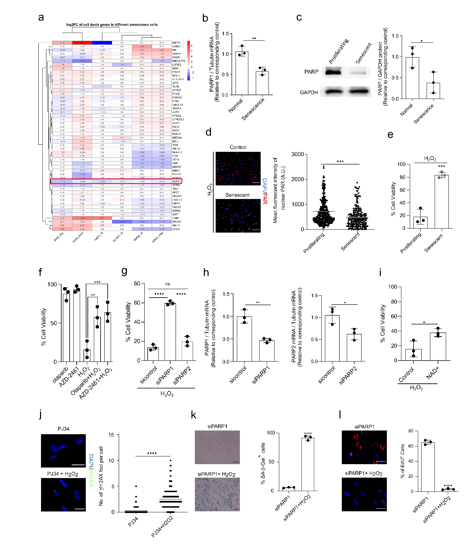

Fig. S1. PARP1 is downregulated in senescence and implicated in cell fate decision upon oxidative stress
a, The heatmap represents expression levels of genes implicated in oxidative stress induced cell death in multiple types of senescence. b-c, IMR90 human fibroblasts were irradiated for senescence induction or sham treated. 7 days later, cells were analyzed using b, qRT-PCR or c, western blot for the expression of PAPR1 relative to housekeeping; n=3. d-e, Senescent (irradiated), and proliferating IMR-90 cells were treated with H₂O₂ (1mM). d, Cells were stained for PAR polymers after 15 min H₂O₂ exposure. Quantification was performed on images taken from multiple microscopic fields of view. Scale bar; 150µm. e, cell survival was measured by using an MTS assay 24 hours after 1h H₂O₂ treatment; n=3. f-g, IMR90 cells were incubated with the indicated PARP inhibitor or vehicle for 2 hours, or transfected with siRNA against PARP1, PARP2, or control, followed by H₂O₂ treatment. Cell survival was measured using MTS assay 24 hours after 1 hour H₂O₂ treatment; n=3. h, expression levels of PARP1 and PARP2 in siRNA transfected cells; n=3. i, IMR90 cells were treated with H2O2 then incubated with 5mM NAD+. 24h later, cell survival was measured using MTS assay; n=3. j, Gamma H2AX staining for cells treated with PJ34 followed by H₂O₂ or sham 10 days after the treatment; n=253 from 3 independent experiments. k-l, cells transfected with siRNA PARP1 were treated with H₂O₂ or sham. 10 days after the treatment, cells were re-plated and k, incubated with EdU for 24h hours and stained (n=3, Scale bar; 150µm) or l, stained for SA-β-gal (n=3, Scale bar; 150µm).
Unpaired two-tailed t-test, data are means ±SD (b, c, e, f, g, h, i, j, k). One-way ANOVA data are means ±SD (d). *p<0.05, **p<0.01, ***p<0.001, ****p<0.0001. Dox, doxorubicin. IR, irradiated, Onco, Oncogene-induced. Rep, replicative.

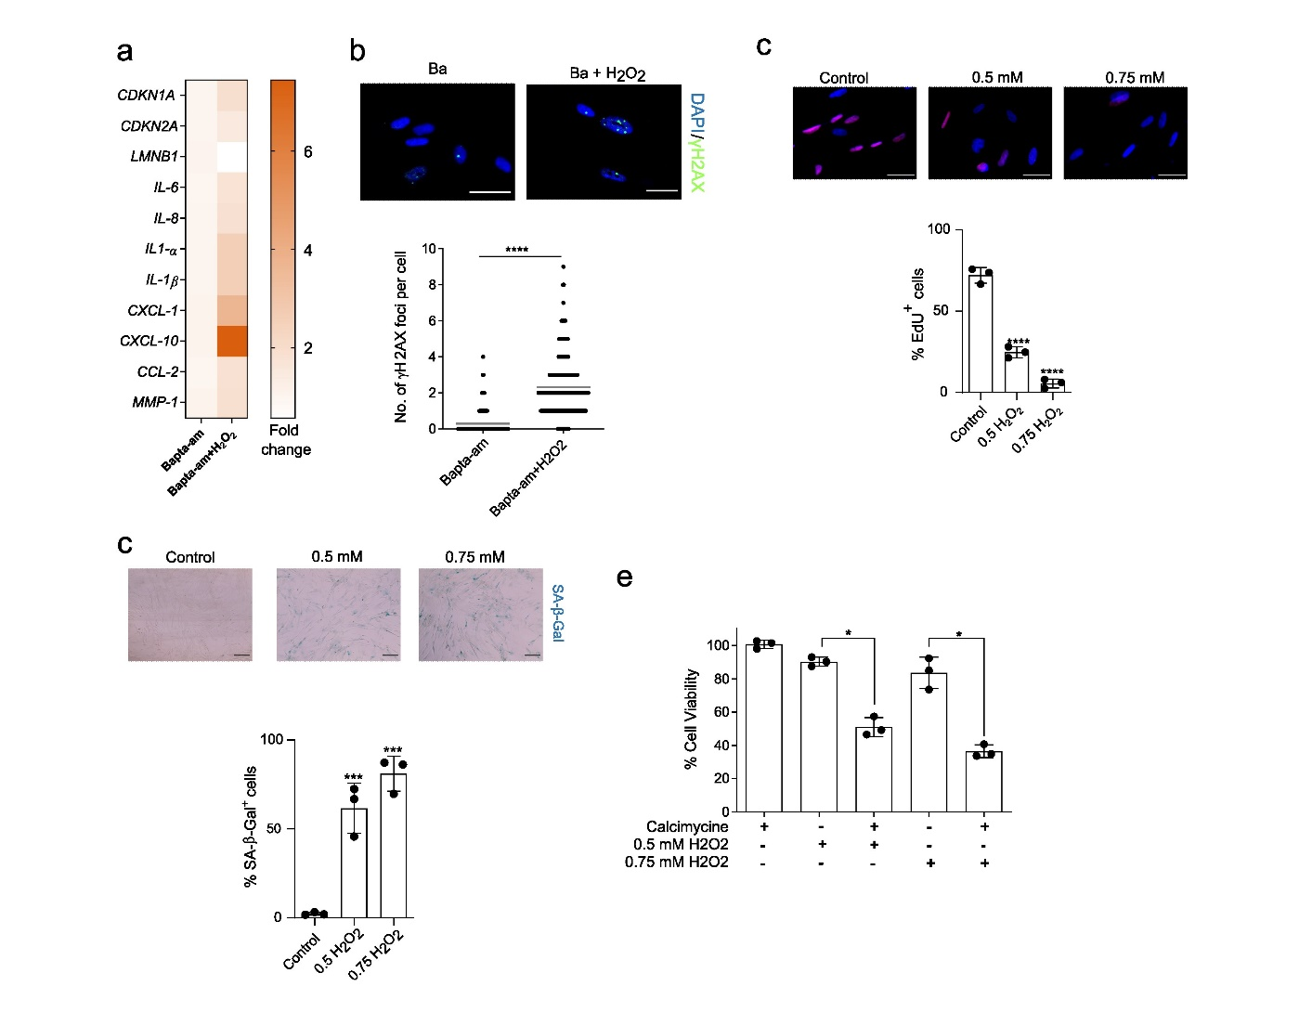

Fig. S2. Calcium signaling is implicated in the decision between senescence and death
a-b, IMR-90 human fibroblast cells treated with BAPTA-am followed by H₂O₂ or sham were re-plated 10 days after the treatment for further analysis. a, cells were analyzed using qRT-PCR for the expression of senescence-associated mRNAs relative to housekeeping (tubulin); n=3. b, Gamma H2AX staining for detecting persistent DNA damage foci; n=185. IMR-90 cells were treated with different H₂O₂ concentrations and stained for c, incubated with EdU for 24h hours, and stained (n=3, Scale bar; 150µm) or d, SA-β-gal (n=3, Scale bar; 150µm), 10 days after treatment; n=3. e, MTS viability measurement after the treatment with the indicated concentrations of H₂O₂ in cells pre-treated with the Ca²⁺ ionophore calcimycine (10uM) or sham; n=3.
Unpaired two-tailed t-test, data are means ±SD (b). One-way ANOVA data are means ±SD (c, d, and e). *p<0.05, **p<0.01, ***p<0.001, ****p<0.0001. Ba, Bapta-am.

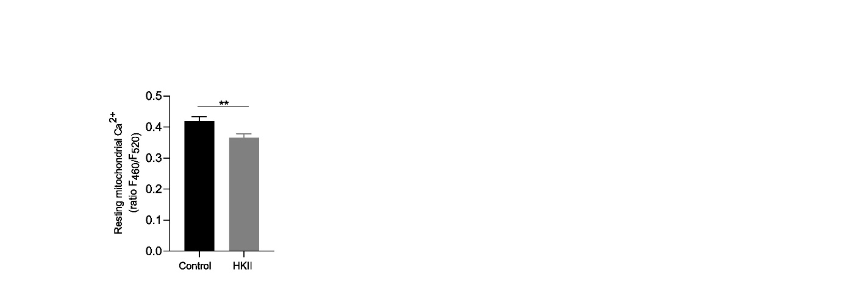

Fig. S3. HKII overexpression decreases mitochondrial Ca²⁺ basal levels
bar diagram comparing the mean of mitochondrial Ca²⁺ basal levels, calculated as signal mass per second; n = 153 for Control and 203 for HKII overexpressing cells (IMR-90).
Unpaired two-tailed t-test, data are means ±SD. **p<0.01.

