A comparative DFT study of methanol decomposition on Mo₂C(001) and Mo₂C(101) surfaces

Yun Shi*
School of Chemistry & Chemical Engineering, Linyi University, Linyi 276000, China
Table of content
The description of structures of adsorbed species Page S2
Figure S1: The most stable adsorption configuration and energy (eV) of surface intermediates involved in the dissociation of methanol on Mo₂C(001) Page S5
Figures S2-S3: The less stable adsorption configuration and energy (eV) of surface intermediates involved in the dissociation of methanol on Mo₂C(001) Pages S6-S7
Figure S4: Top views of the optimized structures for the reaction routes of R1-R8 on Mo₂C(001) Page S8
Figure S5: Top views of the optimized structures for the reaction routes of R9-R16 on Mo₂C(001) Page S9
Figure S6: Top views of the optimized structures for the reaction routes of R17-R22 on Mo₂C(001) Page S10
Figure S7: The most stable adsorption configuration and energy (eV) of surface intermediates involved in the dissociation of methanol on Mo₂C(101) Page S11
Figure S8: The less stable adsorption configuration and energy (eV) of surface intermediates involved in the dissociation of methanol on Mo₂C(101) Page S12
Figure S9: Top views of the optimized structures of the transition state for the reaction routes on Mo₂C(101) Page S13
Table S1: Vibrational frequencies for gas-phase species of methanol decomposition Page S14

The description of structures of adsorbed species
1. Mo₂C(001)
For CH₃OH, the most stable adsorption configuration was at the t1 site, where the oxygen atom interacted with the surface Mo atom with a Mo–O distance of 2.255 Å, and the O–H was nearly parallel to the surface. This adsorption structure is similar to that on metallic surfaces, such as Rh(100),¹² Rh (111),¹³ Pt(100),⁶ Pd(111) ¹⁰, and Pd(100).¹¹ This shows that CH₃OH contacted the surface via the donation of the lone pair of electrons of oxygen. The adsorption energy was -1.03 eV.
CH₃O is generally considered to be adsorbed perpendicularly on the metallic surfaces through O atoms. As expected, on metallic Mo₂C(001), the computed results showed that the CH₃O intermediate was vertically adsorbed at the 3h2 site of the surface via O atoms with Mo–O distances of 2.193, 2.225, and 2.225 Å; CH₃O still maintained its local C3v symmetry, and the three H atoms remained on a plane parallel to the surface. The adsorption configuration was in good agreement with previous studies on metallic surfaces.^{6,10-13} The adsorption energy was -4.22 eV.
For CH₂OH, it was found that the most stable adsorption structure has the C atom at the 3h1 site, the O atom at t1 site, and the two H atoms at two t2 sites; the bond distances of Mo–C were 2.320, 2.324, and 2.335 Å, that of Mo–O was 2.226 Å, and those of two Mo–H bonds were 2.109 and 2.113 Å. The adsorption energy of CH₂OH was -3.27 eV.
CH₂O is well known as the most important intermediate for the decomposition and synthesis of methanol. The computed results showed that it had surface interactions via C, H, and O atoms. C was at the 3h1 site with Mo–C distances of 2.373, 2.370, and 2.246 Å. Moreover, two H and O atoms interacted with two Mo_{B} and one Mo_{A} atoms, respectively, and the two Mo–H distances were 2.067 and 2.069 Å, while the Mo–O distance was 2.029 Å. The computed adsorption energy was -2.86 eV.
For CHOH, geometry optimization showed that it was adsorbed at the 3h1 site via the C atom, and the bond lengths of Mo–C were 2.256, 2.108, and 2.253 Å. In addition, the O and H atoms of the -CH group were in contact with the surface Mo atoms with Mo–O and Mo–H distances of 2.246 and 2.014 Å, respectively; the C-H bond was elongated by 0.035 Å, suggesting the easy breakage of C-H bonds. The adsorption energy of CHOH was -4.63 eV.
For CHO, the calculated results demonstrated that in the most stable adsorption configuration, C and O atoms were located at the 3h1 and b4 sites, respectively, and the bond distances of Mo–C were 2.147, 2.234, and 2.303 Å, while those of Mo–O were 2.230 and 2.190 Å, respectively. The adsorption energy was -4.04 eV.
For COH, the most stable adsorption structure was at the 3h1 site via the C atom with an adsorption energy of -5.43 eV, and the computed distances of Mo–C were 2.084, 2.080, and 2.167 Å, respectively. In addition, the O atom was at the t1 site with a Mo–O distance of 2.335 Å.
For CO, the most stable adsorption configuration revealed that the C atom was at the 3h1 site and the O atom was at the b4 site. The Mo–C distances were 1,975, 2.248, and 2.253 Å and the Mo–O distances were 2.395 and 2.397 Å. The adsorption energy was -2.89 eV.
For H, the computed results showed that it could be adsorbed on all the four hollow sites. The adsorption energies for the four most stable configurations were -1.11 (3h1), -1.07 (3h2), -1.05 (3h4), and -0.73 eV (3h3). Clearly, the H atom prefers to be adsorbed at the 3h1 site with Mo–H distances of 1.998, 2.000, and 1.960 Å. The computed adsorption energy was -1.11 eV (related to gaseous H₂ molecules).
2. Mo₂C(101)
For CH₃OH, the computed results showed that it preferred to be adsorbed at the t2 site with the interaction between the surface Mo_{A} and O atom of the OH group, and the Mo_{A}-O distance was 2.312 Å. In addition, the O-H bond was almost parallel to the surface Mo_{A}-C_{A} bond, and its length was elongated by 0.014 Å relative to gas CH₃OH, implying that the O–H bond is easily broken. The adsorption energy was -1.05 eV, which was very close to that of Mo₂C(001).
For CH₃O, it was found that CH₃O contacted the surface via the O atom at the b1 site with Mo_{A}-O distances of 2.142 and 2.139 Å, and one H atom tended to interact with the surface C_{A}, showing that the dehydrogenation of CH₃O occurred easily. The computed adsorption energy was lower by 0.59 eV than that (-3.73 vs. -4.32 eV) on Mo₂C(001).
For CH₂OH, the most stable adsorption configuration had C at the b4 site and one H at t2 site, and the distances of Mo_{A}-C, C_{A}-C, and Mo_{A}-H were 2.488, 1.508, and 1.974 Å, respectively. It was deduced that the O–H bond can easily break because it is elongated to 1.209 Å because of the interaction between H and the surface Mo_{A}. The adsorption energy was -2.67 eV.
For CH₂O, the most stably adsorbed structure illustrated that both C and O atoms interacted with the surface; C was at the t1 site with a C_{A}-C distance of 1.546 Å, and O was at the b1 site with Mo_{A}-O distances of 2.084 and 2.261 Å, respectively. The C-O bond length was extended to 1.463 Å from 1.214 Å in the gas phase, and it can be inferred that the C-O bond can easily break. The adsorption energy was -2.17 eV.
For CHOH, the calculated results showed that it binds at the b4 site via the C atom with an adsorption energy of -4.25 eV. The distances of Mo_{A}-C and C_{A}-C were 2.426 Å and 1.419 Å, respectively. In addition, it was found that the distance between the H atom of OH and the surface C_{A} was 1.940 Å, indicating that CHOH is prone to dehydrogenation.
For CHO, it was found that CHO was adsorbed via C at the b4 site and O at the b1 site. The distances between C and surface C_{A} and Mo_{A} were 1.429 and 2.174 Å, respectively; the Mo_{A}-O distances were 2.283 and 2.151 Å, respectively. The adsorption energy was -3.56 eV.
For COH, the computed results showed that it preferred to be adsorbed at the b4 site through the C atom with a Mo_{A}-C distance of 2.044 Å and C_{A}-C distance of 1.403 Å. The calculated adsorption energy was -4.53 eV.
For CO, the most stably adsorbed configuration had C at the 4h1 site and O at the b1 site with adsorption energies of -1.92 eV.⁵⁷ The C_{A}-C and Mo_{A}-C distances were 1.461, 1.461 and 2.511, and 2.512 Å, respectively. The Mo_{A}-O distances were 2.183 Å and 2.182 Å. Apart from the most stable 4h1 adsorption, the computed results showed that CO could also be adsorbed at b4 and t2 sites with adsorption energies of − -1.64 and − -1.78 eV, respectively.
For H, H could be adsorbed at both t1 and b1 sites. The most stable t1 adsorption showed an adsorption energy of -0.64 eV with a C_{A}-H distance of 1.117 Å. The b1 adsorption was less stable by 0.18 eV than the t1 one.⁴²
For CH₂, it was most stably adsorbed at the b4 site via the C atom with an adsorption energy of -5.08 eV. The C_{A}-C and Mo_{A}-C distances were 1.434 and 2.312 Å, respectively.
For CH₃, similar to the adsorption of CH₂, it was located at the b4 site with C_{A}-C and Mo_{A}-C distances of 1.510 and 2.504 Å, respectively. The adsorption energy was much lower than that of CH₂ (− -2.64 vs. − -5.08 eV).
For CH₄, it was found that CH₄ was located above the t2 site without direct interaction with the surface, and the adsorption energy was only -0.38 eV, indicating weak physical adsorption.

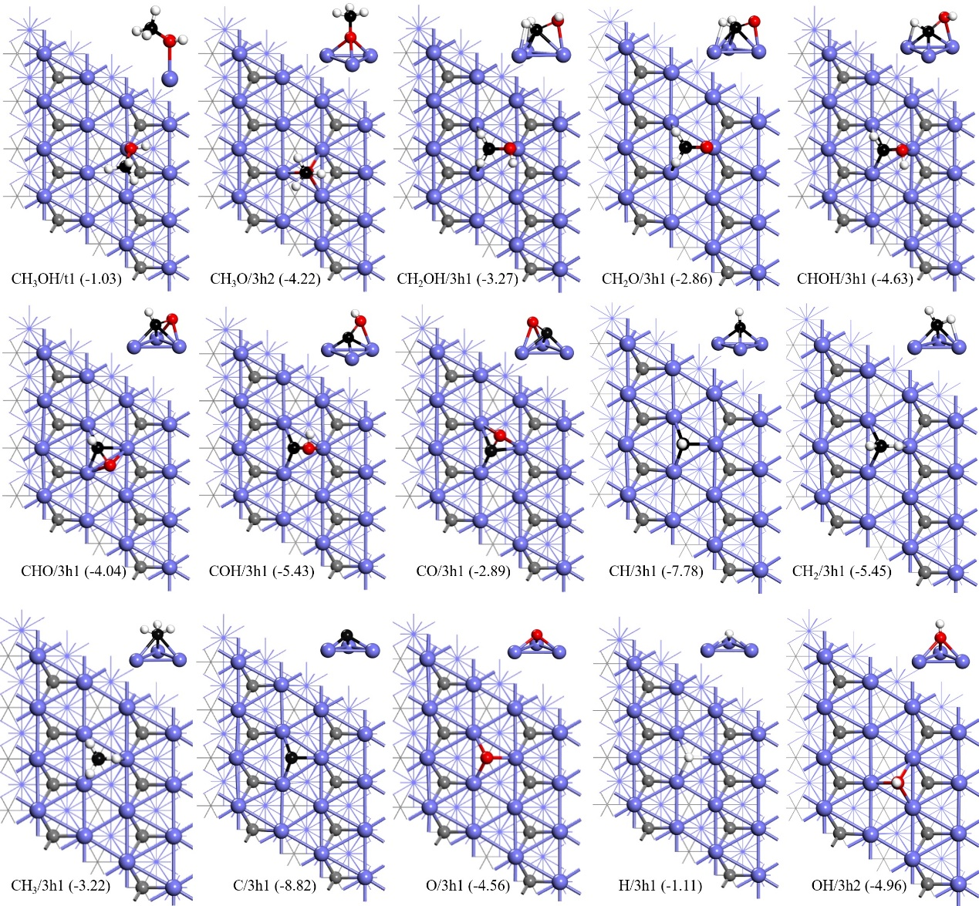
Figure S1. The most stable adsorption configuration and energy (eV) of surface intermediates involved in the dissociation of methanol on Mo₂C(001) (Mo/blue, bulk-C/grey, H/white, adsorbed-C/black, O/red)

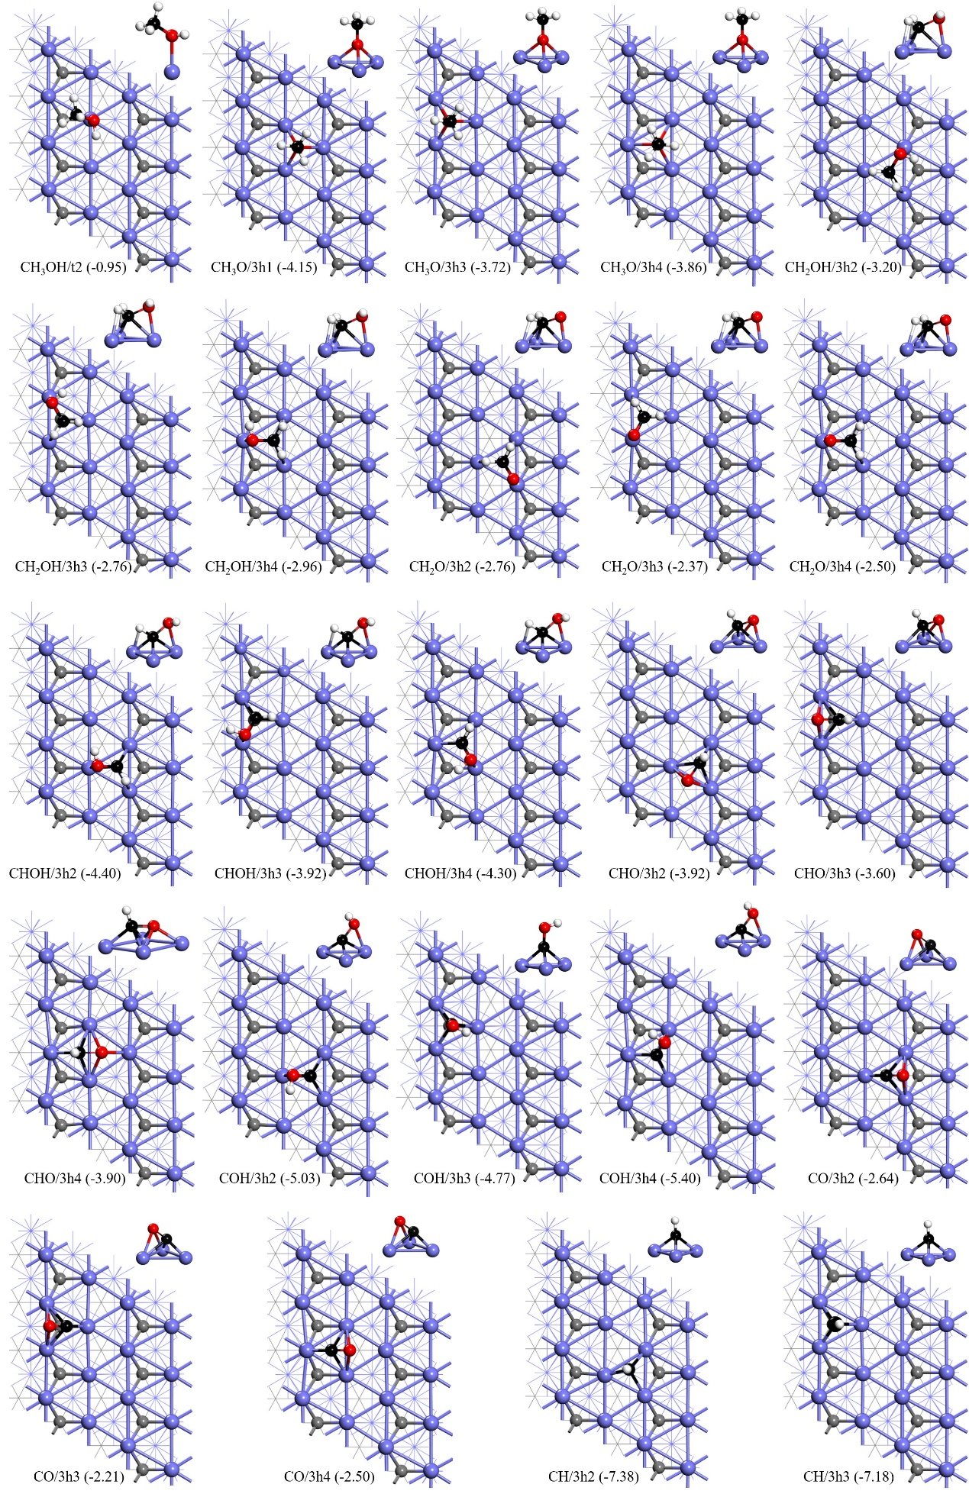
Figure S2. The less stable adsorption configuration and energy (eV) of surface intermediates involved in the dissociation of methanol on Mo₂C(001) (Mo/blue, bulk-C/grey, H/white, adsorbed-C/black, O/red)
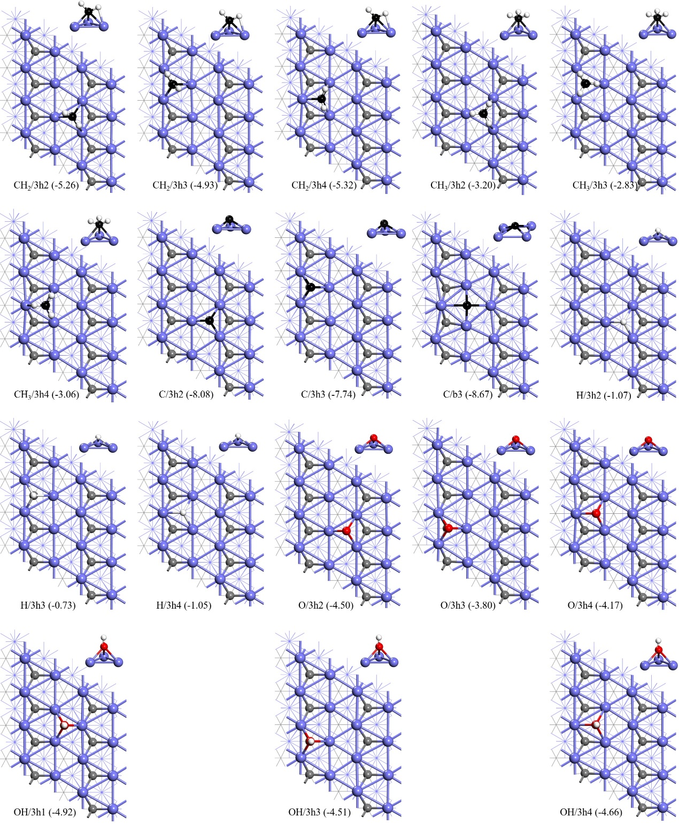
Figure S3. The less stable adsorption configuration and energy (eV) of surface intermediates involved in the dissociation of methanol on Mo₂C(001) (Mo/blue, bulk-C/grey, H/white, adsorbed-C/black, O/red)
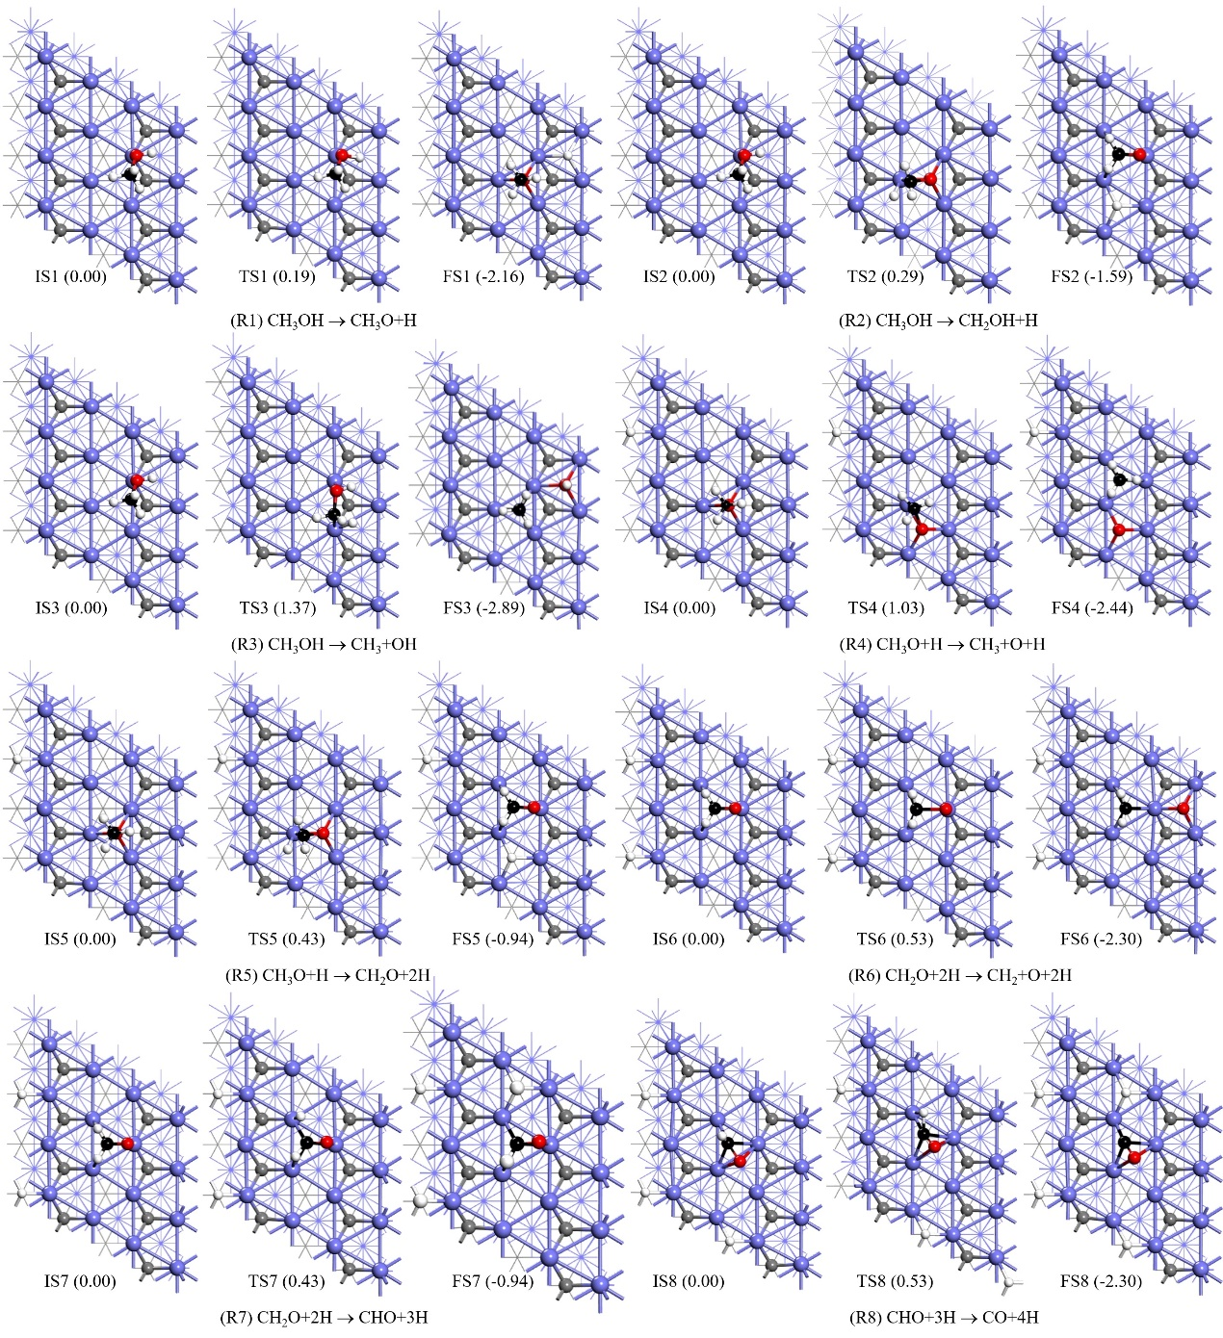
Figure S4. Top views of the optimized structures for the reaction routes of R1-R8 on Mo₂C(001) (Mo/blue, bulk-C/grey, H/white, adsorbed-C/black, O/red)

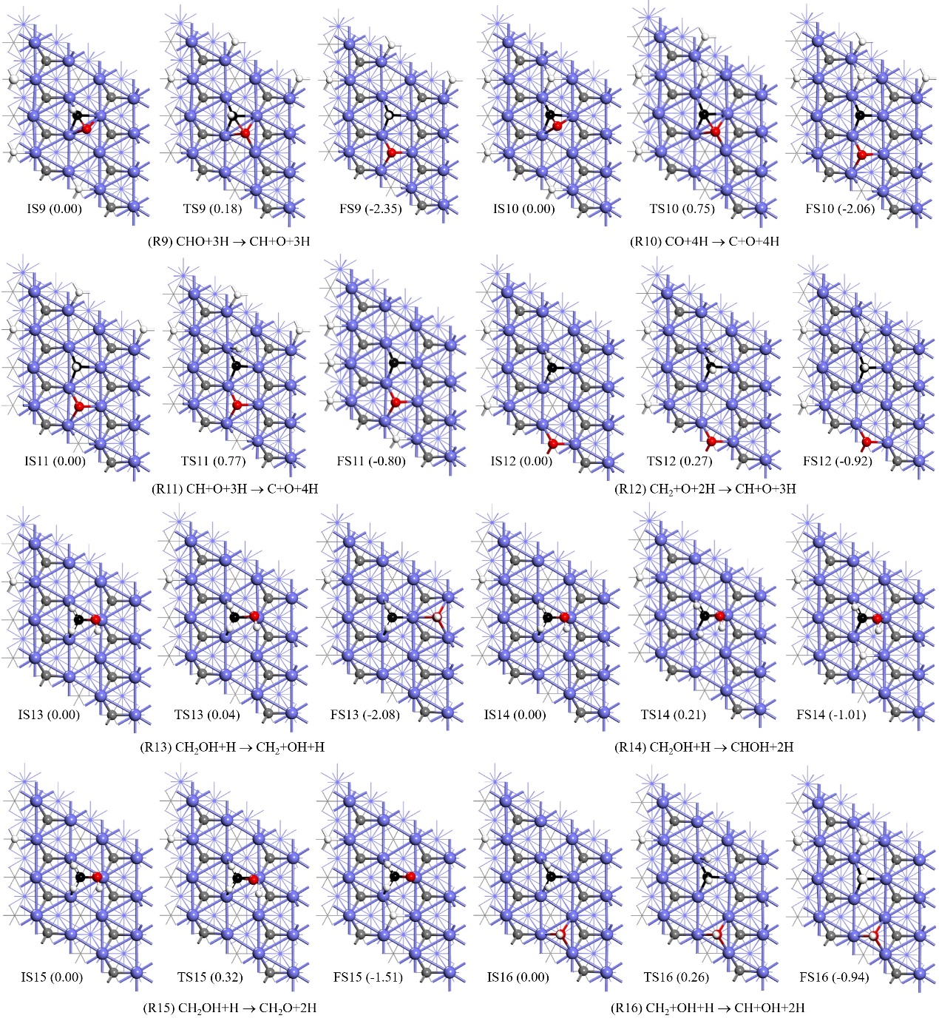
Figure S5. Top views of the optimized structures for the reaction routes of R9-R16 on Mo₂C(001) (Mo/blue, bulk-C/grey, H/white, adsorbed-C/black, O/red)
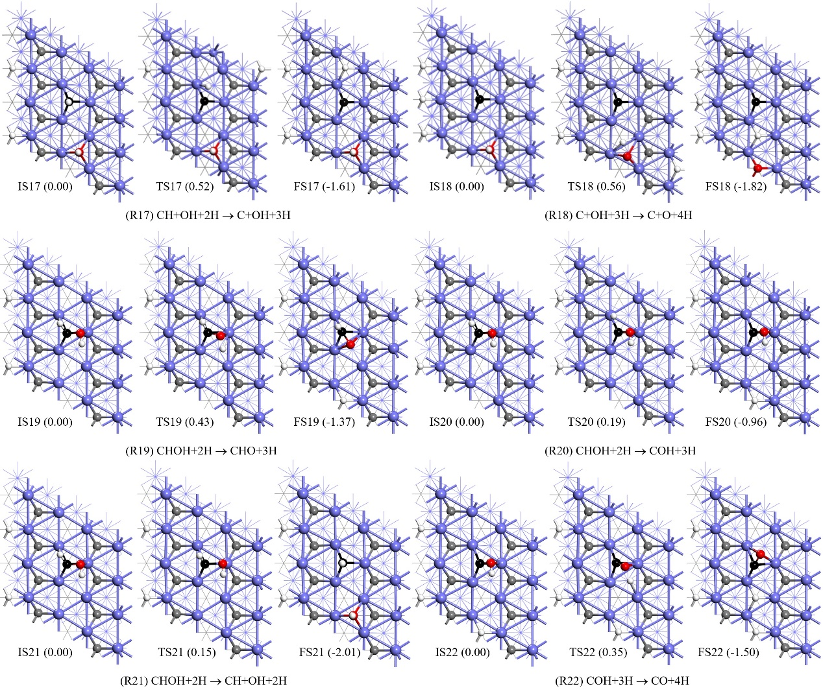
Figure S6. Top views of the optimized structures for the reaction routes of R17-R22 on Mo₂C(001) (Mo/blue, bulk-C/grey, H/white, adsorbed-C/black, O/red)
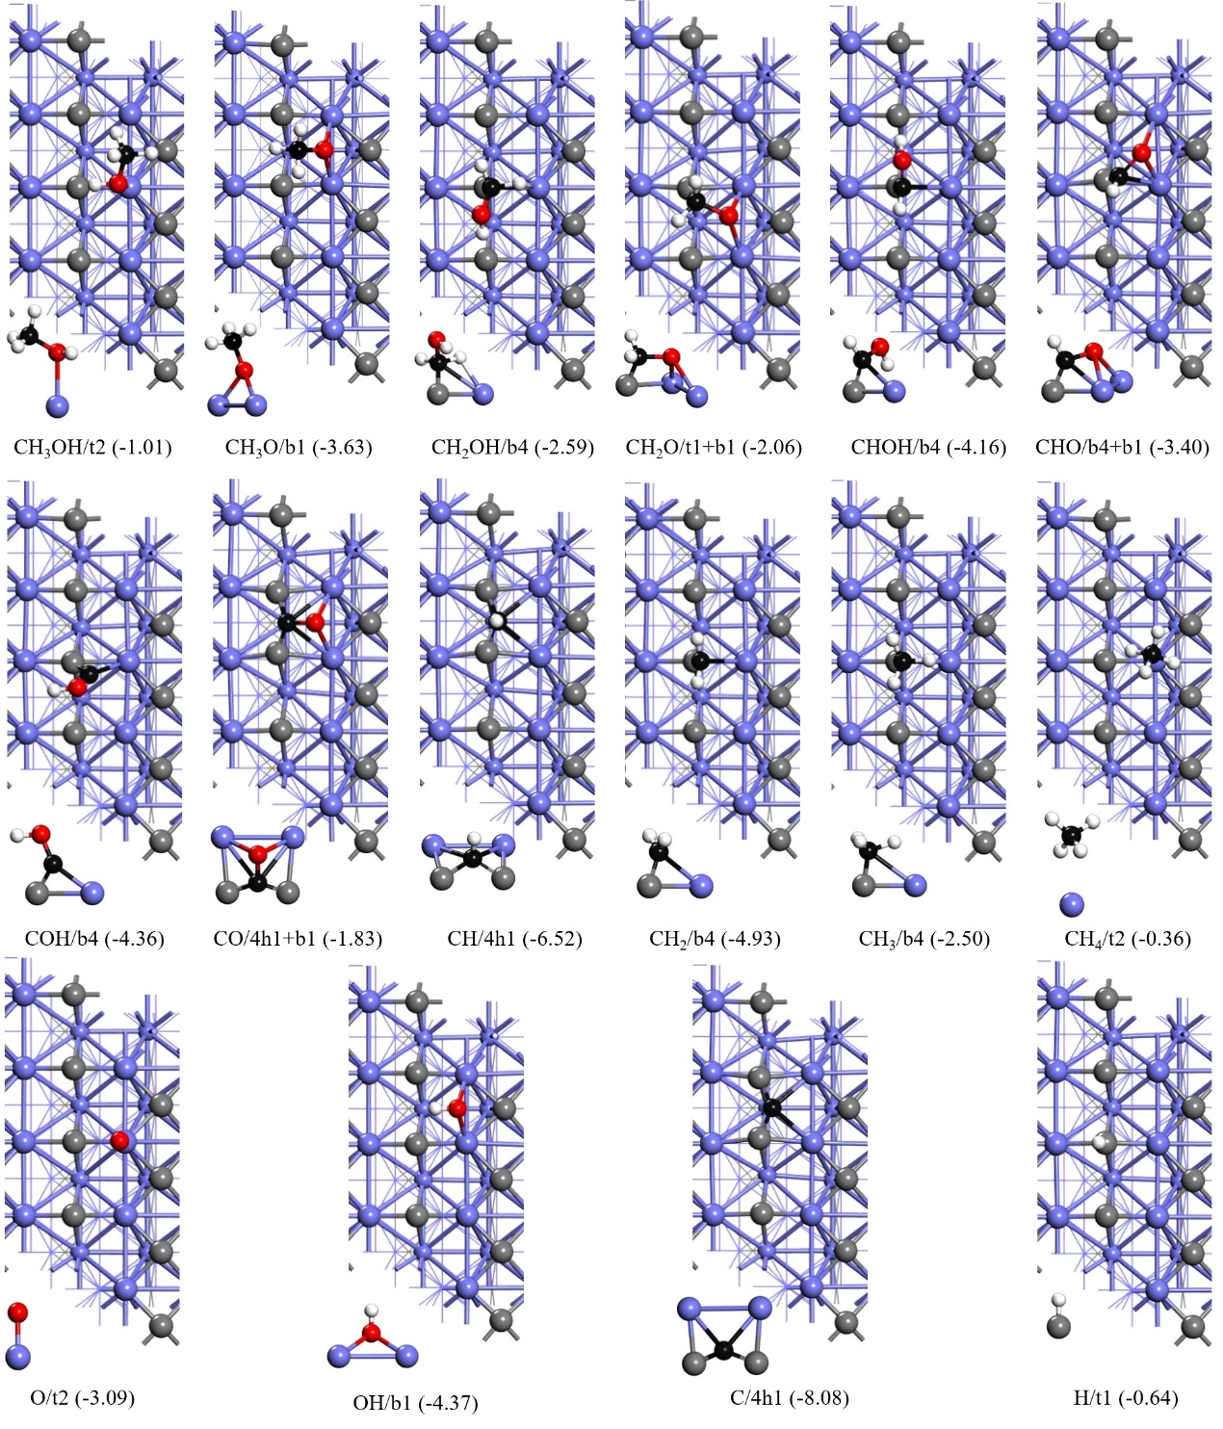
Figure S7. The most stable adsorption configuration and energy (eV) of surface intermediates involved in the dissociation of methanol on Mo₂C(101) (Mo/blue, bulk-C/grey, H/white, adsorbed-C/black, O/red)

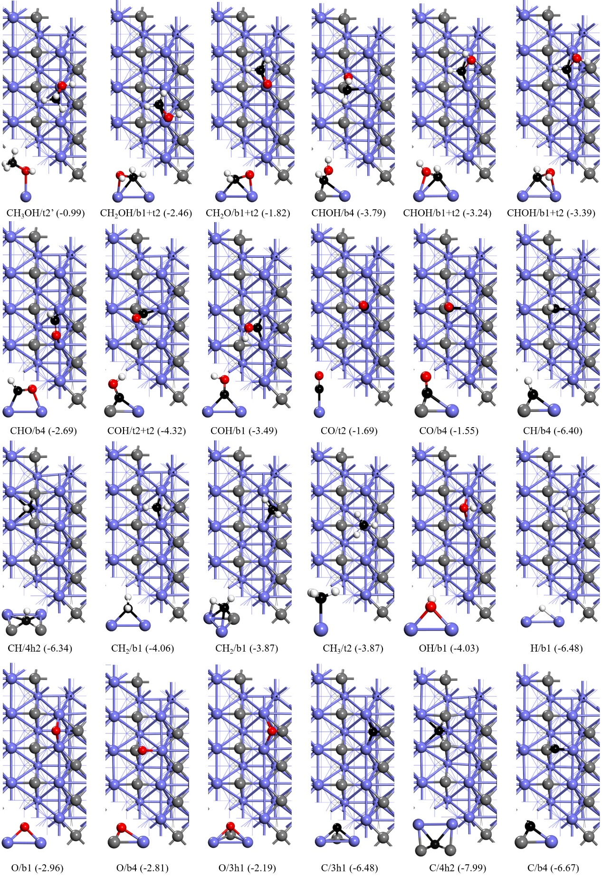
Figure S8. The less stable adsorption configuration and energy (eV) of surface intermediates involved in the dissociation of methanol on Mo₂C(101) (Mo/blue, bulk-C/grey, H/white, adsorbed-C/black, O/red)

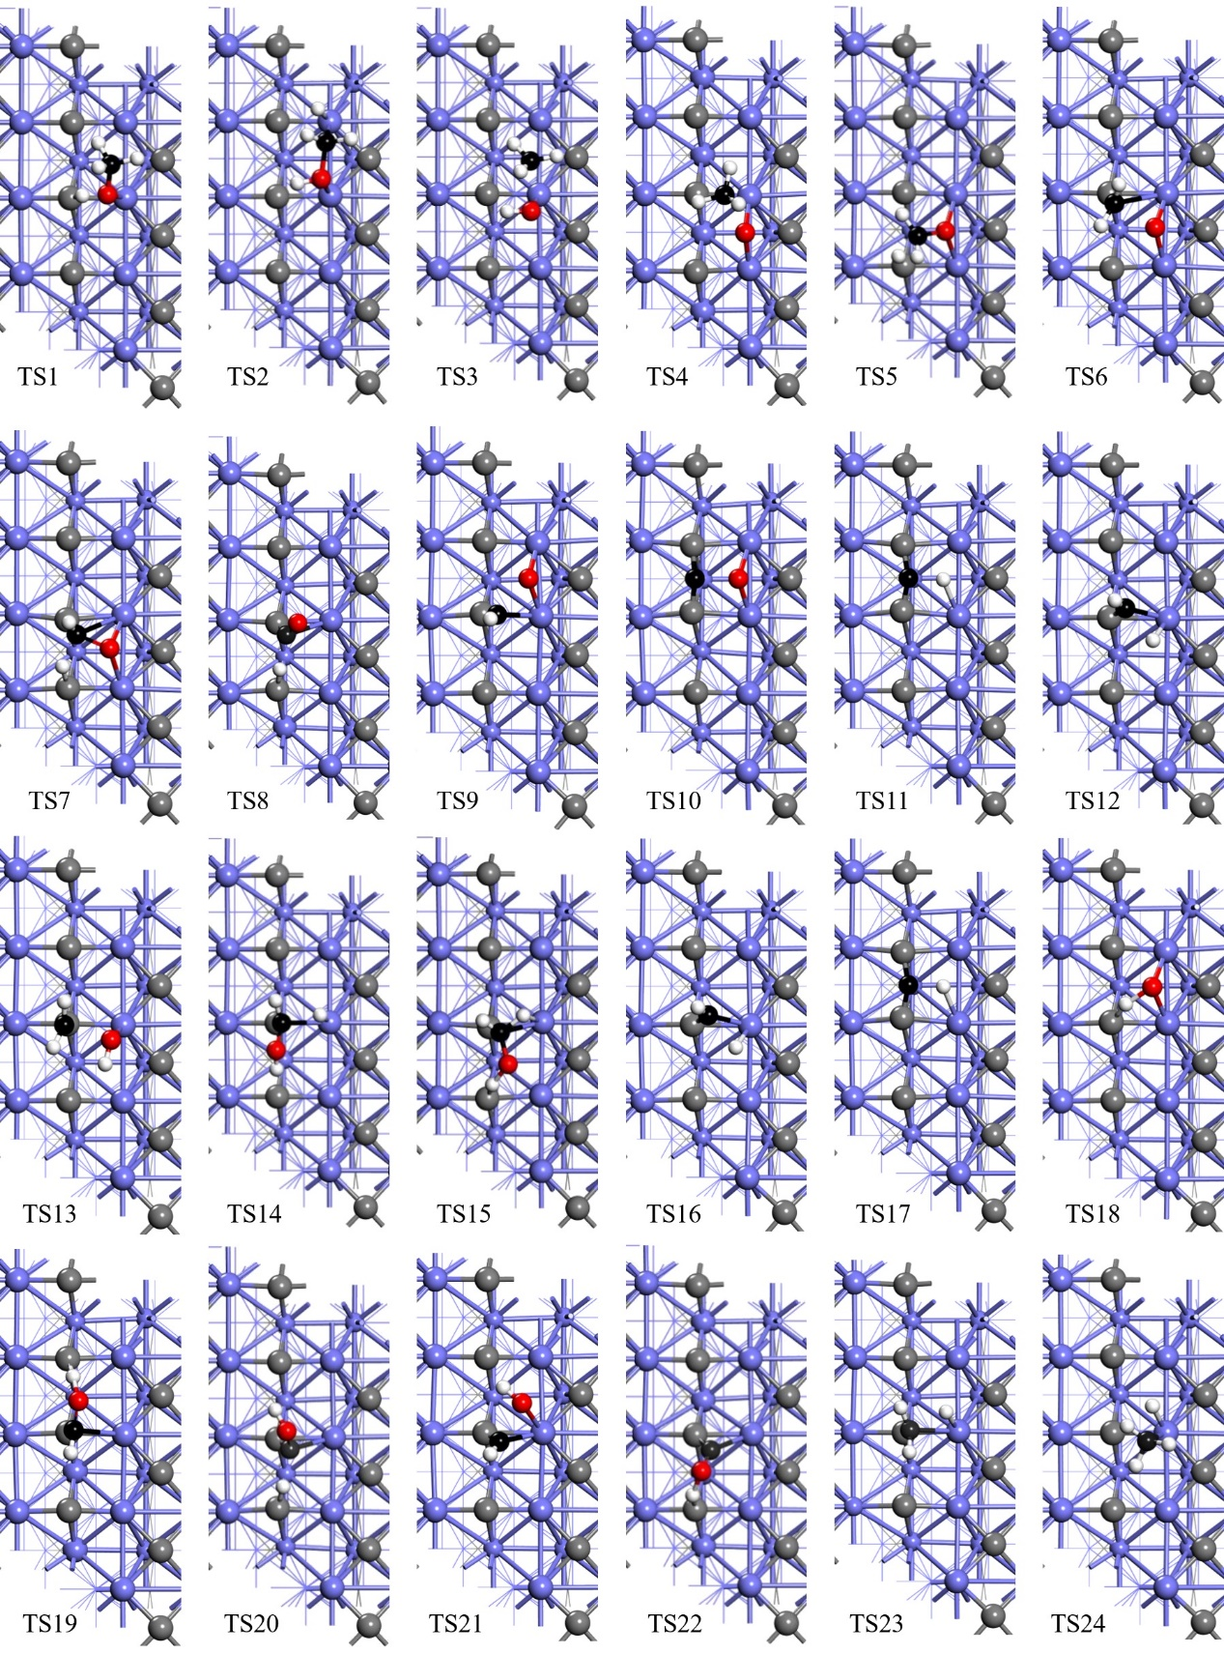
Figure S9. Top views of the optimized structures of the transition state for the reaction routes on Mo₂C(101) (Mo/blue, bulk-C/grey, H/white, adsorbed-C/black, O/red)

Table S1. Vibrational frequencies for gas-phase species of methanol decomposition
species | ν(cm⁻¹) | species | ν(cm⁻¹) | species | ν(cm⁻¹) | species | ν(cm⁻¹) | species | ν(cm⁻¹)
CH₃OH | 3762 | CH₂OH | 3718 | CH₃O | 2911 | CHOH | 3573 | CH₃ | 3242
 | 3055 |  | 3224 |  | 2840 |  | 2772 |  | 3242
 | 3004 |  | 3082 |  | 2760 |  | 1464 |  | 3042
 | 2954 |  | 1432 |  | 1345 |  | 1286 |  | 1363
 | 1460 |  | 1320 |  | 1276 |  | 1157 |  | 1360
 | 1446 |  | 1172 |  | 1240 |  | 1075 |  | 642
 | 1423 |  | 1010 |  | 1090 | CH₄ | 3130 | CO | 2123
 | 1333 |  | 534 |  | 906 |  | 3090 | OH | 3602
 | 1130 |  | 449 |  | 784 |  | 3088
 | 1070 | COH | 2859 | CH₂O | 2884 |  | 2985
 | 1006 |  | 1313 |  | 2851 |  | 1514
 | 292 |  | 994 |  | 1774 |  | 1511
CHO | 2602 | CH | 2751 |  | 1485 |  | 1291
 | 1864 | CH₂ | 3317 |  | 1216 |  | 1284
 | 1047 |  | 3047 |  | 1145 |  | 1284

