SUPPLEMENTARY MATERIAL

Title: The correlation of intraoperative hypotension and postoperative cognitive impairment: a meta-analysis of randomized controlled trials

Authors: Xiaojin Feng, Jialing Hu, Fuzhou Hua, Jing Zhang, Lieliang Zhang, Guohai Xu

SUMMARY
Table S1 PRISMA 2009 Checklist 2
Table S2 Raw and converted data of the secondary outcomes 4
Figure S1 Trial sequential analysis of primary outcomes. 5

Table S1 PRISMA 2009 Checklist.
Section/topic | # | Checklist item | Reported on page #
TITLE
Title | 1 | Identify the report as a systematic review, meta-analysis, or both. | 1
ABSTRACT
Structured summary | 2 | Provide a structured summary including, as applicable: background; objectives; data sources; study eligibility criteria, participants, and interventions; study appraisal and synthesis methods; results; limitations; conclusions and implications of key findings; systematic review registration number. | 2
INTRODUCTION
Rationale | 3 | Describe the rationale for the review in the context of what is already known. | 3
Objectives | 4 | Provide an explicit statement of questions being addressed with reference to participants, interventions, comparisons, outcomes, and study design (PICOS). | 3
METHODS
Protocol and registration | 5 | Indicate if a review protocol exists, if and where it can be accessed (e.g., Web address), and, if available, provide registration information including registration number. | n/a
Eligibility criteria | 6 | Specify study characteristics (e.g., PICOS, length of follow-up) and report characteristics (e.g., years considered, language, publication status) used as criteria for eligibility, giving rationale. | 4
Information sources | 7 | Describe all information sources (e.g., databases with dates of coverage, contact with study authors to identify additional studies) in the search and date last searched. | 4
Search | 8 | Present full electronic search strategy for at least one database, including any limits used, such that it could be repeated. | 4
Study selection | 9 | State the process for selecting studies (i.e., screening, eligibility, included in systematic review, and, if applicable, included in the meta-analysis). | 4
Data collection process | 10 | Describe method of data extraction from reports (e.g., piloted forms, independently, in duplicate) and any processes for obtaining and confirming data from investigators. | 5
Data items | 11 | List and define all variables for which data were sought (e.g., PICOS, funding sources) and any assumptions and simplifications made. | 5
Risk of bias in individual studies | 12 | Describe methods used for assessing risk of bias of individual studies (including specification of whether this was done at the study or outcome level), and how this information is to be used in any data synthesis. | 5
Summary measures | 13 | State the principal summary measures (e.g., risk ratio, difference in means). | 5
Synthesis of results | 14 | Describe the methods of handling data and combining results of studies, if done, including measures of consistency (e.g., I²) for each meta-analysis. | 6
Section/topic | # | Checklist item | Reported on page #
Risk of bias across studies | 15 | Specify any assessment of risk of bias that may affect the cumulative evidence (e.g., publication bias, selective reporting within studies). | 6
Additional analyses | 16 | Describe methods of additional analyses (e.g., sensitivity or subgroup analyses, meta-regression), if done, indicating which were pre-specified. | 6
RESULTS
Study selection | 17 | Give numbers of studies screened, assessed for eligibility, and included in the review, with reasons for exclusions at each stage, ideally with a flow diagram. | 6, Figure 1
Study characteristics | 18 | For each study, present characteristics for which data were extracted (e.g., study size, PICOS, follow-up period) and provide the citations. | 7, Table 1
Risk of bias within studies | 19 | Present data on risk of bias of each study and, if available, any outcome level assessment (see item 12). | 7
Results of individual studies | 20 | For all outcomes considered (benefits or harms), present, for each study: (a) simple summary data for each intervention group (b) effect estimates and confidence intervals, ideally with a forest plot. | 7-9
Synthesis of results | 21 | Present results of each meta-analysis done, including confidence intervals and measures of consistency. | 7-9
Risk of bias across studies | 22 | Present results of any assessment of risk of bias across studies (see Item 15). | 10
Additional analysis | 23 | Give results of additional analyses, if done (e.g., sensitivity or subgroup analyses, meta-regression [see Item 16]). | 9
DISCUSSION
Summary of evidence | 24 | Summarize the main findings including the strength of evidence for each main outcome; consider their relevance to key groups (e.g., healthcare providers, users, and policy makers). | 10-13
Limitations | 25 | Discuss limitations at study and outcome level (e.g., risk of bias), and at review-level (e.g., incomplete retrieval of identified research, reporting bias). | 13
Conclusions | 26 | Provide a general interpretation of the results in the context of other evidence, and implications for future research. | 13
FUNDING
Funding | 27 | Describe sources of funding for the systematic review and other support (e.g., supply of data); role of funders for the systematic review. | 14

From: Moher D, Liberati A, Tetzlaff J, Altman DG, The PRISMA Group (2009). Preferred Reporting Items for Systematic Reviews and Meta-Analyses: The PRISMA Statement. PLoS Med 6(7): e1000097. doi:10.1371/journal.pmed1000097
For more information, visit: www.prisma-statement.org.

Table S2 Raw and converted data of the secondary outcomes.
Perioperative mortality
Author/year | Low-target |  |  | High-target
Author/year | Events | Total |  | Events | Total
Gold 1995 | 5 | 124 |  | 2 | 124
Langer 2019 | 1 | 51 |  | 1 | 50
Siepe 2011 | 0 | 48 |  | 0 | 44
Vedel 2018 | 0 | 99 |  | 4 | 98
Length of hospital stay
Author/year | Low-target |  |  |  | High-target
Author/year | Median (IQR) | Mean (SD) | N |  | Median (IQR) | Mean (SD) | N
Gold 1995 | / | 17 (25) d | 124 |  | / | 13 (14) d | 124
Langer 2019 | 5 (3 - 7) d | 5 (3.1) d | 51 |  | 5 (2 - 8) d | 5 (4.6) d | 50
Siepe 2011 | / | 12.2 (8.1) d | 48 |  | / | 12.6 (6.9) d | 44
Vedel 2018 | 6 (5 - 8) d | 6.4 (2.3) d | 99 |  | 6 (5 - 7.5) d | 6 (1.9) d | 98
Length of ICU stay
Author/year | Low-target |  |  |  | High-target
Author/year | Median (IQR) | Mean (SD) | N |  | Median (IQR) | Mean (SD) | N
Gold 1995 | / | 77 (250) h | 124 |  | / | 60 ( 171) h | 124
Siepe 2011 | / | 96 (93.6) h | 48 |  | / | 76.8 (57.6) h | 44
Vedel 2018 | 21 (20 - 26) d | 22.4 (4.5) h | 99 |  | 21 (19 - 22) d | 20.6 (2.3) h | 98
Mechanical ventilation time
Author/year | Low-target |  |  |  | High-target
Author/year | Median (IQR) | Mean (SD) | N |  | Median (IQR) | Mean (SD) | N
Siepe 2011 | / | 11.9 (5.6) h | 48 |  | / | 10.3 (5.0) h | 44
Vedel 2018 | 4.6 (2.9 - 6.7) h | 4.7 (2.9) h | 99 |  | 4.6 (2.3 - 7.9) h | 4.9 (2.3) h | 98
IQR: Interquartile range; SD: Standard deviation; N: Number of participants; d: Days; h: Hours.

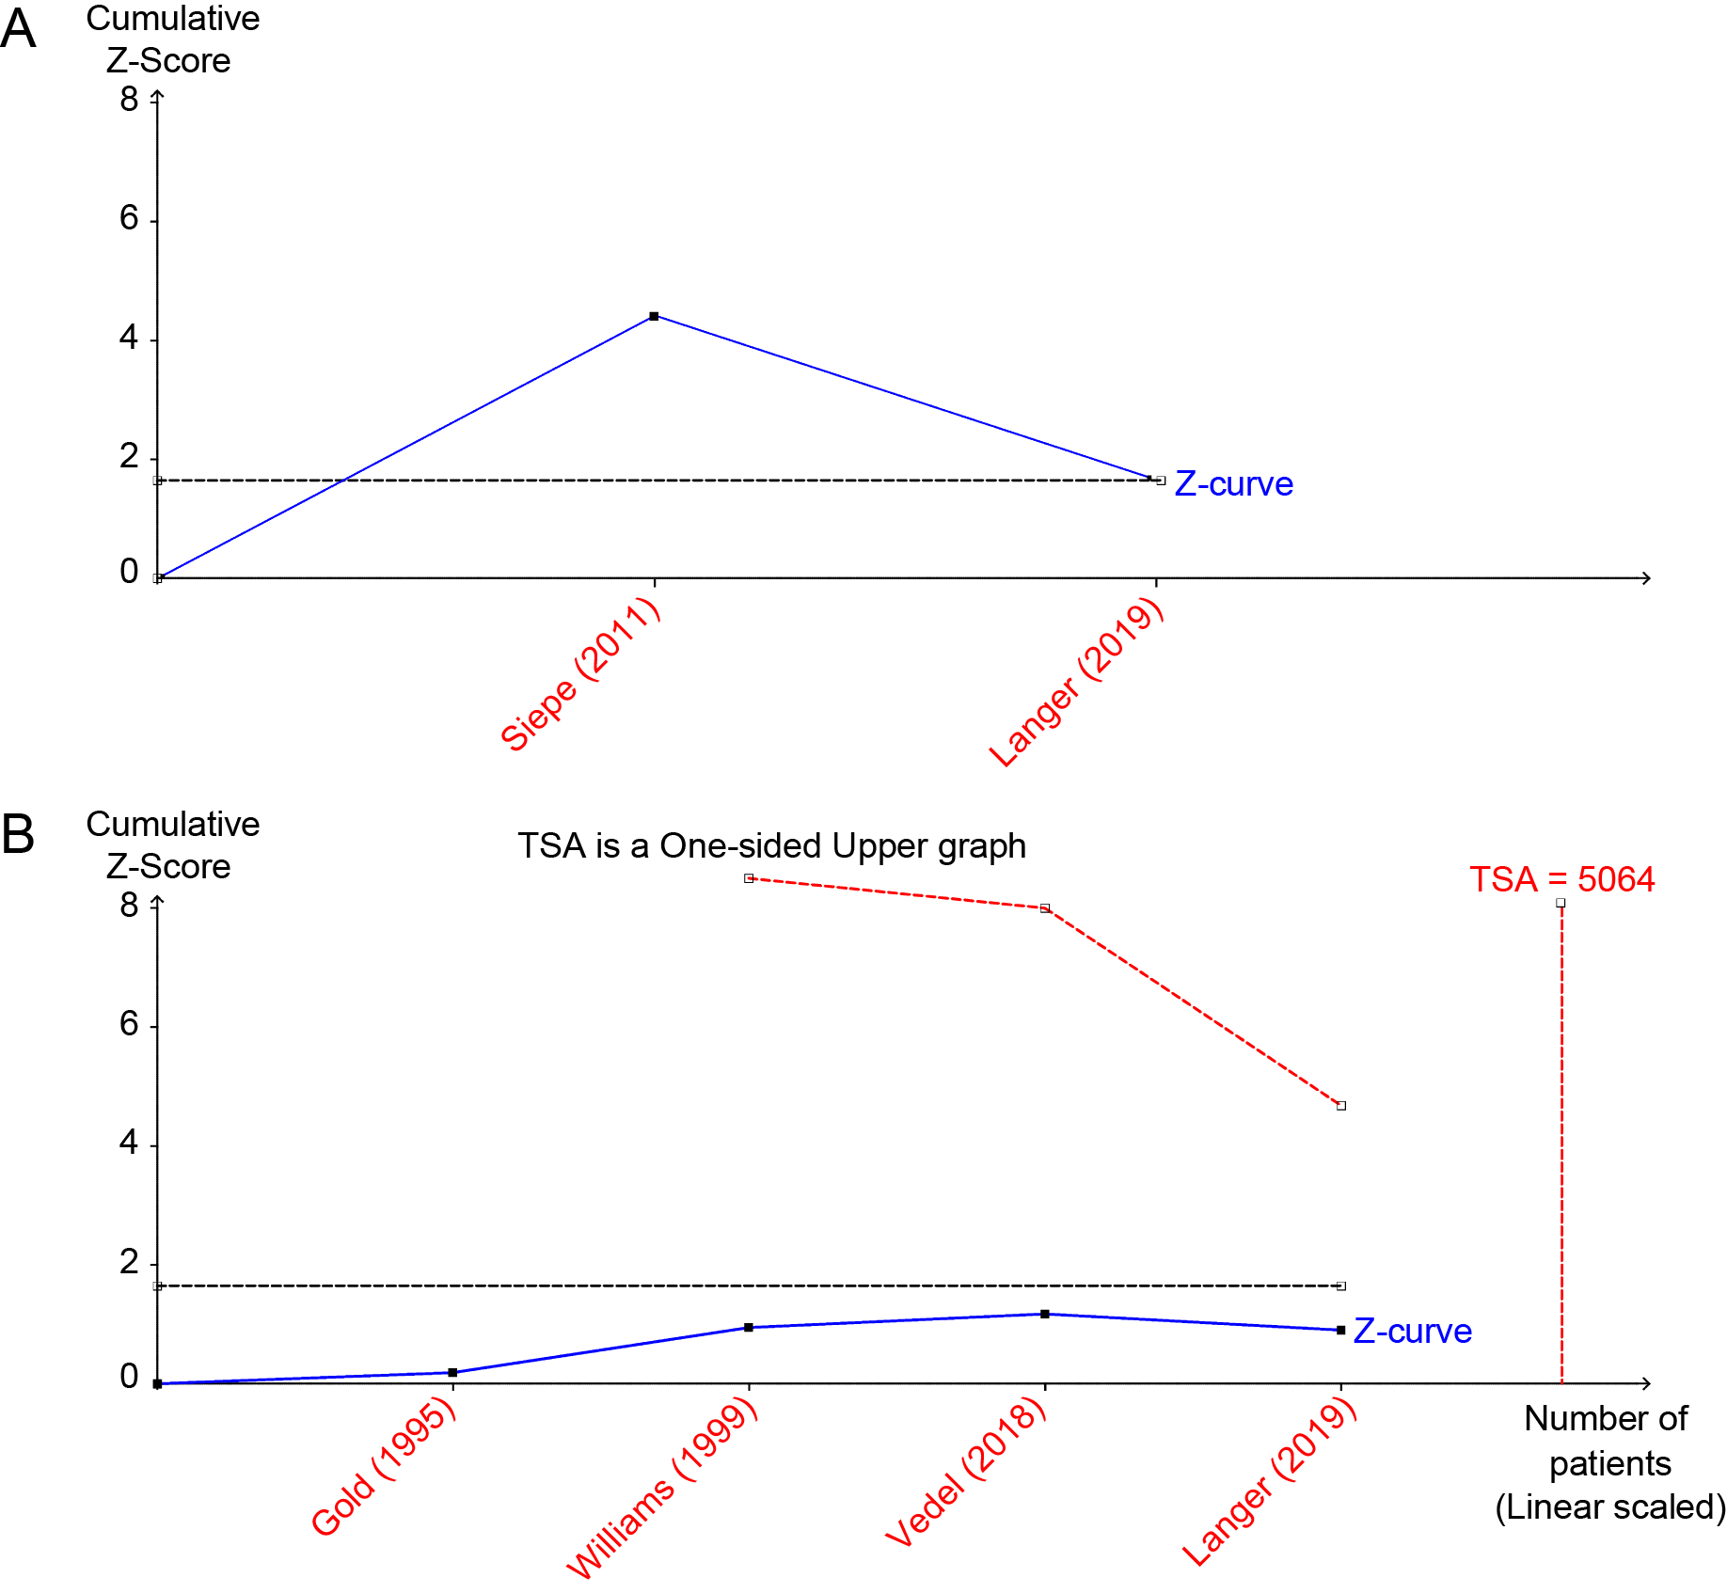
Figure S1. Trial sequential analysis of primary outcomes - incidence of POD (A) or POCD (B).

