Supplementary information

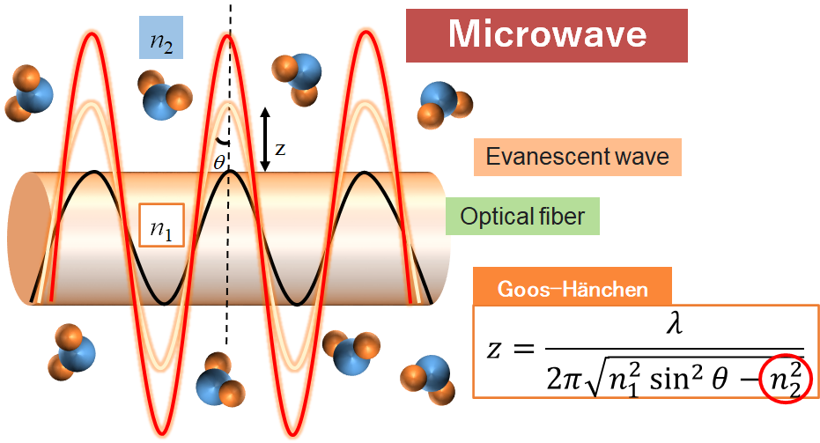
Fig. S1 Theory of evanescent around optical fibre for refractive index measurement

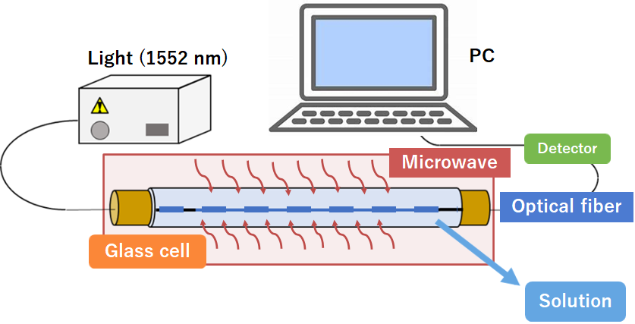 | 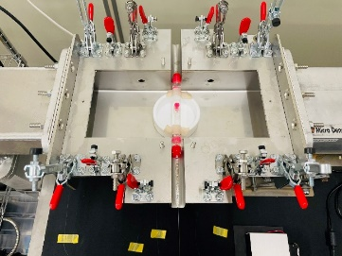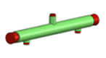  φ12  130  Cell  Size of waveguide reactor  (W:290 D:110 H:50)
(a) Schematic diagram of the system | (b) Cell size and position of the cell when the lid is opened
Fig. S2 Measurement system of refractive index during microwave irradiation

