Supplementary information
A New Path to High-Performance Supercapacitors: Utilizing Ag-embedded CoFe-Phosphate and Ti₃C₂ MXene as Hybrid Electrodes
Sonali Ajay Beknalkar¹, Aviraj Mahadev Teli^{1*}, Atul Chandrakant Khot², Tukaram Dattatray Dongale³, Manesh Ashok Yewale⁴, Kiran Arun Nirmal², Jae Cheol Shin^{1*}
¹ Division of Electronics and Electrical Engineering, Dongguk University-Seoul, Seoul 04620, Republic of Korea.
² School of Electrical Engineering, Korea University, Anam-ro 145, Seongbuk-gu, Seoul 02841, Republic of Korea.
³ School of Nanoscience and Technology, Shivaji University, Kolhapur 416004, India.
⁴ School of Mechanical Engineering, Yeungnam University, Gyeongsan, 38541, Republic of Korea.
Corresponding authors: jcshin@dgu.ac.kr (J. C. Shin); avteli.teli@gmail.com (A. M. Teli)

S.1 Experimental details of CFP and CFPAg positive electrode
S.1 (a)Materials
Cobalt(II) nitrate hexahydrate (Co(NO₃)₂·6H₂O), Iron(III) nitrate nonahydrate (Fe(NO₃)₃·9H₂O), Urea (NH₂CONH₂), Ammonium dihydrogen phosphate ([NH₄]H₂PO₄) and Ag-nanowires were purchased from Sigma Aldrich, Seoul, Republic of Korea. Here all the chemicals included in experimental section of Supplementary file are used as it is without further purification process. Deionised (DI) water used as a solvent for synthesis.

S.1 (b)Synthesis of CFP electrode on Ni-foam
We have firstly synthesized CFP electrode on Ni-foam using 5 mM Cobalt(II) nitrate hexahydrate (Co(NO₃)₂ · 6H₂O), 5 mM Iron(III) nitrate nonahydrate (Fe(NO₃)₃ · 9H₂O), 15 mM Urea (NH₂CONH₂) and 10 mM Ammonium dihydrogen phosphate ([NH₄]H₂PO₄) dissolved in 50 mL DI water by rigours stirring for 30 min. In the next step, the prepared clear solution, was transferred to a Teflon-lined stainless-steel autoclave and the cleaned Ni substrate (1 × 4 cm²) was immersed in it. The autoclave was heated at 150 ⁰C for 12 h and then allowed to cool down naturally at room temperature (~25 ⁰C). After cooling, the Ni-foam was dried at 70 ⁰C for 5 h.

S.1 (c)Synthesis of CFPAg electrode on Ni-foam
For construction of CFPAg, 5 mL of 1 wt % Ag nanowires dispersed in IPA was added to 45 mL of CFP synthesis procedure discussed in above section. Once the solution was prepared, it was transferred to a Teflon-lined stainless-steel autoclave including cleaned Ni-foam. This autoclave was heated at 150 ⁰ C for 12 h and same drying conditions discussed above were utilized.
S.2 Experimental details of MX negative electrode
S.2 (a)Materials
Hydrofluoric acid (HF, 49%) was purchased from Sigma Aldrich, Seoul, Republic of Korea. Titanium aluminium carbide (Ti₃AlC₂) powder was taken from M/s Probes Ltd., Seoul, Republic of Korea. Deionized water (DI: purified using Elix Essential 3 UV, Millipore) and ethanol were used in this study.
S.2 (b) HF acid etching protocol
When handling hazardous hydrofluoric acid (HF), it is extremely important to follow safety protocols. In a typical synthesis, a total of 3 g of MAX precursor (Ti₃AlC₂) powder was slowly added to 60 mL of 49% HF etchant while stirring with a Teflon beaker. The addition should be slow to reduce excessive bubbles formed due to exothermic reaction. The reaction is carried out at room temperature for 18 hours. The resulting powder was washed several times with DI water and ethanol by centrifugation. The washing cycle was repeated until the pH of the supernatant reached 7. Then, the Ti₃C₂ MXene powder is dried in vacuum at 80 °C for 24 h.

Figure and figure captions
Fig. S1 : XRD pattern of (a) CFP and CFPAg samples, (b) Ti₃C₂ and Ti₃AlC₂ samples.
Fig. S2 : EDS mapping analysis of CFP sample, (a) EDS representation of CFP, (b) EDS based layered image of elemental mapping of CFP sample, (c) Co, (d) Fe, (e) P, and (f) O elements.
Fig. S3 : Electrochemical measurements of electrodes in 2M KOH (a) CFP, (b) CFPAg electrodes at different scan rates, (c) column graph of capacitive and diffusion-controlled contribution of CFP electrodes at different scan rates, and (d) CV graph at 100 mV/s scan rate, diffusion (red region) and capacitive (pink region) contribution.
Fig. S4 : (a) GCD curve of CFP electrode at different current densities, (b) Nyquist plot of CFP and CFPAg at 10 mV potential after cyclic stability, inset graph of magnified Nyquist plot, (c) Nyquist plot after cyclic stability of MXene-SCNT electrode, and (d) bode plot of HS device before and after cyclic stability.
Fig. S4 : Schematic representation of assembled hybrid supercapacitor using CFPAg and MX as a positive and negative electrode respectively.

Table and table captions
Table S1 : EDS analysis in weight % of CFP and CFPAg samples.
Table S2 : Calculated value of areal capacitance, specific energy, specific power and rate capability at different current densities of CFP electrode.
Table S3 : Evaluated series and charge transfer resistances of CFP, CFPAg, and MXene electrodes measured before and after cyclic stability.
Table S4 : Series and charge transfer resistances of hybrid supercapacitor device measured before and after cyclic stability.

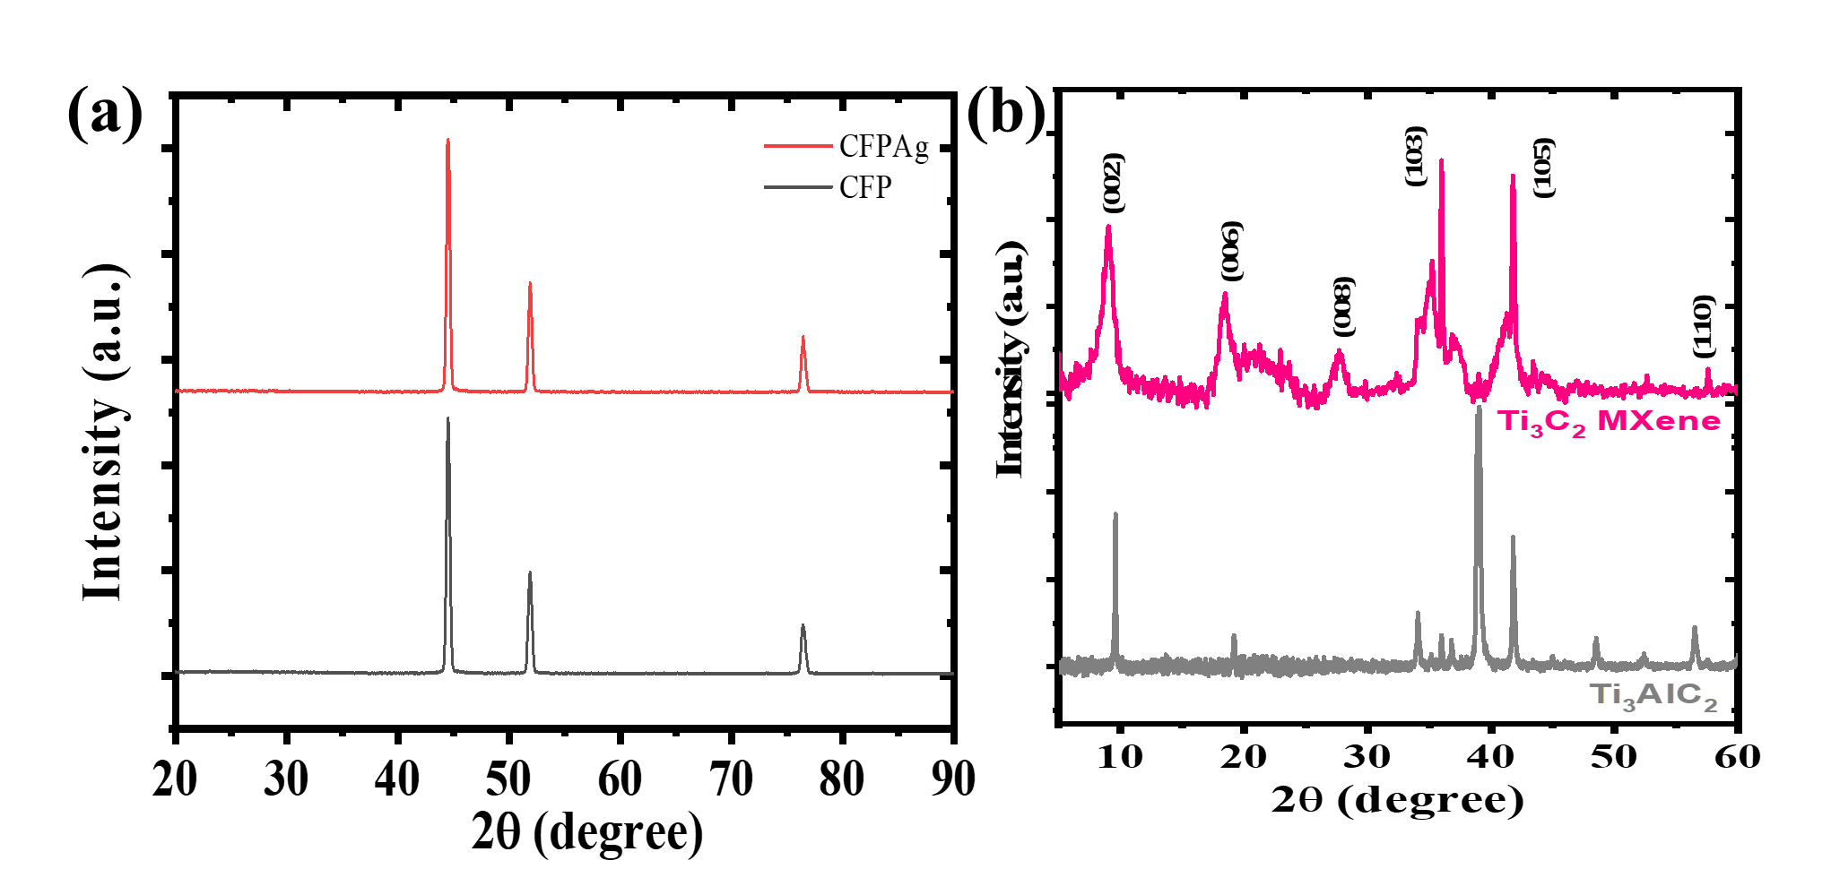
Fig. S1 (a – b)
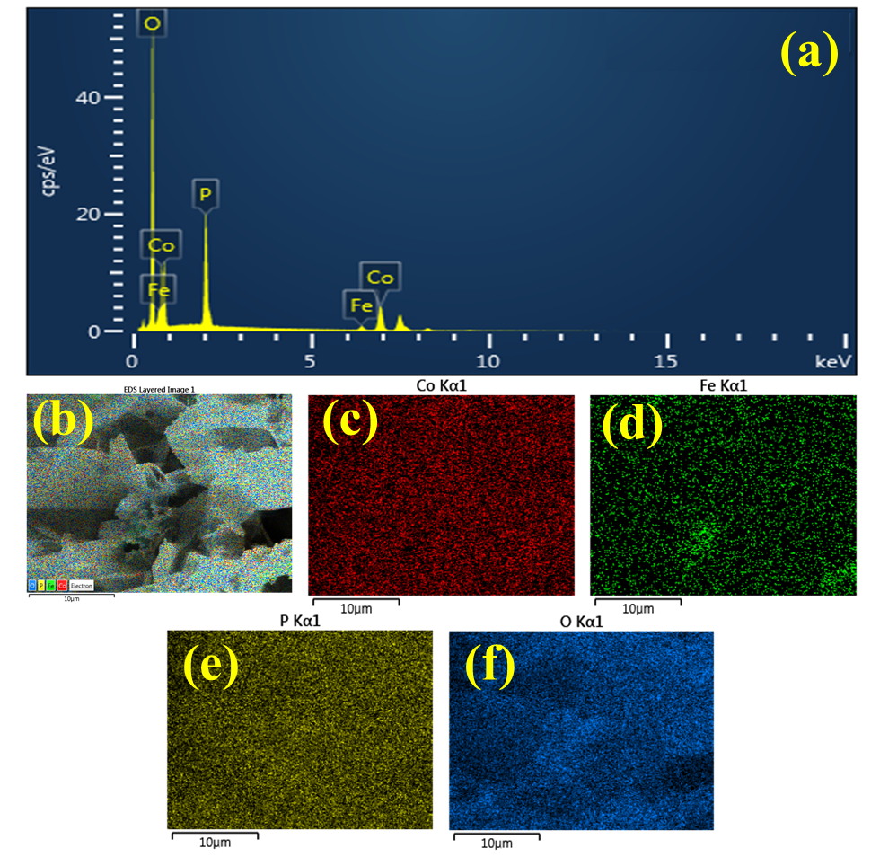
Fig. S2 (a – f)
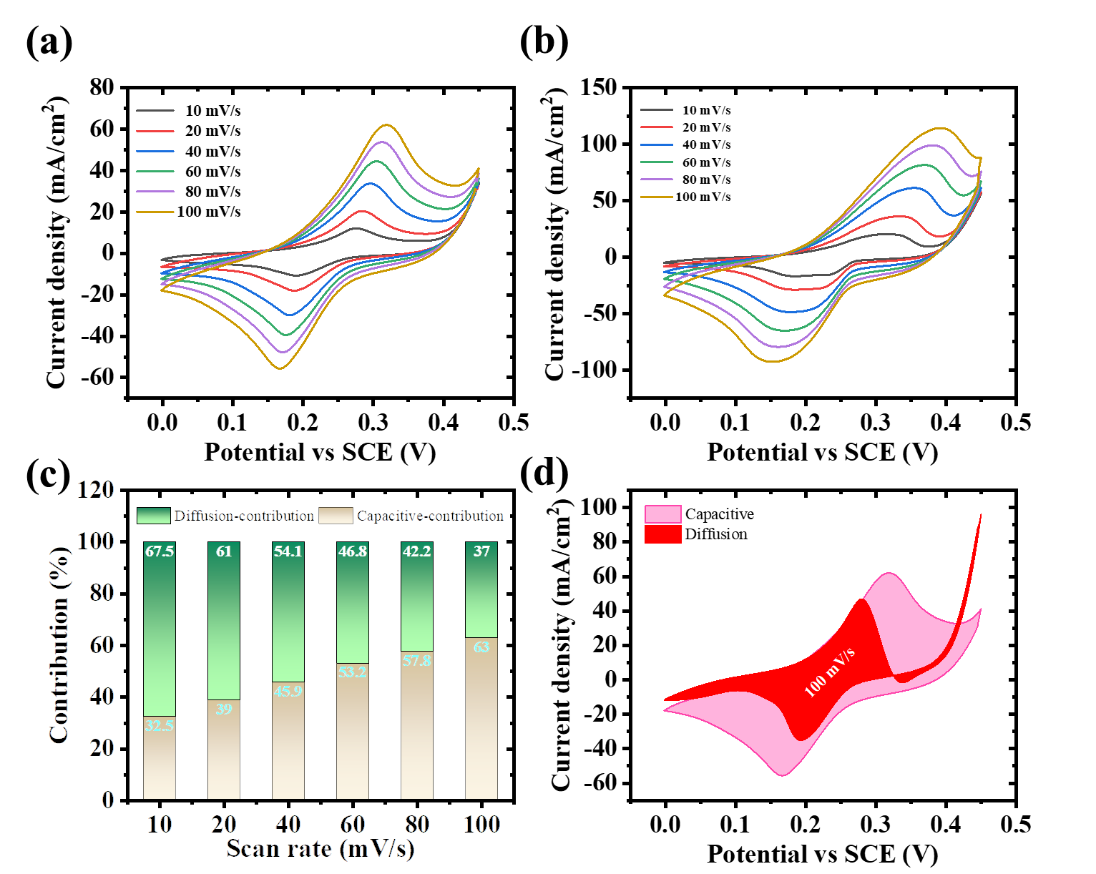
Fig. S3 (a – d)
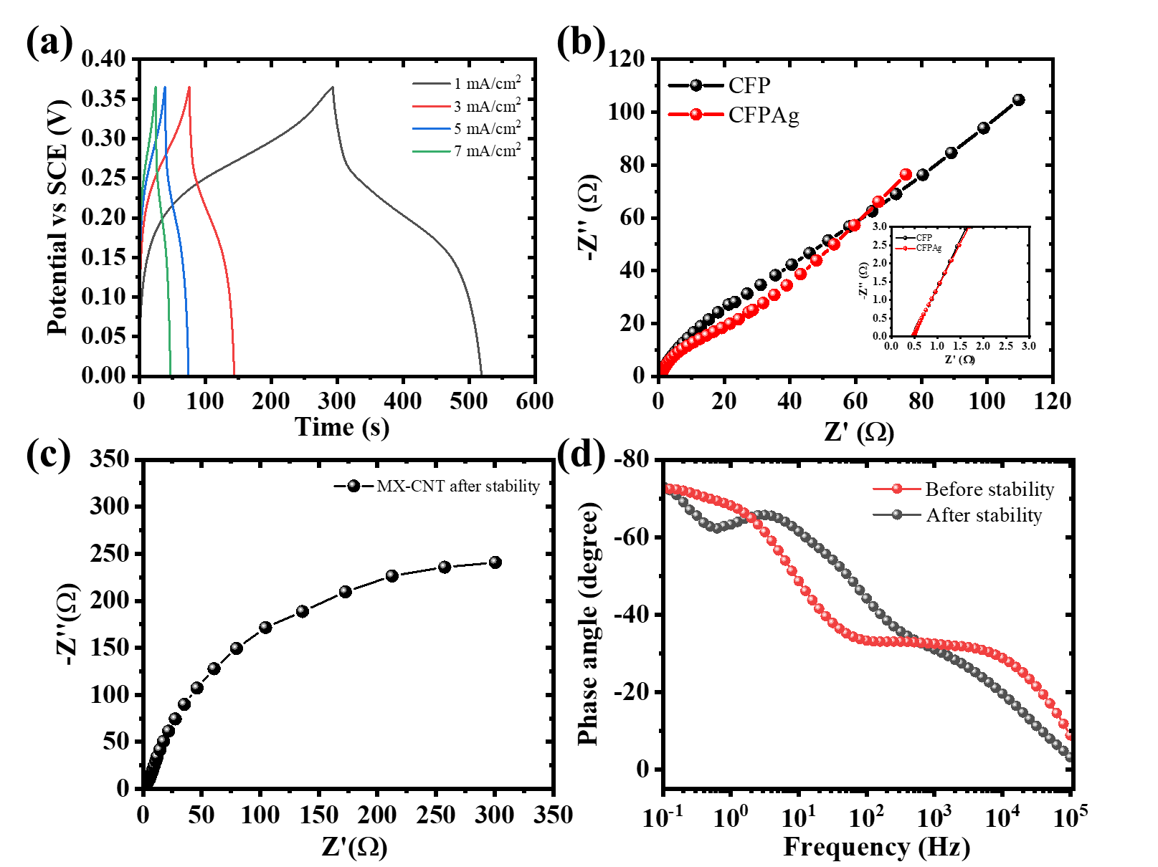
Fig. S4 (a - d)
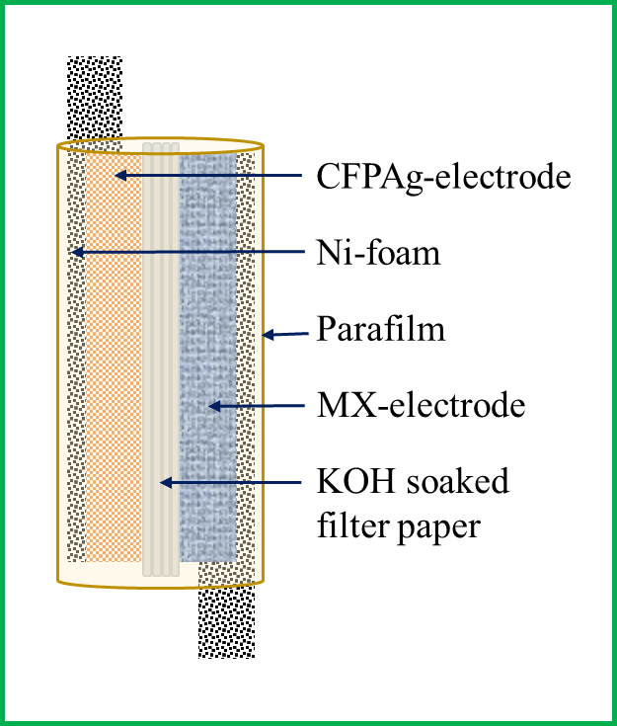
Fig. S5

Elements | CFP (wt.%) | CFPAg (wt.%)
o | 57.66 | 68.09
P | 13.43 | 11.96
Fe | 3.32 | 9.72
Co | 25.59 | 7.44
Ag | - | 2.79
Total | 100 | 100
Table S1

Current density (mA/cm²) | Areal cap. (mF/cm²) | Specific energy (μWh/cm²) | Specific power (mW/cm²) | Rate capability (%)
1 | 616.4 | 5.7 | 0.18 | 100
3 | 550.7 | 5.1 | 0.54 | 89.3
5 | 506.8 | 4.7 | 0.91 | 82.2
7 | 441.1 | 4.1 | 1.27 | 71.6
Table S2

Resistances | Before stability |  |  | After stability
Resistances | CFP | CFPAg | MXene | CFP | CFPAg | MXene
Series resistance (mΩ) | 530.0 | 481.5 | 313.6 | 476.7 | 486.0 | 436.2
Charge transfer resistance (Ω) | 12.3 | 12.9 | 6.4 | 53.5 | 27.6 | 100
Table S3

Resistances | Hybrid supercapacitor device
Resistances | Before stability | After stability
Series resistance (Ω) | 1.2 | 1.6
Charge transfer resistance (Ω) | 12 | 84
Table S4

