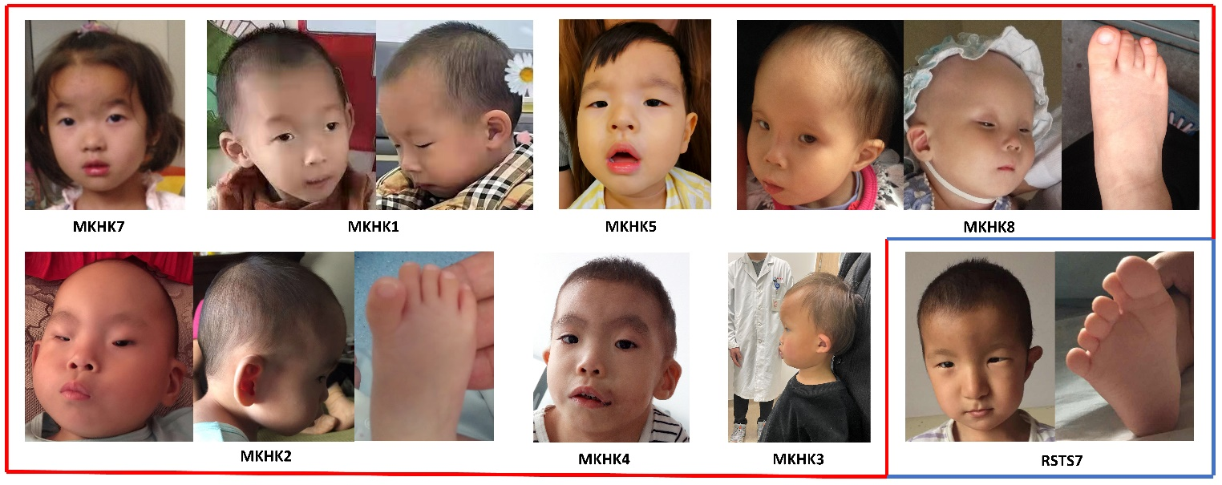
Figure S1 Facial and foot morphology of individuals with CREBBP variants in this study
Photographs of MKHK or RSTS patients with CREBBP variants are displayed when available. Blue and red lines separate MKHK and RSTS categories from each other. MKHK patients exhibit both comparable and distinctive traits. MKHK2, MKHK3, MKHK4, MKHK8 (IDR group) resembled one another strikingly. Representative facial characteristics are short and upslanted palp fissure, depressed nasal ridge, short nose and anteverted nares, long philtrum, everted vermilion of upper lip. MKHK1, MKHK5, MKHK7 (non-IDR group) showed less specific facial features. The halluces of MKHK2 and MKHK8 displayed partial cutaneous syndactyly. RSTS7 presented with downslanted palp fissure, hypertelorism, prominent beaked nose, micrognathia, broad halluces and polydactyly.

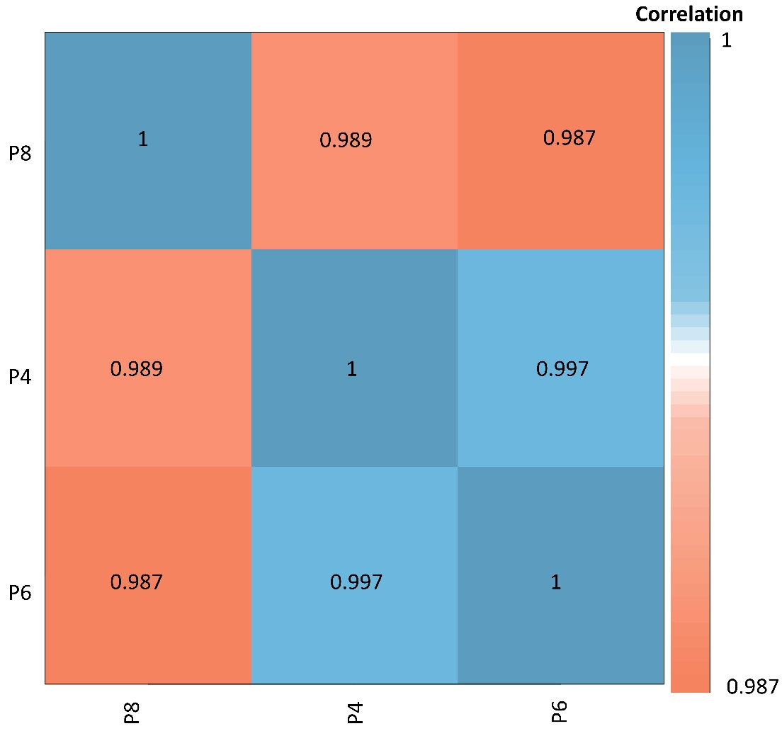
Figure S2 hiPSC correlation in different passages
Different generations (P4, P6, P8) of undifferentiated RSTS2 hiPSCs were used to analyze the correlation of DNA methylation differences in distinct cell passages. The methylation analysis revealed at least a 98% concordance of hiPSC in different passages.

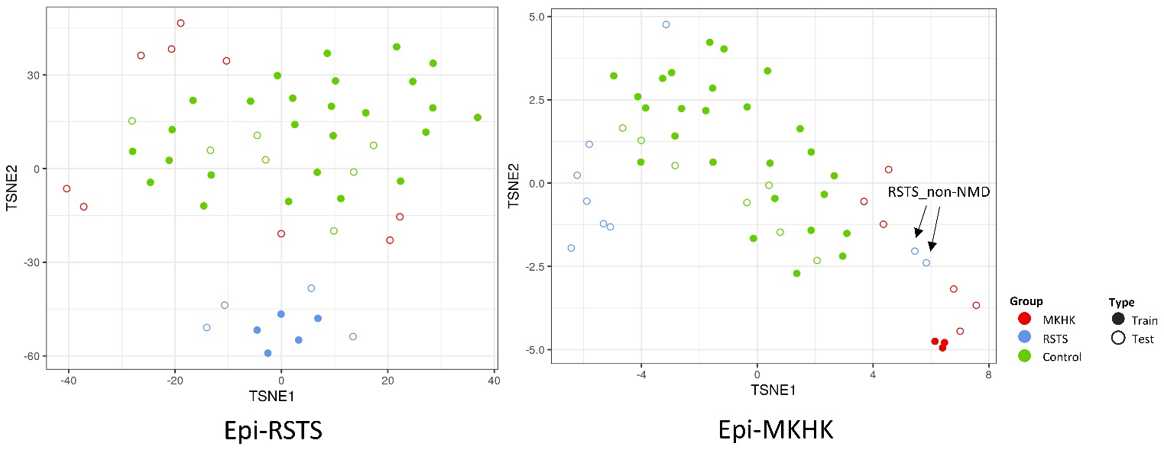
Figure S3 T-SNE analysis based on RSTS and MKHK blood-derived episignature
With non-redundant methylation sites in establishing RSTS and MKHK_IDR SVM model, t-SNE analysis was used to visualize and explore RSTS and MKHK episignatures. Epi-RSTS: t-SNE analysis showing clusters of RSTS subjects (training n=5, test n=4; blue), MKHK subjects (test n=9; red) and healthy controls (training n=26, test n=7; green) in the RSTS episignature. RSTS subjects clearly separate from all other samples, with MKHK subjects discretely mixed with healthy controls. Epi-MKHK: t-SNE analysis showing clusters of MKHK subjects (training n=3, test n=6; red), RSTS (test n=9; blue) and healthy controls (training n=26, test n=7; green) in the MKHK episignature. Two RSTS_non-NMD subjects were indicated by arrows.

