Supporting information

Growth control of Marchantia polymorpha gemmae using nonthermal plasma irradiation

Shoko Tsuboyama¹, Takamasa Okumura², Pankaj Attri³, Kazunori Koga^{2, 4}*, Masaharu Shiratani^{2, 3}, and Kazuyuki Kuchitsu¹**

¹Department of Applied Biological Science, Tokyo University of Science, 2641 Yamazaki, Noda city, Chiba, 278-8510, Japan
²Faculty of Information Science and Electrical Engineering, Kyushu University, Fukuoka 819-0395, Japan
³Center of Plasma Nano-interface Engineering, Kyushu University, Fukuoka 819-0395, Japan
⁴Center for Novel Science Initiatives, National Institute of Natural Science, Tokyo 105-0001, Japan

These authors contributed equally: Shoko Tsuboyama and Takamasa Okumura
Co-corresponding Authors:
*Kazunori Koga
744 Motoka, Fukuoka city, Fukuoka, 819-0395, Japan
Tel: +81-92-802-3716
Fax: +81-92-802-3717
E-mail: koga@ed.kyushu-u.ac.jp

**Kazuyuki Kuchitsu
2641 Yamazaki, Noda city, Chiba, 278-8510, Japan
Tel: +81-4-7122-9404
Fax: +81-4-7123-9767
E-mail: kuchitsu@rs.tus.ac.jp

Figure captions
Fig. S1 Discharge power consumed by SDBD plasma with the applied voltage.
Fig. S2 The shapes of lobes of plasma irradiated gemmalings.
Fig. S3 Standard curve for H₂O₂ concentration.
Fig. S4 Standard curve for concentration of (a) nitrite ion NO₂⁻ and (b) nitrite ion NO₂⁻ and nitrate ion NO₃⁻.

Fig. S1

Discharge power consumed by SDBD plasma was measured by V-Q Lissajous method using a high voltage probe P6015A (Tektronix, Oregon, USA), a digital oscilloscope DS-5110B (Iwatsu, Tokyo Japan), and a capacitor of 100 nF inserted between the SDBD electrode and the ground.

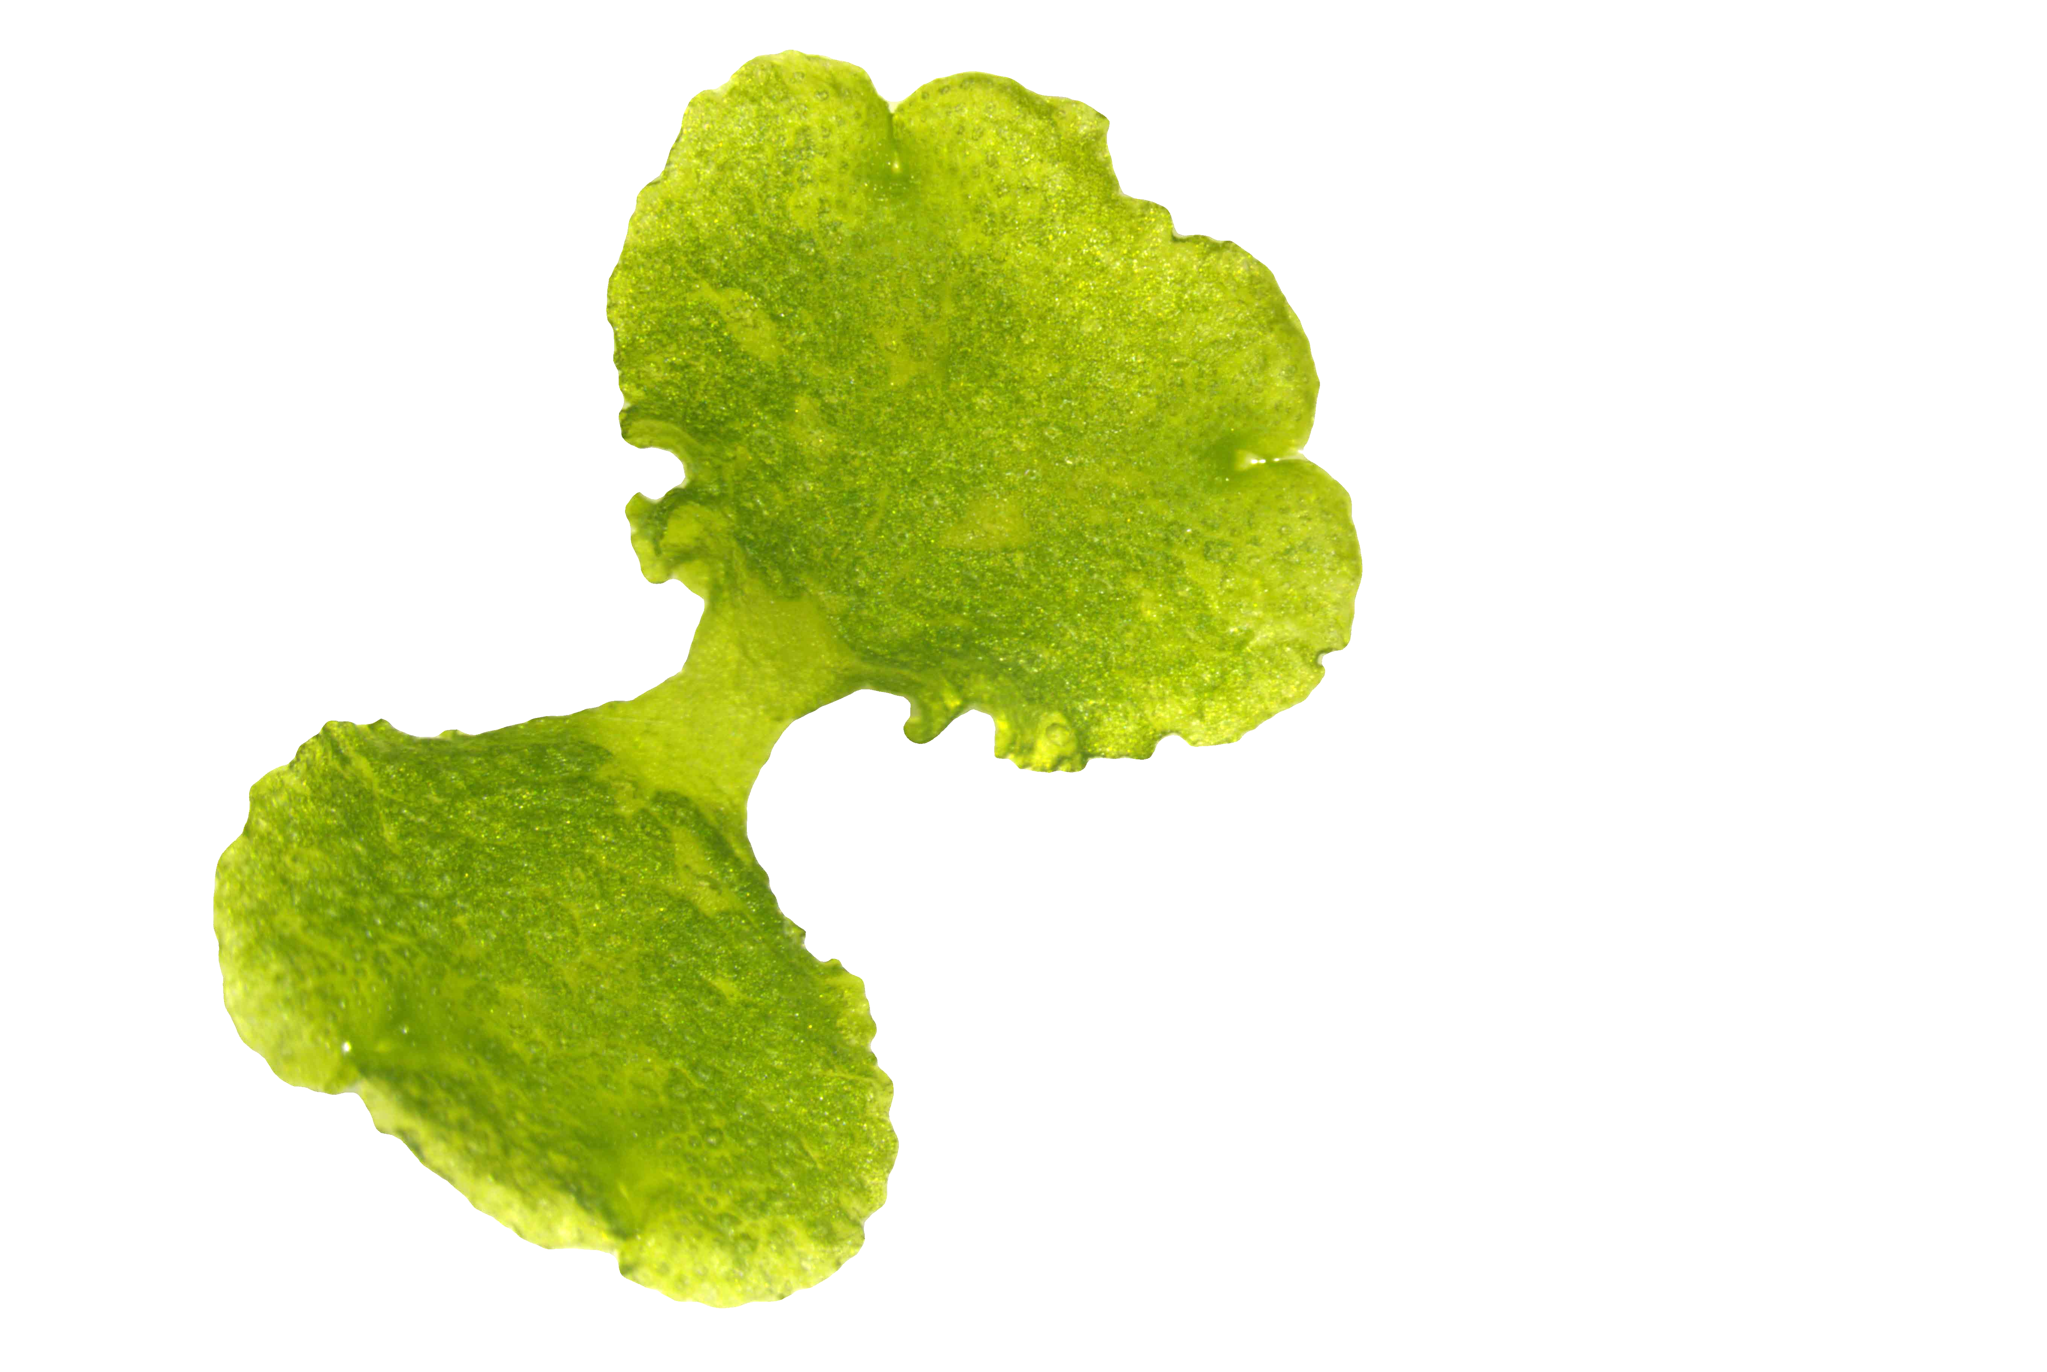
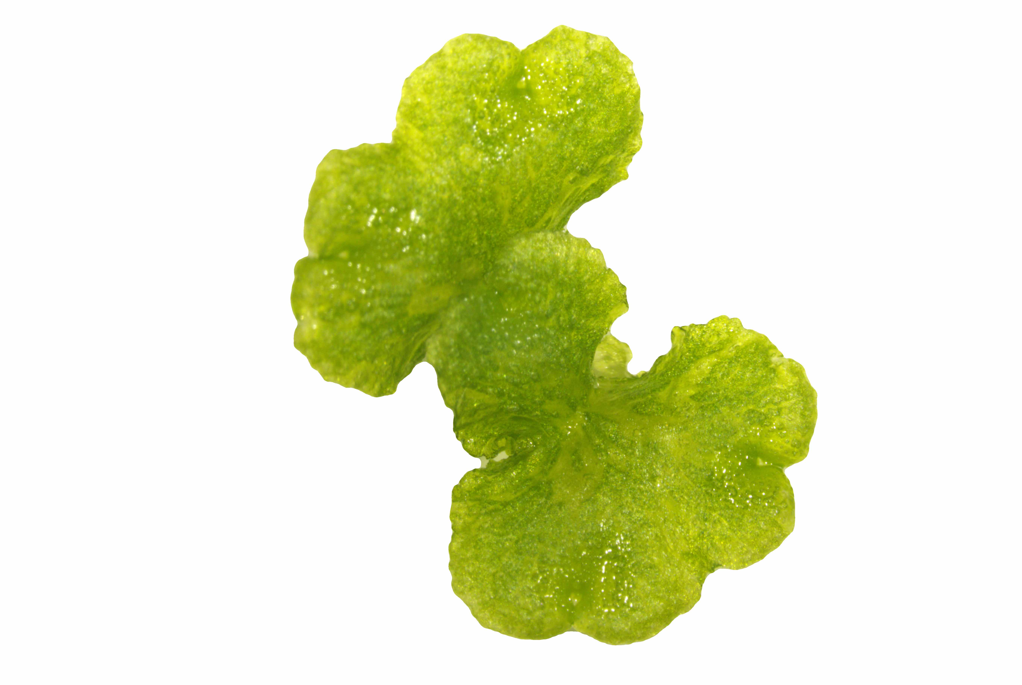
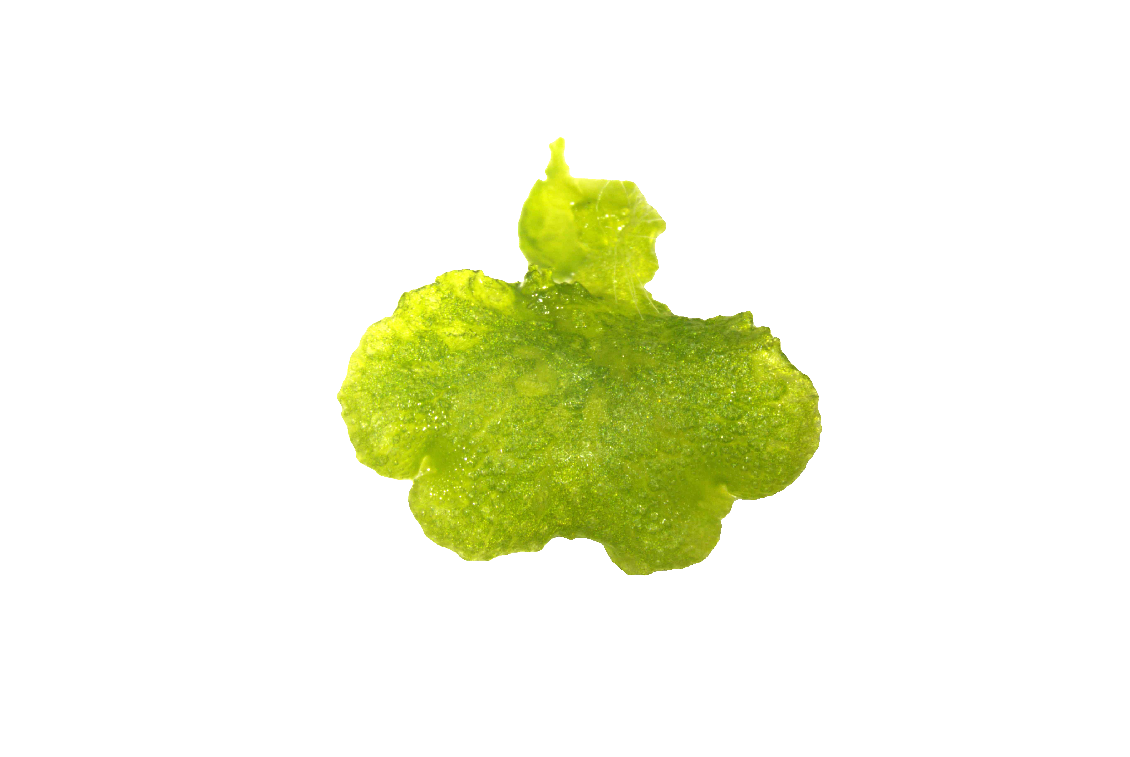
A
B
C

D

Fig. S2

The representative pictures of various shapes of gemmalings in (A–C). The pictures were taken by a S8AP0 microscope (Leica Microsystems, Wetzlar, Germany) and a WRAYCAM-NOA2000 digital camera (WRAYMER, Osaka, Japan). The black dotted line in the center of gemmaling indicates the boundary between the two lobes. The black line traces the lobe of normal shape. Each black bars indicate 5 mm. (A) The normal shape of gemmaling. (B) The gemmaling with an additional lobe on one side lobe. Red dotted line and red arrows indicate the additional lobe. (C) The gemmaling with a growth-inhibited lobe. Blue dotted line and blue arrow indicates the growth-inhibited lobe. (D) The frequency of various shape of each lobe.

Fig. S3

Standard curve was obtained by colorimetry using Hydrogen Peroxide Assay Kit ab102500 (Abcam, Cambridge, UK) and a micro plate reader SynergyHT (Biotec, Tokyo, Japan). The OD value with the concentration was obtained at absorption at 570 nm (standard curve equation: y = 0.0138x - 0.0284, R² = 0.997). The measurement was performed according to the protocol.

(a)

(b)
Fig. S4

Standard curves were obtained by colorimetry using NO₂/NO₃ Assay Kit-C II NK05 (Dojindo Laboratory, Kumamoto, Japan) and a micro plate reader SynergyHT (Biotec, Tokyo. Japan). The OD values with the concentration were obtained at absorption at 540 nm. The standard curve specifications were y = 0.0131 x - 0.0712 (R² = 0.984) for NO₂⁻ and y = 0.00828 x – 0.0102 (R² = 0.999) for NO₂⁻ and NO₃⁻. The measurement was performed according to the protocol.

