Barnacle Cement Protein: An Efficient Bioinspired Corrosion Inhibitor
My Hanh Bui^{1,#}, Shu Hui Hiew^{1,#}, Wuan Geok Saw², Richard Webster³, Gerhard Grüber², Yuguang Mu², and Ali Miserez*^{1,2}
¹ Center for Sustainable Materials (SusMat), School of Materials Science and Engineering, Nanyang Technological University, Singapore 639798
² School of Biological Sciences, Nanyang Technological University, Singapore 637551
³ School of Chemistry and Biological Chemistry, Nanyang Technological University, Singapore 639798

Supplementary Information

Supplementary Figures

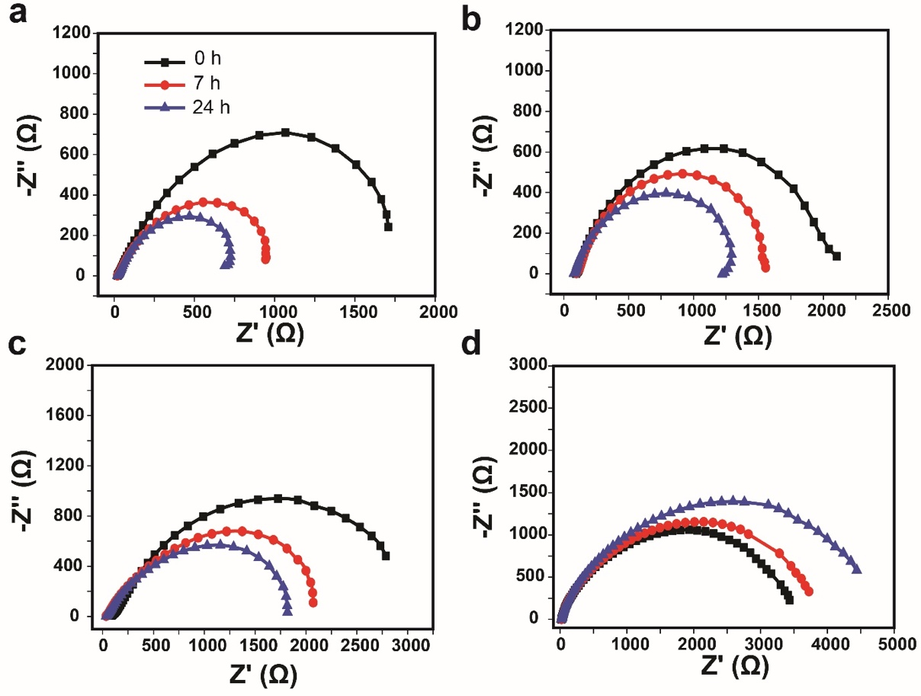
Supplementary Figure 1. Nyquist plots of AH36 in buffer solution containing different concentration of rMrCP20. a. Control (without protein), with b. 1 mg/mL, c. 3 mg/mL and d. 5 mg/mL of rMrCP20 after 0 h (black), 7 h (red) and 24 h (blue).
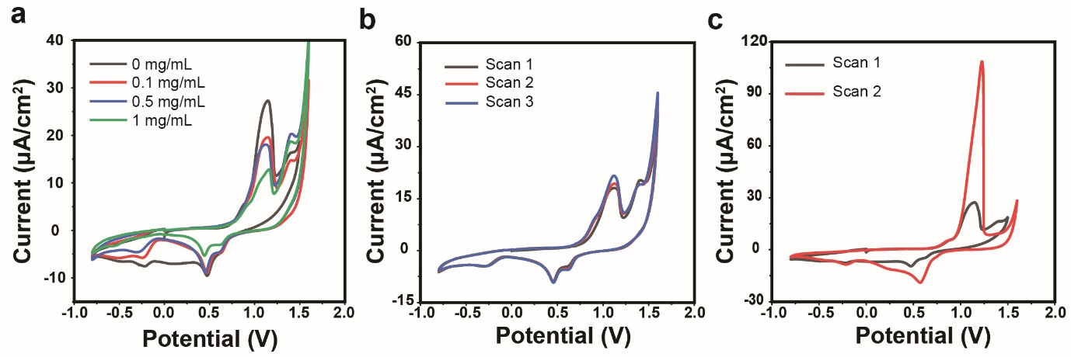
Supplementary Figure 2. Cyclic voltammograms of working electrodes in the presence of varying rMrCP20 concentrations. a Cyclic voltammograms of 1st cycle of working electrode in at different rMrCP20 concentrations. b 3 scanning cycles of electrode in the presence of 1 mg/mL rMrCP20. c 2 scanning cycles of electrode in buffer.
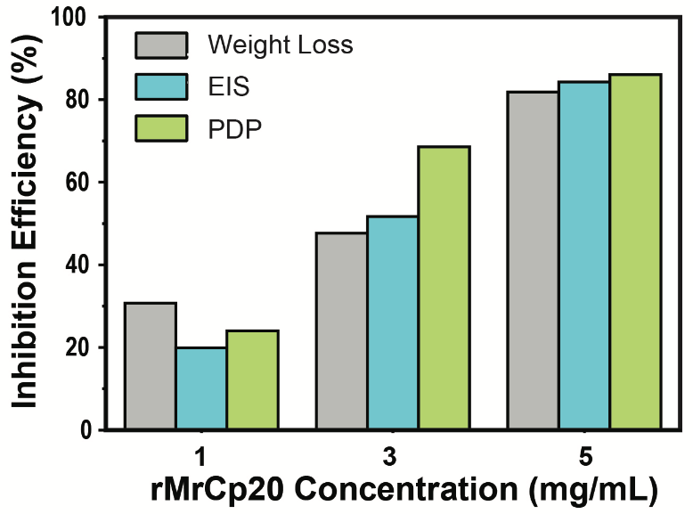
Supplementary Figure 3. Plots showing the corrosion inhibition efficiency of rMrCP20 at different concentrations based on weight Loss, EIS and PDP data.

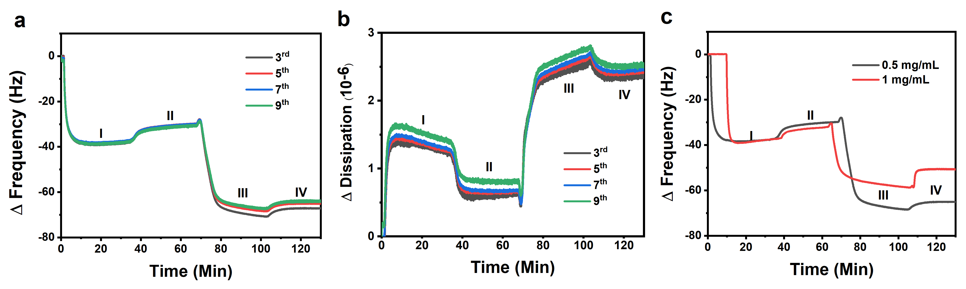
Supplementary Figure 4. a. QCM-D signals frequency and b dissipation of various harmonics during rMrCp20 adsorption onto Fe substrate and subsequent interaction with Fe³⁺. (i) rMrCp20 adsorbs on Fe sensor substrate; (ii) rinse with buffer to remove loose bound protein; (iii) introduction of 100 μM FeCl₃ on to pre-adsorbed rMrCp20 layer, (iv) rinsing with buffer to remove loose bound molecules. c QCM-D frequency shifts of 1 mg/mL (red) and 0.5 mg/mL (black) rMrCP20.

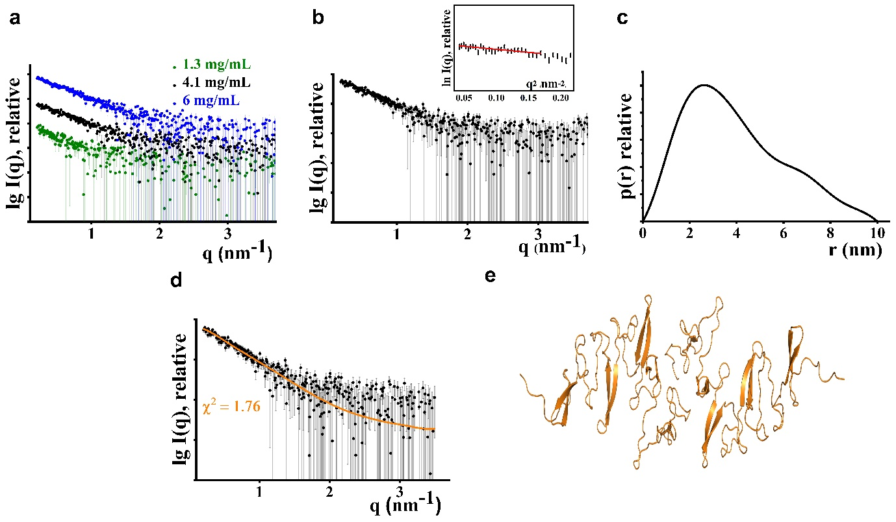
Supplementary Figure 5. Small-angle X-ray scattering (SAXS) studies of rMrCP20. a SAXS patterns (○) at protein concentrations of 1.3 (green), 4.1 (black) and 6 (blue) mg/mL. b SAXS patterns (○) at 4.1 (black) mg/mL and its (Right inset) Guinier plot showed linearity, indicating no protein aggregation. c Pair-distance distribution function P(r) of rMrCP20 at 4.1 mg/mL. d SAXS pattern of rMrCP20 at 4.1 mg/mL (○; black) and the theoretical fit lines (—) calculated from the predicted dimeric AlphaFold model. e Structure of rMrCP20 dimer obtained by AlphaFold.
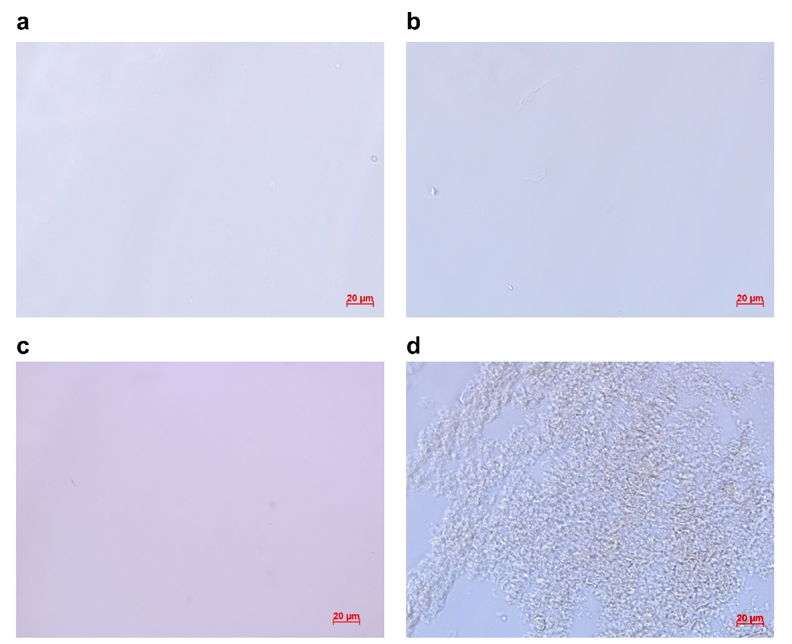
Supplementary Figure 6. Optical microscopy micrographs a. Buffer. b. rMrCP20. c. FeCl₃. d. rMrCP20:FeCl₃ at a 1:60.

Supplementary Tables

Supplementary Table 1. Measured weight loss of AH36 after 24 h of incubation in buffers of different rMrCp20 concentrations, with the corresponding corrosion rate and inhibition efficiency.
rMrCp20 Concentration (mg/mL) | Average Total Iron Release (mg) | Corrosion Rate (mmyr⁻¹) | η (%) | θ
0 | 2.24 ± 0.2 | 1.04
0.1 | 1.95 ± 0.07 | 0.91 | 12.85 | 0.13
0.5 | 1.84 ± 0.11 | 0.85 | 18.01 | 0.18
1 | 1.55 ± 0.03 | 0.72 | 30.72 | 0.31
3 | 1.17 ± 0.04 | 0.54 | 47.69 | 0.48
5 | 0.41 ± 0.05 | 0.19 | 81.82 | 0.82
10 | 0.26 ± 0.07 | 0.12 | 88.48 | 0.88

Supplementary Table 2. R² values of fitting the weight loss data into various adsorption isotherm models
Model | Adsorption Isotherm | $$R^{2}$$
Langmuir | $$\frac{C_{inh}}{θ}=\frac{1}{K_{ads}}+ C_{inh}$$ | 0.94
Temkin | $$θ=lnC_{inh}+K_{ads}$$ | 0.86
Freundlich | $$logθ=\frac{1}{n}logC_{inh}+logK_{ads}$$ | 0.96
Flory–Huggins | $$log\frac{θ}{C_{inh}}=blog\left(1-θ\right)+logK_{ads}$$ | 0.63
Frumkin | $$logC_{inh}\frac{θ}{1-θ}=2aθ+2.303logK_{ads}$$ | 0.95
El-Awady | $$log\frac{θ}{1-θ}=ylogC_{inh}+\log{K, K_{ads}=K^{1/y}}$$ | 0.88

Supplementary Table 3. SAXS structural parameters of rMrCP20.

rMrCP20 | 4.1 mg/mL | 6 mg/mL
R_{g} (nm) (Guinier) | 3.13 ± 0.26 | 4.04 ± 0.32
I(0) (Guinier) | 0.0065 ± 0.0004 | 0.0091 ± 0.0006
R_{g} (nm) (P(r)) | 3.03 ± 0.08
I(0) (P(r)) | 0.0060 ± 0.0002
D_{max} (nm) (P(r)) | 9.5
Porod volume (nm³) (V_{p}) | 64 ± 6.4
MW determined from Vp | 42 ± 4.2
DAMMIF excluded volume (nm³) (V_{EX}) | 90 ± 9
No. of monomer | 45 ± 4.5

