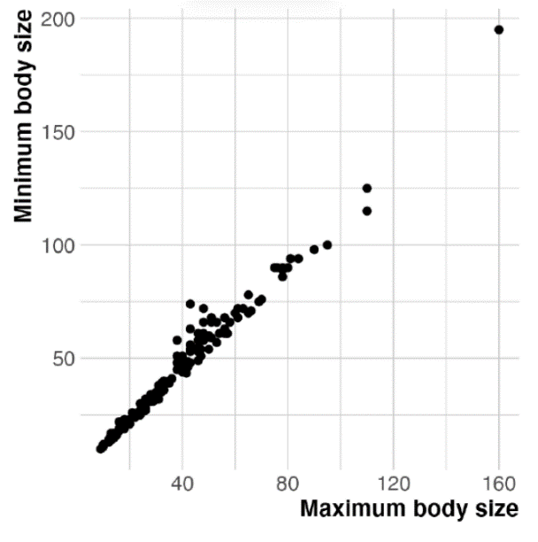

Supplementary Figure S1
Correlation between minimum and maximum size. Minimum size was used as proxy data for maximum size because maximum size is frequently lacking in databases.

