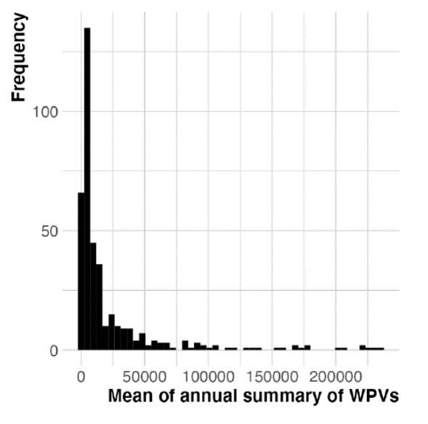

Supplementary Figure S2
The distribution of the mean annual summary of Wikipedia pageviews. The analysis was performed using generalized linear models, specifying a negative binomial distribution for the probability distribution and a log link function for the link function.

