A fully integrated, standalone stretchable device platform with in-sensor adaptive machine learning for rehabilitation

Hongcheng Xu¹, Weihao Zheng¹, Yang Zhang², Yunlong Zhao³, Weidong Wang^{1*}, Yangbo Yuan¹, Ji Zhang¹, Zimin Huo¹, Yuejiao Wang⁴, Ningjuan Zhao¹, Yuxin Qin¹, Ke Liu¹, Ruida Xi¹, Dandan Xu¹, Gang Chen¹, Haiyan Zhang¹, JunYu Yan¹, Chu Tang⁵, Qi Ge⁶, Huanyu Cheng^{7*}, Yang Lu^{8*}, Libo Gao^{3*}
¹School of Mechano-Electronic Engineering, Xidian University, Xian 710071, China
²Department of Medical Electronics, School of Biomedical Engineering, Air Force Medical University, Xi’an 710032, China
³Pen-Tung Sah Institute of Micro-Nano Science and Technology, Xiamen University, Xiamen, 361102, China
⁴Applied Mechanics Laboratory, Department of Engineering Mechanics, Tsinghua University, Beijing 100084, P.R. China
⁵Engineering Research Center of Molecular and Neuro Imaging, Ministry of Education, School of Life Science and Technology, Xidian University, Xi’an, Shaanxi 710126, China
⁶Department of Mechanical and Energy Engineering, Southern University of Science and Technology, Shenzhen 518055, China.
⁷Department of Engineering Science and Mechanics, The Pennsylvania State University, University Park, PA 16802, USA
⁸Department of Mechanical Engineering, The University of Hong Kong, Pokfulam, Hong Kong 999077, Hong Kong SAR
*Author to whom correspondence should be addressed:
E-mail: wangwd@mail.xidian.edu.cn (W.W.); Huanyu.Cheng@psu.edu (H.C.); ylu1@hku.hk (L.Y.); lbgao@xmu.edu.cn (L.G.)
Note 1: Offline sample collection for testing convolutional neural network.
The overall trained data were collected from five healthy human subjects (i.e., four males and one female) who were asked to perform the designed behavior tasks. To validate the convolution neural network (CNN)-based network model and evaluate signal quality, the 2D-SFE was used to analyze the laryngeal activities with three performing states from two new human subjects (not used for the above training). These states were to mimic the physical conditions and special movements/actions of patients. Three performing states include: 1) random interference to the biophysical behaviors (e.g., drinking water while coughing and talking with others while swallowing); 2) all activities with random chewing; 3) tested actions with nodding.
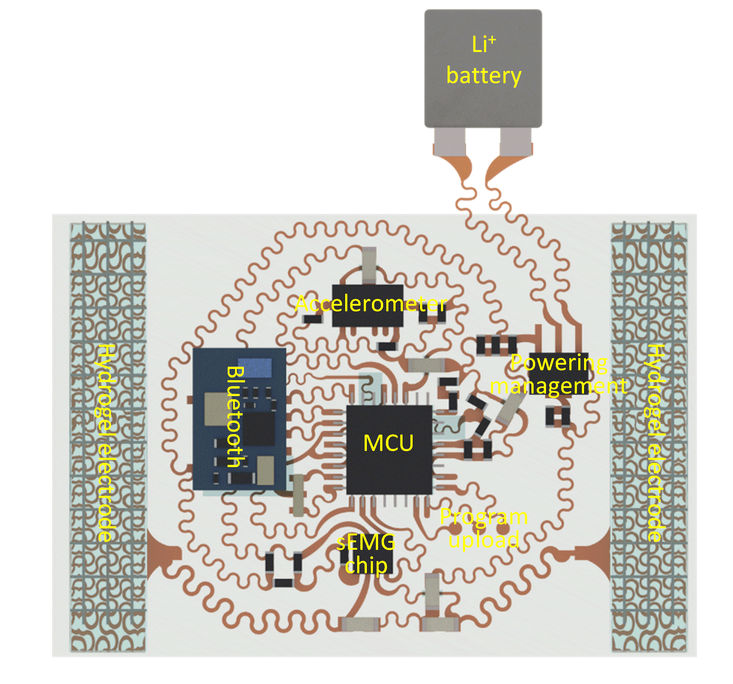
Fig. S1. Schematic showing the device components in the laryngeal patch.

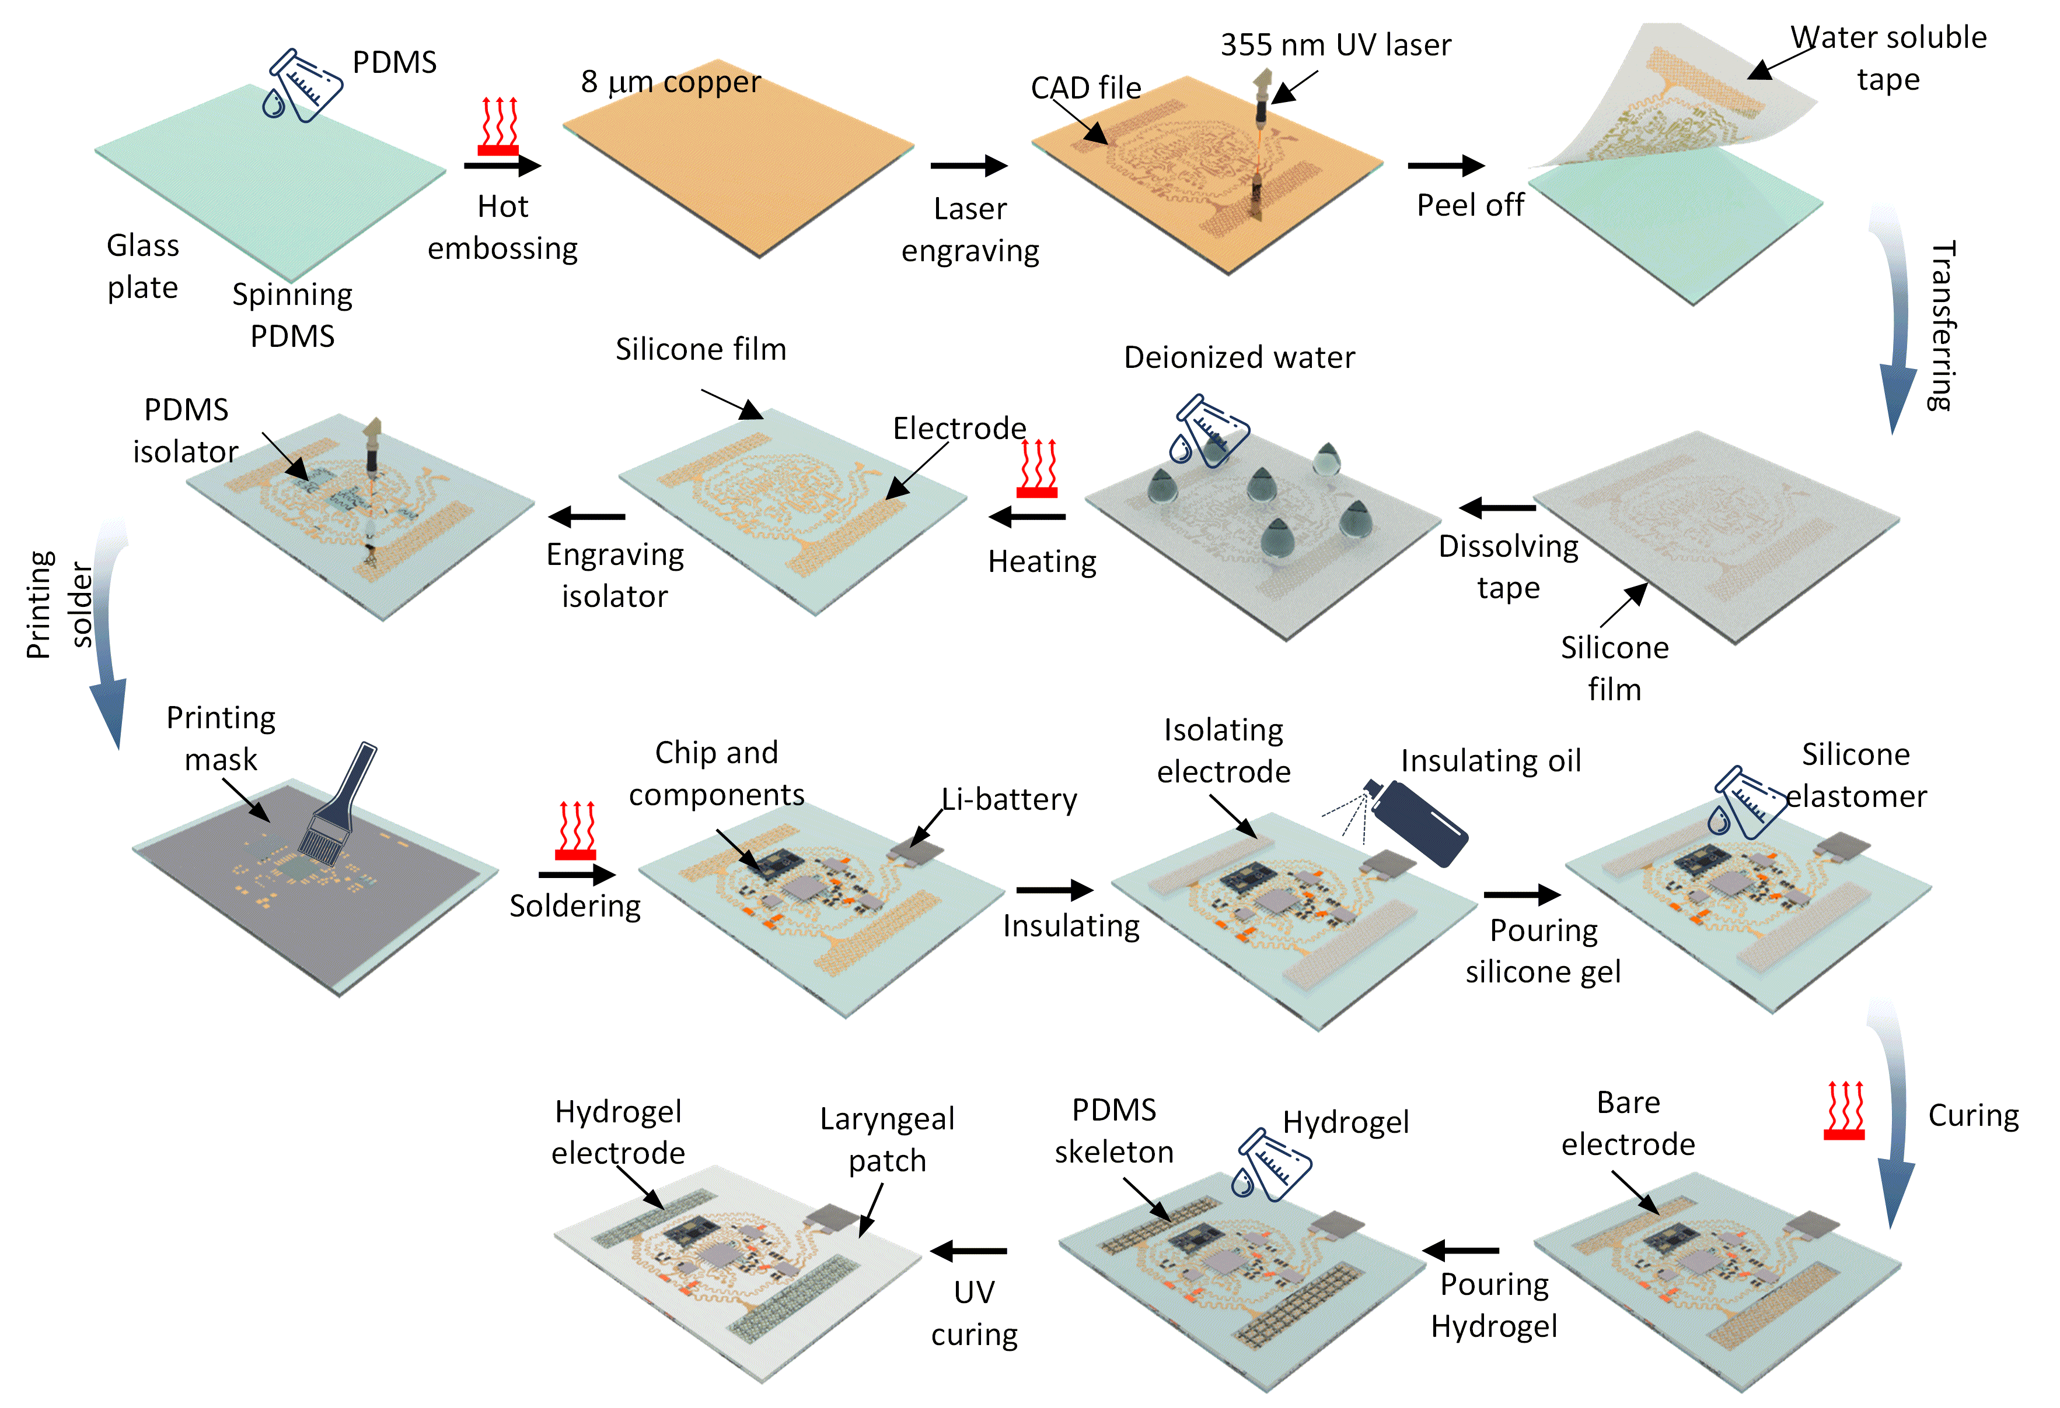
Fig. S2. Fabrication process of the laryngeal patch.

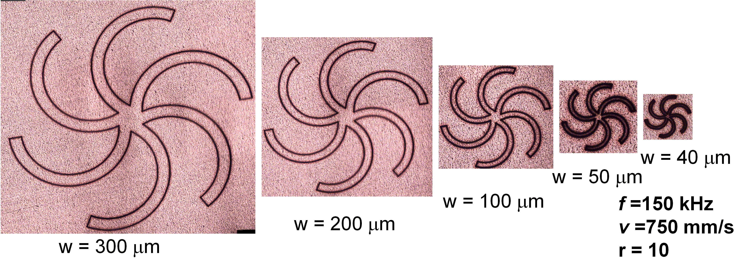
Fig. S3. Optical images of the serpentine structures with different line widths under 10 repeated continuous laser engraving steps.

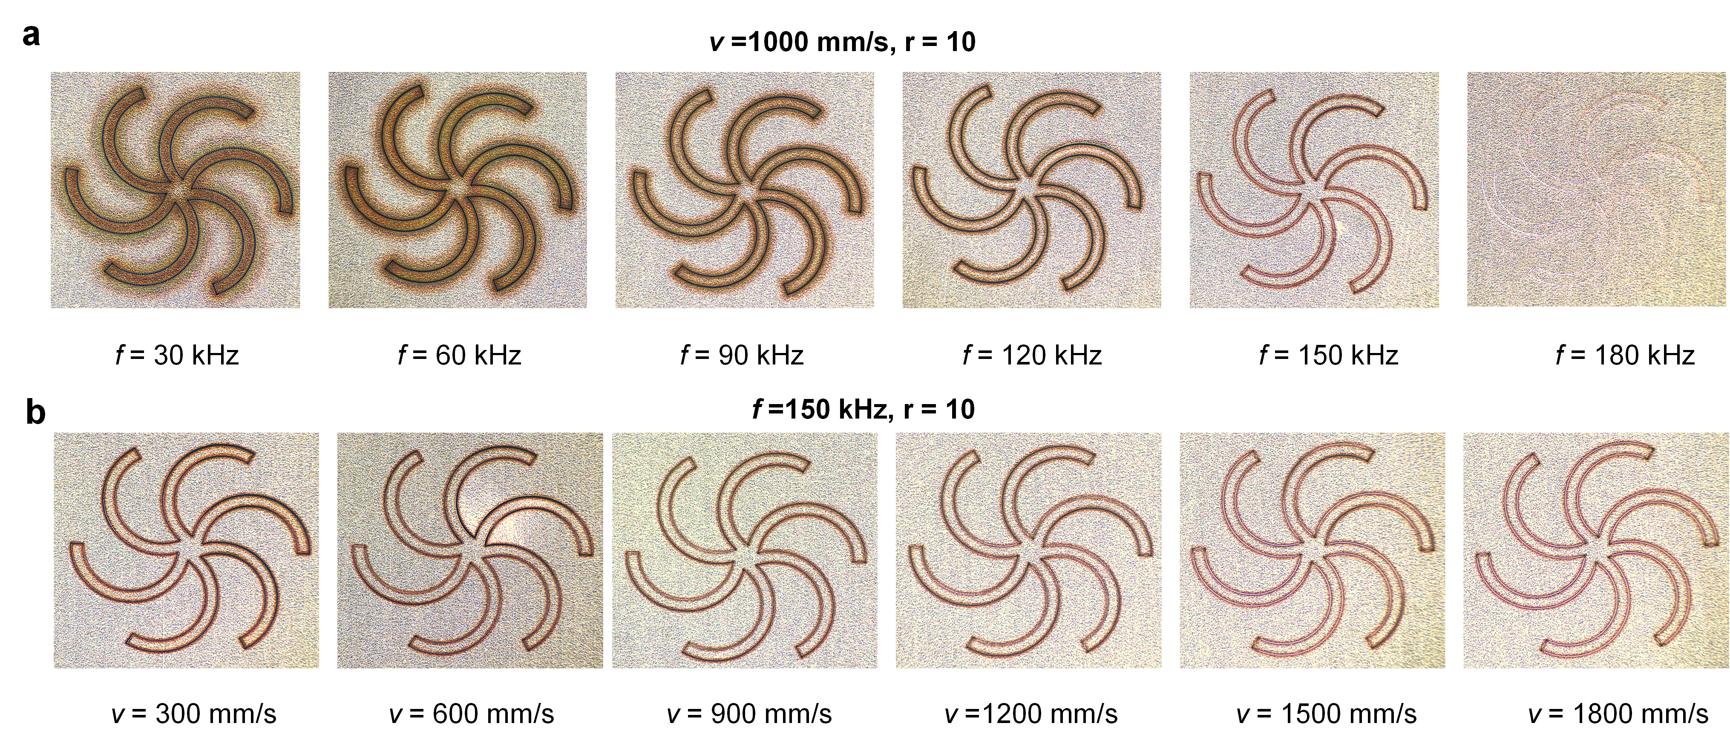
Fig. S4. Optical images of the serpentine structures under continuous laser engraving with different a pulse frequencies and b laser speeds.

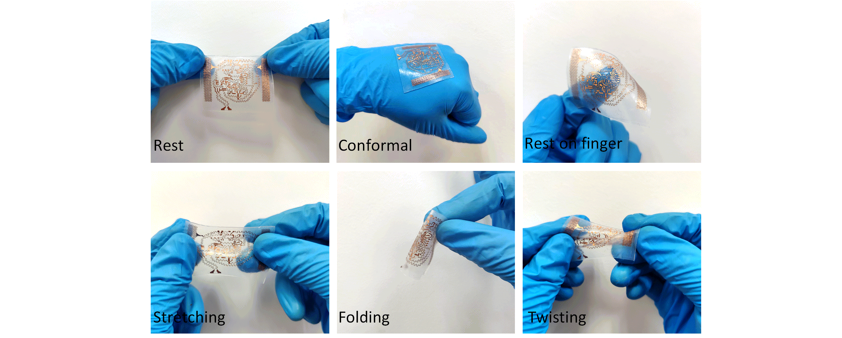
Fig. S5. Optical images of the stretchable serpentine trace on an ultra-soft elastomer before and after conformal contact on the back of the hand, resting on the fingertip, uniaxial stretching, folding, and twisting.

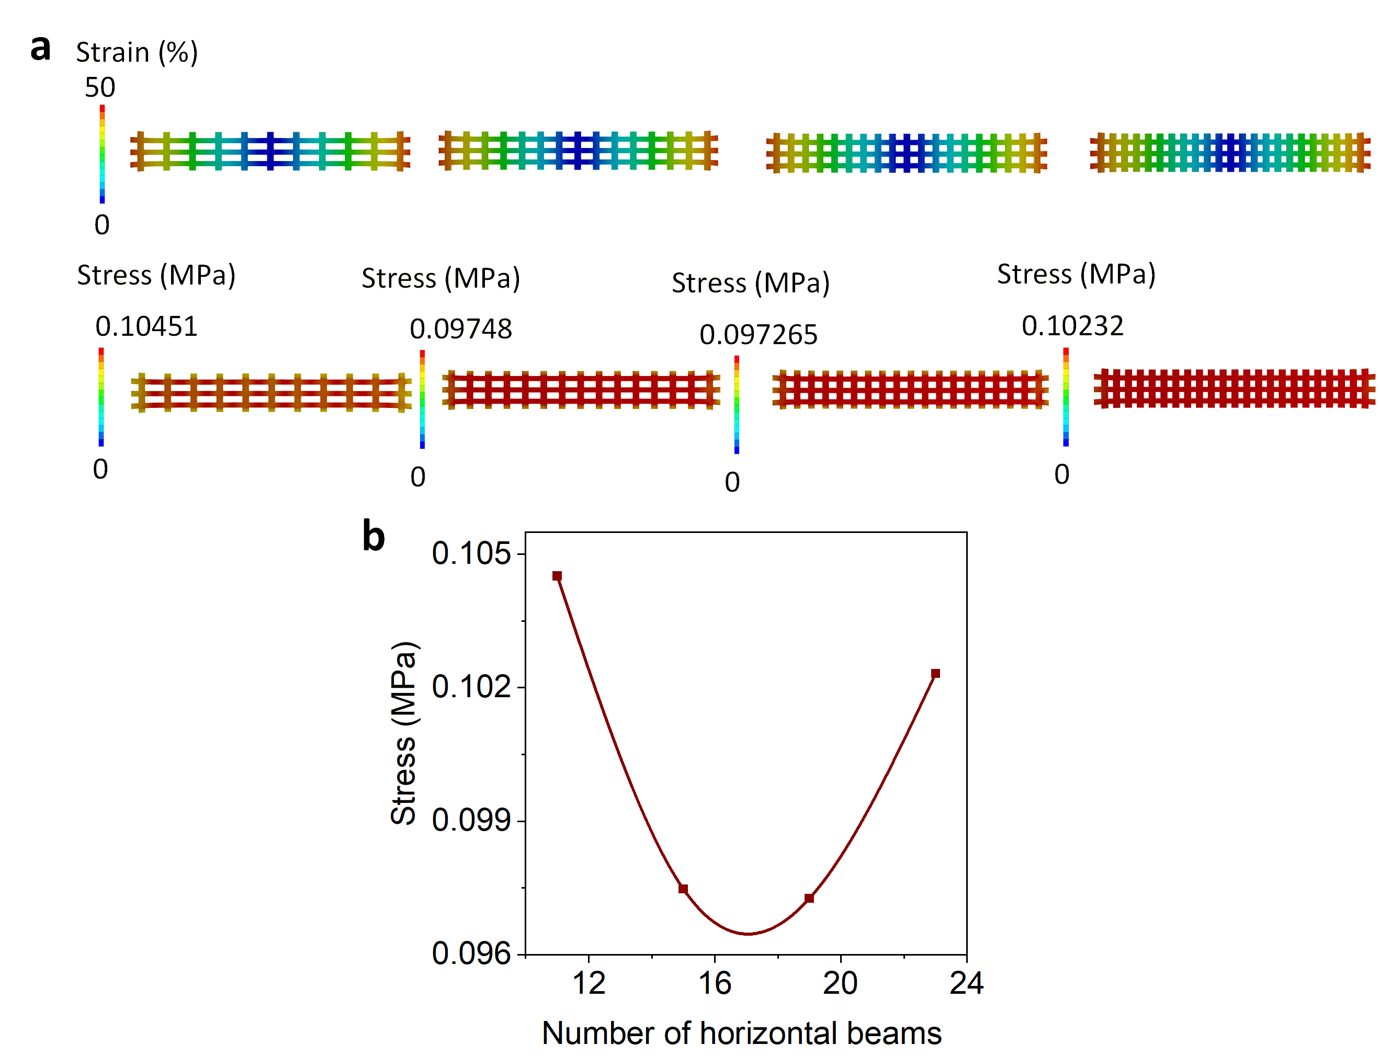
Fig. S6. Finite element analysis of the PDMS mesh structures with different numbers of vertical beams under the uniaxial tensile strain of 50%. a Strain (top) and stress distributions (bottom) of the mesh structure with 11, 15, 19, and 23 vertical beams (from left to right). b Maximum principal stress as a function of the number of vertical beams.

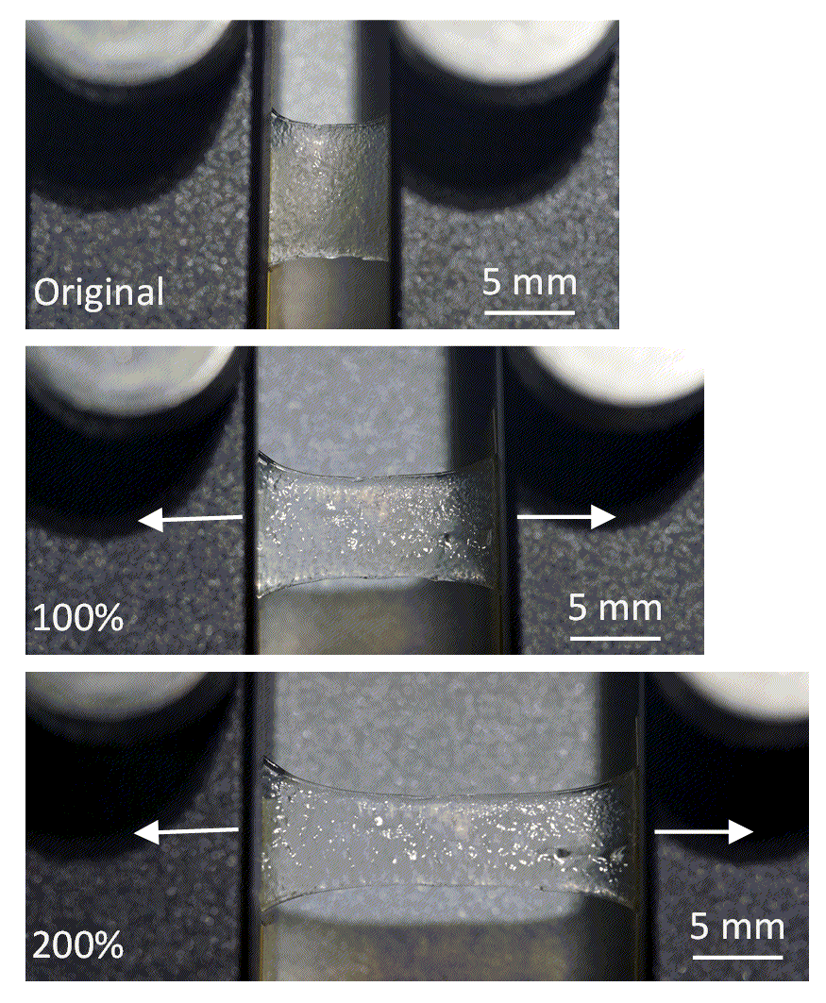
Fig. S7. Optical images of the modified hydrogel under the uniaxial tensile strain of 0, 100, and 200%.
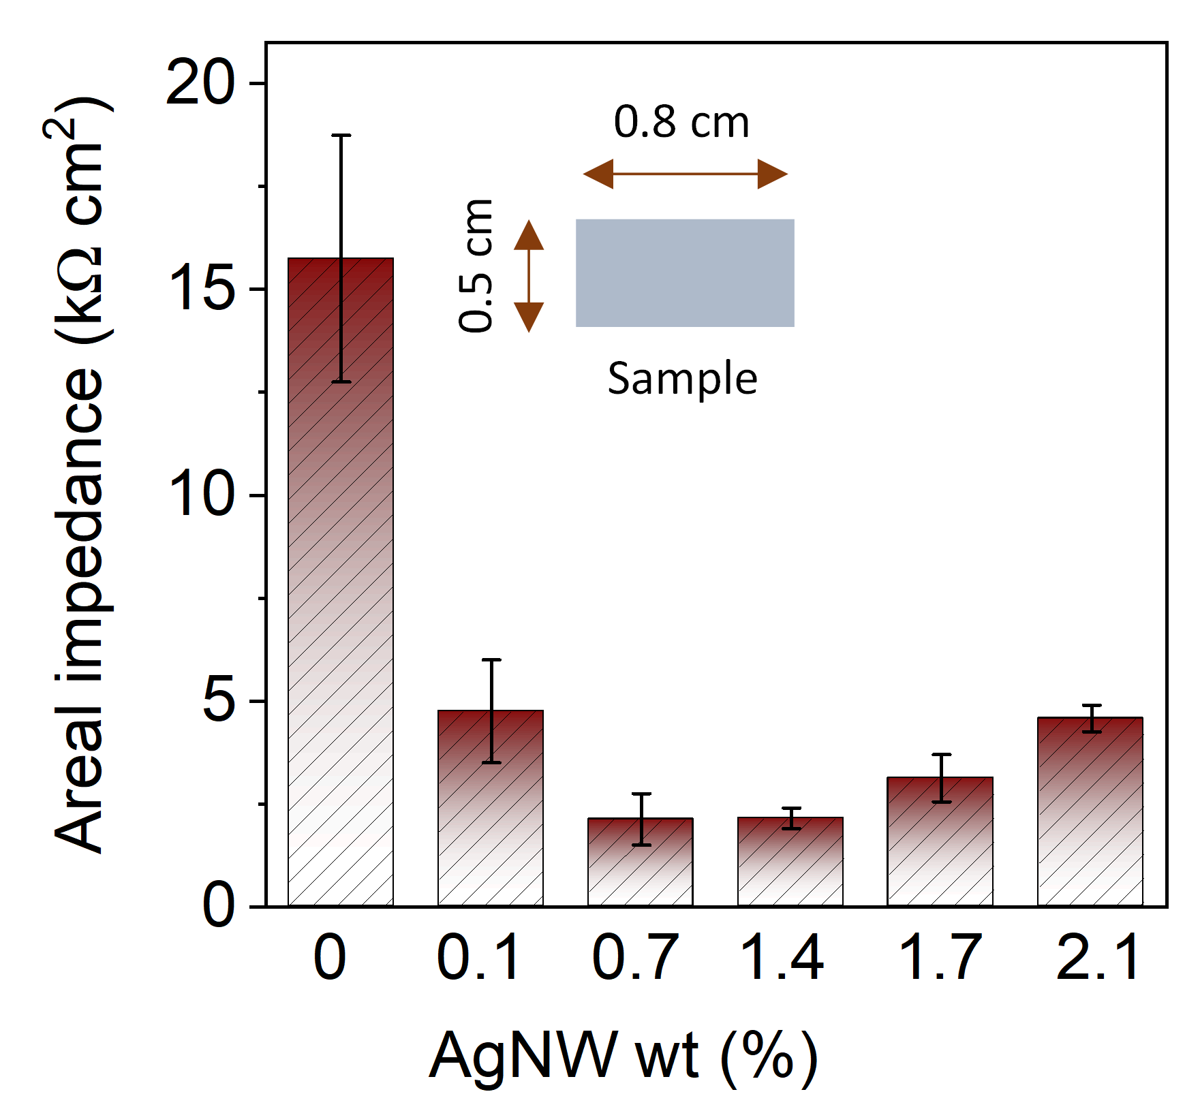
Fig. S8. Sheet resistance of the modified hydrogel with varying weight concentrations of AgNWs from 0 to 2.1%.

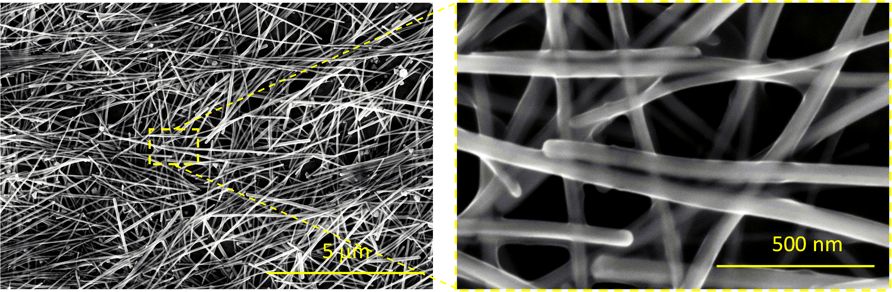
Fig. S9. Scanning electron microscope (SEM) image of Ag NWs (left) and its zoomed-in view (right).

Fig. S10. Comparison in the areal contact impedance of electrodes based on the commercial gel, pure hydrogel, and modified hydrogel (with AgNWs of 0.7%)

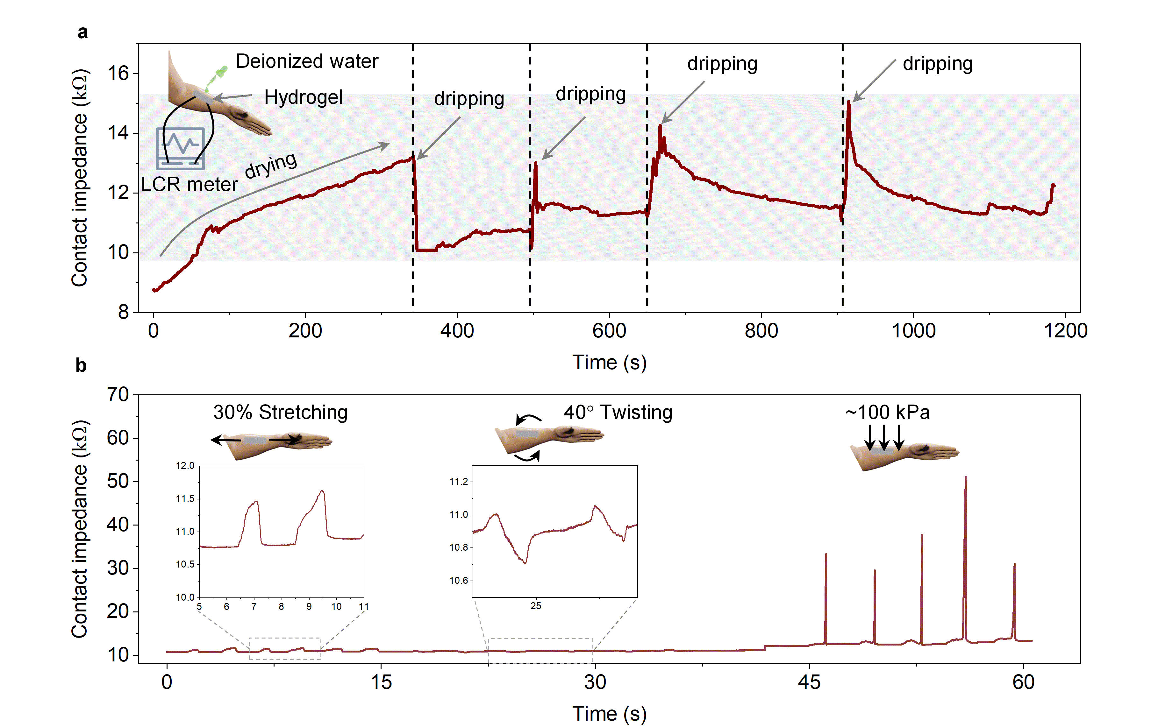
Fig. S11. Contact impedance measured with the modified hydrogel (size: 0.5×1.5 cm²) placed on the forearm under a cyclic natural drying and dripping with deionized water and b continuous deformation.

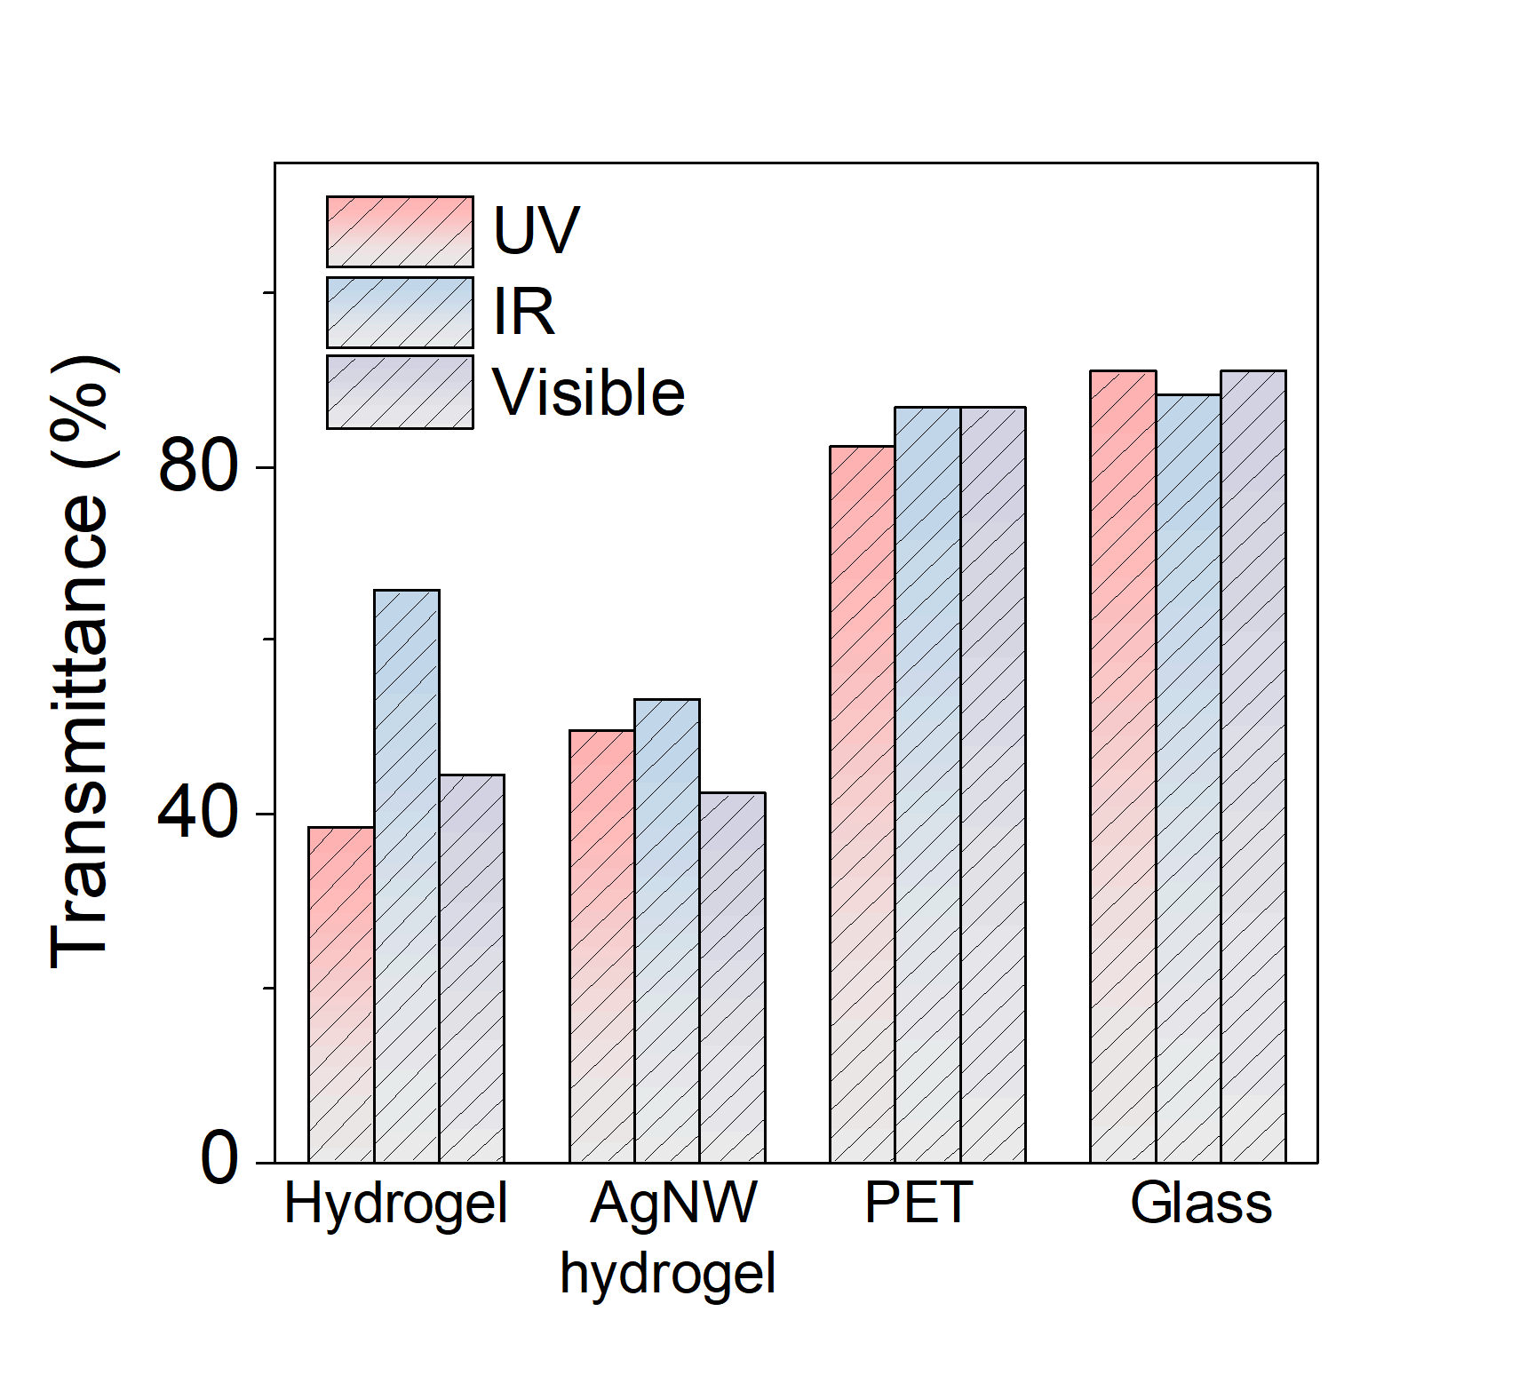
Fig. S12. UV, infrared (IR), and visible light transmittance of the pure hydrogel, modified hydrogel, PET film, and glass plate (thickness of 1 mm).

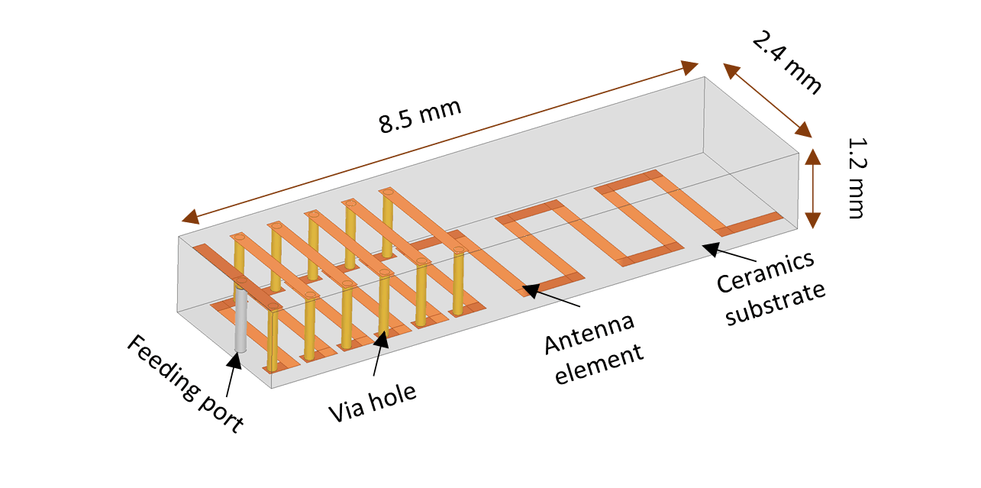
Fig. S13. Designed low-temperature co-fired ceramic (LTCC) antenna in the laryngeal patch.

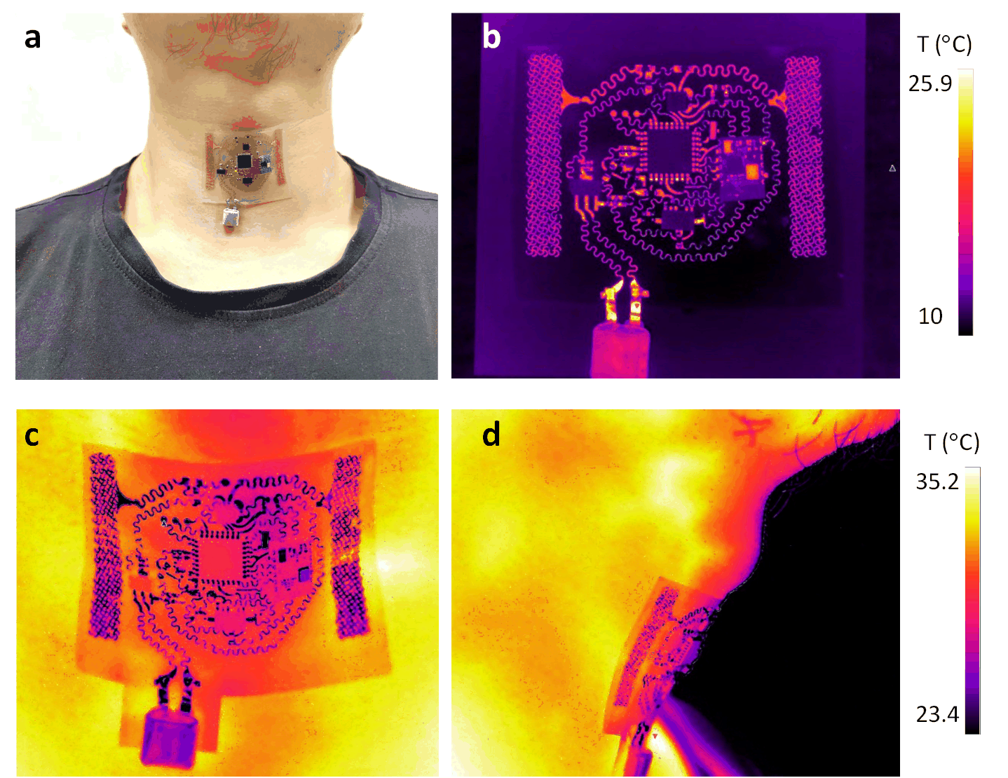
Fig. S14. Optical and thermal images of the patch on the laryngeal skin. a Optical image of the patch on the skin. Thermal images to show the comparison in the temperature distribution of the powered patch on b a cooled platform (10°C) and on the skin in the c front and d side views.

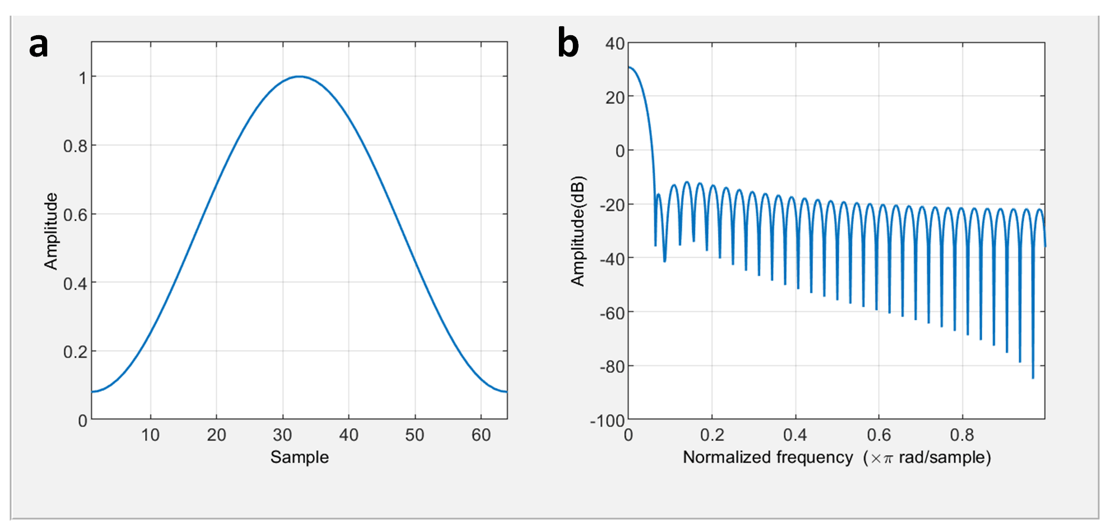
Fig. S15. Hamming windows set for the acquisition of the power spectrum density and signal noise ratio (SNR) in a time and b frequency domains (window length of 64).

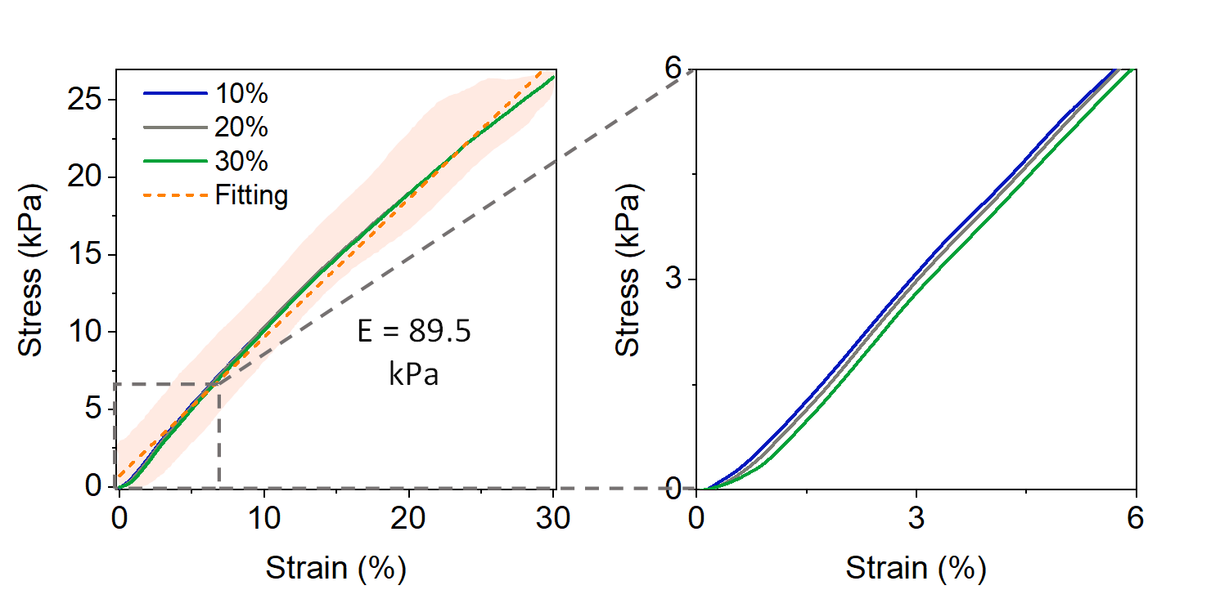
Fig. S16. Stress-strain curves of the stretchable patch under the uniaxial tensile strain up to 30 % (left) and its zoomed-in view (right).

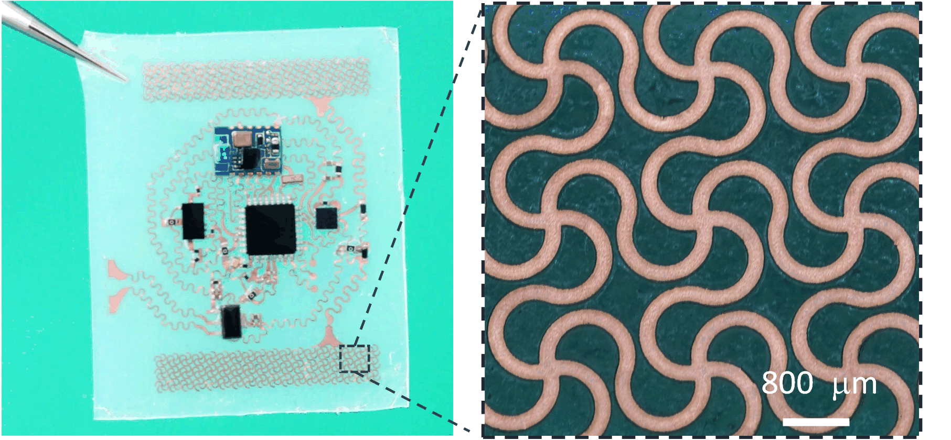
Fig. S17. Optical images of the fabricated laryngeal patch (left) and its zoomed-in view showing the serpentine traces (right).
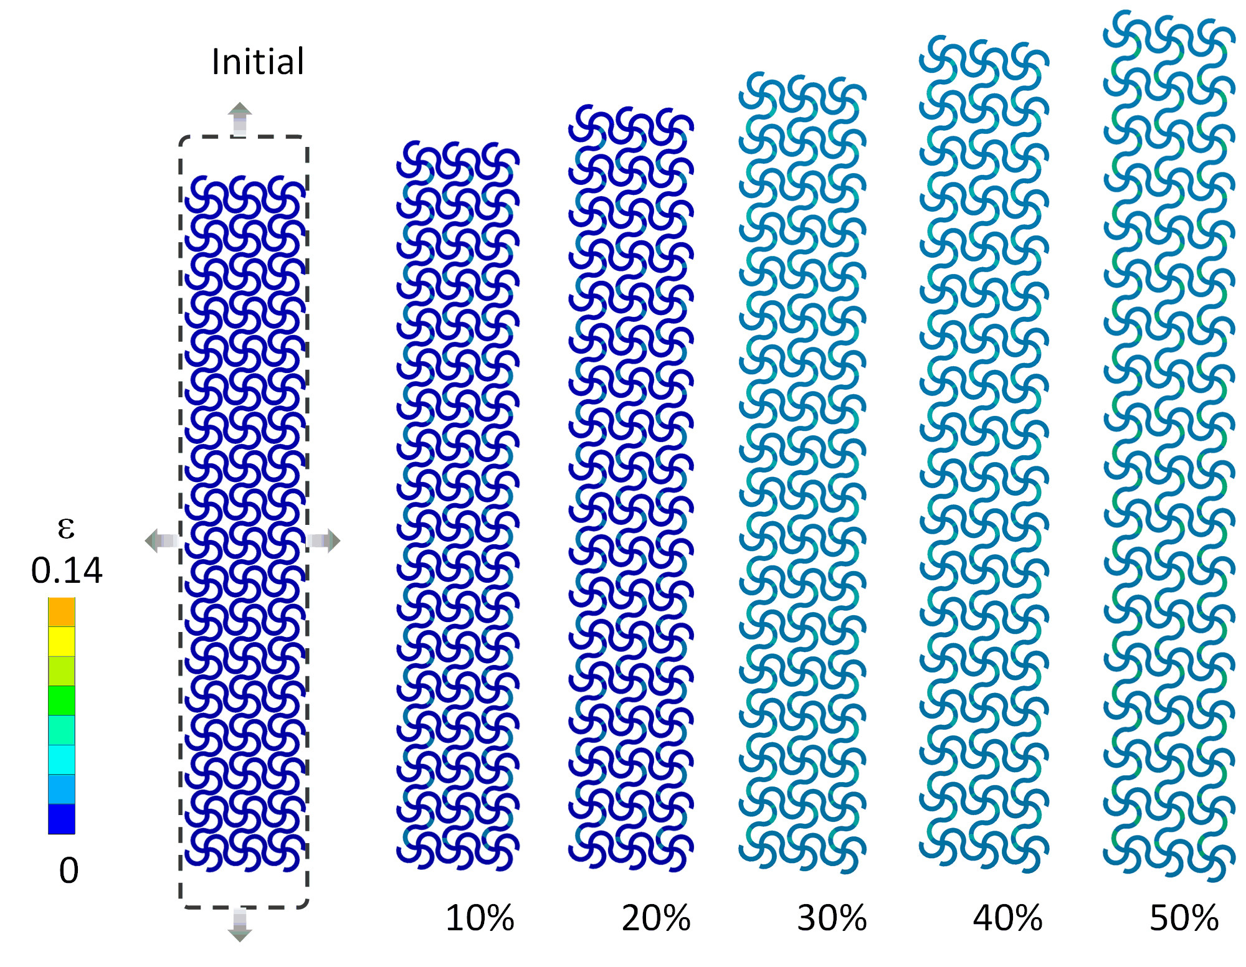
Fig. S18. Strain distribution in the serpentine copper electrode under the biaxial tensile strain of 0, 10, 20, 30, 40, and 50%.

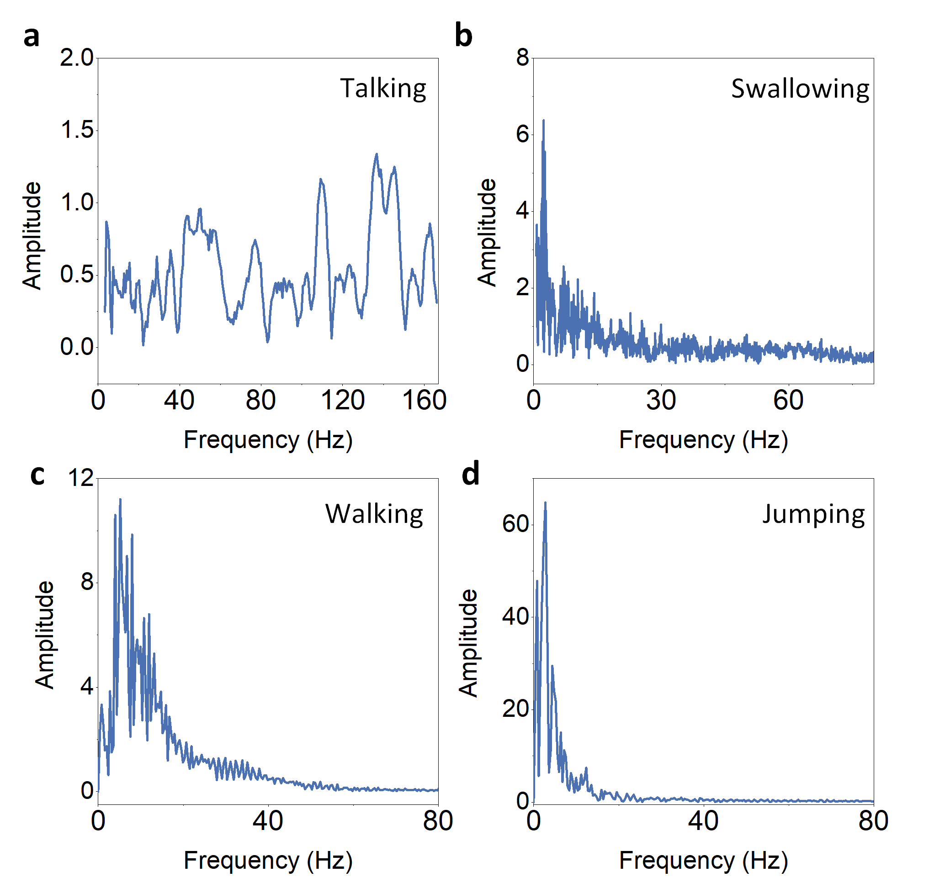
Fig. S19. Fourier transformation of signals captured by the laryngeal patch on a healthy human subject in four typical physiological events: a talking, b swallowing, c walking, and d jumping.

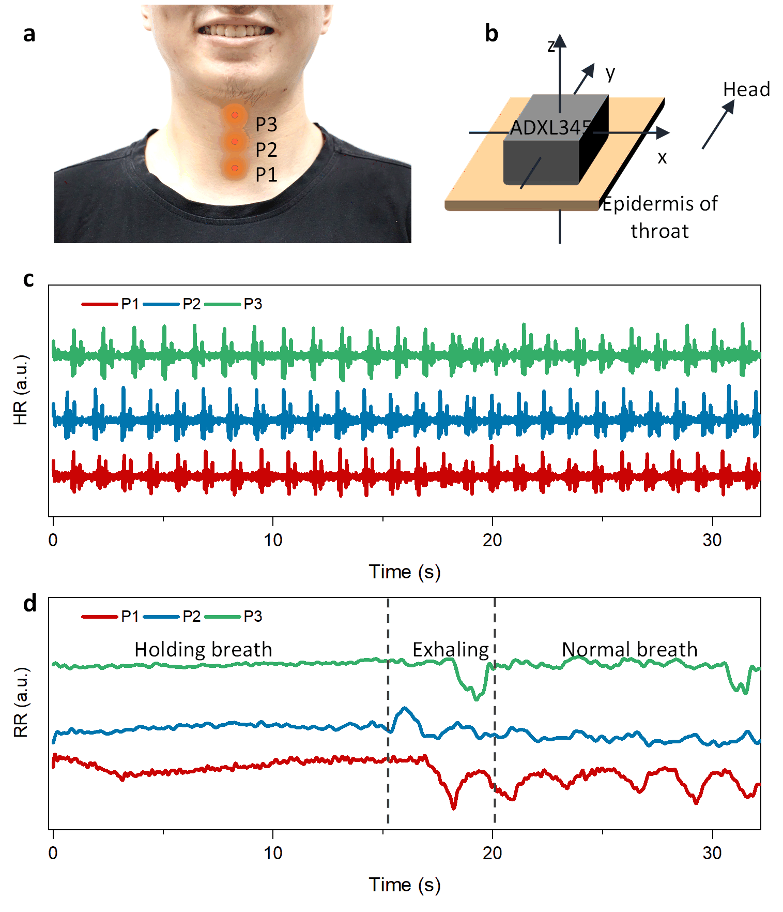
Fig. S20. Decoupled heart rate (HR) and respiration rate (RR) from the acceleration data from the laryngeal patch on varying larynx locations. a Optical image showing the different mounting locations (i.e., P1, P2, and P3 from the bottom to top). b Schematic showing the directions of the accelerometer axis relative to the human head direction. c Comparison in the real-time HR from three different mounting locations. d Continuous monitoring of RR during breath holding, exhaling, and normal breathing.

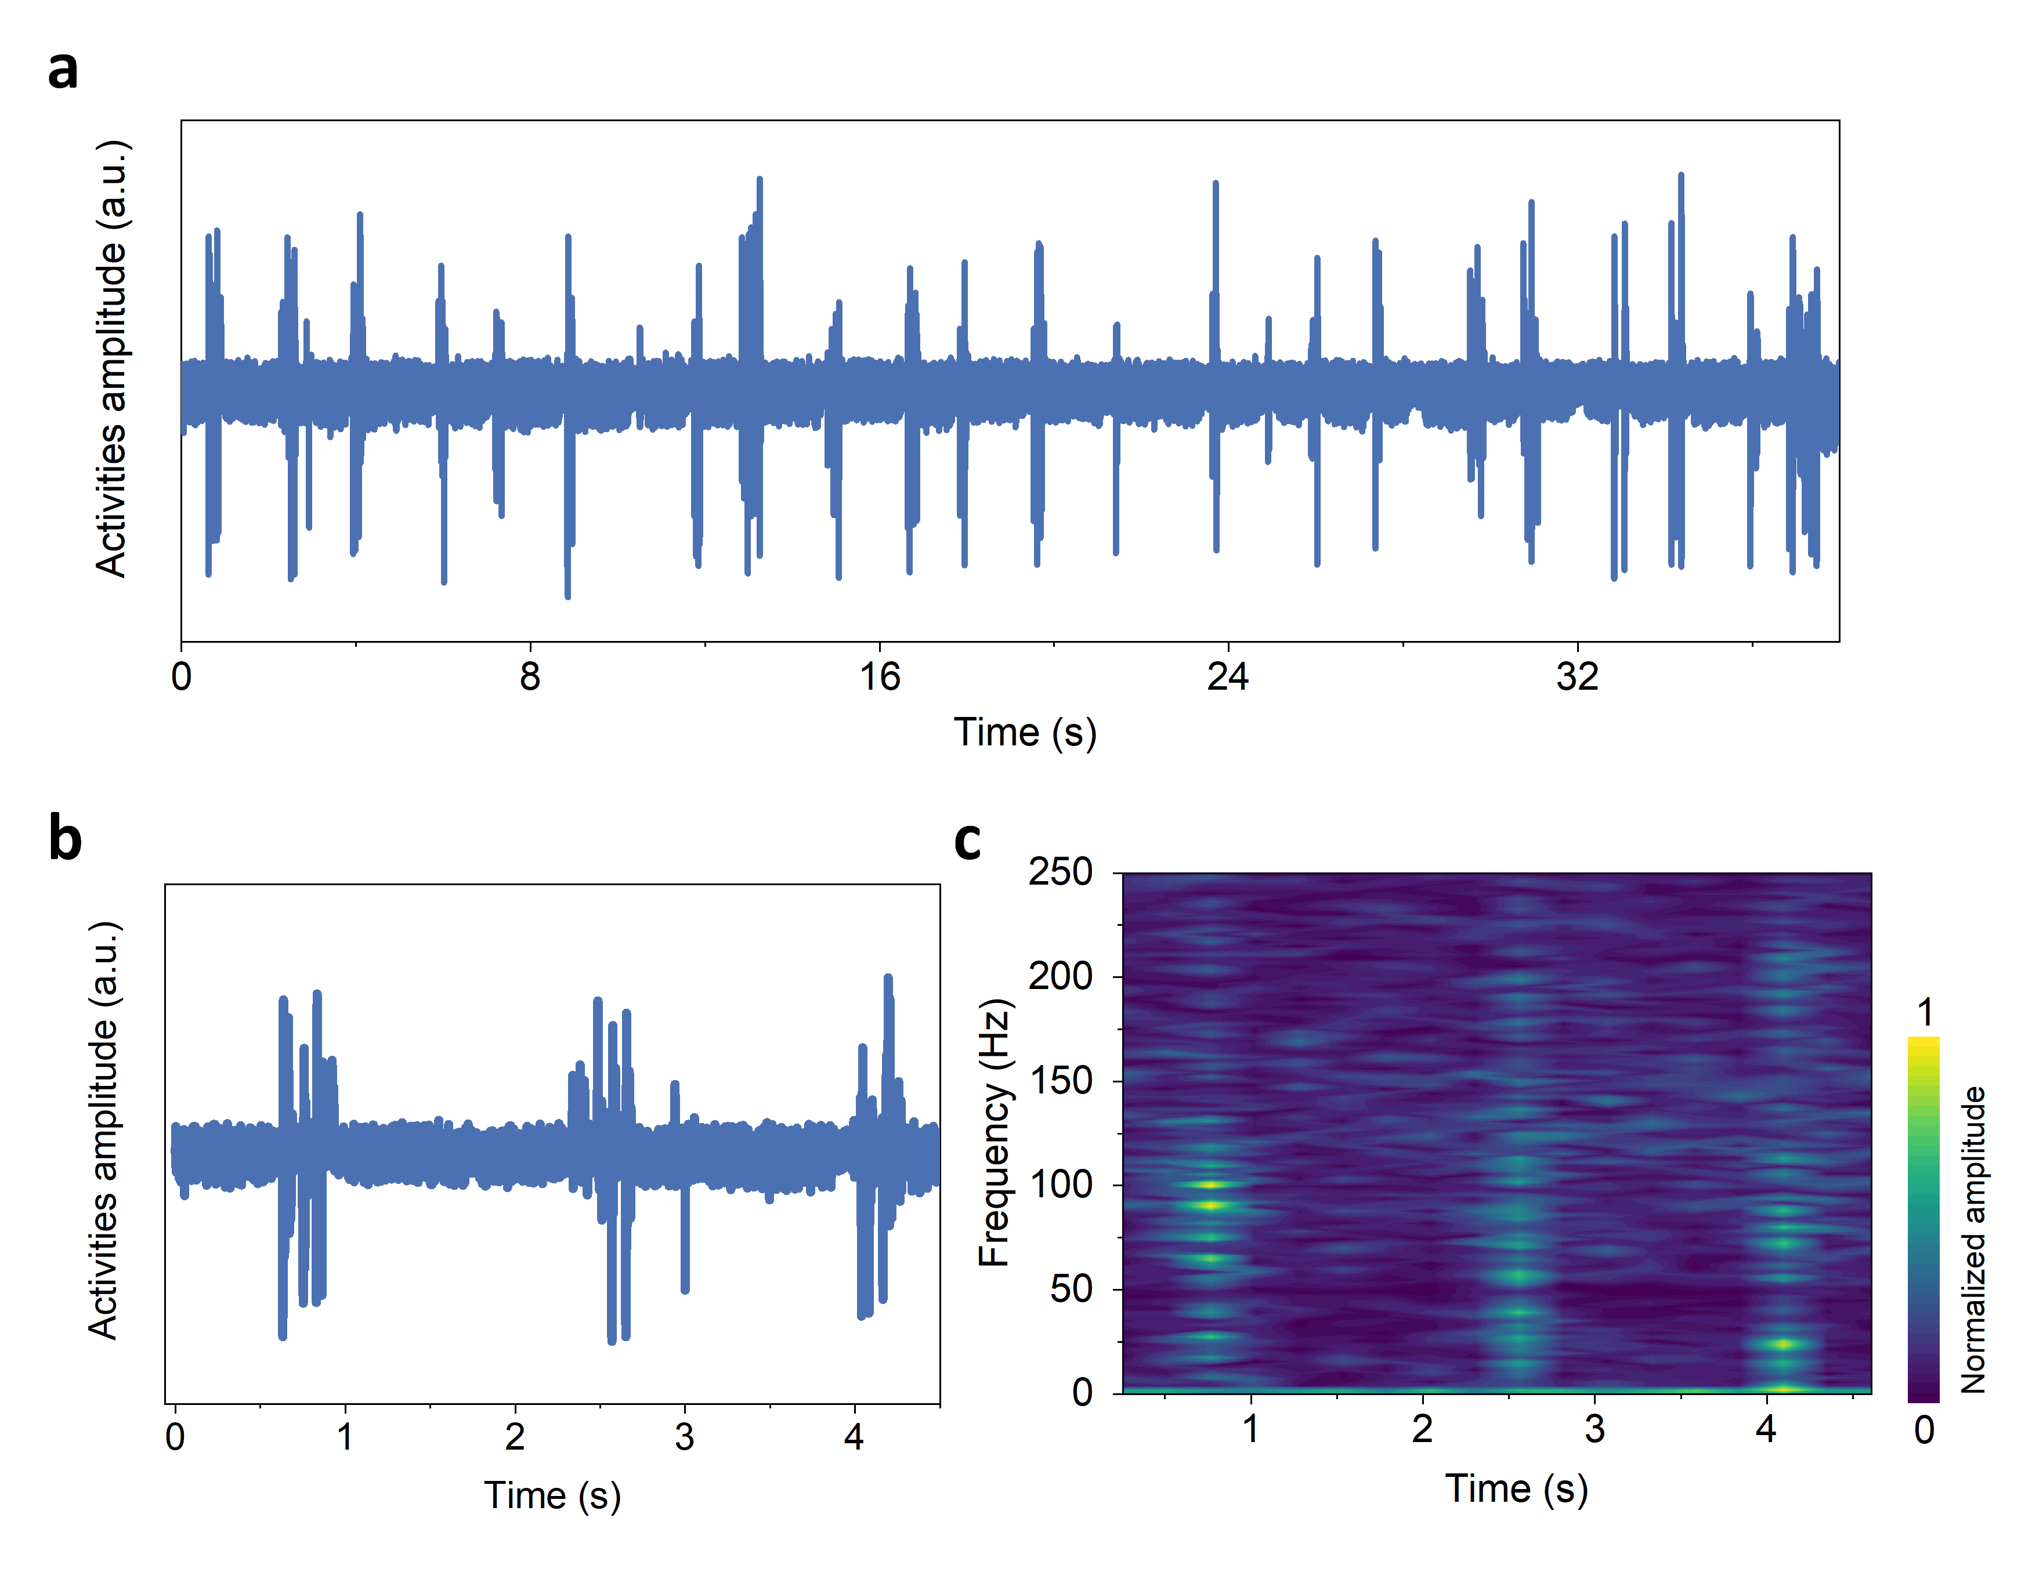
Fig. S21. a sEMG signals over talking captured by the laryngeal patch attached to the middle larynx with the zoomed-in view shown in b and c corresponding frequency-time spectrum after short-time Fourier transform (STFT).

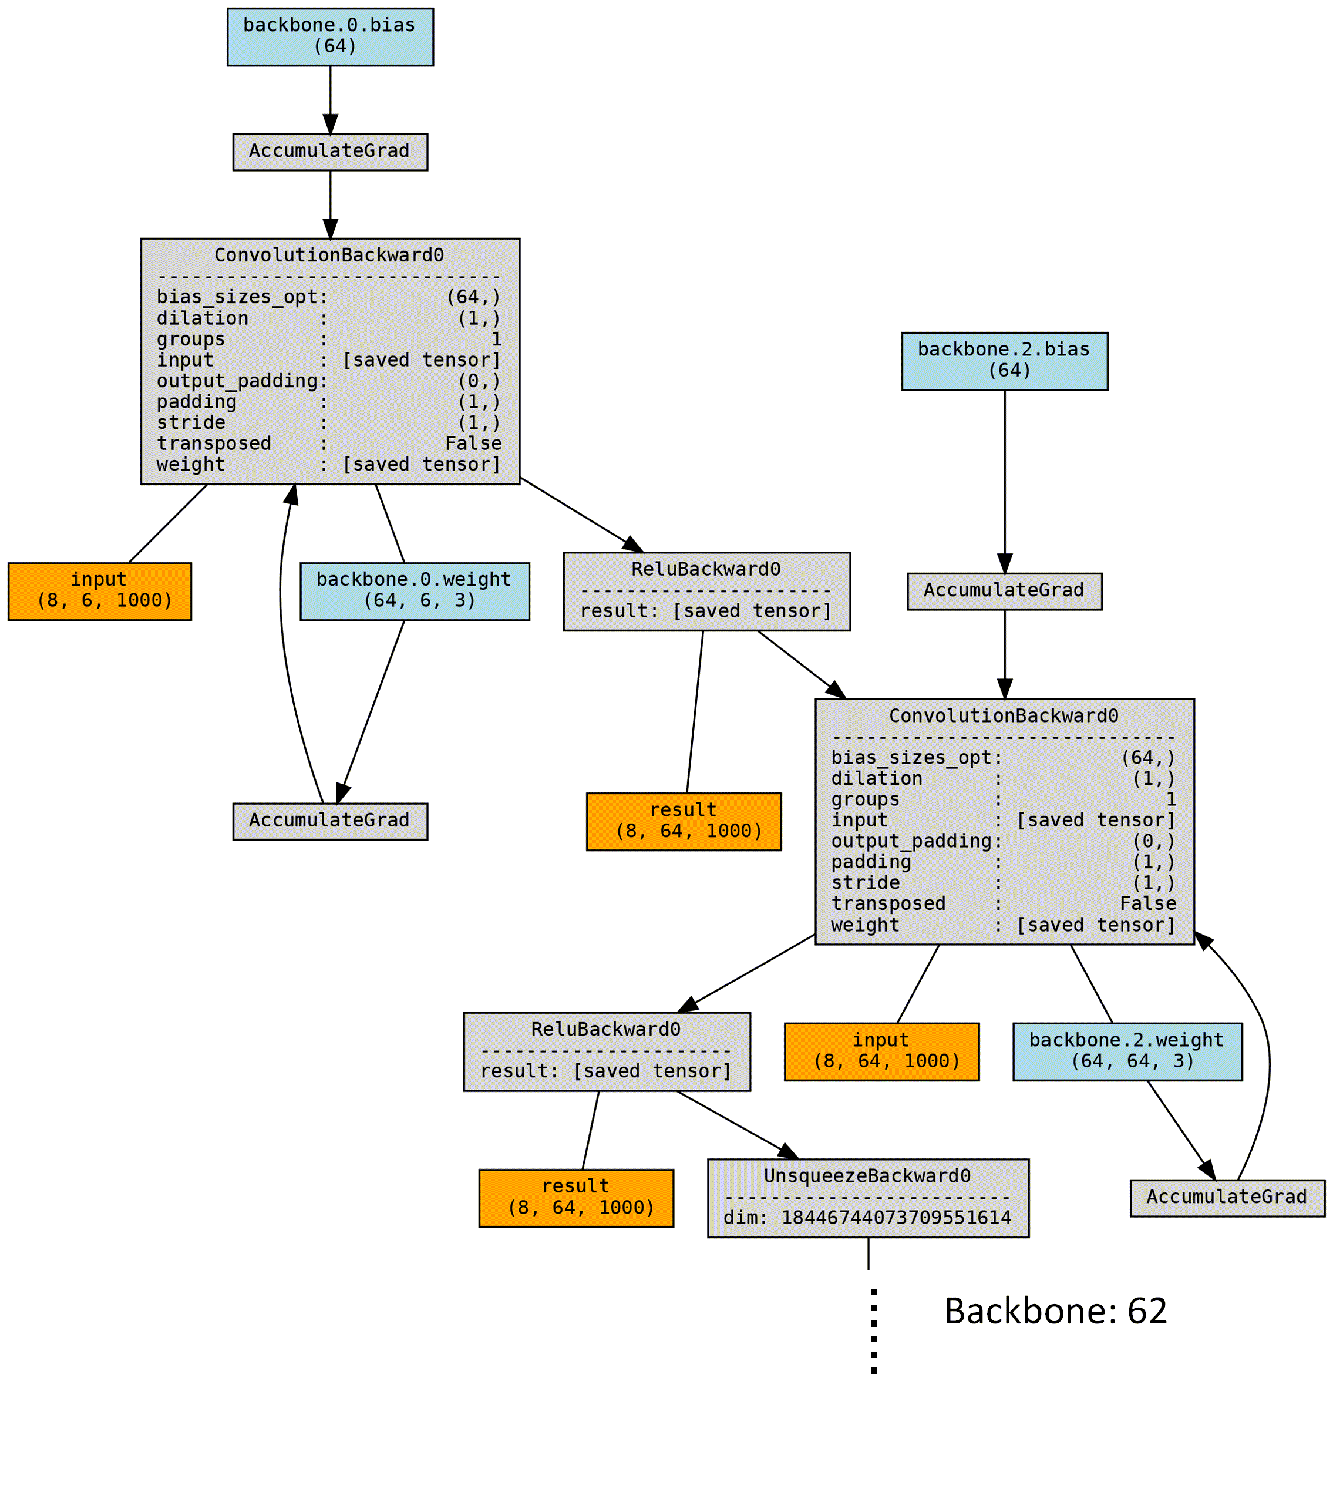
Fig. S22. Flow diagram of the 1-dimension convolutional neural network used for the classification of 13 states in laryngeal postoperative swallowing. The network mainly includes a convolutional layer, active layer, pooling layer, and batch normalization layer.

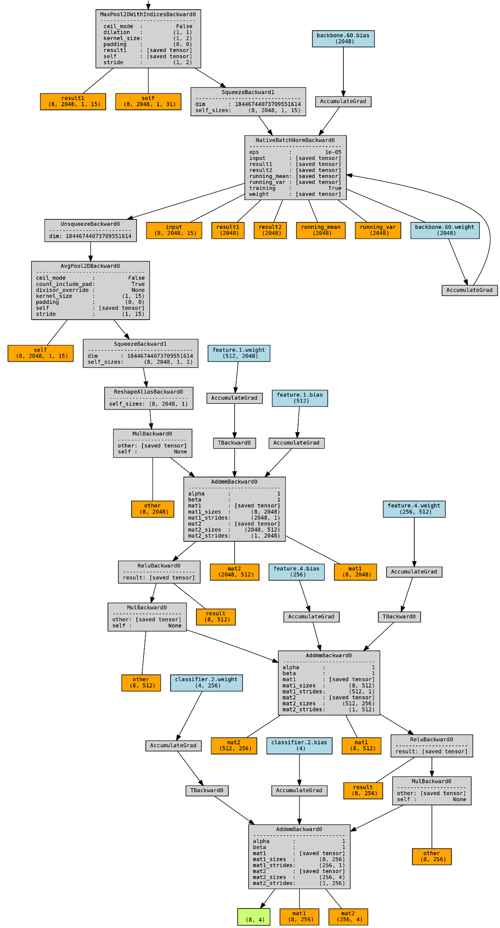
Fig. S23. Flow chart showing the final feature extraction and classification processes that mainly include the convolutional, active, pooling, dropout, batch normalization, max-pooling, and average-pooling layers.
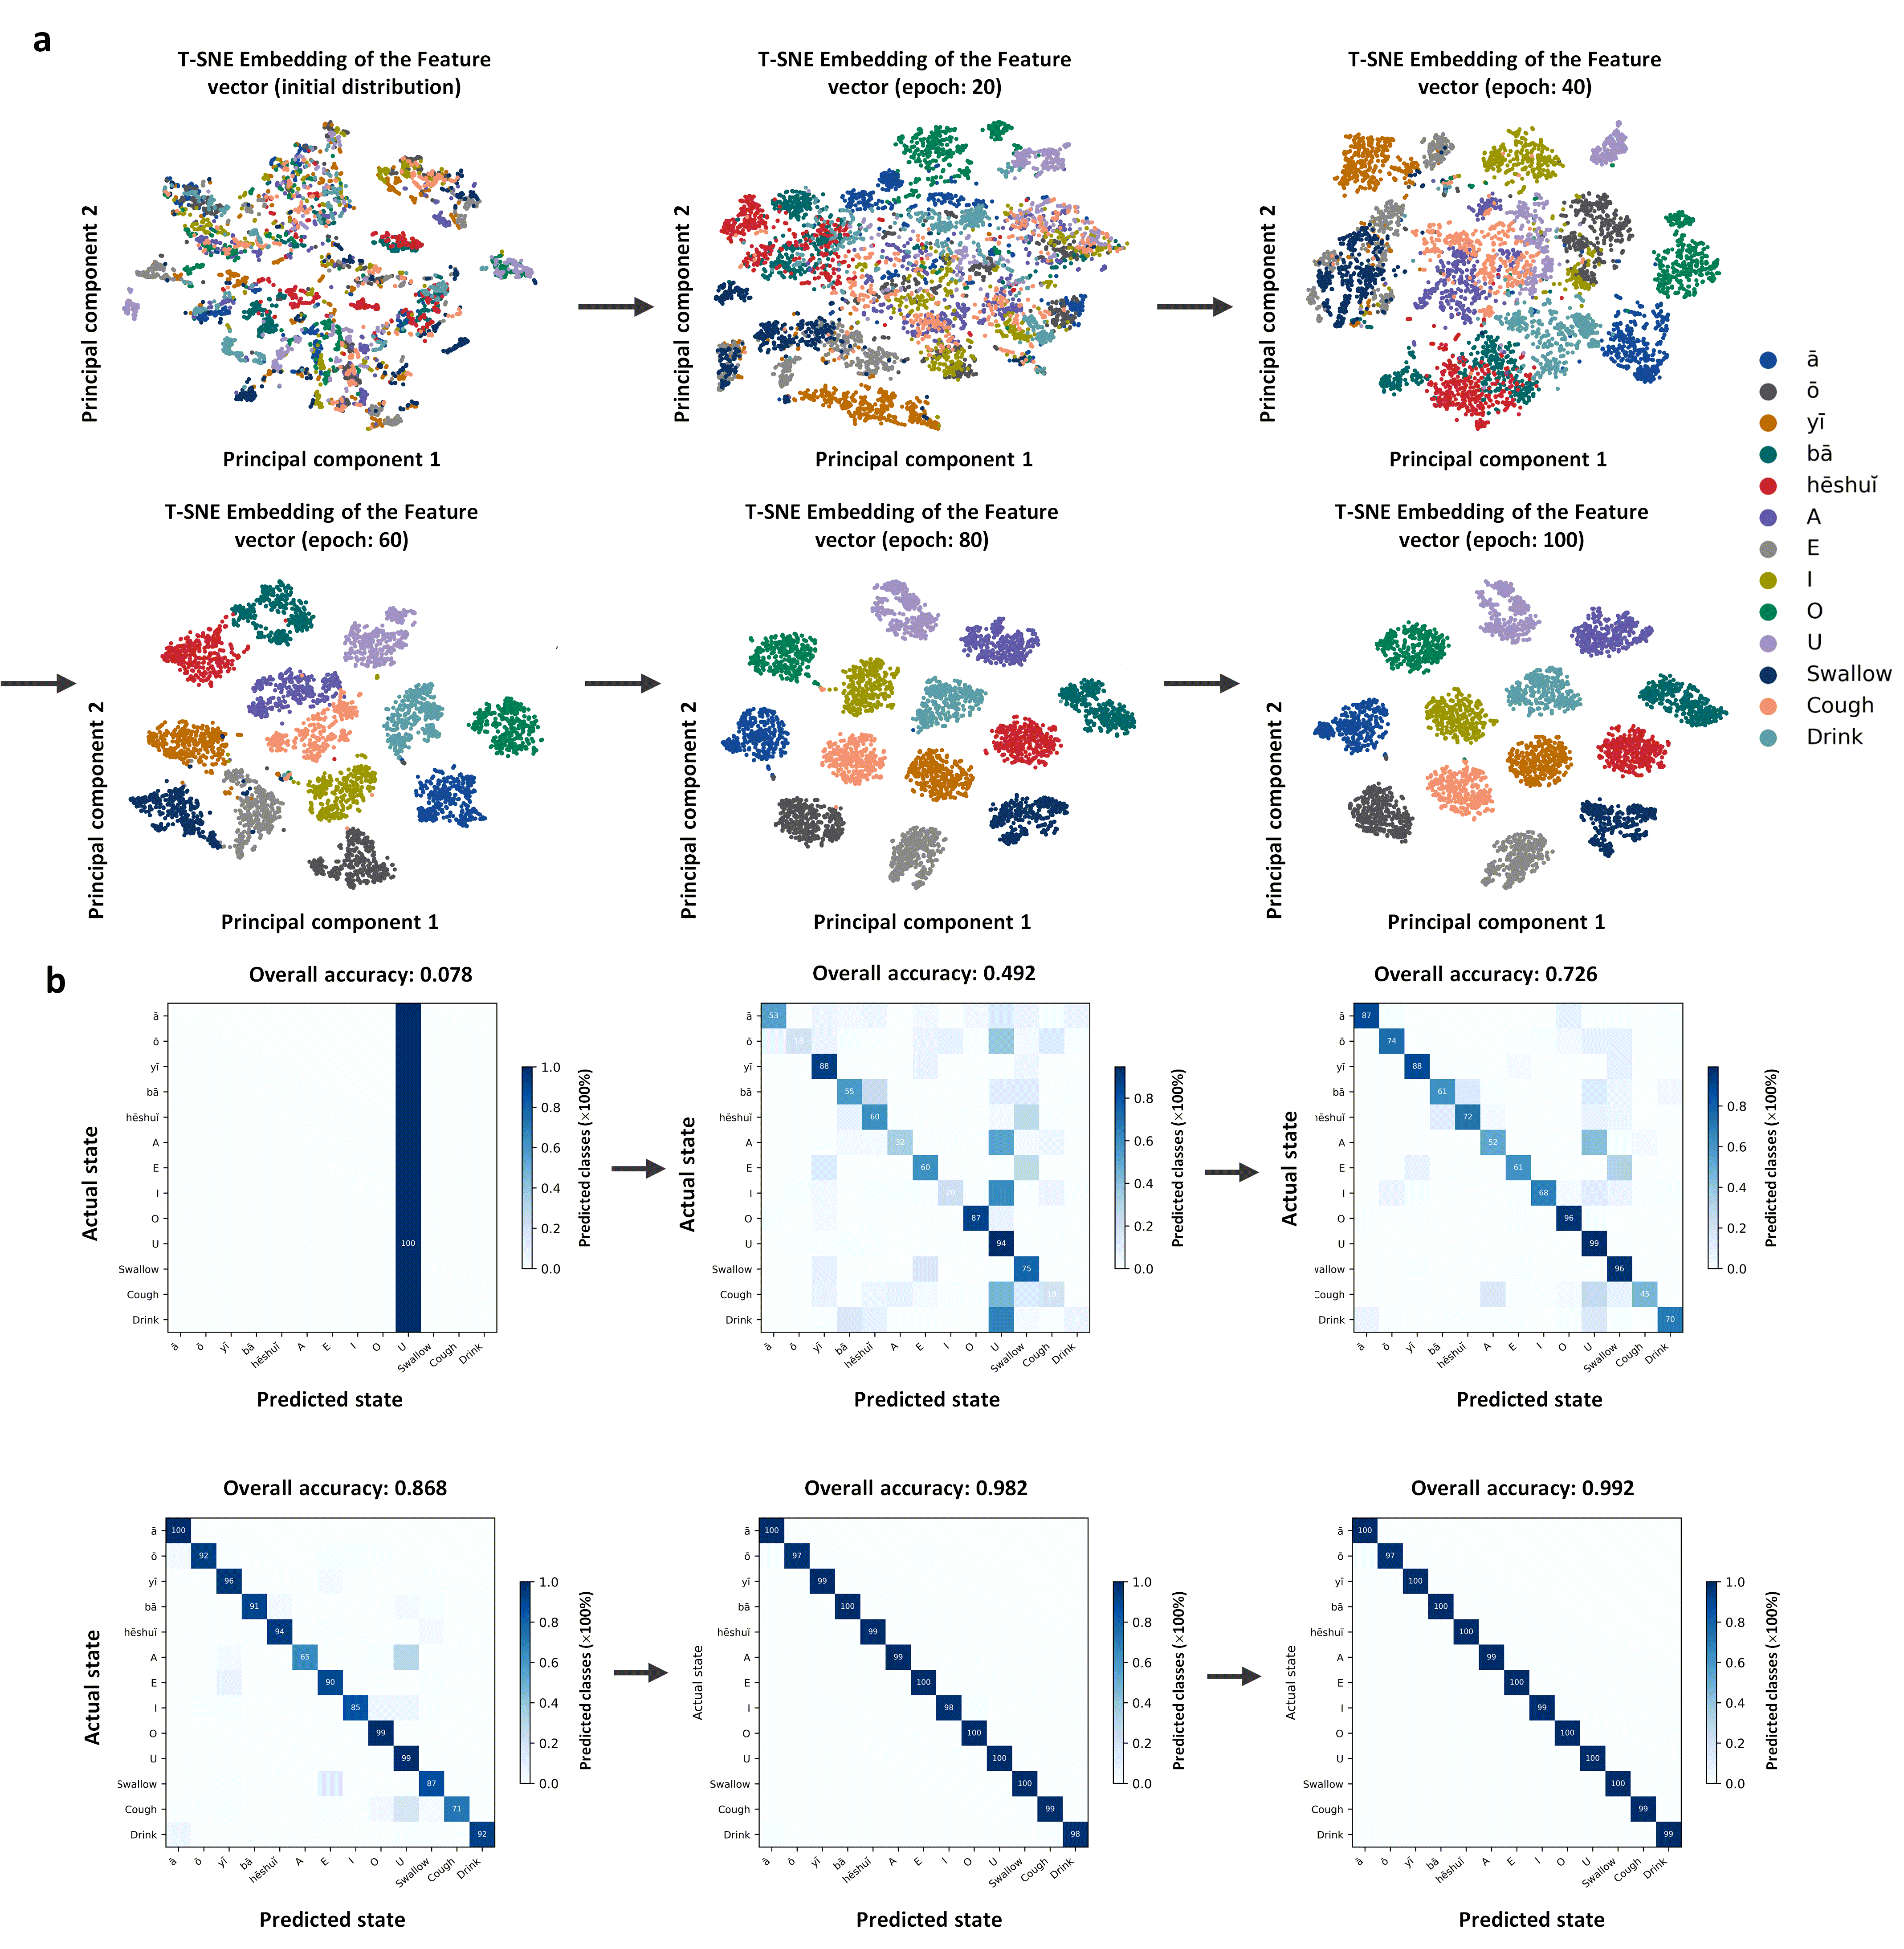
Fig. S24. Feature vector and confusion matrix during the machine learning process for the classification of 13 physiological events. a Feature vector matrix and b corresponding confusion matrix from the initial to 100-epoch iterations during t-distributed stochastic neighbor embedding (T-SNE) processing.

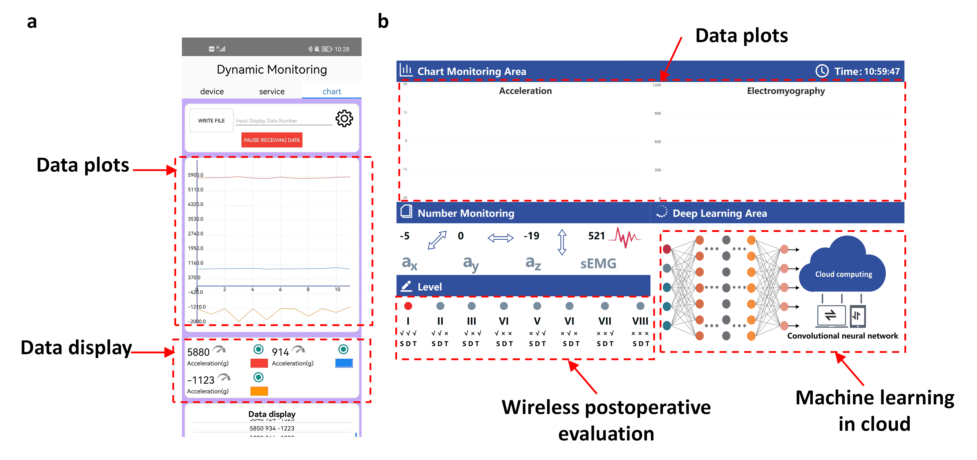
Fig. S25. Display interfaces for continuous real-time monitoring of the signals from the laryngeal patch: a developed APP interface for a smartphone and b demonstrated interface in a PC connected to a developed cloud.

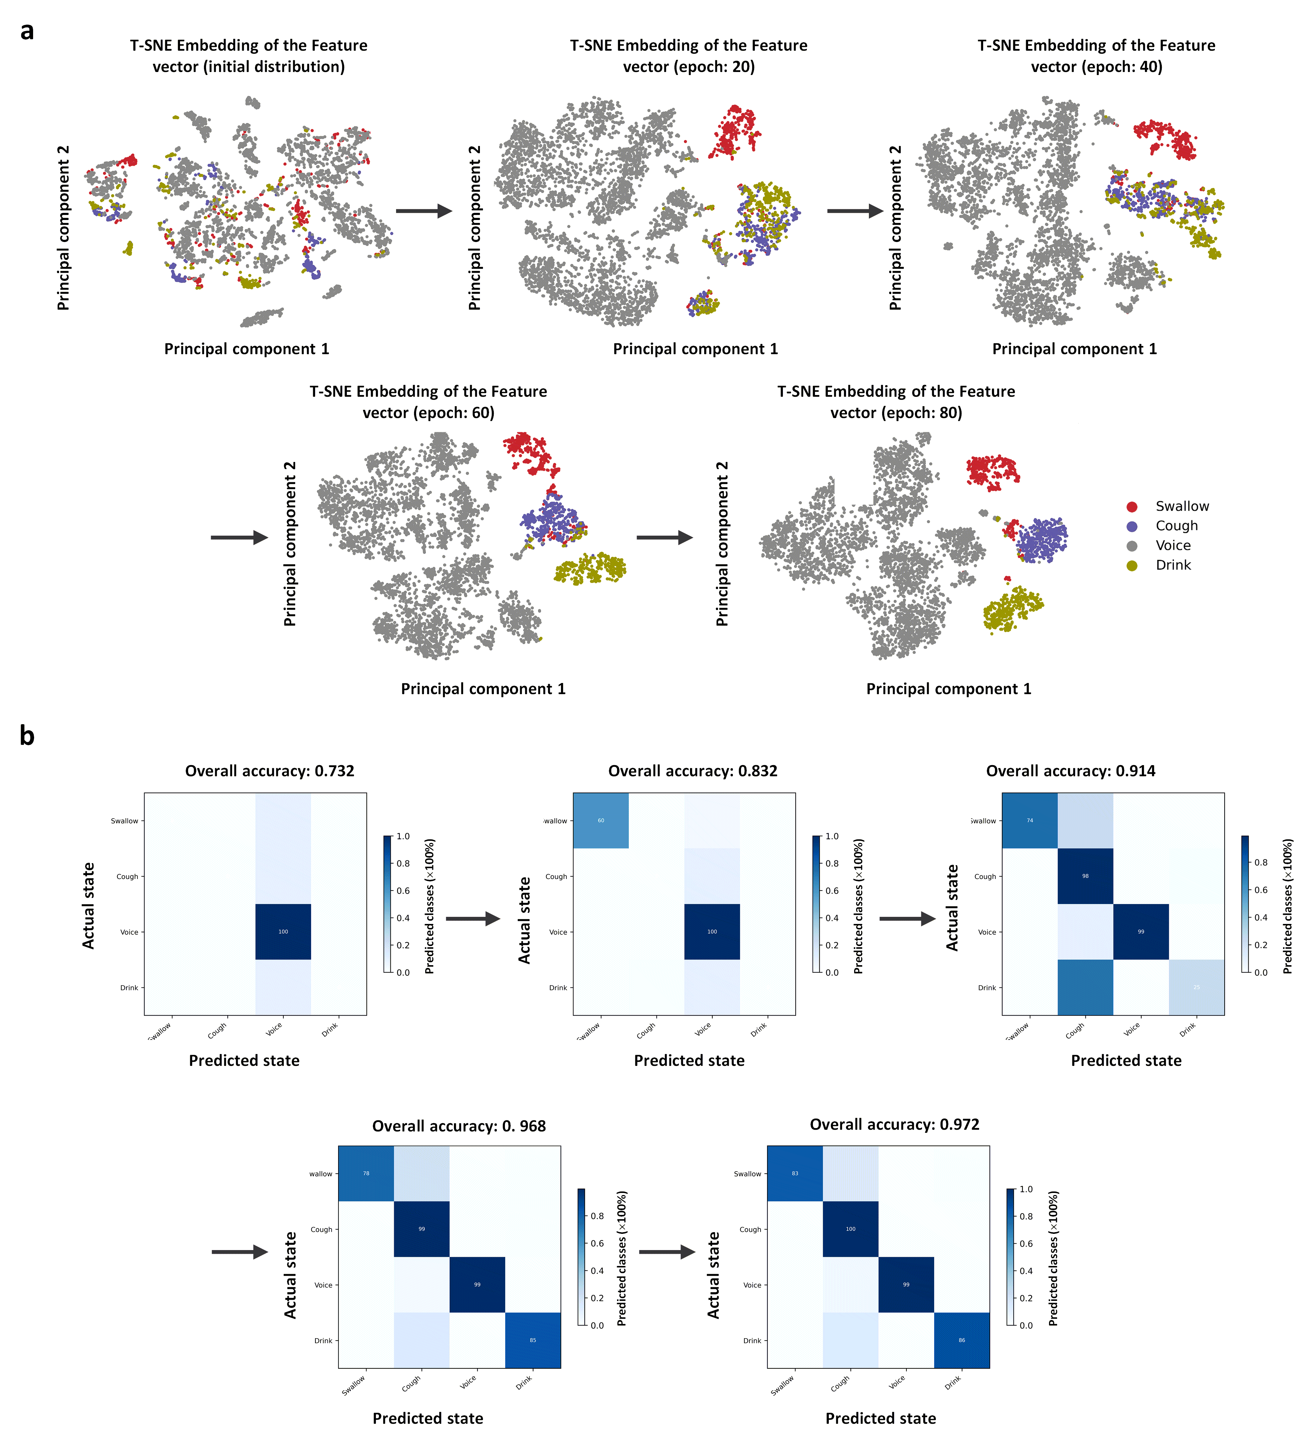
Fig. S26. Feature vector and confusion matrix during the updated machine learning process for the classification of the synthesized 4-category physiological events. a Feature vector matrix and b corresponding confusion matrix from the initial to 80-epoch iterations during T-SNE processing.

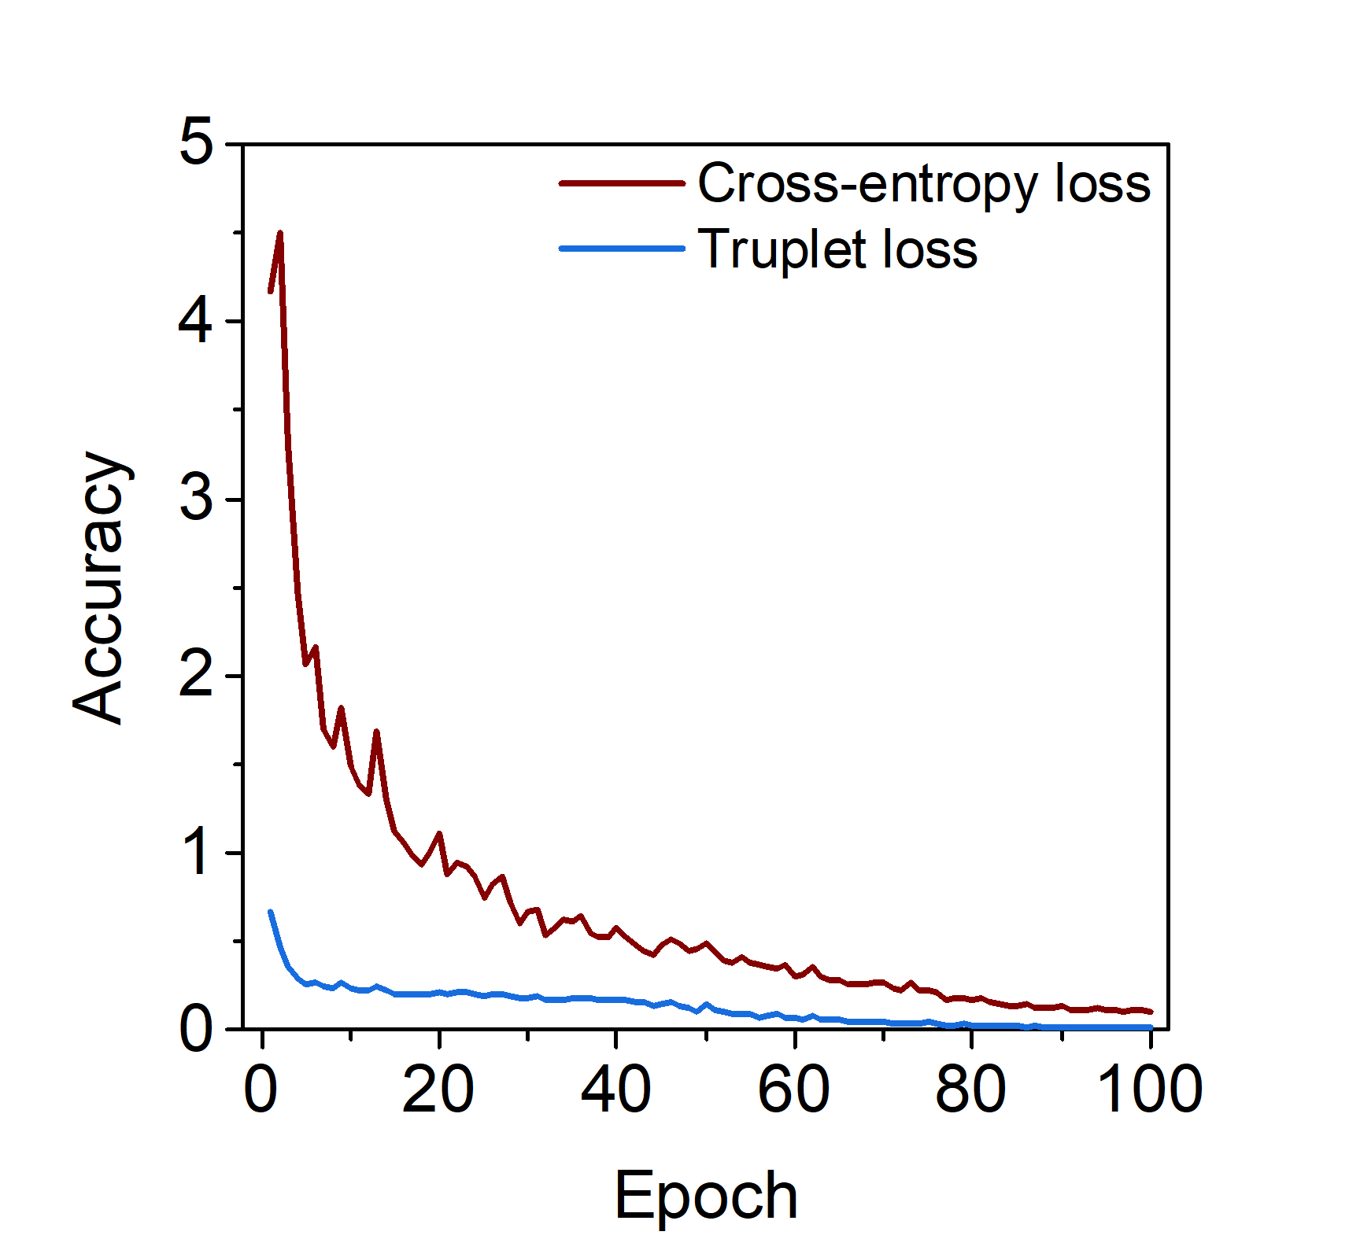
Fig. S27. Normalized loss of the triplet and cross-entropy functions to optimize feature extraction and goal classification for the synthesized 4-category training mode.

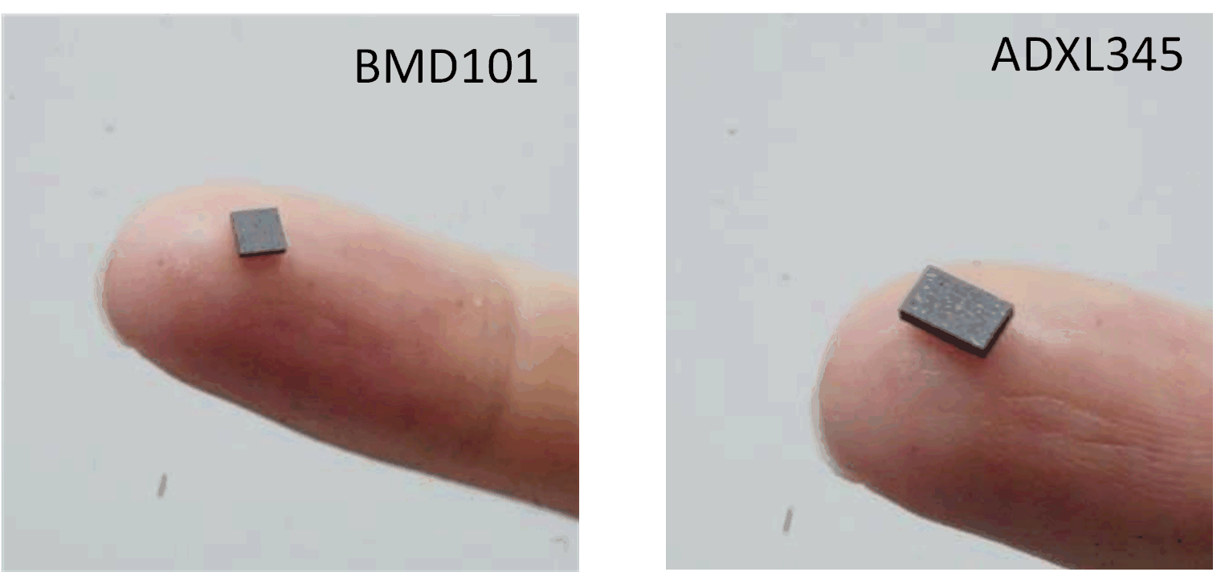
Fig. S28. Optical images of the chips for the acquisition of sEMG (left) and acceleration (right) signals.

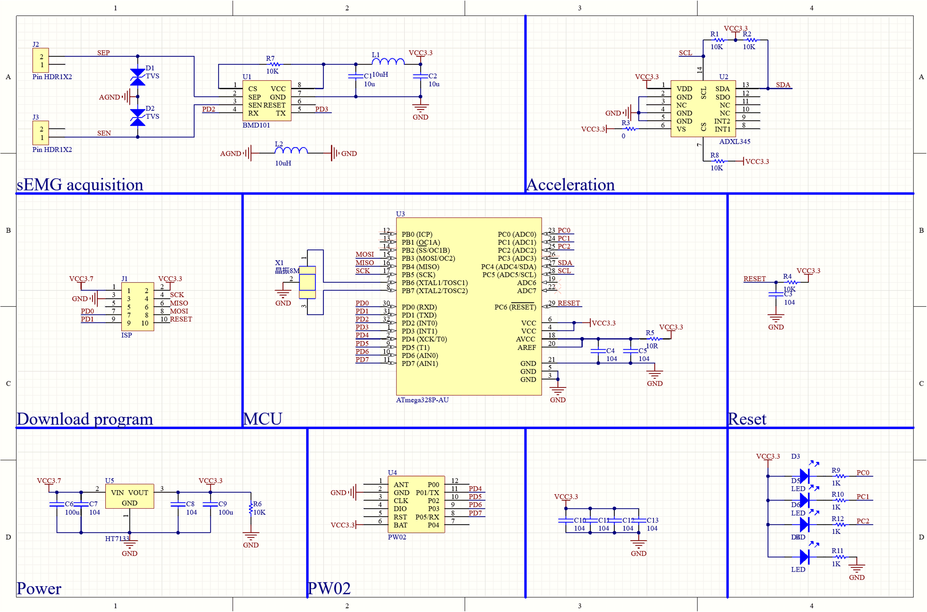
Fig. S29. Circuit diagram of the laryngeal patch.

Table 1 Comparison of different hydrogels (electrodes)
Reference | Conductivity | Transmittance | Biocompatibility | Stretchability | Contact impedance  (1 kHz) | Integrated with circuit
26 | - | Opaque | good | >100% | >10 kΩ | N
43 | 0.14 S m⁻¹ | 98.8% | good | 1529% | - | N
44 | 1 S m⁻¹ | 98% | good | 1000% | 10 kΩ | N
45 | 0.067 S m⁻¹ | - | good | 2636% | - | N
46 | 0.019 S m⁻¹ | Opaque | good | 450% | - | N
47 | 3.8 S m⁻¹ | Opaque | - | 3080% | 5~6.5 kΩ | N
48 | 0.91 S m⁻¹ | 85% | good | 105% | 14.5 kΩ | N
49 | 0.25 S m⁻¹ | 98.8% | good | 2900% | 31 kΩ | N
50 | 0.13 S m⁻¹ | 91% | good | 320% | - | N
51 | 1.2 S m⁻¹ | 80% | - | 850% | - | N
52 | 0.6 S m⁻¹ | - | good | 1530% | 6.3 kΩ | N
53 | 0.34 S m⁻¹ | 95% | - | 10000% | - | N
54 | 0.14 S m⁻¹ | - | - | 1400% | - | N
55 | 0.17 S m⁻¹ | 85% | good | 580% | - | N
56 | ⁻ | >80% | good | 150~200% | 10-20 kΩ | N
57 | 47.4 S cm ⁻¹ | - | good | 20% | 40 kΩ | N
58 | - | <50% | None | None | 23.4~38.3 kΩ | N
59 | <0.5 S m⁻¹ | >80% | good | - | 10~20 kΩ | N
This work | 1.7 S m⁻¹ | 50% | good | 200% | 4.7 kΩ | √
N no, √ yes, Integrated with circuit: integration of the hydrogel with a flexible circuit in the integrated device for health monitoring.

Table 2 Comparison of different laryngeal sensor patches
Sensor patch | Flexibility | Systemic integration | Wireless | Sensing mode | Monitoring | Trained by ML | Reference
Flexible submental sensor | Semi-flexible | N | √ | Strain, EMG | Muscle activity, throat movements | N | 22
Wearable  Accelerometer Sensor | Semi-flexible | N | N | Acceleration | Voices | N | 23
Mechano-acoustic device | Semi-flexible | √ | √ | Acceleration | Physiological  processes, body motions | N | 37
Acoustic MEMS Sensor | / | N | N | Acoustic vibration | Chewing, Swallowing | √ | 58
Epidermal device | Full-soft | N | N | Acceleration, EMG | Electrophysiological signals | √ | 59
Dual-axis swallowing accelerometer | Semi-flexible | N | N | Acceleration | Swallowing | N | 60
Dual wearable sensor | Semi-flexible | √ | √ | Acceleration | Artifact-canceled physiological | N | 61
mechano-acoustic sensors | Semi-flexible | √ | √ | Acceleration | Swallowing, respirations | N | 62
Throat vibrator | Rigid | N | N | Microphone vibration | Dysphagia | √ | 63
Lip-closing force gauge | Rigid | N | N | Force, EMG | Lip-closing | N | 15
Neck belt | Semi-flexible | N | N | Displacements | Swallowing | N | 64
Acoustic detecting array | Semi-flexible | N | N | Acceleration, microphone | Swallowing sounds | N | 65
Proposed sensor patch | Full-soft | √ | √ | EMG, Acceleration | Swallowing, dysphagia | √ | This work
N no, √ yes, EMG Electromyogram, ML: Machine-learning

